

NDRL Newsletter 2013 No. 1

Dear survey participants!

Welcome to the inaugural NDRL Newsletter. This publication is intended to keep survey participants informed of survey updates, data submission updates and news.

What’s happened so far…

- The survey opened August 2011

- 255 compliant surveys were submitted during 2011 (a compliant survey is one with data from at least 10 patients) and from this data the first Australian National DRLs for adult MDCT were established!

- A publication describing the 2011 data collected in greater detail
Hayton A, Wallace A, Marks P, Edmonds K, Tingey D, Johnston P (2013), ‘Australian diagnostic reference levels for multi detector computed tomography’, Aus Phys Eng Sci Med, Vol. 36, No.1, p: 19-26.
[URL:http://rd.springer.com/article/10.1007%2Fs13246-013-0180-6]

- Data from the RANZCR Quality Use of Diagnostic Imaging study was used to calculate and establish paediatric DRLs.

- 553 compliant surveys were submitted during 2012 (showing similar results to those obtained from 2011 data, see graphs on following page).

- Surveys are slowly trickling for the 2013 collection period.

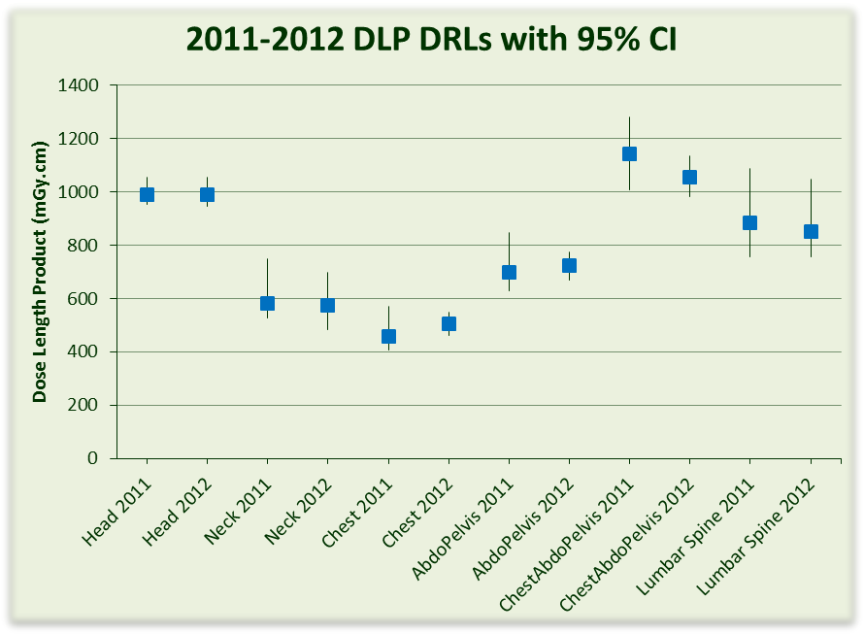

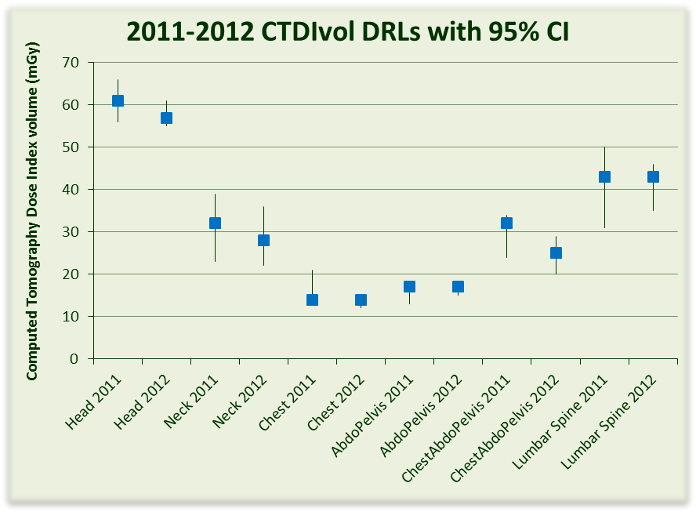

What’s new?

For those of you that have started surveys this year you will already have noticed the addition of Patient Age and Patient Gender columns to the data entry table. We realize these additions mean a little more data collection per patient but the added scope for data analysis will be worth beneficial.

Also two updates that have been made this week are –
- The addition of the Iterative Reconstruction field to the scan settings on the data entry page. This field is a yes or no radio button.
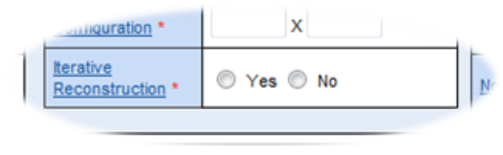

- That reports for paediatric surveys will now make comparisons to the Australian paediatric DRLs rather than the Australian adult DRLs as they have done previously.

2013 data submission so far…

As of April 29th 2013 there was a total of 93 surveys submitted, the following graph shows the distribution by state/territory of these surveys.

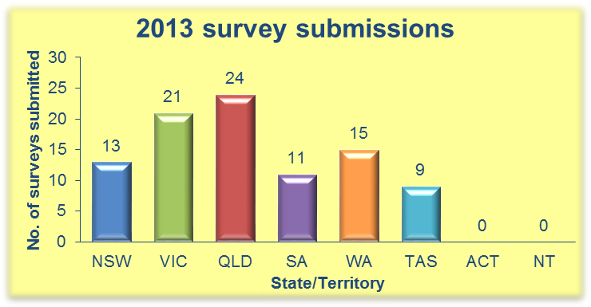

And remember: any surveys started this year have until Dec 31st 3013 to be completed!

Regards,

The NDRLD Team

ARPANSA
Current Australian National DRLs

Australian Adult (15+ yrs) MDCT DRLs
Protocol | DLP  (mGy.cm) | CTDI_{vol}  (mGy)
Head | 1000 | 60
Neck | 600 | 30
Chest | 450 | 15
AbdoPelvis | 700 | 15
ChestAbdoPelvis | 1200 | 30
Lumbar Spine | 900 | 40

Australian Child (5-14 yrs) MDCT DRLs
Protocol | DLP  (mGy.cm) | CTDI_{vol}  (mGy)
Head | 600 | 35
Chest | 110 | 5
AbdoPelvis | 390 | 10

Australian Baby (0-4 yrs) MDCT DRLs
Protocol | DLP  (mGy.cm) | CTDI_{vol}  (mGy)
Head | 470 | 30
Chest | 60 | 2
AbdoPelvis | 170 | 7

Contact us:
Diagnostic Imaging and Nuclear Medicine Section
Australian Radiation Protection and Nuclear Safety Agency
Free call: 1800 033 972
Email: ndrld@arpansa.gov.au

