

NDRL Newsletter 2014 No. 1

Dear service users,

Welcome to the first NDRL Newsletter for 2014. We would like to take this opportunity to invite you to use the service during 2014. You do not need to re-register, all previously approved registrations remain active.

2013 data collection

We are pleased to announce that during 2013 a total of 794 compliant surveys were submitted, which is over 200 more than during 2012! Since the service began operation in 2011 more than 1500 practice dosimetry reports have been generated for over 170 practices/facilities.

What’s new in 2014?

Which practices practice good radiology?....I think we need a change in terminology!
To avoid confusion and align with the terminology of the International Atomic Energy Agency (IAEA) the term Practice Reference Level or PRL, is being replaced with Facility Reference Level or FRL. This is a change in name only, Facility Reference Level will be calculated exactly the same way as the Practice Reference Level.
Please note that it may take some time for this terminology change to reach all NDRLS websites and documentation.

Rather than collecting data all year round why not allocate a single month to data collection! This idea was brought to our attention by one facility who have been using this method for two years now.
Tips for comparing your doses
By allocating a single month to data collection they avoid a long drawn out data collection process. Also, by allocating the same month each year they are less likely to push data collection back due to other work priorities and are building a reliable database of doses each year.

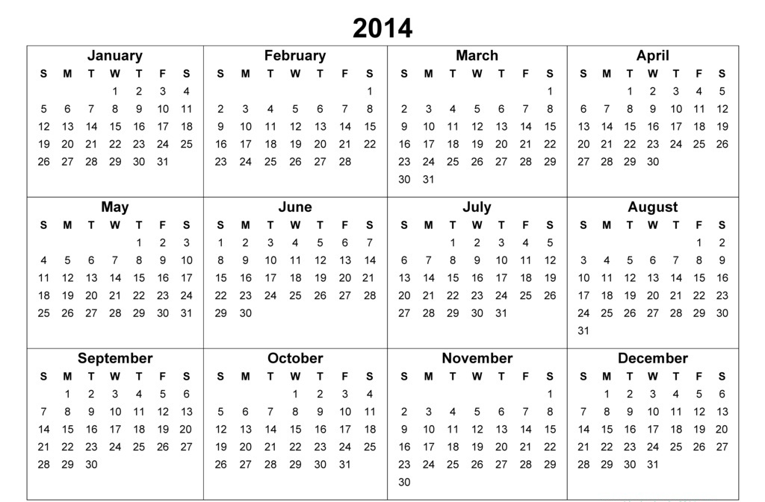
DRLs!

Remember: any surveys started this year have until Dec 31st 2014 to be completed!

Regards,

The NDRLD Team

ARPANSA

Current Australian National DRLs

Australian Adult (15+ yrs) MDCT DRLs
Protocol | DLP  (mGy.cm) | CTDI_{vol}  (mGy)
Head | 1000 | 60
Neck | 600 | 30
Chest | 450 | 15
AbdoPelvis | 700 | 15
ChestAbdoPelvis | 1200 | 30
Lumbar Spine | 900 | 40

Australian Child (5-14 yrs) MDCT DRLs
Protocol | DLP  (mGy.cm) | CTDI_{vol}  (mGy)
Head | 600 | 35
Chest | 110 | 5
AbdoPelvis | 390 | 10

Australian Baby (0-4 yrs) MDCT DRLs
Protocol | DLP  (mGy.cm) | CTDI_{vol}  (mGy)
Head | 470 | 30
Chest | 60 | 2
AbdoPelvis | 170 | 7

Contact us:
Medical Imaging Section
Australian Radiation Protection and Nuclear Safety Agency
Free call: 1800 033 972
Email: ndrld@arpansa.gov.au

A facility is defined as a site of radiology practice as denoted by a Medicare Location Specific Practice Number (LSPN)

