

# How the ACDS derives reference doses from PMMA blocks

The returned OSLDs are read out between one week and one month post-irradiation. The actual dose in the block is determined through a calibrated readout session which employs control OSLDs irradiated to a known dose of 1 Gy by the ACDS. The detectors are also corrected for fading, individual detector sensitivity, energy dependence and non-linearity.

The dose delivered to the block, *Daudit*, is then converted to the equivalent dose under the reference conditions of the facility, *Dref*. The block dose requires corrections for; the different distance and depth between audit and reference conditions, the reduced scatter in the small block compared to a full scatter water phantom; and the difference between the block material and water.

The ACDS combines these corrections into a single beam quality dependent Block Factor (BF). The BF is defined as the ratio of the dose to the OSLD under reference conditions to the dose to the OSLD under audit conditions.

*Dref* = *Daudit* × *BF*

The BF was modelled with BEAMnrc/DOSXYZnrc and compared to measured block factors for the ACDS linac. The modelling of the BF was then extended to a range of beam qualities for each nominal photon and electron energy to cover the existing range of beam qualities in Australia.

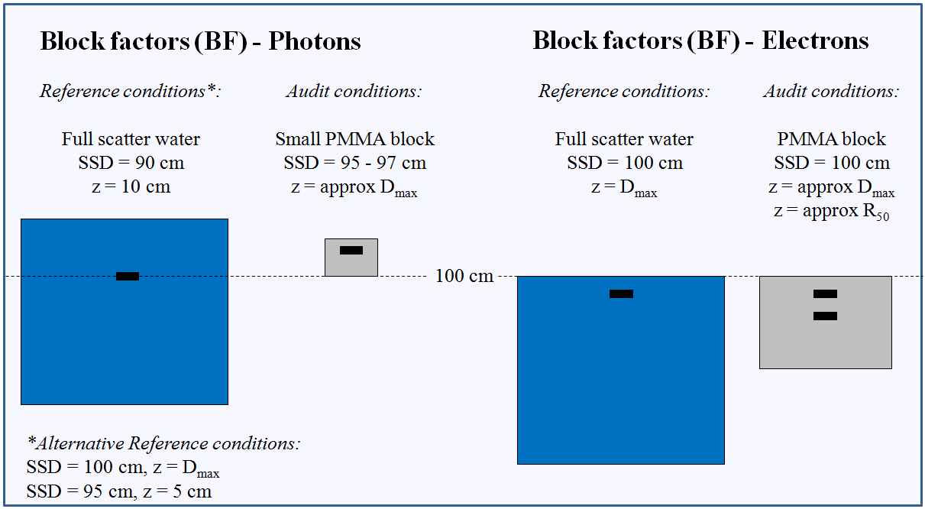The reference and audit conditions used in determining the block factor are summarized below: