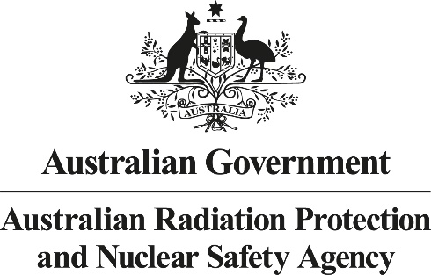 **AMTA–ARPANSA Liaison Forum**

**Summary of the Meeting**

**29 March 2018**

The Chief Executive Officers (CEOs) of the Australian Mobile Telecommunications Association (AMTA) and the Australian Radiation Protection and Nuclear Safety Agency (ARPANSA) met at 619 Lower Plenty Rd, Yallambie.

The objective of the AMTA-ARPANSA Liaison Forum is to provide an open, frank and transparent exchange of information and views on radiation safety and radiation protection issues especially in the area of Electromagnetic Energy (EME), with due regard to the different roles the organisations play.

**Industry update**

AMTA provided an update on significant technology changes occurring in relation to 5G, and the needs for research to fill current gaps in knowledge were discussed as emerging challenges. It was noted that recent global industry forums have discussed technical challenges facing the rollout of 5G technology in various countries.

**5G and EME trials**

Industry representatives and AMTA gave ARPANSA an overview of how they expect 5G technology to be deployed and utilised in Australia, including some information on EME implications. A summary was provided of current trials of 5G technology currently underway, including deployment, testing and measurement of EME outputs.

**World Health Organisation (WHO) Environmental Health Criteria (EHC)**

The WHO is undertaking a health risk assessment of radiofrequency fields (RF), to be published as a monograph in the EHC Series. Project delays have required the project to be delivered as two separate documents – a review of the scientific literature and an assessment of the potential adverse health outcomes.

**Revision of ICNIRP Guidelines**

The International Commission on Non-Ionizing Radiation Protection (ICNIRP) was expected to publish its guidelines for high frequency after the publication of the WHO EHC on the health effects of RF. It is now anticipated that ICNIRP will publish its draft guidelines, irrespective of the WHO EHC, in July 2018.

**Review of Radiation Protection Series No.3 (RPS 3)**

ARPANSA provided an update on the review of RPS 3 – the *Radiation Protection Standard for Maximum Exposure Levels to Radiofrequency Fields - 3 kHz to 300 GHz (2002)*. The review of RPS 3 will consider updated guidance from ICNIRP.

**NHMRC EME research funding**

ARPANSA noted it continues to have ongoing discussions with relevant government agencies to find a solution to the funding of Australia’s EME Program, including ARPANSA’s own activities as well as research funding administered through the National Health and Medical Research Council (NHMRC). The immediate and ongoing viability of Australia’s EME Program was discussed and the need to build a sustainable and independent national funding model to achieve health and safety policy objectives which support industry and the Australian community.

**Other business**

Anticipated changes to the *Radiocommunications Act 1992* were discussed.