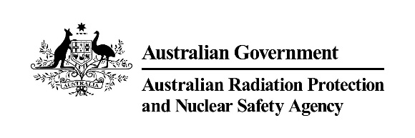 |  | 

AMTA–ARPANSA Liaison Forum Meeting Summary
8 April 2020
11:00am – 12.00pm

Meeting summary
The Chief Executive Officers (CEOs) of the Australian Mobile Telecommunications Association (AMTA) and the Australian Radiation Protection and Nuclear Safety Agency (ARPANSA) and accompanying staff met via a video conference meeting. The objective of the AMTA-ARPANSA Liaison Forum is to provide an open, frank and transparent exchange of information and views on radiation safety and radiation protection issues in the area of Electromagnetic Energy (EME), with due regard to the different roles the organisations play.
EME Standard Update
ARPANSA provided an update on the recent developments around the revision of the EME standard, Radiation Protection Standard for Maximum Exposure Levels to Radiofrequency Fields - 3 kHz to 300 GHz. While ARPANSA has been developing the standard based on the revised ICNIRP guidelines received under embargo, the very recent publication by ICNIRP has enabled ARPANSA to finalise the draft and formally commence discussions with key stakeholders including ACMA before a targeted public consultation later in the year. ARPANSA had also commenced discussions with New Zealand around whether the revised standard may be adopted there as well.

Recent advice provided by ARPANSA
ARPANSA provided an update on the range of recent advice in the area of EME. Of particular note was a mail out to all local government Mayors and CEO’s across Australia and a recent statement addressing some community concern around whether 5G and RF EME more broadly would impact an individual’s immune system making them more at risk of contracting coronavirus.

Enhanced EME Program update
ARPANSA provided an update around the work that ARPANSA was progressing in relation to the enhanced EME Program announced by Ministers in the 2019-20 MYEFO. With additional resourcing to occur in FY 20/21, ARPANSA was focussed over the next six months in the planning and development of key areas of work relating to delivery of an updated EME calibration facility, a measurement program, targeted research, and engagement internationally with key bodies including the World Health Organization and the International Commission on Non-Ionizing Radiation Protection.

Research Update
ARPANSA provided an update on recent developments of ARPANSA staff involvement on two different WHO Systematic Reviews aimed at assessing potential health effects of exposure to EME in the general and working population. Another focus for the agency was finalising our review of scientific research into low level millimetre waves with a view of having it published in a scientific journal.

EME report for small cells
ARPANSA provided an update on recent changes to the environmental EME report template aimed at accommodating its use for small cells.

AMTA Update
AMTA provided an update of recent industry trends, including the recent focus of mobile operators expanding deployment of networks including 5G to accommodate the large surge in remote workers due to COVID-19 restrictions. Also raised that mobile operators where monitoring international developments around physical attacks on telecommunication infrastructure due to perceived health risks of 5G.

