



**Level I OSLD Postal Audit – Facility Instructions**

# General Instructions – Before

1. Fill out the “LI facility data collection – Prior” form and email to [acds@arpansa.gov.au](mailto:acds@arpansa.gov.au)

# General Instructions – On the day

1. Before OSLD irradiation, verify dose per monitor unit calibration of the beam according to facility routine protocol for weekly/monthly output check.
2. Fill out the “LI facility data collection – During” form. Print hardcopy and sign.
3. Review the Level I photon beam audit demonstration video at: <http://www.youtube.com/watch?v=wLRARNlPWPg>
4. Review the Level I electron beam audit demonstration video at: <http://www.youtube.com/watch?v=WchjCEPbzlQ>

# General Instructions – After

1. Repack the kit including:
   * OSLD blocks containing the OSLDs
   * Photon platform
   * Electron phantom blocks (if applicable).
   * Enclose signed “LI facility data collection – During” form.
2. Return the kit to ACDS:

*Australian Facilities*

For your convenience we have enclosed an express post bag for returning the OSLD kit to the ACDS.

*International Facilities*

Please contact the ACDS when you are ready to return the OSLD kit, noting a convenient day for courier collection. ACDS will arrange return courier collection, then email a consignment note and shipping documents for you to print and affix to the shipping case.



619 Lower Plenty Road, Yallambie VIC 3085 [acds@arpansa.gov.au](mailto:acds@arpansa.gov.au)

+61 3 9433 2220 arpansa.gov.au/acds

### Step 1

* Unfold platform stand

### Step 2

* Place platform on top of stand
* Set 100 cm to top of platform

### Step 3 – for each photon energy

* Place appropriate photon block on to the platform centered in the 10 × 10 cm field
* Set to CLINICAL mode
* Deliver 100 MU

### Step 1

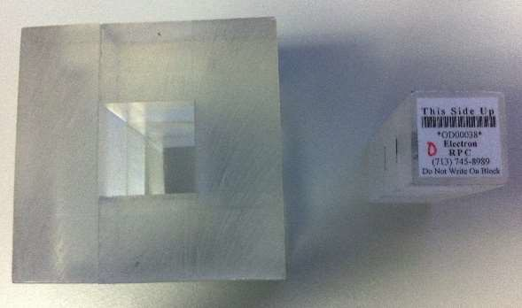

* REMOVE photon platform and stand
* Stack the three acrylic rings with a central square hole on table.
* Insert energy appropriate central acrylic plug.

•

### Step 2

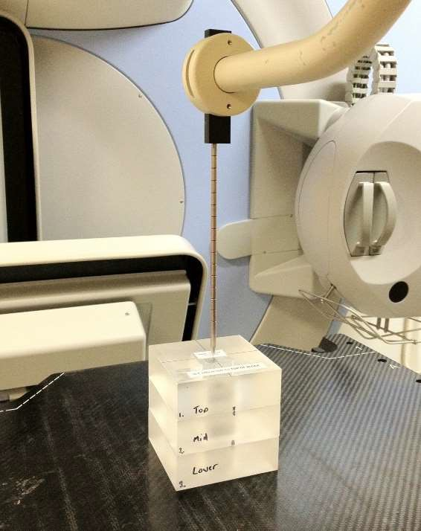

* Set 100 cm to top of acrylic plug.
* Insert 10×10 cm applicator
* Set to CLINICAL mode.
* Deliver 100 MU
* Change plug and repeat for each energy

**NO PLATFORM!**

## FOR PHOTON IRRADIATION:

1. A set of acrylic blocks (one for each photon energy) each containing two OSLDs. Each block is labelled with an ID number and the energy range for which it is appropriate.
2. A small collapsible plastic platform and stand used for photon OSLD irradiation only.

## FOR ELECTRON IRRADIATION:

1. Three 9 x 9 x 3 cm acrylic rings with a central square hole.
2. Central acrylic plugs (one per electron beam) containing OSLDs. Each plug is labelled with a unique ID and the energy range for which it is appropriate.

**CONFIDENTIALITY**

**The results of this audit will be kept confidential by the ACDS and will not be disseminated without the written permission of the participating institution.**