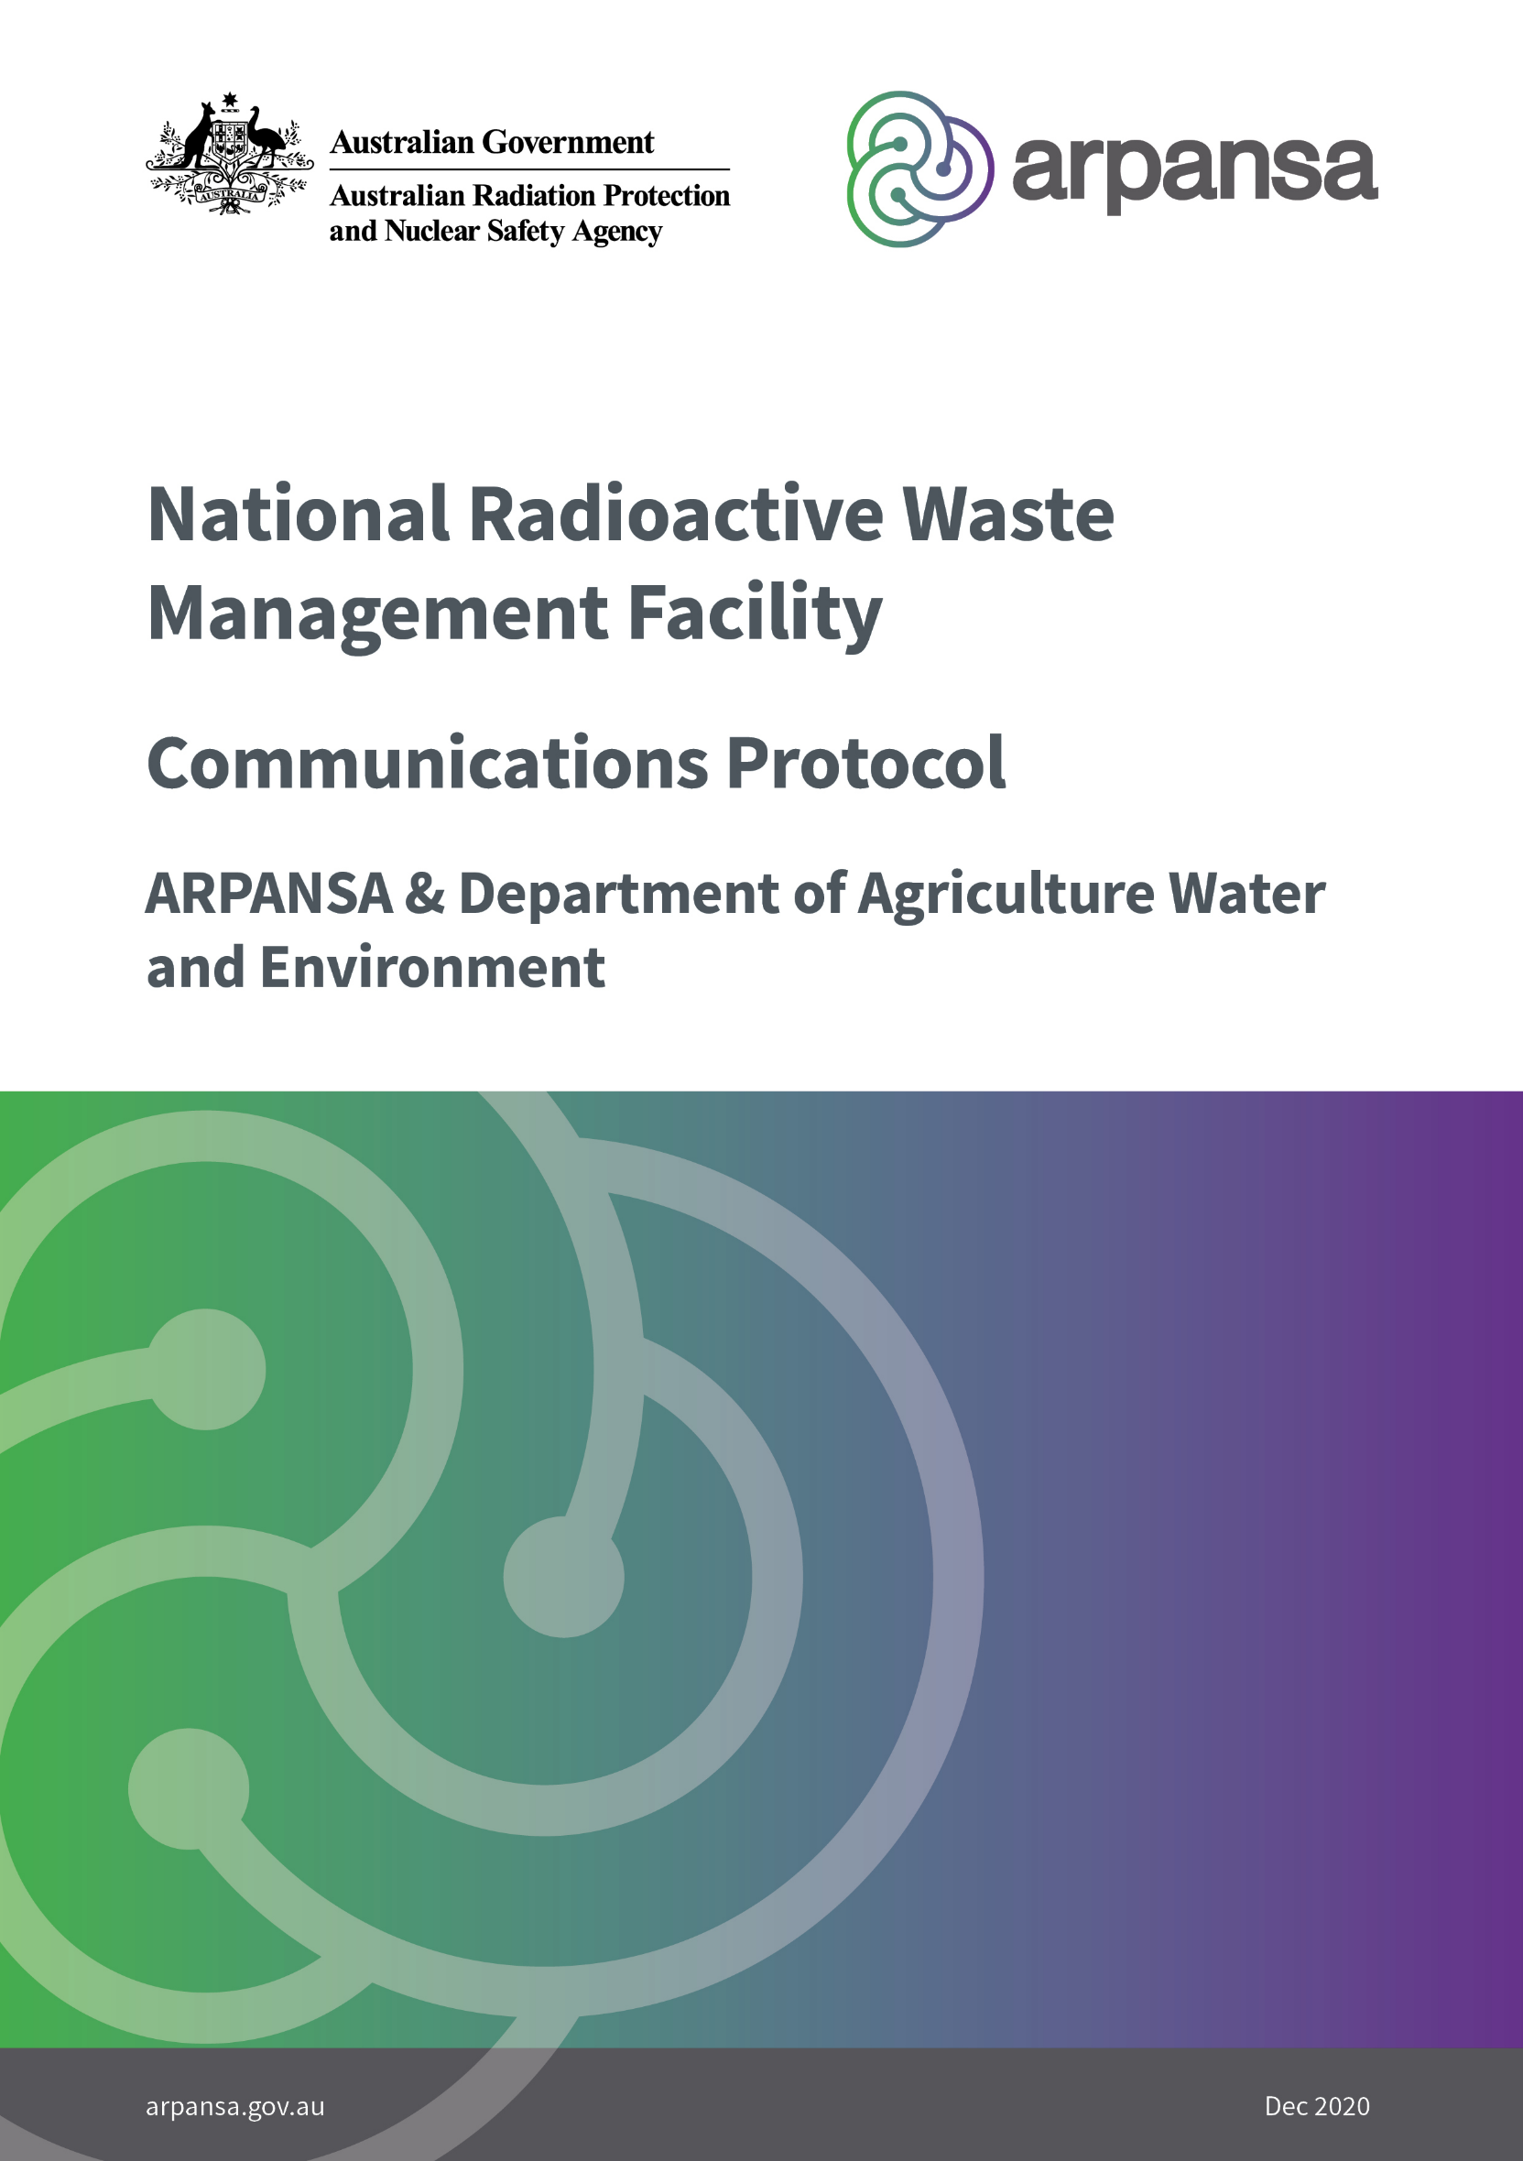

# Purpose

The purpose of this document is to formalise the communications protocol between the Australian Radiation Protection and Nuclear Safety Agency (ARPANSA) and the Department of Agriculture, Water and the Environment (DAWE) relating to the National Radioactive Waste Management Facility (NRWMF) project.

This document defines the mechanism for communication of information in a timely and efficient manner, and minimises the risk that advice provided by ARPANSA to DAWE could be perceived as a pre-emptive regulatory decision by the CEO of ARPANSA under the *Australian Radiation Protection and Nuclear Safety Act 1998* (ARPANS Act) as to whether to issue a site licence or what conditions should be imposed should a licence be issued for the proposed NRWMF.

It also aligns with the communications and working arrangements within the internal probity agreement developed between the DAWE Supervising Scientist Branch (SSB) and the DAWE Environment Assessment Division (EAD) regarding communications with Commonwealth agencies including ARPANSA.

Each party will be responsible for ensuring that all direct reports and subcontractors follow the protocol established in this document.

# Scope

This protocol will cover the period from the receipt of a referral[1] under the *Environment Protection and Biodiversity Conservation Act 1999* (EPBC Act) for the NRWMF to the completion of the formal assessment by DAWE and final decision by the Minister for the Environment and only applies to communication on this proposed facility.

# Background

The Australian Radioactive Waste Agency (ARWA) was established in July 2020, under the Department of Industry, Science, Energy and Resources (DISER) to implement Australia’s radioactive waste management policy. Part of the objective of the policy is to establish the NRWMF in line with the *National Radioactive Waste Management Act 2012*.

The proposed NRWMF is likely to constitute a ‘nuclear action’ under the EPBC Act, and, as such will require assessment and a decision under the EPBC Act from the Minister for the Environment. The EPBC Act contains provisions for how the impact of a facility must be assessed, including provisions for an environmental impact assessment (EIA) and subsequent environmental impact statement (EIS), where relevant. DAWE is responsible for conducting an assessment on the referral, issuing guidelines on any subsequent assessment required, assessing the final application and providing advice to the Minister for the Environment to inform their decision. As part of the assessment process, DAWE’s EAD will request technical advice from SSB in accordance with an internal probity agreement.

The proposed NRWMF would be a controlled facility under the ARPANS Act. Under this Act, licences are required for various stages of a proposed facility’s lifetime, beginning with a licence to prepare a site. Under the ARPANS Regulations, the CEO of ARPANSA will request “any environmental impact statement required or requested by a government agency, and the outcome of the environmental assessment”, as part of the application for a licence to prepare a site for a controlled facility.

ARPANSA will review the Environmental Impact Assessment/Statement (as part of the overall ARPANSA site licence application assessment). This review will form part of the ARPANSA independent assessment as to whether the NRWMF facility as proposed has adequately addressed the requirements of the *Code for Radiation Protection in Planned Exposure Situations* (RPS C-1) and the requirements of codes relevant to the facility proposed (such as the *Code for Disposal of Solid Waste* (RP C3)). In such cases it is reasonable to expect that the EPBC Act approval process will have been finalised prior to a decision being made under the ARPANS Act.

ARPANSA’s Regulatory Services Branch (RSB) is tasked with the assessment of licence applications to inform the CEO’s decision as to whether to issue a licence. While advice can be sought from external and internal experts, the RSB Head provides advice to the CEO on the outcomes of the regulatory assessment of any licence applications.

Both the ARPANS Act and the EPBC Act cover nuclear matters and protection of the environment. On radiological matters, the EPBC Act refers to the ARPANS Act. Together these Acts provide the national framework for protection of the environment from activities involving radioactive waste.

Since the NRWMF will likely require approval under *both* the EPBC Act and the ARPANS Act, as part of its statutory function, ARPANSA will advise stakeholders, including DAWE, on best practice for radiological safety considerations for the environment and provide specific advice on request. This advice will be provided by ARPANSA’s Radiation Health Services Branch (RHSB), which is separate to the RSB, and provides expertise, specialised resources and services for the protection of the public, workers and the environment from the hazards of ionising radiation.

In this respect, given the separation of the two branches within ARPANSA, the risk of technical advice provided to DAWE under their process which may be perceived as pre-empting the outcome of ARPANSA’s licence application assessment and subsequent recommendations to the CEO is avoided.

# Documents

* [ARPANS Act 1998](https://www.arpansa.gov.au/regulation-and-licensing/regulation/about-regulatory-services/why-we-regulate/arpans-legislation)
* [ARPANS Regulations 2018](https://www.arpansa.gov.au/regulation-and-licensing/regulation/about-regulatory-services/why-we-regulate/arpans-legislation)
* [*National Radioactive Waste Management Act 2012*](https://www.legislation.gov.au/Details/C2012A00029)
* [*Environmental Protection and Biodiversity Conservation Act 1999* (the EPBC Act)](https://www.environment.gov.au/epbc/about)
* [Environment Protection and Biodiversity Conservation Regulations 2000](https://www.environment.gov.au/epbc/about)
* [Code for Disposal Facilities for Solid Radioactive Waste (RPS C-3) (2018)](https://www.arpansa.gov.au/regulation-and-licensing/regulatory-publications/radiation-protection-series/codes-and-standards/rpsc3)
* Code for Radiation Protection in Planned Exposure Situations (RPS-C-1) (2020)
* [*Privacy Act 1988*](https://www.legislation.gov.au/Series/C2004A03712)

# Communication agreement and contacts

ARPANSA and DAWE will communicate in accordance with this protocol, working collaboratively to achieve the best results for the Australian community regarding a NRWMF and during the period defined in the scope. ARPANSA and DAWE will observe the terms and conditions of any applicable confidentiality agreement noting that both parties are non-corporate Commonwealth entities.

## ARPANSA personnel

|  |  |  |
| --- | --- | --- |
| Role | Responsibility | Contact details |
| Director - Radiation Health Services Branch | Technical and scientific advice to the EPBC referral and assessment process where required | Director  Assessment and Advice Section  [NRWMFsupportRHSB@arpansa.gov.au](mailto:NRWMFsupportRHSB@arpansa.gov.au) |
| Project Manager - Regulatory Services Branch | Provision of regulatory criteria.  No role in the provision of pre-referral / referral and EIS assessment advice to DAWE. | Project Manager  National Radioactive Waste Management Facility Support Project  [NRWMFsupport@arpansa.gov.au](mailto:NRWMFsupport@arpansa.gov.au) |

## Department of Agriculture Water and the Environment personnel

| Role | Responsibility | Contact details |
| --- | --- | --- |
| EAD | Undertaking the referral, assessment and approval process under the EPBC Act, where required. | Assessment Officer  Environment Assessments West (WA, SA, NT) Branch  Assessments.West@awe.gov.au |
| SSB | Provides technical advice to EAD on referrals under the EPBC Act that may be or are nuclear actions, where required. | Assistant Director Supervision  Supervising Scientist Branch  supervision.ssd@awe.gov.au |

# Protocol

## General information/queries

All formal communications should be raised to the appropriate contact as noted in Section 5 and copied to the respective DAWE and ARPANSA project managers.

Parties will maintain records of all correspondence sent and received. Parties will endeavour to provide a response to a request for information within a mutually agreed timeframe.

If it is unclear who has direct responsibility for the matter of enquiry, the respective Project Manager nominated in this protocol should be contacted. The Project Manager will refer the matter to the appropriate staff member if it goes beyond their role.

## Request for Technical Advice

Requests for advice from DAWE can be responded to by the Director ARPANSA RHSB or RHSB staff member, as nominated by the Director. RHSB provides expertise, specialised resources and services for the protection of the public, workers and the environment from the hazards of ionising radiation.

## Meeting communication

Where formal meetings are held, it is expected that an agenda will be issued at least 5 (five) working days before the scheduled date, insofar as practical.

Where this is not practical, both parties will ensure an agenda is issued prior to the meeting date. Any actions arising from the initial meeting should be captured as actions to be addressed under the agenda of a follow up meeting as required.

The notification that a formal meeting should be held shall be raised electronically via e-mail calendar requests. Requests shall include the list of participants, the agenda, the Chair of the meeting, the date and the venue or video conferencing platform.

Minutes of the meeting shall record only decisions and actions resulting from the meeting agenda. The party hosting the meeting is required to keep minutes of meetings and forward them through to the other party within an agreed timeframe.

Members of the ARPANSA RSB may attend, as an observer, meetings and other as requested from time to time, and only where it is assessed that there is not a conflict of interest (real or perceived).

## Formal correspondence

Formal written correspondence should be raised whenever an exchange of information is required to seek an official response from a receiving party in relation to any project-related matters.

The preferred mode of formal communication between ARPANSA and DAWE is by email correspondence. Correspondence issued in this manner is understood to represent controlled and reliable information reflecting the position of the transmitting party. Communications must display the appropriate security classification. The parties will ensure that they comply with any relevant legal requirements including obligations under the *Privacy Act 1988*.

Where correspondence requires an answer to a specific question(s), the question(s) should as far as possible conform to the following principles:

* Clear and definite question(s) should be raised; responses should address specifically the questions raised.
* Attachments relating to the query should be easily accessible for review and where possible included in the query submittal for review.
* The receiving party should make every effort to provide a response within the agreed upon timeframe. Where a deadline cannot be met, the receiving party should notify and consult with the issuing party to provide an updated timeframe as soon as practicable.
* Only the party raising the correspondence can close the correspondence.
* Revision control of the outgoing correspondence is the responsibility of the issuing party.

Where the intent of correspondence is to state a position or to inform the recipient of new information and no response is required, the issuer of the correspondence should raise the correspondence as “Closed” on issue.

## Technical Advice provided to DAWE

RHSB will provide advice to DAWE and SSB on the following:

* Clarification on ARPANSA’s criteria for the protection of people (public and workers) and the environment under the ARPANS Act, Regulations, national codes and guides and relevant international best practice.
* High level advice on radiation protection matters that are considered under the EPBC Act to ensure alignment with the ARPANS Act, Regulations, national codes and guides and relevant international best practice.
* Provision of technical advice on radiation protection matters related to the EPBC Act referral and assessment process.

# Issue resolution

In the event there is a communication breakdown and/or an issue cannot be resolved in a timely and adequate manner, both parties have the right to escalate an issue to the next highest level within their own respective organisation.

1. A ‘referral’ is the process that is used by DAWE to determine whether or not a proposed action will need formal assessment and approval under the EPBC Act. The referral will be the principal basis for the Minister’s decision as to whether approval is necessary and, if so, the type of assessment that will be taken.