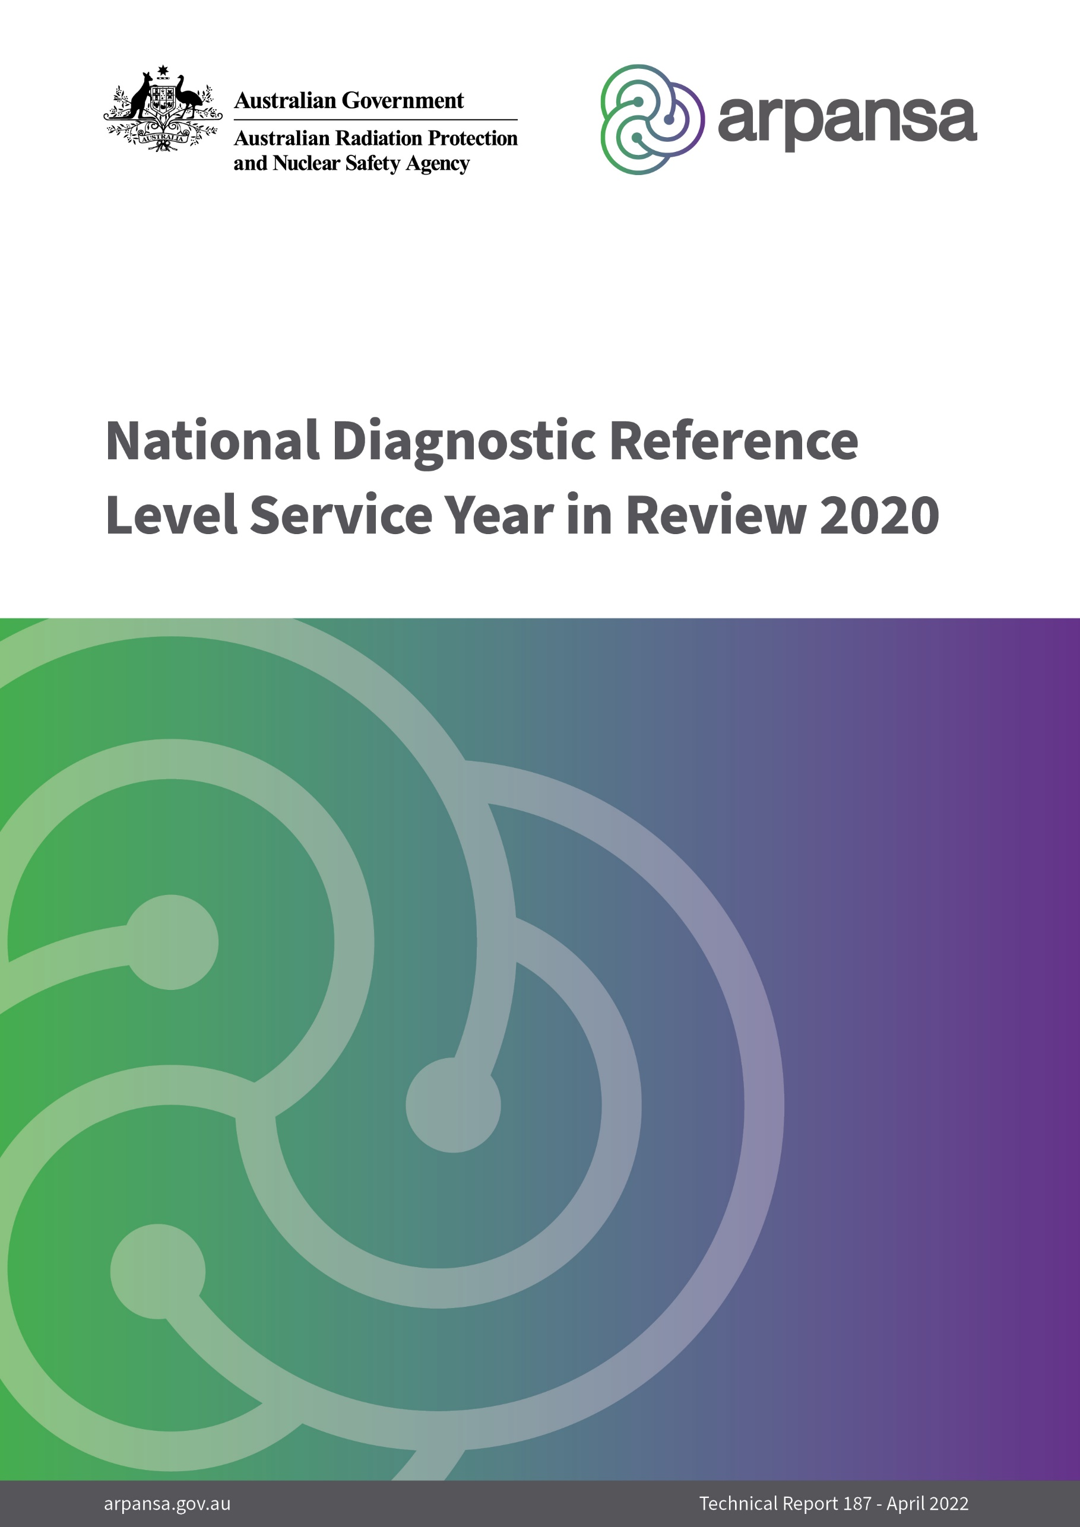

National Diagnostic Reference Level Service Year in Review 2020

Technical Report 187

April 2022

Peter Thomas, Toby Beveridge, Masoumeh Sanagou

|  |
| --- |
| © Commonwealth of Australia 2022  This publication is protected by copyright. Copyright (and any other intellectual property rights, if any) in this publication is owned by the Commonwealth of Australia as represented by the Australian Radiation Protection and Nuclear Safety Agency (ARPANSA).  ISSN 0157-1400    **Creative Commons**  With the exception of the Commonwealth Coat of Arms, any ARPANSA logos and any content that is marked as being third party material, this publication, *National Diagnostic Reference Level Service Year in Review 2020*, by the Australian Radiation Protection and Nuclear Safety Agency is licensed under a Creative Commons Attribution 3.0 Australia licence (to view a copy of the licence, visit [*http://creativecommons.org/licenses/by/3.0/au*](http://creativecommons.org/licenses/by/3.0/au)). It is a further condition of the licence that any numerical data referred to in this publication may not be changed. To the extent that copyright subsists in a third party, permission will be required from the third party to reuse the material.  In essence, you are free to copy, communicate and adapt the material as long as you attribute the work to ARPANSA and abide by the other licence terms. The works are to be attributed to the Commonwealth as follows:-  ‘© Commonwealth of Australia 2022, as represented by the Australian Radiation Protection and Nuclear Safety Agency (ARPANSA)’  The publication should be attributed as: *National Diagnostic Reference Level Service Year in Review 2020*.  **Use of the Coat of Arms**  The terms under which the Coat of Arms can be used are detailed on the Department of the Prime Minister and Cabinet website ([www.dpmc.gov.au/government/commonwealth-coat-arms](http://www.dpmc.gov.au/government/commonwealth-coat-arms)).  Enquiries regarding the licence and any use of this report are welcome.  ARPANSA  619 Lower Plenty Road  YALLAMBIE VIC 3085  Tel: 1800 022 333 (Freecall) or +61 3 9433 2211   Email: [info@arpansa.gov.au](mailto:info@arpansa.gov.au)  Website: [www.arpansa.gov.au](http://www.arpansa.gov.au) |

Acknowledgement of Country

ARPANSA respectfully acknowledges Australia’s Aboriginal and Torres Strait Islander communities and their rich culture and pays respect to their Elders past and present. We acknowledge Aboriginal and Torres Strait Islander peoples as Australia’s first peoples and as the Traditional Owners and custodians of the land and water on which we rely.

We recognise and value the ongoing contribution of Aboriginal and Torres Strait Islander peoples and communities to Australian life and how this enriches us. We embrace the spirit of reconciliation, working towards the equality of outcomes and ensuring an equal voice.

**Contents**

Acknowledgement of Country iv

Executive Summary vi

1. Introduction 1

2. ARPANSA’s National Diagnostic Reference Level Service 1

3. Year in Review – 2020 3

3.1 Computed Tomography 3

3.2 Image-Guided and Interventional Procedures 6

3.3 Nuclear Medicine 7

4. Conclusions 7

References 8

Appendix 1: Cumulative FRL distributions for MDCT surveys in 2020 9

Appendix 2: Historical trends 18

Executive Summary

ARPANSA collects data to establish and update national diagnostic reference levels (DRLs). The National Diagnostic Reference Level Service (NDRLS), a free on-line service maintained and operated by ARPANSA, provides tools for imaging facilities to record data on radiation doses in imaging procedures and compare their practice with the national DRLs, providing guidance to optimise radiation dose. More than 60 per cent of imaging facilities with computed tomography (CT) scanners use this service, which supports patient safety in CT and other imaging procedures.

A total of 5078 surveys from 722 scanners were completed in 2020 for multi-detector computed tomography (MDCT) procedures. For several scan categories the third quartile of the distribution of scanner median dose metrics for 2020 is more than 10% below the relevant national DRL. In many cases more than 85% of surveys have median values under the national DRL. These data suggest that a general review of the MDCT DRLs is warranted, especially the DRLs for pediatric patients.

Forty-six (46) surveys were submitted for image-guided procedures in 2020, mostly for diagnostic coronary angiography. The third quartiles of the distributions of dose metrics were consistent with the national DRLs for diagnostic coronary angiography. More data submissions are needed to establish national DRLs for other image-guided procedures.

A new survey was developed to collect data for nuclear medicine procedures. Updated DRLs for nuclear medicine and positron emission tomography are expected following the completion of the survey and analysis of the data.

The data collected for MDCT over the last decade demonstrate a reduction in dose per procedure for all procedures which have an established national DRL. These changes reflect advances in technology and optimisation of practice. DRL programs in other modalities are less mature and greater engagement is needed to increase the volume of data submission and foster optimisation.

# Introduction

The Australian Radiation Protection and Nuclear Safety Agency (ARPANSA) has a legislated responsibility to “protect the health and safety of people, and to protect the environment, from the harmful effects of radiation.”[1] ARPANSA’s National Diagnostic Reference Level Service (NDRLS) is maintained to support radiation safety for patients undergoing diagnostic imaging with ionising radiation.

ARPANSA’s Medical Imaging section developed the NDRLS in response to the publication and adoption in 2008 of the *Code for Radiation Protection in the Medical Applications of Ionizing Radiation* (RPS 14) (ARPANSA, 2008). The code included a requirement for facilities to compare radiation doses in diagnostic imaging procedures with diagnostic reference levels (DRLs) where such DRLs had been established. Since the inception of the NDRLS in 2011, usage has grown such that nearly 800 facilities with a combined total of more than 1000 computed tomography (CT) scanners are registered with the service. It is estimated that this represents more than 60% of all providers of CT services in Australia. The NDRLS supports patient safety for the approximately 5 million CT imaging procedures performed in Australia each year.

This report analyses data collected through the NDRLS for the 2020 calendar year and presents historical trends over the service’s operational lifetime since 2011.

# ARPANSA’s National Diagnostic Reference Level Service

ARPANSA’s Diagnostic Reference Level (DRL) program supports optimisation of medical exposures by providing guidance on typical doses for common imaging procedures. Routine comparison against DRLs is included in regulatory requirements such as the Medical Exposure Code (RPS C-5) (ARPANSA, 2019) and the Diagnostic Imaging Accreditation Scheme (DIAS) (ACSQHC, 2016).

The International Commission on Radiological Protection (ICRP) recommends that DRLs should reflect common practice within a given geographical region (ICRP, 2017). ARPANSA achieves this by determining national DRLs based on the results of wide-scale surveys of Australian imaging facilities.

ARPANSA has published national DRLs for multi-detector computed tomography (MDCT), image guided and interventional procedures (IGIP) and nuclear medicine (ARPANSA, 2021; Hayton *et al*., 2013a; Lee *et al*., 2020; Beveridge *et al*., 2019). These three modalities include the imaging procedures with the highest radiation doses and are responsible for the majority of the Australian population’s medical imaging dose burden (Hayton *et al*., 2013b).

The NDRLS collects MDCT survey data through a web portal (Wallace *et al*., 2015). Data for IGIP and nuclear medicine procedures are collected using spreadsheet templates[2]. Imaging facilities submit their protocol, patient, and dose information to the ARPANSA NDRLS for a variety of procedures. A single survey consists of the protocol information (technical parameters for the scan or procedure) for a particular scan category along with the dose metrics and patient characteristics for a sample of individual patients undergoing that scan or procedure. Surveys include data for up to 20 patients in MDCT and 50 patients for IGIP. The median value of each dose metric is reported as the facility reference level (FRL) for the survey. The national DRLs are based on the 75th percentile (third quartile) of the resulting FRL distributions across all participating facilities for each scan or procedure category.

What are DRLs?

A key principle for radiation protection in medical uses of ionising radiation is that procedures should be optimised, meaning that the ratio of benefit to risk should be maximised. For a given imaging procedure, the risk is assumed to be proportional to the radiation dose delivered. Benefit is harder to quantify but a key requirement is that the images obtained are of sufficient quality to address the clinical question that prompted the imaging procedure in the first place.

Diagnostic reference levels (DRLs) are an optimisation tool. They provide an indication of the expected radiation dose delivered for a given imaging procedure. A medical imaging facility must periodically compare their typical dose with the DRL for each of the common procedures they perform that have a published national DRL. The typical dose at a facility is the median value of the relevant dose metric from a representative sample of patient exposures. If the facility’s median value is above the DRL, this is an indication that further optimisation (reduction in dose) may be possible. The facility should review the imaging protocol to determine whether a reduction in dose can be achieved, without compromising the image quality required for the clinical task.

DRLs are usually established from surveys of typical doses for common procedures across many facilities in a nation or region. The International Commission on Radiological Protection (ICRP) recommends that DRLs be established at the 75th percentile of the distribution of facility median dose values. This means that 75% of facilities would have a typical dose either at or below the DRL. The other 25% of facilities may be doing the best they can, but the fact that 75% of facilities can perform the same imaging task at a lower dose level suggests that improvement is possible and worth investigating. Improvement may be possible even for sites that are under the DRL, and this is encouraged where resources permit, but it is likely that the best gains can be made in those sites that are above the DRL.

Continued monitoring of facility median dose levels would be expected to show a reduction in the 75th percentile of the distribution over time as facilities review and optimise their imaging protocols and as new equipment is installed with the capability of producing the required image quality at lower doses. DRLs should thus be reviewed over time and revised as necessary to ensure they are continuing to reflect the typical dose achieved by about 75% of facilities. This ongoing process of continuous improvement helps ensure that the ratio of benefit to risk is maximised for patients.

# Year in Review – 2020

## Computed Tomography

The MDCT survey continued to show growth in the number of users participating and the amount of data submitted. At the end of 2020, the MDCT survey had 787 registered participants, with 52 registering during 2020. A total of 5078 CT surveys from 722 scanners were completed in 2020, an increase of 297 surveys from the total for 2019. A breakdown of the surveys by age group and scan category is shown in Table 1.

Table 1 - Number of MDCT DRL surveys submitted in 2020 by age group and scan category

|  |  |  |
| --- | --- | --- |
| Age group | Scan category | Surveys |
| Adult (15+ years) | Head | 729 |
| Cervical spine | 597 |
| Soft-tissue neck | 530 |
| Chest | 682 |
| Chest-abdo-pelvis | 621 |
| Abdomen-pelvis | 693 |
| Kidney-ureter-bladder | 521 |
| Lumbar spine | 672 |
| Total | 5045 |
| Child (5-14 years) | Head | 10 |
| Chest | 6 |
| Abdomen-pelvis | 4 |
| Total | 20 |
| Infant (0-4 years) | Head | 8 |
| Chest | 3 |
| Abdomen-pelvis | 2 |
| Total | 13 |
| Total Surveys |  | 5078 |

Table 2 shows the number of facilities and scanners registered with the ARPANSA NDRLS as at 1/1/2021 in each state and territory. Also shown is the number of scanners for which at least one eligible survey (at least 10 patients) for a scan category was submitted in 2020, the total number of such surveys, and the percentage of registered scanners that submitted at least one survey. Overall, 69% of registered scanners contributed at least one survey in 2020 and the proportion was reasonably consistent across the states and territories, varying from 64% to 74%.

Table 2 – Distribution of registered facilities and scanners by state and territory, number of scanners submitting surveys, total surveys, and percentage of registered scanners submitting data in 2020

|  |  |  |  |  |  |
| --- | --- | --- | --- | --- | --- |
| State | Registered Facilities | Registered Scanners | Scanners with submitted surveys | Surveys | Registered scanners submitting (%) |
| NSW | 278 | 322 | 225 | 1619 | 70 |
| VIC | 225 | 297 | 207 | 1482 | 70 |
| QLD | 153 | 231 | 151 | 1075 | 65 |
| SA | 27 | 66 | 49 | 251 | 74 |
| WA | 64 | 79 | 58 | 409 | 73 |
| TAS | 14 | 15 | 11 | 74 | 73 |
| ACT | 18 | 19 | 14 | 115 | 74 |
| NT | 8 | 11 | 7 | 53 | 64 |
| Total | 787 | 1040 | 722 | 5078 | 69 |

According to data submitted to the Organisation for Economic Co-operation and Development (OECD) (OECD, 2022), Australia had 1769 CT scanners in 2019, however this figure is derived from the Medicare Location Specific Practice Number (LSPN) register and it is not known whether all such scanners are in active use, nor how many are used primarily for diagnostic radiology (in contrast to uses as part of hybrid equipment in nuclear medicine imaging or use in radiotherapy for treatment planning). The number of CT scanners registered with the NDRLS thus represents at least 60% of all diagnostic CT scanners in Australia, and the true proportion may be much higher. It seems likely therefore that the data comes from around half or more of all diagnostic CT scanners and is relatively evenly distributed across the country.

Table 3 shows the breakdown of registered facilities and scanners by facility type, along with the number of registered scanners submitting surveys, the total number of surveys, and the proportion of registered scanners submitting surveys. Public hospital facilities show a lower fraction of submissions from registered scanners; however these facilities also show a higher number of scanners per facility and this may reflect different usage patterns or delay in removing replaced scanners from the registration list.

Table 3 – Distribution of registered facilities and scanners by facility type, number of scanners submitting surveys, total surveys, and percentage of registered scanners submitting data in 2020

|  |  |  |  |  |  |
| --- | --- | --- | --- | --- | --- |
| Facility Type | Registered  Facilities | Registered  Scanners | Scanners with  submitted surveys | Surveys | Registered scanners submitting (%) |
| Public clinic in a Public Hospital | 124 | 236 | 129 | 891 | 55 |
| Private clinic in a Public Hospital | 43 | 65 | 49 | 334 | 75 |
| Private clinic in a Private Hospital | 112 | 147 | 112 | 794 | 76 |
| Private clinic | 508 | 592 | 432 | 3059 | 73 |
| Total | 787 | 1040 | 722 | 5078 | 69 |

Third quartiles of the FRL distributions for adult patients in 2020 are shown in Table 4 and compared with the national DRLs. The percentage of surveys with median values under the relevant DRL is also shown. Plots of the cumulative FRL distributions for adult patients in 2020 for each scan category and dose metric are presented in Appendix 1. Historical trends in the FRL distributions for each scan category and dose metric are presented in Appendix 2.

Table 4 – Third quartiles (75th percentiles) of the 2020 CT FRL distributions for adult patients and comparison with the national DRLs, by scan category.

|  |  |  |  |  |  |  |
| --- | --- | --- | --- | --- | --- | --- |
| Scan Category | CTDIvol (mGy) | | | DLP (mGy.cm) | | |
| 75th percentile | National DRL | Surveys  < DRL (%) | 75th percentile | National DRL | Surveys  < DRL (%) |
| Head | 47.4 | 52 | 91 | 835 | 880 | 85 |
| Cervical spine | 19.7 | 21 | 81 | 407 | 470 | 87 |
| Soft-tissue neck | 14.5 | 15 | 76 | 420 | 450 | 80 |
| Chest | 8.6 | 10 | 89 | 344 | 390 | 85 |
| Chest-abdo-pelvis | 10.3 | 11 | 78 | 842 | 940 | 86 |
| Abdomen-pelvis | 10.8 | 13 | 90 | 532 | 600 | 86 |
| Kidney-ureter-bladder | 9.2 | 10 | 82 | 438 | 460 | 80 |
| Lumbar spine | 21.9 | 26 | 88 | 607 | 670 | 85 |

For several scan categories the third quartile for 2020 is more than 10% below the national DRL. In many cases more than 85% of surveys have median values under the DRL. These data suggest that a general review of the CT DRLs is warranted.

Third quartiles of the FRL distributions for pediatric patients in 2020 are shown in Table 5 and compared with the national DRLs. The percentage of surveys with median values under the relevant DRL is also shown. Nearly all surveys have median values under the DRL. These data suggest that a review of the pediatric CT DRLs is warranted.

Table 5 – Third quartiles (75th percentiles) of the 2020 CT FRL distributions for pediatric patients and comparison with the national DRLs, by scan category.

|  |  |  |  |  |  |  |  |
| --- | --- | --- | --- | --- | --- | --- | --- |
| Age group | Scan Category | CTDIvol (mGy) | | | DLP (mGy.cm) | | |
| 75th percentile | National DRL | Surveys  < DRL (%) | 75th percentile | National DRL | Surveys  < DRL (%) |
| Child  (5-14 years) | Head | 31 | 35 | 90 | 560 | 600 | 80 |
| Chest | 1.6 | 5 | 100 | 56 | 110 | 100 |
| Abdomen-pelvis | 3.3 | 10 | 100 | 130 | 390 | 100 |
| Infant  (0-4 years) | Head | 23 | 30 | 100 | 390 | 470 | 100 |
| Chest | 1* | 2 | 100 | 25* | 60 | 100 |
| Abdomen-pelvis | 1* | 7 | 100 | 35* | 170 | 100 |

*There were insufficient surveys to calculate third quartiles for the Chest and Abdomen-pelvis scan categories for infants; the maximum value is shown instead.

## Image-Guided and Interventional Procedures

Forty-six (46) surveys were submitted for IGIP in 2020, 45 for adult patients and one for pediatric patients. The surveys were submitted by 20 facilities (34 rooms) out of 58 registered facilities (34% of registered facilities). Comparative totals for 2019 were 47 surveys from 21 facilities (41 rooms) out of 49 registered facilities (43%).

Of the adult surveys, 22 were for coronary angiography and the third quartiles of the FRL distributions were consistent with the national DRLs. Data for other procedures were quite sparse and more submissions are needed to establish national DRLs.

Table 6 shows the number of adult IGIP surveys submitted in 2020 for each procedure category.

Table 6 – Adult IGIP surveys submitted in 2020 by procedure category

|  |  |
| --- | --- |
| Procedure category | Surveys |
| Diagnostic coronary angiography | 22 |
| Percutaneous coronary intervention (single lesion) | 7 |
| Diagnostic cerebral angiography | 4 |
| Pelvic embolisation | 1 |
| Endovascular aortic repair | 3 |
| Barium swallow | 3 |
| Water-soluble swallow | 2 |
| Tunnelled line insertion | 3 |
| Total | 45 |

Third quartiles of the FRL distributions for adult patients are shown in Table 7 for the three procedure categories with at least 4 submitted surveys. At present, a national DRL has only been published for diagnostic coronary angiography (ARPANSA, 2021) so no comparison can be shown for the other procedure categories. The third quartiles of the FRL distributions for diagnostic coronary angiography in 2020 are consistent with the current national DRLs.

Table 7 – Third quartiles (75th percentiles) of the 2020 IGIP FRL distributions for adult patients and comparison with the national DRLs by procedure category.

|  |  |  |  |  |  |  |
| --- | --- | --- | --- | --- | --- | --- |
| Procedure | DAP (Gy.cm²) | | | Reference Dose (Gy) | | |
| 75th percentile | National DRL | Surveys < DRL (%) | 75th percentile | National DRL | Surveys < DRL (%) |
| Diagnostic coronary angiography | 30.5 | 30 | 73 | 0.38 | 0.5 | 95 |
| Percutaneous coronary intervention (single lesion) | 62.4 |  |  | 1.2 |  |  |
| Diagnostic cerebral angiography | 57.4 |  |  | 0.47 |  |  |

## Nuclear Medicine

A survey of radiation doses in nuclear medicine and positron emission tomography (PET) procedures was conducted in 2014/15 and DRLs for these procedures were established in 2017 (Beveridge *et al*., 2019). In 2020, a new survey was developed to collect data for nuclear medicine and PET procedures, covering both administered activities of radiopharmaceuticals and metrics for associated CT scans. A liaison panel comprising representatives of relevant professional bodies was formed to advise ARPANSA on the development of the survey. The survey was planned to be conducted towards the end of 2021. Updated DRLs for nuclear medicine and positron emission tomography are expected following the completion of the survey and analysis of the data.

# Conclusions

The data collected for MDCT in 2020 comes from around half or more of all diagnostic CT scanners and is relatively evenly distributed across Australia and across facility types. For several scan categories the third quartile of the distribution of scanner median dose metrics for 2020 is more than 10% below the relevant national DRL, suggesting that a general review of the MDCT DRLs is warranted, especially for pediatric patients. The data collected for MDCT over the last decade demonstrate a reduction in dose per procedure for all scan categories that have an established national DRL. These changes reflect advances in technology and optimisation of practice.

DRL programs in other modalities are less mature and greater engagement is needed to increase the volume of data submission and foster optimisation.

References

Australian Commission on Safety and Quality in Health Care (ACSQHC), 2016. Diagnostic Imaging Accreditation Scheme Standards, online: accessed 17/03/2022, <https://www.safetyandquality.gov.au/standards/diagnostic-imaging/diagnostic-imaging-accreditation-scheme-standards>.

Australian Radiation Protection and Nuclear Safety Agency (ARPANSA), 2008. *Code for Radiation Protection in the Medical Applications of Ionizing Radiation*. Radiation Protection Series 14.

Australian Radiation Protection and Nuclear Safety Agency (ARPANSA), 2019. *Code for Radiation Protection in Medical Exposure*. Radiation Protection Series C-5.

Australian Radiation Protection and Nuclear Safety Agency (ARPANSA), 2021. Current Australian diagnostic reference levels, online: accessed 17/03/2022, <https://www.arpansa.gov.au/research-and-expertise/surveys/national-diagnostic-reference-level-service/current-australian-drls>.

Beveridge, T., Marks, P., Thomas, P., 2019. *Australian Diagnostic Reference Levels (DRLs) for Nuclear Medicine*, ARPANSA Technical Report 180.

Hayton, A., Wallace, A., Marks, P., Edmonds, K., Tingey, D., Johnston, P., 2013a. Australian diagnostic reference levels for multi detector computed tomography, *Australas Phys Eng Sci Med*, 36(1), 19-26.

Hayton, A., Wallace, A., Marks, P., Edmonds, K., Tingey, D., Johnston, P., 2013b. Australian per caput dose from diagnostic imaging and nuclear medicine, *Rad Prot Dosim*, 156(4), 445-450.

ICRP, 2017. *Diagnostic Reference Levels in Medical Imaging*, ICRP Publication 135, ICRP 46(1), 1-143.

Lee, K. L., Beveridge, T., Sanagou, M., Thomas, P., 2020. Updated Australian diagnostic reference levels for adult CT, *J Med Rad Sci*, 67(1), 5-15.

Organisation for Economic Co-operation and Development (OECD), 2022. OECD.Stat, Health, Health Care Resources, Medical technology, online: accessed 17/03/2022, <https://stats.oecd.org/>.

Wallace, A., Hayton, A., Thomas, P., Beveridge, T., 2015. *The 2011-2013 National Diagnostic Reference Level Service Report*, ARPANSA Technical Report 171.

#### Cumulative FRL distributions for MDCT surveys in 2020

This appendix presents the cumulative distributions for CTDIvol and DLP from adult MDCT DRL surveys submitted to ARPANSA in 2020. The plots display the percentage of surveys that achieved a facility reference level (FRL) below the dose specified on the x-axis.

The blue curve represents all the submitted data, the orange curve represents the surveys where iterative reconstruction (IR) was used, and the green curve represents the surveys where IR was not used and image reconstruction was performed using standard filtered back-projection (FBP).

In general, the 75th percentiles of the distributions for all surveys, and for surveys where IR was used, are lower than the present national DRL. The 75th percentiles of the distributions for surveys where IR was not used are higher than the national DRL in some cases, but lower than the national DRL in other cases.

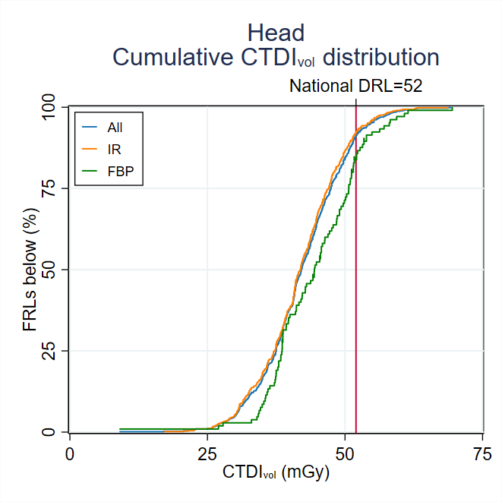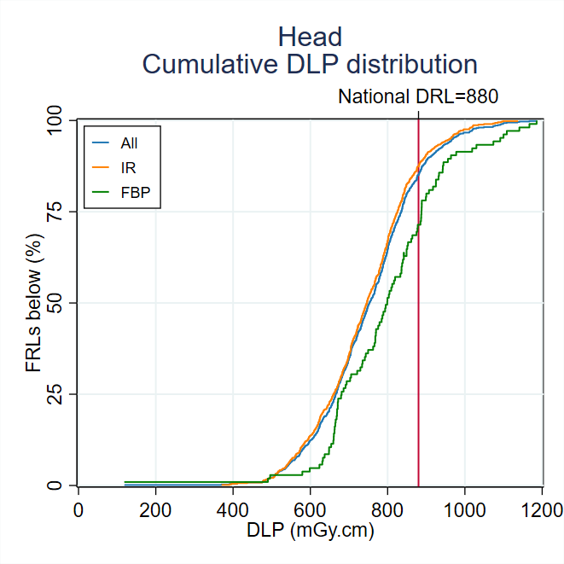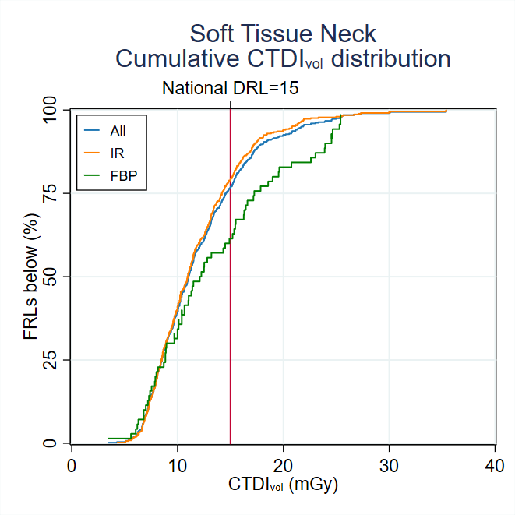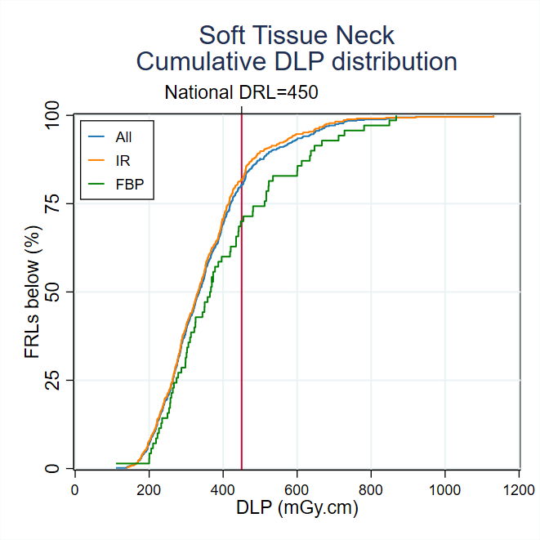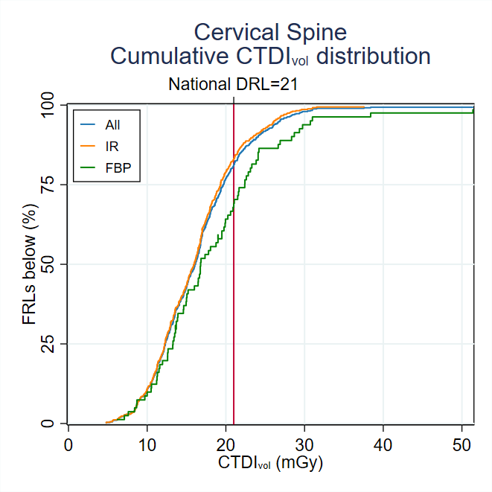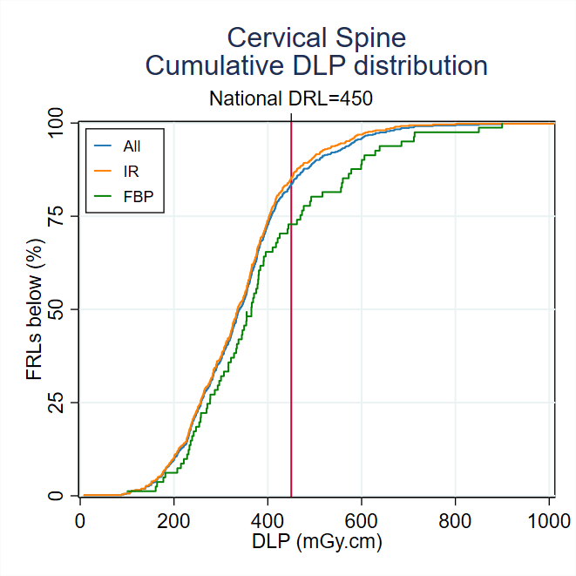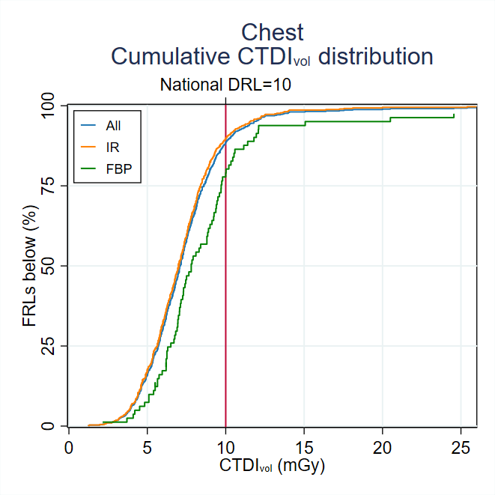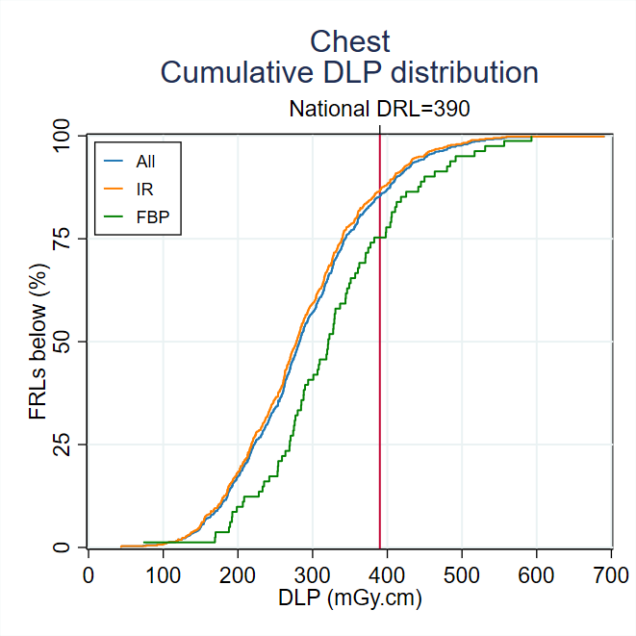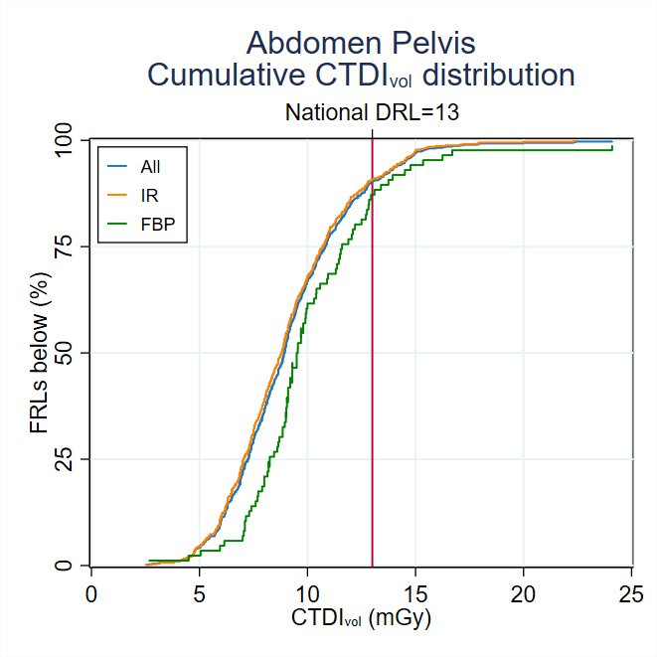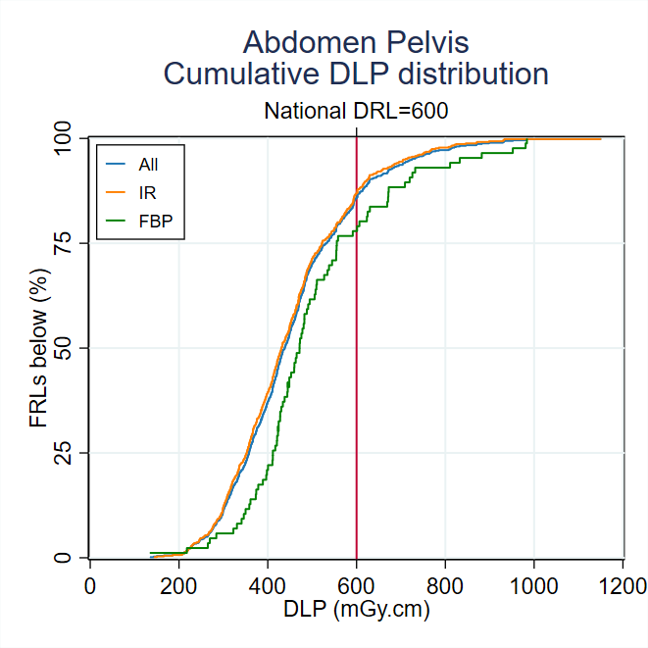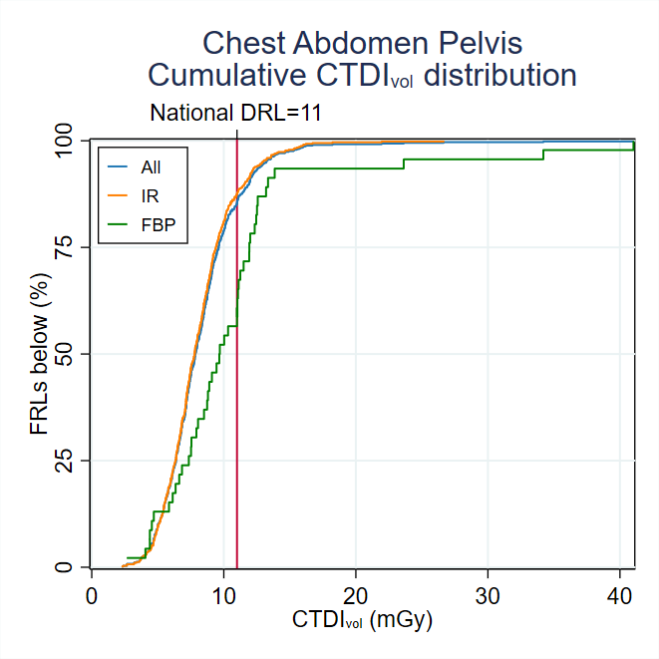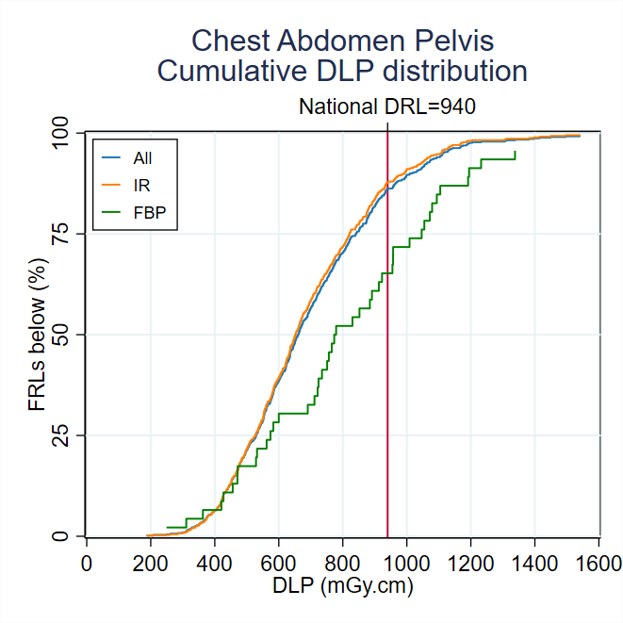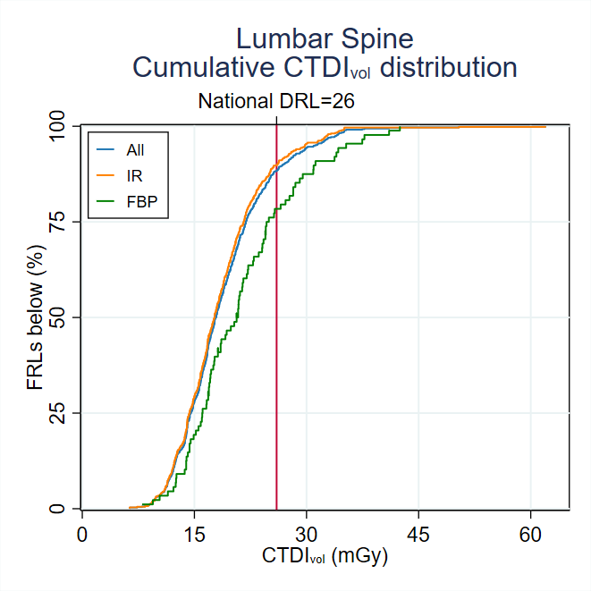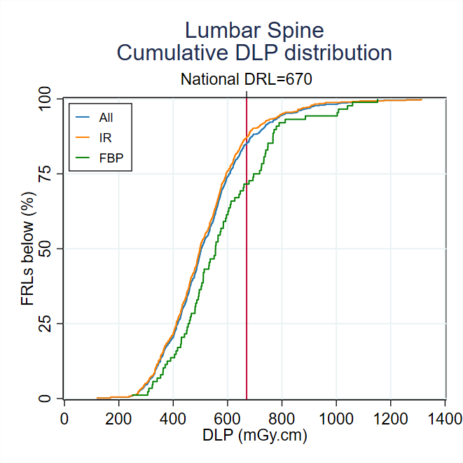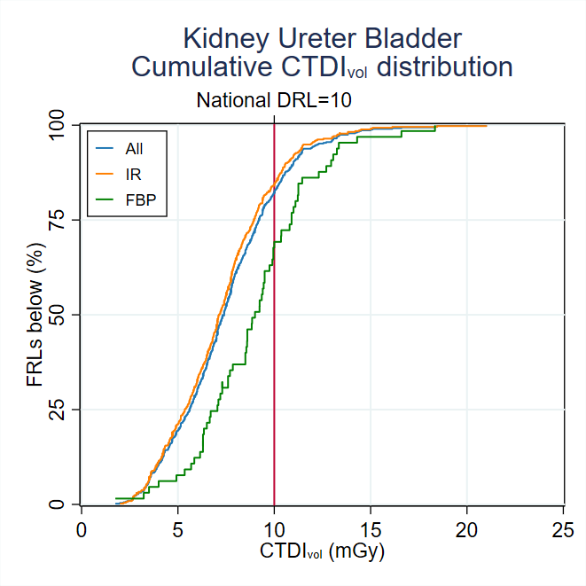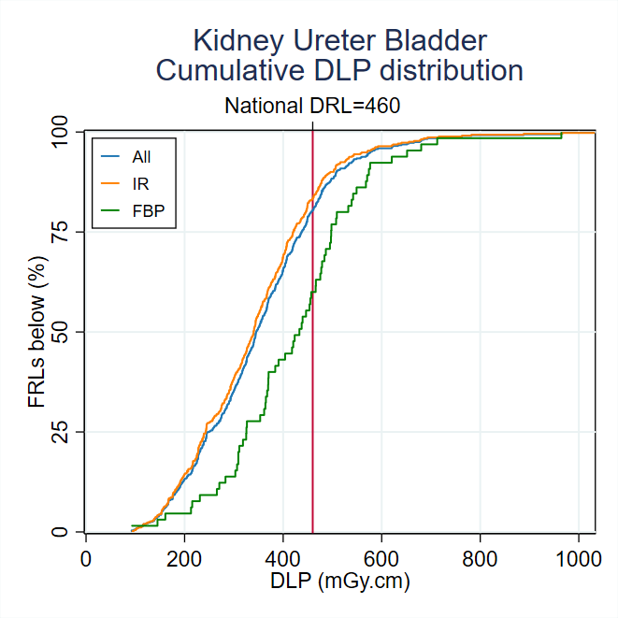

#### Historical trends

This appendix presents the changes in the FRL distributions since the beginning of 2012 for the MDCT protocols. They have been generated by examining the surveys submitted during a moving 12-month period, where the start and end points of the window have been shifted by daily intervals. The x-axis is the end date of the 12-month interval, the blue line is the median (50th percentile, P50) of the corresponding FRL distribution, the red line denotes the current national DRL and the light blue shaded region indicates the 25th-75th percentile (P25 to P75) range.

Surveys for soft-tissue neck, cervical spine and kidney-ureter-bladder scans commenced in July 2018.

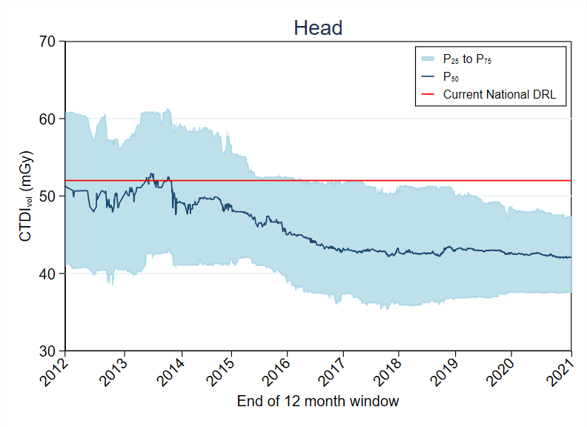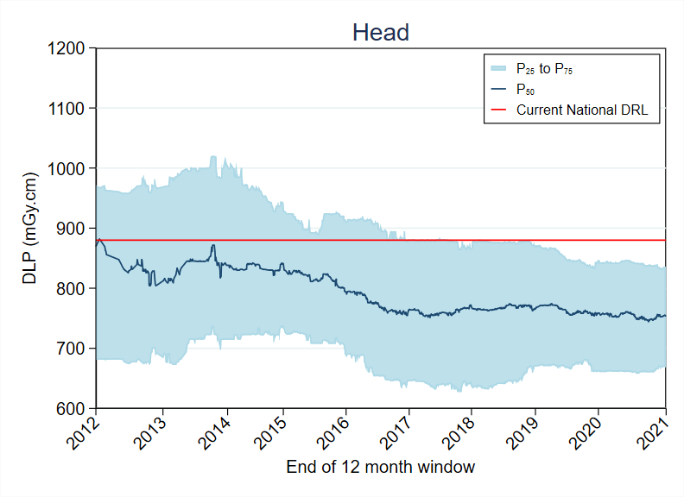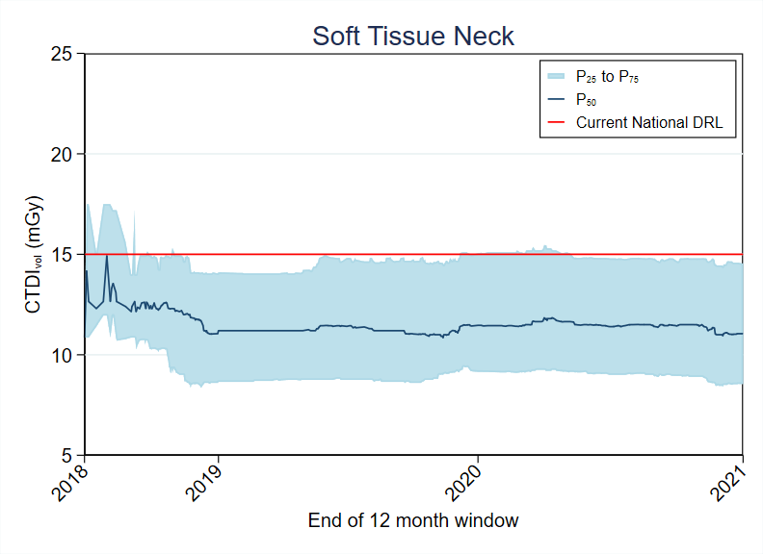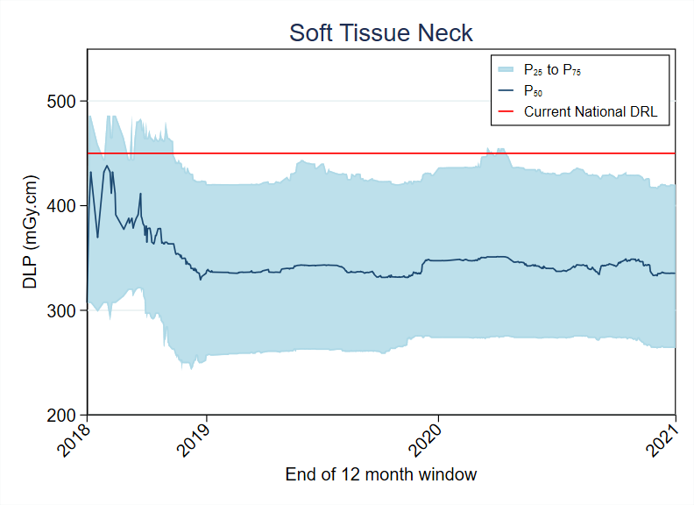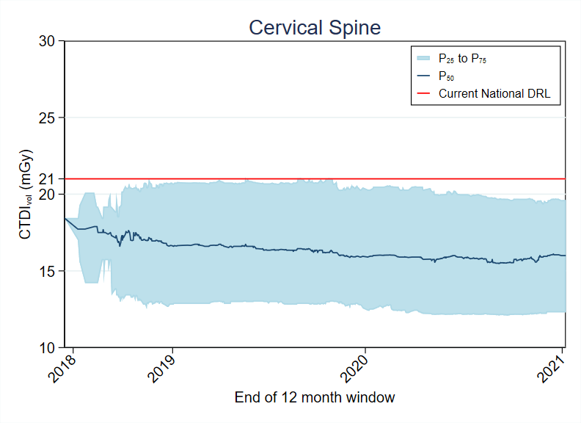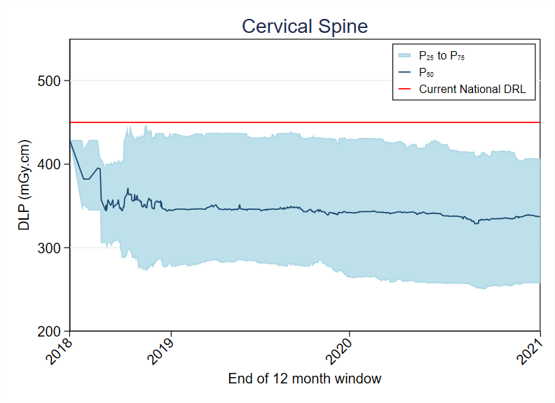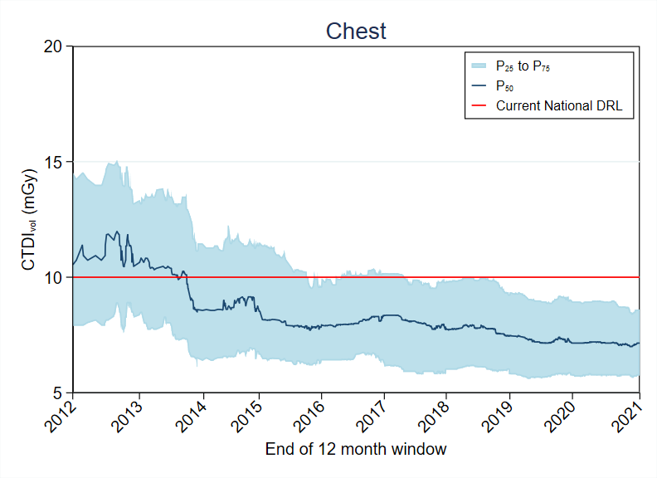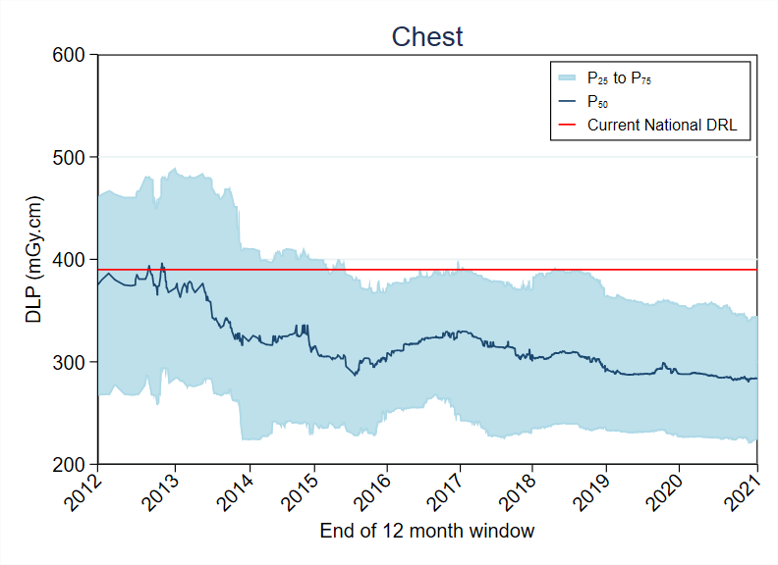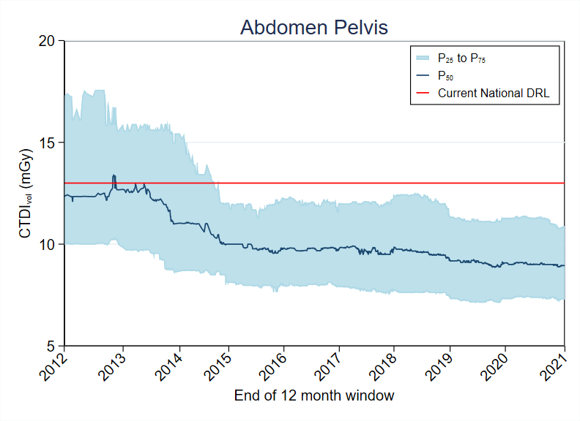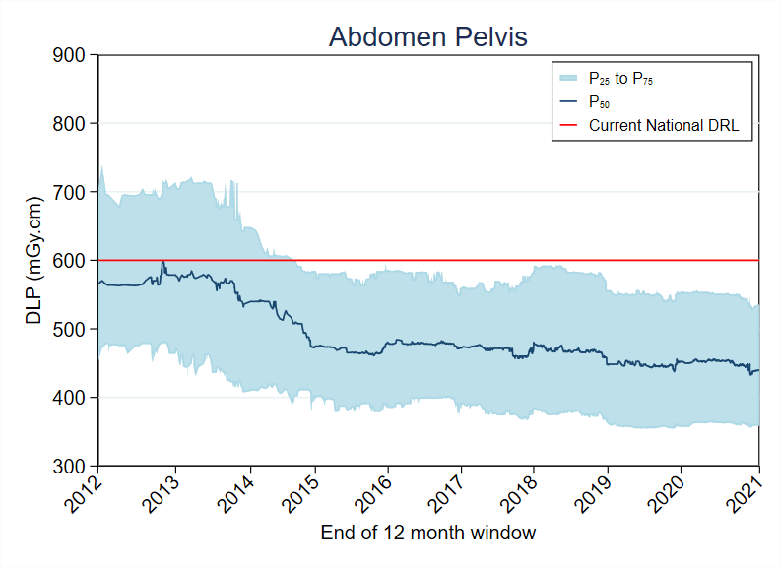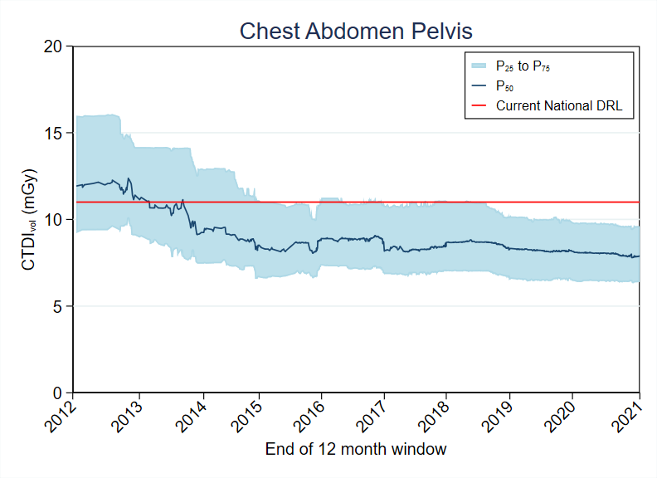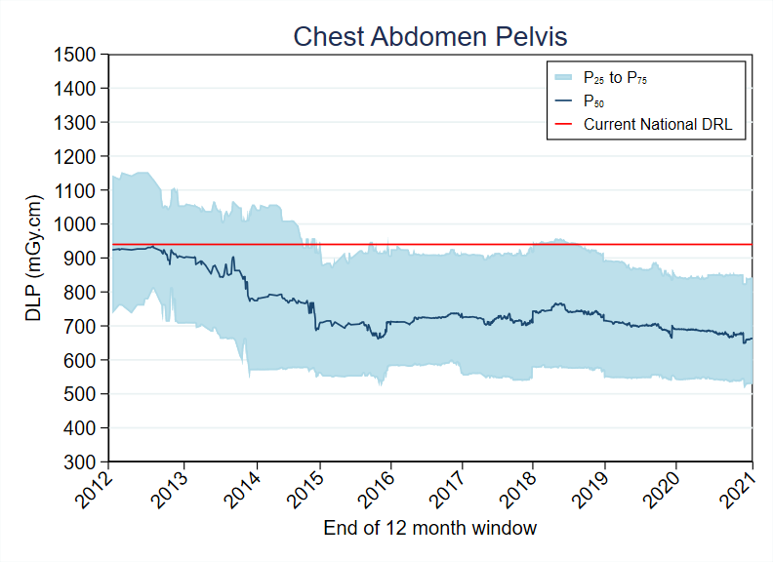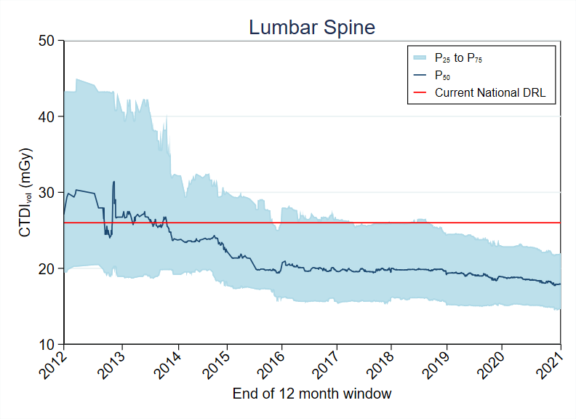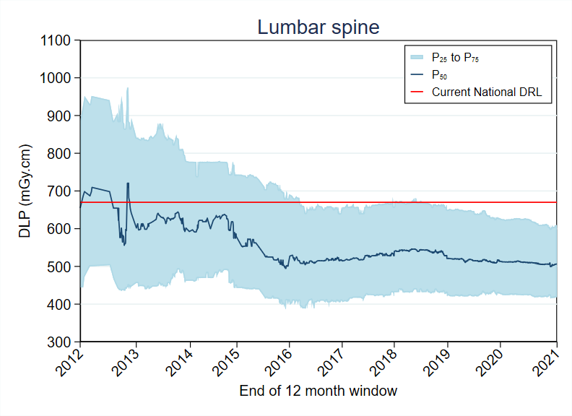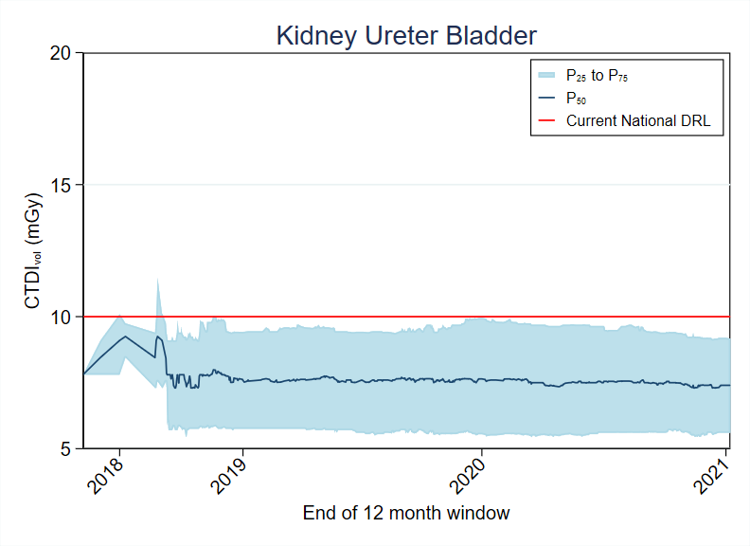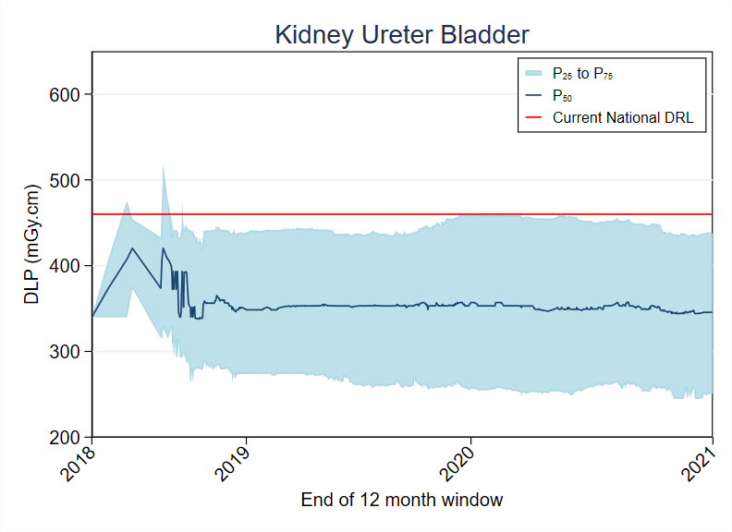

1. Australian Radiation Protection and Nuclear Safety Act <https://www.legislation.gov.au/Details/C2016C00977>
2. IGIP data is collected on an annual basis whereas nuclear medicine has been collected sporadically. For information on the nuclear medicine DRL program please see ARPANSA technical report TR 180 (<https://www.arpansa.gov.au/sites/default/files/tr180.pdf>)