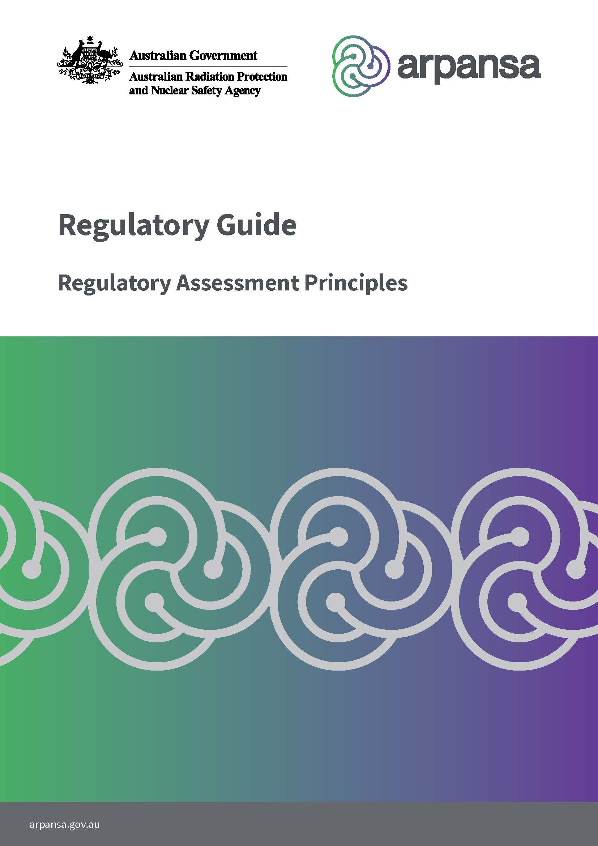
ARPANSA-GDE-2423|2025

Foreword
This publication, the Regulatory Guide - Regulatory Assessment Principles has been developed for use by regulatory bodies as guidance for completing their review of safety assessments from applicants or licence holders, which are submitted in support of new facilities or activities or modifications to existing facilities or activities. They are designed to be applied to a range of facilities, activities and requests for modifications, with a graded approach.
The Regulatory Assessment Principles (RAPs) represent international best practice as they have been derived from documents published by the International Atomic Energy Agency (IAEA) and the ARPANSA Radiation Protection Series.
The adoption of these RAPs by the Australian regulatory body community will help promote consistent regulatory decision making. Whilst not the primary purpose, the RAPs may also provide guidance to licence holders/applicants on the appropriate content of safety submissions, clarifying regulatory expectations in this regard.

Contents
Foreword 2
Contents 3
1. Introduction 5
1.1 Citation 5
1.2 Background 5
1.3 Purpose 6
1.4 Application of the RAPs vs Existing Radiation Protection Series Codes and Standards 6
1.5 Application of the RAPs vs Existing Australian Naval Nuclear Power Safety Requirements 6
1.6 Scope 6
1.7 The RAPs and the Fundamentals 7
1.8 Regulatory Assessment Process 9
1.9 Safety and Security Interface 10
2. Regulatory Assessment Principles 11
2.1 RAP 1 Graded Approach to Safety Assessment 11
2.2 RAP 2 Leadership and Management for Safety 12
2.3 RAP 3 Scope of the Safety Assessment 13
2.4 RAP 4 Assessment of Radiation Risk 13
2.5 RAP 5 Assessment of Provisions for Radiation Protection 14
2.6 RAP 6 Site Characterisation and Evaluation 14
2.7 RAP 7 Assessment of Protection of the Environment 15
2.8 RAP 8 Safety Function 16
2.9 RAP 9 Assessment of Engineering Aspects 16
2.10 RAP 10 Technical, Human and Organisational Factors 18
2.11 RAP 11 Defence in Depth and/or Hierarchy of Controls 19
2.12 RAP 12 Scope of the Safety Analysis 20
2.13 RAP 13 Deterministic and Probabilistic Safety Analysis 23
2.14 RAP 14 Criteria for Judging Safety 23
2.15 RAP 15 Use of Computer Codes 24
2.16 RAP 16 Use of Operating Experience and Data 24
2.17 RAP 17 Documentation of the Safety Assessment 25
2.18 RAP 18 Independent Verification 26
2.19 RAP 19 Uncertainty and Sensitivity Analysis 26
2.20 RAP 20 Use of the Safety Assessment 27
Glossary 29
References 29
Appendix 1 – Mapping of Clauses with IAEA General Safety Requirements GSR Part 4 31
Appendix 2 – Example of Classification Scheme for Structures Systems and Components for Non-Reactor Facilities 33
Appendix 3 – Operational Limits and Conditions 38

Introduction

Citation
This publication may be cited as the Regulatory Guide – Regulatory Assessment Principles.

Background
The Regulatory Assessment Principles (RAPs) have been developed for use by regulatory bodies in completing their review of safety assessments, developed by applicants or licence holders, which are submitted in support of new facilities or activities or modifications to existing facilities or activities.
In the Australian non-naval nuclear context ‘facilities’ include, but are not limited to, irradiation facilities, and places where radioactive materials above a certain activity level are produced, processed, used, handled, stored or disposed of.
‘Activities’ includes the production and use of radiation sources for industrial research, pharmaceutical and medical purposes, the transport of radioactive materials and sources, decommissioning of facilities, radioactive waste management activities and some aspects of remediation of sites affected by radioactive residues from past activities. The RAPs are not intended to be applied to the assessment of licence applications for new reactors; however, they can be applied to the assessment of requests for modifications of such facilities, using a graded approach.
To the extent that the above definitions overlap with the Australian naval nuclear concepts of ‘facility activities’ and ‘material activities’, it is recommended that the principles that underpin ‘facilities’ and ‘activities’ concepts be read as the underlying principles that apply to ‘facility activities’ and ‘material activities.’
The RAPs represent international best practice as they have been derived from documents published by the International Atomic Energy Agency (IAEA) and the ARPANSA Radiation Protection Series. The primary reference the RAPs are based on is the IAEA Safety Standards Series, General Safety Requirements Safety Assessment for Facilities and Activities (GSR Part 4 (Rev. 1)) (IAEA, 2016).
In respect of the Australian nuclear powered submarine enterprise, the IAEA and ARPANSA documents referenced in the RAPs embody best practices for operational contexts beyond activities intrinsic to naval nuclear propulsion.

Purpose
The primary purpose of the RAPs is to provide regulatory bodies with a framework for making consistent regulatory judgements on the safety of proposed facilities and activities and their modification. The RAPs may also provide guidance to licence holders/applicants on the appropriate content of safety submissions, clarifying regulatory expectations in this regard.

Application of the RAPs vs Existing Radiation Protection Series Codes and Standards
The RAPs do not replace the requirements or application of existing facility or activity specific codes or standards from ARPANSA’s Radiation Protection Series. These documents have been based on international best practice and, therefore, it is expected that the main elements of applicable RAPs are already contained in these existing codes and standards. Where there is an existing code or standard, a regulatory review should be conducted against it. The regulatory body could then supplement this with review against relevant RAPs for completeness.

Application of the RAPs vs Existing Australian Naval Nuclear Power Safety Requirements
The RAPS do not replace the current laws, regulations, policies, and other materials that apply in respect of the Australian naval nuclear power submarine enterprise.
Appendices 2 and 3 of the RAPS are illustrative only and must be used in line with the applicable legislative, regulatory, and policy requirements that apply in respect of the Australian naval nuclear power submarine enterprise.

Scope
These RAPs are intended to be applied to the regulatory review of safety submissions for activities and facilities using a graded approach. The RAPs should be applied to the review of applications for new facilities or activities or to requests for modifications of existing ones.
The term safety as used in these RAPs refers to nuclear safety and radiological safety and radiation protection. Nuclear safety is defined as the achievement of proper operating conditions, prevention of accidents and mitigation of accident consequences, resulting in protection of workers, the public and the environment from undue radiation risks. Radiation protection is defined as the protection of people from harmful effects of exposure to ionising radiation, and the means for achieving this. Radiological safety is defined as the system of protection which aims to assess, manage and control exposure to radiation so that radiation risks, including risks of health effects and risks to the environment, are reduced to the extent reasonably achievable. Together these terms define safety in the context of these RAPs and can be summarised as protection against radiation risks and the safety of facilities and activities that give rise to radiation risks.
Security of radioactive material and nuclear security and safeguards matters are currently excluded from the scope of these RAPs.

The RAPs and the Fundamentals
The ARPANSA Radiation Protection Series publication, Fundamentals for Protection Against Ionising Radiation (RPS F-1) (ARPANSA, 2014) outlines the system of radiation protection in Australia. Section 4 of RPS F-1 describes the 10 principles that provide a framework and guide actions towards managing radiation risks to protect human health and the environment from the possible harmful effects of ionising radiation, namely:
- Clear division of responsibilities
- Legislative and regulatory framework
- Leadership and management for safety
- Justification
- Optimisation of protection
- Limitation of risks
- Protection of present and future generations
- Prevention of accidents and malicious acts
- Emergency preparedness and response
- Protective actions to reduce existing or unregulated radiation risks.
The approach to radiation protection taken in RPS F-1 is based on radiation exposure from planned, emergency and existing exposure situations, consistent with The 2007 Recommendations of the International Commission on Radiological Protection, ICRP Publication 103 (ICRP, 2007).
There are a number of key drivers within the 10 fundamental principles which rely on the performance of a safety assessment to either support them or to demonstrate how they are met. Examples of these are summarised in Table 1 below. Therefore, it is important that the regulatory body is satisfied that any safety assessment submitted for a facility or activity is appropriate, as it provides a key mechanism for assessing compliance with the fundamental principles. The RAPs provide a framework for the regulatory body review.

Table 1 – Examples of how the RAPs support the fundamental principles
 | Principle 3 on leadership and management for safety which notes that a facility may only be constructed and commissioned, or an activity may only be commenced once it has been demonstrated to the satisfaction of the appropriate authority by means of the initial safety assessment that the proposed measures are adequate. Therefore, to meet the fundamental principle, there must be adequate safety assessment arrangements in place.
 | Principle 4 on the justification of facilities and activities requires safety analysis to identify the radiation risks that should be compensated for by the benefits yielded by the facility or activity.
 | Principle 5 on the optimisation of protection requires safety assessment to determine whether the radiation risks that arise from the facility or activity have been reduced to a level that is as low as reasonably achievable when economic and societal factors have been taken into account.
 | Principle 6 on the limitation of risks to individuals requires safety assessment to determine whether doses and radiation risks have been controlled within specified limits.
 | Principle 7 on the protection of present and future generations requires safety assessment to determine whether adequate protection is provided, not only for local populations but also for populations that are remote from facilities and activities, and for the environment, now and in the future. A safety analysis will provide input into any necessary environmental impact assessment.
 | Principle 8 on prevention of accidents also states that the primary means of ensuring high levels of safety is to apply defence in depth. In this approach, a number of consecutive and independent levels of protection or physical barriers are provided such that, if one level of protection or barrier were to fail, the subsequent level or barrier would be available.
 | Principle 9 on emergency preparedness and response requires identification of the full range of foreseeable events for which arrangements for emergency preparedness and response need to be considered.
 | Principle 10 on protective actions to reduce existing or unregulated radiation risks requires safety analysis to determine the magnitude of existing or unregulated radiation risks, and to provide an input into the determination of whether proposed protective actions are justified.

Regulatory Assessment Process
The primary purposes of the safety assessment should be to determine whether an adequate level of safety has been achieved for a facility or activity or a modification, and whether the basic safety objectives and safety criteria established by the designer, the operating organisation and the regulatory body, in compliance with the requirements for protection and safety as established in ARPANSA Radiation Protection Series Code for Radiation Protection in Planned Exposure Situations (RPS C-1) (ARPANSA 2020), have been fulfilled. In respect of the Australian naval nuclear powered submarine enterprise, plans and arrangements for nuclear management systems are a condition for the conduct of regulated activity.
The RAPs encourage the regulatory body to conduct a systematic evaluation of the safety assessment and supporting documents to ensure that all the features of the facility/activity relevant to safety are considered. This includes confirmation of the following (noting a graded approach):
- that all the possible radiation risks resulting from normal operations, anticipated operational occurrences and accident conditions for all safety functions have been identified
- site characteristics that relate to the possible radiation risks have been evaluated
- the provisions for nuclear safety and radiation protection have been identified and are shown to be properly covered in the design of the structures, systems and components important to safety, processes and organisational arrangements
- assessment of engineering aspects to determine whether the safety requirements for design relevant to the facility or activity have been met
- technical, human and organisational factors have been considered at all lifecycle stages
- assessment of safety in the longer term has been addressed (for example decommissioning and waste management)
- the outcomes of the safety assessment/analysis have been used to appropriately inform areas such as Emergency Preparedness and Response, Inspection Testing and Maintenance programs, supply chain requirement, training, etc.
The regulatory assessment process should verify that claims for safety in a submission are supported by evidence-based arguments.
Figure 1 below represents the regulatory assessment process and the key areas that the RAPs cover.
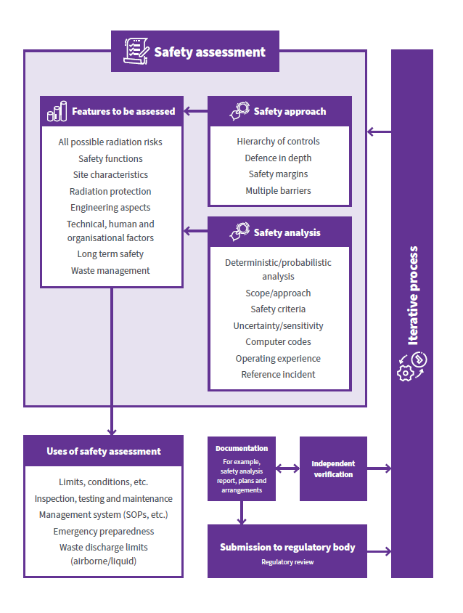
Figure 1 – The regulatory assessment process and key areas covered by the RAPs

Safety and Security Interface
The RAPs do not currently cover security. However, it is important to recognise the importance of the interface between safety and security. Radiation safety and security measures have a common purpose – the protection of people, society, and the environment. Many of the RAPs to ensure protection are common, although their implementation may differ. Many functions or actions serve to deliver high standards of both safety and security simultaneously. Likewise, there are also circumstances in which functions or actions identified to serve one objective can be detrimental to the achievement of the other. It is therefore important that safety and security measures are designed and implemented in an optimised and integrated manner so that security measures do not compromise safety and safety measures do not compromise security.

Regulatory Assessment Principles
For existing licence holders with a demonstrated history of regulatory compliance, the regulatory assessment does not require a repeat of detailed assessments of previously evaluated systems or processes. Where confidence in the organisation’s performance has been established, the assessment should focus on confirming the continued applicability and effectiveness of those elements in relation to the current application or submission.

RAP 1 Graded Approach to Safety Assessment
RAP 1 – The regulatory body should determine the acceptability of the scope and level of detail of safety assessment which has been carried out by the applicant by applying a graded approach which is consistent with the magnitude of the possible radiation risks arising from the facility or activity.

- A graded approach is expected to be applied to the content and scope of the submission by the operator during development of the submission based on the potential radiation risk. It should also be applied to the level, depth and magnitude of submission assessment by the regulator and any recommendations made in the regulatory decision-making process. Both gradings are based on the principles described in this section.
- The regulatory body should be satisfied that a safety assessment has been conducted for a new facility, activity or proposed modification with a graded approach and which is commensurate with the level of radiation risk. This should take into account radiation risk in normal operation and the potential consequences of anticipated operational occurrences and potential accident conditions within the design basis of a facility. It should also consider the possibility of the occurrence of very low probability events with potentially high consequences. The need to apply a graded approach to safety assessment is recognised in Fundamental Principle 5 of RPS F-1 (ARPANSA, 2014).
- Other factors that should be considered are the maturity or complexity of the facility or activity or modification. The consideration of maturity relates to the use of: operating practices and procedures; comprehensive and proven designs; data on operational performance of similar facilities or activities. It should also account for uncertainties in the potential performance of the facility or activity.
- Complexity relates to the extent and difficulty of the efforts required to construct a facility or to implement an activity or modification. It also relates to areas such as the number of related processes for which control is necessary, the extent to which radioactive material has to be handled (where applicable), and the half-life of the radioactive material.
- Since not all safety assessments therefore need to cover all the areas described in Figure 1, not all RAPs are applicable to all regulatory assessments. For example, while taking a graded approach, a low hazard activity may only be determined to need a simple risk assessment, with no supporting safety analysis, no requirement to identify structures, systems and components important to safety and no need to include defence in depth or sensitivity analysis considerations. However, the hierarchy of controls should still be applied (See RAP 11).

RAP 2 Leadership and Management for Safety
RAP 2 – The licence applicant/holder should demonstrate that they have effective leadership and management for safety (effective control).

- The responsibility for carrying out the safety assessment belongs to the legally appointed person or organisation (licence holder responsible for the facility or activity and/or the office holder outlined in the licence. There should be effective arrangements for leadership and management for safety demonstrated within the safety submission. When a safety submission is for a significant modification to an existing activity or facility, the regulatory body may need to assess whether the proposed change may impact the safety management arrangement.
- Demonstration of effective leadership and management for safety covers a wide range of areas. This includes leaders:
- establishing safety as the overriding priority
- holding and institutionalising a strong commitment to safety as an organisational value
- recognising their role in fostering a positive safety culture and role modelling pro-safety behaviour
- understanding, establishing, and adhering to their safety responsibilities and accountabilities, with single points of accountability sitting with senior leaders
- appropriately planning and dedicating resources to prioritise safety
- implementing and maintaining effective management systems
- holding staff accountable to safety expectations
- communicating and engaging across the organisation
- ensuring adequate safety oversight

- Effective leadership and management for safety can be demonstrated in management systems, documentation, compliance history, and observed conduct, including interactions with the regulator.
- It is recognised that some Australian regulatory bodies, such as ARPANSA, have requirements for demonstration of this via an effective control plan built into their existing legal framework.
- An example of guidance for the development of this plan can be found in ARPANSA’s Holistic Safety Guide and the ARPANSA Regulatory Guide - Plans and Arrangements for Managing Safety which provides recommendations and regulatory expectations for leadership and management for safety/effective control. The IAEA Safety Standard: General Safety Requirements Leadership and Management for Safety (GSR Part 2) (IAEA, 2016) can be used as a basis to establish requirements/guidance for those regulatory bodies that do not have specific documentation on this topic. In respect of the Australian nuclear powered submarine enterprise, key aspects that should comprise an organisation’s plans and arrangements for managing safety are a requirement for a licence holder.

RAP 3 Scope of the Safety Assessment
RAP 3 – The safety assessment should be carried out for all situations that give rise to radiation risks and cover the full life cycle of the proposed facility/activity.

- The safety assessment should cover all the stages in the lifetime of a facility or activity or modification in which there are possible radiation risks. For facilities, it is recognised that some regulatory bodies require a staged approach to licensing through their regulatory framework and/or the application of codes. This typically covers siting, construction, commissioning, operation, possession or control, and decommissioning/closure.
- For applications that do not relate to new facilities, the safety assessment should include aspects related to the production of radioactive materials and waste, and their ongoing management where applicable.
- Where regulatory bodies do not have specific guidance for assessing the management of waste, the ARPANSA Regulatory Guide, Plans and Arrangement for Managing Safety (ARPANSA-GDE-1735) (ARPANSA, 2023), and the IAEA General Safety Requirements, Predisposal Management of Waste (GSR Part 5) (IAEA, 2009) should be considered in the assessment. In respect of the Australian nuclear powered submarine enterprise, it is recommended that reference be made to Australian Naval Nuclear Power Safety Regulator (ANNPSR) guidance.
- In the case of a disposal facility for radioactive waste in significant quantities, radiation risks may be considered for the post-closure phase and consideration of the requirements of ARPANSA Code for Disposal Facilities for Solid Radioactive Waste, Radiation Protection Series (RPS C-3) (ARPANSA, 2018) should apply. In respect of the Australian naval nuclear powered submarine enterprise, it is recommended that consideration be given to section 60 of the Australian Naval Nuclear Power Safety Regulations (2025) which outlines the nuclear safety management system, arrangements and plans for the conduct of the activity that covers radiation protection plans.
- Where regulatory bodies do not have specific guidance for assessing the operational limits and conditions of a facility the ARPANSA Regulatory Guide, Decommissioning of Controlled Facilities (ARPANSA-GDE-1731) (ARPANSA, 2020), and the IAEA General Safety Requirements, Decommissioning of Facilities (GSR Part 6) (IAEA, 2014) should be considered in the assessment.

RAP 4 Assessment of Radiation Risk
RAP 4 – The possible radiation risks associated with the facility or activity should be identified and assessed.

- All the possible radiation risks associated with the facility or activity should be identified and assessed. No matter the complexity of the proposed activity or facility the safety assessment should consider the radiation risks associated with normal operations, anticipated operational occurrences and for possible accident scenarios.
- The assessment of the possible radiation risks associated with the facility, activity or modification should include the level and likelihood of radiation exposure of workers and the public, including the possible release of radioactive material to the environment where applicable.
- Risk acceptability thresholds should be established by the licence holder/applicant to guide decision-making. Mitigating controls should be evaluated not only for their effectiveness but also for their suitability in reducing risk to an acceptable level. A balanced approach should be maintained between preventative measures and consequence mitigation to ensure that residual risks are managed and as low as reasonably achievable (ALARA). A hierarchy of controls should be applied as informed by the risk (see RAP 11).
- Where fissile material is proposed to be used, evidence to demonstrate protection against criticality should be included in the safety assessment. This should include a criticality assessment for where there is a credible risk of criticality occurring.

RAP 5 Assessment of Provisions for Radiation Protection
RAP 5 – It should be determined in the safety assessment for a facility or activity whether adequate measures are in place to protect people and the environment from the harmful effects of radiation.

- The safety assessment should include an assessment of the provisions in place for radiation protection to determine whether radiation risks are controlled within specified limits and constraints, and whether they are optimised and reduced to a level that is as low as reasonably achievable.
- Evidence of justification, optimisation and limitation of risk should be clearly identified in the assessment.

RAP 6 Site Characterisation and Evaluation
RAP 6 – An assessment of the site characteristics relating to the safety of the facility or activity should be carried out.

- Where it has been identified that the siting of a facility or activity is important to ensure radiological safety, a siting evaluation should be undertaken.
- Where required, an assessment of the site characteristics relating to the safety of the facility or activity should be carried out that covers:
- The physical, chemical and radiological characteristics that will affect the dispersion or migration of radioactive material released in normal operation or as a result of anticipated operational occurrences or accident conditions.
- The identification of natural and human induced external events in the area that have the potential to affect the safety of facilities and activities. This could include natural external events (such as extreme weather conditions, earthquakes and external flooding) and human induced events (such as aircraft crashes and events due to hazards arising from transport and industrial activities), depending on the possible radiation risks associated with the facilities and activities.
- The distribution of the population around the site and its characteristics to inform as appropriate the development of an emergency plan.
- IAEA, Specific Safety Requirements Site Evaluation for Nuclear Installations (SSR Part 1) (IAEA, 2019) and associated guidance can be used for facilities.

RAP 7 Assessment of Protection of the Environment
RAP 7 – The applicant should demonstrate radiation protection of wildlife (both fauna and flora).

- Where the safety assessment has found that there is a credible risk of radiation exposure to the environment, it should include a radiological assessment of wildlife populations and ecosystems, consistent with the methodology outlined in the ARPANSA Guide for Radiation Protection of the Environment Radiation Protection Series (RPS G-1) (ARPANSA, 2015).
- Modelling and/or an assessment to demonstrate protection of the environment for facilities should always include scenarios that reflect discharges expected for normal conditions (e.g. routine discharges to air or sewer) and anticipated operational occurrences (e.g. leaks, spills). For facilities where the post closure phase is important (e.g. waste disposal sites) this should also be considered.
- It is expected that an applicant or licence holder can demonstrate protection of the environment in a planned exposure situation (i.e. during operation) up to and including design basis accidents. Therefore, when selecting scenarios for modelling, normal operations, anticipated operational occurrences and design basis accidents should be considered.
- For reference incidents which have used beyond design basis analysis, the potential exposures to the environment should still be understood. If a risk assessment indicates the potential for severe impacts on wildlife populations in such an emergency, these impacts should be considered and discussed, with a particular focus on impacts to protected, threatened or endangered species and populations.
- It is recognised in ARPANSA RPS G-1 (ARPANSA, 2015) that, while exposure to the environment in emergency situations should be optimised, it is likely that decision-making, at least in the early phase of an emergency response, is heavily dominated by urgent decisions to protect people and that protection of wildlife is a secondary consideration, although still important from societal, cultural and economic perspectives. An understanding of the potential extent and severity of environmental contamination could, however, provide valuable information to inform protection strategies and planning for post-accident rehabilitation. This should be considered in environmental protection planning for operations.

RAP 8 Safety Function
RAP 8 – All safety functions associated with a facility or activity should be specified and assessed.

- Safety functions are functions or actions that are required to be performed for the facility or activity to prevent or to mitigate radiological consequences of normal operation, anticipated operational occurrences and accident conditions. All safety functions associated with a facility or activity should be considered in the safety assessment. This includes the safety functions associated with engineered structures, systems and components, any physical or natural barriers and inherent safety features, as applicable. Human actions necessary to ensure safety should also be considered. The assessment should determine whether the safety functions can be fulfilled for all normal operations, anticipated operational occurrences and accident conditions. This is a key aspect of assessment and is vital to the assessment of the application of defence in depth (see RAP 11).
- The identification of safety functions can be achieved by identifying mitigating features to radiation consequences in the accompanying risk assessment.
- For other more complex facilities and activities where it is considered appropriate to apply a classification scheme to structures, systems and components important to safety, the safety function of such items should be identified and used to apply this scheme (see RAP 9 for more information).

RAP 9 Assessment of Engineering Aspects
RAP 9 – It should be determined, as appropriate, in the safety assessment that structures, systems and components are of robust and proven engineering design and fulfil their safety functions.

- The safety assessment should identify appropriate design principles (e.g. codes and standards) that have been applied to the engineering aspects identified in the safety assessment, and it should be determined whether these principles have been met. These principles can range from identifying the standards to which a facility (e.g. irradiator apparatus) has been designed and providing evidence of the manufacturer’s factory acceptance testing and planned installation, through to providing details of the standards to which a facility building is being constructed (e.g. to provide confinement, shielding, and fire protection safety functions).
- For more complex or high-risk facilities and activities the design principles may include the need to provide multiple barriers to the release of radiation, and when a significant amount of fissile material may be present, there should be design measures to protect against unplanned criticality (e.g. minimising amounts of fissile material and geometry of containment structures). As necessary, consideration should be given to the identification of safety margins and the need for structures, systems and components (SSCs) to be classified within the safety assessment.
- For complex facilities or activities, where it is deemed appropriate, the safety assessment should demonstrate that a suitable approach to classification has been applied to SSCs based on their safety function. An example of a scheme that could be applied to non-reactor facilities is presented in Appendix 2.
- The SSC scheme as a minimum should:
- adequately reflect the SSC safety function
- take into account the consequences of their failure
- consider the requirement for availability in anticipated operational occurrences and accident conditions
- help to determine the level of safety oversight needed in the original installation, ongoing maintenance and any subsequent modification of SSCs
- determine the SSC equipment qualification and reliability requirements.
- The safety assessment should determine that the SSCs are able to perform their safety function under normal operations and anticipated operational occurrences including accident conditions. Depending on the radiation risks this could include the need for consideration of environmental conditions (e.g. temperature, pressure, humidity and radiation levels) imposed on structures, systems and components, and from internal events and external events (natural and man-made), such as flooding, seismic, missiles, explosions, fire and dropped loads.
- The safety assessment should also consider, where applicable, whether SSCs and other engineered safety features (such as barriers) that are provided to perform safety functions have an adequate level of reliability, redundancy, diversity, separation, segregation, independence and equipment qualification. This should include supporting systems designed to mitigate the consequences of malfunction.
- Operational limits and conditions should be derived as appropriate. See Appendix 3 for more information.
Digital Information and Control Systems
- The safety analysis should consider risks associated with design, implementation, and operation of instrumentation and control systems. The analysis should include where safety can be affected by software verification and validation, periodic testing, and configuration management. This includes evaluating the system's ability to handle failures and unexpected conditions. The degree of separation of control and protection functions should be considered. Digital systems architecture, particularly for novel or Artificial Intelligence systems, should be designed with robustness, reliability, and security in mind.

RAP 10 Technical, Human and Organisational Factors
RAP 10 – The safety assessment should apply a systematic approach to identify and address technical, human and organisation factors that can impact safety for normal operations, anticipated operational occurrences and accident conditions.

- The safety of facilities and activities will always depend on human actions even when it is highly automated. Safety assessments should evaluate whether technical factors have been duly considered in the design, development, operation, testing, and maintenance of facilities and activities, for normal operation, anticipated operational occurrences and possible accident conditions. Technical factors include:
- technology factors including design, testing, maintenance, operation of structures, systems, and components, human-machine interface design, and automation and Artificial Intelligence integration
- control factors including the application of defence in depth.
- Safety assessments should evaluate whether human factors have been duly considered throughout the whole lifecycle of facilities and activities.
- Human factors include:
- cognitive factors including situation awareness, cognitive demands, sensory perception, memory, and decision-making
- health and wellbeing factors including stress, burnout, fatigue, psychosocial hazards, and alcohol and other drug use
- physical ergonomics including design of the physical work environment, and the use of anthropometric design principles.
- Safety assessments should evaluate whether organisational factors have been duly considered in the design, development, operation, testing, and maintenance of facilities and activities, for normal operation, anticipated operational occurrences and possible accident conditions. Organisational factors include:
- workforce factors including competency, training, recruitment, resourcing, as well as the non-technical skills of communication, teamwork, and leadership
- safety culture including leadership for safety, individual responsibility, values, behaviours, questioning attitude, just culture, and fairness
- management systems including procedure management, change management, project management, and contractor management
- systemic factors including security, resilience, user-centred design, and hierarchy of controls.
- Some Australian regulatory authorities prescribe the consideration of technical, human, and organisational factors. For example, regulatory expectations are set out in ARPANSA’s Regulatory Guide – Holistic Safety. A holistic approach to safety will improve resilience to common contributing causes of accidents: leadership issues, attitudes and behaviours, organisational learning, operational/business environments, competence, risk assessment and management, internal oversight and scrutiny, and communication.

RAP 11 Defence in Depth and/or Hierarchy of Controls
RAP 11 – Where applicable, it should be determined in the assessment whether adequate provisions of defence in depth have been made including consideration of the recognised levels of protection. Where applicable, the use of the hierarchy of controls should be demonstrated.

- The application of defence in depth within a safety assessment provides different levels of diverse equipment and procedures to prevent the escalation of anticipated operational occurrences and to maintain the effectiveness of physical barriers placed between a radiation source or radioactive material and workers, members of the public or the environment.
- The regulatory assessment of the 5 levels of defence in depth (protection) should determine whether each level has made adequate provisions to achieve the following:
- address deviations from normal operation or in the case of a disposal facility, from its expected evolution in the long term
- detect and terminate safety-related deviations from normal operation or from its expected evolution in the long term, should deviations occur
- control accidents within the limits specified in the design
- specify measures to mitigate the consequences of accidents that exceed design limits
- mitigate radiation risks associated with possible releases of radioactive material.
- Where the defence in depth concept has been applied the safety assessment should demonstrate that:
- priority has been given to reducing the number of challenges to the integrity of layers of protection and physical barriers, which helps to: prevent the failure or bypass of a barrier when challenged; prevent the failure of one barrier leading to the failure of another barrier; and prevent significant releases of radioactive material if failure of a barrier does occur
- the layers of protection and physical barriers are independent of one another as far as practicable
- conservatism is used in the design and engineering practice
- special attention has been paid to internal and external events that have the potential to adversely affect more than one barrier at once or to cause simultaneous failures of safety systems
- specific measures have been implemented to ensure reliability and effectiveness of the required levels of defence
- emergency plans and arrangements reflect the emergency preparedness category of the facility (see RAP 20).
- The regulatory assessment should determine whether there are adequate defence in depth provisions including the review of safety margins and ensuring a satisfactory margin to failure exists for any key safety structures, systems and components for operational and possible accident conditions.
- Regardless of the application of defence in depth, the safety assessment should demonstrate the use of the hierarchy of controls for any aspects of the controlled activity that presents a safety risk. The hierarchy of controls (from most effective to least effective) is:
  - elimination of the radiation exposure hazard
  - substitution of the radiation hazard with something less hazardous
  - incorporation of engineering controls to restrict radiation levels and intakes of radioactive materials in the workplace
  - application of administrative controls through work procedures, training and installation of warning signs and labels, and restricting access to radiation by designation of controlled and supervised areas
  - the use of appropriate personal protective equipment.
These controls are listed in the order of preference. It is possible for control measures to be taken simultaneously.

RAP 12 Scope of the Safety Analysis
RAP 12 – The performance of a facility or activity throughout the lifecycle should be evaluated in a safety analysis.

- Safety analysis is the evaluation of the potential hazards associated with a facility or an activity. A formal safety analysis is part of the overall safety assessment. This can range from presenting the results of a basic hazard/risk assessment, through to analysis of a complex study of failure modes of safety systems.
- The primary purpose of the safety analysis is to determine and demonstrate compliance with relevant regulatory and safety requirements (such as statutory dose limits) and/or relevant codes/standards. Consequently, a statement confirming the facility complies with applicable regulatory and safety requirements should be included in the safety analysis.
- The level of safety analysis expected should be performed to a scope and level of detail that correspond to areas such as the magnitude of the radiation risks, the frequency of any identified events (during normal operations, anticipated operational occurrences and accidents conditions), the complexity of the facility or activity, and the number of processes that are included in the proposed facility/activity. When determining whether an adequate level of analysis has been conducted, the regulatory body should refer to RAP 1 for guidance.
- Hazard and consequence assessments may also assist in determining the Emergency Preparedness Category (EPC) of a source or facility as per the ARPANSA Radiation Protection Series Guide for Radiation Protection in Emergency Exposure Situations (RPS G-3) (ARPANSA, 2019). For example, the safety analysis may also identify a worst-case credible accident scenario (sometimes referred to as the reference incident). The consequences of this scenario can be used to inform emergency planning and to efficiently derive parameters such as the EPC. The reference incident is consequence driven and is an outcome from the hazard assessment used to inform the Protection Strategy to plan appropriate response and mitigation arrangements. The reference incident may be within the Design Basis, but it is also important to consider credible incidents that are within the Beyond Design Basis when determining the appropriate reference incident.
- Where appropriate, the safety analysis should demonstrate whether there are adequate safety margins in place such that there is an adequate margin to areas such as authorised limits (e.g. airborne discharge limits), or failure of any structures, systems and components (e.g. pressure limits on vessels). It should be demonstrated that there are adequate margins to avoid cliff edge effects that would have unacceptable consequences.
Design Basis Accident Analysis
- For complex facilities the safety analysis should consider design basis accident analysis to define the boundary conditions for the facility to withstand, without acceptable limits for radiation protection purposes being exceeded.
- The analysis of design basis accidents determines the safety margins and provides confidence in the robustness of the facility.
- Design basis accidents are those accidents that are accommodated within the design of the facility. The design for such accidents addresses internal and external initiating events that may cause the facility to operate outside its limits for normal operation and anticipated operational occurrences.
- The scope and level of detail of the design basis accident analysis should be proportionate to the complexity of the facility and the potential risk of the hazard.
- Design basis accidents can be used to define the design basis, including performance criteria, for safety systems and for other items important to safety that are necessary to control design basis accident conditions, with the objective of returning a facility item to a safe state and mitigating the consequences of any accident.
- The design should be such that for design basis accident conditions, key operating parameters do not exceed specified design limits. A primary objective should be to manage all design basis accidents so that they have no, or only minor, radiological consequences, on or off the site, and do not necessitate any off-site emergency response actions.
- Where prompt, reliable action is required in response to an initiating event, the design of the facility/plant should include means of automatically initiating the operation of the necessary safety systems. The design should reduce demands on the operator as far as reasonably practicable, in particular during and following a design basis accident.
- The design basis accidents should be analysed in a conservative manner. This approach could involve the application of the single failure criterion to safety systems, specifying design criteria and using conservative assumptions, models and input parameters in the analysis.
Design Extension Conditions
- For higher risk facilities the regulatory body may require design extension conditions analysis to be conducted for the purpose of enhancing the safety of the facility by improving its capabilities to withstand, without unacceptable radiological consequences, accidents that are either more severe than design basis accidents or that involve additional failures. The use of the term design extension conditions in the case of the RAPs means accident conditions that are not considered for design basis accidents, but that are considered in the design process of the facility in accordance with best estimate methodology, and for which releases of radioactive material are kept within acceptable limits.
- The set of design extension conditions should be derived through engineering judgement, a graded approach, deterministic assessments and complementary probabilistic assessments, as appropriate. The design extension conditions should be used to identify the additional accident scenarios to be addressed in the facility design and to plan practicable provisions for the prevention of such accidents or mitigation of their consequences if they do occur.

RAP 13 Deterministic and Probabilistic Safety Analysis
RAP 13 – The use of deterministic and probabilistic approaches should be included in the safety analysis as appropriate.

- Deterministic and probabilistic approaches complement one another and can be used together to provide input into an integrated decision-making process. The extent of the deterministic and probabilistic analyses carried out for a facility or activity should be consistent with the graded approach.
- For key parameters, deterministic analysis uses, single numerical values (taken to have a probability of 1), leading to a single value for the result. The aim of the deterministic approach is to specify and apply a set of deterministic rules and requirements for the design and operation of facilities or for the planning and conduct of activities. When these deterministic rules and requirements are met, they are expected to provide a high degree of confidence that the level of radiation risks to workers and members of the public arising from the facility or activity will be acceptably low. Conservatism in the deterministic approach compensates for uncertainties, such as in the performance of equipment and in the performance of personnel, by providing a sufficient safety margin.
- Probabilistic analysis should also be used to provide insights into system performance, reliability, interactions and weaknesses in the design, risks, as well as the application of defence in depth, that it may not be possible to derive from a deterministic analysis. The outcomes can also help inform where the most effective improvements to safety can be implemented.
- A combination of probabilistic and deterministic analyses should be applied where practicable. For example, a radiopharmaceutical manufacturing facility could apply probabilistic techniques to calculate the risk of various scenarios but also deterministically model the results of a failure of a target plate in air for completeness. A number of existing models for shielding calculations and airborne dispersion also employ a combination of both.
- Where frequencies and likelihoods are applied to analyses it should be demonstrated that they have been appropriately derived, using a holistic approach, and their use is justified using the claims, arguments and evidence approach where relevant.
- Note that the probabilistic safety assessment levels 1-3 (PSA) technique can be used to determine all significant contributing factors to the radiation risks arising from a facility or activity, and to evaluate the extent to which the overall design is well balanced and meets probabilistic safety criteria where these have been defined. However, this technique is predominantly reserved for reactors.

RAP 14 Criteria for Judging Safety
RAP 14 – Criteria for Judging Safety should be defined by the Safety Analysis.

- Criteria for judging safety, sufficient to meet any requirements of the designer, the operating organisation and the regulatory body, should be defined for the safety analysis. This could range from safety limits imposed on apparatus to statutory dose limits/constraints.
- In addition, detailed criteria may be developed to assist in assessing compliance with these higher-level objectives, principles and requirements, including risk criteria that relate to the likelihood of anticipated operational occurrences or the likelihood of accidents occurring that give rise to significant radiation risks.

RAP 15 Use of Computer Codes
RAP 15 – Computer models and datasets used in support of the safety analysis should be developed, maintained and applied in accordance with quality management procedures and should undergo verification and validation.

- Any computer codes and datasets used in support of the safety analysis should undergo verification and validation to a sufficient degree.
- The models should be developed, maintained and applied with documented quality management procedures with appropriate code and dataset verification, version control, testing, documentation, user qualification requirements, training, peer review and endorsement. The procedures should specify independent verification of computer codes and datasets to confirm consistency with the supporting documentation.
- Model verification is the process of determining that a computational model correctly implements the intended conceptual model or mathematical model; that is, whether the controlling physical equations and data have been correctly translated into the computer codes. System code verification is the review of source coding in relation to its description in the system code documentation. Model validation is the process of determining whether a mathematical model is an adequate representation of the real system being modelled, by comparing the predictions of the model with observations of the real system or with experimental data.
- System code validation is the assessment of the accuracy of values predicted by the system code against relevant experimental data for the important phenomena expected to occur. The uncertainties, approximations made in the models, and shortcomings in the models and the underlying basis of data, and how these are to be considered in the safety analysis, should all be identified and specified in the validation process. In addition, it should be ensured that users of the code have sufficient experience in the application of the code to the type of facility or activity to be analysed.

RAP 16 Use of Operating Experience and Data
RAP 16 – Data on operational safety performance from similar facilities/activities (or the facility being assessed if the application concerns later lifecycle stages) should be collected, assessed and used as an input to the safety assessment as appropriate.

- To a level in accordance with the radiation risks associated with the facility or activity, data on operational safety performance should be collected and assessed, including records of incidents such as human errors, the performance of safety systems, radiation doses, and the generation of radioactive waste and effluents. The data should be used, as appropriate, within the safety assessment and to review the management systems.

RAP 17 Documentation of the Safety Assessment
RAP 17 – The results and findings of the safety assessment should be documented.

- The results and findings of the safety assessment should be documented, as appropriate, in the form of a safety report that reflects the complexity of the facility or activity, and the radiation risks associated with it.
- The quantitative and qualitative outcomes of the safety assessment form the basis for the safety report. The outcomes of the safety assessment are supplemented by supporting evidence for and reasoning about the robustness and reliability of the safety assessment and its assumptions, including information on the performance of individual components of systems as appropriate.
- The safety report should document the safety assessment in sufficient scope and detail to support the conclusions reached and to provide an adequate input into independent verification and regulatory review. The safety report should include:
- a justification for the selection of the anticipated operational occurrences and accident conditions considered in the analysis
- an overview and necessary details of the collection of data, the modelling, the computer codes and the assumptions made
- criteria used for the evaluation of the modelling results
- results of the analysis covering the performance of the facility or activity, the radiation risks incurred and a discussion of the underlying uncertainties
- conclusions on the acceptability of the level of safety achieved and the identification of necessary improvements and additional measures.
- The safety report should be updated as necessary. The safety report should be retained until the facility has been fully decommissioned and dismantled or the activity has been terminated and released from regulatory control. For a disposal facility for radioactive waste, the safety report should be retained for an extended period of time after closure of the disposal facility.

RAP 18 Independent Verification
RAP 18 – The operating organisation should carry out an independent verification of the safety assessment before it is used by the operating organisation or submitted to the regulatory body.

- The operating organisation should carry out an independent verification to increase the level of confidence in the safety assessment before it is used by the operating organisation or submitted to the regulatory body. The independent verification should be performed by suitably qualified and experienced individuals in a group different from those who carried out the safety assessment (i.e. the independent verifier(s) can be from the same organisation that is being assessed). The aim of independent verification is to determine whether the safety assessment has been carried out in an acceptable way and meets its objectives.
- The decisions made on the scope and level of detail of the independent verification should be reviewed in the independent verification itself, to ensure that they are consistent with the graded approach and reflect the possible radiation risks associated with the facility or activity, and its maturity and complexity (see RAP 1 for guidance).
- The independent verification should combine an overall review, to determine whether the safety assessment carried out is comprehensive, with spot checks in which a much more detailed review is carried out that focuses on those aspects of the safety assessment that have the highest impact on the radiation risks arising from the facility or activity. It should be considered in the independent verification whether there are any contributions to radiation risks that have not been taken into account.
- It should be determined in the independent verification whether the models and data used are accurate representations of the design and operation of the facility or the planning and conduct of the activity.
- The verification by the regulatory body is not part of the operating organisation’s process and it is not to be used or claimed by the operating organisation as part of its independent verification.

RAP 19 Uncertainty and Sensitivity Analysis
RAP 19 – Uncertainty and sensitivity analysis should be taken into account in the results of the safety analysis and the conclusions drawn from it.

- Uncertainty analysis refers mainly to the statistical combination and propagation of uncertainties in data, whereas sensitivity analysis refers to the sensitivity of results to major assumptions about parameters, scenarios, or modelling.
- The safety analysis incorporates, to varying degrees, predictions of the circumstances that will prevail in the operational or post-operational stages of a facility or activity. There will always be uncertainties associated with such predictions that will depend on the nature of the facility or activity and the complexity of the safety analysis. These uncertainties should be taken into account in the results of the safety analysis and the conclusions drawn from it. For example, a model may build a percentage uncertainty into the input parameters for conservatism. Also, limits and conditions set for facilities such as an irradiator are expected to have adequate safety margins included.
- Uncertainties in the safety analysis should be characterised with respect to their source, nature and degree, using quantitative methods, professional judgement or both. Uncertainties that may have significant implications for the outcome of the safety analysis and for decisions made on that basis should be highlighted in the overall safety assessment.
- Uncertainty and sensitivity analysis should be performed and taken into account in the results of the safety analysis with the significance and conclusions drawn from the analysis clearly stated.

RAP 20 Use of the Safety Assessment
RAP 20 – The results of the safety assessment should be used: to specify the program for maintenance, surveillance and inspection; to specify the procedures to be put in place for all operational activities significant to safety, and for responding to anticipated operational occurrences and accidents; to specify the necessary competences for the staff involved in the facility; to determine airborne and liquid discharge limits; to select appropriate emergency preparedness categories, the appropriate reference incident scenario and to size emergency planning zones; and to make decisions in an integrated, risk informed approach.

- The process for producing the safety assessment should be planned, organised, audited and reviewed.
- The results of the safety assessment should be used to confirm the key safety functions of the facility or activity and to specify conditions and processes including for example SSCs important to maintaining safety.
- The safety assessment should also be used to inform a program for maintenance, surveillance and inspection (including ageing management) that needs to be established to ensure the facility or activity is operated within a safe operating envelope, i.e. design basis, and to maintain compliance with safety assessment outcomes. This will also include, as appropriate, the classification of SSCs and the definition of any required limits and conditions that are to be implemented by means of suitable procedures and controls.
- To ensure high standards of safety are maintained and within an approach of continuous improvement, the safety assessment should be reviewed periodically to confirm the validity of input assumptions on which compliance is based, to complete a review against modern standards, and to implement any improvements.
- The results of the safety assessment should be used to specify the procedures to be put in place for all operational activities significant to safety, and for responding to anticipated operational occurrences and accident conditions.
- The results of the safety assessment should be used as an input into planning for on-site and off-site emergency response as per the ARPANSA Radiation Protection Series, Guide for Radiation Protection in Emergency Exposure Situations (RPS G-3) (ARPANSA, 2019) and accident management. For example, the safety analysis may also identify a worst-case credible accident scenario (sometimes referred to as the reference incident). The consequences of this scenario can be used to inform emergency planning and be used to efficiently derive parameters such as the Emergency Planning Category.
- The results of the safety assessment should be used to determine airborne and liquid discharge limits for a facility or activity.
- The results of the safety assessment should be used to specify the necessary competences for the staff involved in the facility or activity, which are used to inform their training, control and supervision.

Glossary
For the purposes of this document the International Atomic Energy Agency (IAEA) Nuclear Safety and Security Glossary, 2022 (Interim) Edition applies unless otherwise stated in the text.

References
Australian Naval Nuclear Power Safety Act 2024 (Cth)
Australian Naval Nuclear Power Safety Regulations 2025 (Cth)
Australian Naval Nuclear Power Safety Regulator (ANNPSR), Nuclear Safety Management System (NSMS) Guidance, Technical Practice Instruction; 5401.
Australian Nuclear Science and Technology Organisation (ANSTO), 2022. Guidance on the Radiological Safety Categorisation of Structures, Systems and Components, AG-2494.
Australian Radiation Protection and Nuclear Safety Agency (ARPANSA), 2014. Fundamentals for Protection Against Ionising, Radiation Protection Series; No. RPS F-1.
Australian Radiation Protection and Nuclear Safety Agency (ARPANSA), 2018. Code for Disposal Facilities for Solid Radioactive Waste, Radiation Protection Series; No. RPS C-3.
Australian Radiation Protection and Nuclear Safety Agency (ARPANSA), 2019. Guide for Radiation Protection in Emergency Exposure Situations, Radiation Protection Series; No. RPS G-3. Part 1 and 2.
Australian Radiation Protection and Nuclear Safety Agency (ARPANSA), 2020, Code for Radiation Protection in Planned Exposure Situations, Radiation Protection Series; No. RPS C-1.
Australian Radiation Protection and Nuclear Safety Agency (ARPANSA), 2020, Decommissioning of Controlled Facilities, ARPANSA-GDE-1731.
Australian Radiation Protection and Nuclear Safety Agency (ARPANSA), 2021. Regulatory Guide - Holistic Safety, ARPANSA-GDE-1753.
Australian Radiation Protection and Nuclear Safety Agency (ARPANSA), 2021. Regulatory Guide - Preparation of a Safety Analysis Report for Non-Reactor Facilities, ARPANSA-GDE-1925.
Australian Radiation Protection and Nuclear Safety Agency (ARPANSA), 2023. Regulatory Guide - Plans and Arrangements for Managing Safety, ARPANSA-GDE-1735.
International Atomic Energy Agency (IAEA), 2006. Fundamental Safety Principles, Safety Fundamentals; No. SF-1.
International Atomic Energy Agency (IAEA), 2009. Predisposal Management of Radioactive Waste, General Safety Requirements; No. GSR Part 5.
International Atomic Energy Agency (IAEA), 2014. Decommissioning of Facilities, General Safety Requirements; No. GSR Part 6.
International Atomic Energy Agency (IAEA), 2014. Radiation Protection and Safety of Radiation Sources: International Basic Safety Standards, General Safety Requirements; No. GSR Part 3.
International Atomic Energy Agency (IAEA), 2015. Preparedness and Response for a Nuclear or Radiological Emergency, General Safety Requirements; No. GSR Part 7.
International Atomic Energy Agency (IAEA), 2016. Governmental, Legal and Regulatory Framework for Safety, General Safety Requirements; No. GSR Part 1 (Rev. 1).
International Atomic Energy Agency (IAEA), 2016. Leadership and Management for Safety, General Safety Requirements; No. GSR Part 2.
International Atomic Energy Agency (IAEA), 2016. Safety Assessment for Facilities and Activities, General Safety Requirements; No. GSR Part 4 (Rev. 1).
International Atomic Energy Agency (IAEA), 2016, Safety Assessment for Facilities and Activities, General Safety Requirements; No. GSR Part 4 (Rev. 1).
International Atomic Energy Agency (IAEA), 2019. Site Evaluation for Nuclear Installations, Specific Safety Requirements; No. SSR-1.
International Atomic Energy (IAEA), 2022. Nuclear Safety and Security Glossary 2022 (Interim) Edition.
International Commission on Radiological Protection (ICRP), 2007. The 2007 Recommendations of the International Commission on Radiological Protection, ICRP Publication No. 103.
International Nuclear Safety Advisory Group (INSAG-10) 1996. Defence in Depth in Nuclear Safety.

Appendix 1 – Mapping of Clauses with IAEA General Safety Requirements GSR Part 4
Table 3 below cross-references each principle from section 2 of this guide to the relevant requirement in the International Atomic Energy Agency (IAEA) Safety Standard: General Safety Requirements Safety Assessment for Facilities and Activities (GSR Part 4 (Rev. 1)).

Table 3 – Mapping of IAEA GSR Part 4 against the Regulatory Assessment Principles Guide
IAEA GSR Part 4 |  | Regulatory Assessment Principles Guide
Requirement |  | Principle
Requirement 1 | Graded Approach to Safety Assessment | RAP 1
Requirement 2 | Scope of the Safety Assessment | RAP 3
Requirement 3 | Responsibility for the Safety Assessment | RAP 2
Requirement 4 | Purpose of the Safety Assessment | Section 1.6
Requirement 5 | Preparation for the Safety Assessment | N/A
Requirement 6 | Assessment of the Possible Radiation Risks | RAP 4
Requirement 7 | Assessment of Safety Functions | RAP 5
Requirement 8 | Assessment of Site Characteristics | RAP 6
Requirement 9 | Assessment of the Provisions for Radiation Protection | RAP 5
Requirement 10 | Assessment of Engineering Aspects | RAP 9
Requirement 11 | Assessment of Human Factors | RAP 10
Requirement 12 | Assessment of Safety over the Lifetime of a Facility or Activity in Which There are Possible Radiation Risks | RAP 3
Requirement 13 | Assessment of Defence in Depth | RAP 11
Requirement 14 | Scope of the Safety Analysis | RAP 14
Requirement 15 | Deterministic and Probabilistic Approaches | RAP 12
Requirement 16 | Criteria for Judging Safety | RAP 13
Requirement 17 | Uncertainty and Sensitivity Analysis | RAP 16
Requirement 18 | Use of Computer Codes | RAP 14
Requirement 19 | Use of Operating Experience Data | RAP 15
Requirement 20 | Documentation of the Safety Assessment | Section 1.9
Requirement 21 | Independent Verification | RAP 17
Requirement 22 | Management of the Safety Assessment | Applicable to licence applicant
Requirement 23 | Use of the Safety Assessment | RAP 18
Requirement 24 | Maintenance of the Safety Assessment | RAP 18

Appendix 2 – Example of Classification Scheme for Structures Systems and Components for Non-Reactor Facilities
This appendix represents an example scheme that is currently used by some licence holders for classification of SSCs for non-reactor facilities and activities. Other classification schemes may be used as agreed with the regulatory body.
An SSC relevant for radiological protection for the purpose of safety categorisation is defined as an engineered system, structure or component whose failure could lead to a radiological consequence. The following is an example of an SSC classification scheme that is adopted in Australia for non-reactor facilities.
SSCs typically feature in the risk assessment of a facility as either preventive or mitigation measures.
Examples of SSCs relevant for radiological protection are:
- permanent or built-in shielding in an irradiation enclosure or hot cell
- safety interlocks in irradiators, hot cells, cyclotrons, etc.
- containment systems of radioactive material, such as tanks, piping, valves, etc.
- active ventilation systems
- area radiation monitoring system(s)
- SSCs supporting other SSCs relevant to safety such as electrical power supplies.
It is acknowledged that there are some SSCs that help to reduce the likelihood of human error in accident sequences or reduce the radiation exposure during accident sequences or during routine operations. Such SSCs may not be considered as an SSC requiring categorisation, unless there is a real possibility of increasing the likelihood of an accident with radiological consequence minor or higher due to the failure of such provisions.
Examples of SSCs that are not considered for categorisation include:
- danger signage
- process indications
- tag boards used to record status of an item of equipment
- local temporary or ad hoc shielding used in tasks (failure to use local shielding is generally a human error)
- Personal Protective Equipment (PPE) and tools
- personal electronic dosimeters.
Method
First it is necessary to identify all the SSCs that make up the facility and then identify the SSCs to be categorised in a facility. This should be done using the risk assessment of hazardous scenarios involving radiological consequence identifying engineered safety provisions claimed as necessary preventive and mitigation measures.
SSCs are categorised taking into consideration the worst case credible radiological consequence within the design basis of an accident sequence involving the failure or degradation of the SSC. This involves consideration of:
- the maximum dose rate at the point of possible exposure to personnel
- a realistic time of exposure based on the nature of the task being performed
- the means of detection of the abnormal situation
- the level of redundancy in the detection of an abnormal situation.
The exposure duration for estimating the worst-case radiological consequence depends on the nature of the accident and the possibility of its effects being detected. This has to be based on a case-by-case basis. The assessment of radiological consequence, within the design basis, should be deterministic. This may result in a higher level of consequence being used for the assessment of radiological consequences here compared with risk assessments where a best estimate approach to consequence assessment may be acceptable.
One way of ascertaining the credibility of an accident sequence for worst case radiological consequence, within design basis, would be to assess the frequency with the definite failure of the SSC in question and probable failure of other SSCs and other administrative controls that form preventive or mitigation measures against this accident sequence.
The worst case credible radiological consequence could be based on successful operation of one or more of the mitigation measures. Thus, the worst case credible radiological consequence is based on the accident sequence that would cause a credible challenge to the SSC in question to prevent or mitigate such consequence.
SSCs whose failure could lead to a radiological exposure may include an SSC failing in such a way as to prevent or inhibit an SSC important to safety fulfilling its claimed safety function. If such failure causes radiological consequence to increase, such effect should be taken into consideration in the categorisation.
Where there are several SSCs preventing the scenario sequence or mitigating its consequence, it is necessary to consider what is the primary protection, and what are the secondary and tertiary levels of protection. The method to determine whether an SSC is a primary, secondary or tertiary control against the accident sequence is addressed below:
- Primary: a primary control is considered the most effective in terms of preventing or reducing the radiological consequence of a scenario sequence. Prevention (designed to prevent or minimise likelihood) in this context is considered superior to mitigation (reduction of consequence). If the SSC is designed to prevent a scenario sequence so that there is no radiological consequence, it would be considered the primary control. If there are more than one engineered system that prevents the accident sequence and hence the consequence, the primary control would be the most reliable of all protection features. If there are no engineered systems to prevent the accident but only to limit the consequence, then the primary would be the SSC that reduces the consequence most.
- Secondary: when there are more than one SSCs preventing or mitigating an accident sequence, the second most effective control is considered the secondary. Again, prevention is considered superior to mitigation.
- Tertiary: a tertiary control is considered as any control other than the primary and secondary controls in an accident sequence. It could be a preventive measure or a mitigation measure. However, there are at least two other more effective controls (the primary and secondary) that would either prevent the accident sequence or reduce the consequence more effectively.
Having determined the worst credible radiological consequence of a scenario sequence involving the failure of the SSC in question, and determined its role in the sequence, the safety category of the SSC is determined as shown in the flow chart below. A tabular personation of the categorisation system is shown also.
The above method may be applied to each SSC individually considering the various scenarios for which the selected SSC and other SSCs form controls as defences in depth. The Safety Category for the SSC in question will be based on the highest safety category determined for the various scenarios. Where a group of SSCs form the control (e.g. an active system and its supporting services), the method may also be applied to the group.
It should be noted that the safety categories indicated for a single scenario are only provisional and can be finalised only after considering all other accident scenarios that could be associated with those SSCs. To that end, each SSC and their associated scenarios should be considered in turn. A flowchart of example methodology is shown in figure 2 below.

Figure 2 – Flowchart of example methodology for SSC categorisation
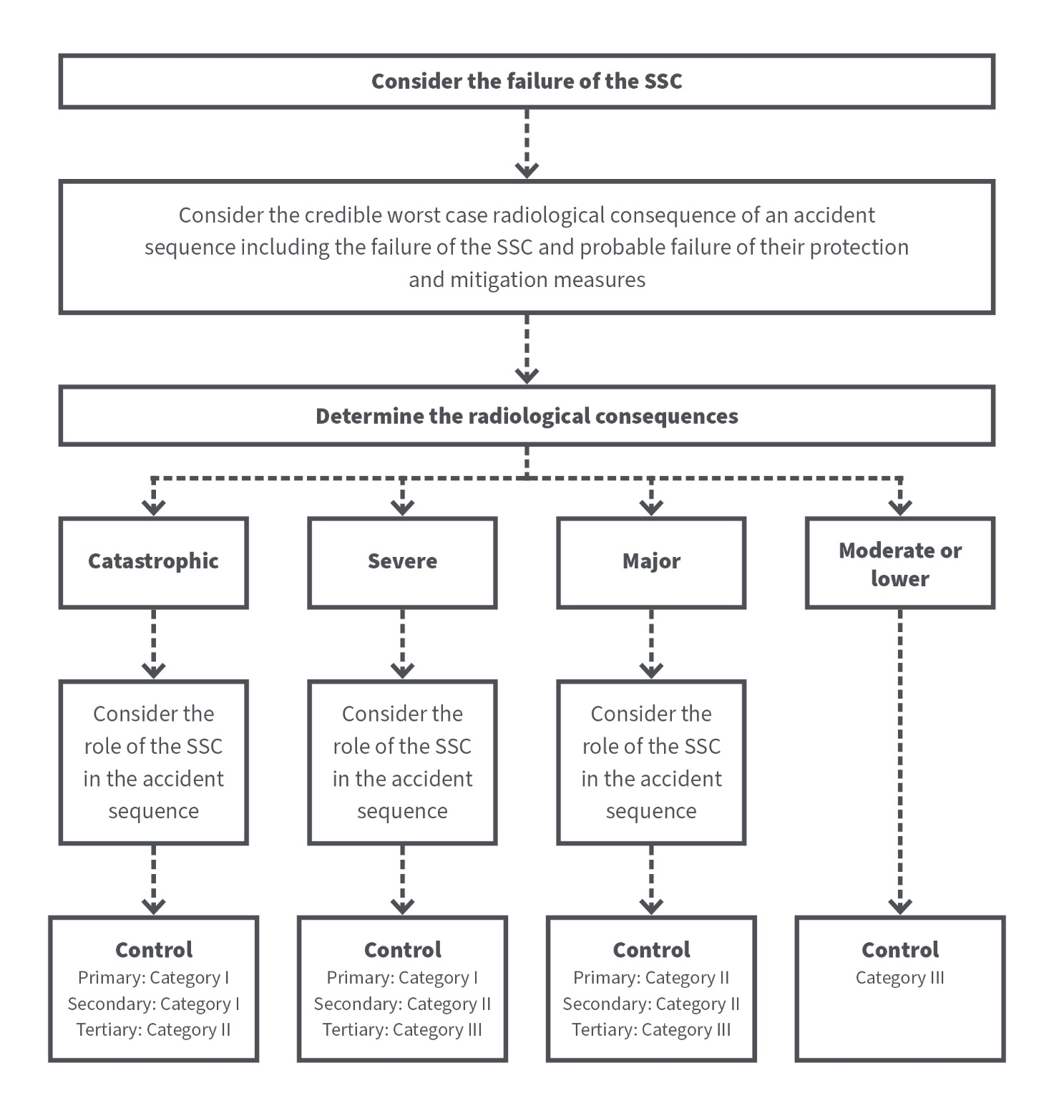

Consider the failure of the SSC
Category III
Primary = Category II
Secondary = Category II
Tertiary = Category III
Primary = Category I
Secondary = Category II
Tertiary = Category III
Primary = Category I
Secondary = Category I
Tertiary = Category II
Tabular Representation of the Categorisation System Credible worst case radiological consequences
Role of SSC | Credible worst case radiological consequence
Role of SSC | Catastrophic | Severe | Major | Moderate or lower
Primary | Primary I | Primary I | Primary II | Primary III
Secondary | Secondary I | Secondary II | Secondary II | Secondary III
Tertiary | Tertiary II | Tertiary III | Tertiary III | Tertiary III
Primary, Secondary or Tertiary
control
Primary, Secondary or Tertiary
control
Primary = Category I
Secondary = Category I
Tertiary = Category II
Primary, Secondary or Tertiary
control
Primary = Category II
Secondary = Category II
Tertiary = Category III
Primary = Category I
Secondary = Category II
Tertiary = Category III
Category III
Consider the role of the SSC in the accident sequence
Consider the role of the SSC in the accident sequence
Category III
Primary = Category II
Secondary = Category II
Tertiary = Category III
Primary = Category I
Secondary = Category II
Tertiary = Category III
Primary = Category I
Secondary = Category I
Tertiary = Category II
The category I criterion for primary SSCs for occupationally exposed individuals is the generally accepted threshold level above which detectable effects can occur and is consistent with the International Commission on Radiological Protection (ICRP) recommendations. The category I criterion for members of the public is a typical value within the generally accepted range of avertable dose levels above which intervention (e.g. sheltering) may be warranted (see ARPANSA Guide for Radiation Protection in Emergency Exposure Situations (2019) (RPS G-3)). The category II threshold criteria are the statutory limits for occupationally exposed individuals (averaged over 5 years) and for members of the public.

Appendix 3 – Operational Limits and Conditions
Operational limits and conditions (OLCs) should be provided where appropriate. The purpose of OLCs is to ensure that the facility is operated within a safe working envelope demonstrated by the safety case. This envelope is a function of the facility rather than a ‘production level of use’, i.e. the OLC should be established from capacity of the facility only. OLCs are only used for critical safety parameters and not for production control.
OLCs should provide and justify functional safety requirements derived from the functions of the SSCs and the accident analysis. IAEA guidance on OLCs for power and research reactors indicates that OLCs should include:
- safety limits
- safety system settings
- limiting conditions for safe operations
- surveillance requirements
- administrative requirements
- limits of non-availability of safety equipment.
It is recommended that OLCs, including surveillance requirements, should be applicable to items of Safety Category I. In addition, OLCs (including surveillance requirements) should be considered for items of SSC Category 2 taking a graded approach. This particularly applies if the SSC Category 2 item provides a backup for passive primary SSC Category 1 item.
Note, however, that OLCs may be formulated in relation to a key functional performance parameter rather than directly relating to the SSC itself. For example, an accelerator target cooling system may have OLCs relating to the target inlet water temperature rather than specifically to the cooling system itself.
Also, for passive/static SSCs, structural integrity may be readily guaranteed providing a specific parameter relevant to an associated medium (e.g. water conductivity/chemistry) is not exceeded.
Therefore, in such cases, OLCs relating to the parameter of the medium may suffice in lieu of OLCs relating directly to the SSC.
OLCs might not be required for passive SSCs whose integrity can be assured without the need for monitoring of specific parameters.
OLCs might also be required to administratively control facilities within the safe envelope (for example limiting inventories, restricting the kinds of material than can be used as an ion source or target in an accelerator, requirement for key safety positions for safe operation of a facility etc.).
Since the safety assessment will generally rely heavily on items of safety category I (if such items exist in the facility), and to a lesser extent to items of safety category II, the safety case should be the main basis for determining OLCs.
More Information
OLCs have an inherit relationship with Defence in Depth as depicted below in Figure 3.
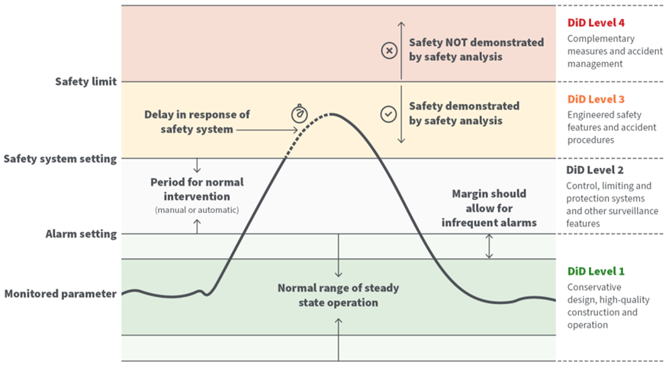
Figure 3 – Principle of Operational Limits and Conditions (OLCs) and relationship to Defence in Depth (DiD)
The safety limits of the process variables or parameters required for adequate control of the operation to protect the integrity of the physical system designed to guard against the uncontrolled release of radioactivity should be clearly described.
Safety system settings should be provided for those process variables and parameters having significant safety functions such that, if not controlled, they could result in a safety limit being exceeded. The analysis should demonstrate that the safety limits will not be exceeded.
Limiting conditions for safe operation should be clearly described demonstrating that there are acceptable margins between normal operating values and the safety system settings for items important to safety.
The settings for limiting conditions for safe operation should avoid the undesirably frequent actuation of safety systems. Limiting conditions for safe operation should include limits on operating parameters, requirements relating to minimum operable equipment and minimal staffing levels, and interventions to be taken by operating personnel to avoid the need for actuation of safety systems.
Surveillance requirements should be included that describe the frequency and scope of periodic testing, calibration, or inspection activities that assure that the performance of systems and components is maintained, and facility operations remain within safety limits, safety system settings and limiting conditions for safe operation.
The administrative and organisational requirements for operational procedures, staffing, training and retraining of personnel, review and audit procedures, maintenance, modifications, records and reports, and required actions following a violation of operational limits and conditions should be clearly described.

As per the Australian Naval Nuclear Power Safety Act 2024 (ANNPS Act): s 11) Each of the following is a facility activity: (a) preparing a site for an NNP facility in a designated zone; (b) constructing an NNP facility in a designated zone; (c) having possession or control of an NNP facility in a designated zone; (d) operating an NNP facility in a designated zone; (e) decommissioning an NNP facility in a designated zone; (f) disposing of an NNP facility in a designated zone. Note: Paragraphs (a) to (f) are not necessarily mutually exclusive of each other. s 14) (1) Each of the following is a material activity: (a) having possession or control of NNP material or NNP equipment or plant in a designated zone or an Australian submarine; (b) using NNP material in a designated zone or an Australian submarine; (c) using or operating NNP equipment or plant in a designated zone or an Australian submarine; (d) maintaining, storing or disposing of NNP material or NNP equipment or plant in a designated zone or an Australian submarine. Note: Paragraphs (a) to (d) are not necessarily mutually exclusive of each other. (2) However, an activity covered by subsection (1) is not a material activity if the regulations prescribe that the activity is not a material activity.
Where applicable, existing regulatory requirements or guidance could assist with the graded approach determination. For example, an operator should identify and categorise structures, systems and components important to safety where relevant (see RAP 9) and/or categorise a facility based on its emergency preparedness category (see RAP 12).
A criticality assessment for fissile materials is crucial to ensure safety by preventing self-sustaining nuclear chain reactions. The assessment involves evaluating the reactivity of fissile materials, considering their geometry, isotopic composition, and surrounding materials. The goal is to demonstrate that systems involving fissile materials will remain subcritical under both normal and abnormal conditions.
The plans and arrangements in place for managing radiation protection should be assessed using regulatory guidance where available such as the ARPANSA Plans and Arrangements for Managing Safety or the ARPANSA Radiation Protection Series, Code for Radiation Protection in Planned Exposure Situations (RPS C-1). In respect of the Australian nuclear powered submarine enterprise, it is recommended that reference be made to ANNPSR guidance.
The ‘site’ is taken to mean the location of the facility or the location where an activity is conducted.
Where innovative designs beyond current practices have been applied (for example design principles have been applied which are outside of established codes and standards) it should be determined in the safety assessment whether compliance with the safety requirements has been demonstrated by an appropriate program of research, analysis and testing complemented by a subsequent program of monitoring during operation.
Control factors are measures that should be applied, in a graded approach, to support safety and security.
See Regulatory Guide - Holistic Safety (ARPANSA-GDE-1753) | ARPANSA
Definition of Defence in Depth can be found in INSAG-10 (1996)
A ‘cliff edge effect’ is an instance of severely abnormal conditions caused by an abrupt transition from one status of a facility to another following a small deviation in a parameter or a small variation in an input value that leads to a disproportionate increase in radiological consequence.
A design basis accident is a postulated accident leading to accident conditions for which a facility is designed in accordance with established design criteria and conservative methodology, and for which releases of radioactive material are kept within acceptable limits.
Single failure criterion is a principle of design requiring that a safety system still remain operable even if any single component of the system should fail.
As a minimum, the validation/verification process should show that the codes are accurate and fulfil the intended purpose.
Note that some existing Australian codes and regulations prescribe a specific type of safety report (for example a Safety Analysis Report (SAR) or a Safety Case) depending on the facility/activity type. For example, using precise referencing, the SAR refers outwards so that any safety claims are supported by information and evidence in the overall safety case. ARPANSA applies the Regulatory Guide Preparation of the safety analysis report for non-reactor facilities for example. From the perspective of the nuclear safety enterprise, a nuclear safety plan to ensure that activities are conducted safely and radiation exposure is kept as low as reasonably achievable within dose limits, is a requirement for licence applications.
Safety limits are limits on operational parameters within which an authorised facility has been shown to be safe. Safety limits are beyond the limits for normal operation. [IAEA Interim Safety Glossary 2022].
Safety system settings are settings for levels at which safety systems are automatically actuated in the event of anticipated operational occurrences or design basis accidents, to prevent safety limits from being exceeded. [IAEA Interim Safety Glossary 2022].

