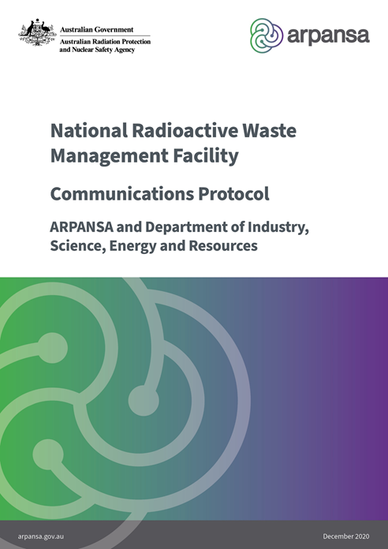

# Background

The Australian Government’s Department of Industry, Science, Energy and Resources (DISER) is responsible for the process of selecting and establishing the National Radioactive Waste Management Facility (NRWMF) under the *National Radioactive Waste Management (NRWM) Act 2012*. The proposed facility is for the disposal of low level waste and storage of intermediate level waste. Under the NRWM Act, any new site for such a facility must be voluntarily nominated. In February 2020, DISER identified a preferred site to host the facility.

The Australian Radioactive Waste Agency (ARWA) was established in July 2020 as a Division within DISER and is responsible for, among other things, the establishment of the NRWMF. The key legislation governing the licensing of the NRWMF is the *Australian Radiation Protection and Nuclear Safety Agency Act 1998* and the Australian Radiation Protection and Nuclear Safety Regulations 2018. A NRWMF would also need to meet the requirements of the *Environment Protection and Biodiversity Conservation Act 1999*, and the *Nuclear Non‑Proliferation (Safeguards) Act 1987* among other Acts and Regulations. ARWA must apply to the CEO of ARPANSA for a licence to establish the NRMWF[1].

# Purpose

The purpose of this document is to formalise communication protocols between the Australian Radiation Protection and Nuclear Safety Agency (ARPANSA), and the Australian Radioactive Waste Agency (ARWA) related to the National Radioactive Waste Management Facility (NRWMF) Project.

This document defines the mechanism for formal communication of information by the identified stakeholders in a timely and efficient manner. Each party will be responsible for ensuring that all its direct reports and subcontractors are aware and follow the Protocol established in this document. This document will be reviewed annually to ensure that it correctly reflects the evolving relationship between ARPANSA and ARWA.

# Relevant documents

* ARPANS Act 1988
* ARPANS Regulations 2018
* *National Radioactive Waste Management Act 2012*
* [Australian Radioactive Waste Management Framework](https://www.industry.gov.au/data-and-publications/australian-radioactive-waste-management-framework)
* Regulatory Guidance for Siting a Controlled Facility
* Regulatory Guide: Applying for a licence for a radioactive waste storage or disposal facility
* Radioactive Waste Storage and Disposal Facilities: Information for Stakeholders

# Communication agreement

ARPANSA and ARWA will communicate in accordance with this Protocol working collaboratively to achieve the best outcomes for the Australian community.

ARPANSA and the ARWA will observe the terms and conditions of any applicable confidentiality agreements.

# Contacts

## ARPANSA personnel

|  |  |  |
| --- | --- | --- |
| Role | Responsibility | Contact details |
| Project Manager (PM) | All general correspondence.  All formal correspondence relating to the nationwide site identification process and site licence application.  Responsible for ensuring that all direct reports are aware of this procedure and its application.  Escalate situations.  Bi-Monthly meetings. | Project Manager  National Radioactive Waste Management Facility Support Project  E: [NRWMF.Support@arpansa.gov.au](mailto:NRWMF.Support@arpansa.gov.au) |
| Alternate PM | Where the PM is not available, undertake the same role as the PM. | E: [NRWMF.Support@arpansa.gov.au](mailto:NRWMF.Support@arpansa.gov.au) |
| Government Relations Office of the CEO | All correspondence and enquiries related to Ministerial matters (and Government relations) | E: [NRWMF.Support@arpansa.gov.au](mailto:NRWMF.Support@arpansa.gov.au) |

## ARWA personnel

|  |  |  |
| --- | --- | --- |
| Role | Responsibility | Contact details |
| Technical Team Manager | All general correspondence.  All formal correspondence relating to the nationwide site identification process and site licence application.  Responsible for ensuring that all direct reports are aware of this procedure and its application.  Escalate situations.  Bi-Monthly meetings. | Cecilia Tran  E: [cecilia.tran@industry.gov.au](mailto:cecilia.tran@industry.gov.au)  GPO Box 2013 Canberra ACT 2601  E: [arwacoord@industry.gov.au](mailto:arwacoord@industry.gov.au) |
| Alternate Technical Team Manager | Where the Technical Team Manager is not available, undertake the same role | Jon Shatwell  E: [jonathan.shatwell@industry.gov.au](mailto:jonathan.shatwell@industry.gov.au) |
| Strategic Policy Team Manager | Policy / Legislation / Government decision related queries | Juanita Naughton  E: [juanita.naughton@industry.gov.au](mailto:juanita.naughton@industry.gov.au) |

# Protocol

## General information/queries

All formal communications should be raised to the appropriate contact as noted in Section 4 and copied to the ARPANSA Project Manager and the ARWA Technical Team Manager. Parties shall use their current official forms and templates for information exchange.

As required by the Commonwealth, Parties will maintain records of all correspondence sent and received. Parties will endeavour to meet a nominal turn around period for a response to a request for information of ten (10) working days.

If it is unclear who has direct responsibility for the matter of inquiry, then contact the respective Project Manager nominated in this Protocol. The Project Manager will refer the matter to the appropriate staff member if it goes beyond their role.

## Meeting communication

Where formal meetings are held, such as the bi-monthly meetings between ARPANSA and ARWA, it is expected that an agenda will be issued at least five (5) working days before the scheduled date, as far as practical.

Where this is not practical, both parties will ensure an agenda is issued prior to the meeting date. Any actions arising from the initial meeting should be captured as actions to be addressed under the agenda of a follow up meeting as required.

The notification that a formal meeting should be held shall be raised electronically via e-mail calendar requests. Requests shall include the list of participants, the agenda, the Chair of the meeting, the date, and the venue.

Minutes of the meeting shall record only decisions and actions resulting from the meeting agenda. The party hosting the meeting is required to keep minutes of meetings and forward them through to the other party within five (5) working days, as far as practical.

## Formal correspondence

Formal written correspondence should be raised whenever an exchange of information is required to seek an official response from a receiving party in relation to any project related matters.

The preferred mode of formal communication between ARPANSA and the ARWA is by way of email correspondence. Correspondence issued in this manner is understood to represent controlled and reliable information reflecting the position of the transmitting party. Communications must display the appropriate security classification. The parties will ensure that they comply with any relevant legal requirements including obligations under the *Privacy Act 1988*.

Where correspondence requires an answer to a specific question(s), the question(s) should as far as possible conform to the following principles:

* Clear and definite question(s) should be raised; responses should address specifically the questions raised.
* Attachments relating to the query should be easily accessible for review and where possible included in the query submittal for review.
* The response time from the receiving party should be ten (10) working days from issue of the correspondence, or as agreed.
* **Only** the party raising the correspondence can close the correspondence.
* Revision control of outgoing correspondence is the responsibility of the issuing party.

Where the intent of a correspondence is to state a position or to inform the recipient of latest information and no response is required, the issuer of the correspondence should raise the correspondence as ‘Closed’ on issue.

## Technical queries/correspondence

### 6.4.1 ARPANSA

* ARPANSA will provide advice to ARWA on the regulatory requirements, including the provision of waste management criteria, ongoing technical advice regarding the elements important to the safety case throughout site characterisation studies and during the development of the detailed business case, as required.
* ARPANSA will only provide advice and information to ARWA to clarify ARPANSA’s criteria for the protection of people (public and workers) and the environment, and what technical and other information ARWA must provide to ARPANSA as part of a licence application.
* ARPANSA may attend, as an observer, ARWA workshops and/or working groups, only where ARPANSA assesses that there is not a conflict of interest (real or perceived).
* ARPANSA may be requested to provide material for ARWA’s Community Engagement Program for the purpose of clarifying ARPANSA’s regulatory requirements and radiation protection/safety concepts to interested parties.
* ARPANSA may be requested to provide advice regarding ARPANSA's regulatory requirements to ARWA for the purposes of informing policy development
* ARPANSA will continue to act as an independent regulatory authority with all matters related to the NRWMF Project.
* ARPANSA will not advise on technical solutions to meet its criteria.
* ARPANSA may invite representatives from ARWA to relevant meetings to discuss the progress of the licence application. These meetings may include the ARPANSA Licence Forum for example.

### 6.4.2 ARWA

* ARWA will keep ARPANSA informed of proposed timings for submission of licence applications.
* ARWA will keep ARPANSA informed of policy matters to which ARWA deems it relevant for ARPANSA to be aware.
* ARWA may invite representatives from ARPANSA to relevant meetings to discuss the Project. These meetings may include the Radioactive Waste Management Interdepartmental Committee (IDC) for example.
* ARWA may only request input/advice from ARPANSA if it is related to clarification of ARPANSA’s criteria for a licence application.

# Issue resolution

In the event there is a communication breakdown and/or an issue cannot be resolved in a timely and adequate manner, both parties have the right to escalate an issue to the next highest level within their own respective organisations.

1. See ARPANSA Regulatory Guide – Applying for a licence for a radioactive storage or disposal facility for full details of the staged

   licensing process required https://www.arpansa.gov.au/sites/default/files/reg-la-sup-240a.pdf