ANRDR in Review
Issue 01, July 2014

Welcome
Welcome to the first issue of the Australian National Radiation Dose Register (ANRDR) newsletter, ANRDR in Review. It is planned that this newsletter will become an annual publication to inform stakeholders of current and future work, data trends and upcoming events.
This year the ANRDR team achieved a significant milestone - complete implementation of the Dose Register to the uranium mining industry. Achievement of this milestone was only possible with the valuable contribution and strong support provided by operators, regulators and industry groups. We thank you for your ongoing support of the ANRDR work programs, and look forward to future collaborations as we continue our journey to promote uniformity and achieve a best practice approach for recording and maintaining occupational dose records that can be requested by workers.
In this first issue of ANRDR in Review our aim is to communicate information to stakeholders about the key ANRDR activities since its establishment in 2010, including the current operational status, analysis of data, stakeholder engagement activities, and plans for future expansion of the Dose Register beyond the uranium mining industry.
We hope you find this newsletter of interest and we appreciate your suggestions and input for future issues of ANRDR in Review.
The ANRDR Team

Featured articles

Analysis of the ANRDR data
Now that all operating uranium mines in Australia are providing records to the Dose Register, ARPANSA has performed a periodic analysis of the ANRDR data in order to characterise the occupational exposure situation at the national level.
See Data analysis and reporting

Expansion activities
ARPANSA is currently seeking to expand the ANRDR beyond uranium mining to include occupationally exposed workers in other industries. This will initially include workers in the mineral sands mining and processing industry, and applicable Commonwealth licence holders.
See Expansion activities

Current status of the ANRDR
ARPANSA operates and maintains the ANRDR (Dose Register), for the collection and long-term storage of radiation dose records for workers who are occupationally exposed in the Australian uranium mining and milling industry. The ANRDR has been open to receive dose records from uranium mining and milling operators since 1 July 2010. The Dose Register has been implemented to all four uranium mines that are licenced to operate in Australia: Olympic Dam, Beverley and Honeymoon in South Australia, and Ranger in the Northern Territory. In November 2013 production at the Honeymoon uranium mine was suspended and the mine has been placed on care and maintenance for an indefinite period.
Records for more than 31,700 individual workers in the uranium mining industry are currently registered in the ANRDR. This includes historical dose records dating back to commencement of uranium production for some operators (Beverley and Honeymoon). Since 2010, ARPANSA staff data have also been included in the Dose Register to test the suitability of the ANRDR for accepting dose histories from non-uranium mining occupational groups. The ANRDR currently maintains 26 years’ worth of ARPANSA staff data (1987 – 2013) for a total of 276 workers.
Summary of data currently registered in the ANRDR from the uranium mining industry
Mine | Mining Technique | Year Production Commenced | Year Included in the ANRDR | Data Collected^{1,2}
Ranger | Open Pit | 1982 | July 2012 | Q1 2010 – Q4 2013
Olympic Dam | Underground | 1988 | October 2010 | Q1 2004 – Q4 2013
Beverley | ISR | 2001 | January 2011 | Q1 2001 – Q4 2013
Honeymoon | ISR | 2011 | February 2014 | Q1 2011 – Q4 2013
Notes: 1. Data correct as of 02/05/2014
2. Q1 means calendar quarter – the period of time covered by the data (i.e. 1 January to 31 March)
The number of individual records submitted to the ANRDR by each uranium mine operator varies considerably, largely due to differences in the way each operator determines who is a radiation worker and hence, who is recorded by the system. Differences in mining techniques (underground, in-situ recovery and open pit) and workforce size across uranium operations are also factors that can affect the number of individual records submitted to the ANRDR by each operator. The number of monitored workers at Olympic Dam is significantly higher than other operations. As such, Olympic Dam contributes around 93% of the total number of individual records registered in the ANRDR.
Total number of dose records (%) registered in the ANRDR from each uranium mine operator

Significant events
Now that the ANRDR has been y implemented to the uranium mining industry, it is timely to share with you some of the significant events and key milestones achieved by the ANRDR team along the way.
Summary of significant events since the ANRDR was established in July 2010.
2014
February | ANRDR implemented to the uranium mining industry  Honeymoon dose records included in the ANRDR  ARPANSA Technical Report No. 165 published on Proposed Expansion of the ANRDR to the Mineral Sands Mining and Processing Industry
2013
December | New ANRDR dose history report format issued to workers
October | Second annual ANRDR workshop held in Cairns
June | ARPANSA contributed ANRDR data to the IAEA UMEX Project for the investigation of occupational radiation protection practices in the uranium mining and processing industry worldwide
2012
November | Implementation of the ANRDR worker outreach program
July | Northern Territory Radiation Protection Amendment Act 2012 commenced. This Act enables the disclosure of dose records from Ranger to the ANRDR  Ranger dose records included in the ANRDR
June | First annual ANRDR workshop held in Adelaide
2011
June | ANRDR officially launched by Department of Resources, Energy and Tourism Minister Ferguson  RPS9.1 Safety Guide published for Monitoring, Assessing and Recording Occupational Radiation Doses in Mining and Mineral Processing
January | Beverley dose records included in the ANRDR
2010
October | Olympic Dam dose records included in the ANRDR
July | ANRDR opens to receive dose records

Worker outreach program
ARPANSA has developed a worker outreach program to educate workers in the uranium mining and milling industry on the existence of the ANRDR. The aim of the outreach program is to inform workers on the capabilities and benefits of the ANRDR, and to encourage workers to check/request their radiation dose history.
A mine site visit by an ARPANSA officer initially helped inform development of the outreach program and implementation strategies. The outreach program consists of a brochure, series of posters and a PowerPoint slide which has been distributed to the mines sites. ARPANSA has engaged with radiation safety officers (RSOs) at each mine site to integrate this information into site induction and radiation safety training programs.

ANRDR successfully implemented to the uranium mining industry
In February 2014, the ANRDR was implemented to the Honeymoon uranium mine, achieving 100 percent coverage of the Dose Register to all four uranium mines in Australia. The success of the ANRDR is largely due to the cooperative arrangements between ARPANSA, regulatory authorities and mine operators. Development and implementation of the Dose Register has been strongly supported by the uranium industry, however implementation of the ANRDR was not a simple and straightforward process.
Record management practices vary significantly between operations, and legislative requirements for radiation protection, mining, and privacy are different in each jurisdiction, so the approach for obtaining dose data was individually managed for each uranium operator. In South Australia, each mine operation’s Radiation Management Plan (RMP) was amended to require the mine operator to report dose records to the ANRDR, at the request of the State regulator. In the Northern Territory, amendments were made to the Radiation Protection Act, requiring a mining site to monitor workers for radiation, keep records, and to provide those records to ARPANSA for inclusion in the ANRDR.
It is anticipated that any privacy concerns raised by future expansion to other jurisdictions can be solved by following the examples set by South Australia and the Northern Territory.

New dose history report format
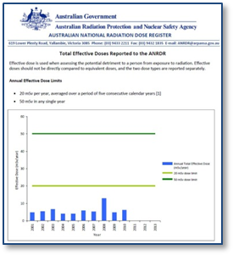
In December 2013, a new version of the ANRDR Dose History Report was released. The dose history report is provided to workers on request, and in December the ANRDR issued it’s first two dose history reports to uranium mine workers. A worker whose doses have been recorded in the ANRDR can request a copy of their personal dose history by completing a form provided on the ARPANSA website and sending it to one of the friendly ANRDR staff either by post or by email.
The new dose history report format was informed by feedback obtained from a useability study achieved by way of contribution from numerous ARPANSA staff with varying levels of knowledge about radiation. The purpose of the useability study was to review the existing report format to assess workers’ understanding of the information presented in the report. To improve the readability of the report for workers, the new report format has simplified wording and concepts with graphical representation of doses in relation to dose limits.

RPS 9.1 Safety Guide
Mining and mineral processing operations have different radiation monitoring methodologies and dose assessment practices. To help achieve uniformity in dose data reported to the ANRDR, a Safety Guide (RPS 9.1) was published to promote a nationally consistent approach to monitoring, assessing and recording occupational radiation doses in mining and mineral processing operations across Australia.
Assessment of the radiation doses received by workers in mining and mineral processing operations requires correction for factors which affect the assessed dose. These factors include, but are not limited to, the solubility class of the radioactive material, time spent in a designated area, breathing rates, and the possible use of personal protective equipment (PPE). In particular, RPS 9.1 recommends that the assessed dose should be corrected to allow for the PPE protection factor and avoid the unnecessary overestimation of the dose received and recorded. Conversely, a dose received can be underestimated when a PPE factor is applied when no or inefficient PPE is used by a worker. The ANRDR database has multiple text fields for recording dose parameters used to calculate the reported doses for which the operator can include PPE correction factors.
It is important that accurate doses are recorded and reported to the ANRDR as this will allow for valid dose comparisons to be made, and will assist ARPANSA in providing valuable information about exposures, risks, work practices, and safety culture in the mining and mineral processing industry.

Data analysis and reporting
The ANRDR collects information on quarterly assessed radiation doses for occupationally exposed workers for the following dose types (where relevant): external gamma, external neutron, inhalation of particulates, inhalation of radon gas and radon progeny, ingestion, wound and extremity dose. Company data and personal information are also collected to match a dose to the correct worker. The data collected is used to monitor individual radiological dose histories and generate annual statistics relating to exposure trends to assist in the optimisation of radiation protection practices for workers.
The flow of information (data) into and out of the ANRDR system.
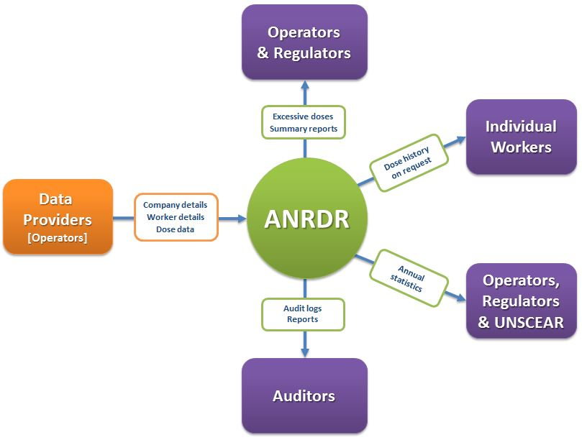

Analysis of Commonwealth licence holder data
ARPANSA staff data have been included in the Dose Register to test the suitability of the ANRDR for accepting dose histories from non-uranium mining occupational groups. ARPANSA staff are monitored for a wide variety of radiation dose types and exposure scenarios. Some of the work for which ARPANSA staff are monitored include: site visits, regulatory inspections, radiochemistry analysis, linear accelerator services, emergency response activities, radon exposures, and quality control exposures using various gamma and neutron sources. The average and maximum annual effective doses to ARPANSA staff exhibit an overall downward trend for the period 1 January 1987 to 31 December 2013. Typically, staff doses are very low, with the average annual dose being kept well below 1 mSv. The graph shows that most maximum doses remained below 3 mSv, however in 2006 the highest individual annual dose of 9.7 mSv was recorded. As this dose was significantly higher than previously recorded maximum doses, an investigation was conducted to identify how the exposure occurred. It could not be disproved that the TLD badge was not being worn at the time of exposure, therefore it was accepted that the dose was ‘real’ and recorded for the individual.
Average and maximum effective dose trends for ARPANSA staff (1987-2013)
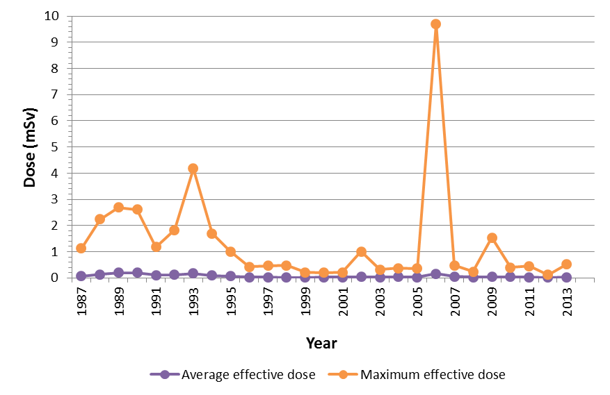

Analysis of uranium industry data
Now that all four uranium mines in Australia are providing records to the Dose Register, ARPANSA has performed a periodic analysis of the ANRDR data in order to characterise the occupational exposure situation at the national level. It should be noted that Olympic Dam contributes more than 90% of the total number of records registered in the ANRDR (as shown on Page 2). As such, the dose trends presented here are dominated by Olympic Dam data, however similar trends are observed across the other operations.
Average and maximum effective dose trends for all Australian uranium mine workers (2004-2013)
The average and maximum annual effective doses to Australian uranium workers exhibit an overall downward trend for the period 1 January 2004 to 31 December 2013. It is clear from the above graph that doses to workers have remained consistently low, with the average dose being kept at less than a tenth of the annual dose limit. The highest individual annual dose of 15.9 mSv was recorded in 2005, however during the reporting period most maximum doses remained well below half the annual dose limit.
Average effective dose trend by work category (2004-2013)
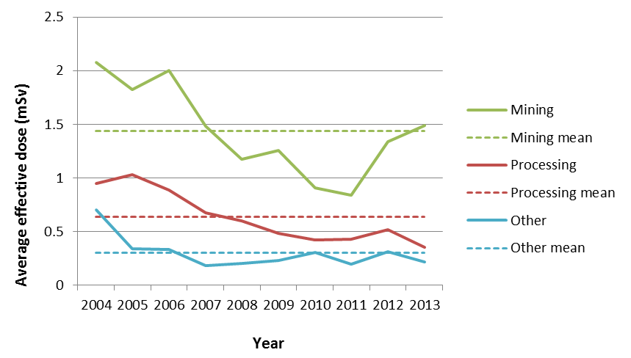
No. of operators included in ANRDR
The graph above shows the breakdown of annual effective dose by work category. During the 10 year reporting period, higher doses were received by mining workers with a mean annual dose of 1.4 mSv compared to a mean annual dose of 0.6 mSv for processing workers, and 0.3 mSv for other workers. Although the reported doses are very low, a slight increase in the average annual dose was observed in all three work categories in 2012.
Annual dose distribution for all Australian uranium mine workers (2013)
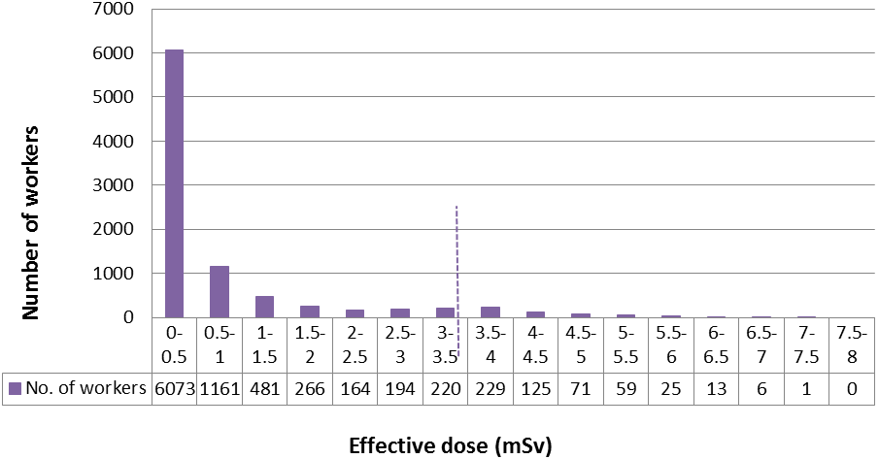
67% of workers < 0.5 mSv
95% of workers < 3.5 mSv
An analysis of the dose distribution for 2013 reveals that approximately 95% of workers received a dose less than 3.5 mSv per year and 67% of workers received a dose below 0.5 mSv per year. The doses currently being recorded in the Australian uranium industry are very low, however it should be noted that doses may increase by a factor of two with the expected changes by the ICRP to radon progeny dose conversion factors. This is particularly important for the maximally exposed workers as there is potential for these individuals to exceed the annual dose limit if doses are increased by a factor of two.

UMEX Project
In June 2013, ARPANSA, in collaboration with uranium mine operators, contributed information to the IAEA survey on uranium mining and processing exposures (UMEX). The ANRDR proved a useful resource for providing the IAEA with dosimetric information on occupational exposure in the uranium mining industry in Australia, including data on worker categories, number of workers, average and maximum doses (γ, inhaled LLAA, inhaled RDP, total), and dose conversion factors.
Analysis of the UMEX data aims to provide a worldwide overview of occupational radiation protection practices in the uranium mining and milling industry, enabling the identification of good practices, existing deficiencies and the need for future action. The publication date for the results from the UMEX Project is yet to be determined.

Stakeholder engagement
The ANRDR team has engaged with key stakeholders by participating in scientific networks and meetings both internationally and regionally. This has included attendance at key industry and government meetings, including the Uranium Council, WA Radiation Industry Group, Australian Uranium Association, Commonwealth Licence Holders Forum, Radiation Health and Safety Advisory Council, and the Alligator Rivers Region Advisory Committee.

International engagement

Visit to Health Canada and the Health Protection Agency
In November 2012, ARPANSA visited the Health Protection Agency (HPA, now Public Health England) and Health Canada to engage with international dose register experts who manage the most established and comprehensive radiation dose registers in the world. The National Dose Registry (NDR) and Central Index of Dose Information (CIDI) contain the occupational radiation dose records of all classified radiation workers in Canada and the United Kingdom, respectively. Both registers are complex programs, collecting information about different categories of individuals using different legal authorities and from a variety of organisations. The HPA also manages the National Registry for Radiation Workers (NRRW) which is an epidemiological database based on a cohort of workers monitored for occupational exposure to radiation and is used for mortality and cancer analysis.
The visit to Health Canada and the HPA provided an excellent opportunity to learn first-hand from their experience in regards to the development, implementation and ongoing management of a national radiation dose registry. The knowledge acquired has assisted ARPANSA to enhance the functionality of the database, ensure that ANRDR operational procedures are in-line with best practice, and identify potential impediments that may impact on future expansion of the ANRDR to other industries.

IAEA training course on harmonisation of national dose registries in Member States
ARPANSA was invited by the IAEA to lecture at a training course on ‘Harmonisation of National Dose Registries in Member States’ at its headquarters in Vienna, Austria from 2-4 April 2014. The purpose of the training course was to support Member States in establishing a national dose registry for the collection and maintenance of dose records for occupationally exposed radiation workers. The course was attended by delegates from Canada, Egypt, France, Germany, Japan, Turkey, Ukraine, and United Arab Emirates.
Member States provided presentations on the current status of practices in their countries for recording and maintaining occupational exposure records. Canada, France and Germany have established the most comprehensive radiation dose registries in the world. Other Member States in attendance do not currently have a national system for the collection and maintenance of occupational dose records in a centralised registry. The Canadian national dose registry is by far the largest database containing over 21 million discrete dose records dating back to the 1940s for more than 820,000 registered radiation workers from many different work sectors.
ARPANSA’s presentation on the ANRDR was well received and promoted discussion amongst Member States concerning the key challenges encountered when establishing a national system, including national uniformity, data quality and integrity, and privacy issues. Participation in the training course provided the opportunity for networking with others who share similar challenges, and allowed ARPANSA to contribute internationally to efforts concerning harmonisation of national dose registries.

Industry engagement

ANRDR workshop
ARPANSA facilitates an annual workshop for key ANRDR stakeholders, including representatives from the uranium and mineral sands mining industries, state and territory radiation and mining regulators, and Commonwealth licence holders. The purpose of the annual workshop is to provide a platform for feedback from industry and facilitate a greater level of communication between ARPANSA and its stakeholders about the ANRDR work programs and plans for future development of the Dose Register.
In June 2012, the first ANRDR workshop was held in Adelaide in conjunction with the AusIMM International Uranium Conference. One of the key outcomes of the workshop was the establishment of a radon progeny measurement group to coordinate an Australian response to changes to recommendations of the International Commission for Radiological Protection (ICRP) for the assessment of radon risk based on the dosimetric approach.
Following the success of the first workshop, a second workshop was held in October 2013 in conjunction with the ARPS Conference. Presentations were made by ARPANSA staff and industry representatives. Material covered included the operational status of the Dose Register, analysis of data, national uniformity and best practice, and proposed expansion of the ANRDR to the mineral sands industry and applicable Commonwealth licence holders.
The ANRDR Team is pleased to announce that ARPANSA will be holding the third annual ANRDR Workshop on Sunday 26 October 2014 in Hobart, Tasmania. The workshop has been scheduled to coincide with the ARPS Conference to be held at the Hotel Grand Chancellor in Hobart. So pencil the date in your diary and further details about this event will be confirmed shortly.

Siemens Low Dose Academy Forum
In March 2013, ARPANSA was invited to deliver a presentation at the Siemens Low Dose Academy Forum on the role of the ANRDR for radiation protection of workers. The rationale for the forum was to provide an update on computed tomography and dose optimisation innovations to facilitate best practice amongst radiologists, cardiologists, radiographers, educators and physicists.
In medical applications of ionising radiation, concerns of radiation exposure have largely centred on patient exposure. The forum provided a unique opportunity for ARPANSA to raise awareness for workers in the medical sector about the Australian radiation protection framework and occupational risks of exposure to radiation in the workplace, together with the role of the Dose Register as a tool for the optimisation of worker protection.

Radon progeny measurement coordination group
Changes to recommendations made in 2011 by the International Commission for Radiological Protection (ICRP) on the calculation of radiation doses from the inhalation of radon and radon progeny have significant implications for assessing doses to uranium mine workers. These changes were based on the ICRP Statement on Radon published in 2009, which concluded that doses from radon and radon progeny should be calculated using a dosimetric approach. This change is likely to result in an increase of around a factor of two for the dose coefficients, thus inducing a major revision of radon reference levels. Of note, this change will also impact on the ability to allow comparisons and long-term trending of ANRDR data.
In response to the ICRP changes, ARPANSA has formed a small working group with representatives from the uranium mining industry and regulatory authorities. The aim of this group is to assist in coordination of measurement programmes directed towards the collection of data related to the assessment of radon progeny dose conversion factors in a modern Australian mining environment. In December 2013, the group commenced a programme of measurements at the Olympic Dam uranium mine in South Australia to characterise the radioactive aerosols in different work situations within the mine. Analysis of the data is currently underway and it is anticipated the results of this study will be published in the later part of 2014.

Publications of interest

ANRDR publications and presentations
The ANRDR Team have contributed to industry publications, conference presentations and technical reports to increase awareness and strengthen support for the ANRDR work programs, and to promote a best practice approach for recording and maintaining occupational exposure records. This has included publication of papers in the Australian Uranium Newsletter and the AusIMM Bulletin, and various presentations at the ARPS, AusIMM, and Uranium and Rare Earths conferences.
A full list of ANRDR publications and presentations can be found on the ANRDR webpage.

IAEA Draft Safety Guide DS453
In February 2014, the Draft Safety Guide DS453 – Occupational Radiation Protection was released for official comment by Member States. Once the final document is approved for publication, the objective of the Safety Guide will be to provide general guidance on fulfilling the requirements for the protection of workers exposed to sources of radiation, in accordance with the International Basic Safety Standards, GSR Part 3 (the BSS).
Section 7 of the Draft Safety Guide gives detailed guidance on the monitoring and assessment of occupational exposure, including the maintenance of dose records. Of particular note is Paragraph 7.265 which states:
Consideration should be given to the establishment of a national dose registry as a central
point for the collection and maintenance of dose records compiled by the dosimetry service
providers. The storage of information at the national dose registry should be such as to allow a person, during and after his or her working life, to retrieve information on the doses received while occupationally exposed.

This statement reflects the current internationally accepted principles and recommended practices for recording and maintaining occupational exposure records. Australia has achieved this requirement for the uranium mining industry through the establishment of the ANRDR. However, there is currently no national system for providing dose histories to occupationally exposed workers in other industries.
Centralising occupational dose records is important for the long-term security of individual workers’ dose histories, especially considering the complex radiation protection regulatory framework that exists in Australia. Long-term storage in a national dose registry also serves to allow periodic analysis of all exposure data collected in order to characterise the occupational exposure situation at the national level.

Future developments

Expansion activities
In Australia, approximately 50,000 workers are monitored annually for occupational exposure to ionising radiation. The largest group of occupationally exposed workers are represented in the medical, research, and industrial work sectors. The ANRDR currently includes more than 20% coverage of all occupationally exposed workers in Australia; however this is obviously limited to workers in the uranium mining industry. This coverage will increase to 30% when the ANRDR is implemented to the mineral sands industry and Commonwealth licence holders.
Estimated number of occupationally exposed workers (%) by work sector in Australia
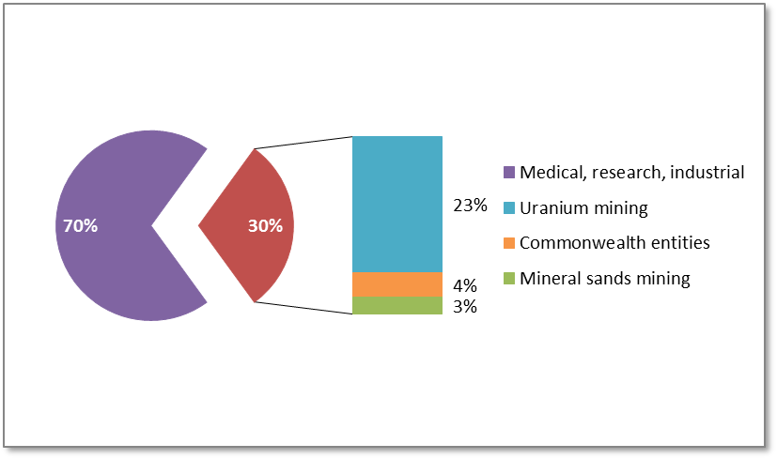

Mineral sands review and technical report
ARPANSA performed a comprehensive review of the Australian mineral sands mining and processing industry to evaluate the feasibility of expanding the ANRDR beyond uranium mining. The purpose of the review was to assess the current status of dose record management practices in the mineral sands industry, and identify legislative and other issues relating to the disclosure of workers’ dose records to the ANRDR.
Based on the findings of the review, ARPANSA has assessed that existing practice for the management of radiation dose records in the Australian mineral sands industry could be improved to facilitate the maintenance of national records within the ANRDR and ensure management of radiation dose records in the Australian mineral sands industry meets best practice.
ARPANSA plans to form a coordinating body consisting of relevant mineral sands industry and regulatory representatives to strengthen support for the ANRDR and guide implementation activities to ensure that future decisions for expansion of the ANRDR are consistent with industry practice and the regulatory framework for radiation protection and mining.
The key findings and recommendations of the review are presented in ARPANSA Technical Report No. 165, which is now available for viewing and can be downloaded from the ARPANSA website.

Commonwealth licence holders
ARPANSA regulates radiation protection and nuclear safety for Commonwealth entities. In parallel to the mineral sands expansion, the ANRDR will also be expanding to include applicable Commonwealth licence holders (CLHs). In March 2014, the ANRDR team circulated a survey to CLHs to gather information on dose reporting and data management practices, and to assess the number and types of workers monitored for radiation exposure. The results of this survey will inform future decisions for expansion of the ANRDR to CLHs.
ARPANSA has received strong support from several CLHs to participate in a pilot phase to test and evaluate the disclosure of dose data to the ANRDR. However, before the pilot phase can commence, the ANRDR database and associated systems require further development to ensure the database is capable of accepting dose data from non-uranium operations. Development of the ANRDR database is planned for 2014 and will be informed by results from the survey completed by CLHs.
ARPANSA will provide CLHs with an information pack outlining the requirements for participation as well as develop a worker outreach program.

Improvements to the ANRDR system
The ANRDR database and associated systems require further development to ensure the database is capable of accepting dose data from non-uranium operations. Development of the ANRDR database is planned for 2014/15 and will be informed by results from the surveys completed by mineral sands operators and Commonwealth licence holders.
As part of the ANRDR’s ongoing improvement, we will be unveiling some new changes in the near future to both the administration component and the portal. The changes, listed below, will help to improve the efficiency and quality of service we provide to industry and workers.

ANRDR administration component
By transitioning to a more automated approach, the new administration component will improve the efficiency of uploading and processing of CSV files, and reduce its dependence on ANRDR Administrators. Some of the new features will include:
- automatic processing of CSV files;
- automatic error notifications;
- browser-based front end (ASP.NET) rather than MS Access-based; and

ANRDR portal
The appearance of the portal will be ‘refreshed’, but most of the current functions within the portal will remain unchanged, however some of the new features include:
- notification upon upload that data already exists in the database;
- ability to enter comments on why data is being re-uploaded, e.g. altering doses, updating data;
- some error checking upon upload to allow immediate feedback on data integrity; and
- automated creation of user accounts (later verified by ANRDR administrators)

The ANRDR Team

Sarsha Collett, ANRDR Manager
Sarsha joined ARPANSA in 2011 to lead the Australian National Radiation Dose Register project. Sarsha and her team have successfully implemented the ANRDR to the uranium mining industry. Sarsha is currently managing the ANRDR expansion project that will focus on collecting dose records from occupationally exposed workers in other industries, including mineral sands mining and processing operations, and Commonwealth licence holders.

Ben Paritsky, ANRDR Science Officer
Since joining the ANRDR team in 2012, Ben has provided scientific support to the operation and ongoing maintenance of the ANRDR, including assisting operators with data upload and providing dose history reports to workers. Ben is currently coordinating activities associated with future development of the ANRDR database to ensure the system is capable of accepting dose data from other industries.

Robert Guilfoyle, ANRDR Science Officer
Since joining the ANRDR team in 2009, Robert has provided scientific support to the administration of the ANRDR database and communication activities, including contributing to the development of a quality management system for database operations, and coordinating the development and implementation of the worker outreach program. Robert is not currently working with the ANRDR Team as he recently accepted a temporary secondment to the Communications Section within ARPANSA.

Upcoming events
- Australian Uranium Conference
16-17 July 2014, Perth, Western Australia
- ARPS Conference
26-29 October 2014, Hobart, Tasmania
- Annual ANRDR Workshop
26 October 2014, Hobart, Tasmania
- Commonwealth Licence Holders Forum Meeting
Late 2014 - date and venue to be confirmed
- IAEA International Conference on Occupational Radiation Protection
1-5 December 2014, Vienna, Austria

Contact the ANRDR
Email: anrdr@arpansa.gov.au
Freecall: 1800 022 333
Website: http://www.arpansa.gov.au/services/ANRDR/
Mailing address:
Australian National Radiation Dose Register
ARPANSA
619 Lower Plenty Road
Yallambie VIC 3085

