

NDRL Newsletter 2013 No. 2

Dear service registrants,

Welcome to the second NDRL Newsletter. Firstly, our name is changing, to more accurately reflect what we do. We are now known as the National Diagnostic Reference Level Service, (changes to the website to reflect this are currently in progress).

While, we are still interested in the data you submit, our principle purpose is to provide practices with a tool for comparing their doses with nationally established DRLs. This is achieved by providing each practice who submits a compliant survey with a formal ARPANSA report which can be used as an indication of compliance with Radiation Protection in the Medical Applications of Ionizing Radiation, Radiation Protection Series No. 14, Section 3.1.8(a).

Secondly, now that June has ended we are officially half way through the submission period for 2013. This means there is less than six more months in which you can compare your doses this calendar year.

Who has been comparing their doses this year?

To date 186 practices have registered with the National Diagnostic Reference Level Service, but not all registered practices have compared their doses. The following graph shows the number of registered practices in each state that have compared their doses this year.

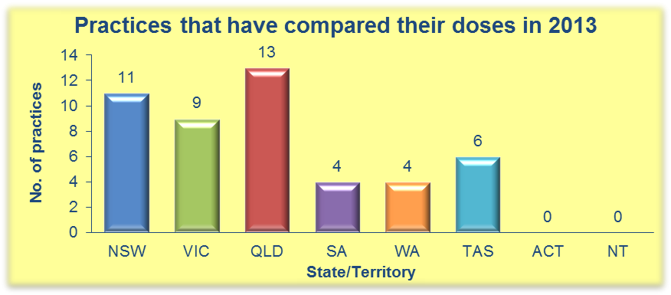

The above graph shows that 47 practices have compared their doses so far this year, which represents only 25% of the total practices registered. The graph below shows the number of registered practices in each state that have not compared their doses at all since registering. In total there are 45 practices in this category which represents 24% of the total practices registered.

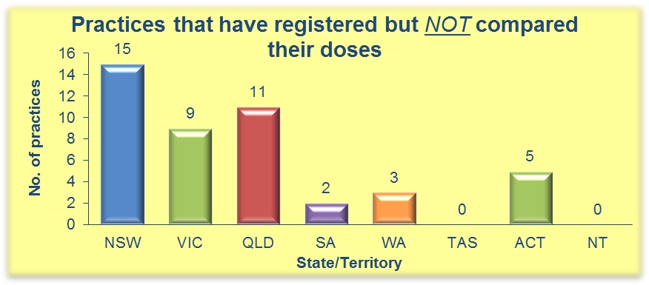

2013 data submission so far…
As of July 2nd 2013 there was a total of 160 surveys submitted, the following graph shows the distribution by state/territory of these surveys.

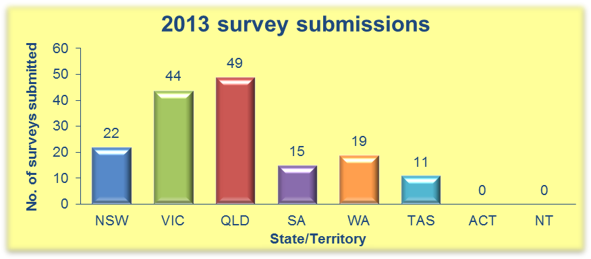

Remember: any surveys started this year have until Dec 31st 2013 to be completed!

NDRL project updates

Recently a draft survey for interventional radiology, specifically on coronary angiography, has been successfully completed and analyzed. It is expected that this survey will be added to the modality list on the NDRL website in due course.

Development work is continuing in the areas of nuclear medicine and mammography with draft surveys or data collection methods being trialed in the near future.

Regards,

The NDRLD Team

ARPANSA

Current Australian National DRLs

Australian Adult (15+ yrs) MDCT DRLs
Protocol | DLP  (mGy.cm) | CTDI_{vol}  (mGy)
Head | 1000 | 60
Neck | 600 | 30
Chest | 450 | 15
AbdoPelvis | 700 | 15
ChestAbdoPelvis | 1200 | 30
Lumbar Spine | 900 | 40

Australian Child (5-14 yrs) MDCT DRLs
Protocol | DLP  (mGy.cm) | CTDI_{vol}  (mGy)
Head | 600 | 35
Chest | 110 | 5
AbdoPelvis | 390 | 10

Australian Baby (0-4 yrs) MDCT DRLs
Protocol | DLP  (mGy.cm) | CTDI_{vol}  (mGy)
Head | 470 | 30
Chest | 60 | 2
AbdoPelvis | 170 | 7

Contact us:
Diagnostic Imaging and Nuclear Medicine Section
Australian Radiation Protection and Nuclear Safety Agency
Free call: 1800 033 972
Email: ndrld@arpansa.gov.au

