

NDRL Newsletter 2013 No. 3

Dear service users,

Welcome to the third NDRL Newsletter for 2013. With 37 new practices registering for the service since the beginning of the year our total registrations are now over 200. With an estimated 850 practices nationwide this represents just under 25% of the national practices.

Since the middle of the calendar year, there has been a significant increase in the number of surveys submitted. The graph below shows the frequency of surveys submitted throughout this year.

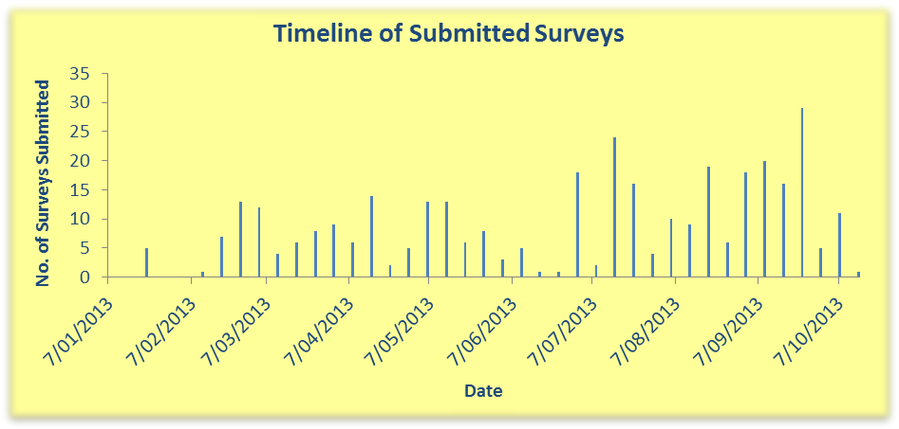

Who has been comparing their doses this year?

A total of 210 practices are now registered for the National Diagnostic Reference Level Service. The graph below shows that a total of 90 practices have compared their doses this year. This is an additional 33 practices in the last three months.

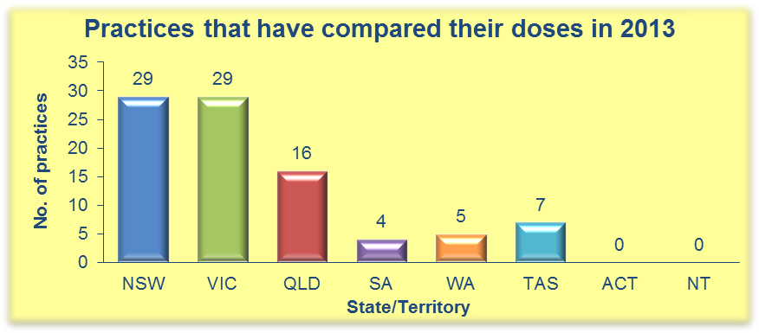
2013 data submission so far…

As of October 8th 2013 there was a total of 350 surveys submitted, the following graph shows the distribution by state/territory of these surveys.

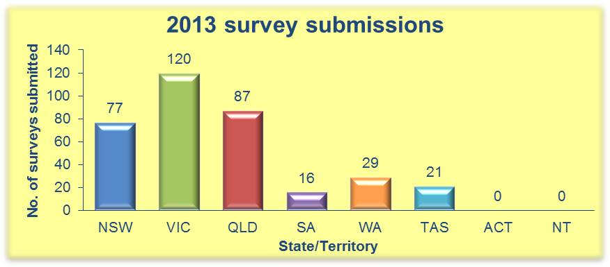

We are now more than three quarters of the way through the submission period for 2013, this means there is less than three months left in which you can compare your doses for this calendar year.

International Comparison

The following graph shows how the Australian Adult National DRLs compare with those published for other countries. For the Head, Chest and AbdoPelvis protocols we are comparable with the EU values, however, for the AbdoPelvis and ChestAbdoPelvis protocols we are significantly higher than the UK and Ireland.

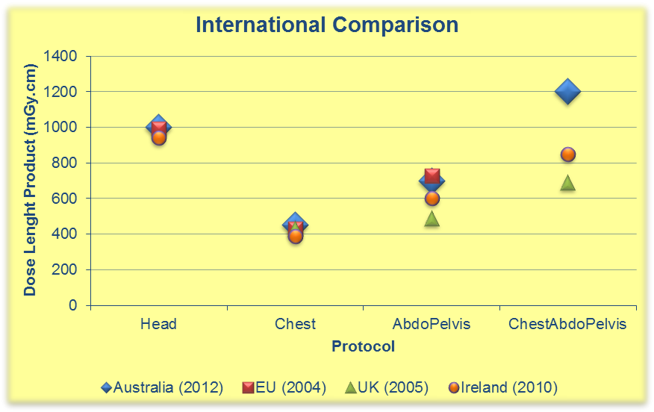
References:
Martin & Huda, Intercomparison of patient CTDI Surveys in Three Countries, RPD (2013),Vol.153, No. 4, pp. 431-440
Foley, Mcentee & Rainford, Establishment of CT diagnostic reference levels in Ireland, BJR, 85 (2012), 1390-1397
Service administrative assistance

We would also like to take this opportunity to remind you that the service administrators will not be available between Dec 22nd 2013 and Jan 6th 2014. This coincides with the annual ARPANSA shutdown period. This means that we will not be responding to queries or issues with forgotten/expired passwords during this time. We suggest that if you intend to use the service in the remainder of the year you insure your login details are up to date now.

Remember: any surveys started this year have until Dec 31st 2013 to be completed!

Regards,

The NDRLD Team

ARPANSA
Current Australian National DRLs

Australian Adult (15+ yrs) MDCT DRLs
Protocol | DLP  (mGy.cm) | CTDI_{vol}  (mGy)
Head | 1000 | 60
Neck | 600 | 30
Chest | 450 | 15
AbdoPelvis | 700 | 15
ChestAbdoPelvis | 1200 | 30
Lumbar Spine | 900 | 40

Australian Child (5-14 yrs) MDCT DRLs
Protocol | DLP  (mGy.cm) | CTDI_{vol}  (mGy)
Head | 600 | 35
Chest | 110 | 5
AbdoPelvis | 390 | 10

Australian Baby (0-4 yrs) MDCT DRLs
Protocol | DLP  (mGy.cm) | CTDI_{vol}  (mGy)
Head | 470 | 30
Chest | 60 | 2
AbdoPelvis | 170 | 7

Contact us:
Medical Imaging Section
Australian Radiation Protection and Nuclear Safety Agency
Free call: 1800 033 972
Email: ndrld@arpansa.gov.au

