

NDRL Newsletter 2013 No. 4

Dear service users,

Welcome to the fourth and last NDRL Newsletter for 2013. The data collection period for 2013 is nearly over so it is time to finish off any surveys you still have open.

2013 data collection close off

Due to resource issues surrounding the ARPANSA shut down period the close off for 2013 data will occur on Jan 13th 2014. On this date any surveys that have not yet been submitted will be closed off and you will not be able to edit any data submitted.

When closed off a practice report for each survey will only be generated if ten or more patient data points have been filled in.

The service will re-open for 2014 data collection on Jan 14th 2014.

Service administrative assistance over the ARPANSA shutdown period

Due to ARPANSA’s shutdown over the Christmas/New Years period survey administrators will not be available between Dec 23rd 2013 and Jan 5th 2014. This means we will not be able to respond to any queries received or issues with forgotten/expired passwords during this time. We suggest that if you intend to use the service during this time period you insure your login details are correct and up to date.

A total of 476 surveys have been submitted so far this year. The graph below shows the distribution of these surveys by state.

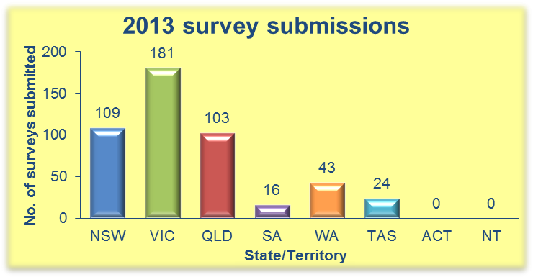

The graph below shows that a total of 101 practices have compared, or are in the process of comparing, their doses this year.
Survey submissions so far…

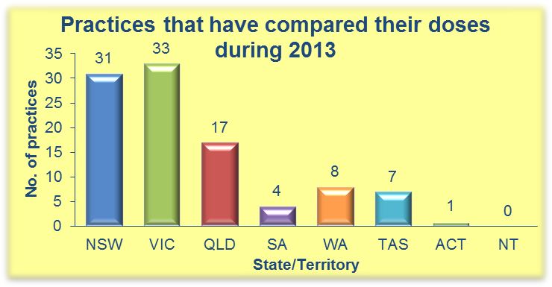

Remember: any surveys started this year have until Jan 13th 2014 to be completed!

Regards,

The NDRLD Team

ARPANSA

Current Australian National DRLs

Australian Adult (15+ yrs) MDCT DRLs
Protocol | DLP  (mGy.cm) | CTDI_{vol}  (mGy)
Head | 1000 | 60
Neck | 600 | 30
Chest | 450 | 15
AbdoPelvis | 700 | 15
ChestAbdoPelvis | 1200 | 30
Lumbar Spine | 900 | 40

Australian Child (5-14 yrs) MDCT DRLs
Protocol | DLP  (mGy.cm) | CTDI_{vol}  (mGy)
Head | 600 | 35
Chest | 110 | 5
AbdoPelvis | 390 | 10

Australian Baby (0-4 yrs) MDCT DRLs
Protocol | DLP  (mGy.cm) | CTDI_{vol}  (mGy)
Head | 470 | 30
Chest | 60 | 2
AbdoPelvis | 170 | 7

Contact us:
Medical Imaging Section
Australian Radiation Protection and Nuclear Safety Agency
Free call: 1800 033 972
Email: ndrld@arpansa.gov.au

