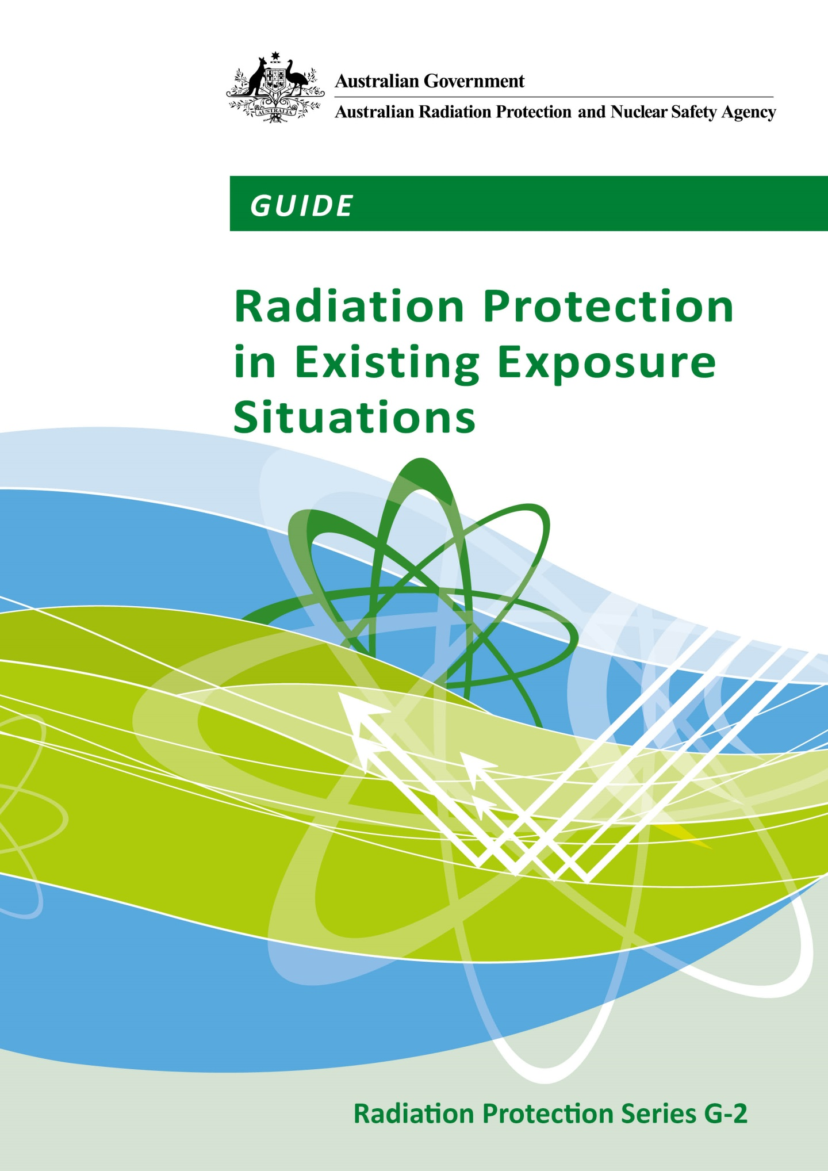

**Public Consultation Draft - 15 December 2016**

**Submissions close Friday 10 March 2017**

**Email submissions to:** [**StakeholderComment@arpansa.gov.au**](mailto:StakeholderComment@arpansa.gov.au)

All submissions will be held in a register of submissions, and unless marked confidential, may be made public.

**Radiation Protection Series**

The Australian Radiation Protection and Nuclear Safety Agency (ARPANSA) publishes Fundamentals, Codes and Guides in the Radiation Protection Series (RPS), which promote national policies and practices that protect human health and the environment from harmful effects of radiation. ARPANSA develops these publications jointly with state and territory regulators through the Radiation Health Committee (RHC), which oversees the preparation of draft policies and standards with the view of their uniform implementation in all Australian jurisdictions. Following agreement and, as relevant, approvals at the Ministerial level, the RHC recommends publication to the Radiation Health and Safety Advisory Council, which endorses documents and recommends their publication by the CEO of ARPANSA.

To the extent possible and relevant for Australian circumstances, the RPS publications give effect in Australia to international standards and guidance. The sources of such standards and guidance are varied and include the International Commission on Radiological Protection (ICRP); the International Commission on Non-Ionizing Radiation Protection (ICNIRP); the International Atomic Energy Agency (IAEA); and the World Health Organization (WHO).

***Fundamentals*** set the fundamental principles for radiation protection and describe the fundamental radiation protection, safety and security objectives. They are written in an explanatory and non-regulatory style and describe the basic concepts and objectives of international best practice.

***Codes*** are regulatory in style and may be referenced by regulations or conditions of licence. They contain either general safety or security requirements which may be applicable for all dealings with radiation, or practice-specific requirements. They provide overarching requirements and are expressed as ‘must’ statements which are to be satisfied to ensure an acceptable level of safety and/or security.

***Guides*** provide recommendations and guidance on how to comply with the Codes or apply the principles of the Fundamentals. They are written in an explanatory and non-regulatory style and indicate the measures recommended to provide good practice. They are generally expressed as ‘should’ statements.

These three categories of publications are informed by public comment during drafting and are subject to a process of assessment of regulatory impact.

All ARPANSA publications (including earlier editions of codes and guides for which ARPANSA is now responsible) are available in electronic format, and can be downloaded free of charge by visiting ARPANSA’s website at [www.arpansa.gov.au/Publications](http://www.arpansa.gov.au/Publications).

Further information can be obtained by telephoning ARPANSA on 1800 022 333 (free call within Australia) or +61 (03) 9433 2211.

***GUIDE***

**Radiation Protection in Existing Exposure Situations**

**Radiation Protection Series G-2**

**MMMM 201Y**

**This publication was prepared jointly with the *Radiation Health Committee*. The *Radiation Health and Safety Advisory Council* advised the CEO to adopt the Guide.**

**CONSULTATION DRAFT – DECMEBER 2016**

© Commonwealth of Australia 201Y

This publication is protected by copyright. Copyright (and any other intellectual property rights, if any) in this publication is owned by the Commonwealth of Australia as represented by the Australian Radiation Protection and Nuclear Safety Agency (ARPANSA).

ISBN XXXXXX

ISSN 1445-9760



**Creative Commons**

With the exception of the Commonwealth Coat of Arms, any ARPANSA logos and any content that is marked as being third party material, this publication, *Guide for Radiation Protection in Existing Exposure Situations (201Y)*, by the Australian Radiation Protection and Nuclear Safety Agency is licensed under a Creative Commons Attribution 3.0 Australia licence (to view a copy of the licence, visit [*http://creativecommons.org/licenses/by/3.0/au*](http://creativecommons.org/licenses/by/3.0/au)). It is a further condition of the licence that any numerical data referred to in this publication may not be changed. To the extent that copyright subsists in a third party, permission will be required from the third party to reuse the material.

In essence, you are free to copy, communicate and adapt the material as long as you attribute the work to ARPANSA and abide by the other licence terms. The works are to be attributed to the Commonwealth as follows:-

“© Commonwealth of Australia 2016, as represented by the Australian Radiation Protection and Nuclear Safety Agency (ARPANSA)”

The publication should be attributed as: Guide for Radiation Protection in Existing Exposure Situations (201Y).

**Use of the Coat of Arms**

The terms under which the Coat of Arms can be used are detailed on the Department of the Prime Minister and Cabinet website ([www.dpmc.gov.au/government/commonwealth-coat-arms](http://www.dpmc.gov.au/government/commonwealth-coat-arms)).

Enquiries regarding the licence and any use of this report are welcome.

ARPANSA  
 619 Lower Plenty Road  
 YALLAMBIE VIC 3085

Tel: 1800 022 333 (Freecall) or +61 3 9433 2211  
  
 Email: [info@arpansa.gov.au](mailto:info@arpansa.gov.au)  
 Website: [www.arpansa.gov.au](http://www.arpansa.gov.au)

The mission of ARPANSA is to protect people and the environment from the harmful effects of radiation.

Published by the Chief Executive Officer of ARPANSA in MMMM 201Y

Foreword

The management of risks from ionising radiation requires actions that are based on fundamental principles of radiation protection, safety and security. The *Fundamentals for Protection Against Ionising Radiation* *(2014)* (RPS F-1) was published as part of ARPANSA’s Radiation Protection Series (RPS) to provide an understanding of the effects of ionising radiation and associated risks for the health of humans and of the environment. RPS F-1is the top tier document in the Australian national framework to manage risks from ionising radiation and explains how radiation protection, safety and security can work individually and collectively to manage radiation risks. Finally, it presents ten principles and their application in management of radiation risks.

This *Guide for Radiation Protection in Existing Exposure Situations* (201Y) sets out the Australian approach to protection of occupationally exposed persons, the public and the environment in ‘existing exposure situations’, i.e. situations of exposure that already exist when a decision on the need for control is taken. Existing exposure situations include situations of exposure to natural background radiation. They also include situations of exposure due to residual radioactive material that derives from past practices that were not subject to regulatory control or that remains after an emergency exposure situation.

ARPANSA, jointly with state and territory regulators in the Radiation Health Committee (RHC), has developed this Guide based on the ‘requirements’ relating to existing exposure situations described in the Safety Requirements of the International Atomic Energy Agency (IAEA); *Radiation Protection and Safety of Radiation Sources: International Basic Safety Standards General Safety Requirements Part 3, GSR Part 3* (IAEA 2014), generally referred to as the Basic Safety Standards or BSS. Further guidance material will be developed relating to existing exposure situations and made available in the form of case-specific studies.

This Guide is not intended to apply to planned exposure situations and emergency exposure situations. These exposure situations are expected to be dealt with by other publications in the RPS and supporting Guides.

Carl-Magnus Larsson  
CEO of ARPANSA

DD MMM 201#

(This page intentionally left blank)

**Contents**

Foreword i

1. Introduction 1

1.1 Citation 1

1.2 Background 1

1.3 Purpose 1

1.4 Scope 1

1.5 Interpretation 2

1.6 Structure 2

2. Radiation Protection Principles for Existing Exposure Situations 3

2.1 Principles for Protection 3

2.2 Identification of Existing Exposure Situations 5

3. Framework for Existing Exposure Situations 8

3.1 General Guidance 8

3.2 Guidance for Public Exposure 9

3.3 Requirements for Occupational Exposure 13

4. The Australian Context: Guidance On Implementation of Radiation Protection in Existing Exposure Situations in Australia 16

4.1 Remediation of Legacy and Post-Accident Sites 17

4.2 Radon Exposure in Homes and Workplaces 17

4.3 Aircrew Exposure to Cosmic Rays 19

4.4 Radionuclides of Natural Origin in Commodities and Bulk Materials 19

4.5 Transition from an Emergency Exposure Situation to an Existing Exposure Situation 20

Annex A: Reference Levels for Existing Exposure Situations in Australia 22

Annex B: Case Studies for Existing Exposure Situations 23

Appendix 1: Derivation of Existing Exposure Guide Clauses from GSR Part 3 Requirements 24

Appendix 2: The Ten Principles of Radiation Risk Management from the *Fundamentals* *for Protection Against Ionising Radiation* (2014) 25

Appendix 3: International Guidance on Existing Exposure Situations 26

Glossary of Terms 27

References 36

Index 38

Contributors to Drafting and Review 39

(This page intentionally left blank)

# Introduction

## Citation

This publication may be cited as the Existing Exposure Guide (201Y).

## Background

The International Commission on Radiological Protection (ICRP) in its *2007 Recommendations of the International Commission on Radiological Protection*, *ICRP* *Publication 103* (ICRP 2007), take a consistent approach for all types of radiation **exposure** situations, with the central consideration being the **optimisation** of **radiation protection.**

This Guide applies to **existing exposure situations** and aims to promote the implementation of the relevant requirements of the IAEA General Safety Requirements Part 3, *Radiation Protection and Safety of Radiation Sources: International Basic Safety Standards* (GSR Part 3) (IAEA 2014). Appendix 1 lists the requirements cross-referenced to GSR Part 3. GSR Part 3 is published on the IAEA website.

## Purpose

The purpose of this document is to provide guidance on protection of **occupationally exposed persons**, the public and the **environment** from the harmful effects of **ionising radiation**, in existing exposure situations.

## Scope

This Guide applies to existing exposure situations, for the control of **occupational exposure**, **public exposure** and **environmental exposure**. Existing exposure situations are exposure situations that already exist when a decision on control has to be taken, including prolonged exposure situations after emergencies.

Existing exposure situations in this Guide apply to exposure due to:

* **contamination** of areas by residual **radioactive material** deriving from:
* past activities that were never subject to **regulatory control** or that were subject to regulatory control but which resulted in situations that, if they were being controlled today, do not meet current radiation protection standards
* a **nuclear or radiological emergency**, after the response to the emergency has been declared to be ended
* commodities, including food, feed, drinking water and construction materials, that incorporate radionuclides deriving from, or contaminated by, material stated in (a) above or contaminated by radioactive material.
* natural sources, including:
* **radon** and **radon progeny** in workplaces other than those workplaces for which exposure due to other radionuclides in the uranium decay chain or the thorium decay chain is controlled as a **planned exposure situation**, in dwellings and in other buildings with high **occupancy factors** for members of the public
* **radionuclides of natural origin**, regardless of activity concentration, in commodities, including food, feed, drinking water, agricultural fertiliser and soil amendments, construction materials, and residual radioactive material in the environment
* materials, other than those stated in (c)(ii) above, in which the activity concentration of no radionuclide in either the uranium decay chain or the thorium decay chain exceeds 1 Bq g-1 and the activity concentration of 40K does not exceed 10 Bq g-1
* exposure of aircrew to **cosmic radiation**.

## Interpretation

This Guide is explanatory in nature and is aligned with international best practice; however, it is not required to be complied with per se.

## Structure

This Guide consists of four sections and two Annexes, a glossary and references.

* Section 1 describes the background, purpose and scope of the Guide.
* Section 2 describes the radiation protection principles for existing exposure situations.
* Section 3 describes the framework for existing exposure situations.
* Section 4 describes considerations for radiation protection in existing exposure situations.
* Annex A provides guidance on the implementation of reference levels in existing exposure situations in Australia.
* Annex B provides case studies for existing exposure situations.
* Appendix 1 provides the derivation of existing exposure guide clauses from the GSR Part 3 Requirements.
* Appendix 2 provides the ten principles of radiation risk management from the fundamentals for protection against ionising radiation.
* Appendix 3 provides international guidance on existing exposure situations.

The meanings of technical terms used in this Guide are defined in the Glossary. Terms defined in the Glossary appear in bold type on first mention in the text. Publications underpinning this Guide are listed in the Reference section.

# Radiation Protection Principles for Existing Exposure Situations

## Principles for Protection

The system of **protection and safety** aims to assess, manage and control exposure to radiation so that **radiation risks**, including risks of health effects and risks to the environment, are reduced to the extent reasonably achievable. The *Fundamentals for Protection Against Ionising Radiation (RPS F-1)* (ARPANSA 2014) sets out the underlying principles that form the basis of the system used to manage risks from ionising radiation in Australia. The ten principles are outlined in Appendix 2.

The *Fundamentals* consider three types of radiation exposure situations, namely, **planned**, **emergency**, and existing exposure, consistent with the *2007 Recommendations of the International Commission on Radiological Protection*, *ICRP Publication 103* (ICRP 2007). The components of the system are illustrated in Figure 2.1. This is also consistent with the GSR Part 3; often referred to as the Basic Safety Standards or BSS, published in 2014. Existing exposure situations are exposure situations that already exist when a decision on control has to be taken, including prolonged exposure situations after emergencies.

The system also considers the three principles of radiation protection, being:

* **justification** (that any activity involving radiation should do more good than harm)
* optimisation (that actual exposure, likelihood of exposures and number of exposed persons should be as low as reasonably achievable)
* **dose limits** (levels of exposure that must not, in normal circumstances, be exceeded).

Under Principle 10 of the *Fundamentals* (ARPANSA 2014),protective actions to reduce existing or unregulated radiation risks must be **justified** and optimised.

There are four categories of exposure, specifically:

* occupational (all exposure incurred by workers in the course of their work)
* public (exposure incurred by members of the public from radiation sources, excluding any occupational or medical exposure and the normal local **natural background** radiation)
* medical (associated with medical diagnosis and treatment)
* environmental (associated with protection of the environment).

Dose criteria serve as boundaries within which the optimisation process takes place and serve to reduce inequities of exposure. The three types of dose criteria are the following:

* **reference levels** (in emergency or existing controllable exposure situations, this represents the level of dose or risk, above which it is judged to be inappropriate to plan to allow exposures to occur, and below which optimisation of protection should be implemented; the chosen value for a reference level will depend upon the prevailing circumstances of the exposure under consideration)
* **dose constraints** (a prospective and source-related restriction on the individual dose from a **source**, which provides a basic level of protection for the most highly exposed individuals from a source, and serves as an upper bound on the dose in optimisation of protection for that source)
* dose limits (the value of the effective dose or the equivalent dose from planned exposure situations that shall not be exceeded).

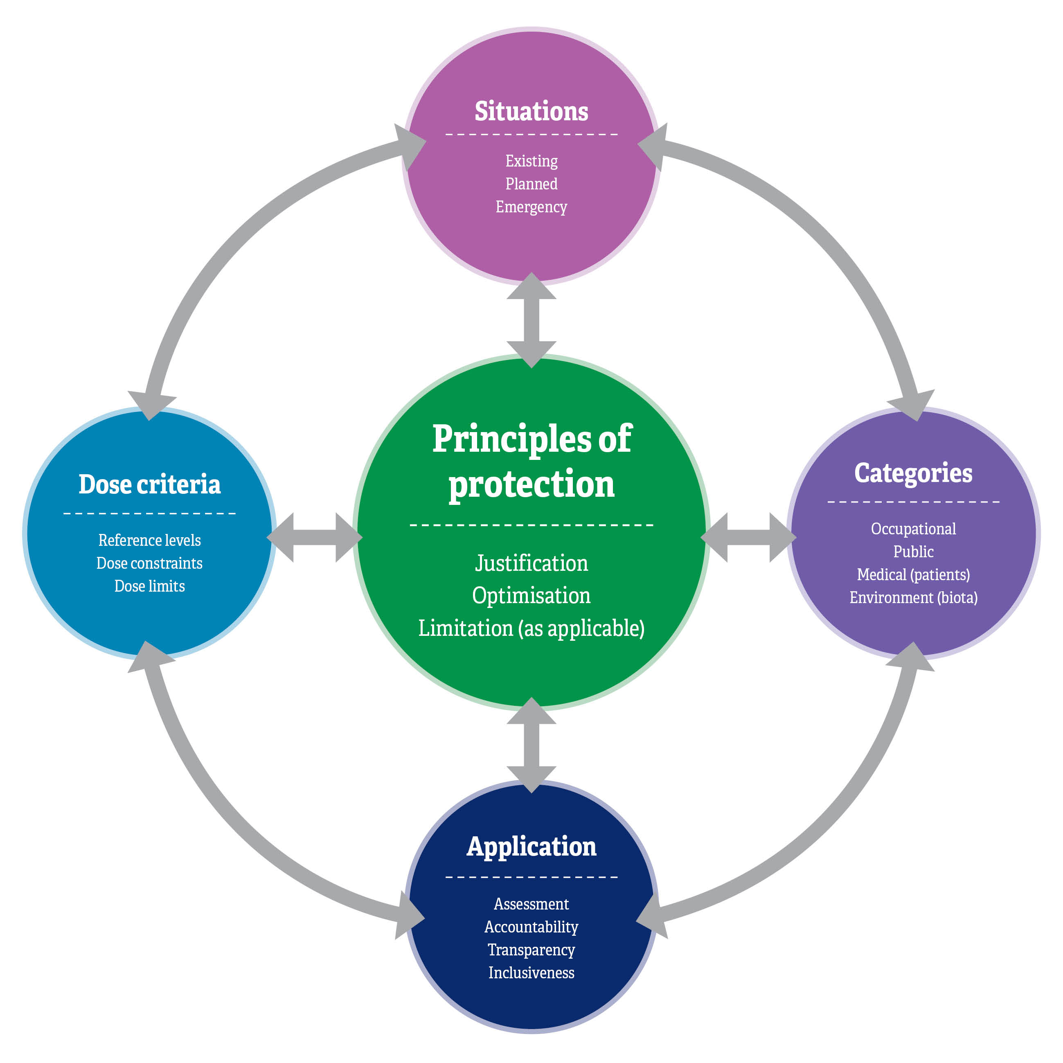

**Figure 2.1**: The system of radiological protection illustrating the interrelationships of the principles of protection, the exposure situations, the categories of exposure, the dose criteria, and the application for implementation of the system.The system of radiological protection illustrating the interrelationships of the principles of protection, the exposure situations, the categories of exposure, the dose criteria, and the application for implementation of the system.

The implementation of the system requires that the exposure situation is well understood through a rigorous assessment that considers all relevant aspects of the exposure. The information from the assessment will form the basis for decisions on actions (if deemed necessary). Such decisions need to be taken in a transparent manner including, as relevant, taking the views and knowledge of stakeholders into consideration. Accountabilities need to be established and communicated, so that it becomes clear who the decision maker is and on what grounds decisions are taken.

## Identification of Existing Exposure Situations

Existing exposure situations are exposures from sources that already exist when decisions to control them are made. The corresponding source is generally natural, such as cosmic radiation in aviation and space flights, NORM, or radon. The source can also be artificial, such as contaminated sites from past activities and contaminated areas after an **accident** (ICRP 2007).

Existing exposure situations have a number of common features. Exposures often affect places of living and day-to-day activities. They need to be measured in order to characterise the exposure situation and are generally characterised by a wide distribution of individual doses. They do not present a potential for accident. In many cases, the exposure can be at least partially controlled by exposed individuals themselves (self-help protection).

One of the crucial points with existing exposure situations is to determine when workers can be considered as occupationally exposed. In existing exposure situations, many workers are exposed adventitiously at work, which can be managed using reference levels. In other cases, the nature of the work activity may warrant treatment as planned exposure situations and be subject to dose limits and constraints (one such example in Australia is uranium mining). The employer in all circumstances has primary responsibility for the protection of workers (see ICRP 2007) and the management of exposures. Once an exposure has been identified, careful management is needed.

While protective actions can be implemented at any time and are effective immediately in planned exposure situations, they must be implemented urgently and in a timely manner in emergency exposure situations in order to be efficient. In existing exposure situations, protective measures can only be implemented *after* characterisation of the exposure situation, and it generally takes time to progressively reduce or maintain exposures through optimisation. However, regardless of the type of exposure situation, protective actions can be envisaged and prepared (i.e. planned) in advance. Protection of the environment should be considered in many existing exposure situations (guidance is provided in RPS G-1 2015).

The first step in the characterisation of any exposure situation is to characterise the exposure in terms of the nature of the exposure, the benefits from the exposure situation to individuals and society, and the practicability of reducing or preventing exposures (ICRP 2007).

The characterisation of the exposure situation should include the assessment of the exposures prospectively (if possible) and retrospectively, provision of information in a clear and transparent manner, accountability for safety and the involvement of relevant stakeholders. Figure 2.2 shows a systematic way for identifying an existing exposure situation.

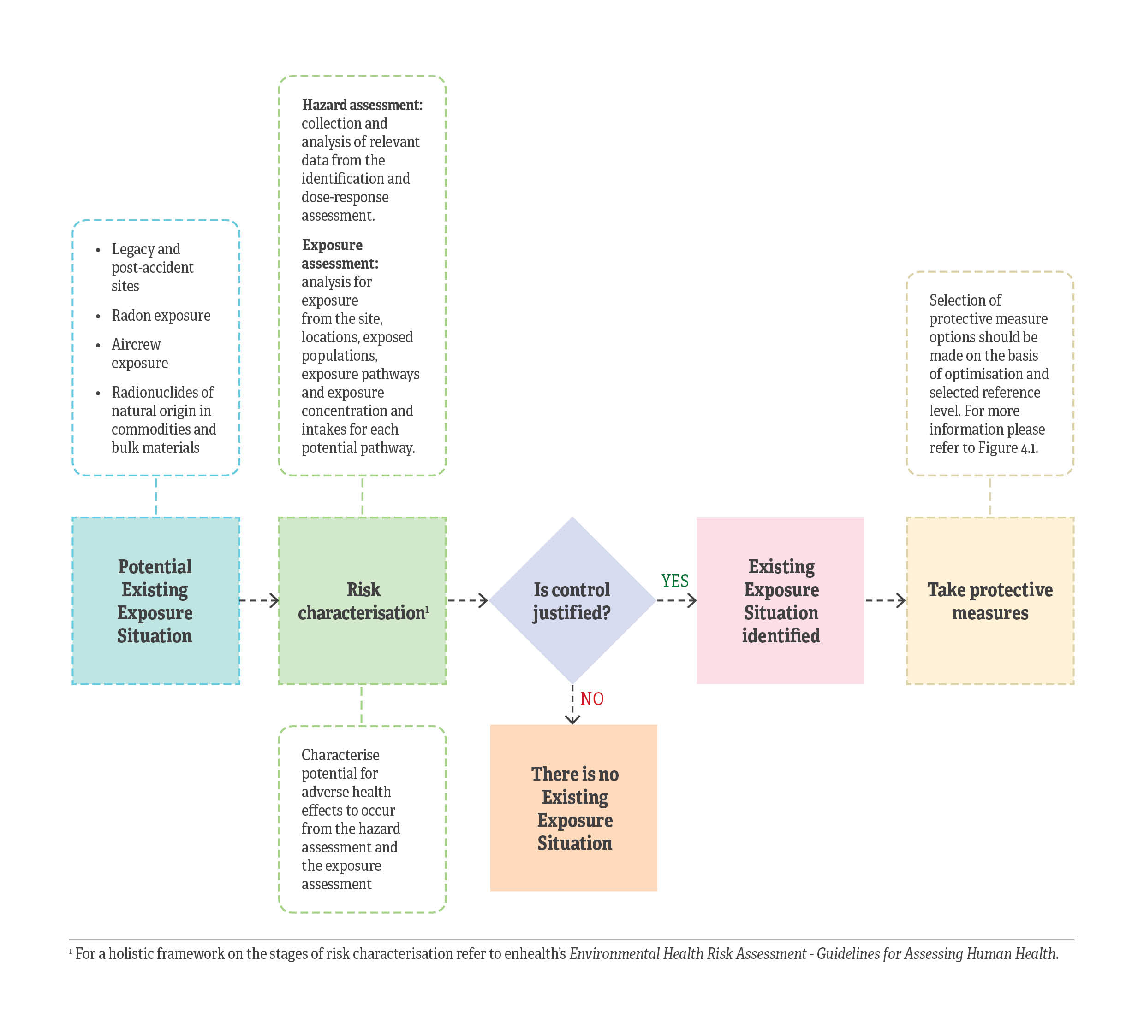

**Figure 2.2**: A systematic way for identifying an existing exposure situation. Risk characterisations refer to the [enHealth Environmental Health Risk Assessment – Guidelines for assessing human health risks from environmental hazards](http://www.eh.org.au/resources/knowledge-centre/enhealth-national-documents).

# 

# Framework for Existing Exposure Situations

The framework for existing exposure situations is derived from the requirements of GSR Part 3 and is presented in this Guide for consistency with relevant international best practice for existing exposure situations.

## General Guidance

|  |
| --- |
| Responsibilities specific to existing exposure situations |

* + - 1. When an existing exposure situation is identified, responsibilities for protection and safety should be assigned and appropriate reference levels established (see Annex A).
      2. The legal and regulatory framework for protection and safety should include provision for the management of existing exposure situations. The legal and regulatory framework, as appropriate should:
         1. specify the exposure situations that are included in the scope of existing exposure situations[1]
         2. specify the general principles underlying the protection strategies developed to reduce exposure when remedial actions and protective actions have been determined to be **justified**[2]
         3. assign responsibilities for the establishment and implementation of protection strategies to the relevant authorities and, as appropriate, to registrants, licensees and other parties involved in the implementation of **remedial actions** and protective actions
         4. provide for the involvement of interested parties in decisions regarding the development and implementation of protection strategies.
      3. An established protection strategy for an existing exposure situation should ensure that it specifies:
         1. the objectives to be achieved by means of the protection strategy
         2. appropriate reference levels (see Annex A)
      4. The implementation of the protection strategy should include:
         1. arrangements for evaluation of the available remedial actions and protective actions for achieving the objectives, and for evaluation of the efficiency of the actions planned and implemented
         2. ensuring that information is available to individuals subject to exposure on potential health risks and on the means available for reducing their exposures and the associated risks.

## Guidance for Public Exposure

The requirements in respect of public exposure in existing exposure situations (clauses 3.2.1–3.2.17) apply to any public exposure arising from the situations specified in Section 1.4.

|  |
| --- |
| Justification for protective actions and optimisation of protection and safety |

* + - 1. A protection strategy for the management of existing exposure situations should be established in accordance with clauses 3.1.1 and 3.1.3, commensurate with the radiation risks associated with the existing exposure situation, and that remedial actions or protective actions are expected to yield sufficient benefits to outweigh the detriments associated with taking them, including detriments in the form of radiation risks.[3]
      2. Remedial actions or protective actions should ensure that the form, scale and duration of such actions are optimised. While this optimisation process is intended to provide optimised protection for all individuals subject to exposure, priority must be given to those groups for whom the dose exceeds the reference level. All reasonable steps should be taken to prevent doses from remaining above the reference levels. Reference levels should typically be expressed as an annual **effective dose** to the representative person in the range of 1–20 mSv or other corresponding quantity, the actual value depending on the feasibility of controlling the situation and on experience in managing similar situations in the past.
      3. There should be a periodic review of reference levels to ensure that they remain appropriate in the light of the prevailing circumstances.

|  |
| --- |
| Responsibilities for remediation of areas with residual radioactive material |

* + - 1. For the remediation of areas with residual radioactive material deriving from past activities or from a nuclear or radiological emergency (Section 1.4(a)), provisions should be made in the framework for protection and safety for:
         1. the identification of those persons or organisations responsible for the contamination of areas and those responsible for financing the remediation program, and the determination of appropriate arrangements for alternative sources of funding if such persons or organisations are no longer present or are unable to meet their liabilities
         2. the designation of persons or organisations responsible for planning, implementing and verifying the results of remedial actions
         3. the establishment of any restrictions on the use of or access to the areas concerned before, during and, if necessary, after remediation
         4. an appropriate system for maintaining, retrieval and amendment of records that cover the nature and the extent of contamination, the decisions made before, during and after remediation, and information on verification of the results of remedial actions, including the results of all monitoring programs after completion of the remedial actions.
      2. A strategy for radioactive waste management should be put in place to deal with any waste arising from the remedial actions ensuring that provision for such a strategy is made in the framework for protection and safety.
      3. The persons or organisations responsible for the planning, implementation and verification of remedial actions should, as appropriate, ensure that:
         1. a remedial action plan, supported by a safety assessment, is prepared and is submitted to the relevant authority for approval
         2. the remedial action plan is aimed at the timely and progressive reduction of the radiation risks and eventually, if possible, at the removal of restrictions on the use of or access to the area
         3. any additional doses received by members of the public as a result of the remedial actions are justified on the basis of the resulting net benefit, including consideration of the consequent reduction of the annual dose
         4. in the choice of the optimised remediation option:
  1. radiological impacts on people and the environment are considered together with non-radiological impacts on people and the environment, including technical, societal and economic factors
  2. the costs of the transport and management of **radioactive waste**, the radiation exposure of and health risks to the workers managing the radioactive waste, and any subsequent public exposure associated with its disposal are all taken into account.
     + - 1. a mechanism for public information is in place and interested parties are involved in the planning, implementation and verification of the remedial actions, including any monitoring following remediation
         2. a monitoring program is established and implemented
         3. a system for maintaining adequate records relating to the existing exposure situation and for actions taken for protection and safety is in place
         4. procedures are in place for reporting to the relevant authority on any abnormal conditions relevant to protection and safety.
       1. In accordance with clauses 3.1.9-3.1.11 (Management for protection and safety) in the Planned Exposure Code, RPS C-1, the relevant authority should take responsibility for:
          1. review of the **safety assessment** submitted by the responsible person or organisation, approval of the remedial action plan and of any subsequent changes to the remedial action plan, and granting of any necessary **authorisation**
          2. establishment of criteria and methods for assessing safety
          3. review of work procedures, monitoring programs and records
          4. review and approval of significant changes to procedures or equipment that may have radiological **environmental** impacts or that may alter the exposure conditions for workers taking remedial actions or for members of the public
          5. where necessary, establishment of regulatory requirements for control measures following remediation.
       2. The person or organisation responsible for carrying out the remedial actions should:
          1. ensure that the work, including management of the radioactive waste arising from that work, is conducted in accordance with the remedial action plan
          2. take responsibility for all aspects of protection and safety, including undertaking a safety assessment
          3. monitor the area regularly during remediation so as to verify levels of contamination, to verify compliance with the requirements for radioactive waste management, and to enable any unexpected levels of radiation to be detected and the remedial action plan to be modified accordingly, subject to approval of the relevant authority
          4. perform a radiological survey after completion of remedial actions to demonstrate that the end point conditions, as established in the remedial action plan, have been met
          5. prepare and retain a final remediation report and should submit a copy to the relevant authority.
       3. After the remedial actions have been completed, the relevant authority should:
          1. review, amend as necessary and formalise the type, extent and duration of any post-remediation control measures already identified in the remedial action plan, with due consideration of the residual radiation risks
          2. identify the person or organisation responsible for any post-remediation control measures
          3. where necessary, impose specific restrictions for the remediated area to control:
  3. access by unauthorised persons
  4. removal of radioactive material or use of such material, including its use in commodities
  5. future use of the area, including the use of water resources and its use for the production of food or feed, and the consumption of food from the area
     + - 1. Should periodically review conditions in the remediated area and, if appropriate, should amend or remove any restrictions.
       1. The person or organisation responsible for post-remediation control measures should establish and maintain, for as long as required by the relevant authority, an appropriate program, including any necessary provision for monitoring, to verify the long term effectiveness of the completed remedial actions for areas in which controls are required after remediation.
       2. For those areas with long lasting residual radioactive material, in which a decision has been made to allow habitation and the resumption of social and economic activities, in consultation with interested parties, should ensure that arrangements are in place, as necessary, for the continuing control of exposure with the aim of establishing conditions for sustainable living, including:
          1. establishment of reference levels for protection and safety that are consistent with day to day life
          2. establishment of an infrastructure to support continuing ‘self-help protective actions’ in the affected areas, such as by the provision of information and advice, and by monitoring.
       3. The conditions prevailing after the completion of remedial actions, if no restriction or controls have been imposed, should be considered to constitute the background radiation conditions for any new facilities and activities or for habitation on the land.

|  |
| --- |
| Public exposure due to radon indoors |

* + - 1. As stated in clause 3.1.2, there should be assurance that:
         1. information is gathered on activity concentrations of radon in dwellings and other buildings with high occupancy factors for members of the public[4] through appropriate means, such as representative radon surveys (see Section 2.2.2)
         2. relevant information on exposure due to radon and the associated health risks, including the increased risks related to smoking, is provided to the public and other interested parties.
      2. Where activity concentrations of radon that are of concern for public health are identified on the basis of the information gathered as required in clause 3.2.13 (a), an action plan should be established comprising coordinated actions to reduce activity concentrations of radon in existing buildings and in future buildings, which includes[5]:
         1. establishing an appropriate reference level for 222Rn for dwellings and other buildings with high occupancy factors for members of the public, with account taken of the prevailing social and economic circumstances that in general will not exceed an annual average activity concentration due to 222Rn of 300 Bq/m3 [6] (see Annex A).
         2. reducing activity concentrations of 222Rn and consequent exposures to levels at which protection is optimised
         3. giving priority to actions to reduce activity concentrations of 222Rn in those situations for which such action is likely to be most effective[7]
         4. including in building codes appropriate preventive measures and corrective actions to prevent the ingress of 222Rn and to facilitate further actions wherever necessary.
      3. Responsibility should be assigned for:
         1. establishing and implementing the action plan for controlling public exposure due to 222Rn indoors
         2. determining the circumstances under which actions are to be mandatory or are to be voluntary, with account taken of legal requirements and of the prevailing social and economic circumstances.

|  |
| --- |
| Exposure due to radionuclides in commodities |

* + - 1. There should be established specific reference levels for exposure due to radionuclides in commodities such as construction materials, food, feed and drinking water, each of which must typically be expressed as, or be based on, an annual effective dose to the representative person that generally does not exceed a value of about 1 mSv (see Annex A).
      2. Consideration should be given to the guideline levels for radionuclides in food traded internationally that could contain radioactive substances as a result of a nuclear or radiological emergency, which have been published by the Joint Food and Agriculture Organization of the United Nations, and the World Health Organization Codex Alimentarius Commission (FAO/WHO 2006). Consideration should be given to the guideline levels for radionuclides contained in drinking water that have been published by the World Health Organization (WHO 2011) (see Annex A).

## Requirements for Occupational Exposure

The requirements in respect of occupational exposure in existing exposure situations (clauses 3.1.1–3.1.4) apply to any occupational exposure arising from the situations specified in Section 1.4.

|  |
| --- |
| Exposure in workplaces |

* + - 1. The requirements in respect of public exposure stated in clauses 3.2.1–3.2.3 should be applied to protection and safety for workers in existing exposure situations, other than in those specific situations identified in clauses 3.3.2–3.3.9.

#### Remediation of areas with residual radioactive material

* + - 1. Employers should ensure that the exposure of workers undertaking remedial actions is controlled in accordance with the relevant requirements on occupational exposure in planned exposure situations as established in Section 3 of the Planned Exposure Code, ARPANSA C-1[8].

#### Exposure due to radon in workplaces

* + - 1. A strategy for protection against exposure due to 222Rn in workplaces should be established, including the establishment of an appropriate reference level for 222Rn. The reference level for 222Rn should be set at a value that does not exceed an annual average activity concentration of 222Rn of 1000 Bq/m3, with account taken of the prevailing social and economic circumstances[9] (see Annex A).
      2. Employers should ensure that activity concentrations of 222Rn in workplaces are as low as reasonably achievable below the reference level established in accordance with clause 3.3.3, and should ensure that protection is optimised.
      3. If, despite all reasonable efforts by the employer to reduce activity concentrations of radon, the activity concentration of 222Rn in workplaces remains above the reference level established in accordance with clause 3.3.3, the relevant requirements for occupational exposure in planned exposure situations as stated in Section 3 of the Planned Exposure Code, ARPANSA C-1 must apply.

#### Exposure of aircrew and space crew due to cosmic radiation

* + - 1. The determination of whether an assessment of the exposure to aircrew due to cosmic radiation is warranted (see Section 2.2.3).
      2. Where such assessment is deemed to be warranted, there should be an established framework which should include a reference level of dose and a methodology for the assessment and recording of doses received by aircrew from occupational exposure to cosmic radiation (see Annex A).
      3. In accordance with clause 3.3.7:
         1. where the doses of aircrew are likely to exceed the reference level, employers of aircrew should:

1. assess and keep records of doses
2. make records of doses available to aircrew
   * + - 1. employers should:
3. inform female aircrew of the risk to the embryo or foetus due to exposure to cosmic radiation and of the need for early notification of pregnancy
4. apply the requirements of clause 3.2.14 in the Planned Exposure Code, ARPANSA C-1 in respect of notification of pregnancy.

# The Australian Context: Guidance On Implementation of Radiation Protection in Existing Exposure Situations in Australia

The GSR Part 3 requires when an existing exposure situation is identified, responsibilities for protection and safety are assigned and appropriate reference levels established. Reference levels are used for optimisation of protection in existing exposure situations. For occupational exposure and public exposure in existing exposure situations, a reference level serves as a boundary condition in identifying the range of options for the purpose of optimisation in implementing protective actions. The reference level represents the level of dose or the level of risk above which it is judged to be inappropriate to plan to allow exposures to occur, and below which the optimisation ofprotection and safety is implemented.

The GSR Part 3 requires that the reference level is set in the range of 1 – 20 mSv effective dose per year. The actual value chosen for the reference level will depend on the prevailing circumstances for the exposures under consideration. The optimised protection strategies are intended to keep doses below the reference level. When an existing exposure situation has been identified, actual exposures could be above or below the reference level. The reference level is used as a benchmark for judging whether further protective actions are necessary and, if so, in prioritising their application.

The main factors to be considered for setting reference levels for existing exposure situations are the feasibility of controlling the situation and the past experience with the management of similar situations. In most existing exposure situations, there is a desire from the exposed individual, as well as from the authorities, to reduce exposures to levels that are close to or similar to situations considered as ‘normal’. This applies particularly in situations of exposures from material resulting from human actions, such as NORM residues and contamination from accidents (ICRP 2007). While an endpoint for the optimisation process should not be fixed, the optimised level of protection will depend on the situation. It is possible to establish intermediate reference levels that provide a starting point for the optimisation process.

For existing exposure situations involving environmental contamination, an initial assessment should be conducted to characterise the existing radiological conditions for the contaminated area, including baseline background data. This should include identifying the sources and pathways of exposure for key receptor organisms, estimating the dose rates to those organisms and comparing with relevant environmental reference values (ARPANSA 2015). A decision should then be made as to what management or intervening action may be required, taking full account of the costs and benefits of the action. The outcome of the initial assessment should help guide the decision-making process.

National authorities, taking into account the prevailing circumstances, may take advantage of the timing of the overall remediation program to adopt intermediate reference levels to improve the situation progressively (ICRP 2009). In cases of severe contamination, or lack of resources to comply with a full remediation program, it may be considered advantageous to select an intermediate reference level and then, in light of experience and resource availability, and revise the reference level downwards. Intermediate reference levels can facilitate timely decision-making on remediation strategies and the effective deployment of resources; however, when establishing intermediate reference levels, consideration should again be given to the principles of justification and optimisation.

Selection of protective measure options should be made on the basis of projected doses. These doses can inform the decision regarding appropriate reference levels:

* If projected doses are above 20 mSv y-1, protective actions are almost always justified.
* If such doses are below 1 mSv y-1, protective actions are unlikely to be justified.
* If the dose is between those two values, several factors could be considered, as illustrated in Figure 4.1.

## Remediation of Legacy and Post-Accident Sites

**Remediation** of contamination from past activities or accidents requires the establishment of a reference level in the range 1 to 20 mSv y-1 to guide optimisation of radiation protection. The overall remediation process involves four main activities: (1) initial site characterisation and selection of remediation criteria; (2) identification of remediation options and their optimisation, followed by subsequent development and approval of the remediation plan; (3) implementation of the remediation plan; and (4) post-remediation management (IAEA 2007).

In the Australian context, a *generic* intermediate reference level for remediation of 10 mSv y-1 is appropriate as a starting point. The intermediate reference level should be revised, generally downwards, progressively as practicable in improving the situation. In Australia, reasonably foreseeable exposure scenarios are such that it can be considered appropriate to set a *site-specific* reference level for remediation of contamination from past activities or accidents at between 1 and 20 mSv effective dose per year. The actual value will depend on prevailing circumstances and will guide the optimisation of radiation protection. The reference level for remediation applies to additional exposure (i.e. exposure above natural background levels). The remediation process should take the relevant aspects of planned exposure situations from the Planned Exposure Code, RPS C-1.

## Radon Exposure in Homes and Workplaces

Within the system of radiological protection, radon exposure has the characteristics of an existing exposure situation as the source is unmodified concentrations of ubiquitous primordial natural activity in the earth’s crust (ICRP 2007). Human activities such as construction of buildings or operation of mines may create or modify pathways that increase exposure to radon and its progeny. These pathways can be controlled by preventive and mitigating actions. The ICRP publication 126 (ICRP 2015) considers that, in most situations, a national radon protection strategy would be justified as radon is ubiquitous; it represents a significant source of radiation exposure in certain locations and, in many circumstances, it can be controlled.

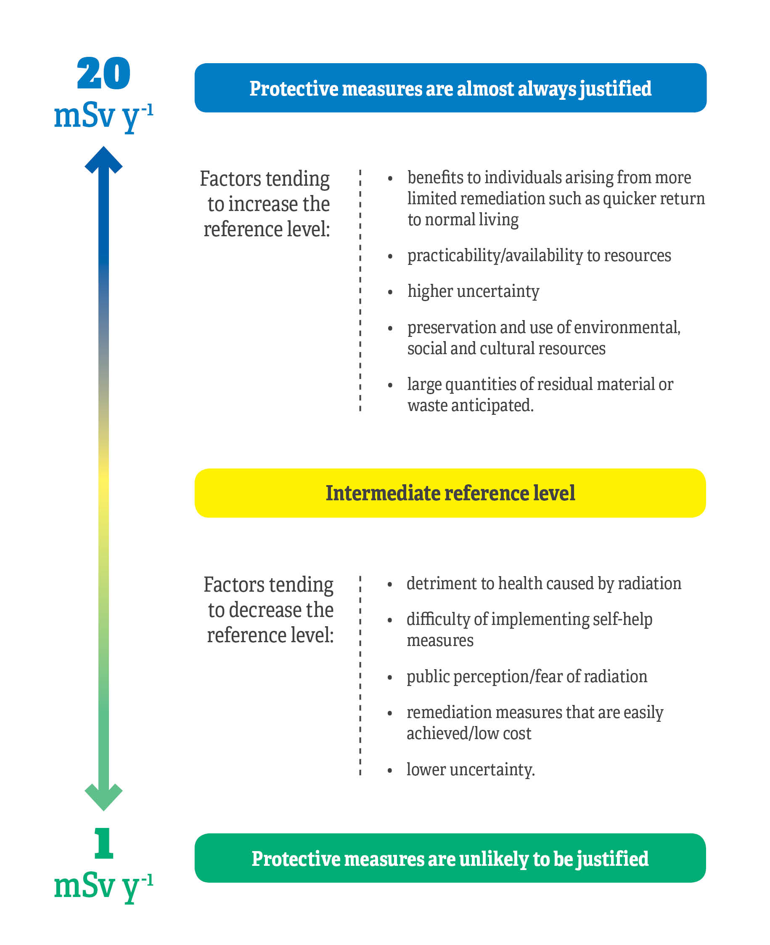

**Figure 4.1**: Key factors informing the selection of the reference level.

For implementing protective measures to control radon in homes and workplaces, Australian guidance (ARL 1990) has been based on an action level of 200 Bq m-3 averaged over a year for radon in homes and 1000 Bq m-3 averaged over a year in workplaces. Based on the updated ICRP dose conversion factors for inhalation (ICRP 2015) these values correspond to about 10 mSv y-1. Radon reference levels based on these action level values would continue to provide an appropriate level of protection for the public and workers for exposure to radon in homes and workplaces in Australia. These reference levels are listed in Annex A of this Guide.

## Aircrew Exposure to Cosmic Rays

Aircrew are exposed to elevated levels of cosmic radiation while flying at high altitude. This is considered to be occupational exposure in an existing exposure situation. The ICRP, in publication 132 (ICRP 2016), recommends that a reference level in the 5 to 10 mSv y-1 range is selected by operating managers. The selected reference value is not a dose limit, but represents the level of dose below which exposure should be maintained and reduced as low as reasonably achievable, taking into account economic and societal factors. For Australia, a reference level of 10 mSv y-1 (see Annex A), is considered appropriate. For pregnant aircrew, additional protection of the embryo/foetus must be considered. The working conditions of a pregnant worker, after declaration of pregnancy, must ensure that the additional dose to the embryo/foetus would not exceed about 1 mSv y-1 during the remainder of the pregnancy.

## Radionuclides of Natural Origin in Commodities and Bulk Materials

Radionuclides of natural origin occur in commodities including food, feed, drinking water, agricultural fertiliser and soil amendments, construction materials, and residual radioactive material in the environment. The requirements for existing exposure situations apply, irrespective of the activity concentrations.

The requirements for existing exposure situations in this Guide apply to material containing radionuclides of natural origin at an activity concentration of less than 1 Bq g-1 for any radionuclide in the 238U and 232Th decay series and of less than 10 Bq g-1 for 40K.

In the context of public exposure in existing exposure situations, all exposure pathways from a given source of exposure need to be considered, including the contributions from external exposure, inhalation and ingestion. A representative person can be exposed to multiple pathways from radionuclides of natural origin in commodities. Therefore, a reference level of about 1 mSv y-1 for exposure to radionuclides in each of the commodities (see clauses 3.2.16 - 3.2.17 and Annex A of this Guide) is considered appropriate for Australia. For existing exposure situations with dose implications exceeding 1 mSv y-1, a protection strategy should be developed and implemented to ensure that any remedial action is justified, and to optimise protection and safety, as described in Section 3 of this Guide.

The concept of **exemption** from the requirements of this Guide does not apply for such material. For radionuclides of natural origin, bulk amounts of material should be considered on a case-by-case basis by using a dose criterion of the order of 1 mSv y-1, commensurate with typical doses due to natural background levels of radiation.

When radionuclides occur in fertilisers, soil amendments and construction materials (or components of such), the requirements for existing exposure situations apply, irrespective of the activity concentrations.

The clauses from the Planned Exposure Code, RPS C-1 apply to material containing radionuclides of natural origin where the activity concentration of any radionuclide in the 238U or 232Th decay series exceeds 1 Bq g-1, or if the activity concentration of 40K exceeds 10 Bq g-1.

## Transition from an Emergency Exposure Situation to an Existing Exposure Situation

The termination of a nuclear or radiological emergency marks the end of the transition phase in a particular area or site and the beginning of either an existing exposure situation or a planned exposure situation, as illustrated in Figure 4.2.

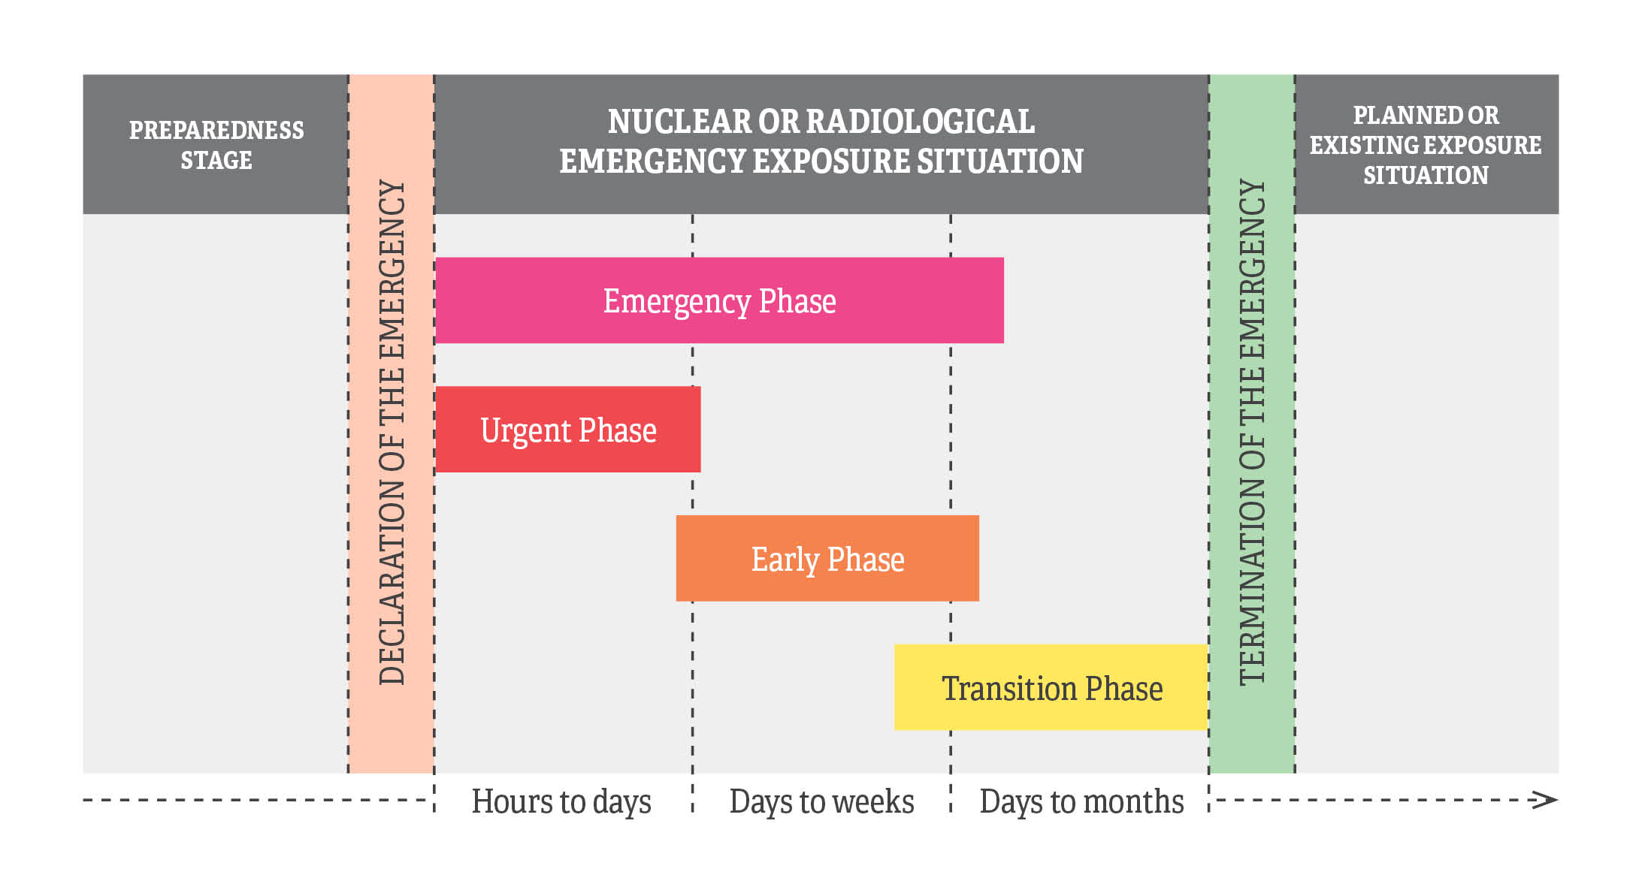

**Figure 4.2**: Temporal sequence of the different phases and exposure situations of a nuclear or radiological emergency within one geographical area/site.

Depending on the nature of the nuclear or radiological emergency, these processes may continue in the longer term after the emergency has been declared terminated. During this period, the implementation of remedial actions might be more efficient than carrying out further disruptive public protective actions.

**Transition Phase**

In addition to the general prerequisites, which can be found in the Emergency Exposure Guide G-3 (draft), the following prerequisites should be met in order to be able to declare the end of an emergency exposure situation and to move to an existing exposure situation:

* Justified and optimised actions have been taken to reach the national generic criteria established to enable transitioning to an existing exposure situation, taking into account the criteria given in Annex B of RPS G-3 (draft).
* Areas have been delineated which may not be inhabited and where it is not feasible to carry out social or economic activity. For these delineated areas, administrative and other provisions have been established to monitor compliance with the restrictions imposed.
* A strategy is implemented for the restoration of infrastructure, workplaces and public services necessary to support normal living conditions in the affected areas.
* Any change or transfer of authority and responsibilities from the emergency response organisation to organisations responsible for the long-term recovery operations have been completed.
* Communication and consultation is continuous with all interested stakeholders, including local communities.
* A long-term monitoring program (e.g. residual contamination) is implemented.
* A long-term medical follow-up program for registered individuals, including mental health and psychosocial support for the affected population in relation to psychosocial health consequences is implemented.
* Administrative arrangements, legislative provisions and regulatory provisions are in place and/or underway for the management of the existing exposure situation.

**Termination of an Emergency**

After terminating the emergency and entering into the existing exposure situation, the reference level for the residual dose in an existing exposure situation should be applied in the band of 1-20 mSv y-1 as stated in Section 3.2 and Annex A. This Guide recommends that the reference level for the optimisation of the protection strategy is selected from the lower part of the reference band of 1-20 mSv y-1 as a long-term objective for existing exposure situations (ICRP 2007 and ICRP 2009). Further guidance on selecting reference levels can be found in Figure 4.1.

Annex A: Reference Levels for Existing Exposure Situations in Australia

The reference levels for Existing Exposure Situations in Australia are:

|  |  |
| --- | --- |
| **Application** | **Reference Level** |
| Radon-222 concentration (in air) in dwellings1 | 200 Bq m-3 |
| Radon-222 concentration (in air) in workplaces2 | 1000 Bq m-3 |
| Transition from an emergency exposure situation to an existing exposure situation | 20 mSv y-1 |
| Remediation of legacy and post-accident sites3 | 10 mSv y-1 |
| Aircrew exposure to cosmic rays4 | 10 mSv y-1 |
| Radionuclides of natural origin in commodities5 | 1 mSv y-1 |
| Radionuclides of commodities in bulk material6 | 1 mSv y-1 |

1 If measured values are found to consistently exceed this level, consideration should be given to possible remedial action within the context of optimisation.

2 Employers must ensure that the activity concentration of 222Rn in the workplace is as low as reasonably achievable below this reference level and must ensure that protection is optimised. If, despite all reasonable efforts by the employer to reduce the activity concentration of radon, the activity concentration of 222Rn in the workplace remains above the reference level, the relevant requirements for occupational exposure in planned exposure situations as stated in the Planned Exposure Code, RPS C-1, must apply (clauses 3.1.12, 3.1.20-3.21 and 3.2.10, RPS C-1).

3 In Australia, a generic intermediate reference level of 10 mSv y-1 applies and revision of the intermediate reference level to improve the situation progressively is required. The remediation of contamination from past activities or accidents requires a site-specific reference level in the range of 1 to 20 mSv y-1, based on prevailing circumstances to guide the optimisation of radiation protection after an assessment of the site. The reference level for remediation applies to additional exposure (i.e. above natural background levels).

4 A reference level of 10 mSv y-1 to be selected by operating managers is considered appropriate for use in Australia.

5 Exposure to radionuclides in each of the commodities.

6 The requirements for existing exposure situations apply to material containing radionuclides of natural origin at an activity concentration of less than 1 Bq g-1 for any radionuclide in the uranium decay chain or the thorium decay chain and of less than 10 Bq g-1 for 40K. For radionuclides of natural origin, bulk amounts of material are to be considered on a case-by-case basis by using a dose criterion of 1 mSv y-1.

Annex B: Case Studies for Existing Exposure Situations

Case studies on Existing Exposure Situations can be found at the website below.

*To be developed.*

Appendix 1: Derivation of Existing Exposure Guide Clauses from GSR Part 3 Requirements

The following table cross-references each clause in Section 3 of this Guide to the relevant requirement in the Trusted International Standard, Radiation Protection and Safety of Radiation Sources: International Basic Safety Standards – General Safety Requirements, IAEA Safety Standards Series GSR Part 3 (IAEA 2014). GSR Part 3 is published on the [IAEA website](http://www-pub.iaea.org/books/IAEABooks/8930/Radiation-Protection-and-Safety-of-Radiation-Sources-International-Basic-Safety-Standards).

|  |  |  |
| --- | --- | --- |
| RPS G-2 | | IAEA GSR Part 3 |
| **Guidance** | **Clause(s)** | **Requirement** |
| Responsibilities specific to existing exposure situations | 3.1.1-3.1.4 | Requirement 47 |
| Justification for protective actions and optimisation of protection and safety | 3.2.1-3.2.3 | Requirement 48 |
| Responsibilities for remediation of areas with residual radioactive material | 3.2.4-3.2.12 | Requirement 49 |
| Public exposure due to radon indoors | 3.2.13-3.2.15 | Requirement 50 |
| Exposure due to radionuclides in commodities | 3.2.16-3.2.17 | Requirement 51 |
| Exposure in workplaces | 3.3.1-3.3.9 | Requirement 52 |

Requirements 1-33 in GSR Part 3 apply to planned exposure situations, Requirements 34-42 in GSR Part 3 apply to medical exposure situations and Requirements 43-46 in GSR Part 3 apply to emergency exposure situations. The provisions in those Requirements will be incorporated into separate Codes or Guides in the Radiation Protection Series.

Appendix 2: The Ten Principles of Radiation Risk Management from the *Fundamentals* *for Protection Against Ionising Radiation* (2014)

The following ten principles of radiation risk management are explained in detail in Section 4 of the Fundamentals for Protection Against Ionising Radiation (2014) (RPS F-1):

1. Clear division of responsibilities
   1. *The prime responsibility for management of radiation risks must rest with the person or organisation responsible for facilities and activities that give rise to radiation risks.*
2. Legislative and regulatory framework

*(ii) An effective framework including legislation, regulation and guidance to promote management of radiation risks, including an independent regulatory body, must be established and sustained.*

1. Leadership and management for safety

*(iii) Effective leadership and management of radiation risks must be established and sustained in organisations concerned with, and facilities and activities that give rise to, radiation risks.*

1. Justification

*(iv) Facilities and activities that give rise to radiation risks must yield an overall benefit.*

1. Optimisation of protection

*(v) Protection must be optimised so that radiation risks are as low as reasonably achievable.*

1. Limitation of risks

*(vi) Measures for controlling radiation risks must ensure that no individual bears an unacceptable risk of harm, and that the environment is protected.*

1. Protection of present and future generations

*(vii) People and the environment, present and future, must be protected against radiation risks.*

1. Prevention of accidents and malicious acts

*(viii) All practical efforts must be made to prevent and mitigate accidents, and acts with malicious intent, that may give rise to radiation risks.*

1. Emergency preparedness and response

*(ix) Arrangements must be made for emergency preparedness and response for incidents, accidents and malicious acts that may give rise to radiation risks.*

1. Protective actions to reduce existing or unregulated radiation risks

*(x) Protective actions to reduce existing or unregulated radiation risks must be justified and optimised.*

Appendix 3: International Guidance on Existing Exposure Situations

The following is a list of guidance documents for case-specific Existing Exposure Situations that will be placed on the ARPANSA website.

WORLD HEALTH ORGANIZATION, WHO Handbook on Indoor Radon: A Public Health Perspective, WHO, Geneva (2009).   
[www.who.int/ionizing_radiation/env/radon/en/index1.html]

WORLD HEALTH ORGANIZATION, Guidelines for Drinking-water Quality — 4th edn, WHO, Geneva (2011).  
[www.who.int/water_sanitation_health/publications/2011/dwq_guidelines/en/]

International Commission on Radiological Protection (2016). Radiological Protection from Cosmic Radiation in Aviation. ICRP Publication 132.  
[www.icrp.org/publication.asp?id=ICRP Publication 132]

International Commission on Radiological Protection (2014). Radiological Protection against Radon Exposure. ICRP Publication 126.  
[www.icrp.org/publication.asp?id=ICRP Publication 126]

International Atomic Energy Agency (2015). Protection of the Public against Exposure Indoors due to Radon and Other Natural Sources of Radiation. SSG-32  
[[www-pub.iaea.org/MTCD/publications/PDF/Pub1651Web-62473672.pdf](http://www-pub.iaea.org/MTCD/publications/PDF/Pub1651Web-62473672.pdf)]

International Atomic Energy Agency (2007). Remediation Process for Areas Affected by Past Activities and Accidents. WS-G-3.1   
[www-pub.iaea.org/MTCD/publications/PDF/Pub1282_web.pdf]

Glossary of Terms

Accident

Any unintended event, including operating errors, equipment failures and other mishaps, the consequences or potential consequences of which are not negligible from the point of view of protection and safety.

Authorisation

The granting by a relevant regulatory body of written permission for a Responsible Person to conduct specified activities.

Contamination

Radioactive substances on surfaces or within solids, liquids or gases (including the human body), where their presence is unintended or undesirable, or the process giving rise to their presence in such places.

 Contamination does not include residual radioactive material remaining at a site after the completion of decommissioning.

 The term ‘contamination’ may have a connotation that is not intended. The term ‘contamination’ refers only to the presence of radioactivity, and gives no indication of the magnitude of the hazard involved.

Cosmic radiation

See ***source***.

Decontamination

The complete or partial removal of contamination by a deliberate physical, chemical or biological process.

 This definition is intended to include a wide range of processes for removing contamination from people, equipment and buildings, but to exclude the removal of radionuclides from within the human body or the removal of radionuclides by natural weathering or migration processes, which are not considered to be decontamination.

Dose

1. A measure of the energy deposited by radiation in a target.

2. Absorbed dose, committed dose (i.e. committed **equivalent dose** or committed effective dose), effective dose, equivalent dose or organ dose, as indicated by the context.

Dose limit

The value of a quantity used in certain specified activities or circumstances that must not be exceeded.

Effective dose, *E*

The quantity *E*, defined as a summation of the tissue or organ equivalent doses, each multiplied by the appropriate tissue weighting factor:

$$E= \sum_{T}{w_{T}}. H_{T}$$

where *H*T is the equivalent dose in tissue or organ T, and  
*w*T is the tissue weighting factor for a tissue or organ T.

From the definition of equivalent dose, it follows that:

$$E= \sum_{T}{w_{T}} . {\sum_{R}{w_{R}}.D}_{T,R}$$

where *w*R is the radiation weighting factor for radiation type R, and  
*D*T,R is the average absorbed dose in the tissue or organ T delivered by radiation type R.

The SI unit for effective dose is joule per kilogram (J/kg), termed the sievert (Sv). An explanation of the quantity is given in Annex B of the *International Commission on Radiological Protection Publication 103*.

Effective dose is a measure of dose designed to reflect the amount of radiation detriment likely to result from the dose.

Effective dose cannot be used to quantify higher doses or to make decisions on the need for any medical treatment relating to deterministic effects.

Values of effective dose from exposure for any type(s) of radiation and any mode(s) of exposure can be compared directly.

Emergency exposure situation

A situation of exposure that arises as a result of an accident, a malicious act, or any other unexpected event, and requires prompt action in order to avoid or reduce adverse consequences.

Emergency

A non-routine situation that necessitates prompt action, primarily to mitigate a hazard or adverse consequences for human health and safety, quality of life, property or the environment. This includes nuclear or radiological emergencies and conventional emergencies such as fires, release of hazardous chemicals, storms or earthquakes. It includes situations for which prompt action is warranted to mitigate the effects of a perceived hazard.

Nuclear or radiological emergency

An emergency in which there is, or is perceived to be, a hazard due to:

(a) the energy resulting from a nuclear chain reaction or from the decay of the products of a chain reaction, or

(b) radiation exposure.

Environment

The conditions under which people, animals and plants live or develop and which sustain all life and development, especially such conditions as affected by human activities. Protection of the environment includes the protection and conservation of:

* non-human species, both animal and plant, and their biodiversity
* environmental goods and services such as the production of food and feed
* resources used in agriculture, forestry, fisheries and tourism
* amenities used in spiritual, cultural and recreational activities
* media such as soil, water and air
* natural processes such as carbon, nitrogen and water cycles.

Environmental exposure

The exposure of wildlife. This includes exposure of animals, plants and other organisms in the natural environment.

Equivalent dose

The quantity *H*T,R, defined as:

*H*T,R = *w*R · *D*T,R

where *D*T,R is the absorbed dose delivered by radiation type R averaged over a tissue or organ T, and   
*w*R is the radiation weighting factor for radiation type R.

When the radiation field is composed of different radiation types with different values of *w*R, the equivalent dose is:

$$H_{T}={\sum_{R}{w_{R}}.D}_{T,R}$$

The SI unit for equivalent dose is joule per kilogram (J/kg), termed the sievert (Sv). An explanation of the quantity is given in Annex B of the *International Commission on Radiological Protection Publication 103*.

Equivalent dose is a measure of the dose to a tissue or organ designed to reflect the amount of harm caused.

Equivalent dose cannot be used to quantify higher doses or to make decisions on the need for any medical treatment relating to deterministic effects.

Values of equivalent dose to a specified tissue or organ from any type(s) of radiation can be compared directly.

Exemption

The determination by a regulatory body that a source or practice need not be subject to some or all aspects of regulatory control on the basis that the exposure or the potential exposure due to the source or practice are too small to warrant the application of those aspects or that this is the optimum option for protection irrespective of the actual level of the doses or risks.

Existing exposure situation

A situation of exposure that already exists when a decision on the need for control needs to be taken. Existing exposure situations include exposure to natural background radiation that is amenable to control, exposure due to residual radioactive material that derives from past practices that were never subject to regulatory control and exposure due to residual radioactive material deriving from a nuclear or radiological emergency after an emergency has been declared to be ended.

Exposure

The state or condition of being subjected to radiation. External exposure is exposure to radiation from a source outside the body. Internal exposure is exposure to radiation from a source within the body.

Graded approach

For a system of control, such as a regulatory system or a safety system, a process or method in which the stringency of the control measures and conditions to be applied is commensurate to the extent practicable, with the likelihood and possible consequences of, and the level of risk associated with, a loss of control.

Health authority

A governmental authority (at the national, regional or local level) that is responsible for policies and interventions, including the development of standards and the provision of guidance, for maintaining or improving human health, and that has the legal power of enforcing such policies and interventions.

Incident

Any unintended event, including operating errors, equipment failures, initiating events, accident precursors, near misses or other mishaps, or unauthorised act, malicious or non-malicious, the consequences or potential consequences of which are not negligible from the point of view of protection and safety.

Ionising radiation

For the purposes of radiation protection, radiation capable of producing ion pairs in biological material(s).

Justified

See ‘Justification’

Justification

For a planned exposure situation, the process of determining whether a practice is overall beneficial, i.e. whether the expected benefits to individuals and to society from introducing or continuing the practice outweigh the harm (including radiation detriment) resulting from the practice.

Medical exposure

Exposure incurred by patients as part of their own medical or dental diagnosis (diagnostic exposure) or treatment (therapeutic exposure) by persons, other than those occupationally exposed, knowingly, while voluntarily helping in the support and comfort of patients and by volunteers in a program of biomedical research involving their exposure.

Natural background

The doses, dose rates or activity concentrations associated with natural sources, or any other sources in the environment that are not amenable to control.

 This is normally considered to include doses, dose rates or activity concentrations associated with natural sources, global fallout (but not local fallout) from atmospheric nuclear weapons tests and the Chernobyl accident.

Nuclear or radiological emergency

See emergency.

Occupancy factor

A typical fraction of the time for which a location is occupied by an individual or group.

Occupational exposure

Exposure of workers incurred in the course of their work.

Occupationally exposed person

A worker who is exposed to ionising radiation in the course of their work.

Optimisation

For existing exposure situations, optimisation of protection and safety is the process of determining what level of protection and safety would result in the magnitude of individual doses, the number of individuals (workers and members of the public) subject to exposure and the likelihood of exposure being ‘as low as reasonably achievable, economic and social factors being taken into account’ (ALARA).

Optimised

See ‘Optimisation’.

Planned exposure situation

The situation of exposure that arises from the planned operation of a sourceor from a planned activity that results in an exposure due to a source.Since provision for protection and safety can be made before embarking on the activity concerned, associated exposures and their probabilities of occurrence can be restricted from the outset. The primary means of controlling exposure in planned exposure situations is by good design of installations, equipment and operating procedures. In planned exposure situations, a certain level of exposure is expected to occur.

Practice

Any human activity that introduces additional sources of radiation or additional exposure pathways, or that modifies the network of exposure pathways from existing sources, so as to increase the exposure or the likelihood of exposure of people or the number of people exposed.

Protection and safety

The protection of people against exposure to ionising radiation or exposure due to radioactive material and the safety of sources, including the means for achieving this, and the means for preventing accidents and for mitigating the consequences of accidents if they do occur. For the purposes of this Code, ‘protection and safety’ includes the protection of people against ionising radiation and safety. It does not include non-radiation-related aspects of safety. ‘Protection and safety’ is concerned with both radiation risks under normal circumstances and radiation risks as a consequence of **incidents**, as well as with other possible direct consequences of a loss of control over a nuclear reactor core, nuclear chain reaction, radioactive source or any other source of radiation. Safety measures include actions to prevent incidents and arrangements put in place to mitigate their consequences if they were to occur.

Public exposure

Exposure incurred by members of the public due to sources in planned exposure situations, emergency exposure situations and existing exposure situations, excluding any occupational exposure or medical exposure.

Radiation

In this Code, the term ‘radiation’ refers only to ionising radiation unless otherwise stated. For the purposes of radiation protection, ionising radiation is capable of producing ion pairs in biological material(s).

For most practical purposes, it may be assumed that weakly penetrating radiation includes photons of energy below about 12 keV, electrons of energy less than about 2 MeV, and massive charged particles such as protons and alpha particles.

Radiation protection

The protection of people from harmful effects of exposure to ionising radiation, and the means for achieving this.

Radiation risk

Detrimental health effects of exposure to ionising radiation including the likelihood of such effects occurring, and other risks including environmental risks, that might arise from exposure to ionising radiation; the presence of radioactive material (including radioactive waste) or its release to the environment; or a loss of control over a nuclear reactor core, nuclear chain reaction, radioactive source or any other source of radiation; alone or in combination.

Radioactive material

Scientific meaning: Material exhibiting radioactivity, emitting or relating to the emission of ionising radiation or particles.

Legal meaning: Material designated by the relevant regulatory body as being subject to regulatory control because of its radioactivity.

Radionuclides of natural origin

Radionuclides that occur naturally on Earth in significant quantities.

 The term is usually used to refer to the primordial radionuclides 40K, 235U, 238U, 232Th and their radioactive decay products.

 Contrasted with radionuclides of artificial origin; also artificial radionuclides, anthropogenic radionuclides and human-made radionuclides.

Radioactive waste

For legal and regulatory purposes, material for which no further use is foreseen that contains, or is contaminated with, radionuclides at activity concentrations greater than clearance levels (refer to RPS C-1 for more information on the clearance process) as established by the regulatory body.

Radon

Any combination of isotopes of the element radon.

 For the purposes of these Standards, radon refers to 220Rn and 222Rn.

Radon progeny

The short-lived radioactive decay products of 220Rn and of 222Rn.

 For 222Rn, this includes the decay chain up to but not including 210Pb, namely 218Po, 214Pb, 214Bi and 214Po, plus traces of 218At, 210Tl and 209Pb. 210Pb, which has a half-life of 22.3 y, and its radioactive progeny — 210Bi and 210Po, plus traces of 206Hg and 206Tl — are, strictly, progeny of 222Rn, but they are not included in this listing because they will not normally be present in significant amounts in airborne form. For 220Rn, this includes 216Po, 212Pb, 212Bi, 212Po and 208Tl.

Reference level

For an emergency exposure situation or an existing exposure situation, the level of dose, risk or activity concentration above which it is not appropriate to plan to allow exposures to occur and below which optimisation of protection and safety would continue to be implemented.

 The value chosen for a reference level will depend upon the prevailing circumstances for the exposure under consideration.

Regulatory body

An authority or a system of authorities designated by the government as having legal authority for conducting the regulatory process, including issuing authorisations, and thereby regulating nuclear, radiation, radioactive waste and transport safety. A list of relevant radiation regulatory authorities in Australia can be found on ARPANSA’s website at [www.arpansa.gov.au/Regulation/Regulators](http://www.arpansa.gov.au/Regulation/Regulators).

Relevant regulatory authority

The radiation protection authority or authorities designated, or otherwise recognised, for regulatory purposes in connection with protection and safety relating to applications of ionising radiation.

Remedial action

The removal of a source or the reduction of its magnitude (in terms of activity or amount) for the purposes of preventing or reducing exposures that might otherwise occur in an existing exposure situation.

 Remedial actions could also be termed longer term protective action, but longer term protective actions are not necessarily remedial actions.

Remediation

Any measures that may be carried out to reduce the radiation exposure due to existing contamination of land areas through actions applied to the contamination itself (the source) or to the exposure pathways to humans and the environment.

 Complete removal of the contamination is not implied.

See decontamination.

Safety

For the purposes of this Code, ‘safety’ means the protection of people and the environment against radiation risks, and the safety of facilities and activities that give rise to radiation risks. ‘Safety’ as used here includes the safety of nuclear installations, radiation safety, the safety of radioactive waste management and safety in the transport of radioactive material. It does not include non-radiation related aspects of safety.

Safety is concerned with both radiation risks under normal circumstances and radiation risks as a consequence of incidents, as well as with other possible direct consequences of a loss of control over a nuclear reactor core, nuclear chain reaction, radioactive source or any other source of radiation. Safety measures include actions to prevent incidents and arrangements put in place to mitigate their consequences if they were to occur.

Safety assessment

Assessment of all aspects of a practice that are relevant to protection and safety. For an authorised facility, this includes siting, design and operation of the facility.

Security

The prevention of, detection of, and response to, criminal or intentional unauthorised acts involving or directed at nuclear material, other radioactive material, associated facilities, or associated activities.

Source

1. Anything that may cause radiation exposure — such as by emitting ionising radiation or by releasing radioactive substances or radioactive material — and can be treated as a single entity for purposes of protection and safety.

 For example, materials emitting radon are sources in the environment; a sterilisation gamma irradiation unit is a source for the practice of irradiation preservation of food and sterilisation of other products; an X-ray unit may be a source for the practice of radiodiagnosis; a nuclear power plant is part of the practice of generating electricity by nuclear fission, and may be regarded as a source (e.g. with respect to discharges to the environment) or as a collection of sources (e.g. for occupational radiation protection purposes). A complex or multiple installations situated at one location or site may, as appropriate, be considered a single source for the purposes of application of the safety standards.

***Natural source.*** A naturally occurring source of radiation, such as the sun and stars (sources of cosmic radiation), rocks and soil (terrestrial sources of radiation), or any other material whose radioactivity is for all intents and purposes due only to radionuclides of natural origin, such as products or residues from the processing of minerals, but excluding radioactive material for use in a nuclear installation and radioactive waste generated in a nuclear installation.

2. Radioactive material used as a source of radiation.

 Such as those sources used for medical applications or in industrial instruments. These are, of course, sources as defined in (1), but this usage in (2) is less general.

References

Australian Radiation Laboratory (ARL) 1990. *A Nation-Wide Survey of Radon and Gamma Radiation Levels in Australian Homes.* MK Langroo, KN Wise, JC Duggleby and LH Kotler. Technical Report No 91.  
[[www.arpansa.gov.au/pubs/technicalreports/arl091.pdf](http://www.arpansa.gov.au/pubs/technicalreports/arl091.pdf)]

Australian Radiation Protection and Nuclear Safety Agency (ARPANSA) 2014. *Fundamentals for Protection Against Ionising Radiation*. Radiation Protection Series F-1.  
[www.arpansa.gov.au/Publications/codes/rpsF-1.cfm]

Australia Radiation Protection and Nuclear Safety Agency (ARPANSA) 2015. *Guide for Radiation Protection of the Environment.* Radiation Protection Series G-1.

Australian Radiation Protection and Nuclear Safety Agency (ARPANSA) 201Y. *Radiation Protection in Planned Exposure Situations*. Radiation Protection Series C-1 *(draft)*.

FAO/WHO Food Standards Programme, CODEX Alimentarius Commission 2016. *Codex General Standard for Contaminants and Toxins in Foods, Schedule 1 — Radionuclides, CODEX STAN 193-1995*, CAC, Rome.  
[www.fao.org/fao-who-codexalimentarius/standards/list-of-standards/en/]

International Atomic Energy Agency (IAEA) 2007. *Remediation Process for Areas Affected by Past Activities and Accidents*. WS-G-3.1   
[www-pub.iaea.org/MTCD/publications/PDF/Pub1282_web.pdf]

International Atomic Energy Agency (IAEA) 2015, *Preparedness and Response for a Nuclear or Radiological Emergency.* General Safety Requirement Part 7, NumberGSR Part 7. [www-pub.iaea.org/books/IAEABooks/10905/Preparedness-and-Response-for-a-Nuclear-or-Radiological-Emergency]

International Atomic Energy Agency (IAEA) 2014. *Radiation Protection and Safety of Radiation Sources: International Basic Safety Standards*. General Safety Requirements Part 3, Number GSR Part 3.  
[[www-pub.iaea.org/MTCD/publications/PDF/Pub1578_web-57265295.pdf](http://www-pub.iaea.org/MTCD/publications/PDF/Pub1578_web-57265295.pdf)]

International Commission on Radiological Protection (ICRP) 2007. *The 2007 Recommendations of the International Commission on Radiological Protection*. ICRP Publication 103.   
[[www.icrp.org/publication.asp?id=ICRP%20Publication%20103](http://www.icrp.org/publication.asp?id=ICRP%20Publication%20103)]

International Commission on Radiological Protection (ICRP) 2015. *Radiological Protection against Radon Exposure*. ICRP Publication 126.  
[www.icrp.org/publication.asp?id=ICRP%20Publication%20126]

International Commission on Radiological Protection (ICRP) 2016. *Radiological Protection from Cosmic Radiation in Aviation*. ICRP Publication 132.  
[www.icrp.org/publication.asp?id=ICRP Publication 132]

World Health Organization (WHO) 2009. *WHO Handbook on Indoor Radon: A Public Health Perspective*, WHO, Geneva (2009).   
[www.who.int/ionizing_radiation/env/radon/en/index1.html]

World Health Organization (WHO) 2011. *Guidelines for Drinking-water Quality* — 4th edn, WHO, Geneva.  
[www.who.int/water_sanitation_health/publications/2011/dwq_guidelines/en/]

Index

<to be prepared>

Contributors to Drafting and Review

1. In the case of exposure due to radon, the types of situations that are included in the scope of existing exposure situations will include exposure in workplaces for which the exposure due to radon is not required by or directly related to the work and for which annual average activity concentrations due to 222Rn might be expected not to exceed the reference level established in accordance with clause 3.3.3.
2. Such actions include remedial actions such as the removal or reduction of the source giving rise to the exposure, as well as other longer term protective actions such as restriction of the use of construction materials, restriction of the consumption of foodstuffs and restriction of land use or of access to land or buildings.
3. The implementation of remedial actions (remediation) does not imply the elimination of all radioactivity or all traces of radioactive substances. The optimisation process may lead to extensive remediation but not necessarily to the restoration of previous conditions.
4. Buildings with high occupancy factors for members of the public include kindergartens, schools and hospitals.
5. Guidance on the preparation of an action plan for radon is provided in Ref. WHO 2009.
6. On the assumption of an equilibrium factor for 222Rn of 0.4 and an annual occupancy of 7000 h, the value of activity concentration due to 222Rn of 300 Bq/m3 corresponds to an annual effective dose of 10 mSv.
7. Examples of giving priority to reducing activity concentrations of 222Rn in those situations for which such action is likely to be most effective include (i) specifying the levels of activity concentrations of 222Rn in dwellings and other buildings with high occupancy factors at which protection can be considered optimised; (ii) identifying radon prone areas; (iii) identifying characteristics of buildings that are likely to give rise to elevated activity concentrations of 222Rn; and (iv) identifying and requiring preventive measures for radon in future buildings that can be introduced at relatively low cost.
8. On the assumption of an equilibrium factor for 222Rn of 0.4 and an annual occupancy of 2000 h, the value of activity concentration due to 222Rn of 1000 Bq/m3 corresponds to an annual effective dose of 10 mSv.
9. On the assumption of an equilibrium factor for 222Rn of 0.4 and an annual occupancy of 2000 h, the value of activity concentration due to 222Rn of 1000 Bq/m3 corresponds to an annual effective dose of 10 mSv.