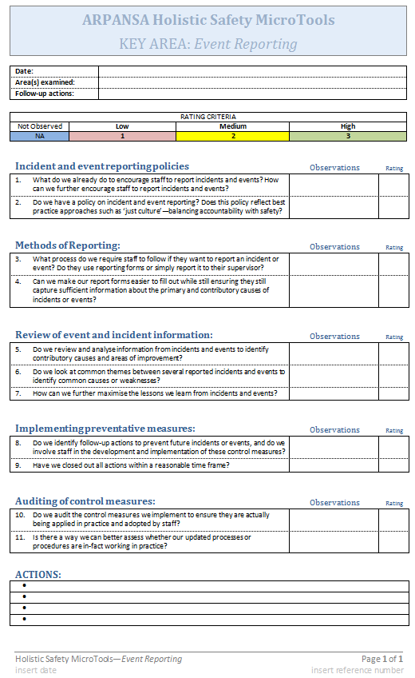
This indicates the area of Holistic Safety being examined, in this case, event reporting.
Fill in these fields for keeping records and document control purposes.
Use these traffic-light rating criteria to discriminate between the weaknesses and strengths of each component examined. Modify the rating system to suit your own operations (e.g. a score out of 100 gives a higher resolution).

This is the sub-element of the overall holistic safety aspect being examined e.g. incident and reporting policies are important sub-elements of Event Reporting.
Use this space to make notes or note down any answers, observations or relevant documentation. You can also use this space to justify the rating given.
These probing questions help audit the aspect being assessed (in this case Event Reporting). Add, remove or tailor the questions to suit your own operations. The Holistic Safety Sample Questions provide more questions should you need.
Place the rating here. Colours provide a quick visual cue/aid of the areas needing improvement. This helps prioritise certain elements over others, depending on their respective weaknesses. Modify the rating or colour system to suit your own operations.
This part can be filled in to for record keeping.
Fill in this table with any actions arising from the assessment. For example, actions to improve or the need to assess or analyse the particular operation or practice in more detail.

