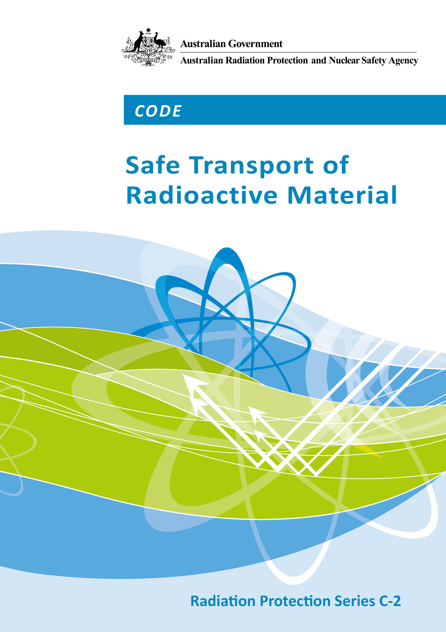

Radiation Protection Series

The Australian Radiation Protection and Nuclear Safety Agency (ARPANSA) produce a number of publications to promote practices which protect human health and the environment from harmful effects of radiation. For the publication categories within the Radiation Protection Series, namely Fundamentals, Codes and Guides, ARPANSA is assisted in this task by the Radiation Health Committee (RHC), which oversees the preparation of draft documents and recommends publication to the Radiation Health and Safety Advisory Council, which endorses documents and recommends their publication by the CEO of ARPANSA.

Fundamentals set the fundamental principles for radiation protection and describe the fundamental radiation protection, safety and security objectives. They are written in an explanatory and non- regulatory style and describe the basic concepts and objectives of international best practice.

Codes are regulatory in style and may be referenced by regulations or conditions of licence. They contain either general safety or security requirements which may be applicable for all dealings with radiation, or practice-specific requirements. They provide overarching requirements and are expressed as ‘must’ statements which are to be satisfied to ensure an acceptable level of safety and/or security.

Guides provide recommendations and guidance on how to comply with the Codes or apply the principles of the Fundamentals. They are written in an explanatory and non-regulatory style and indicate the measures recommended to provide good practice. They are generally expressed as ‘should’ statements.

These three categories of publication are informed by public comment during drafting, and are also subject to a process of assessment of regulatory impact. Further information on these consultation processes may be obtained by contacting ARPANSA.

In addition, ARPANSA has taken over responsibility for the administration of the former Radiation Health Series published by National Health and Medical Research Council as well as codes developed under the Environment Protection (Nuclear Codes) Act 1978. These publications are being progressively reviewed and republished as part of the Radiation Protection Series.

ARPANSA also produces a range of other publications that provide general or technical information on radiation related topics. This includes technical reports, fact sheets, regulatory guides etc. While these are also published by ARPANSA, they are produced independently from the RHC.

All ARPANSA publications (including earlier editions of codes and guides for which ARPANSA is now responsible) are available in electronic format, and can be downloaded free of charge by visiting ARPANSA’s website at www.arpansa.gov.au/Publications.
Further information can be obtained by telephoning ARPANSA on 1800 022 333 (freecall within Australia) or +61 (03) 9433 2211.

CODE

Safe Transport of
Radioactive Material

Radiation Protection Series C-2

December 2014

This publication was approved by the Radiation Health Committee on 25 June 2014 and on 21 August 2014 the Radiation Health
and Safety Advisory Council advised the CEO to adopt the Code.

Notice
© Commonwealth of Australia 2014

This publication is protected by copyright. Copyright (and any other intellectual property rights, if any) in this publication is owned by the Commonwealth of Australia as represented by the Australian Radiation Protection and Nuclear Safety Agency (ARPANSA).

ISBN: 978-0-9873183-5-0
ISSN: 1445-9760

Creative Commons

With the exception of the Commonwealth Coat of Arms, any ARPANSA logos and any content that is marked as being third party material, this publication, Code for the Safe Transport of Radioactive Material (2014), by the Australian Radiation Protection and Nuclear Safety Agency is licensed under a Creative Commons Attribution 3.0 Australia licence (to view a copy of the licence, visit http://creativecommons.org/licenses/by/3.0/au). It is a further condition of the licence that any numerical data referred to in this publication may not be changed. To the extent that copyright subsists in a third party, permission will be required from the third party to reuse the material.

In essence, you are free to copy, communicate and adapt the material as long as you attribute the work to ARPANSA and abide by the other licence terms. The works are to be attributed to the Commonwealth as follows:-
“© Commonwealth of Australia 2014, as represented by the Australian Radiation Protection and Nuclear Safety Agency (ARPANSA)”
Use of the Coat of Arms
The terms under which the Coat of Arms can be used are detailed on the It's an Honour website (http://www.itsanhonour.gov.au/coat-arms/index.cfm).
Enquiries regarding the licence and any use of this report are welcome.
ARPANSA
619 Lower Plenty Road
YALLAMBIE VIC 3085
Tel: 1800 022 333 (Freecall) or +61 3 9433 2211
Email: info@arpansa.gov.au
Website: www.arpansa.gov.au

The mission of ARPANSA is to protect people and the environment from the harmful effects of radiation.

Published by the Chief Executive Officer of ARPANSA in December 2014
Foreword
The regulation of the transport of radioactive material in Australia has, for many years, been based on international requirements published by the International Atomic Energy Agency (IAEA). The regulatory frameworks of the Commonwealth, state and territory jurisdictions currently apply the Code of Practice for the Safe Transport of Radioactive Material (2008) which, in turn, adopts the IAEA’s Regulations for the Safe Transport of Radioactive Material 2005 Edition (No. TS-R-1). The Code establishes requirements for adoption by Commonwealth, state and territory jurisdictions that will maintain a system for the safe transport of radioactive material by road, rail and waterways (other than those subject to the Navigation Act 2012) in Australia.
In 2009 and 2012, the IAEA published revisions of their Regulations for the Safe Transport of Radioactive Material and recommended that ‘adoption of these revised Regulations occur within a period of five years from their publication to achieve worldwide harmonization of their application.’
The Radiation Health Committee, established under the ARPANS Act 1998, has recommended that the Transport Code be revised to incorporate the 2012 IAEA Regulations to cover the transport of radioactive material in Australia by road, rail and waterways (other than those subject to the Navigation Act 2012).
This revised Code has been developed by the Radiation Health Committee, which has reviewed the IAEA 2012 Regulations and compared the requirements therein with those specified in the 2008 Transport Code.
The main changes from the 2008 Transport Code are machinery, grammatical or clarifying in nature and it is expected that there would little or no cost to industry in revising the Transport Code. Any cost to users would result from familiarising themselves with the new requirements and this is expected to be only minor and only occur in the first year.
It should be noted that transport of radioactive materials by air and international waterways incorporate the IAEA 2012 Regulations under the jurisdiction of Civil Aviation Act 1988 and the Navigation Act 2012 respectively. Any company involved with the import or export of radioactive material would therefore already need to be familiar with the requirements of the 2012 IAEA Regulations.
The revised Transport Code was released for a public comment period from 19 February 2014 to 28 March 2014 along with a table outlining the differences between the two Codes and an assessment of the costs to stakeholders. The comments received were reviewed, and the final document was approved by the Radiation Health Committee on 25 June 2014, and the Radiation Health and Safety Advisory Council at their meeting of 21 August 2014 advised the CEO to adopt the Code.
The Code will remain in the Radiation Protection Series, now designated as C-2, with a change to the date (2014) to reflect the revised version. It is expected that the Code will be further revised and updated from time to time to ensure that it continues to provide the highest standards of protection.


Carl-Magnus Larsson
CEO of ARPANSA
1 December 2014

Contents
Foreword i

1. Introduction v
1.1 Background v
1.2 Purpose v
1.3 Scope v
1.4 Structure v

2. Modifications and Clarifications to International Regulations vi

Schedule A The International Atomic Energy Agency Regulations for the Safe Transport of Radioactive Material 2012 Edition IAEA Specific Safety Requirements No. SSR-6 viii

Schedule B Table 1: List of Australian Competent Authorities for the Purpose of this Code 169

Table 2: List of Other Australian Competent Authorities for the Transport of Radioactive Material by Sea or Air 170

Glossary 171

(This page intentionally left blank)

- Introduction
  - Background
This Code replaces the Code of Practice for the Safe Transport of Radioactive Material (2008) and adopts the International Atomic Energy Agency Regulations for the Safe Transport of Radioactive Material 2012 Edition (Specific Safety Requirements No. SSR-6) (the International Regulations).
The transport of radioactive material by any person, organisation or government must comply with the radiation safety legislation of the state, territory or Commonwealth jurisdiction through which the radioactive material is transported.
  - Purpose
This Code is intended to establish uniform requirements for the transport of radioactive material in Australia.
  - Scope
This Code applies to the transport of radioactive material by:
- road,
- rail, and
- waterways under the jurisdiction of states and territories in Australia.
The transport of radioactive material by air is covered by the Civil Aviation Act 1988. Similarly, transport of radioactive material on vessels undertaking voyages by waterways that do not otherwise come under the jurisdiction of states and territories in Australia is covered by the Navigation Act 2012 subject to the application of section 2 of that Act. Details of the relevant Australian competent authorities relating transport of radioactive materials by air or sea can be found in Table 2 of Schedule B.
  - Structure
Section 2 includes modifications and clarifications for Australian circumstances to the International Regulations.
Schedule A of this Code incorporates the International Regulations and includes material, written in regulatory format, which forms part of the regulatory guidance of this Code.
Schedule B contains a list of Australian Competent Authorities for the Transport of Radioactive Material.
The terms used in this Code are defined in the Glossary.
- Modifications and Clarifications to International Regulations
    - A person must not transport radioactive material by road, rail or waterways (other than those subject to the Navigation Act 2012) unless that person does so in accordance with the International Regulations as modified and clarified by Clauses 2.2-2.10 of this Code.
    - Competent Authorities are for the purpose of:
- this Code, those listed in Table 1 of Schedule B, as amended from time to time, or
- transport by sea or air, those listed in Table 2 of Schedule B, as amended from time to time.
    - The ‘relevant transport regulations for dangerous goods’ referred to in paragraph 110 of the International Regulations are the regulations of Australian states, territories and the Commonwealth for the transport of dangerous goods by road and rail which are based upon the 7th edition of the Australian Code for the Transport of Dangerous Goods by Road & Rail (ADG7).
    - Where there is a conflict between the requirements of this Code and ADG7 in relation to the transport of radioactive material by road and rail, the provisions of this Code prevail.
    - Paragraph 308 of the International Regulations is replaced by:
The relevant competent authority may impose requirements to ensure that radiation protection measures comply with the requirements in RPS1.
    - In paragraph 562 of the International Regulations, the word ‘dose’ is taken to mean ‘effective dose’.
    - The limits in relation to U (natural) and Th (natural) are to be applied in terms of the parent radionuclide i.e. U-238 and Th-232 respectively.
    - The paragraphs of the International Regulations to be complied with by consignors are:
109-110, 306, 309-315, 401-434, 501-511, 514, 515(a)-(b), 516-562, 566-568, 570-572, 575-576, 601-686, 701-737, 801-803, 805, 807(a)-(c), 808-809, 811-812, 814-815, 817, 819-825, 827, 829-830.
    - The paragraphs of the International Regulations to be complied with by carriers are:
109-110, 301-306, 309-315, 504-514, 520, 522-525, 529(c), 537-540, 543-544, 562-579, 583-588, 627-630.
    - The default values given in paragraphs 523(a) and (b) of the International Regulations, where used instead of actual measurements, may require transport under exclusive use in accordance with paragraph 526 of the International Regulations0F.

Schedule A

This is a reproduction of

REGULATIONS
FOR THE SAFE TRANSPORT OF
RADIOACTIVE MATERIAL

2012 Edition

IAEA Specific Safety Requirements No. SSR-6

© INTERNATIONAL ATOMIC ENERGY AGENCY, VIENNA, 2012

The authentic version of this material is the version distributed by the IAEA or on behalf of the IAEA by duly authorised persons. The IAEA makes no warranty and assumes no responsibility for the accuracy or quality or authenticity or workmanship of this reproduction and its publication and accepts no liability for any loss or damage consequential or otherwise howsoever caused arising directly or indirectly for any use thereof whatsoever and to whomsoever.

COPYRIGHT NOTICE: Permission to reproduce or translate the information contained in this publication may be obtained by writing to the International Atomic Energy Agency, Wagramerstrasse 5, P.O. Box 100, A-1400 Vienna, Austria.

The following pages of this document are a full version of the IAEA Transport Regulations published in 2012 and described above. This is the version for adoption in Australia for regulatory purposes. The IAEA reviews its Transport Regulations from time to time. The latest version can be found via the following link:

http://www-pub.iaea.org/books/IAEABooks/8851/Regulations-for-the-Safe-Transport-of-Radioactive-Material-2012-Edition-Specific-Safety-Requirements

NOT FOR RESALE

(This page intentionally left blank)

Schedule B Competent Authorities
Table 1: List of Australian Competent Authorities for the Purpose of this Code
COMMONWEALTH STATE / TERRITORY | CONTACT | COMPETENT AUTHORITY
Commonwealth | Chief Executive Officer  ARPANSA  PO Box 655 Tel: (02) 9541 8333  Miranda NSW 1490 Fax: (02) 9541 8314  Email: info@arpansa.gov.au | Australian Radiation Protection and Nuclear Safety Agency (ARPANSA)
Australian Capital Territory | Manager Radiation Safety  Health Protection Service  ACT Health Directorate  Locked Bag 5005 Tel: (02) 6205 1700  Weston Creek ACT 2611 Fax: (02) 6205 1705  Email: hps@act.gov.au | Australian Capital Territory Radiation Council
New South Wales | Manager  Hazardous Materials, Chemicals and Radiation  Environment Protection Authority  PO Box A290 Tel: (02) 9995 5959  Sydney South NSW 1232 Fax: (02) 9995 6603  Email: radiation@epa.nsw.gov.au | Environment Protection Authority
Northern Territory  (i) for radioactive ores and concentrates | Chief Inspector – Radioactive Ores and Concentrates  (Packaging and Transport)  NT WorkSafe  Department of Education, Employment & Training  GPO Box 4821 Tel: (08) 8999 5010  Darwin NT 0801 Fax: (08) 8999 5141  Email: neil.watson@nt.gov.au | Work Health  Authority
(ii) for all other radioactive substances | Manager Radiation Protection  Radiation Protection Section  Department of Health  GPO Box 40596 Tel: (08) 8922 7152  Casuarina NT 0811 Fax: (08) 8922 7334  Email: envirohealth@nt.gov.au | Department of Health
Queensland | Director, Radiation Health  Queensland Health  PO Box 2368 Tel: (07) 3328 9310  Fortitude Valley BC QLD 4006 Fax: (07) 3328 9622  Email: radiation_health@health.qld.gov.au | Queensland Health
South Australia | Manager, Radiation Protection  Environment Protection Authority  GPO Box 2607 Tel: (08) 8463 7826  Adelaide SA 5001 Fax: (08) 8124 4671  Email: radiationprotection@epa.sa.gov.au | Minister for Environment  & Conservation
Tasmania | Senior Health Physicist, Radiation Protection Unit  Department of Health and Human Services  GPO Box 125 Tel: (03) 6222 7256  Hobart TAS 7001 Fax: (03) 6222 7257  Email: radiation.protection@dhhs.tas.gov.au | Director of Public Health
Victoria | Team Leader, Radiation Safety  Department of Health  GPO Box 4541 Tel: 1300 767 469  Melbourne VIC 3001 Fax: 1300 769 274  Email: radiation.safety@health.vic.gov.au | Secretary, Department  of Health
Western Australia | Secretary  Radiological Council  Locked Bag 2006 PO Tel: (08) 9388 4999  Nedlands WA 6009 Fax: (08) 9381 0701  Email: radiation.health@health.wa.gov.au | Radiological Council

Table 2: List of Other Australian Competent Authorities for the Transport of Radioactive Material by Sea or Air

MODE OF TRANSPORT | 0BCONTACT | COMPETENT AUTHORITY
Air Transport | Director, Aviation Safety  Civil Aviation Safety Authority  GPO Box 2005 Tel: +61 131 757  Canberra ACT 2601 Fax: (02) 6217 1300  Email: dg@casa.gov.au or 1300 851 857 | Civil Aviation Safety Authority
Sea (international and interstate) | Manager, Ship Inspections  Maritime Operations  Australian Maritime Safety Authority  GPO Box 2181 Tel: (02) 6279 5048  Canberra ACT 2601 Fax: (02) 6279 5058  Email: MOCBRSHIPMAN@amsa.gov.au | Australian Maritime Safety Authority

Tables 1 and 2 were correct at the time of printing but are subject to change from time to time. For the most up-to-date list, the reader is advised to consult the ARPANSA website (www.arpansa.gov.au).

Glossary
Effective Dose
The quantity E, defined as a summation of the tissue equivalent doses, each multiplied by the appropriate tissue weighting factor:
$$E = \sum_{T}{w_{T}⋅ H_{T}}$$
where H_{T} is the equivalent dose in tissue T and
w_{T} is the tissue weighting factor for tissue T.
From the definition of equivalent dose, it follows that:
$$E = \sum_{T}{w_{T} ⋅ \sum_{R}{w_{R}⋅ }D_{\text{T,R}}}$$
where w_{R} is the radiation weighting factor for radiation R and
D_{T,R} is the average absorbed dose in the organ or tissue T.
The unit of effective dose is J kg⁻¹, termed the sievert (Sv).
International Regulations, the
means the International Atomic Energy Agency Regulations for the Safe Transport of Radioactive Material 2012 Edition (Specific Safety Requirements No. SSR-6) as reproduced in Schedule A.
RPS1
the Recommendations for limiting exposure to ionizing radiation (1995) (NOHSC guidance note) and the National standard for limiting occupational exposure to ionizing radiation. Radiation Protection Series No. 1.

Other meanings in this Code are those defined in the International Regulations.

Where the provisions of clause 2.10 of this Code causes difficulty, the relevant Competent Authority should be contacted.

