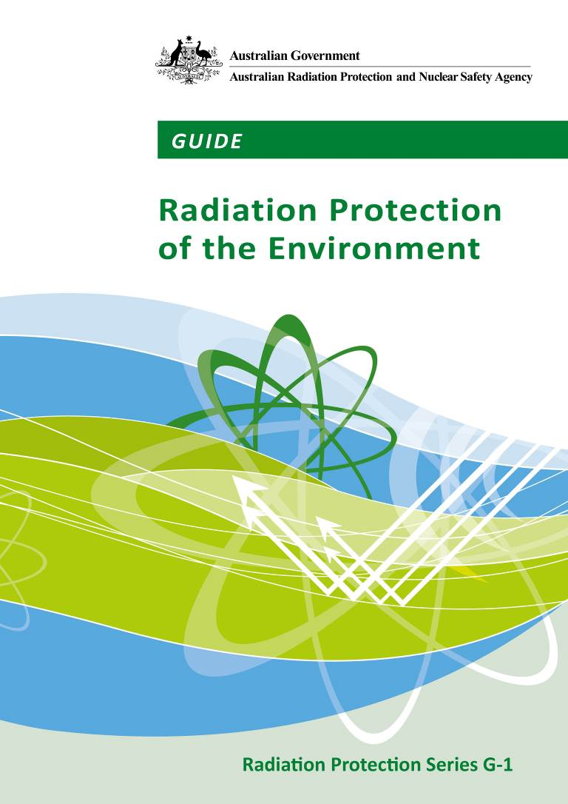

Radiation Protection Series
The Australian Radiation Protection and Nuclear Safety Agency (ARPANSA) produce a number of publications to promote practices which protect human health and the environment from harmful effects of radiation. For the publication categories within the Radiation Protection Series, namely Fundamentals, Codes and Guides, ARPANSA is assisted in this task by the Radiation Health Committee (RHC), which oversees the preparation of draft documents and recommends publication to the Radiation Health and Safety Advisory Council, which endorses documents and recommends their publication by the CEO of ARPANSA.
Fundamentals set the fundamental principles for radiation protection and describe the fundamental radiation protection, safety and security objectives. They are written in an explanatory and non-regulatory style and describe the basic concepts and objectives of international best practice.
Codes are regulatory in style and may be referenced by regulations or conditions of licence. They contain either general safety or security requirements which may be applicable for all dealings with radiation, or practice-specific requirements. They provide overarching requirements and are expressed as ‘must’ statements which are to be satisfied to ensure an acceptable level of safety and/or security.
Guides provide recommendations and guidance on how to comply with the Codes or apply the principles of the Fundamentals. They are written in an explanatory and non-regulatory style and indicate the measures recommended to provide good practice. They are generally expressed as ‘should’ statements.
These three categories of publication are informed by public comment during drafting, and are also subject to a process of assessment of regulatory impact. Further information on these consultation processes may be obtained by contacting ARPANSA.
In addition, ARPANSA has taken over responsibility for the administration of the former Radiation Health Series published by National Health and Medical Research Council as well as codes developed under the Environment Protection (Nuclear Codes) Act 1978. These publications are being progressively reviewed and republished as part of the Radiation Protection Series.
ARPANSA also produces a range of other publications that provide general or technical information on radiation related topics. This includes technical reports, fact sheets, regulatory guides etc. While these are also published by ARPANSA, they are produced independently from the RHC.
All ARPANSA publications (including earlier editions of codes and guides for which ARPANSA is now responsible) are available in electronic format, and can be downloaded free of charge by visiting ARPANSA’s website at www.arpansa.gov.au/Publications.
Further information can be obtained by telephoning ARPANSA on 1800 022 333 (freecall within Australia) or +61 (03) 9433 2211.

GUIDE

Radiation Protection
of the Environment

Guide G-1

November 2015

This publication was approved by the Radiation Health Committee on 18 November 2015 and subsequently the Radiation Health and Safety Advisory Council advised the CEO to adopt the Guide.
© Commonwealth of Australia 2015

This publication is protected by copyright. Copyright (and any other intellectual property rights, if any) in this publication is owned by the Commonwealth of Australia as represented by the Australian Radiation Protection and Nuclear Safety Agency (ARPANSA).

ISBN 978-0-9873183-6-7
ISSN 1445-9760

Creative Commons

With the exception of the Commonwealth Coat of Arms, any ARPANSA logos and any content that is marked as being third party material, this publication, Guide for Radiation Protection of the Environment, by the Australian Radiation Protection and Nuclear Safety Agency is licensed under a Creative Commons Attribution 3.0 Australia licence (to view a copy of the licence, visit (http://creativecommons.org/licenses/by/3.0/au). It is a further condition of the licence that any numerical data referred to in this publication may not be changed. To the extent that copyright subsists in a third party, permission will be required from the third party to reuse the material.

In essence, you are free to copy, communicate and adapt the material as long as you attribute the work to ARPANSA and abide by the other licence terms. The works are to be attributed to the Commonwealth as follows:-

“© Commonwealth of Australia 2015, as represented by the Australian Radiation Protection and Nuclear Safety Agency (ARPANSA)”

The publication should be attributed as: Guide for Radiation Protection of the Environment.

Use of the Coat of Arms
The terms under which the Coat of Arms can be used are detailed on the It's an Honour website (http://www.itsanhonour.gov.au/coat-arms/index.cfm).
Enquiries regarding the licence and any use of this report are welcome.
Enquiries regarding the licence and any use of this publication are welcome.
ARPANSA
619 Lower Plenty Road
YALLAMBIE VIC 3085
Tel: 1800 022 333 (Freecall) or +61 3 9433 2211
Email: info@arpansa.gov.au
Website: www.arpansa.gov.au

The mission of ARPANSA is to assure the protection of people and the environment from the harmful effects of radiation.

Published by the Chief Executive Officer of ARPANSA in November 2015.

Foreword
Internationally and nationally, the legal and regulatory framework that governs management of radiation risks encompasses protection of both people and the environment. While the approach to protection of people has continually evolved for about a century, protection of the environment from the harmful effects of radiation is a relatively new addition to the protection framework. However, it is now included in both the 2007 Recommendations of the ICRP; and in the International Basic Safety Standards that – having been endorsed by a range of UN organisations and other international and regional bodies – was published in its final form as GSR Part 3 in 2014.
Australia has taken a proactive approach to protection of the environment from the harmful effects of ionising radiation, and proponents of facilities and activities that in one way or the other may cause radiation exposure to wildlife have made use of new software tools to support their licence applications and to directly demonstrate that the environment is protected.
The Fundamentals for Protection against Ionising Radiation (RPS F-1) includes environmental exposure as one of the exposure categories (alongside workers, the public, and patients undergoing medical procedures involving ionising radiation), all of which need to be given adequate attention for the purpose of protection against the harmful effects of ionising radiation. This Guide provides advice on how to assess environmental exposures and – on the basis of such information – draw conclusions regarding environmental protection.
I wish to thank all contributors to drafting and review, and commend this Guide to users and stakeholders across all Australian jurisdictions.
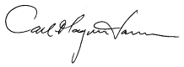

Carl-Magnus Larsson
CEO of ARPANSA
27 November 2015

(This page intentionally left blank)

Contents

Foreword i
1. Introduction 1
1.1 Citation 1
1.2 Background 1
1.3 Purpose 2
1.4 Scope 2
1.5 Interpretation 2
1.6 Structure 2
2. Objectives and framework for radiation protection of the environment 3
2.1 Objectives 3
2.2 Framework 3
3. Elements of the Framework in Detail 6
3.1 Basic Concepts 6
3.2 Practical aspects – estimating exposure 9
3.3 Practical aspects – establishing environmental reference levels (ERLs) and selecting screening values 13
4. Interpreting assessment results in the context of environmental reference values 16
ANNEX A Assessment context 17
A.1 Introduction 17
A.2 When to do an environmental radiological assessment 17
A.3 Exposure scenario 17
A.4 Undertaking the assessment 20
A.5 Stakeholder consultation 23
A.6 Other considerations 23
References 24
Glossary 28
Contributors to Drafting and Review 33

(This page intentionally left blank)

- Introduction
  - Citation
This Guide may be cited as the Guide for Radiation Protection of the Environment (2015).
  - Background
Australia’s system for managing radiation risks from ionising radiation is closely aligned with international best practice as laid out by the International Commission on Radiological Protection (ICRP), the International Atomic Energy Agency (IAEA) in its Safety and Security Series and Codes of Conduct, and in relevant Conventions to which Australia is a party. Protection of the environment from the harmful effects of radiation is integral to this system, although its relative weight in regulatory decision-making may vary considerably, depending on the circumstances.
The Fundamentals for Protection Against Ionising Radiation (RPS F-1; ARPANSA, 2014) includes environmental exposure as one of the exposure categories. The Fundamentals define environmental exposure as follows:
“….the exposure of wildlife to all additional radiation sources resulting from human activities. Wildlife may require protection in order to maintain biological diversity, conservation of species, or the health and status of natural habitats, communities or ecosystems, or anything that may be otherwise required from a conservation point of view in accordance with relevant legislation.”
Protection of the environment from the harmful effects of ionising radiation is an area that has evolved considerably over the last couple of decades. Increased awareness of the potential impact of human activities on the environment has grown and society has come to expect a better understanding of such effects, including possible harm to the environment caused by radiation. These expectations have led to the consideration that radiation protection of the environment has to be clearly demonstrated, while applying a graded approach which is commensurate with the radiation risks.
This Guide builds on recent scientific and regulatory developments. It outlines the framework for protection of the environment from the harmful effects of ionising radiation and the practical aspects of the process through which protection can be demonstrated.
  - Purpose
The purpose of the Guide is to provide best practice guidance on how to assess environmental exposures and demonstrate protection of the environment from the human activities, past and present, that give rise to such exposures. It is for use by industry, regulators and other stakeholders and decision makers, and provides information to all interested in the subject.
  - Scope
This Guide focuses on environmental exposures to ionising radiation as defined under Section 1.2 and in the Fundamentals for Protection against Ionising Radiation (2014). It deals specifically with radiation protection of wildlife under all exposure situations. It does not cover protection of the environment for recreation, food gathering or other purposes.
Radiation protection of people is outside the scope of this Guide. However, assessments and decisions relating to all situations involving radiation exposure should, when relevant, consider radiation protection of people in conjunction with protection of the environment.
  - Interpretation
This Guide is explanatory in nature and is not required to be complied with per se.
  - Structure
This Guide consists of four sections and one Annex, a glossary and references.
Section 1 describes the background, purpose and scope of the Guide.
Section 2 describes the objectives of protection of the environment and outlines the framework.
Section 3 describes the framework in more detail.
Section 4 describes considerations in decision-making.
Annex A provides guidance on the assessment context.
The meanings of technical terms used in this Guide are defined in the Glossary. Terms defined in the Glossary appear in bold type on first mention in the text. Publications underpinning this Guide are listed in the Reference section. The publications are not specifically referenced in the main part of the document in order to maintain the flow of the text (other than when particularly relevant and in Annex A).
Additional information relating to examples and extra details on performing environmental sampling and assessments can be found with electronic versions of this Guide on the ARPANSA website, www.arpansa.gov.au.
- Objectives and framework for radiation protection of the environment
  - Objectives
The protection objective is to ensure maintenance of robust wildlife populations. This involves demonstrating that radiation exposures are of no regulatory concern in relation to the maintenance of biological diversity, the conservation of species, or on the health of natural ecosystems. Some species may have been specifically identified in legislation and other instruments aimed at protecting species that are considered vulnerable, valuable or otherwise important; protection of such species will be assisted by this Guide.
Four endpoints – to some extent overlapping – are generally considered to capture the range of ways a population may be affected by radiation. These are:
- mortality (leading to changes in age distribution, death rate and population density)
- morbidity (reducing ‘fitness’ of individuals, making it more difficult for them to survive and reproduce)
- reproduction (by either reduced fertility or fecundity)
- cytogenetic alteration (by the induction of chromosomal damage).
Wildlife populations may fluctuate considerably for natural reasons, such as drought, availability of food/nutrients, presence of predators and parasites, and disease; often in a cyclic fashion. The impact of radiation may be a very minor contributor to such population changes; however, it can also be hypothesised that radiation may aggravate population effects if the population is already under stress due to other factors. This is an area of ongoing research.
Demonstration that radiation exposure has negligible impact on the four endpoints outlined above, while taking a prudent approach with regard to associated uncertainties and potential synergies, should provide assurance that the protection objective is met.
  - Framework
The framework for radiological protection of the environment is broadly consistent with that for radiation protection of people (Figure 1). It is applicable under all exposure situations, i.e. when activities and facilities that alter the radiation environment are planned and operating in a regulated manner (planned exposure situations), and in the case of dealing with existing exposure situations such as legacy sites. While technically also applicable in emergency exposure situations, it is likely that decision-making – at least in the early phase – is heavily dominated by urgent decisions to protect people and that protection of wildlife is a secondary consideration, although still important from societal, cultural and economic perspectives.
The framework incorporates conceptual and numerical models for determining the level of exposure of both people and wildlife, and numerical dose indices guiding judgements on justification and optimisation, again for both people and wildlife. It can be considered as a best practice approach to assess environmental impacts on wildlife associated with exposure to ionising radiation, which subsequently underpins decision-making in relation to such exposures; this does not preclude the use of other methods for the same purposes.
Planned, emergency, and existing exposure situations
Environmental radionuclide concentrations
Reference Male and Female
Representative Person
Reference Organisms
Representative Organisms
Dose Limits, Dose Constraints, and
Reference Levels
Environmental Reference Levels
Decision-making regarding public health and environmental protection for the same environmental exposure situation by way of Representative Individuals and Representative Organisms
Figure 1: Framework for radiation protection of people (left) and wildlife (right).
Application of this framework may assist at:
- the conceptual level for:
- planning environmental assessments
- identifying sources of radionuclides and radionuclides of concern
- identifying key receptor organisms, exposure pathways and endpoints
- identifying assessment tools (including tiered approaches) that are fit for purpose
- identifying and organising data that are fit for purpose.
- the operational level for:
- providing an indication of the potential environmental impacts from radiation associated with an operation or facility
- developing a flexible environmental monitoring program, including ongoing comparison of assessment predictions with potential outcomes
- optimising the level of effort expended on environmental protection.
- the regulatory level for:
- assessing/demonstrating compliance with environmental protection objectives of relevant legislation or other adopted standards or codes of practice
- demonstrating that stakeholder expectations for radiological protection of the environment have been adequately addressed.
The elements of the framework, as relevant to protection of wildlife, are described in more detail in Section 3 of this Guide.
- Elements of the Framework in Detail
This section outlines basic concepts in assessments and/or in decisions on protection of wildlife, namely: the dosimetric quantity; reference organisms and representative organisms; and environmental reference levels. It then outlines how these basic concepts are utilised when performing assessments that underpin subsequent decision-making.
  - Basic Concepts

3.1.1 Dosimetric quantity for protection of wildlife
The general approach to assessing potential or likely effects of ionising radiation on the health of people and on wildlife involves estimations of the dose and/or the dose rate. The fundamental dosimetric quantity is the absorbed dose, i.e. the energy absorbed per unit mass of the material with which the radiation interacts. Absorbed dose is measured in the unit gray (Gy). For the purpose of radiation protection of people, it has been possible and helpful to factor in the relative effectiveness of different types of radiation in causing health effects by applying a radiation weighting factor, and to consider sensitivities of tissues and organs, to derive the radiation protection quantities equivalent dose and effective dose. Both of these quantities are measured in the unit sievert (Sv). Limits, constraints and reference levels for protection of people are normally set in equivalent or effective dose.
The necessary information to support generic conclusions as to the impact of different types of radiation on wildlife does not currently exist; furthermore, the diversity of wildlife is such that generic conclusions as to sensitivity of tissues, organs and even organisms should be drawn with extreme caution. It is presently not possible to define a radiation protection quantity specific for protection of wildlife. However, in most circumstances it can be assumed that the effect of ionising radiation on wildlife is proportional to the absorbed dose. Normally, and outside of acute phases of emergency exposure situations, it would be relevant to relate the likelihood of occurrence of radiation effects on wildlife to the absorbed dose rate (hereafter referred to ‘dose rate’ for simplicity) resulting from long-term and consistent (chronic) exposures, which would normally be measured in microgray per hour (μGy h⁻¹).

3.1.2 Representative Organisms and Reference Organisms
Among the organisms that inhabit a particular environment where radiation exposures are elevated, it is practical to identify representative organisms, which are typical of that environment or necessary for the structural or functional integrity of an ecosystem exposed to radiation (sometimes referred to as keystone species). These can be considered the direct object of protection in a given exposure situation. However, for the purpose of demonstrating protection, it is generally not feasible to use actual organisms inhabiting the environment under consideration, for the reason that relevant data are missing or scarce.
As an approximation, and to facilitate assessments and decision-making with a reasonable degree of confidence, the assessment and decision-making can be built around reference organisms. These are hypothetical representations of wildlife using a simplified (ellipsoid) geometry, and broadly representative of a group of wildlife (e.g. large terrestrial mammals; pelagic fish), for which data on dosimetry and ‘biology’ including habitat, life cycle, sensitivity to radiation, etc., can be pooled (see Figure 2). Reference organisms are thus not real organisms, but simplified and generalised conceptual and numerical models of wildlife.

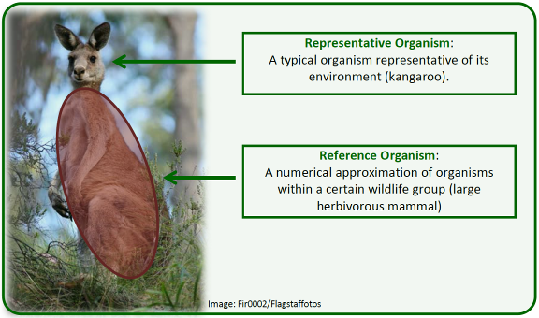
Figure 2: Relationship between a representative organism and a reference organism.
One of the key practical purposes of reference organisms is to provide a means for the estimation of dose rates, where the ellipsoid can be used – by varying its axes – as a reasonable approximation for much of the existing wildlife on Earth (see Figure 3). Radiation damage arises from the ionisation that follows the path that radiation takes as it passes through tissues. Hence the dimensions of the organisms have relevance for the degree of radiation damage that may occur. These estimates, in turn, provide a basis for subsequent assessment of the likelihood and degree of radiation effects, using available effects information.
Under certain circumstances there could be a need to examine in greater detail the impact on actual species inhabiting certain environments (i.e. representative organisms) and for which suitable reference data may not exist. This may require significant efforts and development of databases; however, assessment methods and tools are currently and generally limited to the simple geometries and assumptions on exposure and radionuclide distribution. This would at least be sufficient for undertaking a screening level assessment of the radiation exposure in the environment and associated biological effects, as discussed later.
c
a
b
Figure 3. An ellipsoid, outlining the axes (a, b and c) that can be varied to accommodate
for the different shapes of reference organisms.
In summary, the simplifications introduced when using reference organisms include:
- the representation of different forms of wildlife by simple shapes (e.g. ellipsoids)
- an assumption of homogeneous radionuclide distribution in the tissues of the organism (internal dosimetry) and in environmental media (external dosimetry)
- generic ‘biology’ in terms of habitat, occupancy, life cycle, reproduction and other factors.

3.1.3 Environmental reference levels (ERLs) and tiered assessments
Environmental reference levels (ERLs) are dose rates to wildlife, in addition to those incurred normally from ‘background’ radiation, at which a more considered evaluation of the situation and the potential detriment to wildlife might be reasonable, and which should be considered in the over-all optimisation process. The ERLs should be derived from knowledge of biological effects in wildlife, and their relationship to dose rate. They are not dose limits or ‘substitute’ values for them, and do not imply that higher dose rates are environmentally damaging, or that lower dose rates are in some way ‘safe’ or non-damaging. Rather, ERLs can be considered as:
- a dose rate increment to wildlife above the natural and normal background level, which might result in detrimental health effects in the environment
- a point of reference guiding optimisation, i.e. the level of effort expended on environmental protection, dependent on the overall management objectives and exposure situation.
In practice, ERLs that are tailored to individual organism are not feasible, considering the immense diversity of wildlife on Earth. Simplifications can be made that facilitate assessment and demonstration of protection, where a straightforward approach to estimating the level of radiation impact and to guide decision-making is to use screening values of dose rate (which, like ERL, are in addition to dose rates incurred from ‘background’ radiation) in the assessments. Such screening values should be selected so that if an assessment results in a measured or estimated dose rate below this value, the likelihood of any deleterious effects on wildlife would be small or negligible, and further regulatory actions would not be necessary (see Figure 4).

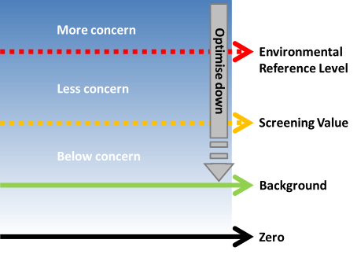

Figure 4: Use of environmetal reference levels (ERLs) and screening levels of dose rate for protection of the environment.
Should the screening value be exceeded, a more refined assessment would be appropriate, including potential consideration of representative organisms. Assessment against a screening value thus becomes the first tier in a tiered approach to assessment. This enables elimination of exposures that are of no concern and identifies those that require attention – the tiered assessment thus supports a graded approach to protection.
  - Practical aspects – estimating exposure
Exposures of wildlife can be measured; however, carrying out such measurements in the natural environment is resource-intensive and mainly performed for scientific purposes – and is in some cases not feasible at all. Also, in the case of proposed facilities, there are no exposures that can be measured – instead they will have to be estimated based on scenario analyses, guided by considerations made when defining the assessment context (see Annex A). This section outlines the practical aspects associated with estimating exposures, and when subsequently assessing the potential impact of such exposures.

3.2.1 External exposure
Concentrations of radionuclides in environmental media such as soil, water and sediments can often be measured in the case of ongoing activities and operational facilities, as well as in the case of existing and emergency exposure situations. Thus, the exposure of wildlife can be directly assessed. If radionuclide concentrations are not known at the point in time when a regulatory decision has to be taken (i.e. for prospective facilities or activities, and in the case of potential exposures), radionuclide concentrations of environmental media will have to be estimated.
Radionuclide concentrations in air, soil, water and sediment (i.e. environmental media) can be estimated using an appropriate mathematical model. These models may take into account relevant environmental transport processes, such as advection and diffusion, sediment scavenging, resuspension or migration. The behaviour of radionuclides, including radioactive half-lives and possible daughter ingrowth should also be taken into account. See Box 1 for some examples of these models and a summary of assumptions that have been applied.
Box 1: Examples of existing databases and models for estimating equilibrium radionuclide concentrations in environmental media when activity concentrations are not known.
- IAEA Safety Reports Series No. 19 (IAEA, 2001) – Generic models for estimating concentrations in air and water due to discharges to the environment
- PC Cream (https://www.phe-protectionservices.org.uk/pccream) – Includes modules for estimation of radionuclide concentration in air, ocean and rivers

3.2.2 Internal exposure – transfer parameters
In order to estimate the internal exposure of wildlife it is essential to have either measured activity concentration data or appropriate organism-to-media Concentration Ratios (CR) and Distribution Coefficients (K_{d}) for the relevant organism-media combinations. These values are normally assumed to reflect an equilibrium situation between the exposed wildlife and the environmental media which they inhabit (note that this differs from the calculation of doses to people, where detailed biokinetic models are applied).
Being mainly derived for equilibrium conditions, the transfer parameter values are particularly appropriate for assessments of constant long-term exposures, but have less applicability in dynamic situations where environmental concentrations are changing rapidly with time. In such situations, the values tend to over-estimate internal activity concentrations in the initial phase, when the activity concentration in media is increasing, but may under-estimate the internal activity concentration if the environmental media concentrations have declined at the time of sampling but are within the biological half-life of the radionuclide in question. Dynamic modelling may be applied in these situations.
Different approaches to determining CR for various environmental circumstances and different forms of wildlife have been utilised; examples are given below.

Whole-organism concentration ratio
The whole-organism to media concentration ratio (CR_{WO-media}) is a value used to quantify the equilibrium activity concentration between an environmental medium and the whole organism. This may previously have been referred to as concentration factor or bioaccumulation factor. It generally does not include parts which might be contaminated by environmental media (soil, silt) such as the gut or pelt.
The definitions of CR_{WO-media} are as follows:
For terrestrial organisms:
CR = Activity concentration in biota whole-body (Bq/kg fresh weight) / Activity concentration in soil (Bq/kg dry weight)
Exceptions for terrestrial biota exist for chronic atmospheric releases of ³H, ¹⁴C, ³⁵S and radioisotopes of P, where:
CR = Activity concentration in biota whole-body (Bq/kg fresh weight) / Activity concentration in air (Bq/m³)
For aquatic organisms:
CR = Activity concentration in biota whole-body (Bq/kg fresh weight) / Activity concentration in filtered water (Bq/l)

Tissue-media concentration ratio
The tissue-media concentration ratio (CR_{tissue-media}) is a value used to quantify the equilibrium activity concentration between an environmental medium and a specific tissue (e.g., muscle, bone, etc.). Some values may already be available as a result of efforts to assess doses to people via the consumption of particular foods, such as meat or milk. Tissue-to-media CRs should not be used in dose assessments for wildlife in lieu of organism-to-media data. This is because radionuclide activity concentrations (and thereby the CR) for a specific tissue may be substantially less than, or greater than, that for the whole body due to preferential uptake of certain radionuclides by certain tissues. However, for some tissues, conversion factors have been published, see further Box 2.

Distribution coefficient (K_{d})
Additionally, in aquatic ecosystems, the distribution (or partition) coefficient (K_{d}) describes the relative activity concentrations of radionuclides in sediment and water, where:
K_{d} (l/kg) = Activity concentration in sediment (Bq/kg dry weight) / Activity concentration in filtered water (Bq/l)
The distribution coefficient can be used to predict the radionuclide activity concentration in sediment from that in water, or vice versa, if data for either are lacking. However it is preferred to use site-specific water and sediment data. The use of model default K_{d} values can have large uncertainty ranges as literature values often do not match well with site-specific conditions.
Box 2: Examples of Concentration Ratio Databases for radionuclide transfer to wildlife.
There are a number of existing references and data sources for Concentration Ratio data, some of which are relevant to Australian environments. These include:
- ICRP Publication 114 (ICRP, 2009) – Includes tables of transfer parameters.
- The Wildlife Transfer Parameter Database (http://www.wildlifetransferdatabase.org).
- International Atomic Energy Agency, Technical Report Series (TRS) 479, Handbook on transfer of radionuclides to Wildlife (IAEA, 2014) – Generic parameter values for transfer of radionuclides from media to wildlife.
- International Atomic Energy Agency, Tecdoc 1616, Quantification of Radionuclide Transfer in Terrestrial and Freshwater Environments for Radiological Assessments (IAEA, 2009a) – Models and parameters to assess exposures of humans and biota.
- Hirth (2014) collates CR data in Australian uranium mining environments.
- Johansen and Twining (2010) reviewed Australian terrestrial wildlife and livestock data, although most data are for muscle alone.
- Yankovich et al. (2010). Discusses factors for converting muscle to whole-organism CRs.

3.2.4 Estimation of dose rates
Databases are available that allow for estimating the dose rate from both external exposure and internal exposure, based on activity concentrations in wildlife and environmental media. These include look-up tables for dose conversion coefficients (DCC) which have been integrated into software tools. Examples are provided in Box 3 below.
Box 3: Databases and models for conversion of external and internal radionuclide concentrations to absorbed dose rates in wildlife.
- ICRP Publication 108 (ICRP, 2008) – Includes tabulated data for dose calculation.
- RESRAD (https://web.evs.anl.gov/resrad) – A family of codes for evaluation of radioactively contaminated sites. This also includes tools for estimating concentrations.
- ERICA Tool (http://www.erica-tool.eu) – A software system for assessing radiological risk to terrestrial, freshwater and marine biota. Includes tools for estimating concentrations.
- EA R&D 128 (https://www.gov.uk/government/uploads/system/uploads/attachment_data/
file/290300/sr-dpub-128-e-e.pdf) – Documented spreadsheet model for coastal, freshwater and terrestrial ecosystems by the Environment Agency of England and Wales.
  - Practical aspects – establishing environmental reference levels (ERLs) and selecting screening values

3.3.1 Establishing ERLs
As outlined in Section 3.1.3, ERLs are the fundamental indicators of dose rates where some level of detrimental effect can be expected among wildlife and where at least some consideration on whether protection is adequate would be warranted. ERLs should be evidence-based and principally derived from review or analysis of the radiation effects literature and other relevant data. Review or analysis of the radiation effects literature should consider the biological effects associated with exposures and their relevance in an environmental context. It is important to assess whether each biological effect is likely to impact only an exposed individual (or small group of individuals) or whether it is likely to manifest as a population level effect within a potentially impacted environment.
Factors to consider when establishing ERLs include the following:
- Observed biological effects reported in the radiation effects literature may arise from acute or chronic exposures depending on the particular experiment or study conducted. In an environmental context, chronic low level exposures of organisms are those that are most likely to occur, particularly in planned and existing exposure situations, and would normally be most relevant in a regulatory context. Thus, it may be appropriate to apply data from the radiation effects literature relevant to the type of exposures expected in the environmental situation being considered.
- Not all organisms share common radiosensitivity. This means that some (e.g. those that are long-lived) organisms will generally experience biological effects at lower dose rates compared with other organisms. The implication is that environmental reference values for the more sensitive organisms should be comparatively lower than those for other, less sensitive, organisms.
- Radiation effects data for most organism types are relatively sparse. Consequently, there is likely to be inherent uncertainty in distinguishing the exact minimum dose rate level at which biological effects in organisms actually occur. In order to account for this uncertainty, it may be desirable to express environmental reference values in an aggregated fashion encompassing a reasonable range of organisms, rather than as a single (discrete) value.
Review and analysis of the radiation effects literature has been conducted internationally to derive exposure levels below which there is not expected to be significant population level effects for a range of organism types. These derived values may be helpful in guiding the selection of environmental reference values for use in assessment. Table 1 summarises some information on effects at different dose rates in the environment that can guide discussions on environmental reference levels. The examples are for broad groups of wildlife in the terrestrial and aquatic environment, and derived consideration reference levels (DCRLs) for Reference Animals and Plants or RAPs. The DCRLs identify a band of dose rates where a decision-maker may need to consider the potential for deleterious effects of radiation in a particular species, although further considerations might be needed in order to take a fully informed decision. Where the reference organism is sufficiently similar to one of the RAPs, the corresponding DCRL for that RAP could be used as the environmental reference value; in other cases other values (such as those discussed by IAEA or UNSCEAR, see Table 1) would be appropriate. The rationale for the selection of ERL should be clearly documented in the assessment report.
Table 1: Summary of derived effects levels (µGy h⁻¹) below which population level effects are not expected to occur. Different values have been derived for similar organisms due to the use of alternative data and/or application of differing levels of precaution. Note that (except where otherwise indicated) IAEA and UNSCEAR values refer to population effects, whereas ICRP give dose rate bands where effects may occur to individuals of that type of RAP.
Organism | IAEA (1992) | UNSCEAR  (1996, 2011) | ICRP (2008)
Terrestrial
Plants | 400 | 100**
Reference pine tree* |  |  | 4–40
Reference wild grass |  |  | 40–400
Animals | 40 | 40–100**
Reference bee |  |  | 400–4000
Reference earthworm |  |  | 400–4000
Reference duck |  |  | 4–40
Reference deer |  |  | 4–40
Reference rat |  |  | 4–40
Aquatic
Freshwater organisms | 400 | 400
Reference frog |  |  | 40–400
Reference trout |  |  | 40–400
Marine organisms |  | 400
Reference crab |  |  | 400–4000
Reference flatfish |  |  | 40–400
Reference brown seaweed |  |  | 40-400
*‘Reference organism type’ refers to the ICRP’s Reference Animals and Plants (RAPs).
**Most highly exposed individuals.

3.3.2 Selecting screening values
It may be convenient to consider an as-simple-as-possible but as-complex-as-necessary approach to demonstrating protection, which assists in optimising the resources spent on the assessment and allows for a graded approach to protection. To facilitate this, a tiered approach may be used, which involves a first screening using simplified methodology and deliberately conservative (although not necessarily unrealistic) assumptions and parameter values, against a screening value (see Section 3.1.3) of dose rate. The screening value should be set to provide reasonable assurance that relevant environmental reference levels are not exceeded provided the assessment results in exposures below the screening value.
Scientific data suggest that, if parameter values are reasonably cautious (this includes choice of transfer factor and maximising the impact of internal and external exposure; as often is the case in available tiered software tools), a screening value of 10 µGy h⁻¹ is relevant; if assessments indicate exposure below this value, one can reasonably assume that the exposure is below regulatory concern.
If the assessment indicates incremental dose rates to wildlife above 10 µGy h⁻¹, then a more complex assessment may be justified. This assessment should use less conservative assumptions or site-specific data obtained from literature or an environmental measurement or monitoring program. If such assessment is required, it would be prudent to compare the results of the assessment with relevant ERL(s) rather than with the screening criterion. The relevant ERL(s) could be either higher or lower than 10 µGy h⁻¹ for the particular scenario under consideration.
If a more complex assessment of the situation still identifies incremental dose rates to wildlife above the ERL(s), then the regulatory body could decide whether additional considerations (e.g. an assessment of the probability, magnitude and distribution (spatially and temporally) of radiation exposures and possible adverse effects) or practical mitigation measures (such as more control on the source or further protection efforts) would be needed. An optimisation process should be undertaken, bearing in mind that ERL(s) are reference points, not limits.
Finally, it is important to note that screening levels are not regulatory limits but, rather, levels above which further investigations and the application of species-specific ERL(s) are warranted.

- Interpreting assessment results in the context of environmental reference values
The approach taken to radiation protection of the environment in this Guide is, by design, cautious. This is in line with the precautionary principle and reflects the paucity of data as regarding transfer of radionuclides to wildlife and the associated biological effects caused by exposure to radiation. Because of this, any finding of exposures above ERLs does not necessarily imply significant effects on the environment, or that the exposure is of regulatory concern. However, any such finding may indicate the need for further work to refine the assessment of exposure, dose and/or impact. In many cases it can be expected that, simply by using realistic assumptions and parameter values, such refined assessment will be able to demonstrate that the environment is being protected. However, if a refined assessment still identifies incremental dose rates above the ERLs, then the regulatory body could decide whether additional considerations (e.g. an assessment of the probability, magnitude and distribution – spatially and temporally – of radiation exposures and possible deleterious effects) or practical mitigation measures (such as improved control of the source) might be required. An optimisation process should be undertaken, bearing in mind that ERLs are reference points guiding optimisation, not limits.
For planned exposure situations, a reasonable ambition for optimisation of protection should be to achieve exposures of wildlife that do not exceed relevant ERLs. For existing exposure situations this may not be readily achievable; however, the ERLs may still inform the optimisation process, which also considers the protection of people and the justification of any actions that would result in long-term mitigation of such exposures.
For the purpose of an environmental impact assessment, the relative risks of radiation and other pollutants or disturbances should be characterised and compared, with radiation treated similarly to a range of ‘conventional’ hazards (earth moving, land disturbance, creek diversion, chemicals usage, etc.), and with due consideration to protection of both people and the environment. Although exposures should be mitigated, some level of exposure does not necessarily prevent a facility or operation being approved. It is important that, when assessing the radiological impact on the environment, the protection of the environment as a whole remains the key aim. Studies conducted in Australia on impacts of radiation on the environment have shown that the effects of radiation may be several orders of magnitude less than those from physical disturbance or toxicological effects. The methodology outlined in this Guide may assist in providing reassurance in the case of projects that are environmentally sound from the radiation point of view; it may also assist in identifying situations where there may be concern over radiation protection of the environment, potentially justifying regulatory action to reduce radiation risks to the environment.

ANNEX A Assessment context
- Introduction
The most common and effective way to demonstrate protection of the environment from ionising radiation is by undertaking an environmental radiological assessment. Whilst each assessment varies in its detail and complexity, this Annex aims to outline aspects which should be considered when performing an assessment. Such considerations are referred to as defining the assessment context.
- When to do an environmental radiological assessment
Knowing whether or not an environmental radiological assessment is needed for a particular radiation practice or source will help to ensure that effort and resources are not expended unnecessarily. As a general guide, an environmental radiological assessment should be undertaken when there is a real or potential risk of environmental exposures of concern due to the nature of the practice and there is uncertainty about the magnitude and extent of exposure. There may also be provisions in the legal framework that mandates such assessments.
- Exposure scenario
The assessor should begin by setting the context through the development of the exposure scenario. This may involve the development of a conceptual model in order to understand the entities and relationships that are being assessed. Building up the exposure scenario(s) is fundamentally important in the assessment process. Scenario building can include a description of the:
- radiation practice or source
- exposure situation (i.e. planned, existing or emergency)
- physico-chemical properties of the released radioactive material and the means of dispersion
- impacted environment, including actual or likely contamination levels
- characteristics and activity patterns of wildlife populations of concern, including their interaction with the impacted environment
- reference organisms selected for the assessment and the rationale for their selection
- transfer and exposure pathways
- features, events and processes that could influence the release of radionuclides from the source into the wider environment
- spatial and temporal scales of potential exposure.
The overall effect of radiation exposure in the context of other contaminants could also be considered at this stage; however more data from the outcome of relevant assessments may be required to reach an informed decision.
General aspects for constructing a scenario are broken down in Figure A-1 and under the subheadings that follow.

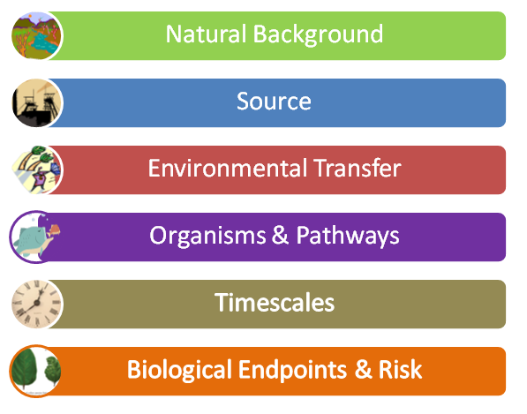
Figure A-1: General aspects which need to be considered when building scenarios.

Natural background
A baseline value for natural background should be established. Environmental radiological assessment of any human practice impacting on the environment focuses on dose rates to wildlife additional to natural background.

Source
The source of radiation exposure should be quantified. This includes a description of the relevant radionuclide quantities, locations of generation or storage, spatial extent, as well as the release type and duration. Typical releases are atmospheric (gases or dusts from stacks or less controlled processes), aquatic (via pipes to rivers, lakes or oceans or through sewerage systems) and/or, potentially, via groundwater (from mines, processing or storage facilities).

Environmental transport
Mechanisms by which radionuclides physically move through the environment should be identified. These can include migration or dispersion through soil, air or water – it also needs to be considered that the spatial and temporal scales of radionuclide transfer can vary. An appropriate dispersion model may need to be applied to estimate the transfer of the source material to the environment. In the case of past releases, the impacted environment should be sampled directly to provide reliable activity concentration data.

Organisms and pathways
An initial (screening) assessment is usually carried out using generic reference organisms. If this assessment indicates that there is no significant risk then this is the end of the process and specific information on organisms at the site is not necessary. For example, if the reference organism ‘Reptile’ is protected, there is no need to undertake a survey to determine which reptiles are present. Note that this applies even for rare, protected, culturally sensitive or keystone species, given the inherently conservative approach taken in a screening assessment, as a precautionary approach (Jordan and O’Riordan, 2004).
Where a more complex assessment is required, representative organisms should be determined – these can be obtained via surveys of organisms in the affected area or literature, and threatened species database searches.
Transfer of radionuclides to wildlife is discussed in Section 3. Relevant pathways of exposure from external and internal sources associated with defined exposure scenarios should be considered. The specific habits of the local wildlife or assumptions associated with these can also be incorporated into the scenario.

Timescales
The duration of source release or exposure time are important aspects to consider during the assessment. Most assessment models generally assume equilibrium conditions, and many standard parameters assume exposure for longer periods (i.e. in the order of years). Exposure times can usually be related to routine organism habits and behaviours. A short-term assessment (days and months following a release) might require specialised dynamic models (see UNSCEAR, 2014).
The nature of the source materials should also be taken into account. In some cases, where long half-life radionuclides are included in the source term, a long-term assessment of radionuclide transfer should be considered. To a reasonable extent, this may take into account timescales in which engineered controls might be expected to fail, potentially leading to the release of radionuclides to the environment.

Biological Endpoints and Risk
Exposure to radiation can cause a biological outcome. The size of the risk (or estimations of probability) that exposure to radiation will bring about deleterious effects on a population or ecosystem should be discussed in the context of ERLs. If possible, the discussion can be extended to how significant this effect may be. This encompasses analysis of transfer, uptake and effects of exposure to ionising radiation, including the derivation of dose-effect relationships for various biological endpoints in exposed organisms (Oughton et al., 2004). Consideration can also be given to the redundancy of the exposed habitat in relation to the broader regional context and the ability of biota to recruit back into the affected habitats from refugia.
- Undertaking the assessment
Once the scenario has been constructed, various aspects for undertaking the environmental assessment should be stepped through (see Figure A-2). Each of these has been included under the four sub-headings that follow.

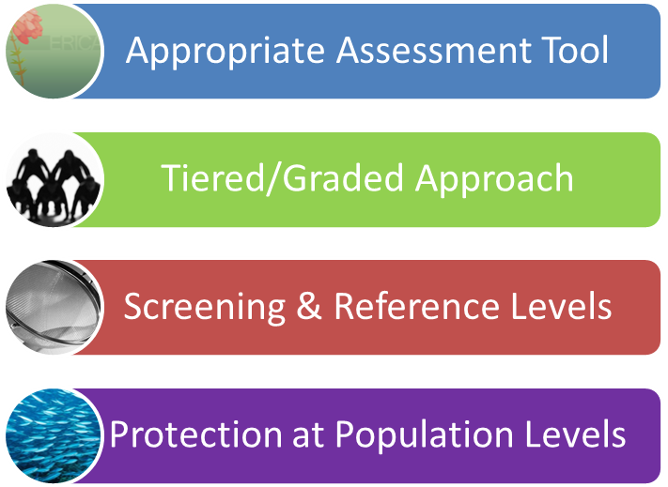
Figure A-2: Aspects which should be considered when performing an environmental radiological assessment (after building the scenario).

Appropriate assessment tool
Various tools (or models) are available for radiological assessment of the environment. These can use differing methodologies of calculation, and the user should take care to choose an appropriate tool for their specific application and be aware of assumptions that are applied within.
Some readily-available assessment tools that could be considered are the ERICA tool (Brown et al., 2008) and RESRAD-BIOTA (USDOE, 2004). These two tools have been tested in various inter-comparison exercises to look at model-model differences introduced by user assumptions (Beresford et al., 2008a; Beresford et al., 2010; Johansen et al., 2012; Vives i Batlle et al., 2007; Stark et al., 2015). The report of Doering (2010) indicates that the ERICA tool is appropriate for use in Australia; however any model consistent with ICRP methodology could be applied.
The above-mentioned models apply the concentration ratio (CR) methodology (see Section 3.2). The selection of appropriate CR data is important, as this parameter is likely to have the greatest influence on the assessment outcome. Most CRs can vary by orders of magnitude, and use of default CR values should be treated with caution, particularly for use in Australia where there are many different climate types. For screening level assessments of minor operations default values can be applied, however for most assessments a literature search would be appropriate. Where a literature search is undertaken, data for similar representative organisms and climate types should be used. Only for the highest risk operations should a monitoring programme for determining CRs be considered.
Some assessment tools evaluate Environmental Media Concentration Limits (EMCLs) to aid in decision making. These are defined as the activity concentration of a given radionuclide in media that will result in a dose rate to the most exposed reference organism equal to the screening dose rate, viz.
EMCL = D_{lim} / F
Here F is the dose rate that the organism will receive for the case of a unit concentration in environmental media, and D_{lim} is the limiting dose rate (e.g. screening dose rate or environmental reference value). See Brown et al. (2008) for more information.

Tiered/graded approach
An assessment tool that includes a tiered or graded approach should be applied (see Section 3.3). This will help to ensure that the assessment is as simple as possible but as complex as necessary.
A pictorial representation of a tiered approach showing screening and further, more complex tiers, is shown in Figure A-3. This flow chart shows the steps of building a scenario, applying a screening level and moving on to more complex assessment methodology if required (see Section 3.3).
The final justification is based upon known biological outcomes, sound ERLs and demonstration of protection (noting that the screening level should not be used as a dose limit).

Screening and reference levels
An initial screening using cautious assumptions applied to a general dose rate of 10 µGy h⁻¹ provides a reliable way to determine exposures which are not of concern and where no further justification is required.
Where the screening level is exceeded, a more complex assessment (with data more relevant to the site being studied) along with more realistic assumptions is required. Once calculated, dose rates should be compared with ERLs, which relate to observed biological effects on representative organisms from ionising radiation.

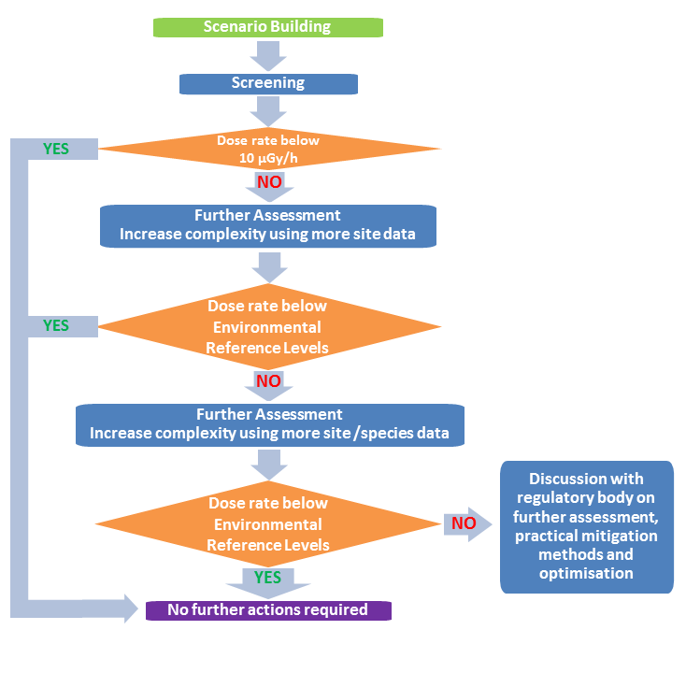
Figure A-3: Applying a tiered/graded approach in radiological assessment. Exposures which are not of concern can be identified at the screening stage. If required, further assessment (at a more complex level) can then be applied and justified by comparison with Environmental Reference Levels (based on species-specific biological effects data, such as ICRP DCRL bands).

Protection at population levels
Populations and ecosystems are the overall objects of protection (rather than aiming to protect at the individual plant or animal level). This can be incorporated into the information used in the setting of a screening value or ERLs and in the overall justification that protection has been demonstrated.
- Stakeholder consultation
During environmental assessment it is recommended that relevant stakeholders are engaged, with the amount of effort depending on the impact of the action being assessed and the level of community concern. The consultation process should demonstrate independence and show transparency and openness, with the aim being to inform stakeholders. It may also assist in checking the veracity of any assumptions made. The engagement of disparate stakeholders also has the advantage of ensuring that as much information as possible is provided for the assessment.
Stakeholders can include, but are not limited to:
- public & community groups
- local liaison groups (or committees)
- special interest groups
- proponents of the development and industry representatives
- journalists and social media commentators
- government authorities and decision makers
- professional bodies
- international organisations
- regulatory bodies (and their staff).
- Other considerations
When performing an environmental assessment, human and environmental protection should be considered in parallel. It is also important to note that other contaminants related to human actions can also have an influence on the environment, including, but not limited to:
- acid or alkaline materials
- heavy metals
- hydrocarbons
- pesticides
- thermal pollution
- chemical pollution.
The possible effects of these contaminants are not specifically considered in this Guide, which is focused on radiation protection. However, any deliberations on environmental impacts (such as in environmental impact assessments and statements) should include the effects of all possible contaminants and a characterisation of the relative risks that they may pose to populations and ecosystems.

References

Andersson, P., Garnier-Laplace, J., Beresford, N.A., Copplestone, D., Howard, B.J., Howe, P., Oughton, D., Whitehouse, P. (2009). Protection of the environment from ionising radiation in a regulatory context (protect): proposed numerical benchmark values. Journal of Environmental Radioactivity 100, 1100–1108.
Beresford, N.A., Barnett, C.L., Brown, J.E., Cheng, J.J., Copplestone, D., Filistovic, V., Hosseini, A., Howard, B.J., Jones, S.R., Kamboj, S., Kryshev, A., Nedveckaite, T., Olyslaegers, G., Saxén, R., Sazykina, T., Vives i Batlle, J., Vives-Lynch, S., Yankovich, T., Yu, C. (2008a). Inter-comparison of models to estimate radionuclide activity concentration in non-human biota. Radiation and Environmental Biophysics 47, 491–514.
Beresford, N.A., Barnett, C.L., Howard, B.J., Scott, W.A., Brown, J.E., Copplestone, D. (2008b). Derivation of transfer parameters for use within the ERICA Tool and the default concentration ratios for terrestrial biota. Journal of Environmental Radioactivity 99, 1393-1407.
Beresford, N.A., Barnett, C.L., Brown, J.E., Cheng, J-J.,Copplestone, D., Gaschak, S., Hosseini, A., Howard, B.J., Kamboj, S., Nedveckaite, T., Olyslaegers, G., Smith, J.T., Vives i Batlle, J., Vives-Lynch, S., Yu, C., 2010. Predicting the radiation exposure of terrestrial wildlife in the Chernobyl exclusion zone: an international comparison of approaches. Journal of Radiological Protection 30, 341–373.
Brown, J.E., Alfonso, B., Avila, R., Beresford, N.A., Copplestone, D., Pröhl, G., Ulanovsky, A. (2008). The ERICA Tool. Journal of Environmental Radioactivity 99, 1371–1383.
Brown J.E., Beresford, N.A., Hosseini, A. (2012). Approaches to providing missing transfer parameter values in the ERICA Tool – how well do they work? Journal of Environmental Radioactivity 126, 399–411.
Coughtrey, P.J., and Thorne, M.C. (1983). Radionuclides distribution and transport in terrestrial and aquatic ecosystems. Vol III, Balkema, Rotterdam.
DEST (Department of Education, Science and Training) (2003). Rehabilitation of former nuclear test sites at Emu and Maralinga (Australia) 2003: Report by the Maralinga rehabilitation technical advisory committee. Commonwealth of Australia, 2002.
Doering, C. (2010). Environmental protection: Development of an Australian approach for assessing effects of ionizing radiation on non-human species. ARPANSA Technical Report Series No. 154, Australian Radiation Protection and Nuclear Safety Agency.
Garnier-Laplace, J., Copplestone, D., Gilbin, R., Alonzo, F., Ciffroy, P., Gilek, M., Agüero, A., Björk, M., Oughton, D.H., Jaworska, A., Larsson, C.M., Hingston, J.L. (2008). Issues and practices in the use of effects data from FREDERICA in the ERICA Integrated Approach. Journal of Environmental Radioactivity 99, 1474–1483.
Garnier-Laplace, J., Della-Vedova, C., Andersson, P., Copplestone, D., Cailes, C., Beresford, N.A., Howard, B.J., Howe, P., Whitehouse, P. (2010). A multi-criteria weight of evidence approach for deriving ecological benchmarks for radioactive substances. Journal of Radiological Protection 30, 215–233.
Higley, K.A., Bytwerk, D.P. (2007). Generic approaches to transfer. Journal of Environmental Radioactivity 98, 4-23.
Hirth, G. (2014). A review of existing Australian radionuclide activity concentration data in non-human biota inhabiting uranium mining environments. ARPANSA Technical Report Series No. 167, Australian Radiation Protection and Nuclear Safety Agency.
Howard, B.J. (2013). A new IAEA handbook quantifying the transfer of radionuclides to wildlife for assessment tools. Journal of Environmental Radioactivity, 126, 284-287.
Howard, B.J., Larsson, C.-M. (2008). The ERICA Integrated Approach and its contribution to protection of the environment from ionising radiation. Journal of Environmental Radioactivity 99, 1361–1363.
Howard, B.J., Beresford, N.A., Copplestone D., Telleria, D., Proehl, G., Fesenko, S., Jeffree, R., Yankovich, T., Brown, J., Higley, K., Johansen, M., Mulye, H., Vandenhove, H., Gashchak, S., Wood, M.D., Takata, H., Andersson, P., Dale, P., Ryan, J., Bollhöfer, A., Doering, C., Barnett, C.L., Wells, C. (2013). The IAEA Handbook on radionuclide transfer to wildlife. Journal of Environmental Radioactivity, 121, 55-74.
IAEA (1992). Effects of ionizing radiation on plants and animals at levels implied by current radiation protection standards. Technical Report Series No. 332. IAEA, Vienna.
IAEA (2001). Generic models for use in assessing the impact of discharges of radioactive substances to the environment. Safety Reports Series No. 19 (2001). IAEA, Vienna.
IAEA (2009). Handbook of parameter values for the prediction of radionuclide transfer in terrestrial and freshwater environments. Technical Report Series No. 472. IAEA, Vienna.
IAEA (2009a). Quantification of radionuclide transfer in terrestrial and freshwater environments for radiological assessments. Technical document 1616. IAEA, Vienna.
IAEA (2012). Proposals for Themes for the IAEA’s model testing and comparison programme: MODARIA: “Modelling and Data for Radiological Impact Assessments”, May 2012.
IAEA (2014). Handbook of parameter values for the prediction of radionuclide transfer to wildlife. Techical Reports Series 479, IAEA, Vienna.
IAEA (2014a). Radiation Protection and Safety of Radiation Sources: International Basic Safety Standards General Safety Requirements. General Safety Requirements Part 3. IAEA, Vienna.
ICRP (2007). The 2007 Recommendations of the International Commission on Radiological Protection. ICRP Publication 103. Ann. ICRP 37(2–4).
ICRP (2008). Environmental Protection: the concept and use of Reference Animals and Plants. ICRP Publication 108. Ann. ICRP 38(4-6).
ICRP (2009). Environmental Protection: Transfer parameters for Reference Animals and Plants. ICRP Publication 114. Ann. ICRP 39(6).
ICRP (2014). Protection of the Environment under different exposure situations. ICRP Publication 124. Ann. ICRP 43(1).
Johnston, A., Humphrey, C., and Martin, P. (2003). Protection of the environment from the effects of ionising radiation associated with uranium mining. International Conference on the Protection of the Environment from the Effects of Ionizing Radiation. Stockholm, Sweded, 6-10 October 2003.
Johansen M.P., Kamboj S., and Kuhne W.W. (2013). Whole-organism concentration ratios for plutonium in wildlife from past US nuclear research data. Journal of Environmental Radioactivity. 126 (2013) 412-419
Johansen M.P., C.L. Barnett, N.A. Beresford, J.E. Brown, M. Černe, B.J. Howard, S. Kamboj, D.-K. Keum, B. Smodiš, J.R. Twining, H. Vandenhove, J. Vives i Batlle, M.D. Wood, C. Yu (2012). Assessing doses to terrestrial wildlife at a radioactive waste disposal site:Inter-comparison of modelling approaches. Science of the Total Environment 427-428 (2012) 238–246
Johansen M.P. and Twining J.R. (2010). Radionuclide concentration ratios in Australian terrestrial wildlife and livestock: data compilation and analysis. Radiation Environment Biophysics (2010) 49:603–611
Jordan A. and O’Riordan T. (2004) The precautionary principle: a legal and policy history, Chapter 3 in The precautionary principle: protecting public health, the environment and the future of our children. Edited by: Marco Martuzzi and Joel A. Tickner. World Health Organization.
Larsson, C-M. (2004). The FASSET Framework for assessment of environmental impact of ionising radiation in European ecosystems—an overview. Journal of Radiological Protection 24, A1–A12.
Larsson, C.-M. (2008). An overview of the ERICA Integrated Approach to the assessment and management of environmental risks from ionising contaminants. Journal of Environmental Radioactivity 99, 1364–1370.
Oughton, D., Zinger, I., Bay, I., and Larsson, C-M. (2004). DELIVERABLE D7a: First EUG Event – Part 2: Briefing notes on assessment frameworks and knowledge gaps. ERICA Contract FI6R-CT-2003-508847.
Psaltaki, M., Brown, J.E., and Howard, B.J. (2013). TRS CR_{WO-Water} values for the marine environment: analysis, applications and comparisons. Journal of Environmental Radioactivity 126, 367-375.
Stark, K., Andersson, P., Beresford, N.A., Yankovich, T.L., Wood, M.D., Johansen, M.P., Vives I Batlle, J., Twining, J., Keum, D.-K., Bollhöfer, A., Doering, C., Ryan, B., Grzechnik, M., Vandenhove, H. (2015). Predicting exposure of wildlife in radionuclide contaminated wetland ecosystems. Environmental Pollution, 196, 201–213.
Ulanovksy, A. and Prohl, G. (2006). A practical method for assessment of dose conversion coefficients for aquatic biota. Radiation and Environmental Biophysics 45(3), 203-214.
UNSCEAR (2011). Sources and effects of ionizing radiation. UNSCEAR 2008 Report to the General Assembly with Scientific Annexes. Annex E, Effects of ionizing radiation on non-human biota. United Nations, New York.
UNSCEAR (2014). Sources and effects of ionizing radiation. UNSCEAR 2013 Report to the General Assembly with Scientific Annexes. Annex A, Levels and effects of radiation exposure due to the nuclear accident after the 2011 great east-Japan earthquake and tsunami. United Nations, New York.
USDOE (2002). A graded approach for evaluating radiation doses to aquatic and terrestrial biota. Technical Standard DOE-STD-1153-2002. U.S. Department of Energy, Washington D.C.
USDOE (2004). RESRAD-BIOTA: a tool for implementing a graded approach to biota dose evaluation. ISCORS Technical Report 2004-02: DOE/EH-0676. United States Department of Energy.
Vives i Batlle, J., Balonov, M., Beaugelin-Seiller, K., Beresford, N.A., Brown, J., Cheng, J-J., Copplestone, D., Doi, M., Filistovic, V., Golikov, V., Horyna, J., Hosseini, A., Howard, B.J., Jones, S.R., Kamboj, S., Kryshev, A., Nedveckaite, T., Olyslaegers, G., Pröhl, G., Sazykina, T., Ulanovsky, A., Vives Lynch, S., Yankovich, T., Yu, C., 2007. Inter-comparison of absorbed dose rates for non-human biota. Radiation and Environmental Biophysics 46, 349–373.
Wood, M.D., Beresford, N.A., Howard, B.J., Copplestone, D. (2013). Evaluating summarised radionuclide concentration ratio datasets for wildlife. J. Environ. Radioactive. http://dx.doi.org/10.1016/j.jenvrad.2013.07.022.
Yankovich TL, Beresford NA, Wood MD, Aono T, Andersson P, Barnett CL, Bennett P, Brown JE, Fesenko S, Fesenko J, Hosseini A, Howard BJ, Johansen MP, Phaneuf MM, Tagami K, Takata H, Twining JR, Uchida S (2010). Whole-body to tissue concentration ratios for use in biota dose assessments for animals. Radiation Environment Biophysics (2010) 49:549–565.

Glossary

assessment context
A set of circumstances or facts which should be considered when performing an assessment of radiological impacts to people and/or wildlife.
background
Concentrations and variability of natural radioactivity and associated radiation dose in any environment. If measured prior to any contamination (q.v.) can be used as a baseline for measuring change.
biokinetic
Relating to dose assessment models that consider the rate and extent of radionuclide transfer processes into, within, and from organisms. Biological half-times (q.v.) are included or assessed by such models.
biological diversity
The variety within and between all species of plants, animals and micro-organisms and the ecosystems within which they live and interact.
biological half-time (half-life)
A measure of the rate at which radionuclides are excreted from organisms after uptake. This factor affects the internal radiological dose (q.v.) received. Given that various portions of the radionuclide contaminant may be sequestered in different tissue types, half-times are often referred to as either ‘fast’ or ‘slow’ to reflect the different excretion rates from those tissues.
chronic
Occurring or recurring over a substantial time period in the context of the effects being observed.
DCRLs (Derived Consideration Reference Levels)
An ICRP (q.v.) term relating to a band of dose rates where a decision-maker may need to consider the potential for deleterious effects of radiation in that particular species. This is conceptually equivalent to environmental reference levels (q.v.) in this safety guide.
dose – absorbed
The energy deposited within any material by the passage through it of ionising radiation (Grays: 1 Gy = 1 joule/kg).
dose – effective
The energy deposited within the human body by the passage through it of ionising radiation which also takes into account the relative biological effectiveness of different radiation types (alpha, beta, gamma) and the sensitivity of different tissue types to radiation damage. (Sieverts: 1 Sv = 1 joule/kg x radiation weighting factor x tissue weighting factor).
dose – equivalent
The absorbed dose delivered by a type of radiation averaged over a tissue or organ multiplied by the radiation weighting factor for the radiation type.
dose – external
Radiological dose to any organism arising from radionuclides present in the environment (i.e. in soil, water or air), or on the surface (e.g. skin, fur, leaf surfaces, etc.) of an organism. It is also affected by occupational factors (e.g. time and proximity near the bottom sediments for fish; immersion for amphibians; time underground for burrowing animals; foraging range; etc.).
dose – internal
Radiological dose arising from radioactivity taken into an organism via ingestion, inhalation or via wounds.
dose conversion coefficients (DCCs)
Factors used to relate radionuclide activity concentrations in soil or water to external doses of exposed organisms, and concentrations in the organism to internal doses. See also modelling; background.
dose rate
The average level of dose that any material or biota is exposed to over time (biota dose rate is typically measured in mGy/hr).
dosimetry
The measurement or modelling of dose (q.v.) or dose rate (q.v.).
dynamic model
A model that incorporates parameters to account for time variable factors such as patterns of radioactive contaminant release, radiological half-life, ingrowth of radioactive progeny, biological half-life (q.v.), environmental transport and other processes.
ecosystem
A community of living organisms in conjunction with the nonliving components of their environment (things like air, water and mineral soil), interacting as a system.
emergency exposure situation
An unexpected situation of exposure that arises as a result of an accident, a malicious act, or any other unexpected event, and requires prompt action in order to avoid or to reduce adverse consequences.
environment (natural and semi-natural)
A collective term for all of the physical, chemical, and biological conditions within which wild animals and plants normally live.
environmental exposure
The exposure of wildlife to ionising radiation (q.v). This includes exposure of animals, plants and other organisms in the natural environment.
environmental impact assessment
The formal process used to predict the environmental (q.v.) consequences (positive or negative) of a plan, policy, program, or project prior to the decision to move forward with the proposed action.
environmental reference level (ERL)
Dose rates to wildlife at which a more considered evaluation of the situation should be considered. The ERLs should be derived from knowledge of biological effects in wildlife (e.g. DCRLs (q.v.)), and their relationship to dose rate.
environmental media concentration limit (EMCL)
The activity concentration of a given radionuclide in media that will result in a dose rate to the most exposed reference organism equal to the screening dose rate.
equilibrium
The assumed condition whereby the activity concentration and/or dose in a reference organism is stable in respect to the environmental media concentrations to which it is exposed.
existing exposure situation
A situation of exposure that already exists when a decision on the need for control needs to be taken, including prolonged exposure situations after emergencies.
exposure scenario
The postulated means by which the wider environment, and biota within it, may be exposed to contamination (q.v.).
exposure situation
Either planned (q.v.), existing (q.v.), or emergency (q.v.).
graded approach
A structured methodology for assessing environmental exposure (q.v.) in which the complexity increases in proportion to the risk.
gray (Gy)
The unit to describe the energy deposited in any material from the passage through it of ionising radiation (1 Gy = 1 joule/kg). See Dose-absorbed.
ionising radiation
For the purposes of radiation protection, radiation capable of producing ion pairs in biological material(s).
linear energy transfer (LET)
A measure of how, as a function of distance, energy is transferred from radiation to the exposed matter. A high value of linear energy transfer indicates that energy is deposited within a small distance.
planned exposure situation
A situation involving the deliberate introduction and operation of sources. Planned exposure situations may give rise both to exposures that are anticipated to occur (normal exposures) and to exposures that are not anticipated to occur (potential exposures).
population (of organisms)
a. A group of individual organisms belonging to a same species and sharing a well-defined pattern of environmental conditions.
b. An abstract group of individuals of the same biological species that share the same geographic patch and can interact with one another with limited interactions from outside.
radiosensitivity
The relative effect of similar radiation on different biota. Some organisms are more sensitive (e.g. mammals, trees) than others (e.g. insects, plankton).
Reference Animals and Plants (RAPs)
A suite of organisms recommended as models by the ICRP (q.v.) as Reference Animals and Plants for the purposes of estimation environmental dose.
reference organism
An numerical approximation of the representative organism (q.v.) that provides a basis for the estimation of radiation dose rate.
relative biological effectiveness (RBE)
A relative measure of the effectiveness of different radiation types at inducing a specified health effect.
representative organism
A living organism that is typical of its class present in a contaminated environment.
screening value
The absorbed dose rate to an organism above which further considerations or investigations are warranted.
sievert
See dose – effective.
species
Groups of actually or potentially interbreeding natural populations, which are reproductively isolated from other such groups.
tiered approach
An approach applied to an assessment of radiological risk which supports the graded approach (q.v.) to protection. The first tier often will involve the application of a screening value (q.v.).
wildlife
Any wild animal or plant living within its natural environment. This excludes stock, farmed, feral or domesticated species. The objects of environmental protection and used interchangeably with non-human biota (q.v.), plants and animals, and flora and fauna (q.v.) in this Guide.

Contributors to Drafting and Review
Dr Marcus Grzechnik Working Group Chair, Radiation Health Services Branch, ARPANSA, Victoria
Assoc Prof Brad Cassels Radiation Health Committee Representative, Health Protection Branch, Department of Health, Victoria
Dr Che Doering Specialist Scientific Member, Environmental Research Institute of the Supervising Scientist (eriss), Department of the Environment, NT
Mr Frank Harris Industry Representative, Rio Tinto, NT
Dr Gillian Hirth Specialist Scientific Member, Radiation Health Services Branch, ARPANSA, Victoria
Dr Mat Johansen Specialist Scientific Member, Radioecology Research, Environmental Research, ANSTO, NSW
Dr Carl-Magnus Larsson Specialist Review, CEO, ARPANSA, Victoria
Dr John Twining Specialist Scientific Member, Austral Radioecology, NSW

Radiation risk, as described in the Fundamentals for Protection Against Ionising Radiation (RPS F-1; ARPANSA, 2014), refers to the likelihood of detrimental human health effects occurring as a result of exposure to ionising radiation, and includes consideration of environmental risks that might arise from such exposure. Exposure may be due to the presence of radioactive material (including radioactive waste) or its release to the environment; or a loss of control over a nuclear reactor core, a nuclear chain reaction, a radioactive source or any other source of radiation; alone or in combination and above and beyond background.
This does not mean zero radiation dose to flora and fauna. The achievement of an effective level of protection of populations is sought.
The United Nations Scientific Committee on the Effects of Atomic Radiation (UNSCEAR) evaluated effects of radiation on wildlife for its 1996 and 2008 Reports to the United Nations General Assembly. While the uncertainties are considerable and the assessed endpoints wide-ranging, the Committee considered that when high linear energy transfer (LET) radiation makes up a significant portion of the exposure, it may be relevant to consider the relative biological effectiveness (RBE) for such radiations (see UNSCEAR, 2011).
The ERICA (Environmental Risks from Ionising Contaminants: Assessment and Management) Project (Larsson, 2008) defined reference organisms as follows: “…. a series of entities that provide a basis for the estimation of radiation dose rate to a range of organisms which are typical, or representative, of a contaminated environment. These estimates, in turn, would provide a basis for assessing the likelihood and degree of radiation effects.” ICRP has used a related concept, Reference Animals and Plants.
Future improvements in biota dosimetry modelling, such as those under development within the IAEA MODARIA program (IAEA, 2012) as well as by the ICRP, may enable more realistic geometries and radionuclide distributions to be investigated, including uptake by and doses to specific tissues and recognition of the temporal nature of environmental exposure and biological response.
Dispersion models for use during emergencies (i.e. those that simulate particles or puffs) could be applied to gain knowledge of a time-series of radionuclide concentrations. This may not be relevant in an equilibrium situation.
Equilibrium and dynamic models were compared for marine exposure modelling by UNSCEAR in its 2013 report to the United Nations General Assembly on radiation exposures and effects of the accident at the Fukushima Daiichi nuclear power station (UNSCEAR, 2014). The use of dynamic models is being investigated in the IAEA’s four-year MODARIA program (IAEA, 2012).
It is important to specify fresh or dry weight when reporting sample results or ratios as a lack of doing so may lead to errors as high as an order of magnitude.
Atmospheric release of ²²²Rn and progeny could also apply here where such releases are enhanced by human activities, however a concentration ratio approach is unlikely to apply.
This screening level value has been derived from statistical analysis of radiation effects data using an accepted methodology for the derivation of benchmark values for chemical stressors on the environment. Garnier-Laplace et al. (2010) used EDR10 data (dose rates giving a 10% effect in comparison with control) to fit a species sensitivity distribution (SSD) and estimate the HDR5 (the hazardous dose rate affecting 5% of species with a 10% effect). An assessment factor (AF) was applied to the HDR5 to estimate a predicted no effect dose rate value. The suggested generic screening value of 10 µGy h⁻¹ was derived using the lowest available EDR10 value per species, an unweighted SSD, and an AF of 2 applied to the estimated HDR5. It represents the dose rate at which 95% of the species in the ecosystem are expected to be protected, with an additional safety factor incorporated to account for limitations in the initial data.
Data obtained from the literature from areas of similar climate type could also be applied.
ICRP discussed optimisation of protection of the environment under different exposure situations in its Publication 124 (ICRP, 2009).
Extent of exposure includes the spatial and temporal scales over which the exposure may occur, as well as the number of species and populations exposed.
An assessment can be undertaken for a planned or emergency exposure without information on the natural background, however it is considered best practice to establish this value in order to verify any potential impacts in the future.

