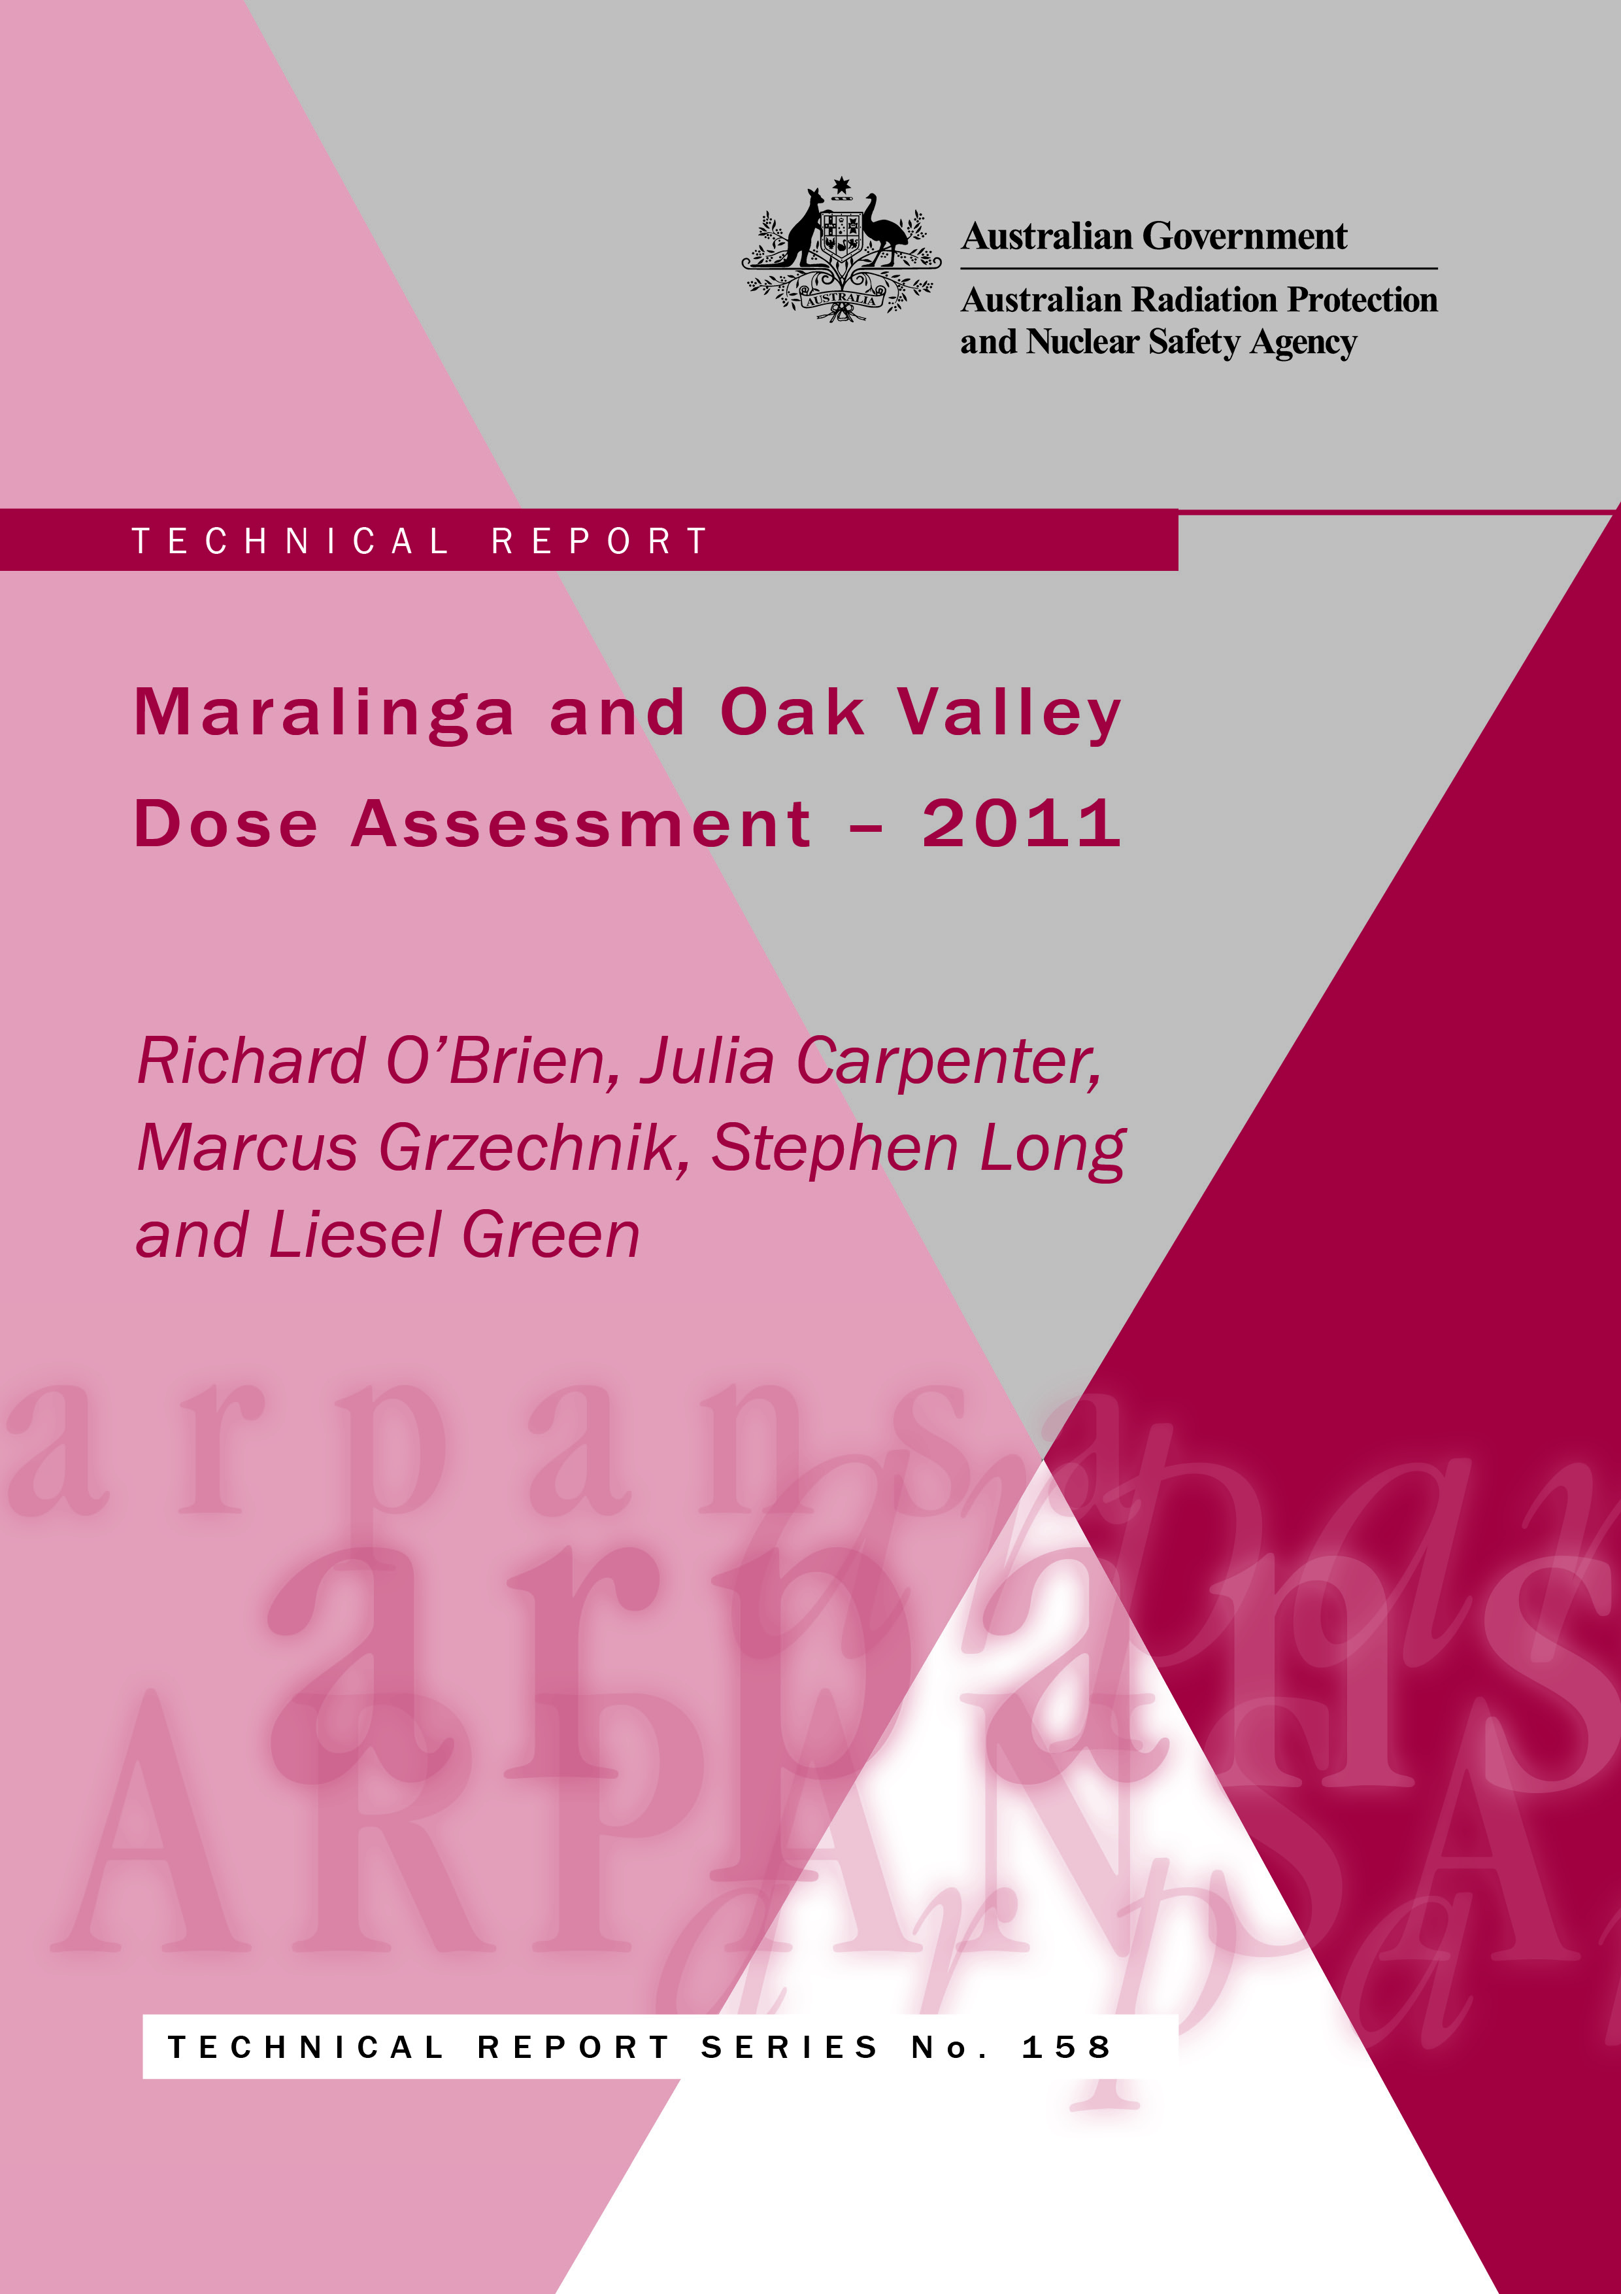

Maralinga and Oak Valley Dose Assessment – 2011

by

Richard O’Brien, Julia Carpenter, Marcus Grzechnik, Stephen Long and Liesel Green

Notice

Australian Radiation Protection and Nuclear Safety Agency

Creative Commons

With the exception of the Commonwealth Coat of Arms, this publication, Maralinga and Oak Valley Dose Assessment – 2011, by the Australian Radiation Protection and Nuclear Safety Agency is licenced under a Creative Commons Attribution 3.0 Australia licence (http://creativecommons.org/licenses/by/3.0/au/).

The publication should be attributed as Maralinga and Oak Valley Dose Assessment – 2011.

Enquiries regarding the licence and any use of this report are welcome.

ARPANSA
619 Lower Plenty Road
YALLAMBIE VIC 3085

Tel: 1800 022 333 (Freecall) or +61 3 9433 2211
Email: info@arpansa.gov.au
Website: www.arpansa.gov.au

Disclaimer
All care has been taken in the preparation of this work and its conclusions. However, where the data or results presented are utilised by third parties the Commonwealth of Australia shall not be liable for any special, indirect, consequential or other damages whatsoever resulting from such use. Nor will the Commonwealth of Australia be liable for any damages arising from or in connection with any errors or omissions that have inadvertently occurred in this work.

Acknowledgements

The authors wish to acknowledge the traditional owners of the land, the Maralinga Tjarutja people, for access to their land at Maralinga and Oak Valley.
We also wish to acknowledge the contribution of Jane McLeish and Wayne Patullo, who carried out the soil sampling and dust loading measurements at Oak Valley in 2011.
We would like to thank the Oak Valley community for allowing indoor and outdoor ambient dust measurements to be taken.
Finally, we wish to thank the Dodd family at Maralinga for their hospitality and their support in operating the equipment at Oak Valley.

Executive Summary
This work was carried out under Memorandum of Understanding Number 001872 (Schedule 1) between ARPANSA and the Department of Resources Energy and Tourism (signed in 2011). The relevant clauses are reproduced in Appendix 1. This study meets the requirements of the Memorandum of Understanding with respect to clauses 1.4(a), 1.4(b), 1.5, 1.6(a), 1.6(b), and 1.6(c).
Experimental results show that the properties of the contaminated dust and surface soil at Maralinga have not changed significantly since the MARTAC assessment was carried out. Comparison of the results from this study and the MARTAC study suggests that the TAG/MARTAC conclusions were reasonable.
The reassessment was carried out using the RESRAD-OFFSITE software code. This code has the capability to model the radiation exposure of an individual who spends time directly above the primary contamination (onsite) and in the vicinity of the primary contamination (offsite). The code uses a pathway analysis method, in which radiation exposures are calculated by evaluation of each pathway of exposure. By making assumptions about the values of the input parameters and the environmental transport factors, RESRAD-OFFSITE can be used to simulate various exposure scenarios, including rural and semi-nomadic life-styles.
The reassessment using RESRAD-OFFSITE estimated a total annual dose of approximately 4 mSv to a 10 year old child spending 100 % of the time outdoors in the contaminated zone, compared with the original TAG/MARTAC assessment of dose of 5 mSv. The consistency between the results confirms that the MARTAC clearance criteria were appropriate.
New information on the 2011 living habits of the indigenous peoples living at Oak Valley and recent dust measurements have been used to estimate the doses to the residents of Oak Valley. This dose assessment shows that the additional doses to people living at Oak Valley due to the contaminated plumes at Taranaki are negligible compared with the natural radiation background levels.
The original TAG/MARTAC dose assessment for the remediated areas of Taranaki was based on conservative assumptions, and was used as the basis for the MARTAC clearance criteria. Using the results of the anthropological surveys and recent dust measurements from Oak Valley, estimates of doses were made for the assumption of continuous habitation within the restricted zone. The reassessment shows that the doses resulting from continuous habitation inside the Taranaki restricted area of the Maralinga land grant area may exceed the 5 mSv MARTAC clearance criteria unless the site is located off the plumes. For infrequent occupancy, the radiation doses within the restricted zone are minimal and pose no concern to health.
This confirms the MARTAC recommendation to set up the restricted area. A detailed assessment of permanent occupation would require up to date site-specific information on soil concentrations, dust loadings, soil ingestion rates, dietary intake and social and cultural factors. There is no justification for changing the clearance criteria established by the MARTAC committee, as these criteria are consistent with current international recommendations on remediation of legacy sites and existing situations.
There have been no significant changes in international recommendations that would affect the radiation safety situation at Maralinga, unless pit covers have been damaged or significant areas of contamination were missed during the remediation work. As no evidence of either of these possibilities has been established, no modifications of the radiation safety measures implemented during the 1995-2000 Maralinga Rehabilitation Project are justified at this time.
Given the long-term nature of the contamination, a similar reassessment should be made in approximately 20-25 years. This could be undertaken earlier if there is any failure of remediation controls, or if any significant change occurs in land use or in environmental conditions. This assumes that regular inspections of the site will be made in the future.

Contents
Executive Summary iii
1 Introduction and History 1
1.1 Purpose of the investigation 1
1.2 Weapons testing 1
1.3 Operation Brumby 2
1.4 The Australian Government Cleanup 2
1.4.1 Technical assessments 2
1.4.2 General remediation methodology 3
2 Scope 7
3 General methodology 8
3.1 The RESRAD-OFFSITE Code 8
3.2 Data required 8
3.3 Lifestyle of local people - anthropological study 8
3.4 Assumptions and Correction Factors 9
3.4.1 Correction for child dose coefficients, and breathing and ingestion rates 9
3.4.2 Correction for preferential attachment of plutonium and americium to the finer dust particles 9
3.4.3 Effects of variation in diet 10
3.4.4 The assumed value for dust loading 10
3.4.5 Soil removal at Taranaki 11
3.4.6 Summary of correction factors 11
4 Reassessment of the TAG doses and MARTAC clearance criteria 12
4.1 TAG/MARTAC dose reassessment 12
4.2 TAG/MARTAC dose reassessment results 13
4.3 Implications of the TAG/MARTAC dose reassessment 14
5 Oak Valley dose estimate 15
5.1 Exposure scenarios 15
5.2 Dust measurements 16
5.3 Methodology 16
5.3.1 The assumed size of the contaminated zone 17
5.4 Total dose estimates 17

6 Investigation of future doses within the restricted area 19
6.1 Doses within the remediated area at Taranaki 19
6.2 Doses at other sites within the restricted area 20
7 Discussion 22
8 Conclusions and recommendations 24
9 Glossary 25
10 References 26
Appendix 1 Extract from Memorandum of Understanding Number 001872 29
Appendix 2 Summary of assumptions 30
Appendix 3 Enhancement Factor and Activity Ratio 32
Appendix 3.1 Methodology 32
Appendix 3.2 Mass Distributions 33
Appendix 3.3 Enhancement Factors 34
Appendix 3.4 Plutonium to Americium Ratio 34
Appendix 3.5 Conclusion 34
Appendix 4 Ambient Dust Levels at Oak Valley 36
Appendix 4.1 Methodology 36
Appendix 4.2 Results 36
Appendix 4.3 Conclusion 38

Introduction and History

Purpose of the investigation
The purpose of the investigation was to check the MARTAC clearance criteria and assess the radiation doses for the Taranaki restricted area and to the indigenous population at Oak Valley using improved knowledge of habit, the physical environment and changes in radiation protection assessment methods.

Weapons testing
The first British atomic bomb explosions in Australia were conducted at the Monte Bello Islands off the Western Australian coast in 1952. In 1953 Britain conducted two atomic explosions at Emu in South Australia. In 1956 two more tests were conducted at the Monte Bello islands. During 1956 and 1957, Britain conducted seven atomic explosions at Maralinga.
From 1957 to 1963 several hundred ‘minor trials’ were also conducted at Maralinga, contaminating the environment with plutonium and other radioactive debris.
The locations of Maralinga and Emu, and Oak Valley (which is the focus of this study) are shown in Figure 1.

Figure 1: A map of north-west South Australia showing the Maralinga land sections and the Woomera prohibited area (MARTAC 2002).
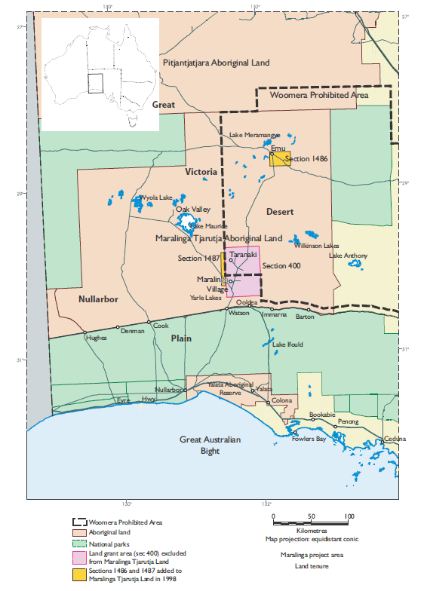

Operation Brumby
In 1966 the British Government conducted a cleanup, code-named operation ‘Brumby’ (Cook 1967). This involved shallow ploughing of finely divided surface material, and collection of large fragments of contaminated material and placement of this material in burial pits which were then capped with concrete. This was supposed to have left most of the Maralinga area in a safe condition for a traditional aboriginal lifestyle.

The Australian Government Cleanup

Technical assessments
Preliminary studies by the Australian Radiation Laboratory (ARL) during 1984 and 1985 (Cooper et al. 1985; Lokan 1985) indicated that contamination levels were significantly higher than previously reported. As a result of these studies, a technical assessment group (TAG) was set up by the Australian Government in 1986 to oversee further technical studies of the site and to advise on rehabilitation options.
More detailed studies in the late 1980s (Johnston et al. 1989) showed extensive contamination by plutonium over well-defined plumes corresponding to the wind direction at the time of each minor trial. The results of these studies for the Taranaki site are shown in Figure 2. Additional plumes were also found at two other sites (TM and Wewak, not shown on map) to the east of Taranaki, where minor trials were also conducted.
Figure 2: A map of the Maralinga area, showing the approximate locations and boundaries of the plutonium plumes resulting from the minor trials (Johnston et al. 1989).

General remediation methodology
The remediation methodology at Maralinga consisted of the following steps:
- site characterisation
- source term characterisation
- risk assessment
- establishment of cleanup criteria (goals)
- cleanup
- verification.
More details can be found in the Maralinga Rehabilitation Technical Advisory Committee (MARTAC) report (MARTAC 2002).

Site characterisation
The site is desert, with very low rainfall. It is characterised by low scrub and desert grasses. The ground water is generally not suitable for drinking due to high salinity. The surface soil is predominantly sandy, with occasional outcroppings of hard sandstone and limestone.

Source term characterisation
Measurements throughout the 1980s and 1990s (Burns et al. 1995; Cooper et al. 1985; Cooper et al. 1994; Johnston et al. 1989; Lokan 1985; MARTAC 2002) showed that most of the contamination remained within 10-20 cm of the surface (due to the low rainfall) and consisted of three components:
- visibly identifiable fragments of plutonium-contaminated debris
- approximately uniformly distributed finely divided material (potentially inhalable), consisting of grains of plutonium oxide or contaminated soil
- randomly distributed sub-millimetre size ‘hot’ particles of soil or other material.
As part of the earlier cleanup activities, many of the fragments had already been placed in 22 burial pits which were capped with concrete.

Risk assessment
MARTAC was established in 1993 to evaluate the risks and determine acceptable cleanup criteria. This committee included experts from Australia, the USA and Great Britain.
The risk assessment was based on a study of the diet and habits of people living in or passing through the area (MARTAC 2002), and established that the group most at risk would be an indigenous community camping and hunting on contaminated land.
The TAG/MARTAC dose assessment considered each exposure pathway separately, and used best estimates of intake rates (based on measurements wherever possible) to estimate the contribution of each pathway to the total dose.
The exposure pathway found to be of greatest concern was inhalation of dust by children playing around camp sites. Measurements showed that the dust concentrations due to these activities were significantly larger than the concentrations due to wind action (Williams et al. 2002).

Cleanup criteria
As a result of its work, the MARTAC committee established a set of cleanup criteria for the Maralinga site (MARTAC 2002). These were based on a maximum dose (due to the effect of contamination from the weapons testing program) of 5 mSv per year to any individual, for full-time occupancy by indigenous people living an outstation lifestyle.
The cleanup criteria were defined as measurable quantities to enable the 5 mSv per year dose constraint to be met. The criteria are:
- the average level of surface radioactive contamination over a hectare would not exceed 3 kBq m⁻² of Am-241
- no particle or fragment exceeding 100 kBq Am-241 would be present
- particles of activity greater than 20 kBq Am-241 would not exceed a surface density of 0.1 per square metre.
The average level was specified in terms of Am-241 because all the measurements were made in terms of the Am-241 concentrations using a procedure developed by Burns et al. (1994). The maximum allowable concentration of finely divided material (after remediation) was estimated at 3 kBq m⁻² of Am-241. The Pu-239:Am-241 ratio was found to vary from one plume to another (Johnston et al. 1988; Burns et al. 1990, 1994, 1995). For the north-west plume at Taranaki, which is relevant to this study, this ratio was found to be 7.2 (Johnston et al. 1988; Burns et al. 1990, 1994, 1995), which leads to a maximum allowable concentration per unit area (areal density) of approximately 21.6 kBq m⁻² for finely divided Pu-239.

Cleanup procedure
The top 10-20 cm of soil were removed by scraping. This material was placed in burial pits and covered with 5 m of clean soil. Material from 11 of the existing burial pits was treated by in-situ vitrification (ISV). Material from the remaining pits was exhumed and placed in another large burial pit.

Radiation protection issues during the cleanup
The main radiation protection and health physics concerns during the cleanup were inhalation of plutonium associated with airborne dust particles, and transfer of plutonium from contaminated to non-contaminated areas via vehicles or clothing. Dust suppression was achieved by spraying water on the haulage routes. A strict health physics regime was applied to all personnel working in the contaminated areas to minimise the probability of inhalation or ingestion of contaminated material. Vehicles were checked before being allowed to leave contaminated areas to minimise transfer of contamination.

Verification
A program of verification measurements was carried out (Martin et al. 2002; Shinn 2003) to demonstrate that the cleanup criteria had been met. Two measurement systems were built by ARL in the early 1990s. They were designed to verify the two main cleanup criteria, namely the average concentration of finely divided plutonium per square metre and the number of ‘hot’ particles per square metre. These systems are shown in Figure 3 and Figure 4.
In addition, measurements of plutonium in suspended dust were made by staff from Lawrence Livermore National Laboratory (USA) and the Australian Radiation Laboratory (Shinn 2003). The results confirmed that the airborne concentrations of plutonium were at acceptable levels.

Figure 3: The purpose-built vehicle used for measurements of the areal distribution of finely divided plutonium as part of the verification studies
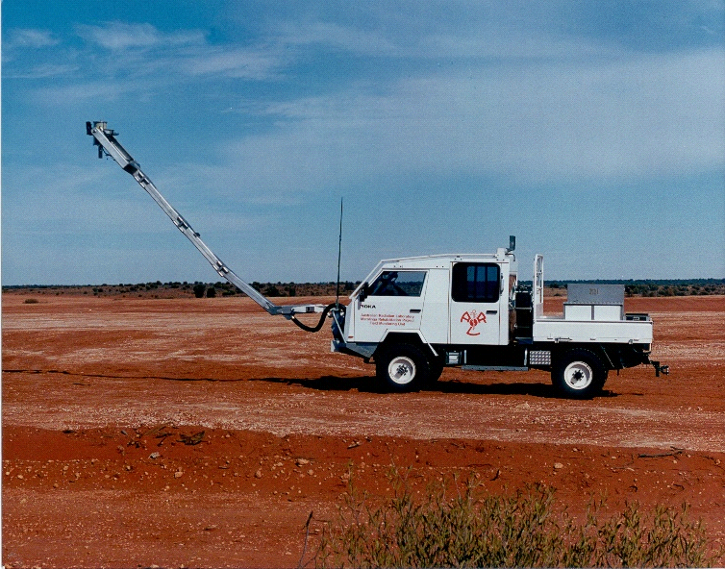

Figure 4: The purpose-built vehicle used for detection of particles contaminated with plutonium during the verification program.

The procedures developed and used at Maralinga have been used and/or adapted for similar situations in other countries.

Scope
Memorandum of Understanding Number 001872 (see Appendix 1) sets out a series of requirements relating to on-going review of the Maralinga site and surrounding areas.
The scope of this study is to check:
- the original TAG dose assessment
- the MARTAC clearance criteria
- whether any modifications are required to the radiation safety measures that were put in place during the 1995-2000 Maralinga Rehabilitation Project.
This study includes a re-evaluation of the doses to the indigenous population at Oak Valley and a determination as to whether the doses are still within the dose criteria established by MARTAC.
It also includes estimations of possible doses to people on the basis of future continuous habitation within the Maralinga restricted area (Section 400).
This is part of the on-going process of providing up to date information and advice to the local people who live in the area, in particular at the village of Oak Valley (see Figure 1 and Figure 2).

General methodology

The RESRAD-OFFSITE Code
This work has been carried out using the RESRAD-OFFSITE (version 2.6) code (Yu et al. 2009). The RESRAD-OFFSITE code uses knowledge of the source term and transfer parameters to derive the radionuclide concentrations used to calculate the dose contributions for a range of exposure pathways, including external exposure, ingestion of contaminated food and water, and inhalation of airborne radioactivity. The code has the capability to model the radiation exposure of an individual who spends time directly above the primary contamination (onsite) and in the vicinity of the primary contamination (offsite). By selecting different pathways, RESRAD-OFFSITE can be used to simulate various exposure scenarios, including rural and semi-nomadic life-styles.
RESRAD-OFFSITE does not model resuspension of dust or ingestion of soil. For the dust resuspension pathway the dust mass loading in air has to be specified as an input parameter. For ingestion of soil the ingestion rate is specified by the user.
Radionuclide concentrations in resuspended dust were not measured for this study. This meant that internal dosimetry models such as IMBA (Birchall et al. 1998; Marsh et al. 2003; Birchall et al. 2005) could not be used directly. RESRAD-OFFSITE allows the dust loading to be used as an input parameter (see above), which makes the code suitable for this study. Using a different modelling and assessment approach from that used in previous studies (Haywood & Smith 1990) provides an independent method of checking the earlier calculations.
Except where specifically indicated in this report, the default values for the RESRAD-OFFSITE input parameters were used in the calculations (Yu et al. 2006, 2007, 2009).
This section describes the features that were common to all parts of the assessment. The specific details relating to the TAG/MARTAC assessment are described in Section 4, while those relevant to the assessment of doses to the residents of Oak Valley and a possible future settlement within the restricted area are described in Section 5 and Section 6.

Data required
The information required for this assessment includes the habits and diet of the local residents, the dust loadings (both natural and man-made), and the radionuclide concentrations in the dust.
The original MARTAC assessment (MARTAC 2002) identified dust inhalation as the major contributor to the total dose. This is unlikely to have changed, unless the habits of the local people have changed significantly or a different methodology of assessment is applied.

Lifestyle of local people - anthropological study
A study of the habits and diet of the local aboriginal population (Palmer and Asche 2011) has shown that:
- The dust exposure to Oak Valley residents due to travel in vehicles is well in excess of those expected for most Australians living in towns or cities. This is due to the use of heavy vehicles and lack of sealed roads.
- Exposure to dust is highly variable within the community. Variations are due to weather conditions, some members of the community choosing to camp outside and children spending considerable time playing outdoors on the ground.
- It is estimated that the local diet now contains no more than 10% traditional food (bush tucker); this is less than in previous studies.
  - Assumptions and Correction Factors
The dose estimates in this work have been made using RESRAD-OFFSITE in its standard form. RESRAD-OFFSITE uses the dose coefficients, breathing rates and ingestion rates for an adult. The TAG/MARTAC assessment (MARTAC 2002) concluded that the ‘critical group’ for dose assessment purposes at Maralinga was children playing on the ground. Several corrections have been made to the RESRAD-OFFSITE estimates to enable comparison with the original MARTAC estimates for the 10 year old child, and to allow for limitations in the RESRAD-OFFSITE model. These are discussed in the following sections.

Correction for child dose coefficients, and breathing and ingestion rates
The RESRAD-OFFSITE estimates used intake rates and dose coefficients for adults. The dose coefficients for inhalation of class S Pu-239 are 1.9×10⁻⁵ Sv Bq⁻¹ for a 10 year old child and 1.6×10⁻⁵ Sv Bq⁻¹ for an adult (ICRP 1996). The class S values were chosen because the Pu-239 and Am-241 were assumed to be in a highly insoluble form. In addition, the class S values are the highest values for the 10 year old, with the exception of the ingestion coefficient for Pu-239. This approach is consistent with the conservative assumptions made throughout this work. This means that the RESRAD-OFFSITE estimates for dust inhalation have to be multiplied by a factor of 1.19 to correct for the age-related differences in the dose coefficients.
The higher inhalation dose coefficient for a child is partially offset by the lower breathing rate for a child relative to an adult (ICRP 1995). This adjustment for dose coefficients and breathing rates introduces uncertainty into the final results. However, this uncertainty is unlikely to be significant, in view of the large uncertainties in the actual exposure times, and other parameters used in the model calculations. For this study, no correction for the lower breathing rate of the child has been applied (the conservative assumption).
For the ingestion pathways the ratio of the dose coefficients for ingestion of class S Pu-239 (2.7×10⁻⁷ Sv Bq⁻¹ for a 10 year old child and 2.5×10⁻⁷ Sv Bq⁻¹ for an adult (ICRP 1996)) was used as a correction factor. This factor (1.08) was applied to the RESRAD-OFFSITE ingestion estimates to correct for the higher dose coefficient for the 10 year child.

Correction for preferential attachment of plutonium and americium to the finer dust particles
RESRAD-OFFSITE implicitly assumes that the radionuclide concentration in respirable dust particles is the same as the radionuclide concentration in surface soil, i.e. the

radionuclides attach uniformly to all dust particles, regardless of the particle size. Several studies (Burns et al. 1990, 1995; Cooper et al. 1985, 1994; Johnston et al. 1993) showed that, at Maralinga, the plutonium and americium tends to associate with the finer particles in soil. As the size of the resuspended dust particles is generally smaller than the average particle size in surface soil, the plutonium activity concentration in resuspended dust will be higher than that in surface soil. The Williams study used an average enhancement factor of 6.2±0.5 for the Taranaki plumes, which include the North-west plume that is assumed to be the source of potential contamination at Oak Valley.
A program of dust measurements was carried out (Long & Green 2012) to determine if the preferential attachment of radionuclides to the finer particles in the surface soil and dust had changed since the original measurements were made. The results of the size segregation studies were consistent with those reported in earlier studies, and indicated that no significant change had taken place in the fraction of plutonium and americium which attached to the finer particles. A summary of this report is given in Appendix 3.
Mechanical dust raising activities will cause a mixture of light and heavy particles to become suspended, whereas wind action will generally resuspend lighter particles. As the enhancement factor is calculated on the assumption that only the lighter particles will be suspended, using an enhancement factor of 6.2 will overestimate the inhalation dose. For the purpose of this assessment the inhalation dose contribution has been multiplied by 6.2, which is consistent with the conservative approach.

Effects of variation in diet
For the present study, it was conservatively assumed that all food ingested, with the exception of milk, was contaminated. Milk was excluded as cattle grazing does not occur in the area. Even with this conservative approach, the predicted dose contribution from ingestion of contaminated food is considerably smaller than the contributions from inhalation of contaminated dust and ingestion of contaminated soil (see Figure 5). This implies that the intake of contaminated food will not make a significant contribution to the total dose, even if the dietary habits of the local population vary from those used for this assessment (Palmer & Asche 2011).

The assumed value for dust loading
The original MARTAC assessment (MARTAC 2002) identified dust inhalation as the major contributor to the total dose. This is unlikely to have changed, unless the habits of the local people have changed significantly or a different methodology of assessment is applied. For the TAG/MARTAC reassessment, the daily average dust loading was taken to be 1.5 mg m⁻³ (Haywood & Smith 1990, 1992). This value was used for the TAG/MARTAC assessment (2002) and is comparable to the maximum dust concentration of 1.3 mg m⁻³ measured by Long & Green (2012) at Oak Valley (see Section 5). It is also high enough to allow for exposure to dust resulting from activities such as travel in vehicles. The use of the maximum value is consistent with the conservative approach used in this assessment.
The average concentration for the respirable fraction of dust was measured to be 0.026 mg m⁻³ (Long & Green 2012). This is considerably lower than the maximum value, therefore it is expected that predicted inhalation doses would be reduced by at least an order of magnitude if these average values were used in the calculations.

Soil removal at Taranaki
The removal of soil at the Taranaki site during the cleanup in the 1990s reduced the average activity concentration in the remediated area to 1.5 kBq m⁻² of Am-241, well below the 3 kBq m⁻² MARTAC clearance criterion. The subsequent windrowing of the cleared area with additional clean topsoil, since the measurements were conducted, will have further reduced the contamination levels of surface soil.

Summary of correction factors
The effect of the conversion from adult to child dose coefficients (Section 3.4.1), combined with the enhancement factor (Section 3.4.2) is to increase the RESRAD-OFFSITE assessed doses from the inhalation pathway by a factor of approximately 7.4, and those from the other pathways by 1.08.

Reassessment of the TAG doses and MARTAC clearance criteria
As stated previously, the default values for the RESRAD-OFFSITE input parameters were used in the calculations (Yu et al. 2006, 2007, 2009) except where specifically indicated in this report.

TAG/MARTAC dose reassessment
The reassessment was done using the same life-style scenario used to establish the original MARTAC cleanup criteria; this means estimating the dose to an individual spending a fixed time per year camped directly on the remediated area and consuming locally grown food (semi-nomadic life-style).
To do this the following criteria were used:
- The axis of the contaminated area was oriented east-west with a width of 10 km (to represent the northwest plume that passes south of Oak Valley as shown in Figure 2).
- The ‘dwelling’ was located at the centre of the contaminated area.
- The agricultural areas were located immediately adjacent to the dwelling site.
- The soil density was assumed to be 1.7 g cm⁻³ (Williams et al. 2002).
- The thickness of the contaminated zone was assumed to be 2 cm (Williams et al. 2002).
- The thickness of the soil mixing zone was assumed to be 1 cm.
- The dust loading was set to 1.5 mg m⁻³ (Haywood & Smith 1990, 1992).
- The rate of ingestion of soil was assumed to be 10 g day⁻¹ (MARTAC 2002).
- The activity concentration of Am-241 in the surface layer was set to 0.0882 Bq g⁻¹, based on the assumption that the 3 kBq m⁻² of Am-241 (see clean up criteria) is uniformly mixed in the top 2 cm of soil.
- The activity concentration of Pu-239 in the surface layer was set to 0.59 Bq g⁻¹, based on the assumption that the 21.6 kBq m⁻² of Pu-239 (see clean up criteria) is uniformly mixed in the top 2 cm of soil.
For consistency with the original assessment the fraction of time spent outdoors on the contaminated area was set to 1. The fraction of contaminated food was set to 1, the fraction of contaminated milk was set to zero (no cattle grazing), and the fraction of time spent in the agricultural areas was set to 0.1, divided equally among all agricultural areas.
The default wind data in the RESRAD-OFFSITE code were used for this assessment. This was appropriate, since the exposed individual was at the centre of the contaminated zone, and variations in wind speed and direction would not affect the dose calculations.
The Tables in Appendix 2 compare the assumptions made in this study with those used by Haywood and Smith (1990, 1992) for the TAG assessment.

TAG/MARTAC dose reassessment results
The results of the RESRAD-OFFSITE calculations, corrected as described in Section 3.4.6, are shown in Figure 5. The figure shows the contribution from each pathway and the total annual dose in mSv.
Figure 5: The total annual dose estimated for the TAG/MARTAC dose reassessment (for a 10 year old child), assuming continuous occupation of a site on the contaminated area, with 100% of the time spent outdoors (see Section 4.1). The y-axis for annual dose is a log scale.
The total annual dose estimated in this way was approximately 4 mSv (taking 1990 as the starting point for the calculations). The contribution from the soil ingestion pathway is considered conservative, as the calculations assumed an ingestion rate for soil of 10 g per day, whereas the TAG/MARTAC assessment assumed 10 g per day for infants only.
The remediation measures discussed in Section 3.4.5 will reduce the potential annual dose in the remediated area to less than 2 mSv.
The TAG/MARTAC assessment concluded that the dominant pathway was inhalation. The current study suggests that soil ingestion gives the major dose contribution when the soil ingestion rate is assumed to be 10 g day⁻¹, and the dust loading is assumed to be 1.5 mg m⁻³. To check this discrepancy the doses for the inhalation and soil ingestion pathways were checked using the formulae
$$E_{\text{soil}}=K_{\text{ing}}I_{\text{soil}}$$
$$E_{\text{inh}}=K_{\text{inh}}I_{\text{inh}}$$
where E is the annual dose (for the specified pathway), K is the appropriate dose coefficient (dose per unit intake), and I is the appropriate annual intake.
The dose coefficients used in RESRAD-OFFSITE were taken from Eckerman et al. (1988). Using these dose coefficients gave a value for the soil ingestion dose that agreed with the RESRAD-OFFSITE calculation for the soil ingestion dose. For the inhalation pathway agreement was achieved only when the wind speed was set to zero.
These calculations verify the RESRAD-OFFSITE estimates. The results also suggest that the original TAG estimate of inhalation dose was overly conservative, as it made no allowance for mixing of uncontaminated and contaminated dust due to wind action.

Implications of the TAG/MARTAC dose reassessment
The TAG/MARTAC dose reassessment estimated a total annual dose of approximately 4 mSv to a 10 year old child spending 100 % of the time outdoors (conservative) in the contaminated zone. This reassessment shows that, with suitable adjustment of some of the model parameters, the original dose assessment results are consistent with the more recent RESRAD-OFFSITE model and current dose conversion factors.
The similarity between the results derived for this assessment using RESRAD-OFFSITE and those from the original MARTAC determination of the cleanup criteria confirms that the original TAG/MARTAC dose assessment has not changed significantly with the new models and dose factors and that the MARTAC clearance criteria were appropriate.
The TAG/MARTAC assessment concluded that the dominant pathway is inhalation. The current study suggests that soil ingestion gives the major dose contribution when the soil ingestion rate is assumed to be 10 g day⁻¹. Soil ingestion rates are likely to be highly variable; the value of 10 g day⁻¹ was chosen for consistency with the TAG/MARTAC assessment.
Conservative assumptions, particularly the choice of the maximum dust loading value, were used throughout this dose reassessment. Therefore it is likely that the doses received by members of the public would be lower than those presented in this reassessment.

Oak Valley dose estimate
In addition to the main objective of this present study, an estimate of the doses to people currently living at Oak Valley as a result of the contamination resulting from the weapons testing program has been made using the RESRAD-OFFSITE model. Although this was not part of the original TAG/MARTAC assessment, the increase over normal background radiation dose to the most highly exposed individual (10 year old child) was estimated to be 0.1 mSv per year at the point where the Oak Valley Road traversed the northwest plume (refer to Figure 2 for the point of intersection of the road and plume). This is shown in Table 6.2 of the MARTAC report (MARTAC 2002).

Exposure scenarios
The report by Palmer and Asche (2011) concludes that dust levels at Oak Valley are likely to be less than those reported in 1988 (Palmer & Brady 1988). However, any dose reassessment should assume dust exposure at levels well in excess of those considered normal for a wholly European settlement in Australia (Palmer & Asche 2011). The reduced consumption of ‘bush tucker’ is likely to lead to a reduction in dose. One other significant contribution to the total dose for children playing on the ground could come from ingestion of soil.
The anthropological study (Palmer & Asche 2011) indicated that dust storms occur frequently at Oak Valley, mostly associated with the passage of synoptic systems across the region.
The north-west plume passes to the south and southwest of Oak Valley (see Figure 2). Redistribution of surface material from this plume could contribute to increasing doses to residents if the prevailing wind direction is from southwest to southeast. For this assessment, in the absence of detailed wind-rose data, the wind was assumed to blow from south to north only, all year round.
The effect of changes in atmospheric stability and the associated changes in wind speed was parameterised using the joint frequency values shown in Table 1. The values in this table imply a mean wind speed of approximately 6 m s⁻¹.
Table 1: The fraction of time that the atmospheric conditions for the specified wind direction (in this case south to north) fall within each wind speed interval and stability class combination.
 | Wind speed (m s⁻¹)
Stability class (Pasquill 1974) | 0.89 | 2.46 | 4.47 | 6.93 | 9.61 | 12.52
A | 0.1 | 0 | 0 | 0 | 0 | 0
B | 0 | 0.1 | 0 | 0 | 0 | 0
C | 0 | 0 | 0.3 | 0 | 0 | 0
D | 0 | 0 | 0 | 0.3 | 0 | 0
E | 0 | 0 | 0 | 0 | 0.1 | 0
F | 0 | 0 | 0 | 0 | 0 | 0.1

Dust measurements
A program of dust measurements was carried out in 2011 to determine the dust loadings at Oak Valley. One sampler was placed in the laundry of a house, to measure indoor dust levels. A second sampler was placed at the rear of the Oak Valley store, to measure outdoor dust levels. Measurements of total suspended particulate matter and size-segregated mass fraction concentrations corresponding to PM1, PM2.5, respirable and PM10 were made (see Glossary).
The results of the measurements of total suspended particulate matter and respirable fraction outdoors and indoors are shown in Figure 11 and Figure 12 in Appendix 4.2.
The results of dust monitoring at specific locations (see Appendix 4.2) show that indoor and outdoor dust levels are similar, with average levels of approximately 0.045 mg m⁻³ for the total dust loading and 0.025 mg m⁻³ for the respirable fraction. Both indoor and outdoor measurements show some marked short-term increases to levels of approximately
1.0-1.3 mg m⁻³, but these are not correlated (indoors and outdoors). The average values are consistent with values reported for rural locations (NCRP 1999:67 and references therein).
The short term increases, which are probably associated with dust storms, appear to be of approximately 2-3 hours in duration, and occur at intervals of approximately 7-8 days. This may be due to increased wind activity associated with the passage of synoptic weather systems across the region.
These high dust levels are likely to cause extreme discomfort, so it is likely that some precautions would be taken to minimise the quantity of dust inhaled. The implications of this are discussed later.
The results of the size segregation studies were consistent with those reported in earlier studies, and indicated that no significant change had taken place in the fraction of plutonium and americium which attached to the finer particles (see Appendix 3).
This means that the correction factors used for this assessment (see Section 3.4.2) are the same as those used for the MARTAC assessment.

Methodology
Having established in Section 4 that RESRAD-OFFSITE can be used for this study, the assessment for the Oak Valley residents can be carried out by beginning with the factors used in the TAG/MARTAC reassessment (see Section 4) and making modifications to the location of the dwelling site and agricultural areas.
There were only four differences between the RESRAD-OFFSITE input parameters used in the assessment in Section 4, and those used for the assessment of doses to the residents of Oak Valley:
- The site of the dwelling was moved from the centre of the contaminated area (the plume) to a point 20 km north of the centre of the plume.
- Based on the report by Palmer and Asche (2011) the fraction of contaminated food was set to 0.1 (10%).
- Based on Figure 2 the average areal concentration of Am-241 on the plume area (south of Oak Valley) was set at 0.2 kBq m⁻²; the activity concentration of Am-241 in the surface layer was set to 0.00588 Bq g⁻¹, based on the assumption that the 0.2 kBq m⁻² of Am-241 is uniformly mixed in the top 2 cm of soil.
- Based on Figure 2 the average areal concentration of Pu-239 on the plume area (south of Oak Valley) was set at 1.44 kBq m⁻²; the activity concentration of Pu-239 in the surface layer was set to 0.0424 Bq g⁻¹, based on the assumption that the 1.44 kBq m⁻² of Pu-239 is uniformly mixed in the top 2 cm of soil.
For the first stage of the assessment, the dust loading was set at 1.5 mg m⁻³ (Haywood & Smith 1990, 1992). This value was chosen as it was used for the TAG/MARTAC assessment (2002) and is higher than the maximum dust concentration of 1.3 mg m⁻³ measured by Long and Green (2012). The selected value therefore exceeds all observed values of dust loading at Oak Valley. The use of the maximum value is consistent with the conservative approach used in this assessment.

The assumed size of the contaminated zone
The dimensions of the contaminated zone are an approximation only. For this assessment a contaminated zone 40 km (east-west) by 10 km (north-south) was used, with the prevailing wind blowing from south to north. While the north-south dimension of the contaminated zone corresponds to the measured width of the north-west plume, the east-west dimension is shorter than the actual plume length (see Figure 2). Increasing the east-west dimension is unlikely to significantly change the estimated dose, because the material transported by the wind will travel predominantly north-south, and contributions from the eastern and western parts of the contaminated zone to the dose on the north-south axis will be relatively small.

Total dose estimates
The final results of the calculations for Oak Valley are shown in Figure 6. Applying the corrections discussed in Section 3 to the RESRAD-OFFSITE calculations, an upper limit to the annual dose (due to the northwest plume) to a 10 year old child living at Oak Valley of approximately 0.03 mSv was estimated. This represents a very small increase over the natural background and has negligible health consequences.
The differences between the results of the original TAG/MARTAC assessments of an increase of 0.1 mSv and this study can be explained by the use of different locations. The original calculation was assessed for the Oak Valley Road, circa 1987, while the present estimate is appropriate to the Oak Valley village.
Figure 6: The estimated total annual dose to a 10 year old resident of Oak Valley. The zero point on the x-axis represents 1990.

Investigation of future doses within the restricted area
The restricted area boundary and the residual contamination at Taranaki and other nearby sites are shown in Figure 7. The original TAG/MARTAC dose assessments for the remediated areas of Taranaki and the reassessment of doses in this current report are based on very conservative assumptions. Using the results of the anthropological surveys and the dust measurements, these assumptions can be modified to make less conservative estimates of doses for possible continuous habitation within the restricted zone.
There are two possible scenarios to consider. The first is a village sited on the remediated area at Taranaki. The second is a village sited outside the remediated area but within the restricted area (see Figure 7).
Figure 7: The restricted area and the residual contamination at Taranaki (from MARTAC 2002, Attachment 6.5).
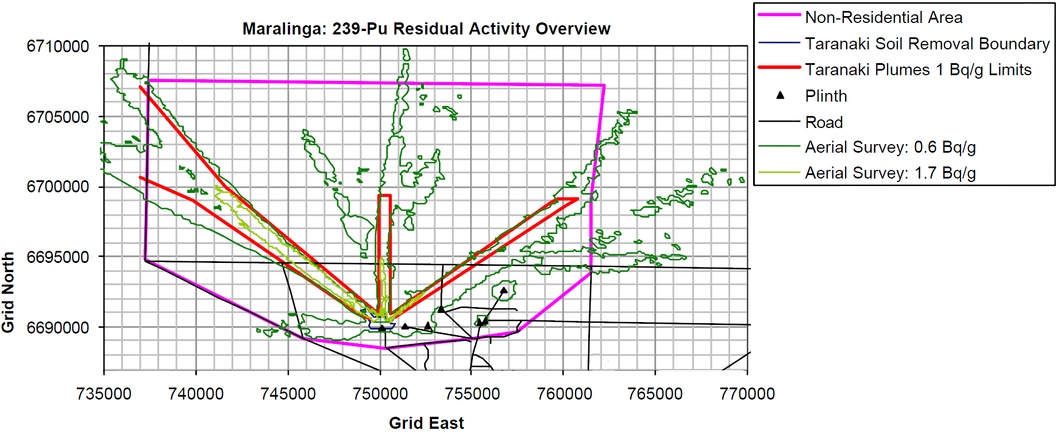

Doses within the remediated area at Taranaki
Assuming continuous habitation at the centre of the remediated area (close to Taranaki) with an Am-241 concentration of 3 kBq m⁻² (the MARTAC clearance value for the areal concentration), RESRAD-OFFSITE gives an estimated annual dose of 4 mSv for a 10 year old child. This includes 2.52 mSv from soil ingestion, 1.50 mSv from dust inhalation, and 0.005 mSv from other pathways. This represents a conservative upper limit estimate.
This assumes an average dust loading of 1.5 mg m⁻³. If this value is reduced by a factor of 10 to 0.15 mg m⁻³, the dust inhalation contribution to the total annual dose is reduced from approximately 1.5 mSv to 0.15 mSv (Figure 5). This is a reasonable assumption as 0.15 mg m⁻³ is approximately double the measured average dust loading at Oak Valley village.
The estimated contribution from ingestion of soil was approximately 2.5 mSv for an assumed intake of 10 g per day. Soil ingestion could be reduced in the community by changes in behaviour and provision of amenities, for example, by ensuring regular washing of clothes and hands, and by modifying food preparation methods and requiring roads to be sealed. Reducing the soil ingestion rate by a factor of two (to 5 g day⁻¹) would give a dose contribution from soil ingestion of 1.25 mSv (Figure 5).
Combining these two results and the effect of the soil removal at Taranaki (discussed in Section 3.4.5) gives a reduction in the upper limit on the total annual dose to less than 1 mSv. Reducing the soil ingestion rate to 1 g day⁻¹ would further reduce the upper limit estimate for the total annual dose to approximately 0.3 mSv.
The contributions from the other exposure pathways were shown to be much smaller, so any changes in the contributions from those pathways would have little effect on the total dose.
A full uncertainty analysis would require considerable effort; extra data would be required, and a detailed analysis of the variability in all relevant transfer parameters would also be needed. It is unlikely that this would lead to any significant change in the estimate of dose.

Doses at other sites within the restricted area
A preliminary examination of the available surface concentration data in the Taranaki area shows that there are areas outside the remediated zone where the surface concentrations are higher than 3 kBq m⁻². This suggests that continuous settlement with an outstation lifestyle (the assumption on which the MARTAC clearance criteria were based) for some localised areas along the plumes could result in upper limits of estimated doses exceeding 5 mSv per year.
Using the results of the anthropological surveys and the dust measurements it is possible to make less conservative estimates of doses for the assumption of continuous habitation within these areas of the restricted zone.
Given the localised nature of the radioactive plumes, the contamination is clearly inhomogeneous over relatively short distances. A first approximation to the possible doses resulting from a village located within the restricted area would be to take the average surface concentration across the entire restricted area, and compare this value with the average values for smaller areas.
Table 2 shows the average residual contamination for the northwest, north and northeast plumes and the areas off these plumes. The clearance ratio for each plume is the ratio of the measured areal concentration for each plume to the TAG/MARTAC clearance value of 3 kBq m⁻².
Table 2: Average residual contamination across plumes
Plume | No. of points | Average activity | Clearance ratio
 |  | kBq m⁻²
NW | 174 | 7.49 | 2.50
N | 7 | 21.53 | 7.18
NE | 161 | 3.80 | 1.27
Off-plume |  | <1.4 | <0.47
These average values were estimated from the data used to prepare Figure 4.10 of the MARTAC Report (Long 2011). An approximate estimate of the doses that might be incurred for continuous habitation on the axis of each of these plumes can be derived by
scaling the results already obtained for an areal concentration of Am-241 of 3 kBq m⁻². While this introduces an uncertainty in the estimates because no allowance is made for the variation of the Pu/Am ratio from one plume to another, this uncertainty is much smaller than the uncertainties in the estimated doses, and will not be considered further.
Table 3 shows the estimated doses as a function of area concentration and soil ingestion rates using a dust loading of 0.15 mg m⁻³ (approximately double the average value of the measured total dust loading at Oak Valley). The estimated doses for other areal concentrations, dust loadings and soil ingestion rates can be obtained from these results by simple scaling.
Table 3: A summary of the estimated upper limit annual doses (mSv) for the plumes, within the restricted area.
 |  |  |  |  | MARTAC Clearance | NW plume | N plume | NE plume | Off plume
Average Am-241 concentration (kBq m⁻²) |  |  |  |  | 3.00 | 7.49 | 21.53 | 3.80 | 1.4
Dust loading (mg m⁻³) | Soil ingestion rate (g day⁻¹) | Annual dose from dust inhalation (mSv) | Annual dose from soil ingestion (mSv) | Annual dose from other pathways (mSv) | Total annual dose (mSv) | Total annual dose (mSv) | Total annual dose (mSv) | Total annual dose (mSv) | Total annual dose (mSv)
0.15 | 10 | 0.15 | 2.52 | 0.005 | 2.68 | 6.69 | 19.23 | 3.39 | 1.25
0.15 | 5 | 0.15 | 1.26 | 0.005 | 1.46 | 3.65 | 10.48 | 1.85 | 0.68
0.15 | 1 | 0.15 | 0.25 | 0.005 | 0.41 | 1.02 | 2.94 | 0.52 | 0.19
These estimates show that if continuous habitation within the restricted area were considered in the future, a detailed impact assessment would be required to determine the optimum site. This assessment would require up to date site-specific information on soil concentrations, dust loadings, soil ingestion rates, dietary intake and social and cultural factors.

Discussion
Experimental results show that the properties of the contaminated dust and surface soil at Maralinga have not changed significantly since the MARTAC assessment was carried out. Comparison of the results from this study and the MARTAC study suggests that the TAG/MARTAC conclusions were reasonable.
The dose estimates in this study also show that the MARTAC clearance criteria were reasonable. These conclusions are strengthened considerably by the fact that the assessment methodology used in this work was significantly different from that used in the earlier assessments.
Given that the results of the current study are known to be conservative, and are comparable with the results of the TAG/MARTAC assessment, it can be concluded that the TAG/MARTAC dose assessment provided a reasonable estimate of the doses to the most highly exposed group (the 10 year old child).
Estimated doses to people living at Oak Valley due to the contaminated plumes are negligible compared with natural radiation background levels in Australia. These doses are likely to be overestimates for several reasons:
- The wind direction will vary considerably throughout the year, whereas the dose calculations assumed that the wind was blowing from the contaminated area towards Oak Valley (i.e. south to north) at all times.
- The dose calculations assumed continuous occupancy. No allowance was made for time spent away from the contaminated areas.
- 10% of the food consumed was assumed to be contaminated and is likely to be an overestimate.
- The breathing rate for adults (higher than that for the child) was used in the calculations.
- The value used for dust loading (1.5 mg m⁻³) is likely to be an overestimate, based on the measurements taken in Oak Valley in 2011 (see Appendix 4).
- The assumed rate of soil ingestion (10 g day⁻¹) is likely to be an overestimate.
The uncertainties in the calculated doses arise from several sources. These include uncertainties in:
- dietary intake
- general lifestyle
- dose coefficients
- dust loadings
- soil ingestion rates
- age and sex of the exposed individuals
- the assumptions used in the RESRAD-OFFSITE computer code
- wind speed and direction.
Using a conservative approach and deliberately overestimating the dose (and corresponding risk of harm), compensates for the fact that these uncertainties are not well quantified.
For these reasons it can be concluded that the doses to the residents of Oak Valley resulting from the contaminated plumes are unlikely to exceed 0.03 mSv per year. This is negligible when compared with the annual dose received from natural background radiation. Any associated health impacts would also be negligible.
Estimates of the annual doses that might be incurred for continuous habitation inside the restricted area at some future time indicate that the doses could exceed the 5 mSv MARTAC clearance criteria unless the settlement is located off the plumes (see Figure 2 and Figure 7). This confirms the MARTAC recommendation to set up the restricted area. These results also show that if in the future a permanent settlement were to be sited within the restricted area, a detailed impact assessment would be required to determine the optimum site. This assessment would require up to date site-specific information on soil concentrations, dust loadings, soil ingestion rates, dietary intake and social and cultural factors.

Conclusions and recommendations
Since the publication of the TAG and MARTAC reports there have been no changes in Australian codes or radiation science that would significantly change the earlier dose estimates. Some of the dose coefficients have been revised since the TAG report was published, but there has been no indication in the scientific literature that these changes would justify a reassessment of the earlier dose estimates.
The use of a different methodology in this study from that used in the earlier dose estimates, combined with the fact that both estimates lead to the same conclusion, suggests that the original (TAG) estimates were appropriate. Given that the results of the current study are known to be conservative, and are comparable with the results of the TAG/MARTAC assessment, it can be concluded that the TAG/MARTAC dose assessment provided an upper limit estimate of the doses to the most highly exposed group (the 10 year old child).
The latest ICRP recommendations (ICRP 2007) maintain that intervention in existing situations is unlikely to be justified for doses of less than 10 mSv per year and may be justifiable for doses above 10 mSv per year. The MARTAC clearance criterion for continuous occupancy was set at 5 mSv per year. Since the present study confirms the results of the earlier TAG/MARTAC dose estimates and the estimated Oak Valley doses are at least an order of magnitude below the MARTAC clearance level, reassessment of the MARTAC clearance levels is not justified.
There have been no significant changes in international recommendations that would affect the radiation safety situation at Maralinga, unless pit covers have been damaged or significant areas of contamination were missed during the remediation work. As no evidence of either of these possibilities has been established, no modifications of the radiation safety measures implemented during the 1995-2000 Maralinga Rehabilitation Project are justified at this time.
Given the long-term nature of the contamination, a similar reassessment should be made in approximately 20-25 years. This could be undertaken earlier if there is any failure of remediation controls, or if any significant change occurs in land use or in environmental conditions. This assumes that regular inspections of the site will be made in the future.
If an assessment is carried out in 20-25 years, that will be approximately 50 years after the TAG/MARTAC assessment. Therefore it would be beneficial to include updated results of measurements on diet, occupancy factors, preferential attachment of radionuclides to the finer particles, dust loadings and radionuclide concentrations in suspended dust.
No evidence has been provided that would justify modification of the radiation safety measures that were implemented during the 1995-2000 Maralinga Project.
Doses resulting from future permanent occupancy inside the restricted area are likely to exceed the 5 mSv MARTAC clearance criteria unless the settlement site is located off the plumes (see Figure 2 and Figure 7). This confirms the MARTAC recommendation to set up the restricted area. A detailed assessment of permanent occupation would require up to date site-specific information on soil concentrations, dust loadings, soil ingestion rates, dietary intake and social and cultural factors.

Glossary
Areal density
concentration per unit area.
Creep
a process in which particles on the ground surface are moved by wind while remaining in contact with the surface.
‘hot’ particle
a highly contaminated particle.
Saltation
a process whereby particles on the ground surface are lifted into the air by wind, but return rapidly to the ground surface.
In-situ vitrification
a process whereby solid material is melted by the passage of a very high electric current and then allowed to cool, resulting in the formation of vitrified (glass-like) material.
Leaching
a process whereby radionuclides in solid material are dissolved and transported away by the infiltration of water.
PM1, PM2.5, PM10
technical terms describing the average particle diameter (in microns) of dust or aerosol particles.
Critical group
see ICRP Publication 26 (ICRP 1977).
Class S Pu-239
material which dissolves in lung fluid over a matter of years.
Source term
the quantitative description of the source of radionuclides.

References
Birchall A, Jarvis NS, Peace MS, Riddell AE, & Battersby WP 1998. The IMBA suite: Integrated modules for bioassay analysis. Radiation Protection Dosimetry 79:107-110.
Birchall A, Puncher M, Marsh JW, Davis K, Bailey MR, Jarvis NS et al. 2005. IMBA Professional Plus: a flexible approach to internal dosimetry. Radiation Protection Dosimetry. Vienna: Special Issue.
Burns PA, Cooper MB, Johnston PN & Williams GA 1990. Properties of Plutonium-Contaminated Particles Resulting from the Vixen B Trials at Maralinga, ARL/TR086. Commonwealth of Australia.
Burns PA, Cooper MB, Johnston PN, Martin LJ & Williams GA 1994. Determination of the Ratios of ²³⁹Pu and ²⁴⁰Pu to ²⁴¹Am for Nuclear Weapons Test Sites in Australia, Health Physics 67:226-232.
Burns PA, Cooper MB, Lokan KH, Wilks MJ & Williams GA 1995. Characteristics of Plutonium and Americium Contamination at the Former U.K. Atomic Weapons Test Ranges at Maralinga and Emu, Applied Radiation and Isotopes 46:1099-110.
Cook W 1967. Operation Brumbie Final Report, submission to the Royal Commission into British Nuclear Tests in Australia (RC 413).
Cooper MB, Burns PA, Tracy BL, Wilks MJ & Williams GA 1994. Characterization of Plutonium Contamination at the former Nuclear Weapons Testing Range at Maralinga in South Australia, Journal of Radioanalytical and Nuclear Chemistry 177:161-184.
Cooper MB, Burns PA, Williams GA, Lokan KH & Duggleby JC 1985. Plutonium Contamination at Maralinga, in Residual Radioactive Contamination at Maralinga and Emu, 1985, ed. K.H. Lokan, ARL/TR070. Commonwealth of Australia.
Eckerman KF, Wolbarst AB & Richardson ACB 1998. Limiting values of radionuclide intake and air concentration and dose conversion factors for inhalation, submersion and ingestion. US Environmental Protection Agency, Washington DC.
Haywood SM & Smith J 1990. Assessment of the Potential Radiological Impact of Residual Contamination in the Maralinga and Emu Areas, Technical Report NRPB-R237, National Radiological Protection Board, Chilton, UK.
Haywood SM & Smith JG 1992. Assessment of Potential Doses at the Maralinga and Emu Test Sites, Health Physics 63:624-630.
ICRP (International Commission on Radiological Protection) 1977. Recommendations of the International Commission on Radiological Protection. ICRP Publication 26. Annals of the ICRP 1(3).
ICRP 1995. Age-dependent Doses to Members of the Public from Intake of Radionuclides: Part 4: Inhalation Dose Coefficients. ICRP Publication 71. Annals of the ICRP 25(3-4).
ICRP 1996. Age-dependent Doses to Members of the Public from Intake of Radionuclides: Part 5: Compilation of Ingestion and Inhalation Dose Coefficients. ICRP Publication 72. Annals of the ICRP 26(1).
ICRP 2007. The 2007 Recommendations of the International Commission on Radiation Protection. ICRP Publication 103. Annals of the ICRP 37(2-4).
Johnston PN, Burns PA, Cooper MB & Williams GA 1998. Isotopic Ratios of Actinides used in British Nuclear Trials at Maralinga and Emu, ARL/TR080. Commonwealth of Australia.
Johnston PN, Lokan KH, Richardson CK & Williams GA 1989. Plutonium Contamination in the Maralinga Tjarutja Lands, ARL/TR085. Commonwealth of Australia.
Johnston PN, Lokan KH & Williams GA 1992. Inhalation Doses for Aboriginal People Reoccupying former Nuclear Weapons Testing Ranges in South Australia, Health Physics 63:631-640.
Johnston PN, Williams GA, Burns PA, & Cooper MB 1993. Plutonium Resuspension and Airborne Dust Loadings in the Desert Environment of Maralinga, South Australia, Journal of Environmental Radioactivity 20:117-131.
Lokan KH (ed.) 1985. Residual radioactive contamination at Maralinga and Emu. ARL Technical Report ARL/TR070. Commonwealth of Australia.
Long S 2011. Internal ARPANSA communication.
Long S & Green L 2012. Radioactivity Enhancement Factors of Maralinga Soils. Australian Radiation Protection and Nuclear Safety Agency. Technical Report 157.
Marsh JW, Jarvis NS, Birchall A, James AC, Peace MS, Davis KE et al. 2003. Validation of IMBA and IMBA Expert TM. Proceedings of the European IRPA Congress 2002 'Towards harmonisation of radiation protection in Europe', Florence, Italy 8-11 October 2003.
MARTAC (Maralinga Rehabilitation Technical Advisory Committee) 2002. Rehabilitation of former nuclear test sites at Emu and Maralinga (Australia). Commonwealth of Australia: Department of Education, Science and Training.
Martin L, Williams G, Long S, Minchin J & Fry J 2002. Maralinga Rehabilitation Project- Radiological Field Monitoring at Taranaki and at other Miscellaneous Sites. Australian Radiation Protection and Nuclear Safety Agency, Melbourne. Attachment 4.3 of the MARTAC Report 2002.
NCRP (National Council on Radiation Protection and Measurements) 1999. Recommended Screening Limits for Contaminated Surface Soil and Review of Factors Relevant to Site-Specific Studies. NCRP Report No. 129.
Palmer K & Asche W 2011. Lifestyle, Dust And A Desert Environment: A study of daily life at Oak Valley Community, Maralinga Lands, South Australia. Final report. Appleby Consulting Pty Ltd.
Palmer K & Brady M 1998. The Diet and Lifestyle of Aborigines in the Maralinga Region, South Australia, Report prepared for Maralinga Tjarutja as part of the Maralinga Rehabilitation Studies, Research Programme No. 1: Anthropology, Australian Institute of Aboriginal Studies, Canberra.
Pasquill F 1974. Atmospheric diffusion: the dispersion of windborne material from industrial and other sources (second edition). Ellis Horwood, Chichester.
Shinn JH 2003. Studies of plutonium aerosol resuspension at the time of the Maralinga cleanup. Lawrence Livermore National Laboratory, University of California, Livermore CA 94551.
Williams GA 1990. Inhalation hazard assessment at Maralinga and Emu. Technical Report 87, ARL/TR087. Commonwealth of Australia.
Williams GA, Martin LJ & Long SA 2002. Inhalation Dose Assessment for Remediated Land at Maralinga. Australian Radiation Protection and Nuclear Safety Agency, Melbourne. Attachment 6.2 of the MARTAC Report 2002.
Yu C, Gnanapragasam E, Biwer B, Cheng J-J, Kamboj S, Klett T et al. 2009. RESRAD-OFFSITE – A new member of the RESRAD family of codes. Radioprotection: 44(5):659-664.
Yu C, Gnanapragasam E, Biwer BM, Kamboj S, Cheng J-J, Klett T et al. 2007. User’s Manual for RESRAD-OFFSITE Version 2. ANL/EVS/TM/07-1, DOE/HS-0005, NUREG/CR-6937.
Yu C, Gnanapragasam E, Cheng J-J & Biwer B 2006. Benchmarking of RESRAD-OFFSITE: Transition from RESRAD (onsite) to RESRAD-OFFSITE and Comparison of the RESRAD-OFFSITE Predictions with Peer Codes, ANL/EVS/TM/06-3, DOE/EH-0708.

- Extract from Memorandum of Understanding Number 001872
Clauses 1.4, 1.5 and 1.6 of the MOU are reproduced here
“...
1.4 ARPANSA is to perform a dose reassessment of the Maralinga site. It is to consider:
(a) the lifestyle of the critical land user groups at Maralinga as detailed in the Anthropological Review; and
(b) the data collected from the dust monitors which have been deployed at Maralinga Village and Oak Valley (SA), respectively.
1.5 A report detailing the dose calculations is to be provided, preferably, to RET by 30 March 2012. That report is to include a comparison to the lifestyle-related Technical Assessment Group (TAG) dose estimates.
1.6 As part of its dose reassessment, ARPANSA is to determine if there have been any scientific advances or changes in Australian radiation codes or radiation science that warrant:
(a) reassessment of the TAG dose estimates;
(b) reassessment of the Maralinga Rehabilitation Technical Advisory Committee (MARTAC) determined Maralinga clearance criteria; and
(c) modification of any of the radiation safety measures implemented during the 1995-2000 Maralinga Rehabilitation Project,
and report its findings to RET (MLEMP 9.3.3.3).”

- Summary of assumptions
This section contains a summary of the assumptions made in the TAG/MARTAC assessment and in this work, and the reasons for any differences (Table 4), and a summary of the correction factors applied to the doses calculated using the RESRAD-OFFSITE code Table 5.
Table 4: A summary of the assumptions made in this study and those used in the TAG/MARTAC. The differences are noted.
 | TAG/MARTAC | Reassessment | Oak Valley | Hypothetical Village
soil density (g cm⁻³) | 1.7 | 1.7 | 1.7 | 1.7
thickness of contaminated zone (cm) | n/a | 2 | 2 | 2
thickness of soil mixing zone (cm) | n/a | 1 | 1 | 1
dust loading (mg m⁻³) | 1.5 | 1.5 | 1.5 | 1.5 / 0.15†
soil ingestion (g day⁻¹) | 10 | 10 | 10 | 10 / 5‡ / 1‡
areal density Am-241 (kBq m⁻²) | 3 | 3 | 0.2‡ | 3
ratio of Pu-239 to Am-241 | 7.2 | 7.2 | 7.2 | 7.2
time outdoors on contaminated zone (%) | 100 | 100 | 100 | 100
% of diet from contaminated foods | 100 | 100 | 10* | 10
mean wind speed (m s⁻¹) | n/a | 6 | 6 | 6
critical group | children playing on the ground | 10 year old child | 10 year old child | 10 year old child
adult dose coefficient (Sv/Bq) - ingestion of Pu-239 | 1.4×10^{-8**} | 2.5×10^{-7††} | 2.5×10^{-7††} | 2.5×10^{-7††}
10 year old dose coefficient (Sv/Bq) - ingestion of Pu-239 | 2.2×10^{-8**} | 2.7×10^{-7††} | 2.7×10^{-7††} | 2.7×10^{-7††}
adult dose coefficient (Sv/Bq)- inhalation of Pu-239 | 3.6×10^{-5**} | 1.6×10^{-5††} | 1.6×10^{-5††} | 1.6×10^{-5††}
10 year old dose coefficient (Sv/Bq)- inhalation of Pu-239 | 4.7×10^{-5**} | 1.9×10^{-5††} | 1.9×10^{-5††} | 1.9×10^{-5††}
† approximately twice the average value measured at Oak Valley.
‡ allows for variations in habits and cooking methods.
§ Based on measured value south of Oak Valley (see Figure 2).
* Palmer and Asche (2011).
†† ICRP (1996)
** Haywood and Smith (1990)

Table 5: Summary of correction factors applied to doses calculated using RESRAD-OFFSITE.
correction to inhalation dose to account for higher child dose coefficient | 1.19
correction to inhalation dose to account for preferential attachment of plutonium and americium to finer dust particles | 6.2 (Long & Green 2012)
correction to ingestion dose to account for higher child dose coefficient | 1.08

- Enhancement Factor and Activity Ratio
The purpose of this study (described in more detail in Long and Green (2011)) was to determine whether the enhancement factors and activity ratios used in the TAG/MARTAC assessment have significantly changed in the two decades since the original assessment was made.
This study compares the enhancement factor, defined as the ratio of the activity concentration of a particular size fraction to that of the bulk soil, with those determined in a previous study (Williams 1990). The Williams study used data from three locations in the north plume, while this study obtained data from 6 sites in the north plume and one site in the northeast plume (see Figure 8).
This study also compares the activity ratio of Pu-239 to that of Am-241 with that measured previously (Johnston et al. 1988).
Figure 8: Location of soil sampling sites at Taranaki.
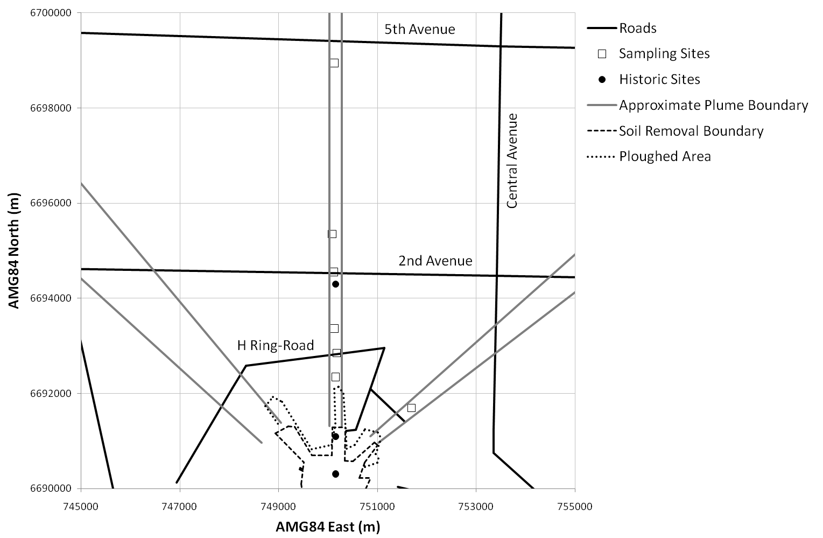
  - Methodology
Soil samples from the top 1 cm were collected from 7 sites at various distances from the Taranaki soil removal boundary. These samples were sieved into various size fractions down to particles less than 20 μm in diameter. Masses of the total sample
and of the sieved fractions were recorded in order to allow the calculation of an overall mass contribution for each fraction. Note that the sampling sites are labelled 1 – 5, 7 and 9 (sites 6 and 8 were not sampled due to time constraints).
A sub-sample of approximately 16 g (12 – 20 g, depending on sample density) from each fraction was weighed into a standard, plastic, 50 mm diameter by 5 mm deep container. These sub-samples were measured by gamma-spectrometry to ascertain the activity concentration of Am-241. The activity concentration of each sub-sample was taken to be representative of the entire fraction.
Of the < 20 μm fraction from each site, 0.1 g was taken to determine the activity ratio between plutonium and americium. Each sub-sample was digested overnight in a mixture of concentrated nitric and hydrochloric acids to leach the radioactive elements from the matrix. The resultant solution was filtered and processed to enable the measurement of plutonium and americium by alpha spectrometry.
  - Mass Distributions
The mass contribution of each of the size fractions for samples from both the current sampling sites and the historic sites from the Williams study were compared. This comparison indicated that, apart from site 3, there are no significant differences between the results of the two studies.
In order to more easily compare the historic and current data, the contributions were averaged. The average for the current data excludes the results from site 3 because its distribution was significantly different from the other sampling sites. These averages are compared in Figure 9.
Figure 9: Comparison between historic and current average mass distributions.
The error bars indicate the standard deviation of the data used to calculate the averages, and are symmetric about the mean value.
  - Enhancement Factors
A comparison of the enhancement factor for each size fraction, for each of the current and historic sampling sites, showed that, apart from the data from site 7, the distributions with particle size are very similar.
The enhancement factors from each of the data sets, for each size fraction, were averaged to more easily compare the current data with the historic data. In this case, data from site 7 was excluded as an outlier in the current data. These averages are compared in Figure 10. This figure shows that, in general, the historic and current enhancement factors are very similar.
Figure 10: The average enhancement factor for each size fraction from each of the historic and current sampling sites. The error bars indicate the standard deviation of the data used to calculate the averages, and are symmetric about the mean value.
  - Plutonium to Americium Ratio
This study found that the Pu-239 to Am-241 activity ratio varied between 5.5 and 8.6, with a mean of 6.9±1.2, in 2010. In order to compare these results with those measured previously (Johnston et al. 1988), the current results were corrected for the ingrowth of Am-241 over the intervening years to give a ratio of 8.3±1.4 in 1985.
This value is larger than the mean value of 7.2±0.6 found in the previous study. However, when the uncertainties are taken into account, the values are not discrepant. Furthermore, the range of corrected values found in this study, 6.6 – 10.4, are within the range found in the previous study of 6.0 – 11.0.
  - Conclusion
The mass distributions in the current work were compared to those obtained in an earlier study (Williams 1990). It was found that the average mass distribution from this work was very similar to the average of those from the earlier work, particularly at the smaller sizes.
The distributions of enhancement factors with particle size from this work were compared to those obtained in the earlier work. It was found that the average distribution from this work and that from the earlier work were similar.
The activity ratio between Pu-239 and Am-241 measured in this work is consistent with that found in an earlier study (Johnston et al. 1988).
Overall, this work shows no indication that the values underpinning the previous dose assessments are questionable or have changed over the past two decades.

- Ambient Dust Levels at Oak Valley
The purpose of this study is to determine whether the ambient dust levels used for the dose re-assessment are relevant to the current situation at Oak Valley.
This study measured the ambient dust levels, both outdoors and indoors, at Oak Valley over a two week period.
  - Methodology
A DustTrak™ DRX monitor was emplaced at a height of 1 metre in the wire cage at the back of the Oak Valley store on September 14 2011. The monitor was set to sample the dust loading continuously with data being stored each hour. It should be noted that this cage is only a simple security cage with 100 mm square grill and should not impede the measurement of ambient dust levels outside the cage. This location was chosen based on discussions to ascertain a high-traffic area that also provided some security and power for the equipment.
A DustTrak™ DRX monitor was also emplaced in the laundry of a private house, at a height of approximately one metre, on September 14 2011 and set to sample the dust loading continuously with data being stored each hour.
The monitors were retrieved approximately two weeks later and the stored data retrieved.
Both monitors provided hourly measurements of size-segregated mass fraction concentrations corresponding to PM1, PM2.5, Respirable, PM10, and Total PM fractions. The monitors were factory calibrated against ISO 12103-1, A1 dust.
  - Results
The measured dust levels outdoors are shown in Figure 11. The maximum dust concentration was measured to be 1 mg m⁻³, while the maximum concentration of the respirable fraction was measured to be 0.6 mg m⁻³. The average concentrations were measured to be 0.031 mg m⁻³ for the total dust loading and 0.026 mg m⁻³ for the respirable fraction.
The measured dust levels indoors are shown in Figure 12. The maximum dust concentration was measured to be 1.3 mg m⁻³, while the maximum concentration of the respirable fraction was measured to be 0.5 mg m⁻³. The average concentrations were measured to be 0.045 mg m⁻³ for the total dust loading and 0.025 mg m⁻³ for the respirable fraction.
The peak and average levels of total dust loading in the indoor location where found to be greater than those observed outdoors, probably due to greater dust-raising activity close to the monitor in the indoor location. However, the peak and average dust loading of the respirable fraction were observed to be very similar in both locations.
It was also observed that the average ratio of the concentration of the respirable fraction to the total dust concentration was 0.90 at the outdoor location while it was only 0.65 at the indoor location.
Figure 11: Ambient dust levels measured in the outdoor location at Oak Valley. The total dust concentration is indicated by the gray line while the black line indicates the concentration levels of the respirable fraction.
Figure 12: Ambient dust levels measured in the indoor location at Oak Valley. The total dust concentration is indicated by the gray line while the black line indicates the concentration levels of the respirable fraction.
  - Conclusion
The study indicates that there is little difference between indoor and outdoor locations at Oak Valley in the concentration of dust in the respirable fraction. The study also shows that the maximum concentration of dust was 1.3 mg m⁻³. The data also show that, for outdoor dust, the concentration of the respirable fraction is approximately the same as that of the total dust concentration.

