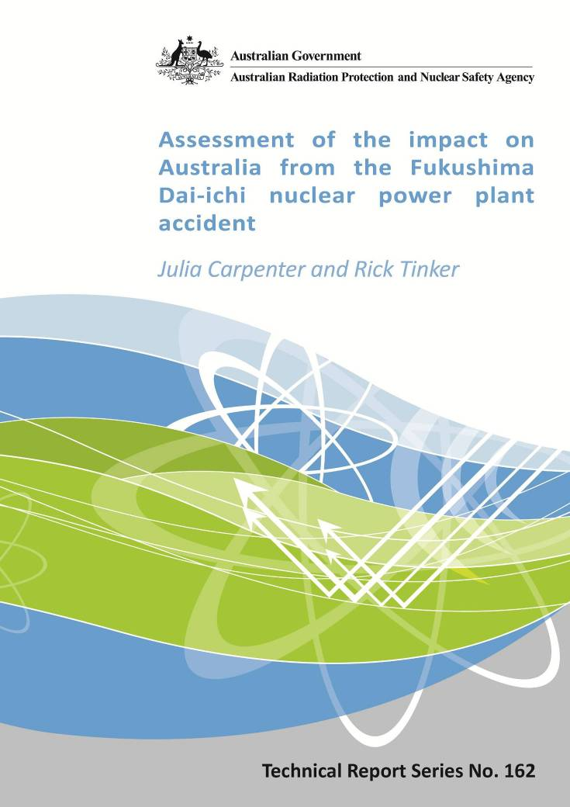

Assessment of the impact on Australia
from the Fukushima Dai-ichi
nuclear power plant accident

by

Julia Carpenter and Rick Tinker

Technical Report No. 162  ISSN 0157-1400  October 2012 | 619 Lower Plenty Road  Yallambie VIC 3085  Telephone: +61 3 6433 2211  FAX: +61 3 9432 1835

Notice
Australian Radiation Protection and Nuclear Safety Agency 2012

ISSN: 0157-1400
Creative Commons

With the exception of the Commonwealth Coat of Arms, any ARPANSA logos and any content that is marked as being third party material, this publication, Assessment of the impact on Australia from the Fukushima Dai-ichi nuclear power plant accident, by the Australian Radiation Protection and Nuclear Safety Agency is licensed under a Creative Commons Attribution 3.0 Australia licence (http://creativecommons.org/licenses/by/3.0/au). It is a further condition of the licence that any numerical data referred to in this publication may not be changed.

The publication should be attributed as Assessment of the impact on Australia from the Fukushima Dai-ichi nuclear power plant accident.
Enquiries regarding the licence and any use of this report are welcome.
ARPANSA
619 Lower Plenty Road
YALLAMBIE VIC 3085
Tel: 1800 022 333 (Freecall) or +61 3 9433 2211
Email: info@arpansa.gov.au
Website: www.arpansa.gov.au

Disclaimer

All care has been taken in the preparation of this work and its conclusions. However, where the data or results presented are utilised by third parties the Commonwealth of Australia shall not be liable for any special, indirect, consequential or other damages whatsoever resulting from such use. Nor will the Commonwealth of Australia be liable for any damages arising from or in connection with any errors or omissions that have inadvertently occurred in this work.

Table of Contents
Acknowledgements iii
Executive summary 1
1. Introduction 3
The nuclear accident at Fukushima Dai-ichi NPP 3
Radioactive contamination in Japan 4
Radioactive contamination beyond Japan 5
Purpose and scope 6
Report structure 6
2. Radioactivity in the atmosphere 7
Radionuclide monitoring stations in Australia 8
Was any radioactive material from the accident detected in Australia? 9
How do we know where the Xenon-133 at Darwin came from? 10
Health impacts from Darwin detections 10
3. Radioactivity in the ocean 11
Ship ballast seawater 12
Health impacts from contaminated ballast water 13
Ship surfaces 13
Health impacts from contaminated ship surfaces 14
4. Testing of food imported from Japan 15
Regulatory limits and guidance for contaminated foods in Japan and Australia 15
Methodology for testing food imported from Japan into Australia 16
Imported food testing results 17
Testing of fish caught in Australia exported to Europe 20
Health impacts from imported foods 20
5. Screening of imported vehicles and military aircraft 21
Screening methodology for imported vehicles 21
Results of imported vehicle screening 22
Health impacts from imported vehicles 23
Screening methodology for military aircraft 23
Results of military aircraft screening 23
Health impacts from military aircraft 24
6. Dose assessment for a family living in Fukushima 25
Dose reconstruction methodology 25
Examination of potential pathways 26
Internal dose assessment 27
External dose assessment 28
Iodine-131 28
Health impact 28
7. Dose assessment for the short-tailed shearwater (mutton bird) 29
Dose reconstruction methodology 29
Examination of potential pathways 30
Results of testing 31
Health effects 31
8. Communicating results to the public 32
Natural background radiation exposure 32
Risk and potential health effects 33
Comparison with the Chernobyl NPP accident 35
9. Conclusions and future work 36
10. References 37
11. Appendix A: Data and Calculations 41
CTBT monitoring stations maintained by ARPANSA 41
Dose calculation for ¹³³Xe detections in Darwin 41
Data from air monitoring station in Darwin, Australia 42
Results of ballast water sampling 43
Operational Intervention Levels (OILs) in a reactor accident 45
Calculating the mean internal dose to the public from contaminated foods 45
Results of imported food testing 47
Dose assessment for a family living in Fukushima 49
Use of ERICA for the Short-tailed shearwater (mutton bird) dose assessment 53
12. APPENDIX B: ARPANSA Fact Sheets 54
Screening for radionuclides in the body using a gamma detector 54
Screening of radionuclides in urine 55
13. Appendix C: Frequently Asked Questions (Japan Nuclear Accident) 56

Acknowledgements
This report on the measurements and studies undertaken to assess the impact of the Fukushima Dai-ichi nuclear power plant (NPP) accident in Australia is the result of the work undertaken by the Australian Radiation Protection and Nuclear Safety Agency (ARPANSA). This work relied on the contribution of many scientists at ARPANSA and the authors gratefully acknowledge their expert contribution.
Blake Orr Marcus Grzechnik
Brendan Tate Paul Martin
Che Doering Peter Johnston
David Hardman Richard O’Brien
David Urban Sandra Sdraulig
Debbie Shallard Shirley Hinton
Jane Courtier Stephen Long
Liesel Green Stephen Solomon
Loch Castle

ARPANSA would also like to acknowledge the valuable support offered by state, territory and Commonwealth agencies and international institutions.
Australian Customs and Border Protection Service
Australian Maritime Safety Authority (AMSA)
Bureau of Meteorology (BOM)
Department of Agriculture, Fisheries and Forestry (DAFF)
Department of Health and Ageing (DoHA)
Department of Foreign Affairs and Trade (DFAT)
Food Standards Australia and New Zealand (FSANZ)
Queensland Health
Tasmania Department Health and Human Services (DHHS)
Tasmania Parks and Wildlife Service
University of Roma Tre (Italy)

Important contributions and support was offered by shipping companies and the Maritime Union of Australia.
ARPANSA would especially like to thank the family living in Fukushima during and after the accident for their patience and contributions in enabling ARPANSA to undertake a dose assessment that included whole body monitoring and urine analysis.

Executive summary
This technical report provides a comprehensive record of the measurements and studies undertaken by the Australian Radiation Protection and Nuclear Safety Agency (ARPANSA) to assess the impact on the health of humans and the environment in Australia from the nuclear accident at the Fukushima Dai-ichi nuclear power plant (NPP), following the 2011 Great East-Japan earthquake and tsunami. These include radiation monitoring of the atmosphere and oceans, testing of imported food and goods for contamination with radioactive materials, and completing detailed dose assessments when required.
Based on the results presented in this report, ARPANSA has assessed that:
- the impact on the health of people living in Australia due to the Fukushima Dai-ichi NPP accident is negligible
- it is not necessary to continue monitoring imports from Japan for contamination with the exception of some foods. These foods are selected based on their location of origin and the type of food.
Following the Fukushima Dai-ichi NPP accident in March 2011, radioactive material was released to both the atmosphere and ocean. Atmospheric circulation patterns transported small amounts of radioactivity around the globe within weeks. Very low levels of radioactive material were detected in Darwin, Australia, in April 2011. At these levels there was no impact on health of people in Darwin. It is expected to take at least 5 years for ocean circulations to transport radioactive material to Australian waters. By this time the radioactivity will be diluted to such a degree that it will be difficult to detect.
Injection of radioactive material into the atmosphere caused immediate fallout, contaminating surfaces in local areas. Once surfaces are contaminated with radioactive material, goods and foods produced in these areas then have the potential to be become contaminated and can be transported quickly around the world. To assess the health impact on Australians from this transport pathway, ARPANSA undertook testing of imported foods, surfaces on shipping vessels and military aircraft, ship ballast water and imported vehicles. No foods tested exceeded the internationally accepted limits with results implying that the risk to the health of Australian consumers would be negligible. No radioactive contamination was found on the surfaces of vehicles and shipping vessels. Low levels of radioactive material were found in shipping ballast water and on the surfaces of military aircraft with results implying a negligible impact on public health and the environment.
Humans and wildlife can also be contaminated from fallout and the consumption of contaminated food. Dose assessments for both people and wildlife were undertaken by ARPANSA. It was estimated that the radiation doses received by a family living 60 km north-west from the Fukushima Dai-ichi NPP during the accident were minimal. A dose assessment for the short-tailed shearwater (mutton bird), which migrates past the Japanese coast during April each year, demonstrated that there will be no impact on the biodiversity of the short-tailed shearwater population in their Tasmanian breeding grounds and that it is unlikely that birds returning to Australia in November of each year will be contaminated.
This accident has provided valuable lessons that will enable Australia and the international community to enhance the safety and security of nuclear facilities and responses to any potential emergency. ARPANSA will continue to monitor the atmosphere and ocean in and around Australia for radioactive material due to the Fukushima Dai-ichi NPP accident in order to provide accurate and current advice to the Australian Government and the public.
Measuring Radiation
A radionuclide is an atom with an unstable nucleus that emits particles or waves, known as radiation.
The becquerel (Bq) is a unit used to measure the amount of radiation, or the activity. For example, an amount of radiation in a food sample might be reported as becquerel per kilogram (Bq/kg).
1 Bq = 1 atomic disintegration per second
A half-life (physical) is the amount of time it takes for the activity of radioactive material to reduce by half. For example, if you start with 20 Bq of caesium-137, after 1 half-life there will be 10 Bq left. After 2 half-lives there will be 5 Bq left. Each radionuclide has a different half-life.
The biological half-life is a measure of how long it takes to expel a substance in the body, such as a radionuclide, by half. This is different to the physical half-life of a radioactive material because it also considers how long the material stays in the body.

Types of radiation and their effects
The particles or waves emitted by radionuclides are generally classified as alpha particles, beta particles and gamma rays, x-rays and neutrons. Each type of radiation has different uses in our society and can have different effects on the body.
Radiation dose is measured in sieverts (Sv). The dose accounts for the type of radiation, the amount of radiation and how it was received. Because radiation doses are usually smaller than 1 Sv, sometimes doses are given in smaller units such as millisieverts (mSv) or microsieverts (µSv). The measurement of dose takes into account that different types of radiation have different degrees of biological effect (equivalent dose). It can also incorporate the sensitivity of specific body organs relative to the whole body (effective dose).
1 Sv = 1,000 mSv
1 Sv = 1,000,000 µSv

Introduction
During and after the 2011 nuclear accident at the Fukushima Dai-ichi nuclear power plant (NPP) in Japan, the Australian Radiation Protection and Nuclear Safety Agency (ARPANSA) undertook a range of measurements and studies to assess the impact of the accident on Australians in Japan and people and the environment in Australia.
This report provides a record and single point of reference for the work undertaken by ARPANSA to assess the impact of the releases of radioactive materials from the Fukushima Dai-ichi NPP on Australia’s people and environment.

About ARPANSA
ARPANSA is the Australian Government statutory agency charged with the responsibility for protecting the health and safety of people and the environment from the harmful effects of radiation. It is also the national centre for excellence in radiation protection and nuclear safety in Australia.
In addition to responsibilities as a regulator, the agency provides:
- advice to the government and the community about radiation protection and nuclear safety
- established radiation emergency assessment capabilities, which can provide 24 hour access to expert radiation protection advice in the event of a radiation incident
- specialised radiation monitoring capability to support the assessment of the radiation levels and the extent of radioactive contamination in the event of a radioactive release from a nuclear or radiological emergency
- laboratory-based facilities for the detailed analysis of environmental samples and for the measurement of radioactivity in contaminated people
- support for national and international radiological and nuclear emergency preparedness.

The nuclear accident at Fukushima Dai-ichi NPP
On 11 March 2011, the Great East-Japan earthquake struck approximately 72 km east of the Oshika Peninsula, Japan. At magnitude 9.0, this was the largest earthquake recorded in Japan since records began. The earthquake triggered a tsunami that reached the east coast of Japan in less than an hour.
The Fukushima Dai-ichi NPP, operated by the Tokyo Electric Power Company (TEPCO), is situated in the Fukushima Prefecture on the eastern coast of the main Japanese island of Honshu about 200 km north of Tokyo, and comprises six boiling water reactors (BWR). At the time of the earthquake, three of the reactors (Units 1 to 3) were in operation, Unit 4 had been de-fuelled and Units 5 and 6 were in cold shutdown for planned maintenance.
Units 1, 2 and 3 shut-down automatically during the earthquake. The external electrical power to the site was interrupted by the earthquake and the back-up diesel generators started up to provide continuity of electrical supply to emergency equipment, including the cooling systems. These cooling systems are essential as the reactor fuel continues to generate heat for some time after the reactors are shut down (IAEA 2011a).
The tsunami resulting from the earthquake, estimated at a height of 14 m at the Fukushima Dai-ichi NPP, overwhelmed the site’s 6 m high sea defences, disabling the shared heat exchangers and diesel generators and breaking the connection to the power grid. With external assistance hindered by flooding, debris and earthquake damage, these serious events resulted in an inability to cool the reactor cores. In the hours and days that followed, the reactor cores of Units 1, 2 and 3 experienced significant to full meltdown, resulting in significant releases of radioactive materials into the environment. It is the most significant nuclear accident in terms of radioactive releases since the Chernobyl accident in 1986. In terms of material damage at the site, it is the largest nuclear accident ever with at least four reactors permanently damaged.
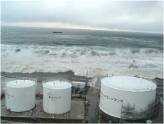
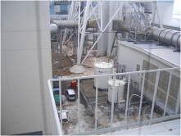
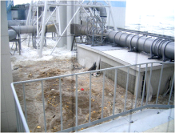
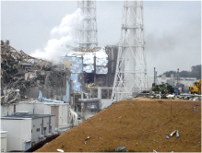
Figure 1.1 Images of the tsunami flooding the Fukushima Dai-ichi NPP Facility and damage to the Fukushima Dai-ichi NPP. These photos (and others) are available for free download from the TEPCO website (TEPCO 2012a).
The potential for release of radioactive material into the atmosphere led to evacuation of the public out to a 20 to 30 km radius. For those remaining in affected areas, instructions to shelter in dwellings were given. These protective measures, whilst based on limited assessment data at the time, proved effective in limiting the radiation exposure to the public. During the emergency, workers were temporarily evacuated at various times when radiation levels made their work environment unacceptably hazardous.
In the 2011 Reports by the Japanese Government to the IAEA Ministerial Conference on Nuclear Safety, a summary of the accident and the protective measures implemented was provided (NERH 2011a, NERH 2011b). These Reports confirmed that fuel had melted in Units 1, 2 and 3. From the analysis of information and temperature data it is highly likely that the insufficient maintenance of the reactor water level in the fuel region had caused the cores to melt, and that the melted fuel had moved to the base of the reactor pressure vessels in the early days of the emergency.

Radioactive contamination in Japan
During the emergency radioactive material was released into the atmosphere and the marine environment, leading to significant contamination of the ground and ocean. Measurements taken by the Japanese government showed radioactive iodine and caesium levels in water and soil to be in excess of the regulatory guidance levels in certain areas of Fukushima and in some other areas within Japan. This led to the government restricting the distribution and consumption of food grown in these areas. Studies undertaken following the emergency have estimated the amount of radioactive materials released as shown in Table 1.1.
Table 1.1 Estimate of radionuclide amounts released into the atmosphere and ocean from the Fukushima Dai-ichi NPP accident. Estimates are based on a combination of environmental measurements and dispersion simulations. Atmospheric release amounts were determined from 13 March 2011 to 6 April 2011 (WHO 2012). *Other radionuclides include those released from 12 March 2011 to 18 March 2011 (WHO 2012). Ocean release amounts were determined from 26 March 2011 to 30 September 2011 (TEPCO 2012b). 1 PBq = 1 x 10¹⁵ Bq.
Radionuclide | Atmospheric release amount (PBq) | Ocean release amount (PBq) | Half-life  (Unterweger et al. 2012)
Caesium-137 (¹³⁷Cs) | 11.3 | 3.6 | 30.17 years
Caesium-134 (¹³⁴Cs) | 9.66 | 3.5 | 2.06 years
Iodine-131 (¹³¹I) | 124 | 11 | 8.02 days
Xenon-133 (¹³³Xe) | 11300 | - | 5.25 days
Other radionuclides* | 52 | - | -

Radioactive contamination beyond Japan
Nuclear accidents do not respect borders. Radioactive materials released into the environment can move around the world, and have the potential to reach Australia by both natural processes and human-influenced activities.
Atmosphere and ocean circulations are the primary means of natural transport of the radionuclides released during the Fukushima Dai-ichi NPP accident. Atmospheric transport processes can carry radioactive material long distances before it decays or settles on the earth’s surface (UNSCEAR 2000). Within weeks small amounts of radioactivity from the Fukushima Dai-ichi NPP accident were detected in most northern hemisphere countries, and contamination was detected in the Asia-Pacific region of the southern hemisphere a month later (Stohl et al. 2012).
Injection of radioactive material into the atmosphere can also cause immediate fallout, contaminating surfaces in local areas. Once surfaces are contaminated with radionuclides, goods and foods produced in these areas then have the potential to become contaminated and can be transported quickly around the world. Humans can also be contaminated by direct fallout, consumption of contaminated food or by handling contaminated goods. Some of these people will travel both short and long distances, transporting contamination to other places.
Radionuclides entered the ocean from fallout, runoff, leakage and intentional releases from the Fukushima Dai-ichi NPP accident. This radioactive material dilutes rapidly once it enters the ocean. Surface currents can carry radionuclides and other contaminants around a hemisphere in a time period of weeks to months; however it takes many years for deeper, slower moving, ocean currents to transport water masses across the equator. Like humans, marine wildlife that has been contaminated by living in environments containing radioactive material can move long distances. For example, tuna contaminated from the accident have been caught off the coast of the United States of America (Madigan et al. 2012).
These pathways of contamination were assessed and monitored by ARPANSA. People returning from Japan were advised to clean clothes and wash before departing to Australia. In Australia, ARPANSA assessed imported foods from the most effected Japanese prefectures for radioactive contamination. For imported goods, such as cars and white goods, ARPANSA recommended that monitoring of surfaces for radioactive contamination was not required as levels would be very low and not detectable. However, ARPANSA did conduct some contamination checks of new and used vehicles being imported into Australia from Japan to provide reassurance to dock workers and consumers. For the same reasons, some contamination checks of surfaces of cargo ships and their ballast water were also undertaken. Contamination checks were also undertaken for military aircraft that were known to have been used in the vicinity of the Fukushima Dai-ichi NPP. Continuous air monitoring was performed in Australia and targeted wildlife was assessed for contamination.

Purpose and scope
This report describes the work undertaken by ARPANSA to assess the impact the releases of radioactivity from the Fukushima Dai-ichi NPP accident had on Australia. Presented is a comprehensive record of the measurements undertaken by ARPANSA and the methodologies applied. An assessment of the health impact on humans and wildlife in Australia is provided.

Report structure
Following this introduction, Sections 2 and 3 provide an overview and monitoring details of radioactivity in the atmosphere and ocean respectively. Section 4 outlines the methodology and results from Australia’s monitoring program for foods imported from Japan. Section 5 outlines ARPANSA’s advice relating to imported Japanese cars and provides results of car monitoring at Port Kembla and contamination checks of military aircraft. Sections 6 and 7 are examples of detailed dose assessments undertaken by ARPANSA to assess the radiation risks to humans and the environment. Section 8 provides a discussion of the ways ARPANSA communicated the risks associated with radiation exposure to the Australian public during the Fukushima Dai-ichi NPP accident. Conclusions and details of future work are given in Section 9.
The Appendix provides additional data and details of some of the calculations described in this report. A number of ARPANSA fact sheets have been included, as well as the Frequently Asked Questions Page relating to the Fukushima Dai-ichi NPP accident that was published on the ARPANSA website during 2011.

Radioactivity in the atmosphere
Radioactive material injected into the atmosphere from the Fukushima Dai-ichi NPP accident contaminated the local, regional, and global environment.
The majority of radioactive material released to the atmosphere from the accident returned to the earth’s surface as fallout, including isotopes such as ¹³¹I, ¹³⁴Cs and ¹³⁷Cs. A portion of the radioactive material was deposited on the ground both at the site of the accident (local fallout) and regionally up to several thousand kilometres downwind (intermediate fallout). The remainder of the material was widely dispersed in the atmosphere. The amount of fallout at each location depended on which radionuclides were released and the meteorological conditions at the time of the release. For example, particulate debris dispersed by the hydrogen explosions during the accident, as well as local rain, resulted in local fallout. The remaining debris travelled regionally, across continents, and around the world. Stohl et al. (2012) estimated that 18% of the total ¹³⁷Cs fallout deposited over Japan, 80% fell onto the ocean and 2% deposited over the rest of the world. Some fission products, such as noble gases like ¹³³Xe, do not leave the atmosphere as fallout. The movement of these non-depositing isotopes will be much more widespread, as the removal of these isotopes from the atmosphere is dominated by radioactive decay.
The process through which radioactive materials are transported throughout the atmosphere, and their subsequent deposition, have been well studied using data collected from atmospheric nuclear weapons testing programs of the 20th century (UNSCEAR 2000). Atmospheric transport processes in the troposphere (ground level to an altitude of 10 to 15 km) are such that radionuclides spread much more quickly in a longitudinal (east-west) direction than in a meridional (north-south) direction. Atmospheric circulations also make it difficult for air to be transported between hemispheres in the troposphere. This means that radioactive material in the troposphere will likely remain in the hemisphere of the release, although a small amount mixing of air between hemispheres does still occur.

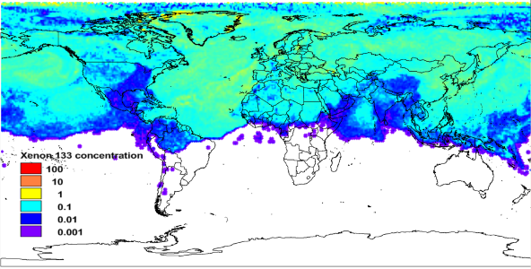
Figure 2.2 Modelled global ¹³³Xe concentrations (Bq/m³) on 12 April 2011 (Orr et al. 2012) using the source term described in Stohl et al. (2012).

Radionuclide monitoring stations in Australia
ARPANSA is responsible for carrying out Australia's radionuclide monitoring obligations to the Comprehensive Nuclear-Test-Ban Treaty (CTBT), including the installation, implementation and operation of seven particulate air-monitoring stations and two noble gas stations within Australia and its territories. The locations of these stations are shown in Figure 2.2. Monitoring takes place continuously, 24 hours a day, 7 days a week at all stations, as information about radionuclide levels in air can provide unambiguous evidence of a nuclear explosion (UN 1996).
In this process, particulate matter suspended in the air is collected onto filters using high volume air sampling. After the completion of each 24 hour sampling period, the filter and its contents are removed and compressed into a disk. The disk is placed in a chamber for another 24 hours to allow for natural decay of some radionuclides. The radionuclide content of the disk is then measured for 24 hours using a standard high-resolution gamma spectrometry technique calibrated using internationally traceable radioactive materials (Shulze et al. 2000).
Nobel gas isotopes of xenon are detected using a different process, as these gases rarely interact with other chemicals and matter and they simply pass through a filter. Low volumes of air are collected to produce a sample about every 12 hours. The sample is then purified by drying and trapping xenon onto charcoal traps. The sample volume is quantified by measuring the stable atmospheric xenon using a thermal conductivity detector. The concentrations of the xenon isotopes are measured using a beta-gamma coincidence technique with acquisition times of 12 hours. This system is calibrated using internationally traceable radioactive materials (Tinker et al. 2010).
Data related to the sampling conditions and radionuclide content is forwarded to the International CTBT Organization’s International Data Centre in Vienna where it is compiled, analysed and released to States Parties to the Treaty (participating countries).
The radionuclide monitoring stations in Australia and the rest of the world provided valuable information relating to the spread of radioactive material from the Fukushima Dai-ichi NPP accident. During the time of the Fukushima Dai-ichi NPP accident, about three quarters of the global network was in operation.
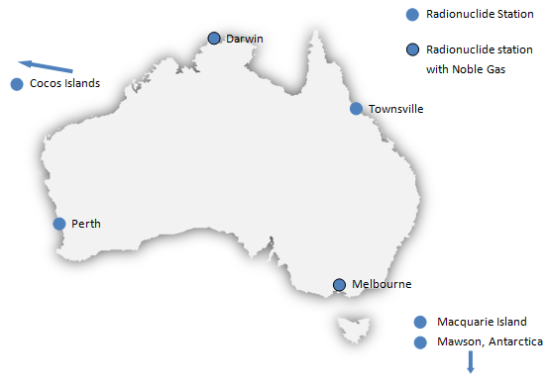
Figure 2.3 CTBT radionuclide stations maintained by Australia (exact locations provided in Appendix A).
About the Comprehensive Nuclear-Test-Ban Treaty (CTBT)
What is the CTBT?
It is a Treaty to ban all nuclear explosion tests everywhere on earth – this includes the earth’s surface, atmosphere, oceans and underground.

How can nuclear explosions be detected?
An International Monitoring System (IMS) is being constructed to monitor compliance with the Treaty. By analysing, integrating and comparing data from the IMS, the time, location and nature of a possible nuclear event can be determined. The network consists of monitoring facilities that use a variety of methods to detect evidence of nuclear weapons testing. Seismic, hydro-acoustic, infrasound and atmospheric sampling stations are employed to monitor the underground, underwater and atmosphere environments.

How many radionuclide monitoring stations are there?
When the IMS is complete there will be 80 radionuclide monitoring stations, in 27 countries around the world. 40 of the 80 radionuclide stations will have additional noble gas detection capabilities (UN 1996).

What other benefits exist from the IMS?
The Treaty’s verification regime can also contribute to a better understanding of the changes in the environment due to natural hazards and disasters. The high sensitivity of the radionuclide monitoring stations has enabled scientists to study the spread of radionuclides around the world following the accident at the Fukushima Dai-ichi NPP.

Was any radioactive material from the accident detected in Australia?
A series of 18 consecutive air samples collected at the Darwin air monitoring station from 8 April to 17 April 2011 contained detectable levels of ¹³³Xe (see Figure 2.3). The maximum ¹³³Xe concentration recorded was 12 mBq/m³. There were also smaller amounts of ¹³³Xe detected either side of this period. The typical detection limit was 0.2 Bq/m³. No radioxenon detections attributable to the Fukushima Dai-ichi NPP accident were made in Australia other than at the Darwin station, and there were no detections of particulate fallout (such as ¹³¹I, ¹³⁴Cs and ¹³⁷Cs) at any Australian monitoring stations.
To put these detections into perspective, the radioactive xenon background levels across much of the world are typically in the range of 1 to 10 mBq/m³, with areas in close proximity of radiopharmaceutical facilities recording ¹³³Xe levels up to a few thousand mBq/m³ (Saey 2009). In Australia detections of ¹³³Xe are routinely made at the CTBT noble gas station located in Melbourne. These detections can reach 10 mBq/m³ and are attributed to releases from the Australian Nuclear Science and Technology Organisation (ANSTO) radiopharmaceutical facility located in Sydney, Australia (Tinker et al. 2010).
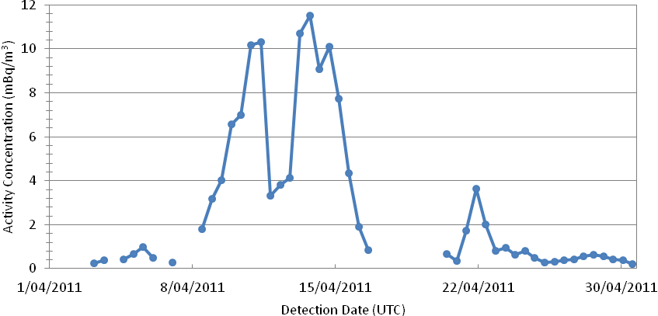
Figure 2.4 ¹³³Xe activity concentrations for detections greater than 0.2 mBq/m³ in air samples collected from the noble gas CTBT monitoring station located at Darwin, Australia (data provided in Appendix A).

How do we know where the Xenon-133 at Darwin came from?
ARPANSA assessed that the detection of ¹³³Xe in Darwin was consistent with a release of radioactive material from the Fukushima Dai-ichi NPP accident.
Atmospheric dispersion modelling was performed by ARPANSA in collaboration with University of Roma Tre in Italy. The FLEXPART Lagrangian particle model (Stohl et al. 2005) and European Center for Medium-Range Weather Forecast weather data was used. The source term chosen was based on the work of Stohl et al. (2012). Modelling showed that ¹³³Xe released from the accident would in weeks distribute evenly through-out the northern hemisphere. This is supported by the continuous detection of radionuclides on the CTBT radionuclide monitoring network (Stohl et al. 2012). The dispersion modelling indicates that some contaminated air would have moved into the southern hemisphere in late April in the south-east Asian region (Figure 2.1).
The modelling predicted ¹³³Xe activities in Darwin would reach about 1 mBq/m³ and detections could occur over a prolonged period. Other regional sources of ¹³³Xe were also modelled, in particular the radiopharmaceutical facilities at ANSTO in Sydney and research reactor in Serpong, Indonesia. Modelling releases from these facilities resulted in predicted ¹³³Xe activities less than those required to cause the observed detections in Darwin. These sources were also inconsistent with the prolonged number of continuous detections that were observed at the Darwin station (Orr et al. 2012).

Health impacts from Darwin detections
Assuming a maximum ¹³³Xe concentration of 12 mBq/m³ over 9 days, and using the method described in Eckerman and Ryman (1993), a dose of only 0.000000015 mSv (or 0.015 nSv) is estimated (see Appendix A for more details). This dose is one hundred million times smaller than the 1.5 mSv annual natural background radiation received by members of the public living in Australia.
At these ¹³³Xe levels there will have been no health impact for any person in Darwin or elsewhere in Australia.

Radioactivity in the ocean
The attempts to cool the damaged Fukushima Dai-ichi reactors resulted in high concentrations of liquid radioactive material leaking into the surrounding coastal waters (see Table 1.1). Due to the lack of storage facilities, some liquid radioactive material was released into coastal water under controlled circumstances (NERH 2011a). Contamination of the local seas also occurred from radioactive material released into the atmosphere that subsequently deposited on the surface of the sea. Another more long term source of ocean contamination is radioactive material deposited on land that is subsequently carried by runoff to the sea.
The radioactive material released to the ocean from the accident has been closely monitored by the Japanese authorities. The results published by the Ministry of Education, Culture, Sports, Science and Technology (MEXT) indicated that levels of radionuclides in seawater were rapidly diluted and dispersed in coastal waters (MEXT 2011a). Some radioactive materials have also settled on the sea floor (MEXT 2011b).
The French Institute de Radioprotection et de Surêté Nucléaire (IRSN) has modelled how these contaminants have been dispersed in local, regional and global waters, and how this dispersion may continue in the future (IRSN 2011; IRSN 2012). These studies indicate that contaminated waters were diluted and dispersed while being carried eastwards towards the centre of the Pacific.
For long term global dispersion, Nakano and Povinec (2012) estimated a transit time of about 5 years before radioactive material reached the north coast of Western Australia and about 10 to 15 years before reaching the east coast of Queensland. Within these time frames it is expected that radioactive material will have been diluted to such a degree that it will be difficult to detect in Australian waters.
A potential mechanism for seawater contaminated with radioactive material from the accident to be transported more quickly to Australian waters is via ship ballast water. Many large shipping vessels have multiple ballast tanks. Ships designed for carrying large amounts of cargo must take on ballast water for proper stability when travelling with light loads and discharge water when heavily laden with cargo. Surface contamination of the surfaces of ships from fallout or seawater spray is another potential way for contamination to spread to the southern hemisphere. These processes are outlined in Figure 3.1.

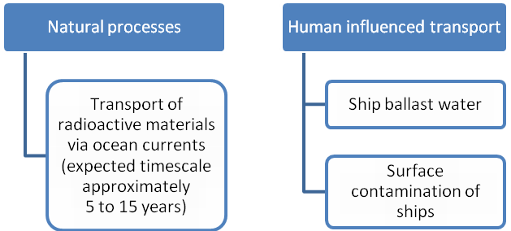
Figure 3.5 Possible mechanisms through which contaminated sea water could reach Australia.

Ship ballast seawater
In June 2011, ARPANSA assessed ballast seawater for contamination from shipping vessels (MV Kaien and MV Shoyo) that had travelled and docked within 80 km of the Fukushima Dai-ichi NPP. The MV Kaien and MV Shoyo were within this area from 7 to 15 June 2011, and 19 to 24 June 2011 respectively.
Ballast seawater was taken on by both vessels after unloading in Onohama Harbour, Japan. On reaching the coast of Australia (about 12 days later) both vessels exchanged seawater at sea as per the International Convention for the Control and Management of Ships' Ballast Water and Sediments (IMO 2004). This process leaves about 5% of the original ballast seawater in the ballast tanks.
While anchored in Australia, ARPANSA staff collected approximately 1 L of ballast seawater from sampling ports located on the deck of the vessels. Two samples were taken from the MV Shoyo and one from the MV Kaien. Ballast seawater overflowed when the sampling port was opened, enabling a sample to be collected by hand from the deck surface. It was assumed that the sample taken was representative of the ballast seawater. Samples were assessed at ARPANSA for the presence of radionuclides using a standard high-resolution gamma spectrometry technique calibrated using internationally traceable radioactive materials (ANSI 1999). Samples of 1 L were assessed in a standard counting geometry (Marinelli beaker).

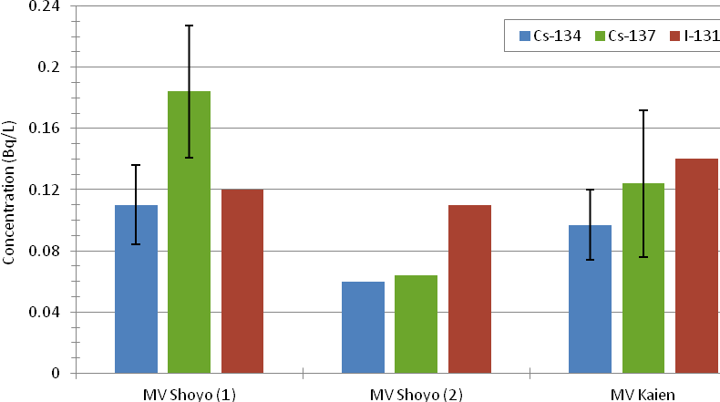
Figure 3.6 Results of radiation testing of 3 ballast water samples. Results with no error bars represent the detection limit, i.e. the radionuclide was not detected and results were reported as being less than the specified value. Uncertainties are 2 standard deviations (k=2). Detailed data is available in Appendix A.

Both ¹³⁴Cs and ¹³⁷Cs were detected at very low levels. The short lived ¹³¹I was not detected. Measured activity concentrations ranged from 0.097 to 0.184 Bq/L (Figure 3.2) with ratios of ¹³⁷Cs to ¹³⁴Cs ranging from 1.28 to 1.67. These ratios are comparable to those measured by Japanese authorities during the period the shipping vessels were in the port of Onahama where ¹³⁷Cs to ¹³⁴Cs ratios ranged from 1.15 to 1.32 (MEXT 2011c). The similarity of ratios indicates that the source of radioactive caesium is from the Fukushima Dai-ichi NPP accident.
The concentrations of caesium ARPANSA measured in the ballast water were about 3% of the levels detected in the port of Onahama (2.49 to 5.50 Bq/L). These lower levels are expected as ballast seawater was exchanged off the coast of Australia where less than 5% contribution of Onahama seawater to the final ballast water is required under International Convention (IMO 2004).
In Australia, ¹³⁷Cs in seawater remains detectable from historical nuclear weapons testing fallout. Levels of ¹³⁷Cs in the Tasman Sea are about 0.01 Bq/L, ranging from 0.004 to 0.013 Bq/L in the South Pacific. Levels are higher in the North Pacific by a factor of 2 (IAEA 2005).

Health impacts from contaminated ballast water
The small quantities of radioactive material from contaminated ballast water are rapidly dispersed and diluted in the ocean to extremely low levels. For example, a release of 10,000 m³ (10 million litres) of ballast seawater contaminated with 5.5 Bq/L of caesium, would mix rapidly with ocean water. Assuming mixing to a depth of 100 m and in a radius of 1000 m from the discharge point, the caesium concentration would drop to 0.000175 Bq/L at the point of discharge.
At these levels and given the unlikely presence of the public at ballast water exchange points, there will be no risk to public health. The effects of dilution would also mean that there will be no impact the biodiversity of marine life.

Ship surfaces
In June 2011, ARPANSA advised the Australian Maritime Safety Authority (AMSA) that ships that transverse the 80 km restricted zone were required to supply to AMSA and ARPANSA an incident report that included a radiation survey report from the departing port. Radiation surveys conducted in Japan were carried out by government endorsed service providers using the methodology described by the Japanese Government’s Ministry of Land, Infrastructure, Transport and Tourism advice (MLIT 2011). Decontamination of surfaces is required when the measured dose rate exceeds 5 μSv/h.

ARPANSA assessed the potential surface contamination on the same shipping vessels that were tested for ballast water contamination, MV Kaien and MV Shoyo, while they were anchored in Australia. Portable handheld radiation monitors were used to assess the gamma radiation dose rates on the surfaces of both ships in the positions described in Table 3.1. Instruments used were Polimaster (1703 GNB) monitors calibrated using radioactive materials traceable to the Australian Standard of exposure. Maximum and minimum gamma radiation dose rates were monitored at about 1 m from the surface of the ships at each location. A background measurement was taken on the pilot boat before docking with MV Shoyo using the same method.

ARPANSA measured radiation levels ranging from 0.01 to 0.02 μSv/h on the surfaces of both ships (Table 3.1). These levels are consistent with the background levels measured by ARPANSA on the pilot vessel (0.01 μSv/h). In addition, these results are the same as the radiation survey results measured in Japan at the departing port (0.01 to 0.02 μSv/h), which are also indicative of normal background levels.
ARPANSA advice to AMSA was cancelled in January 2012 as the potential for surface contamination from fallout or seawater surface spray was considered highly unlikely. A total of 18 ships submitted radiation survey reports issued from the departing port with all measured radiation levels equivalent to background radiation levels.
Table 3.2 Results of the survey monitoring undertaken by ARPANSA and Japanese authorities for the shipping vessels, MV Shoyo and MV Kaien. Locations of surface monitoring are shown on the ship schematic. Details provided in Appendix A.
Bridge
Ship’s office
Weather deck aft
Weather deck in front of bridge
Forecastle
Weather deck mid ship port and starboard

Ship Name | ARPANSA Survey Results  Dose Rate Range (µSv/hr) | Japanese Survey Results  Dose Rate Range (µSv/hr)
MV Shoyo Shipping Vessel | 0.01 to 0.02 | 0.01 to 0.02
MV Kaien Shipping Vessel | less than 0.02 | 0.01 to 0.02
Background | 0.01 to 0.02 (Pilot Vessel) | 0.02

Health impacts from contaminated ship surfaces
No contamination was found on the surface of any monitored shipping vessel and all results were in the range of typical background radiation levels. If ship surfaces were contaminated with radioactive material from sea spray or atmospheric fallout, it is likely that rain, sea spray or ship cleaning during the voyage to Australia would remove any surface contamination.
Health risk assessments for ship crew were not conducted as no radiation levels above background were observed.

Testing of food imported from Japan
In Japan, contamination of the food chain occurred in localised areas from radioactive material deposited on the ground and released to the ocean with levels varying geographically and with time. As Australia imports some food from Japan there is potential for food with radioactive contamination from the Fukushima Dai-ichi NPP accident to enter the Australian food supply.
Three major pathways of food contamination occurred in Japan over different time scales as shown in Figure 4.1.

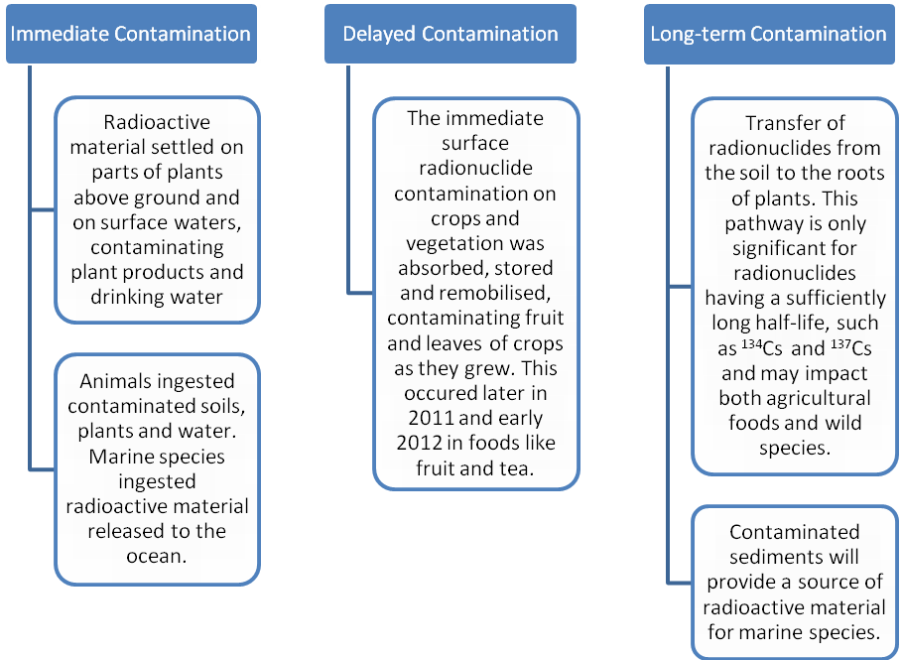
Figure 4.7 Food contamination in affected Japan Prefetures illustrating the immediate, delayed and long-term pathways of contamination (IRSN 2012).

Regulatory limits and guidance for contaminated foods in Japan and Australia
The Japanese government quickly introduced regulations that required all food produced in affected areas to be tested for ¹³¹I, ¹³⁴Cs and ¹³⁷Cs contamination against the government’s provisional limits (Hamada et al. 2012) during and after the accident (Table 4.1). Any food that exceeded the Japanese government’s limit could not be sold and was withdrawn from distribution.
The provisional limits were comparable to limits Australia would apply in the case of a radiological or nuclear emergency occurring in Australia (ARPANSA 2004, ARPANSA 2008). The Japanese government introduced new lower statutory limits in April 2012 which reflected the transition from an emergency to a recovery situation (Hamada et al. 2012).
Table 4.3 Limits for radioactive caesium in foodstuffs. Shown are the new statutory limits for Japan and the provisional limits applied during the accident. Australia’s limits for radionuclides in foodstuffs during a nuclear emergency are shown for comparison. Also shown are the Codex Alimentarius International Food Standards guideline levels applied to foods for human consumption and traded internationally. Note that the International (Codex) guideline level for ¹³¹I is 100 Bq/kg.
Limits for radioactive caesium | Drinking Water  (Bq/L) | Milk  (Bq/L) | General Foodstuffs (Bq/kg) | Food items for babies (Bq/kg)
Japan (new statutory limits from April 2012) | 10 | 50 | 100 (plus dairy products) | 50
Japan (provisional limits during accident and up to April 2012) | 200 | 200 (plus dairy products) | 500 | 200
Australia (operational interventional limits in a reactor accident) | 300 | 300 | 200 | 200
International (Codex) | 1000 | 1000 | 1000 | 1000

For countries importing foodstuffs after a major radiological or nuclear emergency has occurred, the Codex Alimentarius International Food Standards guideline levels are applied for one year after the accident (FAO and WHO 2010). A monitoring program for foods imported to Australia from Japan was established to assess if any foods that enter the Australian food supply exceeded the Codex guideline levels. The Codex guideline levels apply to food after reconstitution or when they are ready for consumption.
There are no Australian regulatory limits for radionuclides in food that can be applied one year after a nuclear or radiological emergency. Instead, ARPANSA provides risk based assessment advice on radionuclide contaminates in food as required. For contamination of food arising from radiation practices, assessments are based on a reference level of 1 mSv per year for members of the public (ARPANSA 2002). In March 2012, one year after the Fukushima Dai-ichi NPP accident, ARPANSA assessed that the Codex guideline levels were still sufficient to ensure that the radiation dose from imported foods would be below 1 mSv/y. The method used for this assessment is outlined in Appendix A.

Methodology for testing food imported from Japan into Australia
Following the Fukushima Dai-ichi NPP accident, Food Standards Australia New Zealand (FSANZ) advised the Department of Agriculture, Fisheries and Forestry (DAFF) that foods from some prefectures in Japan had the potential to be contaminated with radionuclides. This resulted in DAFF implementing a testing program for food originating from specific prefectures. Over time this testing program has become more focused, with fewer foods tested from a reduced number of prefectures.
ARPANSA has provided advice to FSANZ on which prefectures, foods and radionuclides to target. Prefectures were selected if their measured radionuclide deposition data were above the Australian Operation Intervention Levels (ARPANSA 2004) as described in Appendix A. Therefore, there was the potential for food produced in these prefectures to contain radioactive material in excess of the established internationally acceptable levels. Certain food types, such as leaf tea, were targeted for testing based on the advice given by ARPANSA regarding foods that were most likely to be contaminated. This advice was based on previous testing results and the expected impact of delayed contamination on agricultural crops in affected prefectures.
Imported foodstuffs were tested for radionuclide content by ARPANSA using high-resolution gamma spectrometry. The detectors were calibrated using internationally traceable radioactive materials (ANSI 1999). Samples were homogenised and placed into appropriately sized Marinelli beakers (200 mL, 450 mL, 1000 mL) depending on how much sample was available. The prepared samples were counted for a minimum time of 4 hours. In some cases (smaller sample masses), counting times were extended in order to achieve the desired reporting limit of 2 Bq/kg for the activity concentrations of ¹³¹I, ¹³⁴Cs and ¹³⁷Cs.
The types of food tested during this program are presented in Figure 4.2. Beef was not sampled because importation of beef and beef products intended for human consumption from Japan was suspended in 2001 by DAFF when Japan reported its first case of bovine spongiform encephalopathy (BSE). The suspension was extended following the foot and mouth disease outbreak in Japan in 2010 (DAFF 2010). Dry foods include rice and flours. Seaweed is considered a sea-plant.

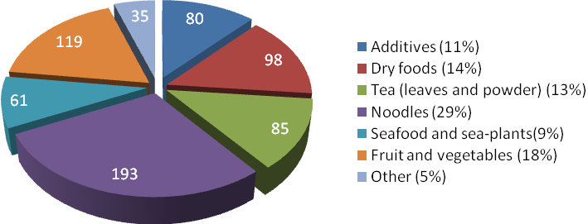
Figure 4.8 Types of food tested by ARPANSA for the presence of radioactive caesium between March 2011 and May 2012. The total number of samples from each food group are given on the pie chart.

Imported food testing results
From March 2011 to the end of May 2012, over 570 samples of imported food were assessed by ARPANSA for ¹³¹I, ¹³⁴Cs, ¹³⁷Cs, or a combination of the three. The results presented in this report include all food samples tested by ARPANSA during this period in relation to the Fukushima Dai-ichi NPP accident. This includes some samples provided by ARPANSA staff members and some samples from private companies that were not part of the DAFF testing program. For this reason the results presented here may differ slightly from other published results.
A total of 49 samples (7%) tested positive to the presence of ¹³⁴Cs and/or ¹³⁷Cs as shown in Figure 4.3. ¹³⁴Cs has a half-life of about 2 years and will remain detectable in the environment for approximately 20 years. ¹³⁷Cs has a half-life of about 30 years and will remain detectable in the environment for more than 300 years. No samples tested positive for the presence of ¹³¹I. After 80 days, ¹³¹I with a short half-life of about 8 days, would have decayed to amounts that would no longer be detectable. Figure 4.3 also shows that the number of samples testing positive to the presence of radioactive caesium has increased over time. This does not necessarily mean that more foods are contaminated and is likely to be a result of the introduction of more targeted testing as discussed above. No foods tested have contained radionuclides in excess of the Codex guideline levels.
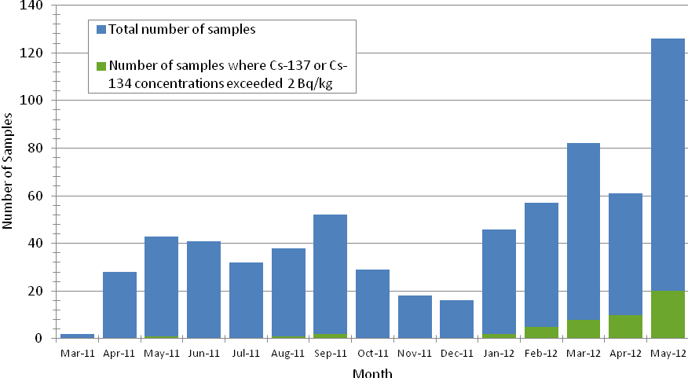
Figure 4.9 Summary of results for food samples measured by ARPANSA. The plot also shows the number of samples that exceeded 2 Bq/kg of ¹³⁷Cs and/or ¹³⁴Cs. All other samples were less than the lowest reporting limit (2 Bq/kg). No sample exceeded the Codex guideline limits and no ¹³¹I was detected in any of the samples. More detailed results are provided in Appendix A.

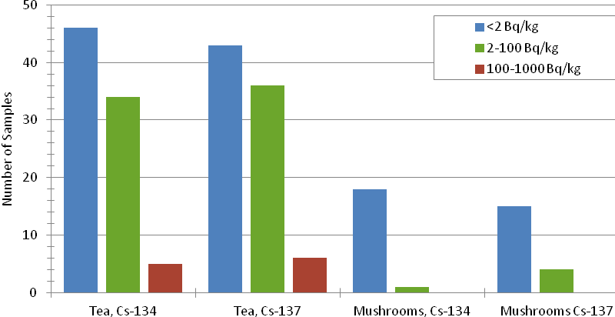
Tea, ¹³⁴Cs Tea, ¹³⁷Cs Mushrooms, ¹³⁴Cs Mushrooms, ¹³⁷Cs
Figure 4.10 Activity concentration ranges for tea and dried mushroom samples analysed from March 2011 to May 2012.

The majority of samples that tested positive to ¹³⁴Cs and/or ¹³⁷Cs were tea and dried mushrooms (see Figure 4.4).
- Of the 85 tea samples tested, 36 tested positive to levels between 2 and 100 Bq/kg of either ¹³⁴Cs or ¹³⁷Cs. 6 samples tested above 100 Bq/kg with a maximum of 238 ± 25 Bq/kg of ¹³⁴Cs and 335 ± 36 Bq/kg of ¹³⁷Cs.
- Of the 19 dried mushroom samples tested, 4 samples tested positive with levels between 2 to 100 Bq/kg of radioactive caesium.
Of the four mushroom samples testing positive to radioactive caesium contamination, three were contaminated with ¹³⁷Cs only. During the Fukushima Dai-ichi NPP accident, ¹³⁴Cs was deposited with roughly a 1:1.2 ratio with ¹³⁷Cs. ¹³⁴Cs has a half-life of about 2 years, therefore it would be expected to be present in the mushrooms if the contamination is from the Fukushima Dai-ichi NPP accident. The absence of ¹³⁴Cs in these mushrooms indicates that they are contaminated from ¹³⁷Cs present in the environment prior to the Fukushima Dai-ichi NPP accident, either due to fallout from nuclear weapons testing in the 20th century or from the detonation of the atomic bombs in Hiroshima and Nagasaki in 1945.
Because the Codex guideline levels apply to foods as they are consumed, any contamination in foods that have not yet been prepared for consumption, like leaf tea and powdered sauces, will be diluted. To investigate the effects of dilution on dry tea samples, two tea samples that tested with concentrations of ¹³⁴Cs and/or ¹³⁷Cs above 100 Bq/kg were brewed and tested to measure the concentration of the actual drink that would be consumed. Approximately 20 g of each sample was brewed in 500 mL of boiling water which was then filtered before measurement in a 450 mL Marinelli beaker. For each sample the activity concentration of the brewed tea was 2 to 3% of the activity concentration of the dried tea leaves. Results are shown in Figure 4.5. About 70% of the radioactive caesium was extracted in to the water when the tea leaves were brewed. This is comparable to results reported by Tagami et al. (2011).
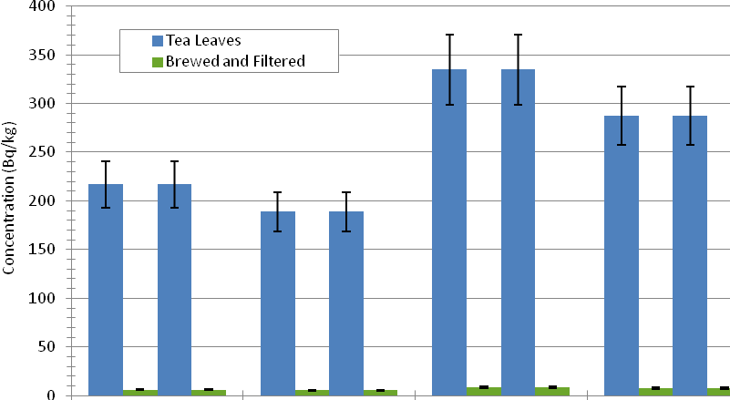
Sample 1 ¹³⁷Cs Sample 1 ¹³⁴Cs Sample 2 ¹³⁷Cs Sample 2 ¹³⁴Cs
Figure 4.11 Two dry tea samples with concentrations of ¹³⁷Cs and ¹³⁴Cs above 100 Bq/kg were assessed when treated in the manner consumed. The brewed and filtered value indicates the ¹³⁷Cs and ¹³⁴Cs concentrations when approximately 20 g of dry tea was brewed in 500 mL of boiling water.

Testing of fish caught in Australia exported to Europe
Following the Fukushima Dai-ichi NPP accident the European Commission recommended its Member States randomly monitor the levels of ¹³¹I, ¹³⁴Cs and ¹³⁷Cs in fish food products, fishery products and other marine products caught in the Food and Agriculture Organization (FAO) Major Fishing Area 61, which includes all seas and oceans surrounding Japan. The European Commission also recommended random monitoring in the FAO Major Fishing Areas 67, 71 and 77. Area 71 includes the waters off the coast of north east Australia (EC 2011).
Monitoring results reported by the European Commission up to April 2012 show that no fish based product caught in Area 71 was contaminated with ¹³¹I, ¹³⁴Cs or ¹³⁷Cs (EC 2012).

Health impacts from imported foods
Of the food imported from Japan into Australia (which represents less than 1% of the food imported into Australia), only 7% tested had detectable amounts of ¹³⁴Cs or ¹³⁷Cs, and all tested well below the Codex guideline level of 1000 Bq/kg.
As an example, for an imported food contaminated with 1000 Bq/kg of ¹³⁷Cs and assuming 55 kg of that food was consumed by an adult over one year, then a dose of 0.7 mSv can be attributed. The health risk associated with this annual dose is negligible. It is highly unlikely that an individual would consume 55 kg of contaminated food imported from Japan. In addition, the food testing undertaken by ARPANSA suggests that foods imported from Japan are not contaminated at levels comparable to the Codex guideline levels. For consumption of a smaller amount of contaminated food (e.g. 0.55 kg), the estimated dose is 0.007 mSv.
These results indicate that the risk to the health of Australian consumers is negligible.

Screening of imported vehicles and military aircraft
In March 2011, ARPANSA advised that it was not considered necessary to introduce any radiation screening measures for mail, sea or air cargo, or aircraft arriving from Japan. This was based on the results of the early monitoring programs established by the Japanese Government and the low probability of highly contaminated items leaving Japan. This was consistent with the approach taken in a number of other countries, such as the UK, Canada and New Zealand.
The Japanese Government and industry had established processes for monitoring of goods exported from Japan (MLIT 2011). The radiation protection criteria used for this contamination screening was consistent with Australian and international guidance.
Despite these processes, dock workers and members of the public were concerned that vehicles being transported from Japan to Australia may have been contaminated with radioactive material arising from the accident. These concerns arose after media reports of low levels of radioactivity in vehicles shipped from Yokohama, Japan to other countries. To address these concerns, ARPANSA undertook two spot checks of imported vehicles to assess if surface contamination on vehicles was present. The first spot check was carried out in June 2011, on a shipment of vehicles carried on the shipping vessel Trans Future 7 when it docked at Port Kembla, Australia, on route from the port of Yokohama, Japan. A second shipment of vehicles on the Trans Future 5 that had followed the same route was assessed in September 2011.
ARPANSA also undertook a contamination assessment on helicopters that had been used in support of the Japanese Natural Disaster Relief efforts, including assisting in responding to the Fukushima Dai-ichi NPP accident. The helicopters, which had already undergone a decontamination process, were to be used by the United States Marine Corps as part of a military training exercise in Australia. In June 2011, DAFF requested ARPANSA to undertake a contamination assessment of the helicopters prior to their entry into Australia in order to assess the health risk to DAFF inspectors, the Australian public and the environment.

Screening methodology for imported vehicles
The main pathway for contamination of vehicles is accumulation of fallout on the surface of the vehicle. Other pathways include mud caked on the inside of wheel guards and transfer of contamination to inside the vehicle. There was potential for fallout of radioactive material from the Fukushima Dai-ichi NPP accident to settle onto surfaces of new and used vehicles destined for the international market that were situated outside during the accident. The amount of fallout at each location depends on the type of radionuclides released and the meteorological conditions. Fallout results in mainly non-fixed contamination on surfaces and can often be removed easily from surfaces by cleaning or natural events, like rain.
In this situation, the Australian Transport Code criteria for assessing contamination (ARPANSA 2008) were applied for the screening of imported goods. The criteria for non-fixed contamination on surfaces are:
- 5 μSv/h for gamma emitters
- 4 Bq/cm² for beta and gamma emitters and low toxicity alpha emitters
- 0.4 Bq/cm² for all other alpha emitters.

Calibrated portable handheld radiation monitors were used to assess gamma dose rates and alpha and beta radionuclide contamination on a range of different surfaces on vehicles. A Radiagem 2000 meter was used to measure gamma dose rate and was calibrated using radioactive materials traceable to the Australian Standard of exposure. An external probe connected to this meter was used to assess alpha and beta contamination (alpha/beta SAB-100 probe). This probe was calibrated using internationally traceable radioactive materials.

Measurements were taken by conducting a general survey while walking around the vehicle and by targeting specific locations on vehicles. Target locations included:

- potential contact points that could accumulate contamination such as tyres
- flat points where fallout contamination could settle such as the roofs and bonnets (which would also detect high levels of contamination in the engine block, including air filters)
- surfaces where contamination could be attracted to such as windshields and wiper blades
- the driver’s seat and door handles where people may routinely sit or touch.

Air filters located in engine blocks were not included in this assessment because of the requirement for removal by a qualified mechanic. Contamination of crews on transport ships, dock workers and members of the public is highly unlikely as they do not handle air filters during normal vehicle operation. Air filters will contain a range of different pollutants and require appropriate disposal when removed, minimising any potential contact with radioactive materials.

Results of imported vehicle screening
ARPANSA conducted monitoring for potential contamination on a total of 130 vehicles. This included new and used vehicles ranging from small cars to medium sized transport vans. On the Trans Future 7 a total of 102 vehicles were monitored, including all used vehicles (53 vehicles), which were part of a consignment of 800 vehicles on the shipping vessel. On the shipping vessel Trans Future 5, a total of 28 used vehicles were monitored, 100% of the used vehicle consignment. A summary of measurement results for all monitored vehicles is given in Figure 5.1.

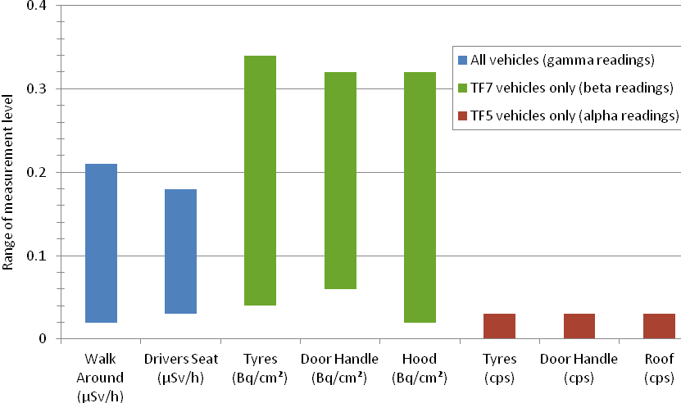
Figure 5.12 Range of gamma, beta and alpha monitoring results of vehicles on the shipping vessels Trans Future 7 and Trans Future 5. Gamma readings are reported in µSv/h, beta readings are reported in Bq/cm² and alpha readings are reported in counts per second (cps). All results were in the normal background range for gamma, beta and alpha levels with no difference between new or used vehicles.
Gamma dose rates ranged from 0.02 to 0.21 µSv/h measured around the outside of all vehicles and in drivers’ seats. These levels can be attributed to naturally occurring radionuclides present in the raw materials of the vehicles and the shipping vessels, and to cosmic radiation. Beta detections over all internal and external surfaces of vehicles ranged from 0.02 to 0.32 Bq/cm². These are due to the presence of naturally occurring radionuclides in or on the surface of vehicles. Alpha detections ranged from 0 to 0.03 counts per second (cps), equating to 0 to 0.001 Bq/cm². The presence of alpha emitting radionuclides can only be detected if they are on the surface of an object. The very small levels detected were in high air flow areas and were likely to be due to natural radionuclides, originating from radon, depositing on surfaces.

Health impacts from imported vehicles
No contamination was found on any monitored vehicle and all results were in the range of typical background radiation levels. This supported ARPANSA’s original advice that it was not necessary to introduce any radiation screening measures for mail, sea or air cargo, or aircraft arriving from Japan.
No health risk assessments were undertaken as no contamination was found.

Screening methodology for military aircraft
ARPANSA requested the United States Marine Corps undertake a dose rate assessment on 6 military helicopter aircraft. In a report provided to ARPANSA, specific areas of the aircraft had readings above background at less than 1 µSv/h. The highest measured dose rates ranged from 0.12 µSv/h to 0.94 µSv/h (Table 5.1). Dose rate measurements were performed using an IM-265/PDQ-1 meter connected with a DT-685 frisker probe. Measurements were taken about 1.3 cm from the aircraft surface at a sampling rate of 5 cm per second.
In order to independently assess the levels of non-fixed contamination present on the aircraft, ARPANSA requested that further contamination monitoring take place targeting areas on each aircraft that are likely to be contaminated (e.g. high air flow areas). Wipe samples, taken by United States Marine Corps staff, were collected by wiping about 100 cm² of the target surface with a standardised 47 mm glass fibre filter supplied by ARPANSA. Wipe samples were tested for radionuclide content at ARPANSA by using high-resolution gamma spectrometry (ANSI 1999).

Results of military aircraft screening
Analysis of the wipe samples for radionuclide content confirmed the presence of ¹³⁴Cs and ¹³⁷Cs on the aircraft surfaces at very low levels ranging from less than detectable to 0.1 Bq/cm² (Table 5.1). The ratio of ¹³⁷Cs to ¹³⁴Cs ranged from 1.2 to 1.6. ¹³¹I was not detected above detection limits. These ratios are comparable to those measured by Japanese authorities during the early phase of the accident (MEXT 2011c). The similarity of ratios indicates that the source of radioactive caesium is the Fukushima Dai-ichi NPP accident.

Table 5.4 Results of the monitoring program undertaken by ARPANSA and the United States Marine Corps on 6 military helicopter aircraft. Locations of surface monitoring are shown on the aircraft schematic. Details provided in Appendix A.
Forward rotor head
Wheel assembly
Aft upper starboard clamshell
Aft rotor
head
Starboard forward sensor
Transmission oil cooler
Port and starboard exhaust
Forward blade tip
Starboard utility cooler

Helicopter Reference | US Marine Corps Maximum Dose Rate Range (µSv/hr) | ¹³⁷Cs  Concentrations Range (Bq/cm²) | ¹³⁴Cs  Concentrations Range (Bq/cm²)
Aircraft 5318 | 0.25 | 0.003 to 0.10 | 0.002 to 0.08
Aircraft 3999 | 0.44 | <0.002 to 0.06 | <0.002 to 0.04
Aircraft 3373 | 0.12 | 0.02 to 0.02 | 0.02
Aircraft 3393 | 0.94 | 0.003 to 0.02 | 0.002 to 0.02
Aircraft 7669 | 0.51 | 0.003 to 0.005 | <0.002 to 0.003
Aircraft 6458 | 0.41 | 0.32 to 1.57 | <0.27 to 1.23

Health impacts from military aircraft
The levels of caesium contamination found on the aircraft surfaces were very low with a maximum of 0.1 Bq/cm². ¹³⁴Cs and ¹³⁷Cs are beta and gamma emitters and the measured levels were significantly lower than the Australian Transport Code criteria of 4 Bq/cm² for assessing beta and gamma emitting radionuclide contamination (ARPANSA 2008).
In May 2011 ARPANSA provided advice to DAFF that it was satisfied that these helicopters do not pose a significant hazard to the public and the environment, including any personnel operating in and around the aircraft, during the exercise in Australia.

Dose assessment for a family living in Fukushima
ARPANSA received many requests for internal contamination checks from Australian citizens who lived in Japan or had returned from Japan following the Fukushima Dai-ichi NPP accident. ARPANSA closely monitored the situation and assessed that there would be no requirement and no health benefit in carrying out tests for contamination, internal or external, for individuals of any age living or visiting outside the 80 km radius of the Fukushima Dai-ichi NPP. Requests received by ARPANSA for testing of Australians who were within the 80 km zone during or immediately following the passage of radioactive plumes from the accident were assessed by ARPANSA to determine if a more detailed dose assessment and testing was required. Those within 30 km would be fully assessed. Only one family triggered a detailed dose reconstruction.
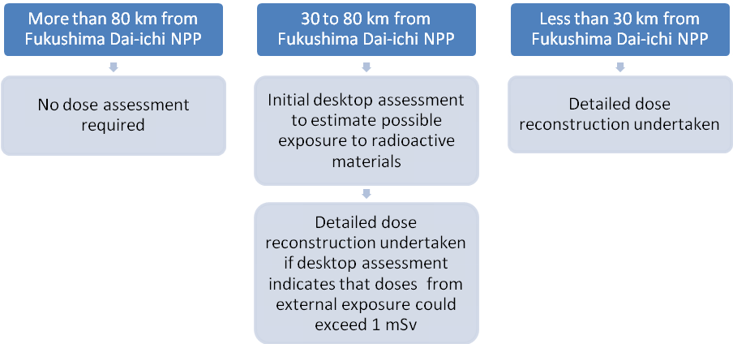
Figure 6.13 Process for assessing doses to Australians in Japan during and following the Fukushima Dai-ichi NPP accident in March 2011.

In July 2011, at the request of an Australian citizen living in Fukushima, ARPANSA undertook an initial desktop assessment on his family (1 adult and 3 children) living 60 km from the Fukushima Dai-ichi NPP during and after the accident. Although the family were located outside the 30 km planned evacuation zone, they were living in an area north-west of the power plant that received elevated levels of contamination. The assessment indicated that external doses may have exceeded 1 mSv, therefore a detailed dose reconstruction which included measurements was undertaken when the family were in Australia during August 2011. An outline of this assessment is provided below and a more detailed description is given in Appendix A.

Dose reconstruction methodology
Dose reconstruction is the process of estimating the radiation dose received from a previous exposure to radiation and radioactive material. This is achieved by defining an exposure scenario, examining potential pathways through which a radiation dose could occur and estimating the likely dose received. The dose reconstruction was conducted in line with the recommendations of the International Commission on Radiological Protection (ICRP 2007) in relation to radiation protection of humans, using living patterns described in ICRP Publication 71 (ICRP 1996).
To assist in developing an exposure scenario ARPANSA asked the family a series of questions to establish living habits, locations and the duration of exposure during and after the accident. In addition, the family was able to provide measured radiation dose rates for indoors and outdoors. ARPANSA undertook a series of in-situ whole body screening and urine measurements when the family travelled to Australia in August 2011.

Exposure Scenario:
The family members assessed (1 adult and 3 children) were living in an area contaminated by radionuclide fallout, including ¹³¹I, ¹³⁴Cs and ¹³⁷Cs, for 150 days following the Fukushima Dai-ichi NPP accident. The family members were assumed to be exposed to radioactive material both internally and externally. Indoor and outdoor dose rates were supplied by the family, as well as details of their location during and after the accident. It was assumed that:
- the family lived at the same residence for five continuous months (150 days)
- the only mechanism for reducing deposited surface contamination was radioactive decay
- the only pathways for ingestion of contamination were the consumption of contaminated food and transfer from contaminated surfaces to the hands and then the mouth
- maximum dose rate measured by the family indoors was 0.9 µSv/h
- maximum dose rate measured outdoors was 4 µSv/h
- all dose rate measurements were assumed to be taken at 1 m

Examination of potential pathways
Based on the exposure scenario, both internal and external exposure types were considered for a continuous 150 day exposure period following the accident (Figure 6.2).
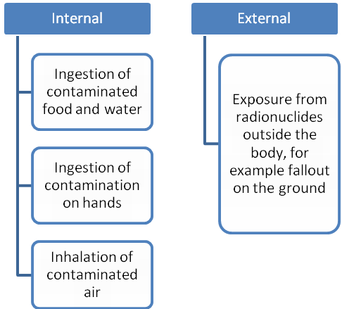
Figure 6.14 Exposure pathways for a family living near the Fukushima Dai-ichi NPP.

External doses occur from exposure to radiation resulting from decay of radionuclides outside the body. This dose depends on the type of radiation, the distance from the source and any shielding that may be present. The primary radionuclides of concern for the family would be caesium isotopes, in particular ¹³⁴Cs and ¹³⁷Cs, which emit high energy gamma rays during their decay. These radionuclides will be present on all surfaces outside and are likely to be present inside the house from natural house ventilation (e.g. open doors) or from human activities.
Internal radiation doses occur when radionuclides decay inside the body. These radionuclides can be taken into the body by ingestion of contaminated food and drinking water, ingestion of contamination on hands (especially for children) or by inhalation of contaminated air. All these pathways were likely intakes for the family for ¹³¹I, ¹³⁴Cs and ¹³⁷Cs.
Once in the body, caesium behaves in a manner similar to potassium and distributes uniformly throughout the body. The biological half-life of caesium in humans is age dependant, with young children able to excrete caesium from the body much quicker than adults. Upon intake, ¹³¹I is rapidly taken up by the thyroid. Clearance from the thyroid is also age dependent, with young children able to excrete ¹³¹I from the body much quicker than adults.

Internal dose assessment
Caesium has a radioactive half-life of about 30 years and once incorporated into the body, it can remain there for many months. For this reason, whole body screening and urine monitoring of the family was performed enabling ARPANSA to estimate internal radiation exposure 150 days after the accident. As ¹³¹I has a short half-life it cannot be detected in the body 150 days after the accident.
All family members were assessed by whole body screening to determine if any of the family members had an amount of caesium exceeding 1000 Bq remaining within their body on 3 August 2011. Whole body screening is a rapid non-invasive technique that can be used to determine the amount of caesium remaining within their body at the time of measurement. The portable detection system was a sodium-iodide scintillation detector (3 by 3 inch crystal) connected to a computer to collect 5 minute measurements. The detector was placed reasonably close to the body in the area of the chest, abdomen and thighs as described in the Triage, Monitoring and Treatment TMT Handbook (TMT 2009). The portable detection system was calibrated using internationally traceable ¹³⁷Cs radioactive material in a geometry that represented a human torso. The detection limit of the system was 1000 Bq.
The whole body screening results were negative for all family members. A negative result was also observed for another family member who was not in Japan during or after the accident.
Urine monitoring was also undertaken as it is a very sensitive technique capable of detecting very low levels of caesium. Urine samples were taken from all family members in a 24 hour period on 8 August 2011. The sample volume collected for the adult was 1.4 L and sample volumes varied from 0.2 to 0.8 L for the children. Samples were couriered back to ARPANSA for assessment using a standard high-resolution gamma (ANSI 1999). Acidified samples were assessed in a standard counting geometry (Marinelli beaker) using an acquisition time of 64 hours.
The levels of caesium measured in urine across all family members were similar ranging from 0.2 to 0.5 Bq/L for ¹³⁷Cs and 0.1 to 0.4 Bq/L for ¹³⁴Cs. This indicates that a chronic intake (daily over 150 days) of low levels of radioactive material has likely occurred. An acute exposure, for example in the first week after the accident, would result in significantly less caesium in urine of children compared to an adult, assuming all members of the family were equally exposed.

Fact sheets were provided to the family before measurements to explain the process of whole body screening and urine monitoring (see Appendix B).
Based on the assumption of a chronic intake (inhalation or ingestion) over a 150 day period, the internal dose has been estimated to be less than 0.005 mSv for all members of the family. This is a very low dose, suggesting that very little radioactive material was consumed.

External dose assessment
An assessment of external dose was made assuming a 150 day exposure period, from March to July 2011. The basis for the external dose assessment was the gamma dose rate measurements around the family home in Japan, provided by the family. The maximum dose rate measured indoors was 0.9 µSv/h and the maximum dose rate outdoors was 4 µSv/h. It was assumed that the external exposure was from the deposition of caesium. Estimates of cumulative external doses are based on the highest doses measured and the living habits of the family.
The external dose for the 150 days following the Fukushima Dai-ichi NPP accident was estimated to be in the range of 3 to 5 mSv for all members of the family. These estimates are conservative and assume that the only contamination reduction mechanism is radioactive decay. Any remediation, such as cleaning and removing top soil, or limiting time in more contaminated areas, would reduce dose estimates significantly.

Iodine-131
¹³¹I is also likely to be an important contributor to overall exposure to the family, with the thyroid being the most exposed organ. Although ¹³¹I was not measured, an estimate of the internal dose from inhalation and ingestion was inferred using the measured caesium concentrations in urine and assuming that the initial deposition of ¹³¹I was ten times greater than that of ¹³⁷Cs. The dose delivered to the thyroid from ¹³¹I was also assessed and reported as an equivalent dose. This is different to a whole body dose. The equivalent dose to the thyroid ranged from 0.03 to 0.6 mSv, which results in an effective dose ranging from 0.0015 to 0.03 mSv.
The World Health Organization (WHO) in its preliminary report estimated thyroid doses to residents of all Japanese prefectures other than the Fukushima prefecture to be in the range of 1 to 10 mSv in the first year (WHO 2012). The dose estimated by WHO also includes contributions to the thyroid dose from other radionuclides, as well as external exposure to the thyroid.

Health impact
The total effective dose to family members was estimated to be less than 5 mSv over 150 days, with only a small fraction of this from internal exposure, including the dose to the thyroid. The conservative doses estimated are equivalent to approximately 2 to 3 years of background dose received from natural sources (internal and external). Another means of comparison is a chest CT scan for an adult, which typically gives up to 10 mSv external dose per visit. Based on this assessment, the doses received by the family are of minimal health concern and no long term testing is required.
These results suggest that the protective measures put in place by the family and Japanese authorities seem to have been effective in reducing or limiting internal doses to the family while living in the Fukushima area.

Dose assessment for the short-tailed shearwater (mutton bird)
The Fukushima Dai-ichi NPP accident released large amounts of radioactive material into the environment, contaminating the ecosystem in which wildlife live. Humans reduced the potential of contamination by evacuating, sheltering and limiting their consumption of contaminated food. Limited protection was provided to plants and animals used in the human food chain. During the accident, there were no protective measures provided for wildlife.

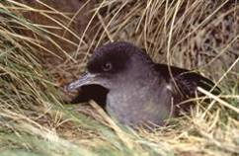
Figure 7.1 Short-tailed shearwater, commonly referred to as the mutton bird. Photo courtesy of Steve Johnson, Tasmania Parks and Wildlife Service.
Short-tailed shearwater (mutton birds) migrate each austral autumn from Australia and New Zealand to the Aleutian Islands in the north Pacific and return to Australia and New Zealand in late spring to nest. This annual migration pattern sees the birds passing the coast of Japan during April and May each year. Little is known about the habits of mutton birds during their migration as they do not come to shore during the months of migration. It is estimated that the birds cover over 15,000 km each direction. Typically, the mutton birds mate on return to their burrows in November and chicks hatch in January. In some areas young mutton birds are harvested and used for meat, feathers and oils (Parks and Wildlife Service Tasmania 2003).
ARPANSA and the Tasmanian Department of Health and Human Services (DHHS) received a number of public enquiries regarding the potential health risks associated with harvesting and consuming the chicks born from migratory birds that may have been in the vicinity of the Fukushima Dai-ichi NPP during the austral autumn, 2011. To address these concerns, ARPANSA undertook a radiation dose reconstruction to assess the potential radiation exposure of the mutton bird population during its northward migration from Australia during April to June 2011.

Dose reconstruction methodology
Dose reconstruction is the process of estimating the radiation dose received from a previous exposure to radiation. This is achieved by defining an exposure scenario and examining potential pathways through which a radiation dose could occur and estimating the likely dose received.
The majority of radioactive material measured in the marine environment surrounding the Fukushima Dai-ichi NPP comprised of ¹³¹I, ¹³⁴Cs and ¹³⁷Cs (WHO and FAO 2011). Therefore, the dose assessment focused on these isotopes.
The dose reconstruction was conducted in line with the recommendations of ICRP (ICRP 2007) in relation to radiation protection of non-human biota. The focus was on both the protection of humans and the radiation effects on biological diversity and conservation of mutton birds. As the dose reconstruction was a desktop study, assumptions have been made based on published literature. A small sample of mutton bird carcasses and meat were tested for radioactive caesium contamination using high-resolution gamma-ray spectrometry.

Exposure Scenario:
Adult mutton birds land and feed in contaminated waters off the east coast of Japan during their northward migration in late April to May. The birds can receive an external dose from the contaminated water and flying through any atmospheric releases from the Fukushima Dai-ichi NPP accident, and an internal dose from eating contaminated food. After spending approximately six months in more northern (uncontaminated) waters they then return via the central and eastern pacific to breed in southern Australia and New Zealand. If internal contamination is present in adult mating birds, developing eggs and chicks could be exposed to radioactive materials during feeding as food is regurgitated by the parents prior to intake by the chicks. The chicks would then have internal contamination and are harvested and eaten by people. Droppings from adult birds may also contain contamination.

Examination of potential pathways
There are two exposure types to consider for the mutton birds; internal and external. These have various exposure pathways associated with them (Figure 7.1).
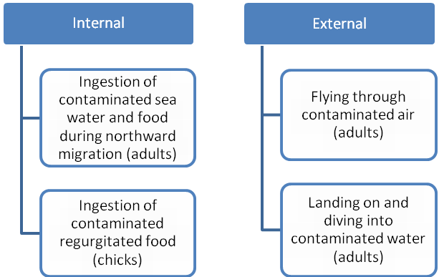
Figure 7.15 Pathways for the contamination of mutton birds and their chicks

Mutton birds could receive an external dose from flying through contaminated air or landing on and diving into contaminated water. Based on water measurements (IAEA 2011b) it is unlikely that the water would be highly contaminated unless it was close to the reactor site. External contamination would be washed off the birds when they land and feed in non-contaminated waters north and east of the reactor site. Contaminated food would be in the form of contaminated fish and shrimp.
Once ingested, caesium distributes uniformly through the body. The biological half-life is the time taken for 50% of a substance to be removed from the body via natural processes. The biological half-life of caesium in various bird species has been measured to range from 6 to 12 days (Eisler 1994). Assuming the maximum measured biological half-life of 12 days, the amount of caesium remaining in the adult mutton bird 12 weeks after eating contaminated food would be less than 1% of the caesium ingested. ¹³¹I has a short radioactive half-life (8 days), therefore much of the ¹³¹I released to the environment would have decayed and dispersed in the ocean before the birds reached Japan on their annual migration. Any remaining ¹³¹I ingested by the mutton birds would continue to decay at this rate as well as being excreted by the birds.

Results of testing
Seven mutton bird carcasses collected and frozen by Tasmanian Parks and Wildlife were supplied to Tasmania DHHS for assessment by ARPANSA in April 2012. The total mass was 1.9 kg. Initial screening was undertaken using high resolution gamma spectrometry (ANSI 1999). The bird carcasses were broken into four batches with each batch placed in the detector for a 15 hour count. No caesium isotopes were detected. Because the carcasses were not in a standard geometry, quantification was not possible. Results are shown in Table 7.1.
Four mutton birds prepared for human consumption by a butcher were purchased by ARPANSA in May 2012. A total mass of 0.41 kg of meat was removed and assessed using high resolution gamma spectrometry. Levels of ¹³⁷Cs and ¹³⁴Cs were less than 0.19 Bq/kg, the detection limit for a 24 hour count. Results are shown in Table 7.1.

Table 7.1 Analysis results of ¹³⁷Cs and ¹³⁴Cs in mutton bird carcasses and meat. The detection limit of the technique is represented in the table as a ‘less than’ number.
Mutton Bird Test Results | Number of Birds | Mass (kg) | ¹³⁷Cs (Bq/kg) | ¹³⁴Cs (Bq/kg)
Mutton Bird Carcasses | 7 | 1.9 | Not detected | Not detected
Mutton Bird Meat | 4 | 0.41 | < 0.19 | < 0.19

Health effects
The three cases considered for mutton birds that migrated via Japan in 2011 were assessed with regards to the bird population as a whole rather than to individual birds. ARPANSA concluded that:
- The birds are unlikely to be contaminated, either internally or externally by the time they arrive in Australia. This conclusion is supported by the absence of detectable radioactive caesium in the bird samples tested by ARPANSA.
- It is unlikely that individual birds would have received a dose large enough to affect reproductive success, and due to the large size of the mutton bird population there should not be a significant impact on the biological diversity of the species due to the Fukushima Dai-ichi NPP accident. This has been confirmed by assessment using the ERICA software tool (Brown et al. 2008) with details of the ERICA assessment provided in Appendix A. This assessment accounts for the fact that any exposure of individual birds would have been transient in nature rather than a chronic exposure.
- Due to the short biological half-life of caesium isotopes and the short radioactive half-life of ¹³¹I, it is likely that if any internal contamination of adult mutton birds had occurred during migration north, that contamination would be no longer present, or present at very low levels by the time the mutton birds return to Australia to nest in late 2011. Therefore, contamination of young birds via regurgitated food is highly unlikely to occur.
As contamination of young birds is highly unlikely, the chance of humans ingesting contaminated young mutton birds is also highly unlikely. Therefore there will be no impact on the health of individuals who consumed young mutton birds born in 2011.

Communicating results to the public
Scientists, physicians and public health officials often encounter the challenge on how to explain radiation dose and health effects from ionising radiation exposure to members of the public. While the need for good communication is recognised, there is no internationally agreed approach.
One approach to explaining the significance of any radiation exposure is to relate the radiation dose to:
- the exposure from natural background ionising radiation, and
- the significance of potential health effects.

Both the comparison to background and a consistent approach to describing health impact were applied in providing advice to the public during and after the Fukushima Dai-ichi NPP accident.

Natural background radiation exposure
All living species are exposed to ionising radiation in the environment, from natural and human sources. Naturally occurring radioactivity is in the air we breathe, the food we eat and the buildings we live in.
ARPANSA has calculated that on average, people in Australia are exposed to about 3.2 mSv of radiation a year (1.5 mSv from our environment (Webb et al. 1999) and 1.7 mSv from medical exposures (Hayton et al. 2012).
As shown in Figure 8.1, the largest exposure to naturally occurring radiation comes from natural radioactivity in building materials and radon gas that seeps from the ground into all buildings. There are also significant contributions from cosmic radiation and naturally occurring radioactivity in food.

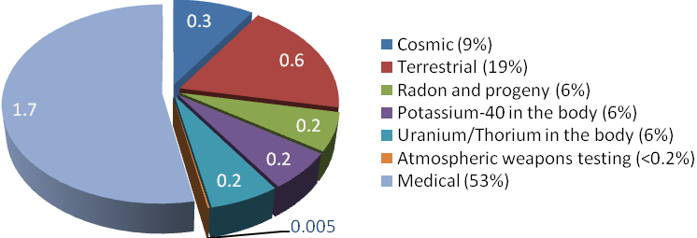
Figure 8.16 The estimated contributions to the annual radiation dose per person from natural and artificial sources in Australia (mSv).
The annual background radiation exposure can be used as a benchmark for comparison with other radiation exposure situations. For instance, a routine chest x-ray results in an effective dose of 0.02 mSv. This is the same dose a person would receive in 5 days from natural sources, or, a person would need to have 75 chest x-rays to receive a radiation dose comparable to a year of natural background radiation exposure (assuming the natural background radiation level is 1.5 mSv). Further examples are provided in Figure 8.2.

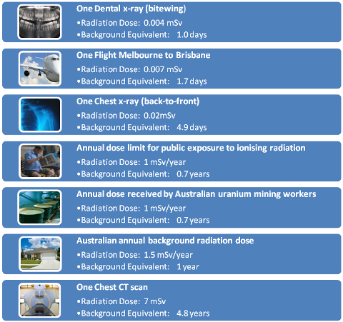

Figure 8.2 Low doses and dose rates compared to natural background radiation exposure (assuming the natural background radiation level is 1.5 mSv).

Risk and potential health effects
There have been many large scale studies worldwide of cancer risk in people arising from radiation exposure, and many of these studies are summarised in the reports of the United Nations Scientific Committee on the Effects of Atomic Radiation (UNSCEAR 2000, UNSCEAR 2008). The risk from exposure to high radiation doses is relatively well quantified, but for low radiation exposures the scientific evidence for increased health risk is uncertain (Figure 8.3). As cancer is a common disease with many causes it is extremely difficult to quantify directly any small extra risk from ionising radiation when the doses are very low. However, for radiation protection purposes it is common to assume a linear relationship between the radiation dose and the increase to cancer frequency in an exposed population.
10 mSv
1000 mSv
100 mSv
Harmful tissue reactions
Effects Unknown (high uncertainty)

Cancer and hereditary effects
(risk increases linearly with dose)

Figure 8.3 Radiation health effects and the doses at which they can occur. Health effects are uncertain at very low doses. While there is a possible increased risk of cancer and hereditary effects at low radiation doses or for radiation delivered over a long period of time, these effects do not always occur because the body is capable of repairing itself. However, their likelihood increases as dose increases. Harmful tissue reactions (acute or deterministic effects) occur when doses are high (greater than about 500 mSv). These effects occur shortly after exposure (minutes to weeks) and can include sterility, skin burns and acute radiation syndrome. Death can occur at very high doses.

Comparison with the Chernobyl NPP accident
Communicating the risks from the Fukushima Dai-ichi NPP accident:
It is difficult to quantify the risks associated with very low radiation exposures (for example doses below 20 mSv). This is because cancer is a common disease, which makes it hard to identify which cancers are due to radiation exposure and which cancers would have occurred naturally. For radiation protection purposes is usual to assume a linear relationship between radiation dose and cancer incidence. This is the approach used by ARPANSA to provide radiation protection advice.
When providing advice to the public about the health impacts associated with any radiation exposure from the Fukushima Dai-ichi NPP accident, ARPANSA used the following terms:
- Negligible Risk (less than 1 mSv)
A 1 mSv annual dose is easily within the range of normal variation in background radiation doses in Australia. An example of a radiation exposure that results in a ‘negligible risk’ is consuming 55 kg of food that is contaminated with 1000 Bq/kg of caesium (see the Health impacts from imported food section of this report for details).
- Minimal Risk (1 to 20 mSv)
20 mSv is the average annual dose limit for a radiation worker in Australia. Radiation exposures from some medical procedures also fall in this range. An example of a radiation exposure that results in a ‘minimal risk’ is a chest CT scan (see Figure 8.2).

The extent of radioactive releases and the potential health impacts from the Fukushima Dai-ichi NPP accident are very different to those of the 1986 Chernobyl NPP accident.
While the radioactive releases from the Fukushima Dai-ichi NPP accident have significantly contaminated areas in the Fukushima and surrounding prefectures, radioactive contamination in other parts of Japan and in neighbouring countries is very low and is of negligible health consequence. There were no worker deaths attributed to direct radiation exposures, nor any cases of acute radiation syndrome.
Estimates made by the Japanese authorities indicate that the release of radioactive iodine, which in the early phase of the accident was a cause for major concern, was approximately one-tenth of the radioactive iodine release from the Chernobyl NPP accident. Protective measures limited this exposure and the levels of radioactive iodine in the environment have now decayed to insignificant levels. The quantity of radioactive caesium released was about one-fifth of the corresponding release from the Chernobyl NPP accident. The amount of contamination in the environment from radioactive caesium released from the Fukushima Dai-ichi reactors only decreased slightly in the year following the accident (mainly through decay of ¹³⁴Cs which has a half-life of 2 years compared to ¹³⁷Cs which has a half-life of approximately 30 years).
During the Chernobyl NPP accident, the reactor core was rapidly destroyed and the resultant graphite fire burnt for 10 days, releasing large amounts of radioactive material into the atmosphere. Some of the workers who dealt with the immediate emergency lost their lives due to exposure to high radiation doses that resulted in acute radiation syndrome. The radioactive material released affected not only the areas close to the accident, but also many other countries in Europe. Exposure to radioactive iodine, mainly in food, led to increased thyroid cancer in children living in the affected area. The United Nations Scientific Committee on the Effects of Atomic Radiation has published a series of reports on the health effects of the Chernobyl NPP accident summarised in UNSCEAR (2008).
An increased level of thyroid cancer among children was one of the significant radiation induced health impacts from the Chernobyl NPP accident. The contamination of milk with ¹³¹I, for which prompt countermeasures were lacking, resulted in large doses to the thyroids of the public. Over 6000 cases of thyroid cancer have been reported, with 15 deaths reported by 2005. The incidence of thyroid cancer was still increasing at that time, with a major proportion of these cases being attributable to the accident. The average thyroid dose to evacuees was about 500 milligray (mGy) (UNSCEAR 2008). For thyroid dose, 1 mGy is about the same as an equivalent dose of 1 mSv.
The World Health Organization (WHO) has estimated thyroid doses from the Fukushima Dai-ichi NPP accident to range from 1 to 10 mSv in most of Japan, and from 100 to 200 mSv (equivalent dose) in the most affected area of the Fukushima prefecture (WHO 2012). These doses are significantly lower than those seen following the Chernobyl NPP accident.

Conclusions and future work
Large amounts of radioactive material were released to the environment during the 2011 Fukushima Dai-ichi NPP accident. The studies and monitoring programs reported here were undertaken by ARPANSA in order to assess the impact of the accident on Australian public and the Australian environment, as well as to have confidence that Australian public could be protected from the harmful effects of potential radiation exposure.
ARPANSA has assessed that the impact on the health of people living in Australia due to the Fukushima Dai-ichi NPP accident was negligible. This assessment was based on:
- Very low levels of ¹³³Xe detected in Darwin during April 2011, which were assessed to have no impact on the health of any person living in Australia. No radioactive caesium or iodine from the Fukushima Dai-ichi NPP accident was detected at Australian monitoring stations.
- International ocean modelling, which predicts that it will take 5 to 15 years for any radioactive material from the Fukushima Dai-ichi NPP accident to reach Australian waters by which time it will have been significantly diluted to levels that would be difficult to detect.
- The monitoring program for imported foods from Japan, which found small amounts of contamination in some foods, with no foods tested exceeding internationally accepted limits. Small amounts of contamination were found on military aircraft and in ship ballast water. At such low contamination levels the impact on human health would be negligible.
- Testing of imported new and used vehicles and surfaces of shipping vessels, which were found to have no radioactive contamination.
- A dose assessment and radioactive contamination screening of Mutton Birds, which found no radioactive contamination on or in any birds tested.
- An assessment of the radiation doses received by members of a family living 60 km north-west of the Fukushima Dai-ichi NPP during the accident. Results of the external assessment and urine and whole body monitoring suggested that doses were minimal.
ARPANSA will continue to monitor the ocean and atmosphere in Australia for radioactive materials released during the Fukushima Dai-ichi NPP accident in order to provide accurate and current advice to the Australian Government and the public. This includes continuing to maintain atmospheric monitoring stations and continuing to test food imported from Japan.
Australia is also supporting a number of international programs to assess the impact of the Fukushima Dai-ichi NPP accident of people and the environment. ARPANSA is contributing to the:
- United Nations Scientific Committee on the Effects of Atomic Radiation (UNSCEAR) program, undertaking a comprehensive assessment of the levels and effects of radiation exposure due to the nuclear accident following the Great East-Japan earthquake and tsunami.
- Regional Co-operative Agreement (RCA) for the East Asia and Pacific region and the International Atomic Energy Agency (IAEA) ‘Marine benchmark study on the possible impact of the Fukushima radioactive releases in the Asia-Pacific Region’ to enhance regional capabilities for monitoring and assessing radionuclide contamination of the marine environment.
- World Health Organization (WHO) preliminary dose estimation from the nuclear accident after the Great East-Japan earthquake and tsunami.

References
All websites accessed on 25 September 2012.
ANSI (American National Standards Institute) 1999. Calibration and Use of Germanium Spectrometers for the Measurement of Gamma-Ray Emission Rates of Radionuclides N42.14-1999.
ARPANSA (Australian Radiation Protection and Nuclear Agency) 2002. Recommendations for Limiting Exposure to Ionizing Radiation (1995) and National Standard for Limiting Occupational Exposure to Ionizing Radiation, Radiation Protection Series Publication No.1 (2002).
ARPANSA 2004. Recommendations for Intervention in Emergency Situations Involving Radiation Exposure, Radiation Protection Series No. 7.
ARPANSA 2008. Code of Practice for the Safe Transport of Radioactive Material, Radiation Protection Series No. 2.
Birchall A, Puncher M, Marsh JW, Davis K, Bailey MR, Jarvis NS, Peach AD, Dorrian M-D and James AC 2005. IMBA Professional Plus: a flexible approach to internal dosimetry, Radiation Protection Dosimetry, Special Issue, Vienna 2005.
Brown JE, Alfonso B, Avila R, Beresford NA, Copplestone D, Prohl G and Ulanovsky A 2008. The ERICA tool. Journal of Environmental Radioactivity, Volume 99, 1371-1383.
DAFF (Department of Agriculture, Fisheries and Forestry) 2010. Import risk analysis for the importation of beef and beef products from Japan. Biosecurity Australia, Advice 2010/13.
EC (European Commission) 2011. Recommendation on the monitoring of the presence of I-131, Cs-134 and Cs-137 in fish and fishery products (and derived/processed products thereof) originating in/caught in certain fishing areas of the pacific region, European Commission, Health and Consumers Directorate-General.
EC 2012. Monitoring of radioactivity in fish and fishery products from the Pacific region, European Commission, Health and Consumers Directorate-General.
http://ec.europa.eu/energy/nuclear/radiation_protection/doc/emergencypreparedness/overview_import_2011_12_31.pdf
Eckerman KF and Ryman JC 1993. External Exposure to Radionuclides in Air, Water, and Soil, Federal Guidance Report No. 12, EPA-402-R-93-081.
Eisler 1994. Contaminant Hazard Reviews Report No. 29 Radiation Hazards to fish, wildlife and invertebrates: a synoptic review, Patuxent Environmental Science Center, U.S. National Biological Service.
FAO and WHO 2010. General Standard for Contaminants and Toxins in Food and Feed, Codex Alimentarius International Food Standards, Food and Agriculture Organization of the United Nations (FAO) and World Health Organization (WHO), CODEX STAN 193-1995.
Hamada N, Ogino H and Fujimichi Y 2012. Safety regulations of food and water implemented in the first year following the Fukushima nuclear accident. Journal of Radiation Research, Volume 00, 1-31.
Hayton AJM, Johnston PN, Baldas J, Marks PA, Edmonds K and Wallace AB 2012. Australian per caput doses from diagnostic imaging and nuclear medicine. 13th International Congress of the International Radiation Protection Association, Glasgow, 13 to 18 May 2012.
IAEA (International Atomic Energy Agency) 2005. Worldwide Marine Radioactivity Studies (WOMARS) Radionuclide levels in oceans and seas, Final report of a coordinated research project, IAEA-TECDOC-1429.
IAEA 2011a. IAEA international fact finding expert mission of the nuclear accident following the Great East Japan earthquake and tsunami, Tokyo, Fukushima Dai-ichi NPP, Fukushima Dai-ni NPP and Tokai NPP, Japan, Preliminary Summary, 24 May to 1 June 2011.
IAEA 2011b. Status of the Fukushima Dai-ichi nuclear power plant and related environmental conditions, IAEA Incident and Emergency centre, 27 April 2011 Report.
ICRP (International Commission on Radiological Protection) 1994a. Publication 67: Age-dependent doses to members of the public from intake of radionuclides: Part 2. Ingestion dose coefficients. Annals of the ICRP. 23(3-4).
ICRP 1994b. Publication 66: Human respiratory tract model for radiological protection. Annals of the ICRP. 24(1-3).
ICRP 1996. Publication 71: Age-dependent doses to members of the public from intake of radionuclides: Part 4. Inhalation dose coefficients. Annals of the ICRP. 25(4-6).
ICRP 2007. Publication 103: The 2007 Recommendations of the International Commission on Radiological Protection.
ICRP 2009. Publication 108: Environmental Protection: the concept and use of reference animals and plants.
IMO (International Maritime Organization) 2004. International Convention for the Control and Management of Ships' Ballast Water and Sediments, Adopted: 13 February 2004.
IRSN (Institute de Radioprotection et de Surêté Nucléaire) 2011. Impact on marine environment of radioactive releases resulting from the Fukushima Dai-ichi nuclear accident, Report 14.
IRSN 2012. Summary of the Fukushima accident's impact on the environment in Japan, one year after the accident, Report 28.
Madigan D, Baumann Z and Fisher S 2012. Pacific bluefin tuna transport Fukushima-derived radionuclides from Japan to California. Proceedings of the National Academy of Sciences of the United States of America 109(24).
MEXT (Ministry of Education, Culture, Sports, Science and Technology) 2011a. Readings of Sea Area Monitoring at Post out of Fukushima Dai-ichi NPP. 31 March 2011 Report.
http://www.mext.go.jp/component/english/__icsFiles/afieldfile/2011/05/10/1304193_0331.pdf
MEXT 2011b. Readings of sea area monitoring at offshore of Miyagi, Fukushima and Ibaraki Prefecture - marine soil. 23 July 2011 Report.
http://www.mext.go.jp/component/english/__icsFiles/afieldfile/2011/07/23/1305745_072314.pdf
MEXT 2011c. Readings of Environmental Radiation Monitoring (Ports and Marine Fishing Grounds) in Fukushima (Preliminary Report). 11 August 2011 Report.
http://radioactivity.mext.go.jp/en/contents /4000 /3628 /24 /1520_0811.pdf
MLIT (Ministry of Land, Infrastructure, Transport and Tourism) 2011. Guideline on Radiation Measurement for Export Containers in Ports, Original Issue April 2011, Revised August 2011, Japanese Government.
http://www.mlit.go.jp/common/000163217.pdf
Nakano M and Povinec P 2012. Long-term simulations of the ¹³⁷Cs dispersion from the Fukushima accident in the world ocean, Journal of Environmental Radioactivity, Volume 111, September 2012.
NERH (Nuclear Emergency Response Headquarters) 2011a. Report of the Japanese Government to the IAEA Ministerial Conference on Nuclear Safety - The Accident at TEPCO’s Fukushima Nuclear Power Stations, Government of Japan, 7 June 2011.
NERH 2011b. Additional Report of Japanese Government to IAEA - Accident at TEPCO's Fukushima Nuclear Power Stations Transmitted by Nuclear Emergency Response Headquarters, Government of Japan, 15 September 2011.
Orr B, Schöppner M, Tinker R and Plastino W 2012. Detection of radioxenon in Darwin, Australia following the Fukushima Dai-ichi nuclear power plant accident, Journal of Environmental Radioactivity (submitted August 2012).
Parks and Wildlife Service Tasmania 2003. Short-tailed Shearwater: Puffinus tenuirostris. http://www.brunyisland.net/Downloads/parks%20pdf/Shearwater.pdf
Saey P 2009. The Influence of radiopharmaceutical isotope production on the global radioxenon background, Journal of Environmental Radioactivity, Volume 100, Issue 5.
Schulze J, Auer M and Werzi R 2000. Low level radioactivity measurement in support of the CTBTO, Applied Radiation and Isotopes, Volume 53.
Stohl A, Forster C, Frank A, Seibert P and Wotawa G 2005. Technical note: the Lagrangian particle dispersion model FLEXPART version 6.2. Atmospheric Chemistry and Physics, Volume 5, 2461-2474.
Stohl A, Seibert P, Wotawa G, Arnold D, Burkhart JF, Eckhardt S et al. 2012. Xenon-133 and caesium-137 releases into the atmosphere from the Fukushima Dai-ichi nuclear power plant: determination of the source term, atmospheric dispersion, and deposition, Atmospheric Chemistry and Physics, Volume 12, 2313-2343.
Tagami K, Uchida S and Ishii N 2011. Extractability of radiocesium from processed green tea leaves with hot water: the first emergent tea leaves harvested after the TEPCO’s Fukushima Daiichi Nuclear Power Plant accident. Journal of Radioanalytical and Nuclear Chemistry, Volume 292, Issue 1, 243-247.
TEPCO (Tokyo Electric Power Company) 2012a. Photos and Videos Library.
http://photo.tepco.co.jp/en/photo/2011/201103-e.html
TEPCO 2012b. Result of estimation of the released amount of radioactive materials into the ocean (in the vicinity of a port), TEPCO, 24 May 2012. http://www.tepco.co.jp/en/press/corp-com/release/betu12_e/images/120524e0204.pdf
Tinker R, Orr B, Grzechnik M, Hoffmann E, Saey P and Solomon S 2010. Evaluation of radioxenon releases in Australia using atmospheric dispersion modelling tools, Journal of Environmental Radioactivity, Volume 101, Issue 5.
TMT 2009. TMT Handbook, Triage, Monitoring and Treatment of people exposed to ionising radiation following malevolent act, Editors Rojas-Palma C, Liiand A, Jerstad AN, Etherington G, Perez M, Rahola T and Smith K.
UN (United Nations General Assembly) 1996. Comprehensive Nuclear-Test-Ban Treaty. United Nations General Assembly Resolution Number 50/245 on 10 September 1996.
UNSCEAR (United Nations Scientific Committee on the Effects of Atomic Radiation) 2000. Sources and Effects of Ionizing Radiation, Report Vol. 1 Sources, Report to the General Assembly, with scientific annexes.
UNSCEAR 2008. Sources and Effects of Ionizing Radiation, Report Vol. 1 Sources, Report to the General Assembly, with scientific annexes, Volume II Scientific Annexes C, D and E.
Unterweger, MP, Hoppes, DD Schima FJ and Coursey JS 2012. Radionuclide Half-life Measurements, National institute of Standards and Technology (NIST).
Webb DV, Solomon SB and Thomson JEM 1999. Background radiation levels and medical exposure levels in Australia. Conference Paper, Radiation Protection in Australasia Volume 16, Number 2.
WHO (World Health Organization) and FAO (Food and Agriculture Organization of the United Nations) 2011. Impact on seafood safety of the nuclear accident in Japan.
http://www.iaea.org/newscenter/focus/fukushima/seafoodsafety0511.pdf
WHO 2012. Preliminary dose estimation from the nuclear accident after the 2011 Great East Japan earthquake and tsunami.

Appendix A: Data and Calculations

CTBT monitoring stations maintained by ARPANSA
Table A.5 Location of CTBT monitoring stations maintained by ARPANSA. *Noble gas monitoring maintained.
Location | State or Territory | Type | Treaty Code | Coordinates
 |  |  |  | Lat | Lon
Melbourne* | Victoria | Radionuclide Station | RN04 | -37.5 | 144.6
Mawson | Antarctica | Radionuclide Station | RN05 | -67.6 | 62.5
Townsville | Queensland | Radionuclide Station | RN06 | -19.2 | 146.8
Macquarie Island | Tasmania | Radionuclide Station | RN07 | -54 | 159
Cocos Islands | Western Australia | Radionuclide Station | RN08 | -12 | 97
Darwin* | Northern Territory | Radionuclide Station | RN09 | -12.4 | 130.7
Perth | Western Australia | Radionuclide Station | RN10 | -31.9 | 116

Dose calculation for ¹³³Xe detections in Darwin
The model applied to determine the dose, D_{Xe}, in Sv, from exposure to ¹³³Xe detected in Darwin during April 2011.

where:
- A_{Xe} is the maximum activity concentration (Bq/m³)
- t is the submersion time (s)
- k_{air} is the dose coefficient for air submersion: 1.56 x 10⁻¹⁵ (Sv/s)/(Bq/m³) for ¹³³Xe from Eckerman and Ryman (1993)

Data from air monitoring station in Darwin, Australia
Table A.2 ¹³³Xe activity concentrations for detections greater than 0.5 mBq/m³ in air samples collected from the noble gas CTBT monitoring station located at Darwin, Australia.
Date | Detection Time (UTC) | Detection > 0.5 (mBq/m³) | Detection Time (UTC) | Detection > 0.5 (mBq/m³)
5/04/2011 | 700 | 0.67 | 1900 | 0.98
6/04/2011 | 700 | 0.51 | 1900 | -
7/04/2011 | 700 | - | 1900 | -
8/04/2011 | 700 | - | 1900 | 1.79
9/04/2011 | 700 | 3.18 | 1900 | 4.01
10/04/2011 | 700 | 6.58 | 1900 | 7
11/04/2011 | 700 | 10.18 | 1900 | 10.32
12/04/2011 | 700 | 3.33 | 1900 | 3.83
13/04/2011 | 700 | 4.13 | 1900 | 10.71
14/04/2011 | 700 | 11.53 | 1900 | 9.08
15/04/2011 | 700 | 10.12 | 1900 | 7.72
16/04/2011 | 700 | 4.36 | 1900 | 1.9
17/04/2011 | 700 | 0.85 | 1900 | -
18/04/2011 | 700 | - | 1900 | -
19/04/2011 | 700 | - | 1900 | -
20/04/2011 | 700 | - | 1900 | -
21/04/2011 | 700 | 0.68 | 1900 | -
22/04/2011 | 700 | 1.73 | 1900 | 3.65
23/04/2011 | 700 | 2.02 | 1900 | 0.8
24/04/2011 | 700 | 0.97 | 1900 | 0.63
25/04/2011 | 700 | 0.8 | 1900 | 0.5
26/04/2011 | 700 | - | 1900 | -
27/04/2011 | 700 | 0.56 | 1900 | -
28/04/2011 | 700 | 0.75 | 1900 | 0.61
29/04/2011 | 700 | 0.72 | 1900 | -
30/04/2011 | 700 | - | 1900 | -

Results of ballast water sampling
Table A.3 Results of radiation testing of three ballast water samples. Less than results represent the detection limit, i.e. the radionuclide was not detected and results were reported as being less than the specified value. Uncertainties are 2 standard deviations (k=2).
ARPANSA Sample No. | Sample ID | Sample Reference Date | ¹³⁷Cs  (Bq/L) | ¹³⁴Cs  (Bq/L) | ¹³¹I  (Bq/L) | Cs Ratio  (¹³⁷Cs: ¹³⁴Cs)
EA11-164-0515 | MV Shoyo WBT 4S | 7/07/2011 | 0.184 ± 0.043 | 0.110 ± 0.026 | <0.12 | 1.67
EA11-164-0516 | MV Shoyo WBT 3S | 7/07/2011 | <0.064 | <0.060 | <0.11 | -
EA11-164-0517 | MV Kaien Tank #2 | 7/07/2011 | 0.124 ± 0.048 | 0.097 ± 0.023 | <0.14 | 1.28

Table A.4 Results from the Environmental Radiation Monitoring (Ports and Marine Fishing Grounds) undertaken by the Ministry of Education, Culture, Sports, Science and Technology (MEXT 2011c).
Port location in Japan | Sampling Date | Sampling Depth (m) | ¹³⁷Cs  (Bq/L) | ¹³⁴Cs  (Bq/L) | ¹³¹I  (Bq/L) | Cs Ratio (¹³⁷Cs: ¹³⁴Cs)
Onahama Port, Iwaki City | 8/07/2011 | 5 | 5.50 | 4.15 | Not detected | 1.32
Onahama Port, Iwaki City | 8/07/2011 | 5 | 2.86 | 2.49 | Not detected | 1.15

Table A.5 Results of the survey monitoring undertaken by ARPANSA and Japanese authorities of the shipping vessels, MV Shoyo and MV Kaien.
Monitoring locations on ship | Ship Name: MV Shoyo |  | Ship Name: MV Kaien
Monitoring locations on ship | Japanese Survey Results taken on June 17, 2011  (µSv/h) | ARPANSA Survey Results taken on July 7, 2011 (µSv/hr) | Japanese Survey Results taken on June 8, 2011  (µSv/h) | ARPANSA Survey Results taken on July 7, 2011 (µSv/hr)
Bridge, inside | 0.01 | 0.01 | 0.01 to 0.02 | Less than 0.02
Bridge, outside | 0.01 | 0.01 | 0.01 to 0.02 | Less than 0.02
Forecastle deck | 0.01 to 0.02 | 0.02 | 0.01 | Less than 0.02
Weather deck (aft.) | 0.01 to 0.02 | 0.02 | 0.01 to 0.02 | Less than 0.02
Weather deck, mid ship (port) | 0.01 | 0.01 to 0.02 | 0.01 to 0.02 | Less than 0.02
Weather deck, mid ship (starboard) | 0.01 to 0.02 | 0.02 | 0.01 | Less than 0.02
Weather deck in front of bridge | 0.01 | 0.01 to 0.02 | 0.01 | Less than 0.02
Ship’s office | 0.01 | 0.02 | 0.01 | Less than 0.02
Background | 0.02 | 0.01 to 0.02 (Pilot Vessel) | 0.02 | 0.02

Operational Intervention Levels (OILs) in a reactor accident
Table A.6 Australian default Operational Intervention Levels (OILs) in a reactor accident (ARPANSA 2004). These were used by ARPANSA to determine trigger points at which imported foodstuffs should be tested for contamination with radioactive material.
Radionuclide | OIL | Radionuclide concentration in ground deposition to trigger testing of general food (Bq/m²) | Radionuclide concentration in ground deposition to trigger testing of milk (Bq/m²)
¹³¹I | OIL6 | 10,000 | 2,000
¹³⁷Cs | OIL7 | 2,000 | 10,000

Calculating the mean internal dose to the public from contaminated foods
The determination of the mean internal dose to the public, E, in mSv, due to annual consumption of imported foods containing radionuclides can be estimated using the following formula as defined in the Codex (FAO and WHO 2010).

where:
- GL(A) is the Codex guideline level (Bq/kg)
- M(A) is the mass of food consumed each year (age dependent) (kg)
- e_{ing}(A) is the ingestion dose coefficient (age dependent) (mSv/Bq)
- IPF is an import factor (dimensionless). This is a ratio between imported contaminated foods and the total amount of food consumed.

When assessing the mean internal dose to the Australian public from foods imported to Australia from Japan the following assumptions were made:
- The mass of contaminated food consumed each year is 550 kg (adult) or 200 kg (infant) (FAO and WHO 2010)
- The IPF was assumed to be equal to 0.1, the default recommended by the Codex (FAO and WHO 2010)
- Ingestion dose coefficients are taken from ICRP Publication 71 (ICRP 1996)

Table A.7 Results of the monitoring program undertaken by ARPANSA and the United States Marine Corps on 6 military helicopter aircraft. Locations of surface monitoring are shown on the aircraft schematic in the main text. The United States Marine Corps dose rates were supplied to ARPANSA on May 9, 2011. Wipe samples were taken on May 13, 2011.
Helicopter Reference | US Marine Corps Maximum Dose Rate Range (µSv/hr) | Area Wiped Collection on Helicopter | ¹³¹I  Activity  (Bq) | ¹³⁷Cs  Activity  (Bq) | ¹³⁴Cs  Activity  (Bq) | Cs Ratio  (¹³⁷Cs: ¹³⁴Cs)
Aircraft 5318 | 0.25 | Wheel Assembly | <0.68 | 10.6 ± 1.3 | 7.63 ± 0.86 | 1.4
Aircraft 5318 | 0.25 | AFT Rotor Head | <0.23 | 0.29 ± 0.14 | 0.223 ± 0.08 | 1.3
Aircraft 5318 | 0.25 | Forward Rotor Head | <0.36 | 4.40 ± 0.57 | 3.29 ± 0.39 | 1.3
Aircraft 3999 | 0.44 | R/H FWP AAR-47 Sensor | <0.24 | <0.21 | <0.15 | -
Aircraft 3999 | 0.44 | AFT Upper Starboard Clamshell | <0.31 | 1.50 ± 0.29 | 1.16 ± 0.17 | 1.3
Aircraft 3999 | 0.44 | XMSN Oil Cooler | <0.46 | 5.97 ± 0.75 | 4.39 ± 0.50 | 1.4
Aircraft 3373 | 0.12 | Starboard Exhaust | <0.28 | 2.22 ± 0.36 | 1.74 ± 0.24 | 1.3
Aircraft 3373 | 0.12 | Utility Oil Cooler | <0.40 | 2.38 ± 0.39 | 1.87 ± 0.27 | 1.3
Aircraft 3373 | 0.12 | Port Exhaust | <0.32 | 2.00 ± 0.32 | 1.66 ± 0.23 | 1.2
Aircraft 3393 | 0.94 | STB Utility Oil Cooler | <0.32 | 0.95 ± 0.22 | 0.73 ± 0.13 | 1.3
Aircraft 3393 | 0.94 | FWD Rotor Head | <0.25 | 0.34 ± 0.12 | 0.281 ± 0.09 | 1.2
Aircraft 3393 | 0.94 | Oil Cooler | <0.31 | 1.83 ± 0.32 | 1.59 ± 0.22 | 1.2
Aircraft 7669 | 0.51 | Trans Oil cooler | <0.20 | 0.36 ± 0.14 | <0.23 | -
Aircraft 7669 | 0.51 | RH AFT Clamshell | <0.26 | 0.28 ±0.13 | <0.26 | -
Aircraft 7669 | 0.51 | RH AFT Clamshell | <0.21 | 0.51 ± 0.14 | 0.316 ± 0.09 | 1.6
Aircraft 6458 | 0.41 | Forward Blade Tip | <0.25 | 0.32 ± 0.10 | <0.27 | -
Aircraft 6458 | 0.41 | Engine Oil Tank Line | <0.29 | 1.57 ± 0.29 | 1.23 ± 0.19 | 1.2
Aircraft 6458 | 0.41 | AFT Rotor Head | <0.30 | 1.28 ± 0.24 | 0.91 ± 0.16 | 1.4

Results of imported food testing
Table A.8 Summary of food testing results. See Figure 4.2 for details of the types of foods tested by ARPANSA.
Month | Number of Samples | Samples where ¹³⁴Cs and/or ¹³⁷Cs concentrations exceeded 2 Bq/kg
Month | Number of Samples | Tea | Mushroom | Flavouring | TOTAL
March 2011 | 2 | - | - | - | 0
April 2011 | 28 | - | - | - | 0
May 2011 | 43 | - | - | 1 | 1
June 2011 | 41 | - | - | - | 0
July 2011 | 32 | - | - | - | 0
August 2011 | 38 | - | 1 | - | 1
September 2011 | 52 | 2 | - | - | 2
October 2011 | 29 | - | - | - | 0
November 2011 | 18 | - | - | - | 0
December 2011 | 16 | - | - | - | 0
January 2012 | 46 | 2 | - | - | 2
February 2012 | 57 | 4 | 1 | - | 5
March 2012 | 82 | 7 | 1 | - | 8
April 2012 | 61 | 9 | - | - | 9
May 2012 | 126 | 18 | 1 | - | 19

Table A.9 Details of samples where concentrations of either ¹³⁴Cs or ¹³⁷Cs exceeded 2 Bq/kg.

Sample Type | Date received | Origin of sample | Results (Concentration, Bq/kg)
Sample Type | Date received | Origin of sample | ¹³⁷Cs | ¹³⁴Cs | ¹³¹I
Oxyde caryophyllene | 4/5/11 | Japan | 6.5 ± 1.1 | 4.47 ± 0.77 | <0.80
Dried mushroom | 23/8/11 | Japan | 12.6 ± 1.5 | <0.61 | <0.57
Tea | 19/9/11 | Japan | 217 ± 24 | 155 ± 16 | <3.6
Tea | 19/9/11 | Japan | 335 ± 36 | 238 ± 25 | <4.6
Green tea | 18/1/12 | Japan | 4.60 ± 0.53 | 3.11 ± 0.33 | <0.30
Green tea | 25/1/12 | Japan | 8.3 ±1.4 | 6.42 ± 0.88 | -
Green tea | 7/2/12 | Japan | 39.1 ± 4.5 | 28.4 ± 3.2 | -
Tea | 10/2/12 | Japan | 8.71 ± 0.96 | 6.84 ± 0.73 | -
Tea | 15/2/12 | Japan | 8.23 ± 0.92 | 6.35 ± 0.67 | -
Shitake mushrooms | 22/2/12 | Japan | 11.3 ± 1.5 | <0.95 | -
Tea | 29/2/12 | Japan | 8.8 ± 1.0 | 7.05 ± 0.77 | -

Sample Type | Date received | Origin of sample | Results (Concentration, Bq/kg)
Sample Type | Date received | Origin of sample | ¹³⁷Cs | ¹³⁴Cs | ¹³¹I
Green tea | 5/3/12 | Japan | 184 ± 19 | 141 ± 15 | -
Green tea | 7/3/12 | Japan | 2.00 ± 0.60 | 0.99 ± 0.28 | -
Japanese green tea | 7/3/12 | Japan | 9.0 ± 1.0 | 6.98 ± 0.76 | -
Green tea | 19/3/12 | Japan | 2.15 ± 0.36 | 1.34 ± 0.19 | -
Green tea | 19/3/12 | Japan | 8.7 ± 1.0 | 6.69 ± 0.72 | -
Tea | 23/3/12 | Japan | 37.4 ± 3.9 | 24.5 ± 2.5 | -
Mushrooms | 27/3/12 | Japan | 8.0 ± 1.4 | 3.04 ± 0.77 | -
Tea | 30/3/12 | Japan | 17.6 ± 2.3 | 13.4 ± 1.6 | -
Tea | 3/4/12 | Japan | 46.9 ± 4.9 | 34.6 ± 3.5 | -
Tea | 4/4/12 | Japan | 15.4 ± 1.6 | 11.4 ± 1.2 | -
Tea | 4/4/12 | Japan | 9.7 ± 1.0 | 7.15 ± 0.73 | -
Leaf tea | 12/4/12 | Japan | 18.6 ± 2.0 | 13.3 ± 1.4 | -
Tea | 12/4/12 | Japan | 5.28 ± 0.62 | 3.53 ± 0.39 | -
Green tea | 16/4/12 | Japan | 2.01 ±0.39 | 1.43 ± 0.24 | -
Tea | 26/4/12 | Japan | 11.9 ± 1.3 | 8.68 ±0.90 | -
Tea | 30/4/12 | Japan | 42.8 ± 4.6 | 30.1 ± 3.1 | -
Tea | 30/4/12 | Japan | 19.8 ± 2.2 | 14.3 ± 1.5 | -
Tea | 2/5/12 | Japan | 8.81 ± 0.97 | 6.40 ± 0.68 | -
Green tea | 7/5/12 | Japan | 12.3 ± 1.4 | 8.39 ± 0.89 | -
Tea | 8/5/12 | Japan | 8.09 ± 0.92 | 5.44 ± 0.59 | -
Tea | 8/5/12 | Japan | 41.1 ± 4.5 | 29.3 ± 3.1 | -
Tea | 8/5/12 | Japan | 108 ± 11 | 78.4 ± 8.0 | -
Tea | 8/5/12 | Japan | 53.8 ± 5.7 | 39.5 ± 4.1 | -
Green tea | 8/5/12 | Japan | 6.53 ± 0.93 | 4.83 ± 0.60 | -
Tea | 9/5/12 | Japan | 22.7 ± 2.5 | 16.8 ± 1.8 | -
Tea | 10/5/12 | Japan | 13.9 ± 1.6 | 10.3 ± 1.1 | -
Tea | 10/5/12 | Japan | 28.4 ± 3.0 | 20.8 ± 2.2 | -
Tea | 10/5/12 | Japan | 8.9 ± 1.3 | 7.00 ± 0.89 | -
Tea | 10/5/10 | Japan | 15.4 ± 1.7 | 11.4 ± 1.2 | -
Green tea | 14/5/12 | Japan | 8.8 ± 1.3 | 6.59 ± 0.95 | -
Mushrooms | 17/5/12 | Japan | 2.74 ± 0.62 | <0.93 | -
Green tea | 23/5/12 | Japan | 8.72 ± 0.99 | 6.06 ± 0.65 | -
Green tea | 23/5/12 | Japan | 23.8 ± 2.7 | 16.7 ± 1.8 | -
Green tea | 23/5/12 | Japan | 178 ± 19 | 128 ± 13 | -
Green tea | 23/5/12 | Japan | 14.7 ± 1.8 | 10.1 ± 1.2 | -
Green tea | 23/5/12 | Japan | 177 ± 19 | 128 ± 13 | -

Dose assessment for a family living in Fukushima
Dose calculation approaches for external, inhalation and ingestion pathways are given below.
A preliminary desktop assessment was done to estimate the doses to the family and to determine if a more detailed assessment was necessary. The preliminary desktop assessment was based on estimating dose from the external pathways. A detailed assessment was undertaken by estimating dose from inhalation and ingestion pathways based on measurements of whole body dose and urine analysis.
The dose estimates do not assess exposure that may have occurred when family members were away from their place of residence or any exposure from plume immersion during the weeks that followed the accident.
Table A.10 Information provided to ARPANSA from the family and assumptions used in the dose assessment.
Information provided to ARPANSA:
Outdoor gamma dose rate | 4 µSv/h
Indoor gamma dose rate | 0.9 µSv/h
Location | living 60 km north-west from the Fukushima Dai-ichi NPP
Time at location (after accident) | 120 days (4 months)
Assumptions:
Isotopes considered | ¹³⁴Cs; ¹³⁷Cs
Deposition ratio (¹³⁴Cs:¹³⁷Cs) | 1.2:1 (as reported by MEXT on 6 June 2011)
Thickness of contaminated layer | 100 µm
No additional deposition occurs after the passage of the initial plume
The only mechanism reducing deposited surface contamination is radioactive decay
Exposure took place over 150 days (conservative assumption)

External dose
Surface contamination levels were determined from the dose rates supplied by the family. It was assumed that these were measured at 1 m. No information was available as to whether the instrument used for the measurements was energy selective or whether the measured dose rates included a contribution from the natural background. Since the measured dose rates were considerably higher than the world-wide average background dose rate, it was assumed that any contribution from background would not affect the calculations.
The external doses estimated for the family range from 3.2 to 4.3 mSv (see Table A.11). Doses provided are the range of external doses estimated for all family members and the range of doses accounts for the different ages of family members. The living patterns (time spent indoors and outdoors) used to calculate doses are taken from Table 5 of ICRP Publication 71 (ICRP 1996). Doses are based on the dose rates provided by the family and calculated using the following equation:
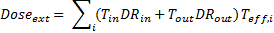
- Dose_{ext} is the external dose (Sv)
- T_{in} is the fraction of time spent indoors each day (h/d)
- T_{out} is the fraction of time spent indoors each day (h/d)
- T_{eff} is the decay corrected exposure time (for each isotope, i)(d)
- DR_{in} is the dose rate indoors (Sv/h)
- DR_{out} is the dose rate outdoors (Sv/h)

Internal dose
Internal dose was estimated based on measurements of whole body dose and urine analysis. These measurements allow the ingestion and inhalation pathway to be estimated
Whole body screening was used to determine if any of the family members had an amount of caesium exceeding 1000 Bq remaining within their body at the time of measurement. The results were negative for all family members. Urine monitoring is a very sensitive technique capable of detecting very low levels of caesium. The range caesium levels measured across all family members are shown in Table A.11.

Table A.11 Radioactive caesium levels measure in urine samples collected from the family approximately 180 days after the Fukushima Dai-ichi NPP accident.
Radionuclide | Activity measured in urine (Bq/L)
Radionuclide | Minimum | Maximum
¹³⁷Cs | 0.214 ± 0.045 | 0.475 ± 0.082
¹³⁴Cs | 0.147 ± 0.022 | 0.381 ± 0.053

Acute versus chronic intake
To estimate the internal dose from caesium levels in urine an assessment was required to determine if the caesium intake was acute or chronic.
A comparison of retention factors can be used to assess if the caesium intake was acute or chronic. Using the Figure A.1 it can be shown that a large difference between the retention of adults and children would be expected for an acute dose. The results of the urine analysis show a similar retention of caesium in all family members, suggesting that an acute intake is unlikely. Therefore, it was assumed that the exposure scenario was chronic for the time until they arrived in Australia. For this assessment caesium is assumed to be highly mobile and have an f₁=1 (gut transfer factor) for both inhalation and ingestion.
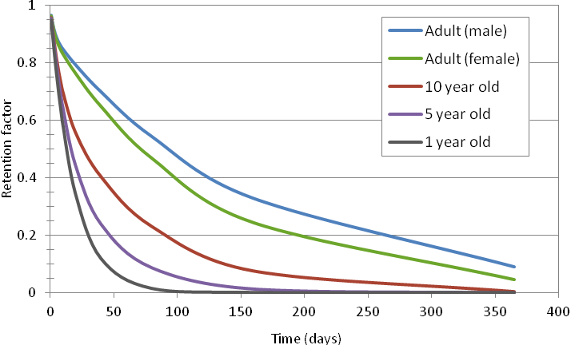
Figure A.1 Caesium retention factors (ICRP 1994a; ICRP 1996) for ICRP default age classifications.

Estimating intakes and determining dose
To estimate the chronic intake of radioactive caesium from ingestion, a simple two-compartment model was used (ICRP 1994a). In this model ingested caesium separates into long and short lived transfer compartments before being excreted. Urine excretion was assumed to account for 80% of the total excretion. The fraction of caesium in each compartment and the half times of each compartment for each age group were taken from ICRP Publication 67 (ICRP 1994a).
For inhalation, a factor from ICRP Publication 66 (ICRP 1994b) for movement from the lungs to the transfer compartments was applied using an aerosol activity median aerodynamic diameter (AMAD) of 1 µm. The calculated urine excretion after 180 days (urine was measured approximately 30 days after the 150 day exposure) was then directly compared to the measurement data, which was used to determine a daily chronic intake rate (see Table A.8). It was assumed each family member excreted 1 L of urine per day.
The chronic intake rate was applied for 150 days to obtain the total intake, which when multiplied by the dose conversion factors (ICRP 1994a, ICRP 1996), gave the total effective dose from those internal pathways (see Table A.12). Good agreement was found when comparing this method with internal dosimetry software IMBA for a reference light worker.
IMBA (Integrated Modules for Bioassay Analysis) is a suite of software modules for internal dosimetry developed by United Kingdom’s Health Protection Agency (Birchall 2005). It implements all of the biokinetic and dosimetric models currently recommended by the ICRP. It also enables the users to specify their own parameter values and apply sophisticated data handling techniques to their customised internal dose calculations.
¹³¹I intake was inferred from the ¹³⁷Cs intake based on an initial deposition ratio of 10:1 (¹³¹I: ¹³⁷Cs). Based on the initial deposition ratio and accounting for radioactive decay, the total intake of ¹³¹I for a 150 day period was about 80% of ¹³⁷Cs. The inferred intake of ¹³¹I was then multiplied by age dependent dose conversion factors (ICRP 1994a, ICRP 1996) to give thyroid dose and total effective dose due to ¹³¹I exposure from internal pathways (see Table A.12).
Table A.12 The range of doses to family members in the 150 days following the Fukushima Dai-ichi NPP accident. External doses were estimated based on dose rates measured by the family. Internal doses from ¹³⁴Cs and ¹³⁷Cs are estimated from urine measurements. Inferred internal doses (thyroid, inhalation and ingestion) to the family from ¹³¹I are based on urine measurements of ¹³⁴Cs and ¹³⁷Cs and assumed ¹³¹I intake as described in the text above.
Dose Type | Radionuclide | Range of doses for first 150 days (mSv)
Dose Type | Radionuclide | Minimum | Maximum
External | ¹³⁴Cs,¹³⁷Cs | 3.2 | 4.3
Inhalation | ¹³⁴Cs | 1.2 x 10⁻³ | 3.5 x 10⁻³
Inhalation | ¹³⁷Cs | 1.1 x 10⁻³ | 2.8 x 10⁻³
Inhalation | ¹³¹I (inferred total effective dose) | 1.4 x 10⁻³ | 2.9 x 10⁻²
Ingestion | ¹³⁴Cs | 1.1 x 10⁻³ | 3.1 x 10⁻³
Ingestion | ¹³⁷Cs | 1.0 x 10⁻³ | 2.6 x 10⁻³
Ingestion | ¹³¹I (inferred total effective dose) | 1.4 x 10⁻³ | 2.9 x 10⁻²
Thyroid | ¹³¹I (inferred organ dose) | 2.7 x 10⁻² | 5.9 x 10⁻¹

Use of ERICA for the Short-tailed shearwater (mutton bird) dose assessment
The ERICA (Environmental Risk from Ionising Contaminants: Assessment and Management) assessment tool was used as part of the mutton bird dose assessment. This tool is a software package based on a tiered approach to assessing radiological risk to non-human biota. Tier 1 assessments use generic, pre-calculated values to estimate risk. Tier 2 assessments allow for the user to edit most of the parameters to provide a more specific assessment. Tier 3 assessments allow for a probabilistic assessment (Brown et al. 2008).
Table A.13 Non-default inputs for ERICA assessment.
Tier 1 Assessment
Parameter | Value
Ecosystem | Marine
Activity concentration ¹³⁷Cs (water) | 2000 Bq/L
Tier 2 Assessment
Parameter | Value
Ecosystem | Marine
Activity concentration ¹³⁷Cs (water) | 2000 Bq/L
Organisms | (Wading) bird
Habitat | 50% in water, 50% on water

Little is known about the habits of mutton birds during their migration as they do not come to shore during this time. As they do not come to shore it is assumed for this assessment that the mutton birds did not fly closer than 100 m to the Fukushima Dai-ichi NPP. Measured radioactive caesium concentrations near the power plant in April 2011 give a maximum activity concentration of 5000 Bq/L at 30 m from the shore and 100 Bq/L at 330 m from the shore. Based on these values the concentration used in this assessment is a radioactive caesium concentration of 2000 Bq/L. This is likely to be an overestimate, as in mid-April (the time mutton birds were likely to be present), the maximum concentration at 30 m from the shore was 2000 Bq/L (IAEA 2011b).
A tier 2 ERICA assessment produced an estimated dose rate of 0.175 mGy/h, equivalent to 4.2 mGy/day. Table 6.1 in ICRP Publication 108 (ICRP 2009) shows that for a reference duck (the closest reference animal to the mutton bird) a dose rate of 1 to 10 mGy/day could result in the potential for reduced reproductive success due to reduced hatchling viability.
As April 2011 was a mid-migration time, a transient exposure was assumed in which each bird was feeding/landing in the area for 1 to 2 days only. The IAEA dose range above is based on chronic exposure. Given the biological half-life of radioactive caesium and the life-span of mutton birds, a significantly longer exposure time (than 1 to 2 days) would be required to produce effects comparable to those observed in chronic exposures. Therefore, for the population as a whole, it is unlikely that there will be a significant effect on biodiversity from the Fukushima Dai-ichi NPP accident.
Based on this result a tier 3 assessment was not considered to be necessary.

APPENDIX B: ARPANSA Fact Sheets

Screening for radionuclides in the body using a gamma detector

Background:
A gamma detector can be used to detect radionuclides which are inside the body. This can be done in a non-intrusive way, and for screening purposes it can be done at a convenient location such as the home.
Gamma detector connected to computer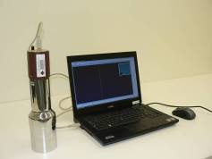
Testing with the detector inside a backpack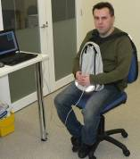

Arrangement:
The detector needs to be placed reasonably close to the body in the area of the chest, abdomen and thighs. One way to do this for adults or mature children is to place the detector inside a small backpack worn across the chest, while the person is sitting in a chair. For a young child, the arrangement may have to be improvised at the time of measurement.
The equipment is reasonably robust, but it should not be dropped or handled too much. The equipment will be connected to a portable computer during the test.
It is better for other people to be away from the person being measured, for example on the other side of the room. This is because the body contains natural radioactivity, and the signal from the other people not being measured would interfere with the measurement.
Time of measurement:
The longer the test is carried out, the more accurate the results are. Some information will be available after a few minutes, but half an hour is better. For children the time may need to be limited. It is possible to do several readings (say three of 10 minutes) and combine the results, although it is more convenient to do it in one sitting.
Results:
Some indication of the levels obtained will be available on the day, however a full analysis may not be available until some days later.

Screening of radionuclides in urine

Background:
Urine contains waste and other materials, including water, extracted by the kidneys from the blood. It is collected for up to several hours and mixed in the bladder before excretion. Collection of urine samples is a non-intrusive process that can provide information on the intake levels of soluble chemicals that are readily transferred to the blood.
The normal daily output of urine depends on physiological and environmental conditions. The excretion volumes and concentrations of chemicals can vary significantly throughout the day. Preferably a 24 hour samples are collected for analysis. If this is not possible a morning sample should be collected.

Sampling equipment showing filled Uritainer™
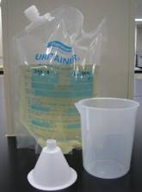
Sampling equipment:
A pre-weighed Uritainer™ sample collection container
Plastic funnel
Plastic beaker
Sampling instructions:
Start the collection by emptying your bladder and discarding to waste. Record the date and time.
From this time, until completion, all urine is collected into the container. A beaker and a funnel can be used to facilitate collection and transfer of the urine to the container.
Exactly 24 hours from the start of the collection, empty your bladder and collect the urine. Record the date and time.
The sample container holds approximately 2.5 L. An additional bag may be required to collect the entire 24 hour sample.
Measurement:
Analysis of the sample will be done using a high resolution gamma-ray spectrometry. This will allow the detection of gamma emitting radionuclides.

Appendix C: Frequently Asked Questions (Japan Nuclear Accident)
Frequently Asked Questions published on the ARPANSA website during 2011.
What are the risks to people living in Australia from radiation emitted from the 2011 Japanese nuclear accident?
The health consequences from the Fukushima Dai-ichi accident are negligible for people living in Australia. This has been confirmed by environmental modelling and radiation monitoring in Australia.
Has radiation from the Japanese nuclear accident reached Australia?
Small amounts of radioactive Xenon-133 (¹³³Xe) were detected at the Darwin air monitoring station from early April to early May 2011. These radiation levels were millions of times lower than safe levels and will have no health impact for any person in Darwin or elsewhere in Australia. There have been no detections of radioactive material from Japan at any other monitoring station in Australia.
Should people living in Australia consider buying or taking potassium iodide tablets?
No. People living in Australia are not at risk of contamination from the Japanese nuclear accident, therefore potassium iodide tablets are not required.
Is there a risk that food imported from Japan will be contaminated with harmful levels of radiation?
No. Japanese food restrictions should ensure that food exported from Japan will not be harmful to people. In addition, food imported from specific regions in Japan is tested by the Department of Agriculture, Fisheries and Forestry (DAFF) for radioactive caesium when it arrives in Australia.

Are imported goods from Japan contaminated?
It is highly unlikely that any Japanese goods arriving in Australia will be contaminated. The Japanese Government and industry have established processes for monitoring goods exported from Japan that is consistent with Australian and international guidance. ARPANSA will continue to coordinate with the Australian Maritime Safety Authority, the Australian Customs and Border Protection Service and other Government Agencies on the transport of goods into Australia to ensure the Australian public is protected.
I have just purchased a Japanese car. Should I get it tested for radiation contamination?
No. The risk of cars being contaminated due to the Japanese nuclear accident is negligible and it is extremely unlikely that any cars from Japan will show significantly elevated radiation levels. The Japanese Government and industries have established a process for monitoring exports, including cars, that is consistent with Australian and international standards. In addition, ARPANSA tested over 100 cars exported from Japan in June 2011. No radiation contamination from the Japanese nuclear accident was detected on any of these cars.
What is ARPANSA's advice for travelling to Japan?
The radiation levels in most parts of Japan, including Tokyo, are now within the normal range of variation of background radiation and are of minimal health consequence. ARPANSA recommends that you follow the advice of the Japanese Government. More detailed travel advice for Japan, including restricted areas, can be found at smartraveller.gov.au, which is updated as required.
Is the food and water in Japan contaminated?
There are ongoing food and water testing programs in Japan which are in line with internationally accepted standards. Some restrictions are in place to prevent the sale and distribution of food contaminated with radiation. Details on food restrictions and testing results can be found on the Japanese Ministry of Health Labour and Welfare website. Contaminated food would need to be consumed over long periods of time to be of concern to health.
What are ‘normal’ levels of radiation exposure?
Background radiation has a typical range of 1 to 13 millisieverts per year (mSv/y). The world average natural background radiation level is 2.4 mSv/y. Variations around the world are due to a number of factors, including rock type, altitude, dwelling type and diet. For more information see Section 8 of this report.
Where can I go to get something tested for radiation?
ARPANSA advises that, with the exception of food products, no imports require routine testing for radiation contamination due to the Japanese nuclear accident. However, if you would like to access radiation testing, a list of possible service providers can be found on the Australasian Radiation Protection Society (ARPS) website. Please note that ARPANSA does not endorse any specific company that may carry out radiation testing under any circumstances.
What is being done in Australia and internationally to improve knowledge of the accident?
The International Atomic Energy Agency (IAEA) and other international organisations are reviewing nuclear safety following the Japanese nuclear accident. The United Nations Scientific Committee on the Effects of Atomic Radiation (UNSCEAR) and the World Health Organization (WHO) are undertaking studies into radiation exposures and doses to the public and environment from the radioactive releases from the Fukushima Dai-ichi nuclear power plant. ARPANSA is actively participating in these projects. In addition, scientific research is continuously being published in international journals. ARPANSA will continue to monitor the situation at the Fukushima Dai-ichi site and will provide further advice if there is a significant change to the situation in Japan.

