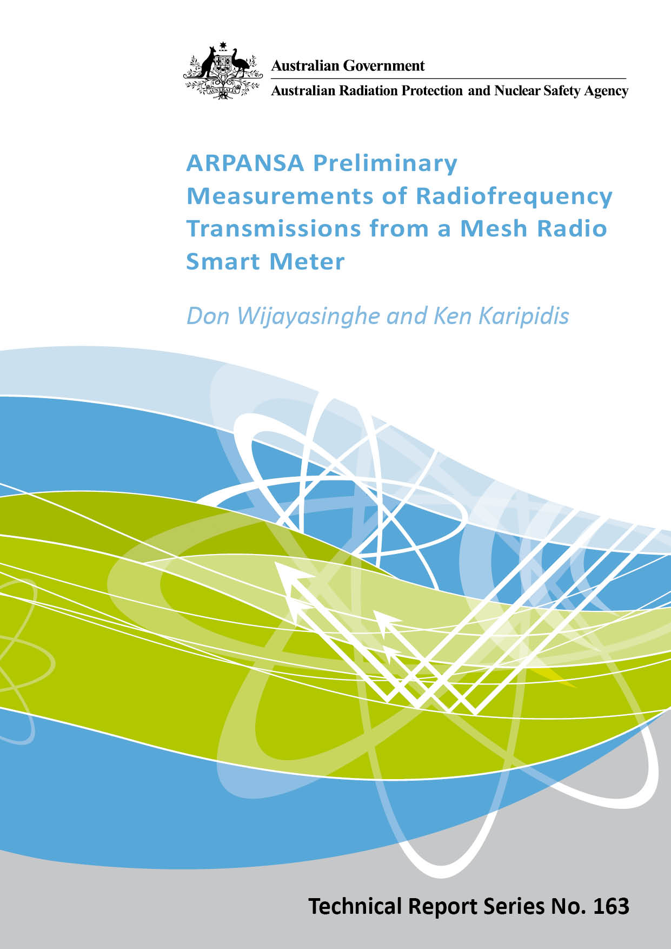

ARPANSA Preliminary Measurements of Radiofrequency Transmissions from a Mesh Radio Smart Meter

by

Don Wijayasinghe and Ken Karipidis

Notice

Australian Radiation Protection and Nuclear Safety Agency 2013


Creative Commons

With the exception of the Commonwealth Coat of Arms, any ARPANSA logos and any content that is marked as being third party material, this publication, ARPANSA Preliminary Measurements of Radiofrequency Transmissions from a Mesh Radio Smart Meter, by the Australian Radiation Protection and Nuclear Safety Agency is licensed under a Creative Commons Attribution 3.0 Australia licence (http://creativecommons.org/licenses/by/3.0/au). It is a further condition of the licence that any numerical data referred to in this publication may not be changed.

The publication should be attributed as ARPANSA Preliminary Measurements of Radiofrequency Transmissions from a Mesh Radio Smart Meter.

Enquiries regarding the licence and any use of this report are welcome.

ARPANSA
619 Lower Plenty Road
YALLAMBIE VIC 3085

Tel: 1800 022 333 (Freecall) or +61 3 9433 2211
Email: info@arpansa.gov.au
Website: http://ww.arpansa.gov.au

Disclaimer
All care has been taken in the preparation of this work and its conclusions. However, where the data or results presented are utilised by third parties the Commonwealth of Australia shall not be liable for any special, indirect, consequential or other damages whatsoever resulting from such use. Nor will the Commonwealth of Australia be liable for any damages arising from or in connection with any errors or omissions that have inadvertently occurred in this work.

Contents

1. Summary 1
2. Background 1
3. ARPANSA Measurements 2
4. ARPANSA Spectrum Analyser Results 3
5. ARPANSA Timing Measurement Results 4
6. Comparison with public exposure limits 5
7. Conclusion 5
Acknowledgements 6
References 6

<Intentionally left blank>

Summary
Smart meters have been deployed in buildings initially in Victoria and increasingly across other areas of Australia. They utilise radiofrequency (RF) electromagnetic energy (EME) at levels very much below the levels permitted in the RF Standard. Despite the low levels of RF EME, there is some public concern about exposures from smart meters and whether the RF transmissions may cause a variety of health effects.

ARPANSA has undertaken some preliminary RF measurements of an installed mesh network smart meter at the home of a staff member in a suburb of Melbourne. It must be emphasised that these measurements by ARPANSA cannot be considered representative of all smart meters.

A typical RF pulse from the smart meter had an average intensity of 7 mW/m² measured at a distance of half a metre from the smart meter with the door to the meter box open. This is 0.00015% of the instantaneous exposure limit in the Australian RF standard for the general public. The measured level with the meter box door closed, or on the other side of the wall on which the meter was mounted was about 20 times lower. The RF transmissions that were measured were not continuous and occurred less than 0.08% of the time that the measurements took place.

The RF electromagnetic energy transmitted in a single pulse from the smart meter is similar to that from a car remote unlocking fob and much less than a single GSM SMS transmission.

The measurements do not provide any indication of why smart meter transmissions would provoke symptoms in people otherwise unaffected by other wireless technologies such as mobile phone handsets. Indeed the low levels and short transmission times make any effects highly unlikely.

Background
One of the wireless technologies being used in the deployment of Advanced Metering Infrastructure in Victoria is a mesh radio system that uses the 915-928 MHz ISM (industrial-scientific-medical) band, very close to the frequency bands used by GSM mobile phones throughout Australia. The AMI meters, commonly called smart meters, operate in this frequency band without a specific spectrum allocation and must share it with a variety of other devices. The radio transmitter is typically of 1-watt power. The antenna distributes this power a little more in some directions than others.

A continuous transmission from the 1-watt transmitter would be expected to produce an intensity of approximately 300 mW/m² at a distance of 0.5 m if spread uniformly in all directions. Intensities up to twice this might be expected in some directions, and perhaps 10 to 50 times less in others, due to the directional characteristics of the antenna. Scattering of the radio transmissions from the ground, fences and buildings are also expected to produce local increases and decreases in the intensity.

The ARPANSA Radiation Protection Standard for Maximum Exposure Levels to Radiofrequency Fields - 3 kHz to 300 GHz (2002) provides three separate limits within which the smart meter should operate:
- the localised specific absorption rate (SAR), less than 2 W/kg or 20 mW/10g
- the whole body instantaneous electric and magnetic field strength, or equivalent plane-wave power flux density, less than 1313 V/m, 3.47 A/m, and 4,575 W/m² respectively
- the whole body, 6-minute time averaged, electric and magnetic field strength, or equivalent plane-wave power flux density, less than 41.4 V/m, 0.11 A/m and 4.574 W/m², respectively.

Typically, for devices like the smart meter, operated away from the body, measurements of just the electric field provide sufficient reassurance of compliance. The electric field is often converted to the equivalent plane-wave power flux density for comparison with limits.

The transmissions from the mesh radio smart meters have been measured on behalf of the Victorian Department of Primary Industries by the NATA accredited EMC Technologies Pty Ltd. Their report demonstrated that exposures from the 1-watt transmitter contained within the smart meters clearly met current exposure standards by a large margin. (http://www.smartmeters.vic.gov.au/__data/assets/pdf_file/0011/138926/AMI-Meter-EM-Field-Survey-Report-Final-Rev-1.0.pdf).

ARPANSA Measurements
In the light of the public concern about exposures from smart meters and to provide some information on, ARPANSA undertook some measurements of an installed smart meter at the home of a staff member in suburban Melbourne. The mesh radio component was a Silver Springs device and operated within the AMI network provided by the electric supplier, Jemena.
Measurements were taken during parts of several days with a NARDA SRM 3000 portable spectrum analyser at distances of approximately 50 cm from the outside of the meter box, with the steel meter box door open or closed, and at 50 cm from the inside of the wall on which the meter box was mounted. Additional measurements were made with a simple on-off microwave detector and recordings made every 12.5 microseconds of the transmission status.

It must be emphasised that the measurements by ARPANSA cannot be considered representative of all smart meters and do not replace the more systematic measurements undertaken by EMC Technologies.

ARPANSA Spectrum Analyser Results
The spectrum analyser measurements identified the transmissions as occurring in the 915-928 MHz frequency band, consisting of very short, frequency-hopping, bursts. The spectrum analyser averages the intensity of a pulse over 1/10 second. A typical pulse showed an average intensity of 7 mW/m² at a distance of 0.5 m from the smart meter with the door to the meter box open.

This result is consistent with the smart meter transmitting for only 7/300 of 100 milliseconds (ms), or about 2.3 ms. This agrees with the timing measurements given below.

The measured level with the meter box door closed, or on the other side of the wall on which the meter was mounted was about 20 times lower.

Table 1: RF Field Power Density Measurements for a smart meter in a Jemena Mesh Network
Location | Power Flux Density  (mW/m²)¹
50cm (meter box door open) | 7.2
50cm (meter box door closed) | 0.33
50cm (inside garage, directly behind meter box wall) | 0.29
^{1 .}Average over 100 ms from a single transmission pulse.

ARPANSA Timing Measurement Results
The spectrum analyser does not provide information on the duration of such short transmissions or of the number of individual transmissions, so a special piece of equipment and system was assembled to detect, and time, the transmissions but without giving a precise measure of intensity or radiofrequency. Timing measurements were collected over three periods of 4:10, 5:26 and 25:58 hours duration for the initial assessment. The results are summarised below.

Table 2: RF transmission timing measurements for a smart meter in a Jemena Mesh Network
 | 1/Jul/2012 | 30/Sep/2012 | 24/Jan/2013
Duration of measurement (h:mm) | 4:10 | 5:26 | 25:58
Total no. of pulses | 2177 | 2611 | 15,139
Total transmission time (s) | 9.5 | 11.3 | 68.4
Average duty cycle (%) | 0.064 | 0.058 | 0.073
Maximum pulse duration (ms) | 82.8 | 82.8 | 82.8
Average pulse duration (ms) | 4.4 | 4.3 | 4.5
Maximum transmission in 1 s (s) | 0.17 | 0.11 | 0.53
Maximum transmission in 10 s (s) | 0.20 | 0.23 | 1.68
Maximum transmission in 1 m (s) | 0.41 | 0.29 | 1.75
Maximum transmission in 6 m (s). | 1.46 | 1.41 | 2.46
Maximum duty cycle over 6 m (%) | 0.41 | 0.39 | 0.68

Comparison with public exposure limits
The instantaneous exposure at 0.5 m expected from the 1-watt transmitter is less than 1/15,000 of the instantaneous exposure limit, and actually much lower still because only part of the body can be exposed to the highest value.

Based on the timing measurements, the maximum duty cycle over any 6 minute period (including the periods when the maximum length pulses were transmitted) was less than 0.7%. The average duty cycle was 0.07%. The maximum 6-minute average exposure expected at 0.5 m is 2.1 milliwatt/m² (0.21 microwatt/cm²). This represents 0.046% (1/2,180) of the public exposure limit.

Exposures (6-minute average) at more typical distances from the smart meter of, for example 5 metres, would be expected to be a factor of 100 lower, or less than 21 microwatt per square centimetre.

The measurements over a few hours may have missed the main communications periods but 24-hour measurements showed several periods when the longest pulses of 83 ms were transmitted. At 16:20, a group of 18 such pulses were transmitted within a few seconds. As mentioned, scattering and antenna directionality may increase these values by factors of 2 – 5, perhaps.

Conclusion
The measured and calculated exposures are all well below the public exposure limits. The radiofrequency used is similar to the frequency used by GSM mobile phones and the peak transmission power is somewhat less. Many other wireless technologies have pulsed structure to their transmissions and many transmit throughout the whole day. The radiofrequency electromagnetic energy transmitted in a single pulse from the smart meter is similar to that measured from a car remote unlocking fob and much less than measured from a single GSM SMS transmission. The measurements do not provide any indication of why smart meter transmissions would provoke symptoms in people otherwise unaffected by other wireless technologies such as GSM mobile phone handsets.

Acknowledgements
The authors are indebted to Dr Lindsay Martin for his contribution in the development of this paper. Timing measurements in the study were conducted by special equipment that was assembled by the staff in the ARPANSA workshop.

References
Australian Radiation Protection and Nuclear Safety Agency, (2002) “Radiation Protection Standard for Maximum Exposure Levels to Radiofrequency Fields - 3 kHz to 300 GHz”, Radiation Protection Series, No. 3.

