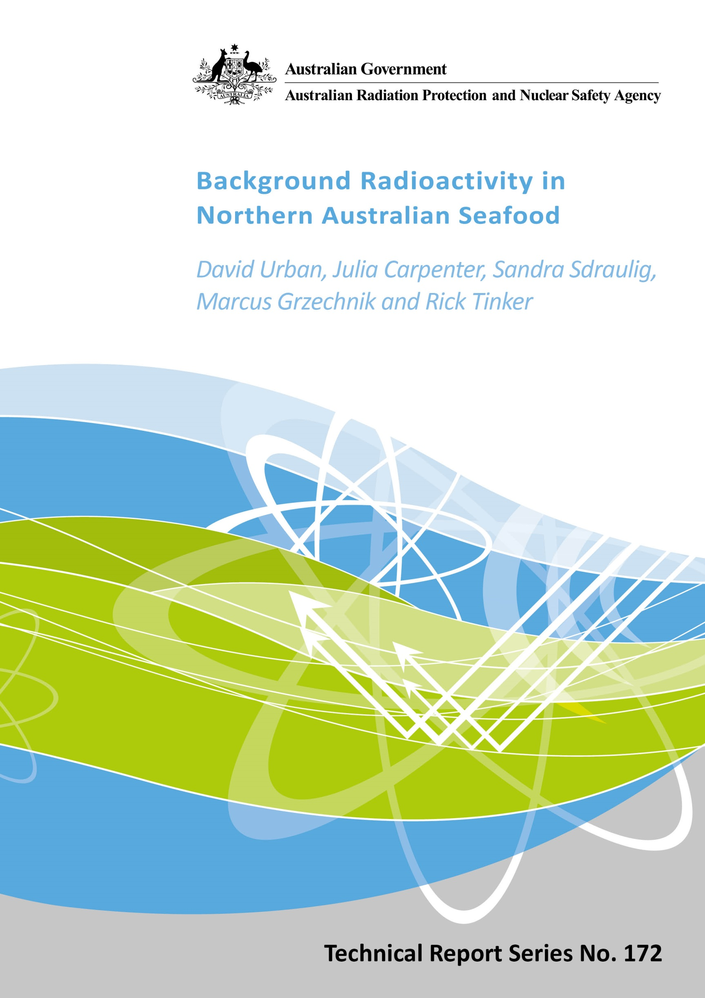

Background Radioactivity in Northern Australian Seafood

By

David Urban, Julia Carpenter, Sandra Sdraulig, Marcus Grzechnik and Rick Tinker

Notice
© Commonwealth of Australia 2015

This publication is protected by copyright. Copyright (and any other intellectual property rights, if any) in this publication is owned by the Commonwealth of Australia as represented by the Australian Radiation Protection and Nuclear Safety Agency (ARPANSA).

ISSN: 0157-1400

Creative Commons

With the exception of the Commonwealth Coat of Arms, any ARPANSA logos and any content that is marked as being third party material, this publication, Background Radioactivity in Northern Australian Seafood by David Urban, Julia Carpenter, Sandra Sdraulig, Marcus Grzechnik and Rick Tinker of the Australian Radiation Protection and Nuclear Safety Agency is licensed under a Creative Commons Attribution 3.0 Australia licence (to view a copy of the licence, visit http://creativecommons.org/licenses/by/3.0/au). It is a further condition of the licence that any numerical data referred to in this publication may not be changed. To the extent that copyright subsists in a third party, permission will be required from the third party to reuse the material.

In essence, you are free to copy, communicate and adapt the material as long as you attribute the work to ARPANSA and abide by the other licence terms. The works are to be attributed to the Commonwealth as follows:

“© Commonwealth of Australia 2014, as represented by the Australian Radiation Protection and Nuclear Safety Agency (ARPANSA)”

Use of the Coat of Arms

The terms under which the Coat of Arms can be used are detailed on the It's an Honour website (http://www.itsanhonour.gov.au/coat-arms/index.cfm).

Enquiries regarding the licence and any use of this report are welcome.
ARPANSA
619 Lower Plenty Road
YALLAMBIE VIC 3085
Tel: 1800 022 333 (Freecall) or +61 3 9433 2211
Email: info@arpansa.gov.au
Website: www.arpansa.gov.au

Disclaimer

All care has been taken in the preparation of this work and its conclusions. However, where the data or results presented are utilised by third parties the Commonwealth of Australia shall not be liable for any special, indirect, consequential or other damages whatsoever resulting from such use. Nor will the Commonwealth of Australia be liable for any damages arising from or in connection with any errors or omissions that have inadvertently occurred in this work.

Table of Contents
EXECUTIVE SUMMARY 3
1. INTRODUCTION 4
1.1 Background radiation in the oceans 4
1.2 Radioactive materials released during the Fukushima Dai-ichi nuclear power plant accident 4
1.3 Objectives 7
1.4 Scope 7
2. METHOD 8
2.1 Selecting Sampling Locations 8
2.2 Selection of Seafood 9
2.3 Sourcing Seafood 9
2.4 Sample Preparation 10
2.5 ¹³⁴Cs and ¹³⁷ Cs Analyses 10
2.6 ²¹⁰Po Analysis 10
2.7 Calculation of Committed Effective Dose 11
3. RESULTS 13
3.1 Activity Concentrations 13
3.2 Dose to the Public from Ingestion of Seafood 17
4. DISCUSSION 18
4.1 Health Impacts 19
5. CONCLUSION 20
6. REFERENCES 21

EXECUTIVE SUMMARY
The accident at the Fukushima Dai-ichi Nuclear Power Plant (NPP) raised concerns about the possible impact to Australia from the release of radionuclides, including caesium-137 (¹³⁷Cs) and caesium-134 (¹³⁴Cs), to the ocean. Numerical ocean modelling indicates that these anthropogenic radionuclides will reach the Australian coastline around 2016 and therefore could potentially impact marine organisms.
This study was conducted to determine the background activity concentrations of ¹³⁷Cs and ¹³⁴Cs in commonly consumed seafood from northern Australia. In addition, the background activity concentrations of naturally occurring radionuclide polonium-210 (²¹⁰Po) were also determined in order to provide a comparison with the anthropogenic radionuclides. The results were used to estimate the committed effective dose to the public from the consumption of seafood.
Seafood samples, sourced from northern Australian waters, were analysed in this study to establish typical radionuclide levels in seafood prior to the arrival of any contamination from radionuclides released during the 2011 Fukushima Dai-ichi NPP accident.
The key findings of this study are:
- ¹³⁷Cs activity concentrations are consistent with the anthropogenic background radioactivity in the region due to global fallout, mainly from historical nuclear weapons testing.
- The absence of any measurable ¹³⁴Cs activity in all of the seafood samples analysed indicates that the anthropogenic activity detected is not from the Fukushima Dai-ichi NPP accident, which is consistent with the modelling predictions for contamination transport by Nakano and Povinec (2011).
- Based on a daily consumption of the seafood over one year, the committed effective dose contribution from ¹³⁷Cs to the Australian public is considered negligible with estimations less than 0.001% of the average background (1.5 mSv/year). The committed effective dose from ²¹⁰Po ingestion is less than 2% of the average background.
- There are no health implications due to the ingestion of seafood containing the amounts of ²¹⁰Po and ¹³⁷Cs measured in this study.
This study has established a benchmark for ¹³⁷Cs activity concentrations in seafood sourced from the northern waters of Australia. Further seafood collections and analysis will be undertaken after 2016 to ascertain if seafood sourced from northern waters of Australia is affected by the predicted arrival of contaminated water from the Fukushima Dai-ichi NPP accident.

INTRODUCTION

Background radiation in the oceans
Radionuclides, of both natural and anthropogenic origins, are present in the marine environment throughout the world. The weathering and dissolution of rocks containing radionuclides from the naturally occurring uranium and thorium series, and the emanation and decay of radioactive radon in the atmosphere, results in the deposition of naturally occurring radionuclides in the marine environment. These radionuclides enter the water column where they are dispersed or adsorbed to sediment and can be taken up by marine organisms.
The naturally occurring radionuclides of polonium (Po) accumulate in the tissues of marine organisms and concentrates up the trophic levels of the food chain. Polonium is known to be present in higher activity concentrations in marine organisms due to its solubility in water and continued input into the marine environment through natural geochemical and physical processes. ²¹⁰Po has the longest half-life (t_{1/2} = 138.4 days) of all the natural isotopes of polonium and is produced as part of the decay of uranium-238 (²³⁸U). ²¹⁰Po has a tendency to bind to amino acids and proteins and therefore concentrates in the muscle tissues of marine organisms (Carvalho, 2010). ²¹⁰Po therefore provides a benchmark to enable comparison to levels of other radionuclides, either from natural or anthropogenic origins, to assess potential health impacts to humans who consume seafood.
Anthropogenic radionuclides have also been deposited into the oceans, predominantly as a consequence of the atmospheric nuclear weapons testing conducted between 1945 and 1980 (UNSCEAR, 2000), and nuclear accidents such as the Chernobyl nuclear power plant accident in 1986 and the Fukushima Dai-ichi nuclear power plant accident (the Fukushima Dai-ichi NPP accident) in 2011. Radionuclides released to the environment are then transported around the world by atmospheric and oceanic circulation.

Radioactive materials released during the Fukushima Dai-ichi nuclear power plant accident
The Fukushima Dai-ichi NPP accident resulted in significant releases of radionuclides including caesium-137 (¹³⁷Cs), caesium-134 (¹³⁴Cs) and iodine-131 (¹³¹I) to the atmosphere and the ocean, which in turn led to significant public concern in Japan and internationally regarding exposure to the radionuclides that were released into the environment. Estimates of the total release of ¹³¹I and ¹³⁷Cs to the environment are 100-500 PBq and 6-20 PBq respectively. Of these releases it was estimated that 3-6 PBq of ¹³⁷Cs entered the ocean directly by leakage and deliberate discharge, and 5-8 PBq entered the oceans as a result of atmospheric fallout (UNSCEAR, 2013). ¹³¹I has a short half-life of 8 days and was only a risk to public health in the weeks following the accident. ¹³⁷Cs and ¹³⁴ Cs remain in the environment for longer, with radioactive half-lives of approximately 30 years and 2 years respectively.
Following the Fukushima Dai-ichi NPP accident most northern hemisphere countries detected small amounts of released radioactivity in air samples within weeks, and in the Asia-Pacific region of the southern hemisphere detection occurred about a month later (Stohl et al. 2012, Orr et al 2013). In the deep oceans radionuclides and other contaminants can take many years to transport in water across the equator.
Animals and plants (wildlife) living in the marine environment were also exposed to radionuclides released from the Fukushima Dai-ichi NPP accident, and in the most impacted regions this has resulted in uptake and incorporation of ¹³⁷Cs and ¹³⁴Cs into their tissues (MAFF, 2014). Some marine wildlife exposed to radionuclides can also travel long distances. For example, migratory tuna exposed to radionuclides from the Fukushima Dai-ichi NPP accident have been caught off the coast of the United States of America. These were found to contain low activity concentrations of ¹³⁷Cs and ¹³⁴Cs in their tissues (Madigan et al. 2012). In this case, the presence of the short lived ¹³⁴Cs was the indicator that this radionuclide was from the Fukushima Dai-ichi NPP accident, as any ¹³⁴Cs from the 1986 Chernobyl nuclear power plant accident would have already decayed to levels unable to be detected.
Figure 1.1 shows the results of long-term global dispersion modelling of the ¹³⁷Cs released to the marine environment following the Fukushima Dai-ichi NPP accident. It has been estimated that radioactive materials from the Fukushima Dai-ichi NPP could reach the northern waters of Australia via Malaysia and Indonesia between 2016 and 2021 (Nakano and Povinec, 2012). By the time the discharge from Fukushima reaches the waters off northern Australia, it is predicted that the continued dilution of these materials will result in ¹³⁷Cs activity concentrations of 100 to 300 mBq/m³. At these levels the ¹³⁷Cs signature may be indistinguishable from the background ¹³⁷Cs currently present as a result of global fallout from historical nuclear weapons testing (Nakano and Povinec, 2012). ¹³⁴Cs was released in approximately a 1:1 activity ratio with ¹³⁷Cs but is less likely to be detectable by the time it is predicted to reach Australian waters due to its shorter half-life.
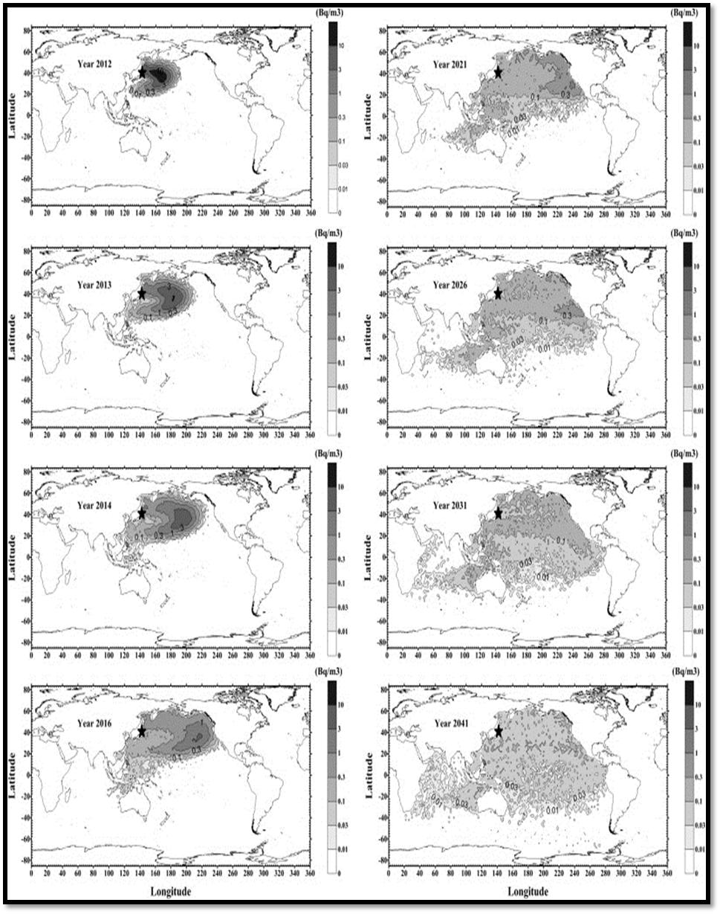
Figure 1.1: ¹³⁷Cs distribution in the world’s oceans over time following radionuclide releases from the Fukushima Dai-ichi NPP accident in 2011. Reproduced from Nakano and Povinec (2012).

Objectives
The aim of this investigation was to determine the background levels of the anthropogenic radionuclides, ¹³⁷Cs and ¹³⁴Cs, in edible portions of seafood sourced from northern Australian oceans, before the predicted arrival of radioactive caesium from the Fukushima Dai-ichi NPP accident to Australian waters. The levels of the naturally occurring radionuclide, ²¹⁰Po, were also determined for comparative purposes.

Scope
The scope of the Background Radioactivity in Northern Australian Seafood study was to:
- Collect representative samples of seafood from the waters of northern Queensland, the Northern Territory and the north of Western Australia.
- Ensure that samples were collected well before 2016, the earliest predicted arrival date of the radionuclides released from the Fukushima Dai-ichi NPP accident based on oceanographic modelling undertaken by Nakano and Povinec (2012).
- Determine the activity concentrations of ¹³⁷Cs, ¹³⁴Cs and ²¹⁰Po in the seafood samples to determine background levels of these radionuclides in Australian seafood.
- Assess the radiation dose and potential health impact of the target radionuclides based on the average annual dietary intakes of seafood in the Australian diet.
- Provide data that will inform future decisions for further monitoring of seafood in Australia beyond 2016.

METHOD

Selecting Sampling Locations
In Australia, seafood for human consumption is sourced from a variety of marine species occupying a range of trophic levels. Based on the predicted dispersion (see Figure 1.1) of contaminants from the Fukushima Dai-ichi NPP accident, the seafood for this study was sourced from the marine waters of northern Queensland, Northern Territory and northern Western Australia.
The Food and Agriculture Organisation of the United Nations (FAO) has established nineteen major marine fishing areas (see Figure 2.1) covering the waters of the Atlantic, Indian, Pacific and Southern Oceans, with their adjacent seas (FAO, 2014). In this study seafood was sourced from the major marine fishing areas 57 and 71, as these cover the Australian geographical regions of interest.
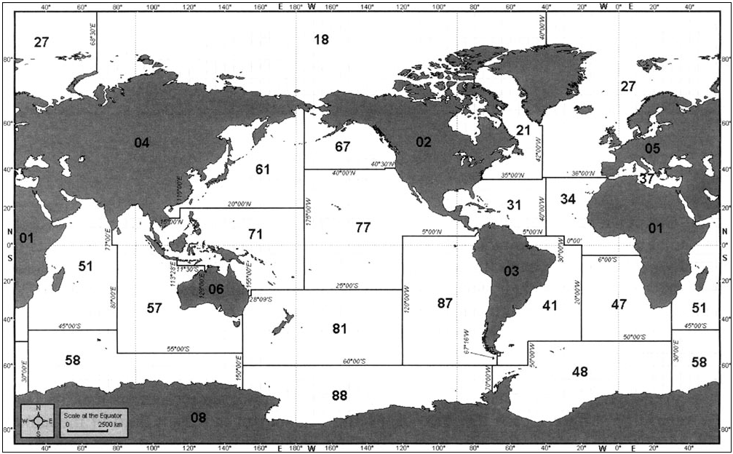
Figure 2.1: The nineteen Food and Agriculture Organisation (FAO) major fishing areas. Samples of seafood were sourced from the marine waters of Queensland and the Northern Territory (FAO Area 71) and the north of Western Australia (FAO Area 57). Reproduced from FAO (2014).

Selection of Seafood
Seafood was selected to represent a variety of marine biota. The following factors were considered:
- information on Australian seafood consumption
- geographical areas of capture (northern Australian waters)
- references containing species information including physical descriptions, distribution and feeding behaviour
- advice provided by wholesalers and retailers of seafood, which assisted in confirming the availability and sources of each seafood product and securing alternatives in the case where items of interest were not available.
Based on this information it was decided that the sample set should contain commonly consumed seafood sourced from the following groups:
- crustaceans (crabs, lobsters, bugs, prawns)
- pelagic predatory fish (Spanish mackerel, cobia)
- estuarine predatory fish (jewfish, threadfin salmon, barramundi, mangrove jack)
- reef predatory fish (coral trout, snapper)
- foraging fish (whiting)
- mollusc bivalves (scallops, oysters)
- mollusc cephalopods (squid, cuttlefish).
Although the sample set was small, it was considered to be adequate for the purpose of a study into the background radioactivity levels. The groups represented a mixture of trophic levels, habitats, behaviours and diets for the species identified.

Sourcing Seafood
Samples were obtained through direct purchase from seafood retailers within the three regions covered in this study. Sampling for Queensland was conducted in September 2012 when the seafood was purchased from a retailer in Townsville. The Northern Territory sampling was conducted in May 2013 when the seafood was purchased from a retailer in Darwin. The Western Australia sampling was conducted in February 2014 when the seafood was purchased from a seafood supplier in South Fremantle, who sourced their seafood from the Pilbara or Shark Bay area (northern Western Australia).
In May 2014, the laboratory analysed four samples of seafood, caught in the southern waters of Western Australia by a recreational fisherman. These samples represented only one group, the pelagic predators. The results for these samples have been included as information only and serve as a comparison against the samples obtained from northern waters.
Seafood was obtained either fresh or frozen. Since the study focussed on the edible portion of the species the samples were obtained as fillets and, wherever possible (in the case of crustaceans), peeled or shelled. The minimum mass required per sample was 2 kg of the edible portion. This enabled low limits of detection in analysis and ensured a greater probability that the sample contained more than one specimen from the catch. The samples were sent by airfreight from the supplier to ARPANSA in Melbourne. The shipments were collected on the same day of arrival and frozen until analysis commenced.

Sample Preparation
The frozen samples were thawed and diced or blended into smaller pieces. Approximately 2 kg of each sample was distributed evenly in foil trays. The sample trays were then placed in an oven at 90°C and dried to a constant mass. The dry weight was recorded to determine the wet to dry mass ratios. The dry samples were then homogenised by grinding to a fine powder using a knifemill.

¹³⁴Cs and ¹³⁷ Cs Analyses
Depending on the mass available for analysis, the dry samples were placed into 200 mL or 450 mL Marinelli beakers. These beakers, cylindrical in shape and incorporating an inverted cylindrical well, improve detection of gamma radiation by allowing them to fit over a larger surface area of the detector. The samples were then analysed, to determine the activity concentrations of ¹³⁴Cs and ¹³⁷Cs, by high resolution gamma-ray spectrometry with Genie 2000 software. High purity germanium detectors were used, designed to achieve a low minimum detectable activity concentration (MDC) for the sample geometries selected. The calibration sources for the sample geometries, traceable to NIST (National Institute of Standards and Technology), are multi-radionuclide standards that define the efficiency curve for all energies including ¹³⁴Cs and ¹³⁷Cs. Counting times of up to 100 hours were used to further improve the MDC.

²¹⁰Po Analysis
²¹⁰Po activity concentrations were determined by high resolution alpha spectroscopy following radiochemical separation. The dry samples were weighed (5 - 20 g) into beakers and each was spiked with a known activity of ²⁰⁸Po tracer solution obtained from QSA Amersham International, or a ²⁰⁹Po tracer solution obtained from Eckert & Ziegler. The samples were then dissolved in 100 mL concentrated HNO₃ and refluxed overnight on a stirring hotplate. The solution was then allowed to cool and any excess solidified fats were skimmed from the surface. The solutions were evaporated until approximately 20 mL remained. Another 100 mL of concentrated HNO₃ was added and the reflux procedure was repeated. After cooling any remaining organic matter in the solutions was destroyed using a 1:1 mixture of concentrated HNO₃ and 30% H₂O₂. The solutions were evaporated until 10 mL of acid solution remained. This was diluted to approximately 250 mL with deionised water.
The solutions were adjusted to a pH of 9 using ammonia hydroxide solution. Solutions of MnCl₂ and KMnO₄ were added to co-precipitate the polonium with manganese dioxide. The precipitate was separated by centrifuging and dissolved in a solution of hydroxylamine hydrochloride and hydrochloric acid. The polonium in the resulting solution was auto deposited onto silver discs for approximately 1.5 hours. The discs were counted by alpha spectrometry for 24-72 hours depending on activity concentration.
For each batch of samples a tracer blank and a ²¹⁰Po in-house reference standard were incorporated into the analysis as quality control. Some samples were randomly analysed in duplicate and some matrix spikes were analysed where a duplicate sample was spiked before with a known amount of ²¹⁰Po to determine the ²¹⁰Po recoveries.

Calculation of Committed Effective Dose
The radionuclides present in seafood enter the human body via the ingestion pathway. The committed effective dose was calculated taking into account the varying sensitivities of organs and tissues in the body, the type of radiation emitted, and the biological half-life of the particular radionuclide (the time it takes for half of the radionuclide to be excreted).
The committed effective dose to the public from consumption of seafood was estimated for ¹³⁷Cs and ²¹⁰Po using equation (1):
Committed Effective Dose (mSv/year) = D*R*C*1000 (1)
Where: D is the age-related dose coefficient for ingestion (Sv/Bq) (ICRP, 2012).
R is the rate of consumption (kg/year).
C is the average activity concentration in fish or shellfish (Bq/kg).
For ¹³⁷Cs and ²¹⁰Po, the minimum detectable activity concentration was applied as the activity concentration for samples where ‘no detection’ was reported. Due to its short half-life, ¹³⁴Cs from atmospheric nuclear weapons testing or the Chernobyl accident in 1986 would have decayed to levels unable to be detected. Therefore the contribution to overall dose from ingestion was assumed to be insignificant. As ¹³⁴Cs was not detected in any of the samples it has been excluded from the dose calculations. The dose coefficients used for the calculation are listed in Table 2.1.
Table 2.1: Age dependant ingestion dose coefficients. Sourced from ICRP (2012).
Age Group | Dose Coefficient (Sv/Bq)
Age Group | ¹³⁷Cs | ²¹⁰Po
Adult | 1.3E-08 | 1.2E-06
Child (10 years) | 1.0E-08 | 2.6E-06

The most recent available consumption data was from the 1995 National Nutrition Survey (McLennan and Podger, 1995). This quoted the following consumption rates for adults and 10 year old children respectively:
- fin fish (excluding canned fish) at 6.4 g/day (2.3 kg/year) and 2.1 g/day (0.8 kg/year),
- crustacean and mollusc at 2.7 g/day (1 kg/year) and 1.1 g/day (0.4 kg/year),
- total seafood (including canned) at 25.7 g/day (9.4 kg/year) and 13.7 g/day (5 kg/year).
The consumption data of Australians will vary depending on geographical location, sex and nationality of the survey participants. For this study the calculation of committed effective dose was based on an approximate consumption value of 10 kg/year for adults and 5 kg/year for a child.

RESULTS

Activity Concentrations
The measured activity concentrations of ¹³⁴Cs, ¹³⁷Cs and ²¹⁰Po for the seafood samples are shown in Tables 3.1 – 3.4. All activity concentrations are reported on a wet weight basis. The activity concentration values for seafood from southern Australian waters (Table 3.4) are presented for comparison with the northern sample set.
The mean ¹³⁷Cs activity concentration in those samples where ¹³⁷Cs was detected was 126 mBq/kg and 87 mBq/kg for fish and crustaceans respectively. ¹³⁷Cs was not detected in any of the mollusc samples analysed. ¹³⁴Cs was not detected in any of the seafood samples analysed. ²¹⁰Po was detected in every sample except for the barramundi sourced from Queensland. The mean ²¹⁰Po activity concentration was 1280 mBq/kg and 3560 mBq/kg for fish and crustaceans respectively. The activity concentrations of ²¹⁰Po were generally higher than those determined for ¹³⁷Cs. For some groups of seafood the activity concentration of ²¹⁰Po was more than an order of magnitude higher than the activity concentration of ¹³⁷Cs.
Table 3.1: Activity concentrations of ¹³⁴Cs, ¹³⁷Cs and ²¹⁰Po in seafood purchased from Queensland.
Seafood Type | Species | Activity Concentration  (mBq/kg Fresh Weight)
Seafood Type | Species | ¹³⁴Cs | ¹³⁷Cs | ²¹⁰Po
Crustaceans | Spanner Crab  Ranina ranina | <33 | <28 | 1220 ± 210
Crustaceans | Tiger Prawn  Penaeus sp. | <36 | <23 | 2120 ± 360
Crustaceans | Morten Bay Bug  Thenus sp. | <33 | <43 | 2680 ± 480
Pelagic Predators | Spanish Mackerel  Scomberomorus commerson | <60 | 279 ± 60 | 7300 ± 1100
Estuarine Predators | Barramundi  Lates calcarifer | <33 | <28 | <20
Reef Predators | Saddletail Snapper  Lutjanus malabaricus | <42 | 112 ± 32 | 229 ± 60
Reef Predators | Coral Trout  Plectropomus sp. | <47 | 195 ± 40 | 264 ± 70
Bivalves | Scallops  Pecten fumatus | <35 | <28 | 3020 ± 470
Cephalopods | Squid  Loligo sp. | <35 | <35 | 3140 ± 590

Table 3.2: Activity concentrations of ¹³⁴Cs, ¹³⁷Cs and ²¹⁰Po in seafood purchased from the Northern Territory.
Seafood Type | Species | Activity Concentration  (mBq/kg Fresh Weight)
Seafood Type | Species | ¹³⁴Cs | ¹³⁷Cs | ²¹⁰Po
Crustaceans | Mud Crab  Scylla serrata | <17 | 12.7 ± 4.4 | 4930 ± 600
Crustaceans | Tiger Prawn  Penaeus sp. | <43 | 73 ± 16 | 1390 ± 190
Pelagic Predators | Spanish Mackerel  Scomberomorus commerson | <37 | 273 ± 18 | 3170 ± 390
Estuarine Predators | Barramundi  Lates calcarifer | <34 | 56 ± 12 | 311 ± 56
Estuarine Predators | Mangrove Jack  Lutjanus argentimaculatus | <32 | 85 ± 14 | 198 ± 42
Estuarine Predators | King Threadfin Salmon  Polydactylus macrochir | <28 | 100 ± 15 | 178 ± 37
Estuarine Predators | Black Jewfish  Protonibea diacanthus | <27 | 87 ± 13 | 361 ± 63
Reef Predators | Saddletail Snapper  Lutjanus malabaricus | <39 | 118 ± 19 | 106 ± 29
Foraging Fish | Sand Whiting  Sillago sp. | <51 | 42 ± 13 | 2600± 340
Bivalves | Pearl Oyster  Pteriidae sp. | <37 | <42 | 442 ± 89
Cephalopods | Squid  Loligo sp. | <21 | <14 | 6280 ± 720

Table 3.3: Activity concentrations of ¹³⁴Cs, ¹³⁷Cs and ²¹⁰Po in seafood purchased from northern Western Australia.
Seafood Type | Species | Activity Concentration  (mBq/kg Fresh Weight)
Seafood Type | Species | ¹³⁴Cs | ¹³⁷Cs | ²¹⁰Po
Crustaceans | Morten Bay Bug  Thenus sp. | <42 | 176 ± 96 | 9040 ± 930
Pelagic Predators | Cobia  Rachycentron canadum | <25 | 128 ± 17 | 984 ± 68
Estuarine Predators | Barramundi  Lates calcarifer | <42 | 75 ± 16 | 69 ± 16
Reef Predators | Saddletail Snapper  Lutjanus malabaricus | <29 | 87 ± 14 | 812 ± 70
Cephalopods | Cuttlefish  Sepiidae sp. | <32 | <33 | 1174 ± 79

Table 3.4: Activity concentrations of ¹³⁴Cs, ¹³⁷Cs and ²¹⁰Po in seafood obtained from southern Western Australia.
Seafood Type | Species | Activity Concentration  (mBq/kg Fresh Weight)
Seafood Type | Species | ¹³⁴Cs | ¹³⁷Cs | ²¹⁰Po
Pelagic Predators | Australian Salmon  Arripis trutta | <42 | 246 ± 32 | 10900 ± 1300
Pelagic Predators | Bonito  Sarda australis | <52 | 271 ± 35 | 8270 ± 970
Pelagic Predators | Skipjack Tuna  Katsuwonus pelamis | <43 | 167 ± 24 | 9700 ± 1100
Pelagic Predators | Samson Fish  Seriola hippos | <40 | 387 ± 44 | 1440 ± 200
Some species were sampled across multiple regions. Spanish mackerel was obtained from Queensland and the Northern Territory. Saddletail snapper was obtained from all three regions. This allowed for a comparison of activity concentrations across regions as shown in Figures 3.1 and 3.2.
The comparison of ¹³⁷Cs in seafood from each region shows that there was no difference within the experimental uncertainty in the activity concentrations between identical species however the ²¹⁰Po results did show differences in activity concentrations between sampling areas, with Northern Territory samples showing the lowest activity concentrations.
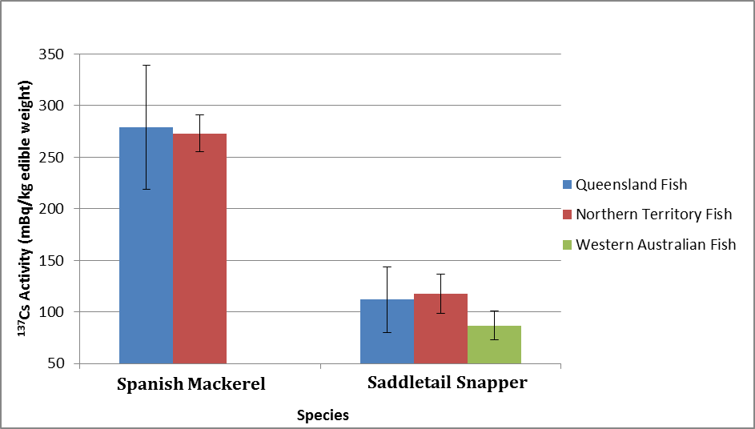
Figure 3.1: Variation in ¹³⁷Cs activity concentrations in the same species from different geographical locations.

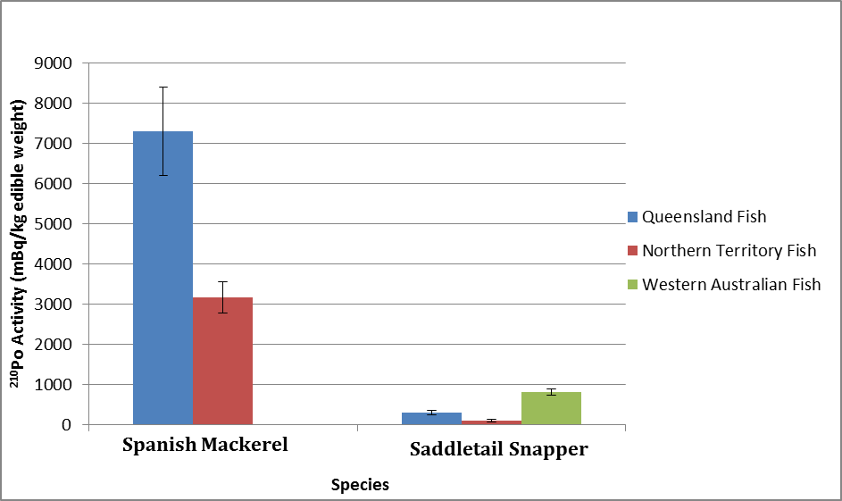
Figure 3.2: Variation in ²¹⁰Po activity concentrations in the same species from different geographical locations.

Dose to the Public from Ingestion of Seafood
The committed effective dose (mSv/year) has been calculated for the consumption of:
- migratory fish (pelagic predators)
- local fish (estuarine predators, reef predators and foraging fish)
- crustaceans and molluscs (bivalves and cephalopods).
Table 3.5 shows the estimate of annual committed effective dose (mSv/year) for the three different seafood categories and for all samples (based on the average activity concentration and consumption of all the seafood types).
The contribution to the ingestion dose from ²¹⁰Po is significantly higher than that for ¹³⁷Cs for both adults and children. This is due to the higher ²¹⁰Po activity concentrations, the type of ionising radiation being emitted (alpha) and the behavior of radionuclides in the body.
The ingestion doses for children from ²¹⁰Po are higher than for adults since children have higher dose coefficients. This is despite the consumption rate for a child being half that of an adult. In contrast the doses to children from the beta and gamma emissions from the decay of ¹³⁷Cs in seafood are lower than that for adults. This calculation is dominated by the consumption rates, as the ingestion dose coefficients for a child and an adult are similar.
Table 3.5: Committed effective doses from consumption of seafood in the average Australian diet based on ingestion of ¹³⁷Cs and ²¹⁰Po.
Seafood Type | Age Group | Committed Effective Dose (mSv/year)
Seafood Type | Age Group | ¹³⁷Cs | ²¹⁰Po
Migratory Fish | Adult | 2.95E-05 | 2.72E-03
Migratory Fish | Child | 1.13E-05 | 4.96E-02
Local Fish | Adult | 1.16E-05 | 5.62E-03
Local Fish | Child | 4.48E-06 | 6.08E-03
Crustacean/Mollusc | Adult | 6.00E-06 | 3.87E-02
Crustacean/Mollusc | Child | 2.31E-06 | 4.19E-02
All samples | Adult | 1.13E-05 | 2.50E-02
All samples | Child | 4.35E-06 | 2.71E-02

DISCUSSION
The activity concentration of ¹³⁷Cs in marine organisms in this report were compared to the Fisheries and Agriculture Organisation (FAO) fishing areas regional data published by the IAEA in 1995 (MARDOS). Consistent with the approach in the IAEA MARDOS report, the results were compared across three categories; fish, molluscs and crustaceans. Table 4.1 shows the 1995 MARDOS data, with the MARDOS data decay corrected to the 1st June 2013 compared to the results from this study.
Table 4.1: Mean ¹³⁷Cs activity concentration results compared with those documented in the 1995 MARDOS report.
Seafood Type | Mean ¹³⁷Cs activity concentration (mBq/kg)
Seafood Type | MARDOS (1995) | MARDOS  Decay corrected to 2013 | Experimental Results from this study
FAO Area 57:
Fish | 140 | 92 | 97
Molluscs | 140 | 92 | Not detected
Crustaceans | 90 | 59 | 176
FAO Area 71:
Fish | 300 | 196 | 130
Molluscs | 140 | 92 | Not detected
Crustaceans | 110 | 72 | 43
The results obtained in this current study are generally consistent with the published data for the two areas. Values for molluscs could not be compared because ¹³⁷Cs was not detected in any of the samples within this category. In this study only one crustacean sample was analysed for FAO Area 57. Observed differences may be due to several reasons.
- Distribution of radionuclides in the marine environment is not uniform. Distribution is far more complex as sediments and biota scavenge and retain different radionuclides at different rates. Therefore the activity concentrations will vary spatially and temporally.
- The IAEA sample set was larger and included results from specimens caught in a much larger area covering both the northern and southern hemispheres as well as several major ocean currents as shown in Figure 2.1.
- The ages of the specimens examined and the food sources they exploit play a significant part in the accumulation of radionuclides in their tissues.
The agreement of the ¹³⁷Cs activity concentrations with the results reported in the 1995 MARDOS IAEA report supports the likelihood that the ¹³⁷Cs detected in this study, is due to fallout from historical releases of ¹³⁷Cs into the environment.
The Queensland samples were collected about 18 months after the Fukushima Dai-ichi NPP accident. Any ¹³⁴Cs released to the ocean following the accident would be at levels approximately two thirds that of ¹³⁷Cs. For the Northern Territory sample period, about 24 months after the accident, any ¹³⁴Cs from the accident would be about half that of ¹³⁷Cs. The samples from northern Western Australia were obtained almost three years after the accident; therefore any ¹³⁴Cs from the accident would be at levels approximately one third of ¹³⁷Cs. The ¹³⁴Cs activity concentration results can be used as an indicator as to whether contaminated water has reached Australian waters. This current study did not detect any ¹³⁴Cs in the samples collected.
In general, higher activity concentrations were observed in large pelagic predators, crustaceans and molluscs. However, though the general trend is maintained when comparing similar species in the three regions, there was more variability in ²¹⁰Po activity concentrations than in ¹³⁷Cs activity concentrations. These differences may be attributed to differing ages of the specimens caught, different food sources, and the non-uniform distribution of ²¹⁰Po in the environment (Sirelkhatim et al., 2008).

Health Impacts
The results from the study were used to determine a committed effective dose to children and adults for both ¹³⁷Cs and ²¹⁰Po from the ingestion of seafood. The dose to children from ¹³⁷Cs is less than half that for adults. For both age groups, the dose estimates from the consumption of seafood containing ¹³⁷Cs based on this study are very small. For adults the calculated dose from ¹³⁷Cs was 1.1E-05 mSv/year, over 100,000 times lower than the average background dose of 1.5 mSv/year to the Australian public from natural sources of radiation (Webb at al., 1999).
The ²¹⁰Po dose contribution was similar for adults (2.5E-02 mSv/year) and children (2.7E-02 mSv/year) regardless of the consumption rate. For both age groups, the dose is over 50 times lower than the average background dose to the Australian public from natural sources of radiation (Webb at al., 1999). This represents less than 2 % of the overall average background dose.
Overall, based on the assumed consumption value of 10 kg/year for adults and 5 kg/year for a child, the radiation dose from the ingestion of seafood containing the amounts of ²¹⁰Po and ¹³⁷Cs measured in this study have no health implications.

CONCLUSION
Activity concentrations for ¹³⁴Cs, ¹³⁷Cs and ²¹⁰Po were determined in all of the seafood samples obtained from northern Australian oceans. When compared to data published by the IAEA (MARDOS) report, it was found that ¹³⁷Cs activity concentrations, although slightly lower than expected, were consistent with the levels of anthropogenic background radioactivity due to global fallout, mainly from historical nuclear weapons testing. The absence of any measurable ¹³⁴Cs activity in all of the seafood samples analysed indicates that the anthropogenic activity detected is not from the Fukushima Dai-ichi NPP accident, which is consistent with the modelling predictions for contamination transport by Nakano and Povinec (2012). The results of the analysis of samples for ¹³⁷Cs from southern waters of Western Australia are consistent with the results obtained for the same group of seafood (pelagic predators) collected from the other regions. This further supports the conclusion that releases resulting from the Fukushima Dai-ichi NPP accident have not impacted Australian seafood.
This study has enabled the establishment of baseline information for anthropogenic radionuclides found in Australian marine wildlife that are commonly consumed in Australia. This baseline provides useful data for comparison in the case of radiological accidents such as the Fukushima Dai-ichi NPP accident, where radioactive material has the potential to reach Australian coastlines and be detected in marine organisms.
The results from the ²¹⁰Po activity concentrations detected provide a useful means of comparing the annual dose contributions from this naturally occurring radionuclide to the anthropogenic radionuclides of concern. It was found that the dose from ²¹⁰Po was many orders of magnitude higher than that from ¹³⁷Cs.
Based on a daily consumption of the seafood over a year (10 kg/year for an adult and 5 kg/year for a child), the committed effective dose from ²¹⁰Po ingestion would contribute less than 2 % of the average background dose to the Australian public from natural sources of radiation (1.5 mSv/year). The contribution from ¹³⁷Cs from ingestion of seafood was considered negligible, less than 0.001% of the average background dose to the Australian public. At the levels of ²¹⁰Po and ¹³⁷Cs measured in this study, there are no health implications from the ingestion of seafood.

REFERENCES
ARPANSA (Australian Radiation Protection and Nuclear Safety Agency), 2002. Recommendations for Limiting Exposure to Ionizing Radiation (1995) and National Standard for Limiting Occupational Exposure to Ionizing Radiation (republished 2002), Radiation Protection Series No. 1.
Carvalho FP, 2010. Polonium (²¹⁰Po) and lead (²¹⁰Pb) in marine organisms and their transfer in marine food chains, Journal of Environmental Radioactivity 102 (2011) 462-472.
FAO (Food and Agriculture Organization of the United Nations ) and World Health Organization (WHO), 2010. General Standard for Contaminants and Toxins in Food and Feed, Codex Alimentarius, CODEX STAN 193-1995.
FAO, 2014. Food and Agriculture Organisation of the United Nations (FAO) Fisheries and Aquaculture Department, FAO Major Fishing Areas for Statistical Purposes.
Fowler SW, 2010. ²¹⁰Po in the marine environment with emphasis on its behaviour within the biosphere, Journal of Environmental Radioactivity 102 (2011) 448-461.
IAEA (International Atomic Energy Agency), 1995. Sources of radioactivity in the marine environment and their relative contributions to overall dose assessment from marine radioactivity (MARDOS), Final report of a coordinated research programme, IAEA-TECDOC-838.
ICRP (International Commission on Radiological Protection), 2012. Compendium of Dose Coefficients based on ICRP Publication 60. ICRP Publication 119. Ann. ICRP 41(Suppl.).
Madigan DJ, Baumann Z, Fisher NS, 2012. Pacific Bluefin tuna transport Fukushima-derived radionuclides from Japan to California. Proceedings of the National Academy of Sciences of the United States of America 109 (24) 9483-9486.
MAFF (Ministry of Agriculture, Forestry and Fisheries), 2014. Results of the monitoring on radioactivity level in fisheries products. <http://www.jfa.maff.go.jp/e/inspection/>
McLennan W and Podger A, 1999. National Nutritional Survey, Foods Eaten Australia 1995, Australian Bureau of Statistics.
Nakano and Povinec, 2012. Long-term simulations of the ¹³⁷Cs dispersion from the Fukushima accident in the world ocean. Journal of Environmental Radioactivity 111 (2012) 109-115.
Orr B, Schöppner M, Tinker R, Plastino W, Detection of radioxenon in Darwin, Australia following the Fukushima Dai-ichi nuclear power plant accident, Journal of Environmental Radioactivity 126 (2013) 40-44.
Sirelkhatim DA, Sam AK and Hassona RK, 2008. Distribution of ²²⁶Ra-²¹⁰Pb-²¹⁰Po in marine biota and surface sediments of the Red Sea, Sudan, Journal of Environmental Radioactivity 99 (2008) 1825-1828.
Stohl A, Seibert P, Wotawa G, Arnold D, Burkhart JF, Eckhardt S et al., 2012. Xenon-133 and caesium-137 releases into the atmosphere from the Fukushima Dai-ichi nuclear power plant: determination of the source term, atmospheric dispersion, and deposition, Atmospheric Chemistry and Physics, Volume 12, 2313-2343.
Suriyanarayanan S, Brahmanandhan GM, Malathi J, Ravi Kumar S, Masilamani V, Shahul Hameed P and Selvasekarapandian S, 2007. Studies on the distribution of 210Po and 210 Pb in the ecosystem of Point Calimere Coast (Palk Strait), India, Journal of Environmental Radioactivity 99 (2008) 766-771.
UNSCEAR (United Nations Scientific Committee on the Effects of Atomic Radiation), 2000. Sources and Effects of Ionizing Radiation, Report Vol. 1 Sources, Report to the General Assembly, with scientific annexes.
UNSCEAR, 2013. Sources, Effects and Risks of Ionizing Radiation, Report Vol. 1 Sources, Report to the General Assembly, Scientific Annexes A: Levels and effects of radiation exposure due to the nuclear accident after the 2011 great east-Japan earthquake and tsunami.
Webb DV, Solomon SB and Thomson JEM, 1999. Background radiation levels and medical exposure levels in Australia. Conference Paper, Radiation Protection in Australasia Volume 16, Number 2.

