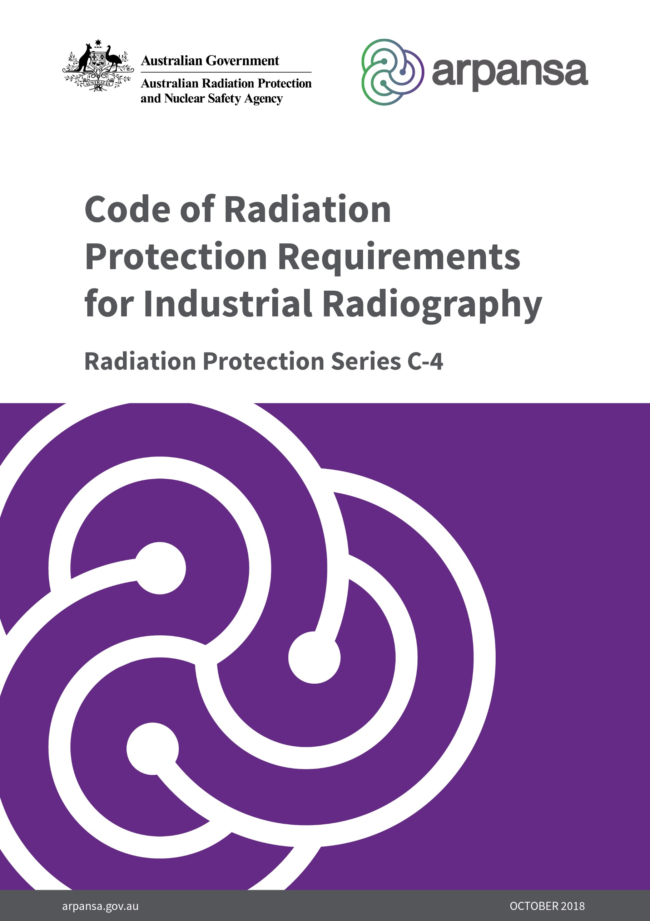

**Radiation Protection Series**

The Australian Radiation Protection and Nuclear Safety Agency (ARPANSA) publishes Fundamentals, Codes and Guides in the Radiation Protection Series (RPS), which promote national policies and practices that protect human health and the environment from harmful effects of radiation. ARPANSA develops these publications jointly with state and territory regulators through the Radiation Health Committee (RHC), which oversees the preparation of draft policies and standards with the view of their uniform implementation in all Australian jurisdictions. Following agreement and, as relevant, approvals at the Ministerial level, the RHC recommends publication to the Radiation Health and Safety Advisory Council, which endorses documents and recommends their publication by the CEO of ARPANSA.

To the extent possible and relevant for Australian circumstances, the RPS publications give effect in Australia to international standards and guidance. The sources of such standards and guidance are varied and include the International Commission on Radiological Protection (ICRP); the International Commission on Non-Ionizing Radiation Protection (ICNIRP); the International Atomic Energy Agency (IAEA); and the World Health Organization (WHO).

***Fundamentals*** set the fundamental principles for radiation protection and describe the fundamental radiation protection, safety and security objectives. They are written in an explanatory and non-regulatory style and describe the basic concepts and objectives of international best practice.

***Codes*** are regulatory in style and may be referenced by regulations or conditions of licence. They contain either general safety or security requirements which may be applicable for all dealings with radiation, or practice-specific requirements. They provide overarching requirements and are expressed as ‘must’ statements which are to be satisfied to ensure an acceptable level of safety and/or security.

***Guides*** provide recommendations and guidance on how to comply with the Codes or apply the principles of the Fundamentals. They are written in an explanatory and non-regulatory style and indicate the measures recommended to provide good practice. They are generally expressed as ‘should’ statements.

These three categories of publications are informed by public comment during drafting and are subject to a process of assessment of regulatory impact.

All ARPANSA publications (including earlier editions of codes and guides for which ARPANSA is now responsible) are available in electronic format, and can be downloaded free of charge by visiting ARPANSA’s website at <https://www.arpansa.gov.au/regulation-and-licensing/regulatory-publications/radiation-protection-series>.

Further information can be obtained by telephoning ARPANSA on 1800 022 333 (free call within Australia) or +61 (03) 9433 2211.

**Code of Radiation Protection Requirements for Industrial Radiography**

***Radiation Protection Series C-4***

**October 2018**

**This publication was prepared jointly with the *Radiation Health Committee*. The *Radiation Health and Safety Advisory Council* advised the CEO to adopt the Code.**

**© Commonwealth of Australia 2018**

This publication is protected by copyright. Copyright (and any other intellectual property rights, if any) in this publication is owned by the Commonwealth of Australia as represented by the Australian Radiation Protection and Nuclear Safety Agency (ARPANSA).

ISBN 978-0-6483704-1-3

ISSN 1445-9760



**Creative Commons**

With the exception of the Commonwealth Coat of Arms, any ARPANSA logos and any content that is marked as being third party material, this publication, Radiation Protection Requirements for Industrial Radiography (2018), by the Australian Radiation Protection and Nuclear Safety Agency is licensed under a Creative Commons Attribution 3.0 Australia licence (to view a copy of the licence, visit <http://creativecommons.org/licenses/by/3.0/au>). It is a further condition of the licence that any numerical data referred to in this publication may not be changed. To the extent that copyright subsists in a third party, permission will be required from the third party to reuse the material.

In essence, you are free to copy, communicate and adapt the material as long as you attribute the work to ARPANSA and abide by the other licence terms. The works are to be attributed to the Commonwealth as follows:-

“© Commonwealth of Australia 2018 as represented by the Australian Radiation Protection and Nuclear Safety Agency (ARPANSA)”

The publication should be attributed as: Radiation Protection Requirements for Industrial Radiography (2018)

**Use of the Coat of Arms**

The terms under which the Coat of Arms can be used are detailed on the Department of the Prime Minister and Cabinet website ([www.dpmc.gov.au/government/commonwealth-coat-arms](http://www.dpmc.gov.au/government/commonwealth-coat-arms)).

Enquiries regarding the licence and any use of this report are welcome.

ARPANSA

619 Lower Plenty Road

YALLAMBIE VIC 3085

Tel: 1800 022 333 (Freecall) or +61 3 9433 2211

Email: info@arpansa.gov.au

Website: [www.arpansa.gov.au](http://www.arpansa.gov.au)

The mission of ARPANSA is to protect people and the environment from the harmful effects of radiation.

Published by the Chief Executive Officer of ARPANSA in October 2018.

Acknowledgement of Country

ARPANSA proudly acknowledges Australia's Aboriginal and Torres Strait Islander community and their rich culture and pays respect to their Elders past and present. We acknowledge Aboriginal and Torres Strait Islander people as Australia’s first peoples and as the Traditional Owners and custodians of the land and water on which we rely.

We recognise and value the ongoing contribution of Aboriginal and Torres Strait Islander people and communities to Australian life and how this enriches us. We embrace the spirit of reconciliation, working towards the equality of outcomes and ensuring an equal voice.

Foreword

The management of risks from ionising radiation requires actions that are based on fundamental principles of radiation protection, safety and security. The *Fundamentals for Protection Against Ionising Radiation* *(2014)*, Radiation Protection Series F-1 (RPS F-1) was published as part of ARPANSA’s Radiation Protection Series to provide an understanding of the effects of ionising radiation and associated risks for the health of humans and of the environment. RPS F-1is the top tier document in the Australian national framework to manage risks from ionising radiation and explains how radiation protection, safety and security can work individually and collectively to manage such risks. It presents ten principles and their application in management of radiation risks.

The code *Radiation Protection in Planned Exposure Situations (2016)*, Radiation Protection Series C-1(RPS C-1) sets out the requirements in Australia for the protection of occupationally exposed persons, the public and the environment in planned exposure situations. The primary means of controlling exposure in planned exposure situations is by good design of facilities, equipment, operating procedures and through training – all of which contribute to optimisation of protection.

This code *Radiation Protection Requirements for Industrial Radiography (2018),* Radiation Protection Series C-4(RPS C-4) sets out the specific radiation protection requirements in Australia for the protection of occupationally exposed persons and the public from planned exposure situations in the use of radiation for the purpose of conducting industrial radiography.

ARPANSA, jointly with state and territory regulators in the Radiation Health Committee, developed this Code based on the requirements relating to industrial radiography described in the *Code of Practice for the Safe Use of Industrial Radiography Equipment*, Radiation Health Series No.31 (1989) and guidance in the International Atomic Energy Agency (IAEA) publication *Radiation Safety in Industrial Radiography,* Specific Safety Guide No. SSG-11 (IAEA 2011).

RPS C-4, together with RPS C-1, supersedes Radiation Health Series No.31 and is intended to complement the requirements of the relevant Work Health and Safety legislation in each jurisdiction. The relevant regulatory authority should be contacted should any conflict of interpretation arise. A listing of such authorities is provided at [www.arpansa.gov.au/regulation/regulators](http://www.arpansa.gov.au/regulation/regulators).

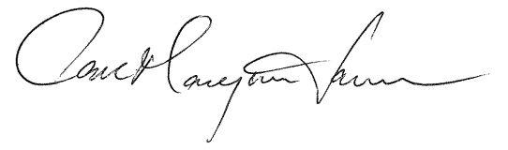

Carl-Magnus Larsson  
CEO of ARPANSA

22 October 2018

(This page intentionally left blank)

**Contents**

Foreword i

1. Introduction 1

1.1 Citation 1

1.2 Background 1

1.3 Purpose 1

1.4 Scope 1

1.5 Interpretation 2

2. Requirements for the sale or supply of sealed radioactive sources and radiation generators for industrial radiography 3

2.1 Equipment requirements 3

3. Requirements for industrial radiography practices 6

3.1 General requirements 6

3.2 Work practices 7

3.3 Radiation monitoring 9

3.4 Radiography within fully enclosed sites 11

3.5 Radiography within partially enclosed sites 11

4. Requirements applying to operators of industrial radiography equipment 12

4.1 General requirements 12

4.2 Additional requirements for open site radiography 14

Appendix A – Example work practices and protocols 16

5. Glossary 24

6. References 27

(This page intentionally left blank)

# Introduction

## Citation

This publication may be cited as the Industrial Radiography Code (2018).

## Background

Industrial radiography uses the penetrative properties of radiation to obtain information non-destructively on the internal state of inanimate objects and materials through radiographic imaging. Its application is well established and, when used in a safe and controlled manner, brings significant benefits to society.

Due to the intense radiation fields used in industrial radiography, improper use can create significant radiological health hazards including potentially lethal radiation doses. Harmful radiation doses have been received in the past by both industrial radiographers and members of the public from a variety of accidents, which could have been avoided had appropriate safe working practices been followed.

Industrial radiography is often carried out under difficult working conditions and in a variety of environments including remote locations. At **open sites**, in particular, radiographs may have to be made in circumstances that involve risk of serious accidental exposure unless site working rules are rigorously followed. Personal monitoring records consistently show that doses received by **operators** involved in industrial radiography are amongst the highest of any group of radiation workers.

Dose rates of the order of a **sievert** (Sv) per second are not uncommon in the radiation beam. Accidental exposure for a few seconds to such high dose rates would lead to doses of several sieverts, which will cause severe radiation damage to any limbs or tissues exposed. Doses above 10 Sv to the torso can be fatal.

## Purpose

This code specifies the requirements to be followed to ensure that any unnecessary exposure of persons to ionising radiation is avoided, that all exposures are kept as low as reasonably achievable (ALARA), and that the dose limits specified in *Radiation Protection in Planned Exposure Situations,* Radiation Protection Series C-1 (RPS C-1) are complied with.

The implementation of these requirements serve to minimise accidents, **incidents,** and **emergency exposure situations** or mitigate their consequences.

The radiation protection requirements in this publication apply to **Responsible Persons**, and to operators authorised to carry out industrial radiography work.

The numbered paragraphs can be used as licence conditions, either singly or *in toto*, by the relevant regulatory authority or authorities as deemed appropriate.

## Scope

This Code applies to industrial radiography utilising **radiation generators**, **sealed radioactive sources, exposure containers** and **industrial radiography equipment** to form an image of the internal state of an inanimate object or material which may be evaluated visually, instrumentally or digitally.

## Interpretation

The presence of the term ‘must’ when it appears in this Code indicates that the requirement to which it refers is mandatory.

Each of the terms in bold type has the meaning given in the Glossary together with any amplification given in this Code. In particular, the term ‘radiation’ means ‘ionising radiation’, as defined in the Glossary.

# Requirements for the sale or supply of sealed radioactive sources and radiation generators for industrial radiography

To ensure that unnecessary exposure of persons to radiation is avoided and that all exposures are kept as low as reasonably achievable, it is important that all radiation generators, sealed radioactive sources, exposure containers and industrial radiography equipment supplied for industrial radiography comply with appropriate standards and the requirements of this Code.

## Equipment requirements

### A Responsible Person that is in possession of an exposure container, a sealed radioactive source, a radiation generator, or industrial radiography equipment for the purposes of sale or supply must ensure that:

* + - 1. the requirements of RPS C-1 are complied with
      2. a Radiation Management Plan, as required by RPS C-1, is implemented which includes the work practices and protocols to be followed[1], and emergency preparedness plans and emergency response procedures to be followed[2]
      3. the requirements of the *Code for the Safe Transport of Radioactive Material*, Radiation Protection Series C-2 (RPS C-2) are complied with
      4. the requirements of the *Code of Practice for the Security of Radioactive Sources*, Radiation Protection Series No.11 (RPS 11) are complied with
      5. they hold an appropriate authorisation issued by the relevant regulatory authority which permits the sale or supply of the sealed radioactive sources or radiation generators under their control
      6. for sealed radioactive sources;
         1. each sealed radioactive source supplied conforms with *ISO 2919 Radiological protection – Sealed radioactive sources – General requirements and classification* (or equivalent standard subject to written agreement with the relevant regulatory authority)
         2. the purchaser or recipient is provided with a ‘dummy source’, and if required a dummy source holder of the same appearance, or a photograph or other documentation necessary to enable the operator to recognise an accidentally detached source, by size and appearance in an emergency exposure situation
         3. the purchaser or recipient is provided with the manufacturer’s operating manual which details the safe instruction to operate the item and the maintenance to be undertaken to ensure the item continues to operate as intended
         4. when supplying a replacement sealed radioactive source in an exposure container, that the source holder and couplings are inspected and replaced if worn, frayed or damaged beyond the manufacturer’s specifications or recommendations
      7. each exposure container and associated industrial radiography equipment conforms with ISO 3999 *Radiation Protection – Apparatus for industrial gamma radiography – Specifications for performance, design and tests* (or an equivalent standard subject to written agreement with the relevant regulatory authority)
      8. for radiation generators;
         1. the radiation generator is shielded to ensure that dose rate values for leakage radiation do not exceed 5 mSv·h-1 at 1m from the target under continuous operation at maximum energy and output
         2. the radiation generator has a warning light (‘fail-to-safe’) which illuminates when radiation is produced, or a remote flashing warning light (‘fail-to-safe’) is supplied for use in close proximity to the radiation generator housing
         3. the radiation generator is durably labelled to indicate where the primary radiation beam exits the radiation generator
      9. radiation generator control panels include the following features;
         1. a label incorporating the radiation symbol (trefoil), a notice indicating that radiation is emitted when in operation, and a warning label prohibiting unauthorised use
         2. a key switch to prevent unauthorised use
         3. a key that is removable only when the switch is in the ‘off’ or ‘standby’ position (i.e. it must not be possible to lock the system in the ‘on’ condition)
         4. key positions that are clearly marked
         5. a labelled warning light (‘fail-to-safe’) that indicates when the radiation generator is enabled
         6. a labelled warning light (‘fail-to-safe’) that indicates when the radiation generator is emitting radiation
         7. a timer that controls the exposure duration and terminates the exposure after a pre-set interval, or an ‘on’ switch that requires continuous pressure by the operator to maintain the generation of radiation
         8. an indicator that shows the kilovolts (kV) and the current in milliamperes (mA) when radiation is being emitted, or for radiation generators operating at fixed kV or fixed mA, a durable label specifying the kV or mA is affixed to the radiation generator
         9. a clear and durably labelled means of immediately terminating the generation of radiation
         10. are fitted with a device to connect a remote flashing light or a series of flashing lights which can be used to define a boundary or provide a visible warning
      10. for radiation generators to be used in open site situations, the length of the cable connecting the control panel to the generator is not (typically) less than;
          1. 7 m for a 100kV or less generator
          2. 10 m for a 200kV or less generator
          3. 15 m for a 250kV or less generator
          4. 20 m for generators 250 kV or greater
      11. radiation generators designed or configured for direct-viewing fluoroscopy are;
          1. shielded such that the dose rate at any accessible position does not exceed 25 µSv·h-1
          2. designed or configured such that, when in use, the primary beam is totally intercepted
      12. pipe crawlers;
          1. are fitted with an audible alarm so that when the pipe crawler reaches the exposure position, the audible alarm automatically operates for a warning period of approximately 10 seconds immediately prior to the exposure, and continues in a manner distinguishable from the 10 second warning while the exposure takes place
          2. are operable by remote control, or by an automatic device such as a trip wheel
          3. are fitted with a safety device which prevents unintentional exposure
          4. incorporate a safety device which disconnects power from the pipe crawler propulsion unit in the event of a malfunction during operation.

# Requirements for industrial radiography practices

The overall responsibility for radiation protection in an industrial radiography practice lies with the Responsible Person.

The Responsible Person is obliged to ensure that radiation generators, sealed radioactive sources, exposure containers, industrial radiography equipment, fully enclosed sites and partially enclosed sites for industrial radiography comply with appropriate standards and the requirements of this Code.

The Responsible Person must also ensure that a Radiation Management Plan is implemented, which includes the local rules and practices to be followed by operators when carrying out industrial radiography work.

## General requirements

### The Responsible Person must ensure that:

* + - 1. the requirements of RPS C-1 are complied with
      2. a Radiation Management Plan, as required by RPS C-1, is implemented which includes the work practices and protocols to be followed[3], and emergency preparedness plans and emergency response procedures to be followed[4]
      3. the requirements of RPS C-2 are complied with
      4. the requirements of RPS 11 are complied with
      5. they hold an appropriate authorisation issued by the relevant regulatory authority which permits the possession and use of the sealed radioactive sources or radiation generators under their control
      6. an in-house Radiation Safety Officer[5] is appointed to carry out the duties specified in the Radiation Management Plan
      7. sealed radioactive sources used for industrial radiography conform to ISO 2919 (or an equivalent standard subject to written agreement with the relevant regulatory authority)
      8. exposure containers and industrial radiography equipment conform to ISO 3999 (or an equivalent standard subject to written agreement with the relevant regulatory authority)
      9. a durably marked and fire resistant label is attached to each exposure container which incorporates the following information;
         1. the maximum radiation level at one metre from the container
         2. the name, address and telephone number of the Responsible Person or emergency contact person
      10. radiation generators and pipe crawlers meet the relevant requirements of sub-paragraphs 2.1.1(h) to 2.1.1(l) of this Code
      11. exposure containers, radiation generators and industrial radiography equipment under their control are serviced and maintained in accordance with the manufacturer’s requirements
      12. the necessary equipment and facilities are available to enable the work practices and protocols, and emergency preparedness plans, as specified in the Radiation Management Plan, to be followed.

## Work practices

### The Responsible Person must ensure that:

* + - 1. industrial radiography is performed only by persons authorised to do so by the relevant regulatory authority
      2. under no circumstances are untrained, inappropriately qualified, or unauthorised persons to use, remove, maintain, adjust, modify or in any way interfere with an exposure container, radiation generator or industrial radiography equipment[6]
      3. a second person to the operator, a suitably trained assistant operator, is available at an open site or a **partially enclosed site** who, in case of an emergency, is capable of;
         1. ensuring that no person remains unnecessarily in an area where the dose rate exceeds or might exceed 25 µSv·h-1
         2. using any of the exposure containers, radiation generators or industrial radiography equipment, or any other equipment at their disposal to render the exposure situation safe
         3. using a radiation survey meter in order to confirm the situation
         4. recognising a loose sealed radioactive source or source holder by being familiar with the dummy source (or its photograph) supplied with the sealed radioactive source
         5. informing the Radiation Safety Officer and the Responsible Person of the details of the emergency without delay
      4. exposure containers, radiation generators and industrial radiography equipment are inspected prior to first use and at intervals specified by the relevant regulatory authority
      5. inspections of exposure containers, radiation generators and industrial radiography equipment include tests to ensure that;
         1. all safety interlocks, shutters and control mechanisms operate effectively
         2. no components are unacceptably worn or damaged
         3. the details of any inspections and tests performed on exposure containers, radiation generators and industrial radiography equipment are kept and made available to the relevant regulatory authority upon request.
      6. if damage to an exposure container or radiation generator, or any variation in radiation pattern comes to their attention, the container or generator is not further used until inspected, and declared safe, by a suitably competent or authorised person
      7. after any repairs to exposure containers or radiation generators, that they are tested for proper functioning and, before re-use, comply with all applicable standards and the requirements of this Code
      8. details of any repairs to exposure containers or radiation generators are kept and made available to the relevant regulatory authority upon request
      9. sealed radioactive sources and exposure containers loaded with sealed radioactive sources are kept in a radiation store that is not used for any other purpose, other than the storage of industrial radiography equipment, and in a manner that ensures safe and secure storage
      10. the radiation store is designated as a controlled area and is;
          1. resistant to fire, to minimise the potential for loss of shielding and containment in the event of a fire in the vicinity
          2. located at a remote distance from any corrosion and explosion hazards
          3. made of materials that provide sufficient shielding so that radiation levels at any readily accessible position outside the store do not result in an ambient dose equivalent rate or directional dose equivalent rate, as appropriate, exceeding 10 μSv·h-1
          4. kept locked and the keys are held only by authorised personnel
          5. affixed with a warning sign bearing the word ‘CAUTION’ and a trefoil symbol and lettering that makes it clear that it is a store for radioactive material[7]
          6. affixed with a sign or separate notice containing instructions for contacting the Radiation Safety Officer (or appointed deputy) in an emergency
      11. operators are familiar with the nature and physical appearance of any sealed radioactive source or source holder for which they have responsibility
      12. all sealed radioactive sources within their control are accounted for at all times by reference to a documented radiation source movement book
      13. an up to date record is maintained of the following information for all sealed radioactive sources within their control;
          1. their date of receipt and the name of the supplier
          2. their location and identification numbers
          3. the radionuclide in each sealed radioactive source
          4. the activities and dates of measurement of the sealed radioactive sources
          5. the make, model and identification number of the exposure container
          6. inspection reports and details of any repairs
          7. any approvals issued by the relevant regulatory authority for the disposal of any sealed radioactive source
          8. the date and manner of disposal
      14. a record is kept of the following information for all radiation generators within their control;
          1. radiation generator type
          2. the location and identification number of the radiation generator
          3. the maximum tube potential difference (kV (peak)) and current (mA), and maximum energy (keV)
          4. any inspection reports and details of any repairs
          5. any approvals issued by the relevant regulatory authority for the disposal of any radiation generator
          6. the date and manner of disposal
      15. the relevant regulatory authority is notified as soon as possible, or within a timeframe specified by the regulatory authority, if a sealed radioactive source or radiation generator cannot be accounted for.

## Radiation monitoring

### The Responsible Person must ensure that:

* + - 1. each person involved in conducting industrial radiography is issued with;
         1. an approved personal radiation monitoring device which records cumulative radiation dose
         2. a personal electronic dosimeter, which provides an audible indication of changing dose rate
      2. electronic personal dosimeters issued to personnel directly involved in industrial radiography operations;
         1. are capable of responding to the range of energies of the radiation emitted during industrial radiography
         2. continue to give a maximum audible response when exposed to dose rates in excess of 500 mGy·h-1 in air
      3. all radiation survey meters provided to personnel;
         1. have sufficient measurement range to measure radiation levels at least through the ranges 1 µSv·h-1 to 10 mSv·h-1 for the radiations emitted from the radiation sources to be used
         2. when radiation levels exceed the maximum readings in their measurement ranges, continue to indicate that fact and should provide an audible warning
         3. indicate the measured quantity with a measurement uncertainty not greater than ±25%, inclusive of uncertainty due to response variation with energy over the range of energies of the radiation to be measured
         4. are calibrated by a calibration facility recognised by the relevant regulatory authority at intervals not exceeding 12 months, and following any damage or repairs to the working components
      4. the most recent calibration certificate for each survey meter is available for inspection by the regulatory authority if required.

Notes:

1. Electronic personal dosimeters normally incorporate an audible warning alarm, however this may be supplemented by a vibration or visible signal in situations where the ambient noise level is high or if hearing protectors or other safety equipment is being worn.
2. While many types of radiation survey meter are suitable for measuring gamma radiation levels, some may not be suitable for accurately measuring low energy X rays, which could result in a significant underestimation of the true dose rate. Information and guidance on the suitability of monitors should be obtained from radiation survey meter manufacturers and qualified experts.

## Radiography within fully enclosed sites

### The Responsible Person must ensure that **fully enclosed sites**:

* + - 1. are designed and engineered to;
         1. provide adequate shielding from ionising radiation to persons in the vicinity
         2. prevent or minimise the potential exposure of persons who might enter the enclosure when the sources are exposed or energised
      2. are designed so that exposure controls for exposure containers and radiation generators are located outside the shielded enclosure
      3. are designed to keep all direct and scattered radiation arising from radiography exposures within a totally enclosed volume and the dose rates do not exceed 25 µSv·h-1 measured at 5 cm from any accessible surface of the enclosure
      4. are clearly identified as a fully enclosed site through the use of warning notices at access points
      5. are fitted with a warning light that is;
         1. illuminated during exposure
         2. clearly visible from outside the enclosure
      6. are fitted with interlocks to all access points which will activate a visible and audible alarm if an interlock is opened during exposure
      7. automatically interrupt the power supply to a radiation generator upon the opening of an interlock, and subsequent closing of the interlock does not automatically re-energise the radiation generator
      8. are fitted with visible and audible warning devices inside the enclosed site which are activated during exposure
      9. have suitable means of exit to enable any person accidentally within the enclosure to exit without delay
      10. activate an alarm upon the opening of any exit during exposure, and subsequent closing of the exit must not automatically reset the alarm or re-energise the radiation generator
      11. have conduits for feeding cabling, including **wind out cables**, electric power or other services through the walls, incorporating a dog-leg or baffle that leaves no line-of-sight aperture through the walls so that the radiation shielding integrity of the walls is not impaired.

## Radiography within partially enclosed sites

### The Responsible Person must ensure thatpartially enclosed sites:

* + - 1. have walls at least 2.1 m high
      2. have sufficient shielding such that the dose rate measured outside the enclosed site does not exceed 25 µSv·h-1 measured 5 cm from any accessible surface
      3. are clearly identified as a partially enclosed site through the use of warning notices at its perimeter and at access points.
      4. are fitted with a warning light which is;
         1. illuminated during exposure
         2. clearly visible from outside the enclosure
      5. are fitted with interlocks at all entrances to activate a visible and audible alarm if any interlock is opened during exposure
      6. automatically interrupt the power supply to the radiation generator upon the opening of an interlock, and subsequently closing of the interlock does not automatically re-energise the radiation generator
      7. are provided with visible and audible warning devices to be activated during exposure and which can be seen and heard from both inside and outside the enclosure
      8. are provided with a suitable means of exit to enable any person accidentally shut in to leave the enclosure without delay
      9. activate an alarm upon opening of any exit during exposure, and subsequent closing of the exit does not automatically reset the alarm or re-energise the generator
      10. are fitted with doors or panels covering access apertures into partially enclosed sites that overlap to prevent the leakage of scattered radiation
      11. that incorporate a maze used for access by personnel, are fitted with a lockable door or barrier that is connected to an interlock
      12. are designed with minimal or no roof does not present a radiation hazard in occupied areas from scattered radiation (or ‘skyshine’) from the roof or objects outside the enclosure,
      13. are clear of personnel during an exposure.

# Requirements applying to operators of industrial radiography equipment

While the primary responsibility for radiation safety lies with the Responsible Person, operators have a responsibility to work safely in accordance with this Code and the working rules and work practices to be followed as detailed in the Radiation Management Plan approved by the Responsible Person. Operators are expected to undertake all reasonable actions to restrict their own exposure and those of other workers and members of the public.

## General requirements

### The operator must ensure that:

* + - 1. they comply with the Radiation Management Plan approved by the Responsible Person, including any working rules, work practices to be followed, and emergency procedures
      2. prior to commencing industrial radiography work;
         1. all interlocks, shielding, collimators, signs, barriers and other protective devices are properly positioned
         2. all persons not involved in the operation are at safe locations
         3. a suitable radiation survey meter is available for immediate use
      3. at all times during industrial radiography work they wear;
         1. a personal radiation monitoring device, approved by the relevant regulatory authority, which records their cumulative radiation dose, and
         2. a personal dosimeter, which provides an audible indication of changing dose rate
      4. the following details of the movement of exposure containers and radiation generators are legibly entered in a radiation source movement book;
         1. the identification number of the exposure container or radiation generator
         2. for exposure containers, the sealed radioactive source involved and its activity at the time of transfer
         3. the location of sites where the exposure container or radiation generator is to be used
         4. the date and time of removal from the radiation store
         5. the estimated date and time of return to the radiation store
         6. the date and time of return to the store
         7. the name of the operator
      5. on removing an exposure container from the store, they verify that the sealed radioactive source has been transferred to their custody by checking the exposure rate from the exposure container with a radiation survey meter and record this fact in the radiation source movement book
      6. except for minor adjustment in position for the purpose of further radiography, whenever an exposure container is moved within a site or when placed in a radiation store;
         1. the source control or source control mechanism is locked or otherwise secured in the fully shielded position
         2. all required port plugs and caps secured in place.
      7. a radiation survey meter is used to verify that;
         1. the sealed radioactive source is correctly located in the fully shielded position, and
         2. the radiation exposure pattern is as expected
      8. exposure containers are stowed within a locked storage compartment during transport, including when the transport vehicle is left unattended
      9. at the completion of each radiography exposure, the sealed radioactive source has been returned to the fully shielded position, or for radiation generators, that they are no longer emitting radiation, by using a suitable radiation survey meter
      10. on returning an exposure container to the radiation store, check with a radiation survey meter that;
          1. the source control or source control mechanism is locked or otherwise secured in the fully shielded position
          2. all port plugs are firmly secured in place
          3. the sealed radioactive source is correctly located in the fully shielded position
      11. they do not operate any exposure container, radiation generator, or industrial radiography equipment which is known or reasonably suspected to be malfunctioning, deteriorated or damaged, and to report such circumstances promptly to the Radiation Safety Officer for appropriate investigative action
      12. under any of the following circumstances, they immediately cease industrial radiography by returning the sealed radioactive source to its fully shielded position within the exposure container or by de-energising the radiation generator, as applicable;
          1. a malfunction occurs during operation
          2. any person other than the operator or assistant operator enters an area where the dose rate exceeds or might exceed 25 µSv·h-1
          3. the only available radiation survey meter fails to function
      13. in the event of an accident or incident;
          1. they promptly take the appropriate measures in accordance with any emergency preparedness and response plans specified in the Radiation Management Plan to bring the incident under control
          2. they immediately inform the Radiation Safety Officer and the Responsible Person of the circumstances of the incident.

## Additional requirements for open site radiography

### For industrial radiography at an open site, the operator must ensure that:

* + - 1. prior to commencement of industrial radiography, a well-defined and clearly visible boundary is established using warning signs and devices such as barriers and ropes around, above and below the site as appropriate
      2. the calculated dose rates at the boundary established under 4.2.1(a) do not exceed 25 μSv·h-1 during exposure
      3. the dose rates at the boundary are measured during exposure using a radiation survey meter and rectified if necessary
      4. when directing the primary beam towards the ground or floor, no person below the ground or floor level is in the path of the beam
      5. site radiography work is carried out in an area designated as a controlled area
      6. no other work is permitted in the controlled area until the;
         1. radiography work has been finished
         2. controlled area is no longer so designated
      7. if site boundaries overlap, close communication is maintained between operators to avoid accidental exposure
      8. the control position (the position at which the operator controls the radiography work) is located such that the dose rate to operators is ALARA, and that this is checked regularly by means of a radiation survey meter
      9. whenever possible the exposure position (the position at which the radiography exposure takes place) is clearly visible to the operator from the control position
      10. the area inside the boundary is inspected prior to initiating an exposure to ensure no person is within it
      11. the controlled area is kept under constant observation during exposure to ensure no person enters it
      12. one or more warning lights and an audible alarm located immediately adjacent to the exposure position are used to indicate when an exposure in underway
      13. when a radiation generator is being used, a beam stop is used when performing warm up operations
      14. beam stops or collimators are used whenever practicable to ensure the dose rates outside of the boundary are ALARA.

# Appendix A – Example work practices and protocols

Example work practices and protocols for industrial radiography   
(including labels and warning signs)

The following example work practices and protocols for industrial radiography serve as a guide only in developing such work practices and protocols for inclusion in a Radiation Management Plan. It is not intended that they be cited as mandatory requirements of this Code.

* 1. Work practices and protocols for a fully enclosed site (exposure room)

The inherent safety of a fully enclosed site affords adequate protection of persons during an exposure, provided the following conditions are met.

* + 1. Only operations for which the fully enclosed site provides adequate shielding must be carried out. The dose rate must be periodically measured by the operator and must not exceed 25 μSv·h-1 in any accessible position outside the fully enclosed site.
    2. Before commencing an exposure the operator must ensure, by visual inspection, that the fully enclosed site is unoccupied.
    3. All entrances to the fully enclosed site must be locked or interlocked to an audible and visible alarm during radiographic exposure.
    4. A personal radiation monitoring device and a personal dosimeter must be worn by the operator and assistant operator at all times during industrial radiography operations.
    5. At the completion of an exposure the operator must ensure, by using a radiation survey meter, that the radiation generator has been switched off or the sealed radioactive source has returned to its fully shielded position within the exposure container.
    6. The operator must, according to appropriate advice prepared by the Radiation Safety Officer, ensure that dose rates in occupied areas are such that no member of the public will receive a dose exceeding 1 mSv per year from radiography performed within the site.
  1. Work practices and protocols for a partially enclosed site (exposure bay)
     1. A second person, who is capable of promptly taking charge in an emergency, must be immediately available to assist during industrial radiographic exposures. This second person must be able to:
        1. ensure that no person remains unnecessarily in an area where the dose rate exceeds or might exceed 25 μSv·h-1
        2. use the source control equipment or any other means at their disposal to render the situation safe and under control, and if necessary, use a radiation survey meter in order to confirm the situation
        3. recognise a loose sealed radioactive source holder or ‘pigtail’ by being familiar with the dummy source or its photograph
        4. inform the Radiation Safety Officer and Responsible Person of the circumstances of the emergency without delay.

This person must not be in charge of any work at an adjacent site, unless scheduling arrangements are made such that they are not simultaneously responsible for work taking place at both sites.

* + 1. Before commencing an exposure, the operator must ensure by visual inspection that the partially enclosed site is unoccupied.
    2. All openings into the partially enclosed site must be closed during exposure and when ‘radiation on’ indicators are activated.
    3. The dose rate must be periodically measured by the operator particularly when radiography exposure configurations are changed, and must not exceed 25 µSv·h-1 in any readily accessible position outside the partially enclosed site.
    4. Unnecessary occupancy of the area immediately adjacent to the partially enclosed site should be avoided during exposure, unless radiation survey measurements show that dose rates there are negligible. In particular, the area above a partially enclosed site must be kept under surveillance during exposure to ensure that no persons (for example, gantry drivers, personnel on a higher floor or roof) stray into a position where the dose rate exceeds or might exceed 25 µSv·h-1.
    5. A personal radiation monitoring device and a personal dosimeter must be worn by operators and assistant operators at all times during industrial radiography operations. At the completion of an exposure, the operator must ensure, by using a radiation survey meter, that the radiation generator has been switched off or the sealed radioactive source has returned to its fully shielded position within the exposure container.
    6. The operator must, according to appropriate advice prepared by the Radiation Safety Officer, ensure that dose rates in occupied areas are such that no member of the public will receive a dose exceeding 1 mSv per year from radiography performed within the site.
  1. Work practices and protocols for an open site (field site)
     1. On first arriving at the site, the operator must:
        1. advise the person responsible for the area in which the radiography exposure will be set up of the intended operations and the estimated amount of time required to complete the work
        2. ascertain the nature, duration and location of all other work to be performed in the vicinity of the site and the possible points of entry to the site.
     2. Before commencing exposures, a well-defined and clearly visible boundary must be established (using, for example, flagged rope) around the site, including above and below as necessary, such that the dose rate at the boundary must not exceed 25 µSv·h-1 during exposures. This must be checked periodically by the operator by means of a radiation survey meter. The boundary must be marked with radiation warning signs. An example of a suitable warning sign to be used during exposure is given in this appendix. Warning lights must be used to indicate that an exposure is underway. The area within the boundary must be kept under surveillance at all times during exposures to ensure that no person enters it or remains within it. Unnecessary occupation of areas near the boundary should be avoided.
     3. The boundaries of adjacent exposure sites should not overlap. If an overlap is unavoidable, close liaison must be maintained between operators responsible for the overlapping sites to avoid accidental exposures.
     4. The operator must, according to appropriate advice prepared by the Radiation Safety Officer, ensure that dose rates in occupied areas are such that no member of the public will receive a dose exceeding 1 mSv per year from radiography performed within the site.
     5. A sealed radioactive source must not be partially or wholly exposed outside its exposure container nor a radiation generator switched on except when it is positioned within the site boundary. The immediate surroundings of the exposure position must be clearly visible from the control position. The control position must be in an appropriately safe place, as far as practicable from the exposure position. The dose rate at the control position or at the position taken up by the operator during exposure must be checked regularly by means of a radiation survey meter.
     6. A second person, who is capable of promptly taking charge in an emergency, must be immediately available to assist during radiography exposures. This person must be able to:
        1. ensure that no person remains unnecessarily in an area where the dose rate exceeds or might exceed 25 µSv·h-1
        2. use the source control equipment or any other means at their disposal to render the radiography equipment safe, if necessary
        3. use a radiation survey meter in order to confirm the situation
        4. recognise a sealed radioactive source or pigtail by being familiar with the dummy source or its photograph
        5. inform the Radiation Safety Officer and the Responsible Person of the circumstances of the emergency without delay.

This person must not be in charge of any work at an adjacent site, unless scheduling arrangements are made such that they are not simultaneously responsible for work taking place at both sites.

* + 1. Whenever possible, collimators must be used to restrict the area of the primary radiation beam to the minimum necessary for radiography. The beam should be directed towards the ground, but if this is not possible, a back shield should be used. Shielding should also be used to reduce stray radiation, when practicable. Radiation generators should incorporate beam filters to reduce scattered radiation.
    2. Radiography equipment and the item to be radiographed must be set up so that each of the components, particularly the radiation generator or the sealed radioactive source, are stable and therefore will not move during the exposure.
    3. Before commencing an exposure, the operator must ensure by inspection that all unauthorised persons are outside the boundary and that the assistant operators are in an area where the dose rate is as low as, or lower than, where the operator is located.
    4. Just prior to commencing an exposure, a warning signal must be given to warn persons within a reasonable distance that an exposure is about to take place.
       1. A personal radiation monitoring device and a personal dosimeter must be worn by the operator and assistant operators at all times during radiography operations.
       2. The operator must frequently monitor the radiation level at their location during exposure using a radiation survey meter.
    5. The operator alone must exercise control over:
       1. the radiation exposure
       2. the occupancy of the site during the period of exposure by continuous and competent supervision of the site.
    6. Care must be taken at all times to ensure that unauthorised persons cannot operate the exposure container or radiation generator.
    7. Exposure containers and radiation generators should not be left unattended. If it is necessary to leave these items unattended for a ‘brief interval of time’[8], the sealed radioactive source must be returned to its fully shielded condition or switched off, as appropriate, and locked. The operator must retain the key in their possession and before re-inserting the key, confirm that the equipment has not been tampered with in any way. If the equipment has been tampered with, this fact must be reported immediately to the Responsible Person. For long periods without use the exposure container or radiation generator must be returned to an appropriate storage location.
    8. Before a site is vacated the operator must ensure, by monitoring with a survey meter, that all radioactive sources are locked in the fully shielded condition or radiation generators are switched off, are returned to an appropriate store or to the transport vehicle, and that all boundary defining equipment has been removed. The operator must inform the person responsible for the area when this has been carried out.
  1. Additional work practices and protocols for radiation generators
     1. Radiation generators must be transported or relocated only with the power supply disconnected.
     2. When setting up, the power cable must be laid out to ensure as large a distance as possible between the radiation generator and the control panel and in such a way that the cable is unlikely to be damaged, for example, by falling objects or by being run over by vehicles.
     3. The window on the radiation generator must be completely shielded during warm-up procedures.
     4. Immediately after each exposure, the operator must use a radiation survey meter to confirm that the radiation generator is de-energised and must first turn the kV control back to its lowest setting, if it does not automatically reset, before other controls are changed.
     5. The radiation generator must be properly earthed.
  2. Additional work practices and protocols for pipe crawler devices
     1. Where a right of way is situated adjacent to the pipeline in which a pipe crawler is operating, unless there is sufficient shielding in place to lower radiation levels, the boundary that is established must restrict the passage of vehicles and personnel along that right of way while the pipe crawler is activated.
     2. In a very noisy environment in which the pipe crawler audible alarm may not be readily audible to all those who should be warned by it, particular attention must be given to competent and continuous supervision of access to the site and to the possible use of a high-intensity flashing (strobe) light or an ancillary audible alarm outside the pipe.
     3. While a radiation generator pipe crawler is not in operation in a pipeline and prior to its transfer into or out of a pipeline, the exposure control must be made safe so that it is not possible for an exposure to be initiated by unintentional tripping of the exposure initiation device. Where there is no exposure control safety device, the power supply must be disconnected. When a fault condition causes a battery-operated pipe crawler to be continually energised, with the consequence that the battery voltage falls, the energy of the radiation generated may be below the range of the survey meter. If such a fault occurs, it must be assumed that the pipe crawler is emitting radiation until the battery supply has been disconnected.
     4. A radiation generator pipe crawler must not be handled manually unless the power supply is disconnected or the equipment is otherwise made safe.
  3. Additional work practice and protocols for radiography using exposure containers
     1. Only radiation workers, who are wearing personal dosimeters, are to travel in vehicles used in the transport of sealed radioactive sources. There must be at least one functional radiation survey meter and one audible alarm dosimeter also in the vehicle, and the latter should be left operating during the journey.
     2. When setting up source control cables, collimators and exposure containers for exposure, the equipment must be laid out to ensure as large a distance as possible between the exposure container and the control mechanism and in such a way that the control cable is unlikely to be damaged, for example, by falling objects or by being run over by motor vehicles. Control cables and guide tubes must be laid out such that they do not contain sharp bends or kinks which might cause the cable or source to jam or which cause excessive wear of the control cable.
     3. Radiography equipment and the item to be radiographed must be set up so that each of the components, particularly the sealed radioactive source or source holder in its exposure position, is stable and therefore will not move during the exposure.
     4. Before exposure, the correct operation of the wind out cable must be verified. The wind out mechanism should be wound out through two revolutions and back through two revolutions, and a radiation survey meter used to confirm movement of the sealed radioactive source.
     5. Wind out and wind in operations should be performed quickly but carefully.
     6. A correctly operating radiation survey meter must be placed adjacent to the wind out mechanism during winding so as to confirm the status of the sealed radioactive source. In particular, the radiation survey meter must be used to confirm that the sealed radioactive source has been returned to the exposure container at the completion of the exposure. The operator must use a radiation survey meter when approaching the source, irrespective of its operating status.

Example radiation label and warning signs for industrial radiography

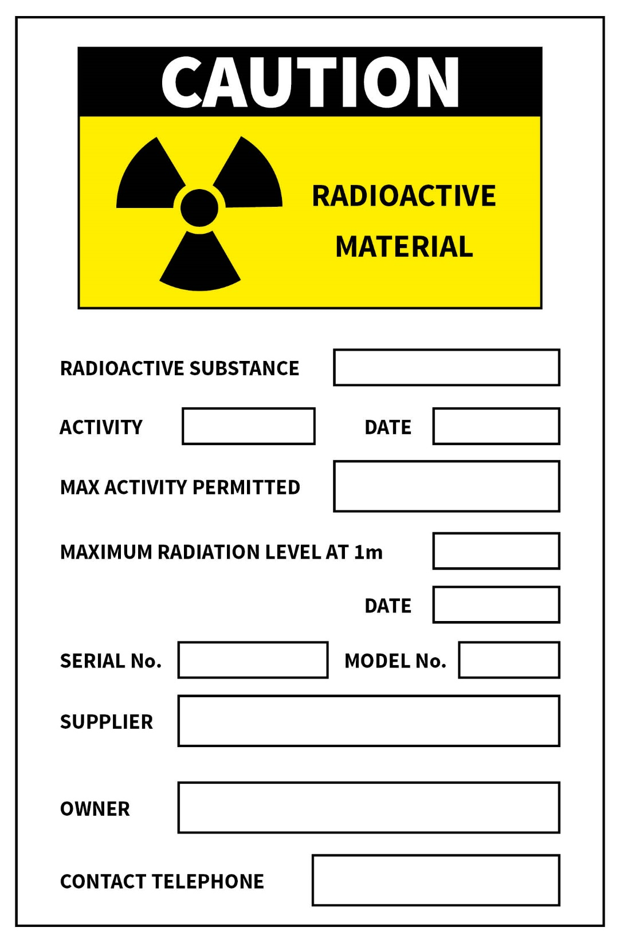

***Label for attachment to an exposure container***

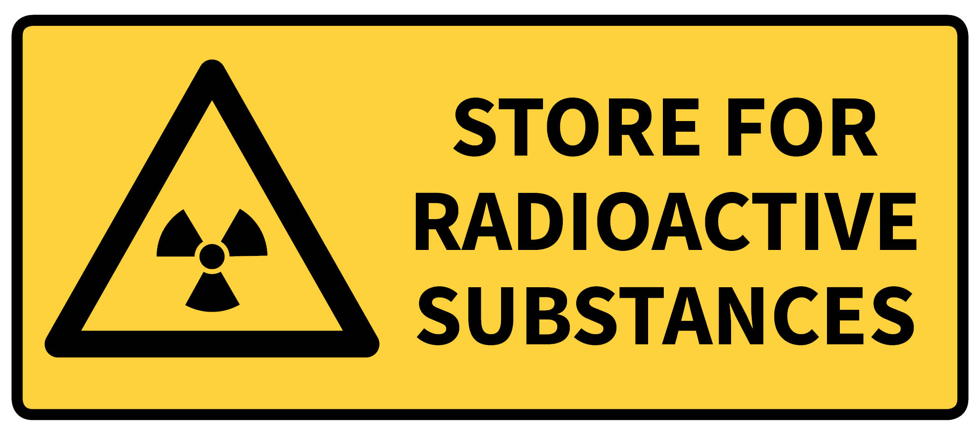

***Warning sign for a radiation store***

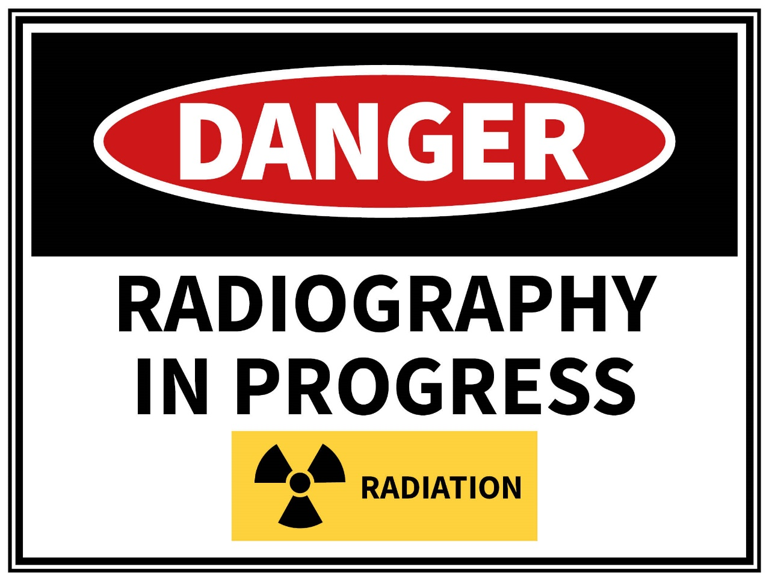

***Warning sign for display during industrial radiography***

# Glossary

Control cable

A component of a source control mechanism which, for shutter type exposure containers, controls the shutter from a location remote from the exposure area or, for a projection type exposure container is a wind out cable.

Controlled area

A defined area in which specific protection measures and safety provisions are or could be required for controlling exposures or preventing the spread of contamination in normal working conditions, and preventing or limiting the extent of potential exposures.

Emergency exposure situation

A situation of exposure that arises as a result of an accident, a malicious act, or any other unexpected event, and requires prompt action in order to avoid or reduce adverse consequences.

Exposure container

One of three types of container designed to house a sealed radioactive source and to provide, through shielding, protection of persons from the high levels of radiation close to the source, and to which a source control mechanism can be attached.

* A shutter type container fully encloses the radioactive source except during exposure, when the shutter is opened, and in some cases the source is moved to a window, to permit the passage of radiation.
* A projection type container retains the radioactive source in a shielded position except during exposure, when it is propelled from the container along a guide tube to its exposure position.
* A projection shutter type container combines features of both of the above types.

Fully enclosed site

A purpose built enclosure used specifically for industrial radiography in which the irradiation area is completely enclosed by shielding, including walls, floor and ceiling, and within which no person is permitted to remain during exposure.

Guide tube

A tube, typically of flexible construction, designed to provide an enclosed path along which a radioactive source may be moved from its source container to its exposure position and back again.

Incident

Any unintended event, including operating errors, equipment failures, initiating events, accident precursors, near misses or other mishaps, or unauthorised act, malicious or non-malicious, the consequences or potential consequences of which are not negligible from the point of view of protection and safety.

Industrial radiography equipment

Ancillary equipment used in industrial radiography such as control cables, guide tubes, collimators, wind out cables, source control mechanisms, and imaging devices.

Ionising radiation

For the purposes of radiation protection, radiation capable of producing ion pairs in biological material(s).

Open site

A radiography site at which, due to operational requirements, the shielding afforded by a fully enclosed site or a partially enclosed site cannot be provided and for which a clearly marked boundary is set up and strict control of access and occupancy is observed.

Operator

A person who is involved in conducting industrial radiography by operating industrial radiography equipment, exposure containers or radiation generators and who, having successfully completed a suitable course of training, has the approval of the appropriate regulatory authority to do so.

Partially enclosed site

A radiography site at which all objects exposed to direct radiation are completely contained inside a permanent, shielding enclosure having walls at least 2.1 m high but typically open at the top to permit the transfer in and out of the objects to be radiographed, and within which no person is permitted to remain during exposure.

Pipe crawler

A device designed to travel automatically or by remote control through pipes; and which contains either a sealed radioactive source or radiation generator, which is typically used to radiograph pipeline welds through the pipe wall.

Radiation

In this Code, the term ‘radiation’ refers only to ionising radiation unless otherwise stated.

For the purposes of radiation protection, ionising radiation is capable of producing ion pairs in biological material(s).

For most practical purposes, it may be assumed that strongly penetrating radiation includes photons of energy above about 12 keV, electrons of energy more than about 2 MeV, and neutrons.

For most practical purposes, it may be assumed that weakly penetrating radiation includes photons of energy below about 12 keV, electrons of energy less than about 2 MeV, and massive charged particles such as protons and alpha particles.

Radiation generator

A device capable of generating ionising radiation, such as X rays, neutrons, electrons or other charged particles.

Radiation survey meter

A hand held instrument which measures radiation dose rate.

**Responsible person**[9]

In relation to any radiation source, prescribed radiation facility or premises on which radiation sources are stored or used means the legal person:

* + - 1. having overall management responsibility including responsibility for the security and maintenance of the radiation source, facility or premises
      2. having overall control over who may use the radiation source, facility or premises
      3. in whose name the radiation source, facility or premises would be registered if this is required.

Sealed radioactive source

A radioactive source in which the radioactive material is:

* + - 1. permanently sealed in a capsule, or
      2. closely bonded and in a solid form.

Sievert (Sv)

The SI unit of equivalent dose and effective dose, equal to 1 J/kg.

Source control mechanism

A system or device that operates a shutter or projection mechanism on an exposure container by remote control. Such a control mechanism may operate mechanically, electrically or pneumatically, and includes a device to lock the shutter in the closed position or to lock the sealed radioactive source in its shielded position.

Wind out cable

A control cable which can be attached to an exposure container of projection type to move a sealed radioactive source through a guide tube between its fully shielded position and its exposure position, and which can be wound out and in from a location remote from the exposure area.

# References

Australian Radiation Protection and Nuclear Safety Agency (ARPANSA) 2014. *Fundamentals for Protection Against Ionising Radiation*. Radiation Protection Series F-1 <https://www.arpansa.gov.au/regulation-and-licensing/regulatory-publications/radiation-protection-series/fundamentals/rpsf-1>

Australian Radiation Protection and Nuclear Safety Agency (ARPANSA) 2016. *Radiation Protection in Planned Exposure* Situations. Radiation Protection Series C-1 [www.arpansa.gov.au/regulation-and-licensing/regulatory-publications/radiation-protection-series/codes-and-standards/rpsc-1](http://www.arpansa.gov.au/regulation-and-licensing/regulatory-publications/radiation-protection-series/codes-and-standards/rpsc-1)

Australian Radiation Protection and Nuclear Safety Agency (ARPANSA) 2014. *Code for the Safe Transport of Radioactive Material*, Radiation Protection Series C-2 [www.arpansa.gov.au/regulation-and-licensing/regulatory-publications/radiation-protection-series/codes-and-standards/rpsc-2](http://www.arpansa.gov.au/regulation-and-licensing/regulatory-publications/radiation-protection-series/codes-and-standards/rpsc-2)

Australian Radiation Protection and Nuclear Safety Agency (ARPANSA) 2007. *Code of Practice for the Security of Radioactive Sources*. Radiation Protection Series No.11. [www.arpansa.gov.au/regulation-and-licensing/regulatory-publications/radiation-protection-series/codes-and-standards/rps11](http://www.arpansa.gov.au/regulation-and-licensing/regulatory-publications/radiation-protection-series/codes-and-standards/rps11)

International Atomic Energy Agency (IAEA) 2011. *Radiation Safety in Industrial Radiography Safety Standards*. Specific Safety Guide, No SSG-11. <https://www-pub.iaea.org/books/IAEABooks/8500/Radiation-Safety-in-Industrial-Radiography>

International Organization for Standardization (ISO) 2012. *Radiological Protection – Sealed radioactive sources – General requirements and classification*. ISO 2919:2012. [www.iso.org/standard/54441.html](http://www.iso.org/standard/54441.html)

International Organization for Standardization (ISO) 2004. *Radiation Protection - Apparatus for industrial gamma radiography - Specifications for performance, design and tests*. ISO 3999:2004. [www.iso.org/standard/40447.html](http://www.iso.org/standard/40447.html)

1. Appendix A: Example work practices and protocols (including labels and warning signs)
2. *Radiation Safety in Industrial Radiography*, Specific Safety Guide No. SSG-11, IAEA (2011) provides guidance on emergency preparedness and response
3. Appendix A: Example work practices and protocols (including labels and warning signs)
4. IAEA Safety Guide No. SSG-11 provides guidance on emergency preparedness and response.
5. Refer to IAEA Safety Guide No. SSG-11 for guidance on the role and duties of a Radiation Safety Officer. Note that IAEA Safety Guide No. SSG-11 uses the term Radiation Protection Officer in place of Radiation Safety Officer.
6. The relevant regulatory authority should be contacted for advice on the qualifications or training requirements for gaining authorisation to use radiation generators or sealed radioactive sources for industrial radiography. IAEA Safety Guide No. SSG-11 provides guidance on training and qualifications for industrial radiography personnel.
7. Appendix A: Example work practices and protocols (including labels and warning signs)
8. For a sealed radioactive source - ‘brief interval of time’, as defined in the source security plan required under Radiation Protection Series No.11
9. Note: A Responsible Person has the same meaning as a person conducting a business or undertaking, as defined in the Commonwealth *Work Health and Safety Act 2011*, who is conducting a business or undertaking that uses radiation and requires an authorisation under relevant legislation.