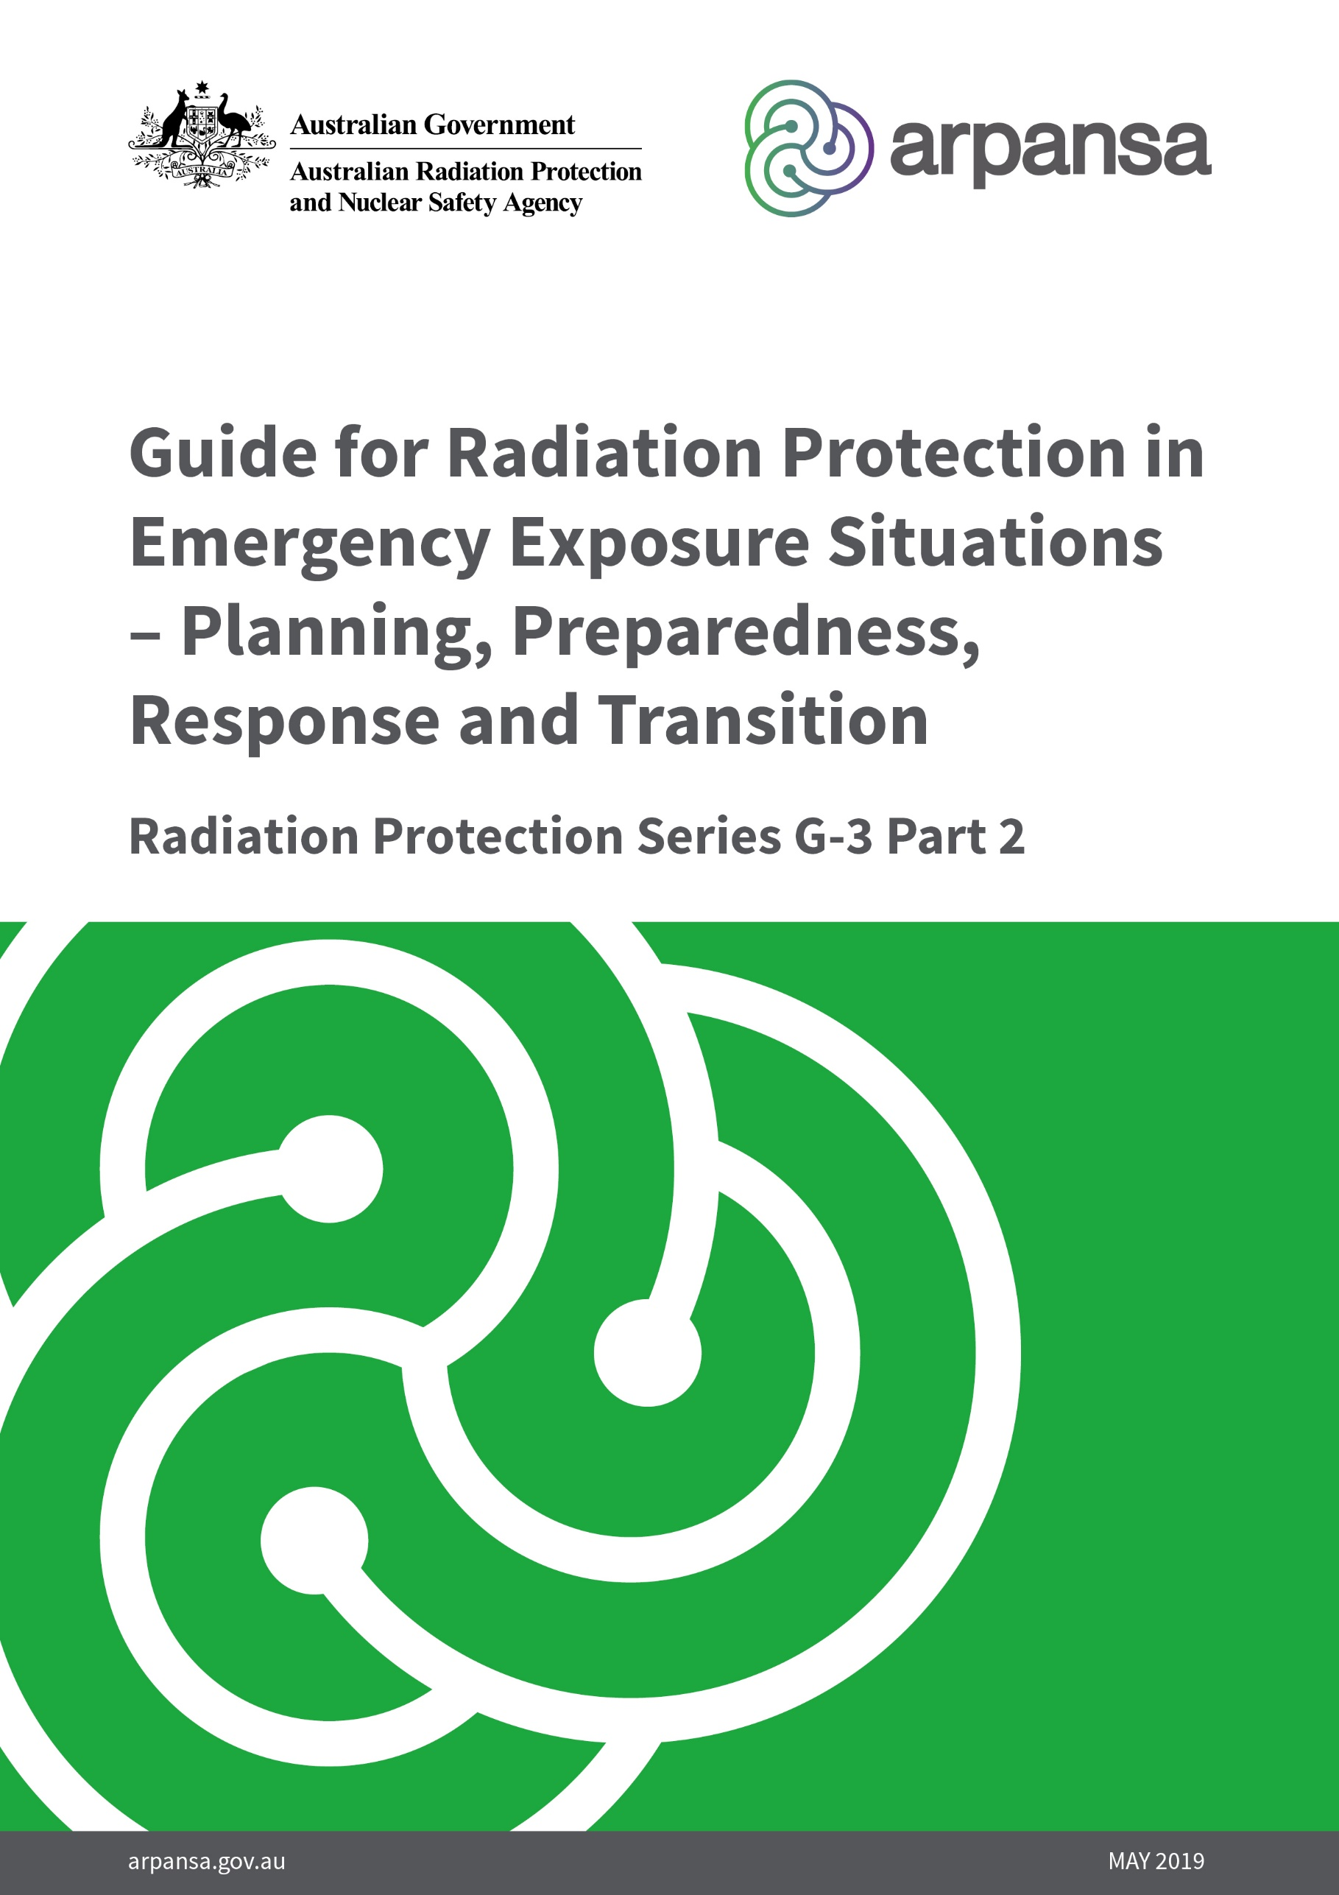

**­Radiation Protection Series**

The Australian Radiation Protection and Nuclear Safety Agency (ARPANSA) publishes Fundamentals, Codes and Guides in the Radiation Protection Series (RPS), which promote national policies and practices that protect human health and the environment from harmful effects of radiation. ARPANSA develops these publications jointly with state and territory regulators through the Radiation Health Committee (RHC), which oversees the preparation of draft policies and standards with the view of their uniform implementation in all Australian jurisdictions. Following agreement and, as relevant, approvals at the Ministerial level, the RHC recommends publication to the Radiation Health and Safety Advisory Council, which endorses documents and recommends their publication by the CEO of ARPANSA.

To the extent possible and relevant for Australian circumstances, the RPS publications give effect in Australia to international standards and guidance. The sources of such standards and guidance are varied and include the International Commission on Radiological Protection (ICRP); the International Commission on Non-Ionizing Radiation Protection (ICNIRP); the International Atomic Energy Agency (IAEA); and the World Health Organization (WHO).

***Fundamentals*** set the fundamental principles for radiation protection and describe the fundamental radiation protection, safety and security objectives. They are written in an explanatory and non-regulatory style and describe the basic concepts and objectives of international best practice.

***Codes*** are regulatory in style and may be referenced by regulations or conditions of licence. They contain either general safety or security requirements which may be applicable for all dealings with radiation, or practice-specific requirements. They provide overarching requirements and are expressed as ‘must’ statements which are to be satisfied to ensure an acceptable level of safety and/or security.

***Guides*** provide recommendations and guidance on how to comply with the Codes or apply the principles of the Fundamentals. They are written in an explanatory and non-regulatory style and indicate the measures recommended to provide good practice. They are generally expressed as ‘should’ statements.

These three categories of publications are informed by public comment during drafting and are subject to a process of assessment of regulatory impact.

All ARPANSA publications (including earlier editions of codes and guides for which ARPANSA is now responsible) are available in electronic format, and can be downloaded free of charge by visiting ARPANSA’s website at [www.arpansa.gov.au/Publications](http://www.arpansa.gov.au/Publications).

Further information can be obtained by telephoning ARPANSA on 1800 022 333 (free call within Australia) or +61 3 9433 2211.

**Guide for Radiation Protection in Emergency Exposure Situations – Planning, Preparedness, Response and Transition**

***Radiation Protection Series G-3 Part 2***

**30 May 2019**

**This publication was prepared jointly with the Radiation Health Committee. The Radiation Health and Safety Advisory Council advised the CEO to adopt the Guide.**

© Commonwealth of Australia 2019

This publication is protected by copyright. Copyright (and any other intellectual property rights, if any) in this publication is owned by the Commonwealth of Australia as represented by the Australian Radiation Protection and Nuclear Safety Agency (ARPANSA).

ISBN 978-0-6483704-5-1

ISSN 1445-9760



**Creative Commons**

With the exception of the Commonwealth Coat of Arms, any ARPANSA logos and any content that is marked as being third party material, this publication, *Guide for Radiation Protection in Emergency Exposure Situations (2019)*, by the Australian Radiation Protection and Nuclear Safety Agency is licensed under a Creative Commons Attribution 3.0 Australia licence (to view a copy of the licence, visit [*http://creativecommons.org/licenses/by/3.0/au*](http://creativecommons.org/licenses/by/3.0/au)). It is a further condition of the licence that any numerical data referred to in this publication may not be changed. To the extent that copyright subsists in a third party, permission will be required from the third party to reuse the material.

In essence, you are free to copy, communicate and adapt the material as long as you attribute the work to ARPANSA and abide by the other licence terms. The works are to be attributed to the Commonwealth as follows:-

“© Commonwealth of Australia 2019, as represented by the Australian Radiation Protection and Nuclear Safety Agency (ARPANSA)”

The publication should be attributed as: Guide for Radiation Protection in Emergency Exposure Situations (2019).

**Use of the Coat of Arms**

The terms under which the Coat of Arms can be used are detailed on the Department of the Prime Minister and Cabinet website ([www.dpmc.gov.au/government/commonwealth-coat-arms](http://www.dpmc.gov.au/government/commonwealth-coat-arms)).

Enquiries regarding the licence and any use of this report are welcome.

ARPANSA  
 619 Lower Plenty Road  
 YALLAMBIE VIC 3085

Tel: 1800 022 333 (Freecall) or +61 3 9433 2211  
  
 Email: [info@arpansa.gov.au](mailto:info@arpansa.gov.au)  
 Website: [www.arpansa.gov.au](http://www.arpansa.gov.au)

Acknowledgement of Country

ARPANSA respectfully acknowledges Australia's Aboriginal and Torres Strait Islander communities and their rich culture and pays respect to their Elders past and present. We acknowledge Aboriginal and Torres Strait Islander people as Australia’s first peoples and as the Traditional Owners and custodians of the land and water on which we rely.

We recognise and value the ongoing contribution of Aboriginal and Torres Strait Islander peoples and communities to Australian life and how this enriches us. We embrace the spirit of reconciliation, working towards the equality of outcomes and ensuring an equal voice.

Foreword

The management of risks from ionising radiation requires actions that are based on fundamental principles of radiation protection, safety and security. The *Fundamentals for Protection Against Ionising Radiation*, Radiation Protection Series (RPS) F-1 (ARPANSA 2014) provides an understanding of the effects of ionising radiation and associated risks for the health of humans and of the environment. As the top tier document in the Australian national framework to manage risks from ionising radiation, RPS F-1 also explains how radiation protection, safety and security can work individually and collectively to manage radiation risks. Finally, it presents ten fundamental principles and outlines how they can be applied in the management of radiation risks.

Exposures to ionising radiation can be incurred under different circumstances. RPS F-1 differentiates between *planned exposure situations* (where management of the exposure can be planned in advance); *existing exposure situations* (an exposure that exists when a decision on its management needs to be taken); and *emergency exposure situation*s arising from loss of control or breakdown of radiation protection, from malicious acts, or from any other unexpected situation that requires urgent action in order to reduce or avoid undesirable consequences.

This *Guide for Radiation Protection in Emergency Exposure Situations - Planning, Preparedness, Response and Transition*, RPS G-3 Part 2, sets out guidance for the planning, preparedness, response and transition required in order to effectively respond to a nuclear or radiological emergency.

The phases of a nuclear or radiological emergency can be distinguished on the basis of the timescales in which protective actions and other response actions are to be undertaken in order to achieve the goals of emergency response. Defining the discrete phases of a nuclear or radiological emergency supports the planning process. This guide provides guidance on the preparedness stage, declaration of an emergency, the emergency response phase, the transition phase and the termination of the nuclear or radiological emergency.

Essential to effective response to a nuclear and radiological emergency is the preparedness stage. It is when protection strategies and arrangements are justified, optimised and established prior to a nuclear or radiological emergency. Regular training, drills and exercises should be conducted to test the effectiveness of the programs to support preparedness and an analysis should be undertaken to incorporate areas identified for improvement.

This guide should be read in combination with the *Guide for Radiation Protection in Emergency Exposure Situations - The Framework,* RPS G-3 Part 1 (ARPANSA 2019) and is intended to be used in conjunction with guidance for planned exposure situations and existing exposure situations. These exposure situations are dealt with by other publications in the Radiation Protection Series.

Carl-Magnus Larsson  
CEO of ARPANSA

30 May 2019

(This page intentionally left blank)

**CONTENTS**

1. Introduction 1

1.1 Citation 1

1.2 Background 1

1.3 Purpose 1

1.4 Scope 1

1.5 Interpretation 2

1.6 Structure 2

2. Phases of an emergency exposure situation 4

3. Planning for a nuclear or radiological emergency 7

3.1 Hazard assessment 10

3.2 Emergency management strategy 11

3.3 Establishing emergency planning zones off-site 11

3.4 Establishing emergency planning zones for a criticality accident 15

4. Preparedness for a nuclear or radiological emergency 17

4.1 Plans and procedures 17

4.2 Designation of organisations and personnel 18

4.3 Training, drills and exercises 21

4.4 Logistical support and facilities 21

4.5 Quality management system 21

5. Response during a nuclear or radiological emergency 24

5.1 Declaration of a nuclear or radiological emergency 26

5.2 Emergency response phase 28

6. Transition from a nuclear or radiological emergency 35

6.1 Transition phase 35

7. Termination phase 39

7.1 Prerequisites to terminate the emergency 39

8. Medical response 42

9. Radioactive waste management 44

10. Communication during an emergency 46

Annex A: Operational criteria – Default operation intervention levels (OILs), observables   
and response time objectives (RTOs) 48

Annex B: Emergency action levels (EALs) and other observable indicators 58

Annex C: Effects of radiation 61

References 62

Contributors to drafting and review 65

# Introduction

## Citation

This publication may be cited as the *Emergency Exposure Guide - Planning, Preparedness, Response and Transition* (2019).

## Background

The International Commission on Radiological Protection (ICRP) in its *2007 Recommendations of the International Commission on Radiological Protection*, ICRP Publication 103 (ICRP 2007), take a consistent approach for all types of ionising radiation exposure situations (planned, emergency and existing exposure situations), with the central consideration being the optimisation of radiation protection.

This guide applies to emergency exposure situations and aims to promote the implementation of the relevant requirements of the International Atomic Energy Agency (IAEA) General Safety Requirements No. GSR Part 3, *Radiation Protection and Safety of Radiation Sources: International Basic Safety* (IAEA 2014), and the IAEA General Safety Requirements No. GSR Part 7, *Preparedness and Response for a Nuclear or Radiological Emergency* (IAEA 2015a).

## Purpose

The purpose of this guide is to provide recommendations on the planning, preparedness, response and transition required in order to effectively respond to a nuclear or radiological emergency, to mitigate and minimise the consequences of emergencies, including impact on health[1], and for protection of occupationally exposed persons, members of the public and the environment from the harmful effects of ionising radiation in emergency exposure situations.

It is intended that the relevant regulatory authorities and response organisations around Australia will use this document in conjunction with the *Guide for Radiation Protection in Emergency Exposure Situations - The Framework*, RPS G-3 Part 1 (ARPANSA 2019) to guide their actions for preparedness and response in emergency exposure situations.

## Scope

This guide applies to emergency exposure situations and covers:

* recommendations on planning, preparedness, response and transition activities that should be undertaken when preparing for or during a nuclear or radiological emergency. It therefore considers all hazard types in Australia regardless of potential consequences
* preparedness and response for a nuclear or radiological emergency in relation to all those facilities and activities, as well as sources, with the potential for causing radiation exposure, environmental contamination or concern on the part of the public warranting protective actions and other response actions
* adoption of graded approach, consistent with the inherent radiological hazard posed by a particular radioactive source of facility containing radiological material
* preparedness and response for a nuclear or radiological emergency in relation to off-site jurisdictions, who may need to take protective actions and other response actions
* preparedness and response for a nuclear or radiological emergency irrespective of the initiator of the emergency; whether the emergency follows a natural event, a human error, a mechanical or other failure, or a nuclear security event. Such security events include, but are not limited to, criminal or intentional unauthorised acts involving or directed at nuclear or radiological material, associated facilities or associated activities.

This guide applies to the protection of people in an emergency, and does not provide advice on the protection of non-human biota (i.e. wildlife or domestic animals). Calculation of dose rate to wildlife during emergency exposure situations is considered in the *Guide for Radiation Protection of the Environment*, RPS G-1 (ARPANSA 2015).

## Interpretation

This guide is explanatory in nature and provides guidance on radiation protection and emergency planning and response considerations, based on international best practice that should be implemented by relevant parties where appropriate and/or practicable. A graded approach should be adopted, consistent with the inherent radiological hazard posed by a particular radioactive source or facility containing radioactive material.

This guide will use the generic term emergency throughout which may be interpreted in reference to a nuclear or radiological incident, accident or event.

This guide should be used in conjunction with the following publications:

* *Guide for Radiation Protection in Emergency Exposure Situations - The Framework*, RPS G-3 Part 1 (ARPANSA 2019)
* *Code for Radiation Protection in Planned Exposure Situations*, RPS C-1 (ARPANSA 2016)
* *Guide for Radiation Protection in Existing Exposure Situations*, RPS G-2 (ARPANSA 2017)
* *Fundamentals for Protection Against Ionising Radiation*, RPS F-1 (ARPANSA 2014).

## Structure

This guide consists of:

* Section 1: background, purpose and scope
* Section 2: arrangements for an emergency exposure situations
* Section 3: planning for a nuclear or radiological emergency
* Section 4: preparedness for a nuclear or radiological emergency
* Section 5: response during a nuclear or radiological emergency
* Section 6: transition from a nuclear or radiological situation
* Section 7: terminating nuclear or radiological emergency
* Section 8: medical response during a radiological or nuclear emergency
* Section 9: radioactive waste management during a radiological or nuclear emergency
* Section 10: communicating during a radiological or nuclear emergency
* Annex A: default operation intervention levels, observables and response time objectives
* Annex B: emergency action levels and observable indicators during a response
* Annex C: health risks associated with exposure to radiation.

Explanations of technical terms used in this guide are provided in the Glossary. Publications underpinning this guide are listed in the References section.

# Phases of an emergency exposure situation

The phases of a nuclear or radiological emergency can be distinguished on the basis of the timescales in which protective actions and other response actions are to be undertaken in order to achieve the goals of emergency response and to fulfil the prerequisites that would allow the declaration of the end of the emergency.

Defining discrete phases of a nuclear or radiological emergency supports the planning process. These efforts depend on the characteristics of each phase, subject to the information available and the specific activities to be carried out (see Figure 2.1).

The *preparedness stage* is when arrangements for an effective emergency response are established prior to a nuclear or radiological emergency. These arrangements include the development of a hazard assessment and a protection strategy. Hazard assessments identify potential consequences of an emergency and provide a basis for establishing arrangements for preparedness and response for a nuclear or radiological emergency. Assessed hazards are grouped in accordance with the categories described in Table 3.1 of RPS G-3 Part 1 (ARPANSA 2019). The five emergency preparedness categories in this table establish the basis for a graded approach to the application of this guidance. Protection strategies are developed, justified and optimised at the preparedness stage for taking protective actions and other response actions. These strategies are needed for planning and executing effective communication during a nuclear or radiological emergency. Annex C in RPS G-3 Part 1 (ARPANSA 2019) provides the Australian framework for preparedness and response applicable to a nuclear or radiological emergency.

The *declaration of an emergency* is when a nuclear or radiological emergency is identified and the activation of emergency response plans and arrangements, which have been established at the preparedness stage, begins.

The *emergency response phase* is the period of time from the declaration of an emergency until the completion of all actions taken in anticipation of, or in response to, the radiological conditions expected during the emergency. This phase typically ends when the situation is under control, and the off-site radiological conditions have been characterised sufficiently well that all protective measures, such as food restrictions and temporary relocations, have been implemented. While the distinction between various phases of a nuclear or radiological emergency may be helpful for planning purposes, it can be difficult to clearly define the delineation of the different phases of an emergency during the emergency response as the emergency response actions are implemented on a continuous basis.

The *transition phase* is the period following the emergency response phase, when the situation is under control, detailed characterisation of the radiological situation has been carried out and activities are planned and implemented in order to enable the emergency to be declared terminated. For example, the transition phase may last only a few days for small scale emergencies (e.g. short-term loss of control of a hazardous radioactive source) but could take months or years for large scale emergencies (e.g. emergencies at nuclear installations resulting in significant off-site contamination).

The *termination of the nuclear or radiological emergency* marks the end of the transition phase in a particular area or site and the beginning of an existing exposure situation or a return to a planned exposure situation.

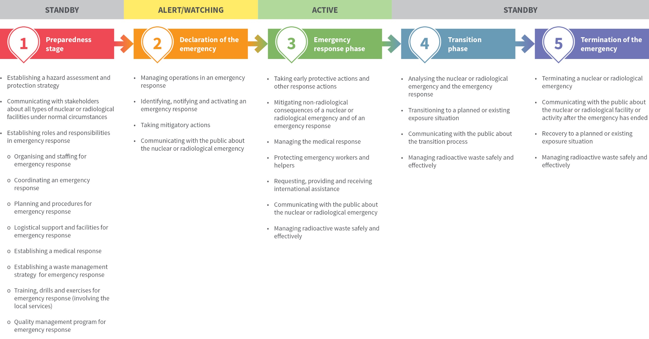

**Figure 2.1:** Phases of an Emergency Exposure Situation as documented in this Guide and an example of their alignment with phases of an emergency response plan.

# Planning for a nuclear or radiological emergency

In Australia, the planning and preparedness for response to a nuclear or radiological emergency should be integrated with the all-hazard planning framework and should fully involve the national, State, Territory and local organisations that respond to conventional emergencies such as those due to fires, floods, earthquakes, tsunamis and cyclones/storms. Since an emergency may involve criminal activity such as terrorism or theft, preparations should also involve law enforcement agencies. Annex C in RPS G-3 Part 1 (ARPANSA 2019) provides the Australian framework for preparedness and response applicable to radiation or nuclear events.

Defining the phases of a nuclear or radiological emergency is intended to support the planning and preparedness stages. The phases of a nuclear or radiological emergency are distinguished on the basis of:

* the different timescales in which specific protective actions are implemented
* response actions to be undertaken in order to achieve the goals of emergency response and to fulfil the prerequisites that would allow the declaration of the end of the emergency.

The sequence of the phases of a nuclear or radiological emergency is illustrated in Figure 3.1.

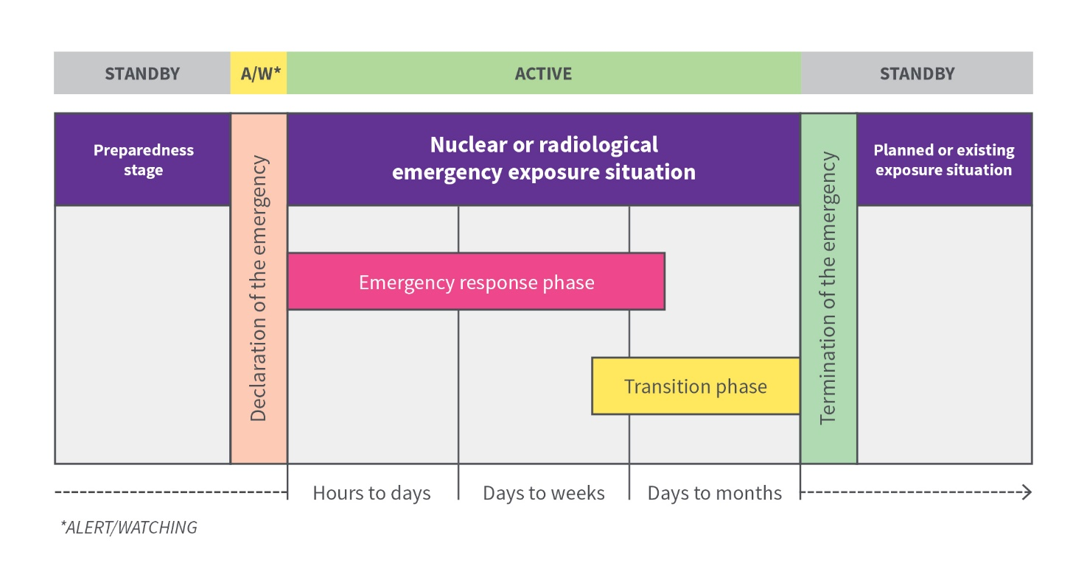

**Figure 3.1**: Temporal sequence of emergency phases and exposure situations of a nuclear or radiological emergency within one geographical area/site. Adapted from IAEA 2018.

The planning stage should consider a safety and security analysis in conjunction with a consequence analysis as part of a hazard assessment to determine the outcomes required in a protection strategy for a response to a nuclear or radiological emergency (IAEA 2015b, IAEA 2015c, ARPANSA 2001).

The planning and preparedness stages need to consider plans, procedures, arrangements, hazards and threat assessments, training and exercises to facilitate an effective response to nuclear and radiological emergencies. Figure 3.2 illustrates a systematic way for identifying risks associated with facilities, activities, sources or materials for inclusion in the emergency management strategy (see Section 3.2).

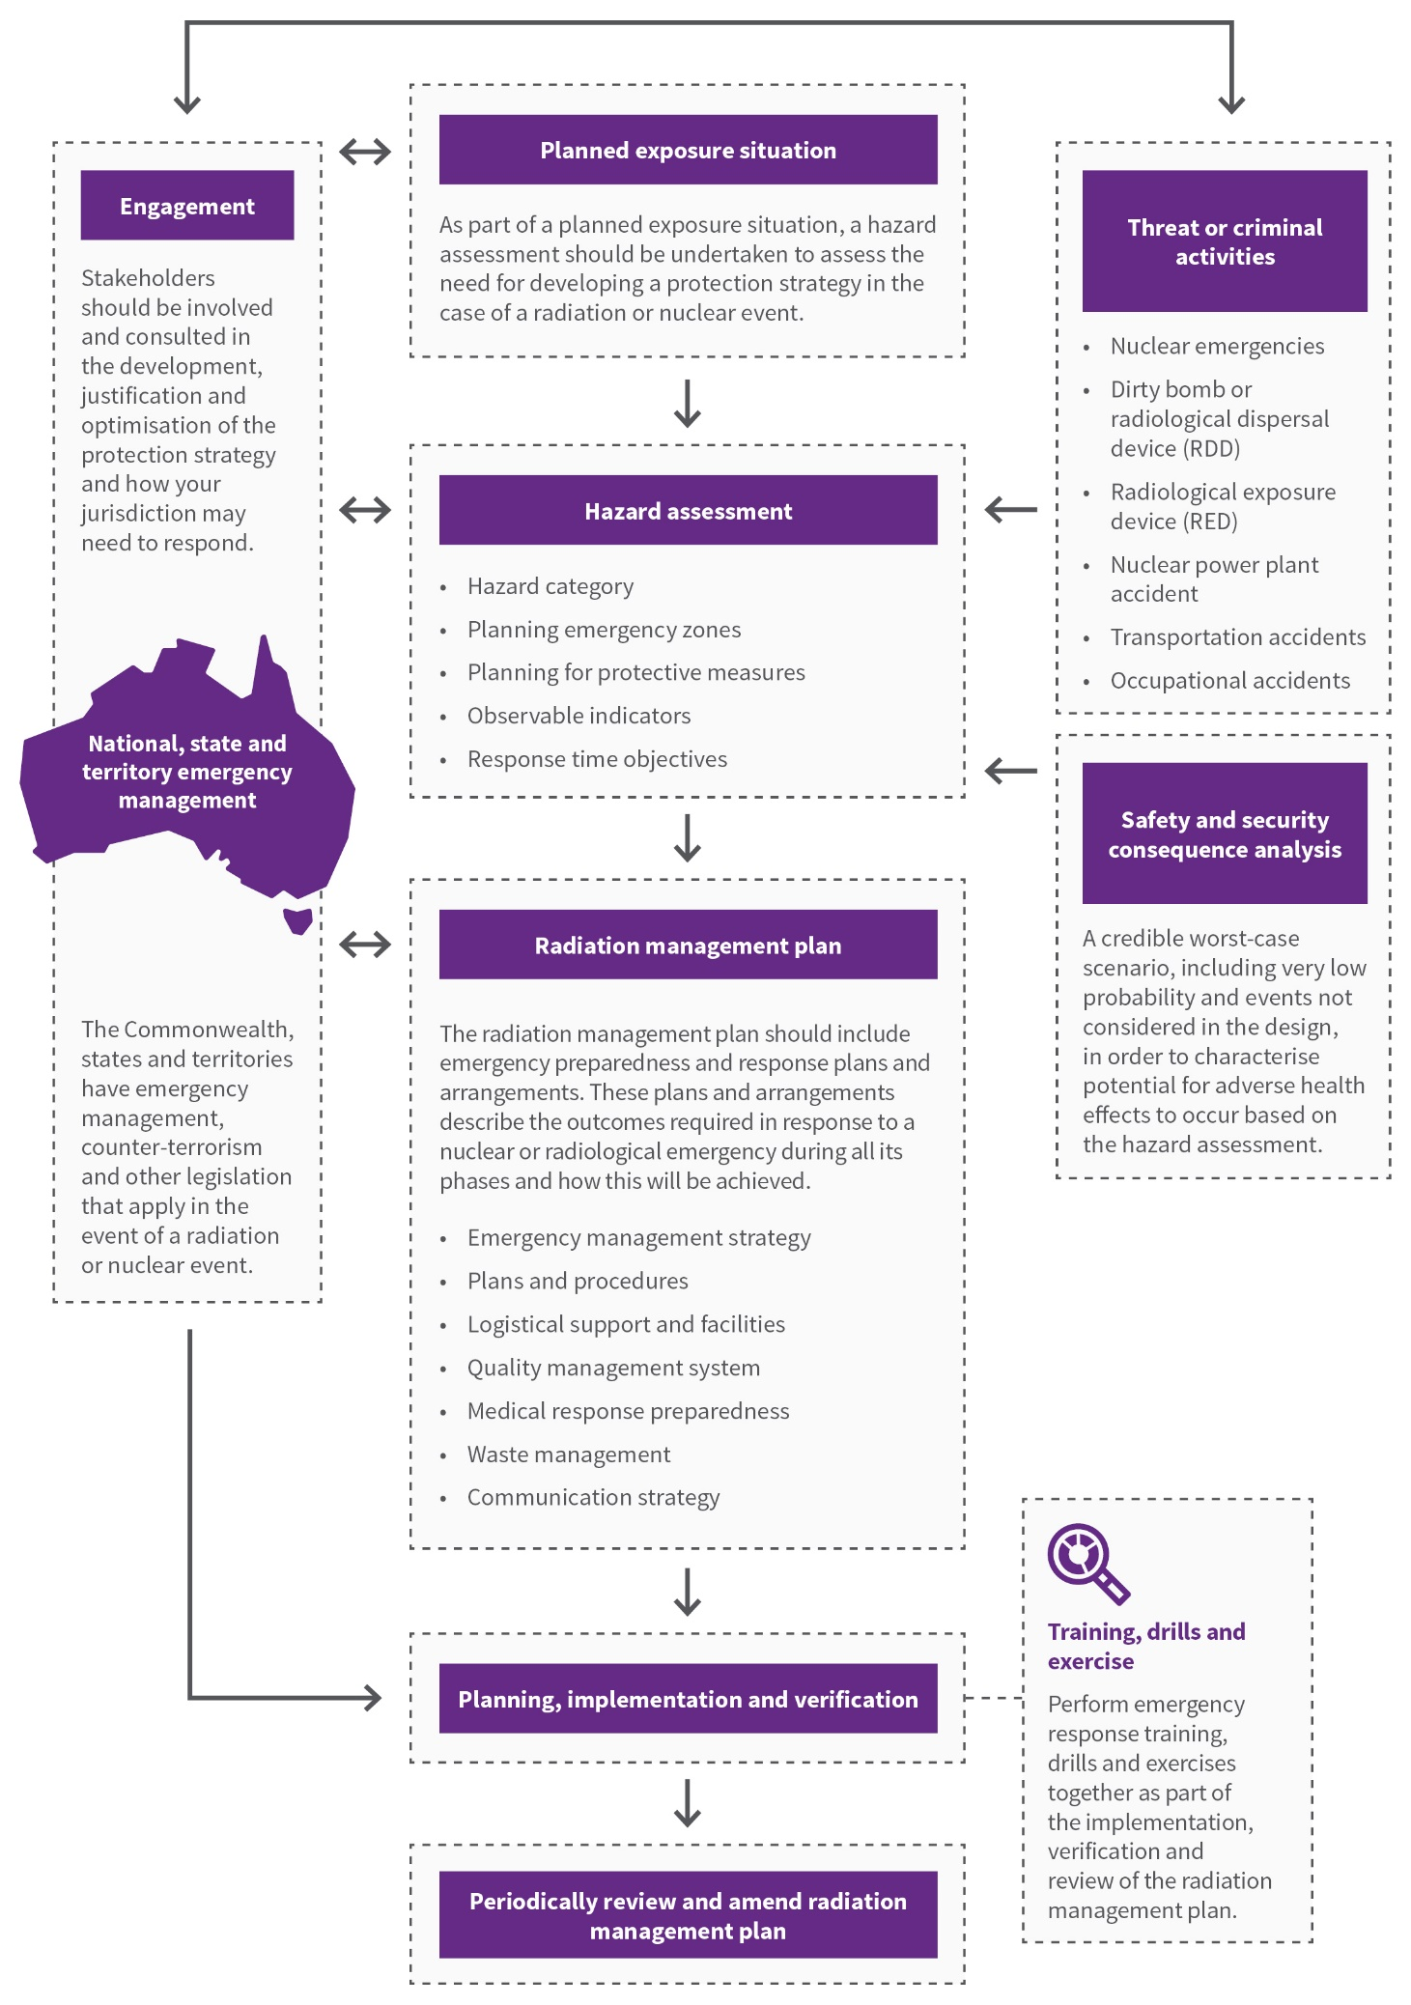**Figure 3.2:** A systematic way for identifying risks associated with facilities, activities, sources or materials.

## Hazard assessment

A hazard assessment is an evaluation of hazards associated with facilities, activities, sources or materials within or beyond the site boundary in order to identify:

* those events and the associated areas for which protective actions and other response actions may be required
* actions that would be effective in mitigating the consequences of such events.

A hazard assessment should be carried out in order to provide a basis for developing generic arrangements in the preparedness and response for a nuclear or radiological emergency that are justified and can be optimised, and are consistent with the five emergency preparedness categories described in Table 3.1 of RPS G-3 Part 1 (ARPANSA 2019).

The hazard assessment for all identified facilities and activities, on-site areas, off-site areas and locations for which a nuclear or radiological emergency could warrant taking protective actions and other response actions, should include the detailed characterisation at all levels of the following:

* consequences based on a credible worst-case scenario[2]:
  + source terms expected
  + mechanism of release into the environment
  + population and areas (including infrastructure) affected, including detailed characterisation of at risk groups and the use of land and water surfaces
  + exposure scenario, including dominant exposure pathways and period of exposure
  + projected doses (for all potentially affected populations) and associated health hazards
  + other non-radiological impact on the economy and society
  + estimated time for declaring the emergency terminated.
* resources (human, technical, financial) and infrastructure available
* applicable legislative framework in areas relevant to the termination of an emergency.

The responsible organisations and operating organisations should use the hazard assessment and the postulated nuclear or radiological emergencies associated with a facility or activity to anticipate the level of response that is warranted. The process undertaken involves assessment of the likelihood and possible consequences of, and the level of risk associated with, a loss of control based on the credible worst-case scenario to determine which emergency preparedness category described in Table 3.1 of RPS G-3 Part 1 (ARPANSA 2019) the facility, activity or source falls under.

The insights gained through the hazard assessment should be used for the identification of options and limitations of specific emergency arrangements in consideration of:

* an inability to accurately predict when, where and what the actual impact of a range of postulated nuclear or radiological emergencies might be
* the complexity of potential recovery efforts
* the potential impact of non-radiological factors, such as public concerns and the political situation, on decision making at the time of the emergency.

## Emergency management strategy

The emergency management strategy needs to be implemented for each facility, activity, source or material. It should take into account the national protection strategy (see Section 2.6 in RPS G-3 Part 1 (ARPANSA 2019). The emergency management strategy should be developed to address the key responsibilities from the operator, local officials and jurisdictional officials.

The emergency management strategy should be developed to address, but not be limited to, the following scenarios:

* emergencies at facilities with large amounts of spent fuel or dispersible radioactive material, where the primary risk comes from atmospheric releases
* emergencies at facilities with the potential for off-site releases where doses from criticalities are not predictable with any accuracy and the release could result in very complex dose patterns and contamination off-site
* emergencies at facilities where an emergency that may occur with little warning could result only in significant exposure on-site
* emergencies involving sources, transport, severe overexposure and terrorist threats or criminal activities.

Capabilities should be developed to address the arrangements required to respond to an emergency which include, but are not limited to, plans, procedures, staff, organisation, facilities, equipment and training.

The development of an emergency management strategy should involve stakeholders in order to allow for a common understanding. Broad consultation will enhance the acceptability and feasibility, and ensure any associated practicalities are considered in the development of the strategy. This requires that stakeholders are involved and consulted, as appropriate, in the development, justification and optimisation of the emergency management strategy.

The material in this guide should be integrated with the national and local arrangements in the jurisdiction in which it will be used.

## Establishing emergency planning zones off-site

When planning for emergencies involving radiation exposure, a series of emergency zones should be established around any facility, activity, source or material. The size of these emergency zones are derived from the hazard assessment and protection strategy, e.g. the type of emergency, the magnitude of risk and the nature of the response.

Emergency Planning Zones and Emergency Planning Distances for emergencies involving radiation exposure can be categorised into the following:

* precautionary action zone (PAZ)
* urgent protective action planning zone (UPZ)
* extended planning distance (EPD)
* ingestion and commodities planning distance (ICPD).

These emergency zones and distances are illustrated in Figure 3.3.

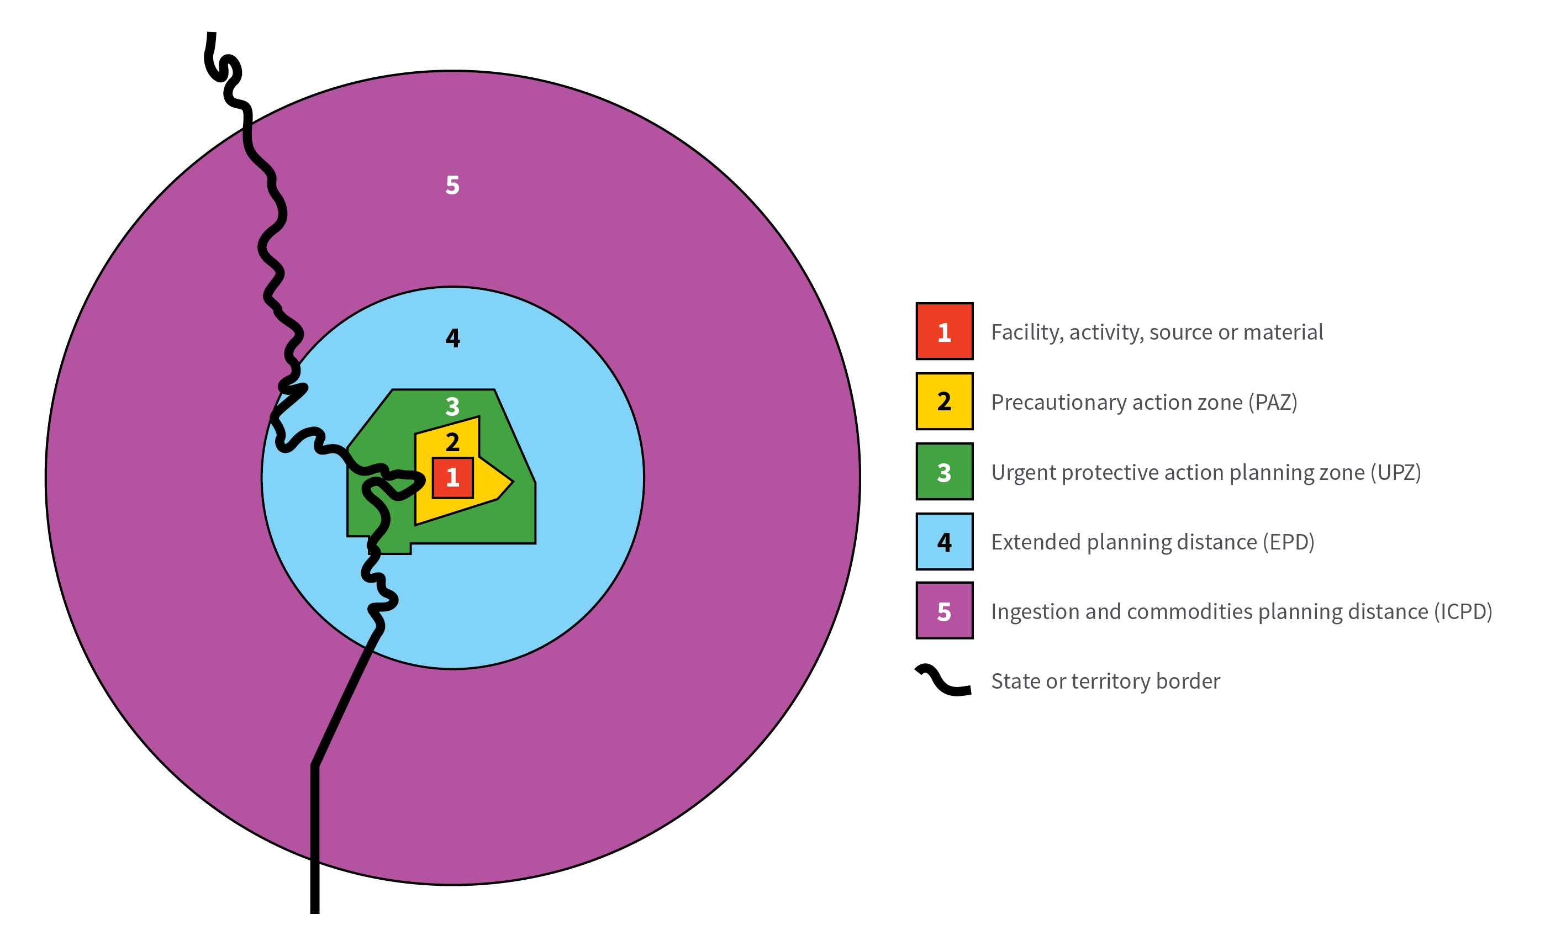

**Figure 3.3:** Emergency planning zones and distances. Adapted from IAEA 2013a.

### Precautionary action zone (PAZ)[3]

A PAZ is an area around a facility for which emergency arrangements have been made to take precautionary urgent protective actions. These precautionary urgent protective actions (see Section 5.2.2) should be implemented:

* before any significant release of radioactive material occurs, based on conditions (emergency action levels (EALs) and observables – see Annex B) at the facility, activity, source or material.

Precautionary urgent protective actions are implemented in order to avoid or to minimise severe tissue reactions off-site. Figure 3.4 demonstrates the protective actions to be taken in the PAZ.

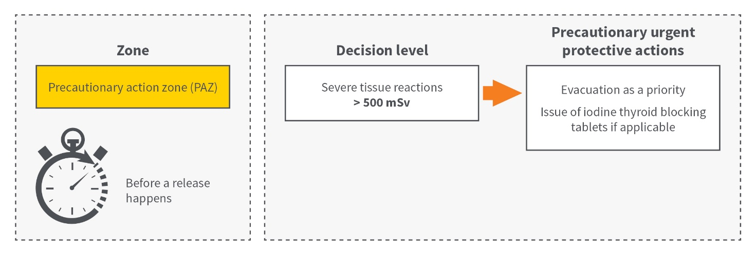

**Figure 3.4:** Precationary urgent protective actions to be taken in the PAZ. Consequences are based on a credible worst-case scenario.

### Urgent protective action planning zone (UPZ)

An UPZ is an area around a facility, activity, source or material for which arrangements have been made to initiate urgent protective actions and other response actions. These urgent protective actions (Section 5.2.2) should be initiated:

* before any significant release of radioactive material occurs based on conditions (EALs and observables – see Annex B) at the facility, activity, source or material  
  or
* after a release occurs, based on monitoring and assessment of the radiological situation off-site OILs.

Urgent protective actions are implemented in order to reduce the risk of stochastic effects. Any such actions should be undertaken in a manner that does not delay the implementation of precautionary urgent protective actions and other response actions within the PAZ. Figure 3.5 demonstrates the protective actions to be taken in the UPZ.

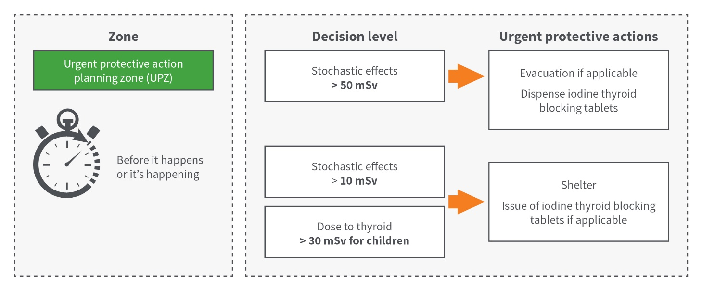

**Figure 3.5:** Urgent protective actions to be taken in the UPZ.

### Extended planning distance (EPD)

An EPD is an area around a facility, activity, source or material, which is classified as an emergency preparedness category I or II (see Table 3.1 in RPS G-3 Part 1 (ARPANSA 2019)). An EPD is a zone beyond the urgent protective action planning zone for which emergency arrangements are made to conduct monitoring and assessment of the radiological situation off-site.

Monitoring of the EPD should occur within a day to a week or to a few weeks following a significant radioactive release in order to identify areas that would allow the risk of stochastic effects among members of the public to be effectively reduced by taking protective actions and other response actions.

The area within the EPD serves for planning purposes only and may not be the actual area in which monitoring is to be conducted. While efforts need to be made at the preparedness stage to prepare for taking effective early protective actions within this area, the actual area will be determined by the prevailing conditions in an emergency. Figure 3.6 demonstrates the emergency arrangements to be taken in the EPD.

As a precaution, some urgent protective actions may be warranted within the EPD to reduce the risk of stochastic effects among members of the public release (see Section 5.2.2).

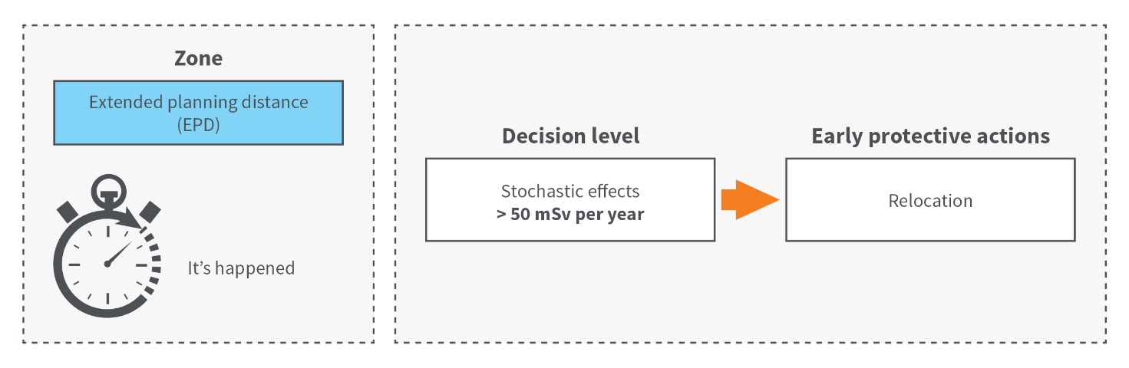

**Figure 3.6:** Example of emergency arrangements to be taken in an EPD.

### Ingestion and commodities planning distance (ICPD)

An ICPD is an area around a facility, activity, source or materials, which is classified as an emergency preparedness category I or II (see Table 3.1 in RPS G-3 Part 1 (ARPANSA 2019)). An ICPD is a zone beyond the EPD for which arrangements are made to take effective emergency response actions for:

* protecting the food chain and water supply as well as for protecting commodities other than food from contamination following a significant radioactive release
* protecting the public from the ingestion of food, milk and drinking water and from the use of commodities other than food with possible contamination following a significant radioactive release.

The area within the ICPD is used to prepare for monitoring and control of commodities including food, either for domestic use or for international trade, should an emergency response be triggered. The actual area will be determined on the basis of the prevailing conditions in the emergency. Figure 3.7 demonstrates the emergency arrangements to be taken in the ICPD.

As a precaution, some urgent protective actions may be warranted within the ingestion and commodities planning distance to prevent the ingestion of food, milk or drinking water and to prevent the use of commodities that may have been contaminated following a significant radioactive release (see Section 5.2.2).

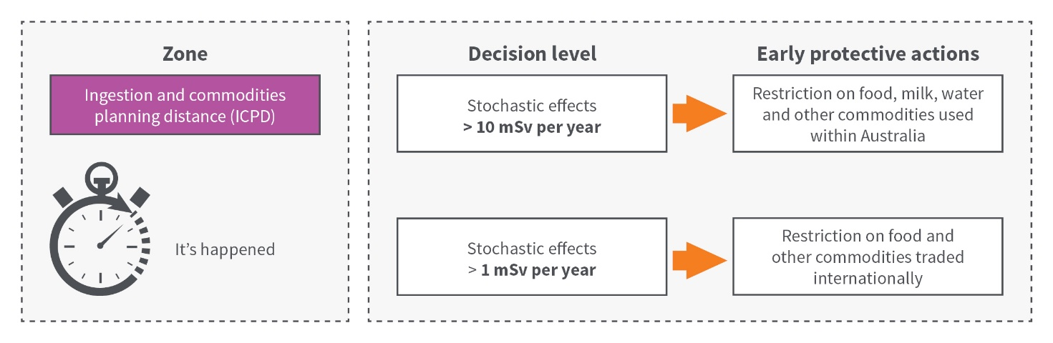

**Figure 3.7:** Emergency arrangements to be taken in an ICPD.

## Establishing emergency planning zones for a criticality accident

The measures to ensure criticality safety in facilities where fissile material is handled, processed, used or stored are required to be based on the concept of defence in depth. Two vital parts of this concept are passive safety features and fault tolerance. To ensure safety, the design should be such that a failure occurring anywhere within the safety systems provided to carry out each safety function will not cause the system to achieve criticality. For criticality safety, the double contingency principle is the preferred means of ensuring fault tolerance. The double contingency principle calls for the design process to include sufficient safety factors to require at least two unlikely, independent and concurrent changes in process conditions before a criticality accident is possible.

Facilities or operations where there is a risk of exceeding sufficient quantities of nuclear material for fission will need to consider criticality detection and alarm systems to initiate immediate evacuation[4]. For criticality accident response planning the following additional elements need to be considered and are based on *Nuclear Criticality Accident Emergency Planning and Response*, ANSI/ANS-8.23-2007 (ANSI 2012):

* potential criticality accident locations and predicted accident characteristics need to be evaluated and documented in sufficient detail to assist emergency planning and should include the estimated fission yield, and the likelihood of recurrence of criticality
* an immediate evacuation zone needs to be established based on the documented evaluation. Shielding may be considered in establishing the immediate evacuation zone. The localised effects of a criticality accident, and the fact that rapid evacuation is not without risk, may result in an immediate evacuation zone that is significantly smaller than the entire site.

# Preparedness for a nuclear or radiological emergency

The preparedness stage is when emergency arrangements for an effective emergency response are established and tested.

## Plans and procedures

Effective response to a nuclear or radiological emergency requires the development, establishment and maintenance of an effective emergency management system.

At the preparedness stage, plans, procedures, arrangements, hazards and threat assessments, training and exercises are essential to facilitate an effective response to nuclear and radiological emergencies.

An emergency plan should be developed and be aligned with the Radiation Management Plan (RMP) outlined in RPS C-1 (ARPANSA 2016) and any other relevant plans for emergency response in a coordinated manner consistent with an all-hazards approach. Emergency plans should specify how responsibilities for managing operations in an emergency response are to be discharged on-site, off-site and across state borders, as appropriate. The emergency plans should be coordinated with other plans and procedures that may be implemented in a nuclear or radiological emergency, to ensure that the simultaneous implementation of the plans would not reduce their effectiveness or cause conflicts. Such other plans and procedures include:

* emergency plans for facilities, activities, sources and materials
* security plans and contingency plans
* procedures for the investigation of a security event, including identification, collection, packaging and transport of evidence contaminated with radionuclides, nuclear forensics and related activities
* evacuation plans
* plans for firefighting.

Emergency response plans for circumstances where an emergency may result in exposure to high doses of radiation or severe contamination of the environment should include provision for:

* access to appropriate medical care of exposed persons
* identifying the roles and functions of relevant organisations that will be involved
* the availability of personnel trained to deal with the situation
* the availability of appropriate emergency equipment
* specified procedures to bring the situation under control
* specified measures to mitigate the impacts of the emergency
* necessary equipment, methodologies and procedures for assessment of doses received as a consequence of the emergency
* arrangements with relevant first responders and rescue services
* information to the occupationally exposed persons on site
* providing relevant information to the public
* appropriate counselling to any person affected
* acquiring information for assessing the cause of the emergency
* classifying the emergency
* reporting the emergency to line management and regulatory authorities
* consideration of non-radiological consequences of the emergency in the context of possible evacuation of the workplace
* conditions, criteria and objectives to be met for declaring the emergency terminated.

Emergency response plans for facilities, activities, sources or materials need to consider emergency action levels (EALs) or other observable conditions and response time objectives (RTOs). EALs should be predefined and are related to abnormal conditions for a facility or practice. RTOs should be predefined and activated on selected critical response functions or tasks for facilities in emergency preparedness categories I, II and III.

Emergency plans are also necessary for the development of an effective public communications strategy and program (see Section 10). In order to be effectively implemented, emergency medical response (see Section 8) needs to be planned and organised in accordance with the potential consequences of different radiation emergencies. Arrangements should be made, as part of overall emergency preparedness, to address the expected issues and challenges in radioactive waste management following the emergency (see Section 9).

The emergency plans, procedures and other arrangements for the transition phase should be developed by all relevant organisations in a manner that would allow for the effective implementation of the management strategy, which includes considerations for meeting relevant clauses in Section RPS G-3 Part 1 (ARPANSA 2019) and taking into account the results from the hazard assessment.

## Designation of organisations and personnel

Plans and procedures should clearly describe the roles and responsibilities of all stakeholders during all phases of an emergency and beyond. These should account for any changes in the authority and discharge of responsibilities between different phases, the triggering mechanism of this change, the coordination arrangements, the decision-making processes and criteria, and the staffing resources required. The type of data and information that needs to be transferred or made accessible to stakeholders and the arrangements and mechanisms for distributing this data should also be considered.

Roles, responsibilities and coordination of the various organisations (e.g. operating organisations, response organisations and the relevant authority) who will be involved in emergency response should be planned and defined in advance. These arrangements should be consistently reflected in all relevant organisational, local and national emergency plans.

Efforts should be made to assess hazardous conditions in which emergency work might be undertaken and designate emergency workers at the preparedness stage. Designation of emergency workers provides the basis for an adequate discharge of rights, duties, responsibilities and commitments when needed.

Arrangements should also be established to register and integrate into emergency response organisations those emergency workers and helpers who were not designated prior to an emergency.

Emergency workers may include workers employed, both directly and indirectly, by an operating organisation, as well as personnel of response organisations, such as police officers, firefighters, medical personnel, and drivers and crews of vehicles used for evacuation.

Members of the public who willingly and voluntarily help in the response to a nuclear or radiological emergency are known as helpers. These volunteers are to be made aware that they could be exposed to radiation while helping in response to a nuclear or radiological emergency.

The following four groups of workers may be exposed in a nuclear or radiological emergency, owing either to their involvement in the emergency response or to the nuclear or radiological emergency at a facility or an activity:

1. emergency workers who have specified duties
2. workers performing their duties in workplaces and not being involved in the response to a nuclear or radiological emergency
3. workers who are requested to stop performing their duties in workplaces and leave the site
4. workers who are accidentally exposed as a result of an accident or other incident at a facility or during the conduct of an activity and whose exposure is not related to the emergency response.

Groups b), c) and d) do not have a role in emergency response, and are classified as members of the public during the emergency. The national reference level of 50 mSv is applied for protective actions, as defined in in Section 2.6.1 of RPS G-3 Part 1 (ARPANSA 2019).

The group of emergency workers specified in (a) can be further divided into three categories of emergency worker:

* **Category 1:** Emergency workers undertaking mitigatory actions and urgent protective actions on‑site, including lifesaving actions, actions to prevent serious injury, actions to prevent the development of catastrophic conditions that could significantly affect people and the environment, and actions to prevent severe tissue reactions. Emergency workers in Category 1 are required to be designated at the preparedness stage. They are likely to be operating personnel at the facility or undertaking the activity, but they may be personnel from the emergency services. They should receive training in occupational radiation protection. Category 1 designated workers may receive a dose of up to the national reference level of 50 mSv when implementing protective actions and other response actions. They may also receive a dose of up to 500 mSv for life saving actions, to prevent the development of catastrophic conditions and to prevent severe tissue reactions.
* **Category 2:** Emergency workers and helpers undertaking urgent and/or early protective actions (see Section 5.2) during the emergency response phase. They include police, firefighters, medical personnel, drivers, crews of evacuation vehicles and other emergency workers not designated under Category 1. Every effort should be made to designate emergency workers in Category 2 at the preparedness stage – this category includes the majority of emergency workers. They are to have pre-specified duties in an emergency response and should receive training in occupational radiation protection on a regular basis as first responders, even if not normally considered to be occupationally exposed to radiation. Category 2 designated workers may receive a dose of up to the national reference level of 50 mSv, consistent with members of the public during a nuclear or radiological emergency.
* **Category 3:** Emergency workers undertaking long-term recovery operations during transition and/or termination phases and beyond. Emergency workers in Category 3 may be designated at the preparedness stage. They should be considered to be occupationally exposed to radiation and should receive relevant training, including training in radiation protection. Category 3 workers may receive a dose of 20 mSv (averaged over 5 consecutive years), consistent with the dose limit allowed during a planned exposure situation as specified in RPS C-1 (ARPANSA 2016).

Doses for the three categories of emergency worker are summarised in Table 4.1. It should be noted that doses are, in most cases, expected to be optimised below the guideline values stated for planning.

Any limit in the duration of work undertaken by emergency workers and any conditions under which they will conduct the work should be applied by planning the emergency work on the basis of guidance values of dose.

Workers should not normally be precluded from incurring further occupational exposure because of doses received in an emergency.

Table 4.1: Summary of the relationship between individuals in the three emergency worker categories with recommended dose allowances.

|  |  |  |  |  |
| --- | --- | --- | --- | --- |
| Category | | Activity | Dose | Dose classification |
| **1** | | Applied to emergency workers involved in urgent protective actions – including life‑saving, and prevention of serious injury or development of catastrophic conditions | 500 mSv | Guidance value |
| **2** | | Applied to most emergency workers and all helpers, and members of the public in an emergency exposure situation | 50 mSv | National reference levela |
| **3** | | Long-term recovery operations | 20 mSvb | Occupational dose limitc |
| a. | See Section 2.6.1 in RPS G-3 Part 1 (ARPANSA 2019). | | | |
| b. | Averaged over 5 consecutive years. | | | |
| c. | See RPS C-1 (ARPANSA 2016). | | | |

## Training, drills and exercises

Regular training, drills and exercises should be conducted to test the effectiveness of the programs and an analysis should be undertaken to incorporate areas identified for improvement.

In effects-based training frameworks, drills are practiced in order to embed specific skills. Training is conducted through the use of multiple skills to achieve an effect. Exercises are multiple effects in order to achieve the specific goals of emergency response.

For example, ‘donning personal protective equipment (PPE)’ is a skill, ‘donning PPE, entering a contaminated area, using detectors to safely search for a victim’ is an effect, ‘searching for a victim and recovering them safely (multiple effects)’ achieves a goal of emergency response.

The training programs developed in the area of emergency preparedness and response at different levels and for all phases (e.g. emergency, transition and termination phase) should consider the personnel that will participate in the training and re-training. These programs should also consider the level of training (duration, frequency, type and format, performance review, etc.) warranted for the personnel carrying out the different activities for each phase.

The exercise programs developed and implemented to systematically test the overall adequacy and effectiveness of the emergency arrangements should include the objective of facilitating the timely resumption of normal social and economic activity. These exercises should include the participation of the relevant organisations and be tested within an agreed timeframe (once every three to five years). Small scale exercises (e.g. table top exercises) should also be designed and used frequently to test various aspects of the emergency, transition and termination phase within an organisation at the facility, local, regional or national levels. These aspects can include coordination, transfer of information and data, changes in authority, discharge of responsibilities and decision-making processes.

As part of the management system, training, drill and exercise programs should be evaluated, and areas of improvement should be identified. The feedback from this evaluation should be used for review and, as necessary, revision of the emergency arrangements for the emergency, transition and termination phases.

## Logistical support and facilities

Adequate logistical support and facilities should be provided to enable emergency response functions to be performed effectively during each phase.

The logistical support and facilities required should be identified and selected in consideration of the activities necessary to be carried out during each phase to meet response objectives. Arrangements for the acquisition, deployment and mobilisation of logistical support should be established and communicated with the stakeholders at the preparedness stage.

## Quality management system

A quality management program should be established and integrated into the emergency management system. This is to ensure the availability and reliability of all supplies, equipment, communication systems and facilities, plans, procedures and other arrangements. The quality management program should include periodic and independent appraisals, arrangements for incorporating lessons identified from research, operating experience and exercises, and for record keeping. The quality management program should cover all arrangements from the planning and preparedness stage to the termination phase of an emergency.

Quality management is a broad field and can have varied meanings and emphasis depending on the area in which it is applied. In Australia, two common quality management approaches applicable to emergency exposure situations are ISO 9001 (ISO 2015) and ISO/IEC 17025 (SA 2018).

The ISO 9001 (ISO 2015) standard sets out the criteria for a quality management system which can be used by any organisation and applied across any field or activity. It provides guidance and tools for organisations to ensure products and services consistently meet customer’s requirements, with an emphasis on continual improvement of quality.

ISO/IEC 17025 (SA 2018) enables laboratories to demonstrate that they operate competently and generate valid results, thereby promoting confidence in their work both nationally and internationally.

Even though organisations can be formally accredited and certified against the above standards, quality management when applied to emergency exposure situations can be less rigorous, while still adopting the same principles governing the standards described above.

Some examples of quality approaches applicable to emergency exposure situations include:

* **Equipment**: Ensuring that equipment used is fit for purpose, that is sufficiently rugged and ergonomic for the task, that it reads in the correct units, is calibrated and checked for reliability at regular intervals and that sufficient quantities are available and reinvestment is provided on an ongoing basis to replace aging and failing items.
* **Training**: A competent workforce will both aid in reducing the likelihood of an emergency but also ensure an adequate response can be activated. Training can be a mix of formal and on the job activities that cover overarching roles and responsibilities, working within an emergency management system and also be role specific. A mixture of practical and theory-based training is required and should be incorporated into an ongoing training program where knowledge is reinforced through training and exercises. The functional areas for responding to emergency exposure situation are outlined in the IAEA Emergency Preparedness and Response publication, *IAEA Response Assistance Network* (EPR-RANET) (IAEA 2013b).
* **Documentation**: Response plans and arrangements should be documented. It is also appropriate from a quality perspective to ensure that operational documents on the undertaking of individual tasks adequately reflects what should be done in an emergency exposure situation. A regular schedule of review should be established and also conducted post incident or exercise.
* **Data quality**: Emergency exposure situations require decision-making to be based upon data. This needs to be acquired rapidly and accurately. Establishing a framework at the preparedness stage that allows for determining the type, quantity, and quality of data needed to reach defensible decisions or make credible estimates is paramount to an effective response (see the United States Environmental Protection Agency *Guidance on Systematic Planning Using Data Quality Objective Process* (USEPA 2006). Regardless of whether the response is provided by local capabilities or supported through national or international assistance, all parties responding and assisting need to work together in an effective and harmonised manner and will need to generate compatible and comparable products containing the necessary information that will contribute to the decision making process. The IAEA has developed guidance outlined in the Emergency Preparedness and Response publication, *Guidelines on the Harmonization of Response and Assistance Capabilities for a Nuclear or Radiological Emergency* (IAEA 2017).

This data quality framework ideally forms part of a larger incident management system that integrates field and laboratory measurements, decision support tools to aid in situational awareness, and information management that can be readily used in communication products which enables flow through to the target audience as required.

# Response during a nuclear or radiological emergency

In Australia, response to a nuclear or radiological emergency should be integrated with the all-hazard framework[5] (enHealth 2012, COAG 2011) and should fully involve national, state, territory and local organisations responsible for response to conventional emergencies such as those due to fires, floods, earthquakes, tsunamis or storms.

The response phase is the period of time from the declaration of an emergency until the completion of all protective actions that are taken due to the radiological conditions during the emergency (see Figure 5.1). This phase typically ends when the situation is under control, and the off-site radiological conditions have been characterised sufficiently well that all protective measures have been implemented.

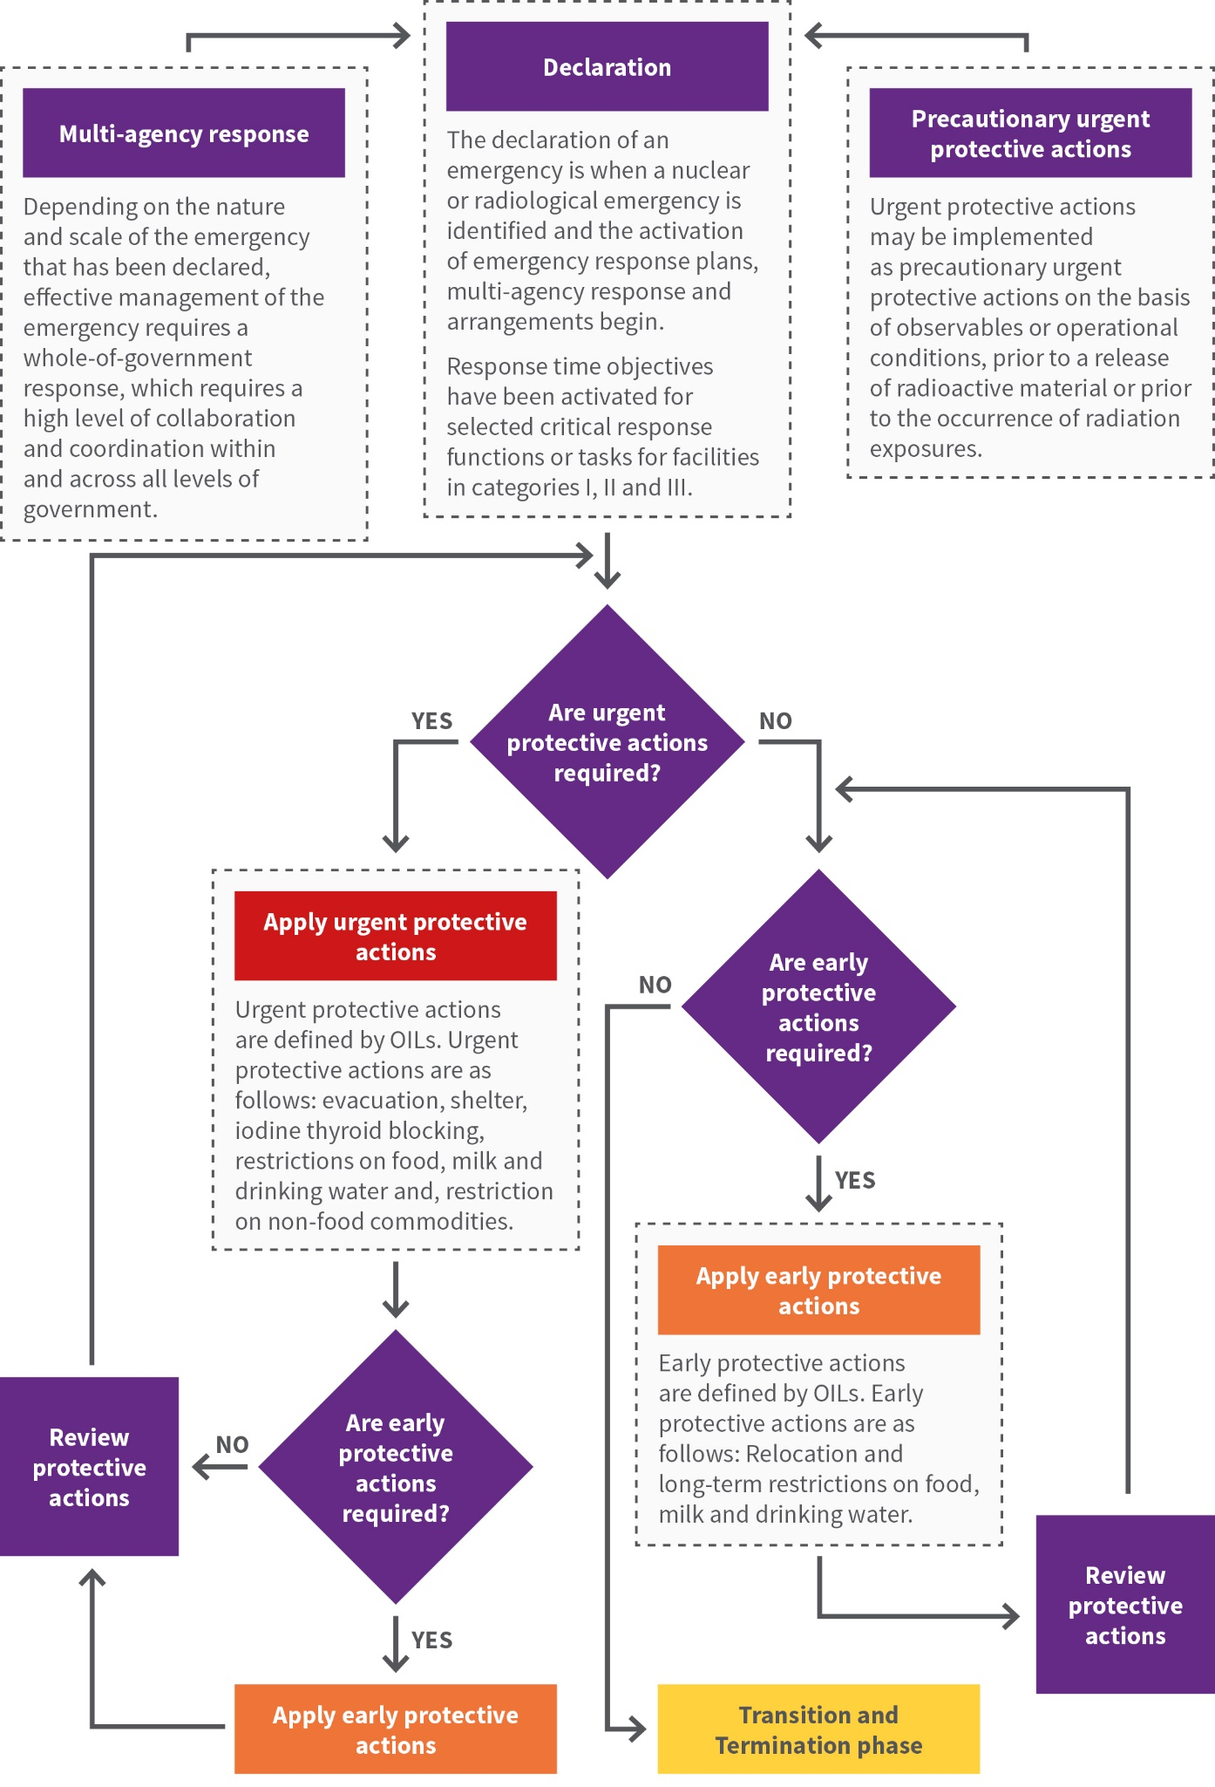

**Figure 5.1:** A systematic approach to applying protective actions during a response.

## Declaration of a nuclear or radiological emergency

The declaration of an emergency is the beginning of a response to a nuclear or radiological emergency whereby operational criteria (see Annex A in RPS G-3 Part 1 (ARPANSA 20019)) are used during the response.

The operator of a facility or activity in emergency preparedness category I, II, III or IV should make arrangements for the prompt classification, identification and notification of a nuclear or radiological emergency and for the activation of an emergency response.

The responsibilities and initial response actions of all response organisations should be defined for each class of emergency (see Figure 5.2). The classification system for a nuclear or radiological emergency is described in RPS G-3 Part 1 (ARPANSA 20019).

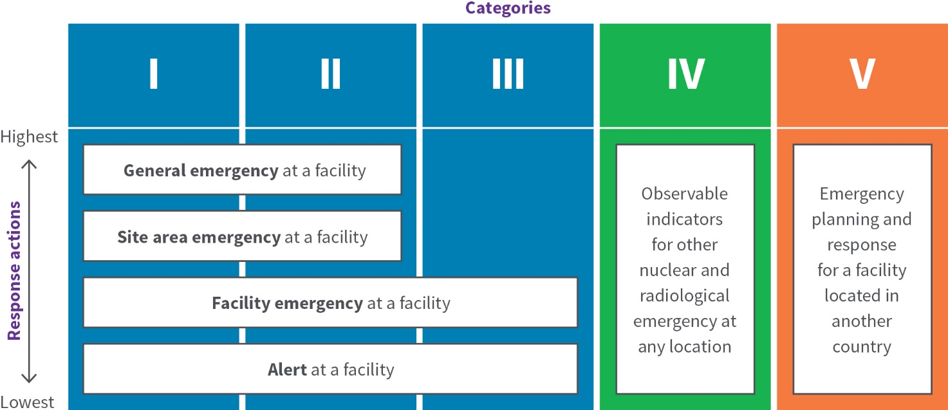

**Figure 5.2:** Relationship between Emergency Preparedness Categories and Classification for a nuclear or radiological emergency. Category V hazards may invoke any of the alerts, depending on the nature of the hazard.

### Facility emergencies

For facilities, the classification system determines the actions that should be taken on-site and off-site by response organisations immediately upon declaration of the emergency and should be carried out in accordance with established emergency plans as documented in the protection strategy (see Section 2.6 in RPS G-3 Part 1 (ARPANSA 2019)).

The emergency should be declared based on EALs or other observable indicators[6] (e.g. conditions of a facility) (see Annex B). EALs are predefined criteria that relate to abnormal conditions for the facility or activity concerned, security related concerns, releases of radioactive material, environmental measurements and other observable indications that are used to declare a particular class of emergency.

EALs and other observable indicators should use the following classification system:

* **general emergency** at a facility in emergency preparedness category I or II leading to an actual or substantial risk of a significant release of radioactive material into the environment warranting taking urgent protective actions off-site
* **site area emergency** at a facility in emergency preparedness category I or II leading to taking protective actions on-site and in the vicinity of the site
* **facility emergency** at a facility in emergency preparedness category I, II or III leading to taking protective actions on-site and for which no off-site consequences are expected
* **alert at facilities** in category I, II or III for an event that warrants taking actions to assess and to mitigate the potential consequences at the facility.

### All other nuclear or radiological emergencies

Other nuclear or radiological emergencies cover a broad spectrum of events in emergency preparedness category IV that may occur at any location. As such, the following sub-classifications should be used:

* dangerous radioactive material out of regulatory control
* severe overexposure
* space object re-entry
* elevated radiation levels of unknown origin
* criminal or other unauthorised acts
* any other radiological event not addressed above, e.g. a transport emergency.

Scenarios related to these types of emergencies are unpredictable and are not location specific. In these cases, observable characteristics are generally used to determine the extent of the emergency (see Section B.5 in Annex B). Protection strategies developed for these scenarios should be flexible and adaptable.

### Response time objectives (RTOs)

Response time objectives (RTOs) are suggested time objectives for selected critical response functions or tasks for facilities in emergency preparedness categories I, II and III. They should, once established, be part of the performance objectives for a response capability and should be used as part of the evaluation criteria for exercises (see Section 3 of RPS G-3 Part 1 (ARPANSA 2009)).

These time objectives were developed on the assumption that:

1. emergencies resulting in severe conditions can be classified and off-site officials can be notified within minutes (DoHS 2003)[7]
2. severe conditions warranting protective action on-site can occur within minutes
3. releases can occur from a facility in emergency preparedness category I that require the implementation of urgent protective action to prevent tissue reactions within the precautionary action zone (PAZ) within one or two hours
4. monitoring within the urgent protective action planning zone (UPZ) may be warranted within 4 to 6 hours following a release to identify locations where additional protective actions may be needed
5. the news media such as social media will become aware of events and will become a major source of information for the public within hours.

Suggested time objectives for selected critical response functions or tasks can be found in Table A.5 in Annex A.

## Emergency response phase

The emergency response phase involves the application of response arrangements for the period following the declaration of a nuclear or radiological emergency, until the time the situation is brought under control and radiological conditions are characterised sufficiently well. The emergency response phase is divided into an *urgent response phase* and an *early response phase*.

* **Urgent response phase:** The period of time from the detection of conditions warranting emergency response actions that must be taken promptly in order to be effective until completion of all such action. Such emergency response actions include mitigatory actions by the operator and urgent protective actions on-site and off-site. This phase may last from hours to days depending on the nature and scale of the nuclear or radiological emergency[8]. In cases involving a sealed dangerous source, an urgent response may not be necessary, as the situation is sufficiently characterised. Urgent protective actions are as follows:
* evacuation
* sheltering
* Iodine thyroid blocking
* restrictions on food, milk and drinking water
* restriction on non-food commodities.
* **Early response phase:** The period of time from when a radiological situation is being characterised sufficiently well to identify a need for taking early protective actions and other response actions until completion of all such actions (see Figure 5.1). This phase may last from days to weeks depending on the nature and scale of the nuclear or radiological emergency[9]. Early protective actions are as follows:
* relocation
* long-term restrictions on food, milk and drinking water.

### Operational intervention levels (OILs)

Operational intervention levels (OILs) are measurable values, which indicate the need to implement protective actions. Generally, OILs are a very useful tool for promptly assessing the results of environmental monitoring to aid decision making on protective actions for the public (see Annex A).

OILs are operational criteria that allow the prompt implementation of protective actions and other response actions on the basis of monitoring results that are obtained during a nuclear or radiological emergency. A default OIL value is a measured quantity that indicates the need to implement predetermined response actions (e.g. evacuation, relocation, food restrictions, etc.). The response actions implemented based on the default OIL values are intended to minimise radiation induced health effects. The default OIL values follow a reasonably conservative approach; they are established below those levels at which radiation induced health effects will be observed, even in a very large exposed group of people composed of the most sensitive members of the public.

The generic criteria described in Table B.2, Annex B of RPS G-3 Part 1 (ARPANSA 2019) can be used to derive OILs for taking precautionary urgent protective actions and other response actions to prevent severe tissue reactions. Default Australian OILs for nuclear or radiological emergencies can be found in Annex A.

**Operational intervention levels (OILs) explained**

OIL1 is a measured value of plume dose rate, air concentration or ground contamination calling for:

* urgent protective actions (e.g. evacuation) to keep the dose to any person living in a contaminated area below the generic criteria for urgent protective actions provided in Table B.2, Annex B of RPS G-3 Part 1 (ARPANSA 2019)
* medical actions, as required, because the dose received by evacuees may be above the generic criteria for medical actions provided in Table B.2, Annex B of RPS G-3 Part 1 (ARPANSA 2019).

OIL2 is a measured value of ground contamination calling for early protective actions to keep the dose for one year to any person living in the area below the generic criteria for taking actions to reasonably reduce the risk of stochastic effects provided in Table B.2, Annex B of RPS G-3 Part 1 (ARPANSA 2019).

OIL3 is a measured value of ground contamination calling for immediate restrictions on the consumption of local produce, milk from animals grazing in the area and rainwater collected for drinking to keep the dose to any person below the generic criteria for taking the urgent protective actions provided in Table B.2, Annex B of RPS G-3 Part 1 (ARPANSA 2019).

OIL4 is a measured value of skin contamination calling for performing decontamination or providing instructions for self-decontamination and for limiting inadvertent ingestion so as:

* to keep the dose due to skin contamination to any person below the generic criteria for taking urgent protective action provided in Table B.2, Annex B of RPS G-3 Part 1 (ARPANSA 2019)
* to initiate medical treatment or screening, by registering all those monitored and record the dose rate because the dose received by any person may exceed the generic criteria for medical actions provided in Table B.2, Annex B of RPS G-3 Part 1 (ARPANSA 2019).

For radiological emergencies, OIL5 are measured values for concentrations in milk or water and OIL6 are measured values of concentrations in food, milk or water that warrant the consideration of restrictions on consumption so as to keep the effective dose to any person below 10 mSv per year.

For nuclear emergencies, OIL7 are measured values for the marker radionuclides I-131 and Cs-137. The use of OIL7 during a nuclear emergency is preferable over OIL5 and OIL6 because of the limited availability of time and resources early in an emergency. The marker radionuclides are easily measured and are representative of the other radionuclides present. Once sufficient resources and time become available, OIL5 and OIL6 may be used, if considered necessary and justified.

OIL8 is a measured value for the thyroid. People who may have inhaled or ingested radioactive iodine need to be registered, instructed to take iodine thyroid blocking agent if not already taken and have their dose estimated to determine whether a medical follow-up is warranted.

All default OIL values for a nuclear or radiological emergency are provided in Annex A.

OILs are specified in terms of operational parameters that can easily be measured during an emergency, such as ambient dose rate from deposition of a release plume, or marker radionuclide concentration in foodstuffs. They relate directly to field measurements for the implementation of protective actions. OILs are a useful tool, especially early in the release, when little is known about the nature of the hazard but there is a need for prompt decision-making.

Annex A contains OILs for assessing the results of field monitoring in plume and contamination of the ground, skin and clothing. An OIL is exceeded if any of its OIL values are exceeded. These OILs apply for emergencies involving all radionuclides, including fission products released by melting reactor fuel. In the development of these OILs, all members of the population (including children and pregnant women) as well as all usual activities (such as children playing outdoors) were considered. The OILs were calculated to ensure that the protective actions to be taken protect against the most radiotoxic radionuclides.

When using default values, the user should be aware of assumptions under which these values were calculated. As more detailed isotopic information becomes available during an emergency, the assumptions used to derive the OIL values can be reviewed and the OILs re‑assessed if required. Only if there are major differences between the default and re-calculated values should the OILs be revised.

### Protective measures

There are several types of protective measures designed to ensure that the radiation doses to individuals or to a collective population, including emergency workers and helpers, are minimised. The effectiveness of these measures is largely dependent on the time taken to implement them (see Figure 5.3). Effective protective measures that can be applied in the event of an emergency involving radiation exposure are described in Annex B of RPS G-3 Part 1 (ARPANSA 2019) and Annex A for operation criteria. Protective actions for emergencies involving radiation exposure can be categorised into *urgent* and *early.*

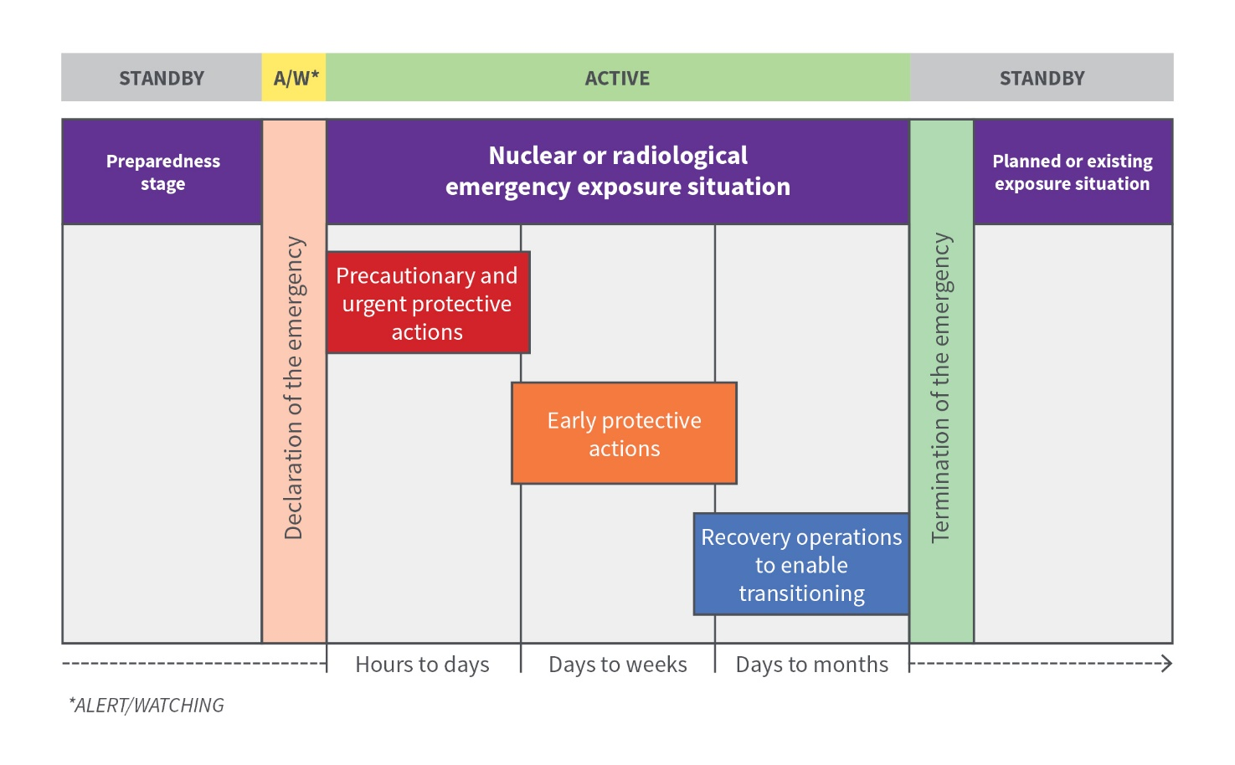

**Figure 5.3:** Temporal sequence of various types of protective actions and recovery operations in a nuclear or radiological emergency within one geographical area/site. Adapted from IAEA 2018.

### Urgent protective actions

Urgent protective actions are those which must be taken within hours of an emergency situation arising to be effective. Urgent protective actions should always be introduced to avoid doses approaching levels at which, if received, severe tissue reactions could occur. It should be recognised that the doses received before implementation of a protective action could contribute to the induction of tissue reactions.

Many of these urgent protective actions may be implemented as a precaution (see precautionary urgent protective action in Section 3.3) on the basis of observables or operational conditions, prior to a release of radioactive material or prior to the occurrence of radiation exposures. The decision on these actions is often based on limited information about the emergency situation and is guided by conservative assumptions on the potential development and impacts of the situation. Non-radiological issues will need to be considered with an all-hazard approach, e.g. traffic, transport, relief shelters, etc.

Examples of urgent protective actions include:

* **Evacuation:** The rapid, temporary removal of people from an area to avoid or reduce short-term radiation exposure in an emergency. Evacuation may be taken as a precautionary urgent action based on observable conditions or operating conditions. The generic criteria for evacuation in a nuclear or radiological emergency are given in Table B.2, Annex B of RPS G-3 Part 1 (ARPANSA 2019) and the operational criteria in Annex A.
* **Sheltering:** The short-term use of a structure (e.g. the home) for protection from an airborne plume and/or deposited radioactive material. Sheltering is an urgent protective action that is easy to implement in an emergency situation, either as a precautionary action or as a transitional action before more effective but more disruptive actions (such as evacuation) can be safely implemented. Sheltering should not be carried out for long periods (more than approximately 2 days). The Generic Criteria for sheltering are given in Table B.2, Annex B of RPS G-3 Part 1 (ARPANSA 2019) and the operational criteria in Annex A.
* **Iodine thyroid blocking:** The short-term urgent protective action that provides protection for the thyroid against the uptake of radioactive iodine; it may be implemented as a precaution, as a standalone action or combined with other protective actions such as sheltering.

Iodine thyroid blocking is not a protective action to be implemented for prolonged periods. If there is a need to consider this action for a longer duration (e.g. days), consideration should be given to implement evacuation or relocation. Iodine thyroid blocking is suitable for use in the urgent response phase and is not appropriate as a measure during the transition phase. The generic criteria for iodine thyroid blocking is given in Table B.2, Annex B of RPS G-3 Part 1 (ARPANSA 2019) and the operational criteria in Annex A. Information on iodine thyroid blocking is provided in the *Australian Clinical Guidelines for Radiological Emergencies* (DoH 2012).

* **Restrictions imposed on food, milk and drinking water:** Restrictions imposed on food, milk and drinking water may be taken as a precaution in the urgent response phase based on calculated estimates. During the early response phase, these restrictions may be applied and/or revised based on monitoring. Restrictions on the food chain and water supply during a nuclear or radiological emergency can be applied based on the generic criteria in Table B.2, Annex B of RPS G-3 Part 1 (ARPANSA 2019) and the operational criteria in Annex A.
* **Restriction on non-food commodities:** Restriction on non-food commodities implemented during the emergency response phase as a precaution or based on estimates (e.g. based on EALs or OIL3 in Annex A) should be adjusted based on monitoring results. The purpose is to identify non-food commodities that are justified to remain under restriction in the longer term and to identify those restrictions that may be lifted. OILs for non-food commodities derived based on sampling and analysis can be applied based on the generic criteria in Table B.2, Annex B of RPS G-3 Part 1 (ARPANSA 2019) and the operational criteria in Annex A.
* **Other protective measures:** Other protective measures in the urgent response phase include decontamination of individuals and medical treatment when appropriate.

### Early protective actions

*Early protective actions* are those which may need to be adopted in a matter of days following an emergency situation arising. Decisions on the adaptation of urgent protective actions and the implementation of early protective actions are taken based on increasingly more detailed information and improved knowledge of the radiological exposure situation.

Examples of early protective actions include:

* **Relocation:** Temporary Relocation action is the removal of people from the area for a longer period of time (more than a few months) as an early protective measure. Its adaptation or lifting is less urgent in comparison to evacuation, and it allows more time for planning. The generic criteria for temporary relocation in a nuclear or radiological emergency are given in Table B.2, Annex B of RPS G-3 Part 1 (ARPANSA 2019) and the operational criteria in Annex A. When substituting evacuation with relocation, people evacuated should be granted short access to the evacuated areas in a controlled manner, in order to allow for the preparation of longer-term relocation.
* **Long-term restrictions on food, milk and drinking water:** Restrictions imposed on food, milk and drinking water may have been taken as a precaution in the urgent response phase based on calculated estimates. Long-term restrictions on the food chain and water supply during a nuclear or radiological emergency can be applied based on monitoring data and the generic criteria in Table B.2, Annex B of RPS G-3 Part 1 (ARPANSA 2019) and the operational criteria in Annex A.
* **Other protective measures:** Other protective measures in the early response phase include restrictions on the use of commodities that have the potential to result in significant exposures, actions to prevent inadvertent ingestion, actions to control the spread of contamination, and decontamination of areas or commodities to further reduce individual doses.

### Emergency workers and helpers

Under normal conditions, exposure of people to radiation is subject to the system for radiation protection for practices, including compliance with the dose limits specified in the RPS C-1 (ARPANSA 2016).

In an emergency, where there may be a need for emergency workers to take action to save lives or to bring an emergency under control, dose limits are no longer appropriate and reference levels expressed as guidance values should be used. These are given in Table A.1, Annex A of RPS G-3 Part 1 (ARPANSA 2019) and in Section 2. Every effort should be made to keep the doses to emergency workers below those specified in Table A.1, Annex A of RPS G-3 Part 1 (ARPANSA 2019), consistent with provision of the emergency response. The need for emergency workers to be exposed to radiation in an emergency must be justified and the protection against the exposure to that radiation must be optimised. This applies to all emergencies.

Helpers in an emergency (i.e. members of the public who willingly and voluntarily help in response to a nuclear or radiological emergency) should be registered and integrated into the emergency response operations and be provided with the same level of protection as emergency workers (see clause 3.2.57 of RPS G-3 Part 1 (ARPANSA 2019).

Workers and helpers should be fully informed of the health risks associated with an emergency exposure situation. Health risks associated with exposure to radiation are provided in RPS F-1 (ARPANSA 2014), and ranges of health effects are illustrated in Annex C.

# Transition from a nuclear or radiological emergency

The transition and termination phases follow the emergency response phase. They occur when the situation is under control, detailed characterisation of the radiological situation has been carried out and activities are planned and implemented in order to enable the emergency to be declared terminated (see Figure 6.1).

## Transition phase

The transition phase is the period following the emergency response phase, when the situation is under control, detailed characterisation of the radiological situation has been carried out, and activities are planned and implemented to enable the emergency to be declared terminated. In comparison to the urgent response phase and, to some extent the early response phase, the transition phase is not driven by urgency and allows for planning, justifying and optimising future protection strategies, and for consultation with stakeholders.

During all phases of an emergency, and especially during the transition phase, the process of justification and optimisation of the protection strategy should be undertaken to continuously assess the impact of the protection strategy on the overall radiological situation. This should include assessing the residual doses incurred by people compared to the reference levels, the impact on society and other non-radiological impacts. This continuous reassessment should lead to an adaptation of the protection strategy where necessary to allow for achieving the relevant prerequisites (see Section 7.1) given for the termination phase (see Figure 6.1).

### Applying justification in the transition phase

The application of the justification principle for each protective action, in the context of the protection strategy, and the protection strategy itself, allows the determination of whether a proposed protective action or remedial action is likely, overall, to be beneficial; i.e. whether the expected benefits to individuals and to society (including the reduction in radiation detriment) from introducing or continuing the protective action or remedial action outweigh the cost of such action and any harm or damage caused by the action.

Justified actions within a protection strategy should be determined during the preparedness stage. Protective actions and other response actions solely justified on the basis of political pressure or public concerns that do not have any scientific and technical merit should be avoided, as they may lead to remediation activities that are not justified considering the associated harm and costs they may cause, particularly in the longer term. In addition, taking such unjustified actions may give the impression to the public that the risk associated with the emergency is much greater than the actual risk, causing psychosocial health consequences and unnecessary anxiety and psychological harm.

A periodic reassessment of the protective actions and the protection strategy should be undertaken during the transition phase to ensure they continue to do more good than harm considering any new information that becomes available.

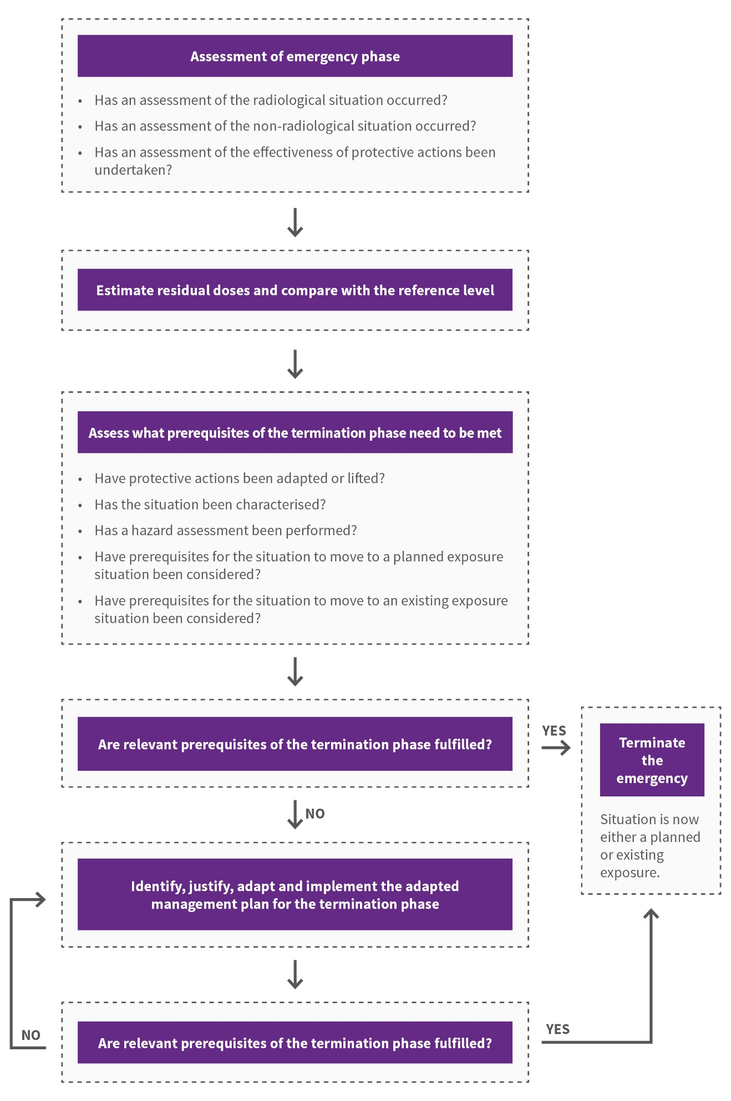

**Figure 6.1:** A systematic way for identifying, assessing and implenting the radiation management strategy during the transition phase.

### Applying optimisation in the transition phase

Implementation of the optimised protection strategy should result in exposure levels below the reference level, and as low as reasonably achievable, as long as these reductions are justified. Optimisation should be applied even if the initially projected doses are below the defined reference level, but only if actions which are justified are available to reduce exposures.

### Applying reference levels in the transition phase

The reference levels are introduced as a tool for optimisation of the protection strategy so that any optimisation of protection gives priority to exposures above the reference level; at the same time, the optimisation of protection may continue to be implemented below the reference level as long as this is justified, i.e. does more good than harm.

Two examples may clarify the process for the selection of the reference level during the transition phase for large scale and small-scale emergencies:

* Emergencies involving large-scale contamination resulting in exposures of the public due to long lasting residual radioactive material in the environment would result in longer-term exposures, which are expected to decrease with time. Therefore, the reference level to be chosen may change with time. For example, it may start with a level of 50 mSv acute or annual effective dose for the urgent response phase and approach an effective dose of 10 mSv per year residual dose after successful implementation of the protection strategy to enable the transition to an existing exposure situation. The timing of the reduction of the reference level will depend on various circumstances, including the effectiveness and the efficiency of the implementation of the protection strategy.
* Emergencies that do not result in long lasting residual radioactive material in the environmental will not require the gradual decrease in reference levels as in the above example. As such, while the reference level for the emergency exposure situation has been selected to be 50 mSv for the purpose of the emergency response, once the source is recovered safely the concept of the reference level will no longer apply, as the situation returns to a planned exposure situation.

### Generic criteria and operational criteria in the transition phase

Generic and operational criteria are concepts within the protection strategy that are to be used to implement protective actions and other response actions in a nuclear or radiological emergency.

During the transition phase, further OILs will need to be developed based on the generic criteria for taking specific protective actions and other response actions and on the generic criteria (see Annex B of RPS G-3 Part 1 (ARPANSA 2019)) for enabling the transitioning to an existing or planned exposure situation. These should be used as a tool to support:

* decision making on lifting or adapting protective actions, including the determination of what protective actions may need to be lifted, when this might happen, and to whom it may apply
* implementation of activities to enable the transitioning from an emergency exposure situation to an existing exposure situation by providing a basis to guide simple dose reduction activities.

The default OILs during an emergency should be revised if the situation is well understood and there are compelling reasons to do so. The public and other interested stakeholders should be informed of the reasons for any change in the OILs applied in an actual emergency.

Decisions on adapting and/or lifting protective actions (such as lifting evacuation, relocation or restrictions on certain foods for consumption) in the transition phase should be justified and optimised and should be made after their impact on the residual doses among the affected population has been assessed.

# Termination phase

The termination of the nuclear or radiological emergency marks the end of the transition phase in a particular area or site and the beginning of either an existing exposure situation or a planned exposure situation (see Figure 6.1).

Depending on the nature of the nuclear or radiological emergency, these protective actions may continue in the longer term after the emergency has been declared terminated. During this period, the implementation of remedial actions might be more efficient than carrying out further disruptive public protective actions.

## Prerequisites to terminate the emergency

The primary objective and the prerequisites to be considered in planning and decision making regarding the termination of a nuclear or radiological emergency should be undertaken in the transition phase.

The primary objective of the termination of the emergency is to facilitate the timely resumption of normal social and economic activity.

The following prerequisites should be met in order to be able to declare the termination of an emergency:

* A nuclear or radiological emergency should not be terminated until the necessary urgent and early protective actions have been implemented. At the time of deciding on the termination of a nuclear or radiological emergency, some of these actions may be already be under consideration to be adapted or lifted (e.g. evacuation). Other actions may remain in place in the longer term after the termination (e.g. restrictions on food, milk and drinking water), while some actions such as iodine thyroid blocking may have been implemented and require no further consideration during the transition phase.
* Prior to the termination of the emergency, the exposure situation should be well understood and confirmed to be stable. This means that the source has been brought under control, no further significant accidental releases or exposures resulting from the event are expected and the future development of the situation is well understood.
* The radiological situation should be well characterised, exposure pathways identified and doses assessed for all affected populations. This characterisation should consider the impact of lifting and adapting the protective actions implemented earlier in the emergency response and, where applicable, possible options for the future use of land and water surfaces (e.g. imposing restrictions or identifying alternative ways in which they can be exploited).
* A thorough hazard assessment of the situation and its future development should be performed. The hazard assessment should provide a basis to prepare for dealing with any future hazards associated with a new emergency situation that may occur in relation to the facility, activity or the source involved in the emergency considered for termination.
* Based on the hazard assessment, the need to revise the existing emergency arrangements and/or to establish new arrangements should be reviewed.
* Prior to the termination of the emergency, it should be confirmed that the requirements for occupational exposure, as described in RPS C-1 (ARPANSA 2016), can be applied to all workers that will be engaged in recovery activities (see Sections 4.2 and 5.2.3).
* The radiological situation should be assessed as appropriate, against reference levels, generic and operational criteria and dose limits, to determine if the relevant prerequisite for the transition to the respective exposure situation has been achieved.
* Non-radiological consequences (psychosocial, economic) and other factors (technology, land use options, availability of resources, community resilience, and availability of social services) relevant to the termination of the emergency should be identified and actions to address them considered.
* Consideration should be given to the management of radioactive waste arising from the emergency (see Section 7).
* Consultation with stakeholders is required prior to the termination of the emergency. This process should not unduly impede the timely and effective decision making by the responsible authority to terminate the emergency. The following should be communicated to the public and other interested stakeholders:
* the basis for the termination of the emergency, which includes rationale on why it is safe to end the emergency and an overview of the actions taken and restrictions imposed
* the need for adjusting imposed restrictions, for continuing protective actions or for introducing new ones
* any necessary modification in people’s personal behaviours and habits
* possible options for the implementation of self-help actions
* the need for continued environmental, source and individual monitoring following the termination of the emergency
* the need for continued efforts to restore services and workplaces
* radiological health hazards associated with the new exposure situation.

### Transition from an emergency exposure situation to a planned exposure situation

The following prerequisites should be met in order to be able to declare the end of an emergency exposure situation and to move to a planned exposure situation:

* Circumstances surrounding the emergency have been analysed, corrective actions have been identified and an action plan has been developed for the implementation of corrective actions by the respective authorities. In some cases, the formal analysis and development of the action plan may be a lengthy process. Therefore, establishing administrative procedures that limit or prevent the use or handling of the source until a better understanding of the circumstances surrounding the emergency situation is understood should be considered, with the aim to prevent the unnecessary delay of the termination of the emergency.
* Conditions have been assessed to ensure compliance with the safe and secure handling of the sources in accordance with RPS C-1 (ARPANSA 2016).
* Compliance has been confirmed with the requirements for dose limits for public exposure in planned exposure situations and with requirements for planned exposure situations in accordance with RPS C-1 (ARPANSA 2016).

### Transition from an emergency exposure situation to an existing exposure situation

In addition to the general prerequisites, which can be found in Section 7.1, the following prerequisites, which can be found in the RPS G-2 (ARPANSA 2017), should be met in order to be able to declare the end of an emergency exposure situation and to move to an existing exposure situation. These prerequisites are:

* justified and optimised actions have been taken to reach the national generic criteria established to enable transitioning to an existing exposure situation
* areas have been delineated which may not be inhabited and where it is not feasible to carry out social or economic activity. For these delineated areas, administrative and other provisions have been established to monitor compliance with the restrictions imposed
* a strategy is implemented for the restoration of infrastructure, workplaces and public services necessary to support normal living conditions in the affected areas
* any change or transfer of authority and responsibilities from the emergency response organisation to organisations responsible for the long-term recovery operations have been completed
* communication and consultation is continuous with all interested stakeholders, including local communities
* a long-term monitoring program (e.g. residual contamination) is implemented
* a long-term medical follow-up program for registered individuals, including mental health and psychosocial support for the affected population in relation to psychosocial health consequences is implemented
* administrative arrangements, legislative provisions and regulatory provisions are in place and/or underway for the management of the existing exposure situation.

# Medical response

In order to be effectively implemented, emergency medical response needs to be planned and organised in accordance with the potential consequences of different radiation emergencies. The medical response needs to take the same approach to planning as given in Sections 3 and 4 for preparedness and response to a radiation emergency, for all response organisations. The healthcare sector must be prepared to respond and to provide medical care to the injured.

The goals of medical response to nuclear or radiological emergency are:

* to save lives and perform required emergency medical procedures
* to treat radiation injuries and injuries resulting from an emergency situation
* to perform required healthcare actions, including public advice and counselling, and long term medical follow-up.

Actions of medical response need to be in line with the goals of emergency response (see Section 2.2 in RPS G-3 Part 1 (ARPANSA 2019)).

The response to a radiation emergency and the medical care for individuals involved depend on, to a large extent, factors associated with the emergencies, such as the type of the emergency, i.e. whether the individuals have been exposed to external sources of radiation or contaminated with radioactive material; the number of victims; and the association and severity of conventional injuries. The same general principles of medical care apply at the scene of the emergency as at the hospital, but the details and extent of medical care differ.

The responders to a radiation emergency must have confidence that when they follow appropriate procedures there will be no consequences to them, either directly or indirectly, as a result of providing care for victims. This confidence must also be conveyed to the victims themselves. The responders need to be aware that if an individual has only been exposed to external sources of radiation, there is no radiation threat whatsoever to them and specific precautions are not needed in patient handling and care.

If individuals have external contamination of the skin, clothing and/or contaminated excreta, then they present a hazard in spreading contamination. Special precautions and procedures need to be implemented to prevent the spread of contamination.

If individuals are contaminated internally as a result of inhalation or ingestion of radioactive material, then they do not present a direct hazard of external exposure to others, unless the intake was extremely large and involves gamma emitters. However, contaminated excreta or vomit can spread contamination to equipment, environment and attending staff. Using appropriate procedures can prevent the spread of contamination.

The Australian Health Protection Principal Committee (AHPPC) commissioned a comprehensive technical guide for clinicians and healthcare professionals to provide a reference for education and planning for the management of radiation emergencies. The document also provides specific therapeutic indications and protocols for the use of decorporation agents used to treat radiation injuries. The *Australian Clinical Guidelines for Radiological Emergencies* (DoH 2012) were developed to complement existing national guidelines on Anthrax, Smallpox and Chemical Agents.

The WHO and its global network Radiation Emergency Medical Preparedness and Assistance Network (REMPAN) assist countries to strengthen preparedness and response to radiation emergencies.

Arrangements for the medical follow-up, should consider:

* initial duration of the medical follow-up
* management of the information and reporting and sharing of results
* choice of medical specialists to be involved in the medical follow-up
* management of biological and non-biological samples
* management of mental health and psychosocial consequences
* ethical and cost-benefit aspects.

Arrangements for the long-term medical follow-up should provide individuals access to information about the results of their medical evaluations and to adequate sources of information such as respective health care providers.

Experience has shown that psychosocial effects of a radiation emergency can far outnumber any direct effects. The widespread public anxiety associated with events such as the 2011 Japan nuclear power plant emergency appears to be out of proportion to the radiation induced health effects. Decision makers must take psychological effects into account in emergency management because the reality of public distress has direct relevance for policy makers, public health and medical personnel. The assessment of psychosocial effects on an impacted population should consider the combined influence that psychological factors, such as fear, stress and anxiety, and the surrounding social environment, have on their state of well-being.

Each emergency preparedness category includes possible medical consequences that could be used as a basis for planning a medical response. The IAEA *Generic Procedures for Medical Response During a Nuclear or Radiological Emergency* (IAEA 2005) provides a brief description of possible medical effects for each emergency preparedness category, as well as the desired response and the medical response concept of operations for emergencies within preparedness categories. Generic guidance on management and prevention considerations of psychological consequences of the emergencies is also provided.

# Radioactive waste management

A nuclear or radiological emergency may generate radioactive waste as well as conventional waste. In particular, nuclear or radiological emergencies resulting in significant contamination of the environment can be expected to generate radioactive waste with various radiological, chemical, physical, mechanical and biological properties. These may be of a volume that can overwhelm national capabilities and resources for radioactive waste management. The generation of radioactive waste in a nuclear or radiological emergency may pose a challenge to the implementation of the national policy and strategy for radioactive waste management, as well as to overall efforts to enable the termination of the emergency and achieving long term recovery objectives.

The management of radioactive waste will not be of primary importance early in the response (especially during the urgent response phase), when the focus will be on the effective implementation of the protection strategy and on bringing the situation under control. Arrangements should be made, as part of an overall emergency preparedness, to address the expected issues and challenges in radioactive waste management following the emergency. The following should be considered:

* Responsibilities for radioactive waste management during and after an emergency should be allocated clearly and consistently, to the extent possible, with the national policy and strategy for radioactive waste management.
* Responsibilities for conventional waste management and conditions under which conventional waste arising from the emergency and emergency response actions will be managed should be agreed upon for radioactive waste versus conventional waste generated during the emergency.
* A mechanism should be established to coordinate the development of various arrangements by responsible organisations at the preparedness stage as well as to coordinate, under the unified command and control system, radioactive and conventional waste management during the emergency response.
* Characteristics and the volume of radioactive waste to be generated in postulated nuclear or radiological emergencies should be identified, to the extent possible, on the basis of the hazard assessment, taking into account past experiences.
* Guidance should be put in place on the characterisation and classification of radioactive waste, which takes into account the diversity of radiological, chemical, physical, mechanical and biological properties of the waste to be generated in a range of postulated emergencies. This guidance should be in accordance with the applicable regulations and guidance on waste management.
* Guidance should be put in place on the handling of conventional and radioactive waste during an emergency, including where the acceptance criteria of this waste deviates from that of existing storage or disposal facilities. This guidance should be in accordance with the applicable regulations and guidance on waste management.
* Methodologies should be developed for initiating radioactive waste predisposal management activities (e.g. segregation, packaging, transport, storage) in a timely and appropriate manner following the emergency. As part of these methodologies:
  + options for radioactive waste minimisation (such as clearance, reuse and recycling) that are feasible should be identified
  + necessary tools, equipment, procedures, training, drills and exercises to support effective waste management should be identified and put in place
  + consideration should be given to the interdependences among various steps in the predisposal management of radioactive waste as well as the impact on the future disposal options
  + limitations of available options and resources should be identified and well understood by all stakeholders and mechanisms for requesting and obtaining international assistance should be determined.

# Communication during an emergency

Communicating with the public about radiation is challenging. It is important to remember, at all times, to communicate in plain language. Trust and availability of information are the key elements for risk communication.

Effective public communication in any response is contingent on the level of preparedness of all organisations involved. Not only does this include planning, training and exercising for public communications in emergency response, it also depends on the strength of the overall communication program and culture of transparency. Communications officers (those who are responsible for communicating with the public, the media and other stakeholders to coordinate all official public information) as well as all response personnel of a unified command and control structure (those who would or could be expected to provide information to the public and other stakeholders during a given nuclear or radiological emergency) need to ensure a consistent message is delivered.

Effective response to a nuclear or radiological emergency requires development, establishment and maintenance of an emergency management system. An effective emergency management system includes preparedness, response and the transition to an existing or planned exposure situation (see Section 4.1).

At the preparedness stage, plans, procedures, arrangements, hazards and threat assessments, training and exercises are essential parts of an effective emergency preparedness and response program to facilitate the response to a nuclear or radiological emergency. The development of a public communications strategy and program requires coordination between all respective stakeholders (facility, local, regional, national, international, public, media and others).

Effective communication with the public and other stakeholders before and during a nuclear or radiological emergency is paramount to ensuring effective implementation of actions to protect health. This needs to be conducted in a transparent, timely, clear, factually correct and objective way, which is easily understandable.

Effective public communication has been shown to encourage the smooth implementation of appropriate protective actions by people at risk and to reassure individuals who are not directly at risk, by reducing rumours and fears. It can facilitate relief efforts and maintain public trust and confidence in the organisations responsible for ensuring the welfare of the public.

All personnel who are communications officers and others, such as senior managers, technical experts and emergency response personnel, should be prepared for situations when members of the public, the media and other stakeholders address questions to them. Therefore, appropriate spokespersons from the various organisational elements should be identified in advance and provided with necessary training comprised of basic lectures on risk and crisis communication and hands-on practices such as media training and public communication training. These individuals should be identified throughout the command and control structure and known by all emergency personnel. Also, any and all personnel who are part of or could be part of the command and control structure should be provided with at least basic public communication training to ensure that they understand the complexity and problems that could arise from discussions with the media, the public, interested stakeholders and others who seek information regarding the nuclear or radiological emergency.

This training should be provided to ensure that all communications officers are aware of and given instruction about the factors that support risk and crisis communications strategies, such as the difference of the terms ‘risk’ and ‘hazard’, the construction of risk perception, social amplification of risks and the importance of interested stakeholder dialogues and interested stakeholder involvement. Examples for putting the health-hazard of radiation exposure into perspective, as shown in Annex C, is desirable.

Exercises, including drills, provide a means to test and validate program effectiveness and a means for continuous improvement and necessary adjustments to plans, procedures and response protocols. Drills and exercises should be as realistic as possible. Public communication should be integrated within existing emergency preparedness and response programs as a routine component of an organisation’s drill and exercise program.

Response organisations should establish the frequency of their drill and exercise programs to ensure that the skill level of the communications officers, spokespersons and other identified emergency communicators remains sufficient to respond to an emergency event.

Organisations should include an evaluation, review and an after action report following the conclusion of each drill and exercise in order to determine gaps, lessons and other necessary improvements for effective communication during an emergency event.

# Annex A: Operational criteria – Default operation intervention levels (OILs), observables and response time objectives (RTOs)

A.1 Default OIL values and their application in a nuclear emergency

Default OIL values for a nuclear emergency where the majority of contaminants are generated via a nuclear fission process and multiple radionuclides are present. This would include nuclear reactors, nuclear detonations, some medical isotope incidents etc. The default OIL values in Table A.1 are generally based on conservative exposure conditions. OIL values may be revised when more knowledge of a situation is known, such as the radionuclides involved and exposure duration.

Table A.1: Default OIL values in a nuclear emergency.

|  |  |  |  |  |  |  |
| --- | --- | --- | --- | --- | --- | --- |
| Phase | OIL | | Protective action | In-plume dose rate | Dose rate from deposition | Concentration |
| **Urgent**  **(hours to days)** | OIL1a | A | Evacuate | 500 µSv h-1 | |  |
| B | Shelter | 100 µSv h-1 | |
| C | Iodine thyroid blocking | 100 µSv h-1 (Adult)  20 µSv h-1 (Childrenb and pregnant women) |  | I-131 In-plumec  50 000 Bq m-3 (Adult)  10 000 Bq m-3 (Childrenb and pregnant women) |
| **Early (days to weeks)** | OIL2 |  | Temporarily relocate |  | 50 µSv h-1 in first 7 days  10 µSv h-1 after 7 days |  |
| OIL3 | Restrict consumption of non-essential local produced, rainwater and milk from animals grazing in the area | 1 µSv h-1 | Ground concentration  1000 Bq m-2 of  I-131 or Cs-137 |
| OIL4 | Skin decontamination | 1 µSv h-1 skin monitoring (at 10 cm from the bare skin) | Beta skin monitoring  1000 counts s-1 (at 2 cm from the bare skin) |
| OIL7 | Restrictions on local produce, milk from grazing animals, rain water or other open sources of drinking water |  | Food, milk, water  100 Bq kg-1 of  I-131 or Cs-137 |
| OIL8 | Medical follow-up of thyroid | 0.5 μSv h-1 thyroid monitoring (in front of the thyroid in contact with skin) |  |

|  |  |
| --- | --- |
| a. | Based on exposure time of 4 hours for in-plume dose rate. Based on exposure time of 7 days for dose rate from deposition. |
| b. | A child is considered to be under 18 years. |
| c. | Based on exposure time of 4 hours for in-plume concentration. |
| d. | Based on exposure duration of 365 days. |

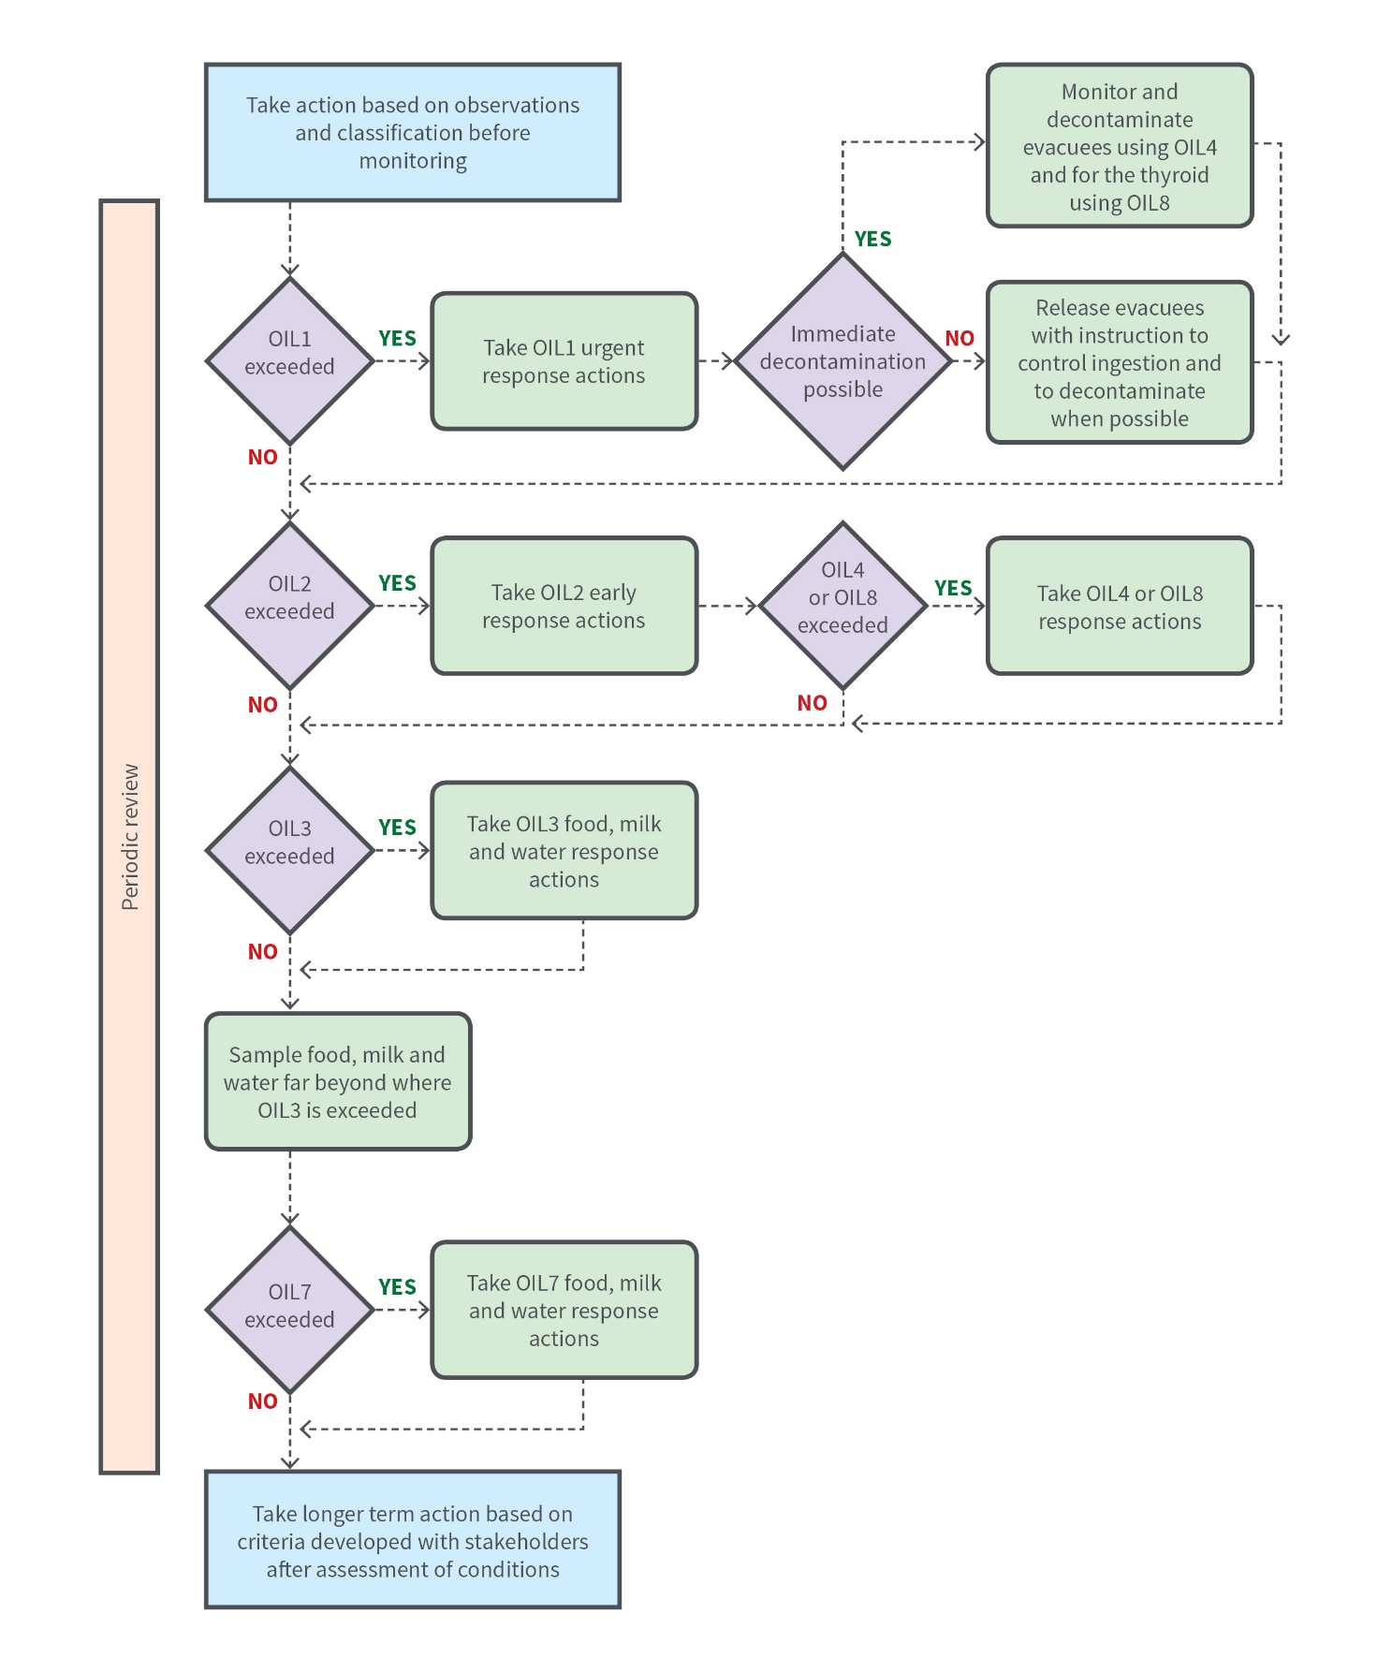

**Figure A.1:** Application of the OILs from Table A.1 for a nuclear emergency.

A.2 Default OIL values and their application in a radiological emergency

Default OIL values for a radiological emergency where only one (or a few) radionuclides are present, such as those found in radiological dispersion devices (RDDs), industrial sources and transport accidents. The default OIL values in Table A.2 are generally based on conservative exposure conditions. OIL values may be revised when more knowledge of a situation is known, such as the radionuclides involved and exposure duration. Table A.3 provides guideline levels for radionuclides in food, milk and water examples following a radiological emergency for specific nuclides grouped against decay type.

Table A.2: Default OIL values in a radiological emergency.

|  |  |  |  |  |  |
| --- | --- | --- | --- | --- | --- |
| Phase | OIL | | Protective action | Dose rate from deposition | Concentrationa b |
| **Urgent (hours to days)** | OIL1c | A | Evacuate | 500 µSv h-1 | Total ambient air concentration (Bq m-3)  Gamma: 10 000  Beta: 5000  Alpha: 1  Total ground concentration (Bq m-2)  Gamma or beta: 10 000 000  Alpha: 500 000 |
| B | Shelter | 100 µSv h-1 | Total ambient outdoor air concentration (Bq m-3)  Gamma: 5000  Beta: 1000  Alpha: 0.5  Total ground concentration (Bq m-2)  Gamma or beta: 5 000 000  Alpha: 100 000 |
| **Early (Days to weeks)** | OIL2d |  | Temporarily relocate | 10 µSv h-1 | Total ambient air concentration (Bq m-3)  Gamma: 500  Beta: 100  Alpha: 0.05  Total ground concentration (Bq m-2)  Gamma or beta: 1 000 000  Alpha: 50 000 |
| OIL3 | Restrict consumption of non-essential local produce, rainwater and milk from animals grazing in the area | 1 µSv h-1 | Total ground concentration (Bq m-2)  Gamma: 10 000  Beta: 1000  Alpha: 100 |
| OIL4 | Skin decontamination | 1 µSv h-1 skin monitoring (at 10 cm from the bare skin) | Beta skin monitoring  1000 counts s-1 (at 2 cm from the bare skin)  Alpha surface monitoring  50 counts s-1 (as close as possible to the bare skin) |
| OIL5 | Rain water or other open sources of drinking water |  | Water concentration (Bq kg-1)  Gross beta: 100  Gross alpha: 5 |
| OIL6 | Restrictions on local produce, milk from grazing animals, rain water or other open sources of drinking water | Refer to Table A.3 |

|  |  |
| --- | --- |
| a. | See Table A.3 for the decay type group as examples for specific nuclides. |
| b. | For the case of the presence of multiple radionuclides within the same decay type group (gamma, beta or alpha), the sum of the radionuclide activity concentrations should not exceed the default OIL value concentration. For example, if both gamma emitting radionuclides Cs-137 and Co-60 are present, then their ambient air concentrations need to be summed and compared to 10 000 Bq m-3. |
| c. | Based on exposure duration of 7 days. |
| d. | Based on exposure duration of 365 days. |

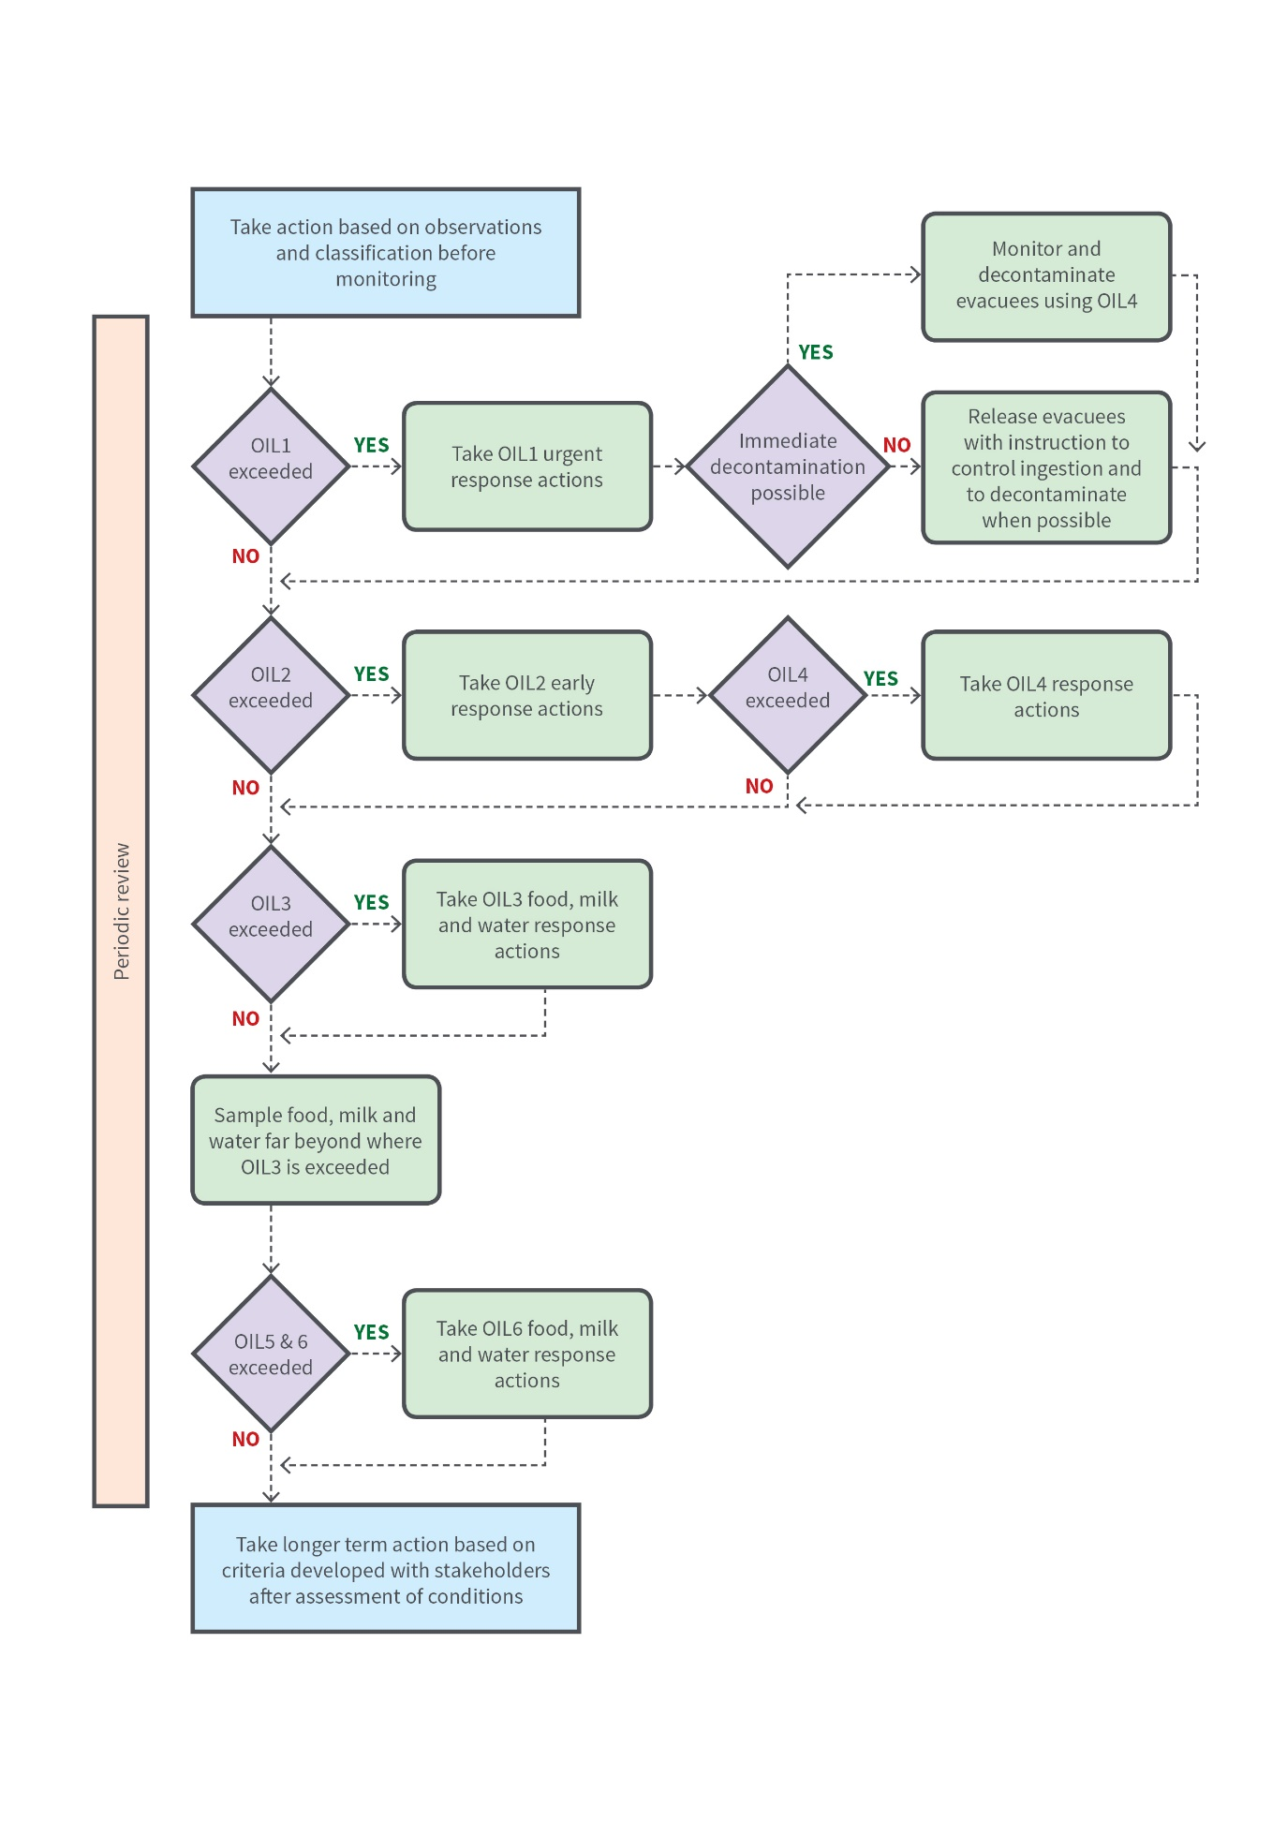

**Figure A.2:** Application of the OILs from Table A.2 for a radiological emergency.

Table A.3: Default OIL value concentrations for radionuclides in food, milk and water following a radiological emergency.

|  |  |  |
| --- | --- | --- |
| Groupa | Nuclides | Default OIL value  concentrations (Bq kg-1)b |
| 1 (Alpha) | Pu-238, Pu-239, Pu-240, Am-241, Cf-252 | 10 |
| 2 (Beta) | Sr-90, Ru-106, I-129, I-131, U-235 | 100 |
| 3 (Gamma) | S-35, Co-60, Sr-89, Ru-103, Cs-134, Cs-137, Ce-144, Ir-192 | 1000 |

|  |  |
| --- | --- |
| a. | The group names generically link back to the OIL table and don’t always represent decay type for a given radionuclide. |
| b. | For the case of the presence of multiple radionuclides within the same decay type group (gamma, beta or alpha), the sum of the radionuclide activity concentrations should not exceed the default OIL value concentration. For example, if both alpha emitting radionuclides Pu-238 and Pu-239 are present, then their activity concentrations need to be summed and compared to 10 Bq kg-1. If the radionuclides are across multiple groups the guideline levels may require recalculation to account for the multiple dose contributions. |

A.3 Observables on the scene of a radiological emergency

In a radiological emergency, the inner cordoned area is where protective action is implemented to protect responders and the public. Initially the size of the area is determined on the basis of information that can be directly observed (e.g. markings).

The size of the area may be expanded on the basis of dose rates and environmental measurement OILs (see Table A.2) when this data becomes available. Table A.4 provides suggestions for the approximate radius of the inner cordoned area. Instruction 1 in the IAEA *Manual for First Responders to a Radiological Emergency* (IAEA 2006) provides a list of observables that can be used by first responders to identify a dangerous source. The actual boundaries of the safety and security perimeters should be defined in such a way that they are easily recognisable (e.g. by roads) and should be secured. However, the safety perimeter should be established at least as far from the source as is indicated in the table until the radiological assessor has assessed the situation.

Table A.4: Suggested radius of the inner cordoned area (safety perimeter) in a nuclear or radiological emergency. Based on the IAEA *Criteria for Use in Preparedness and Response for a Nuclear or Radiological Emergency* (IAEA 2011).

|  |  |
| --- | --- |
| Situation | Initial inner cordoned area (safety perimeter) |
| *Initial determination — Outside* | |
| Unshielded or damaged potentially dangerous source | 30 m radius around the source |
| Major spill from a potentially dangerous source | 100 m radius around the source |
| Fire, explosion or fumes involving a dangerous source | 300 m radius |
| Suspected bomb (possible radiological dispersal device), exploded or unexploded | 400 m radius or more to protect against an explosion |
| Conventional (non-nuclear) explosion or a fire involving a nuclear weapon (no nuclear yield) | 1000 m radius |
| *Initial determination — Inside a building* | |
| Damage, loss of shielding or spill involving a potentially dangerous source | Affected and adjacent areas (including floors above and below) |
| Fire or other event involving a potentially dangerous source that can spread radioactive material throughout the building (e.g. through the ventilation system) | Entire building and appropriate outside distance as indicated above |
| *Expansion based on radiological monitoring* | |
| OIL1 and OIL2 from Table A.2 in Annex A | Wherever these levels are measured |
| *Package* | |
| Intact package with a I-WHITE, II-YELLOW or III-YELLOW label | Immediate area around the package |
| Damaged package with a I-WHITE, II-YELLOW or III-YELLOW label | 30 m radius around the package |

A.4 Response time objectives (RTOs)

RTOs described in Table A.5 are suggested time objectives for selected critical response functions or tasks for facilities in emergency preparedness categories I, II and III. They form part of the objectives for a response capability once established and can be used as part of the evaluation criteria for exercises. RTOs are adapted from IAEA *Arrangements for Preparedness for a Nuclear or Radiological Emergency* (IAEA 2007).

Table A.5: Suggested RTOs for selected critical response functions or tasks.

|  |  |  |  |  |  |  |  |  |  |  |
| --- | --- | --- | --- | --- | --- | --- | --- | --- | --- | --- |
| Element/task | Emergency preparedness category I facility | | | Emergency preparedness category II facility | | | | | Emergency preparedness category III facility | |
| Facility level | Local level | National level | Facility level | | Local level | National level | | Facility level | Local level |
| *Establishing emergency management operation (the objective is timed from the time at which the emergency is classified by the facility operator)* | | | | | | | | | | |
| Announce who is the director of on-site emergency response to those on-site | <15 min |  |  |  |  | |  | |  |  |
| Activate emergency operations facility and/or incident command post (see Appendix VIII, IAEA 2007) | <1 h | <1 h |  | <1 h | <1 h | |  | |  | <2 h |
| Emergency operations facility/incident command post is fully functional (all organisations represented) | <2 h | <2 h |  | <2 h | <2 h | |  | |  | <3 h |
| *Identifying, notifying and activating (the objective is timed from the time at which conditions indicating that emergency conditions exist are detected)* | | | | | | | | | | |
| Classify the emergency (declaration of emergency) | <15 min |  |  | <15 min | |  | |  | <15 min |  |
| Notify local authorities (PAZ and UPZ) after classification | <15 min |  |  | <15 min | |  | |  | <1 h |  |
| Fully activate emergency organisation | <2 h | <6 h | <12 h | <2 h | | <6 h | |  | <2 h |  |
| Notify all jurisdictions within the UPZ | <1 h |  | <1 h |  | |  | | <1 h |  |  |
| Notify the IAEA |  |  | <2 h |  | |  | | <2 h |  |  |
| *Performing mitigatory actions (the objective is timed from the time at which the emergency is classified)* | | | | | | | | | | |
| Initiate mitigatory actions | <15 min |  |  | <15 min | |  | |  | <15 min |  |
| Have operational support centre functional | <30 min |  |  |  | |  | |  |  |  |
| Provide technical assistance to the on-site responders (activate technical support centre) | <1 h |  |  |  | |  | |  |  |  |
| Provide on-site damage control teams | <30 min |  |  | <1 h | |  | |  | <1 h |  |
| Obtain support of off-site emergency services | <30 min |  |  | <30 min | |  | |  | <30 min |  |
| *Taking urgent protective action* | | | | | | | | | | |
| Recommend urgent protective actions for the public on the basis of the emergency classification | <30 min |  |  | <30 min | |  | |  |  |  |
| Make decisions on urgent protective actions | <30 min | <30 min |  | <30 min | | <30 min | |  |  |  |
| Complete implementation of facility protective actions | <1 h |  |  | <1 h | |  | |  | <1 h |  |
| *Providing information and issuing instructions and warnings to the public (the objective is timed from the time at which the initial notification by the facility of a general emergency is received)* | | | | | | | | | | |
| Initially warn and inform the public within the PAZ and UPZ of urgent protective actions required | <1 h |  |  |  | | <2 h | |  |  |  |
| Activate the public information centre and commence coordinated (between the facility and off-site officials) briefings for the news media | <4 h |  |  |  | | <4 h | |  |  | <6 h |
| *Assessing the initial phase* | | | | | | | | | | |
| Conduct environmental monitoring near the facility | <1 h |  |  | <1 h | |  | |  | <2 h |  |
| Conduct environmental monitoring within the PAZ, near the facility |  | <4 h |  |  | |  | |  |  |  |
| Conduct environmental monitoring within the UPZ |  | <12 h | <12 h |  | | <12 h | | <12 h |  |  |
| Radiological monitoring and assessment centre fully functional |  | <24 h |  |  | | <24 h | |  |  |  |

# Annex B: Emergency action levels (EALs) and other observable indicators

EALs and other physical observables should be continuously assessed as circumstances may change during an emergency.

B.1 General emergency

General emergencies are events resulting in an actual or substantial risk of an atmospheric release or radiation exposure (e.g. from criticality or loss of shielding) requiring implementation of urgent protective actions off-site. This could be:

* actual or projected[10] severe core damage or damage to large amounts of recently discharged reactor fuel
* actual damage to barriers or critical safety systems that will result in a release or criticality warranting protective action off-site
* potential or actual criticality near the facility boundary
* detection of radiation level off-site warranting implementation of urgent protective measures
* terrorist or criminal act resulting in an inability to effectively monitor or control critical safety systems needed to prevent a release or exposure that could result in doses off-site warranting urgent protective actions.

B.2 Site area emergency

Site area emergencies are events resulting in a major decrease in the level of protection for those on-site and near the facility. This could be:

* a major decrease in the level of protection provided to the core of a reactor or a large amount of actively cooled spent fuel
* a major decrease in protection against an accidental unshielded criticality
* conditions such that any additional failures could result in a general emergency
* doses off-site that may warrant implementing urgent protective actions
* terrorist or criminal activity with the potential to disrupt performance of critical safety functions or result in a severe release or exposure.

B.3 Facility emergency

A facility emergency is an event resulting in a major decrease in the level of protection for on-site personnel. However, these events cannot evolve into one (general or site-area emergency) warranting implementation of protective actions off-site. For emergency preparedness category I and II facilities this could be:

* fuel handling emergency
* on-site fire or other emergency not affecting safety systems
* terrorist or criminal activity resulting in hazardous on-site conditions but with no potential to result in a criticality or release off-site that would warrant urgent protective actions.

For emergency preparedness category III, this could be:

* a major decrease in the level of protection provided to the core of a small reactor (see Emergency Preparedness Category III in Table II of *Developing Arrangements for Response to a Nuclear or Radiological Emergency* (IAEA 2003)
* loss of shielding or control for a large gamma emitter or spent fuel
* a criticality away from the site boundary
* doses on-site that may warrant implementing urgent protective actions
* emergencies resulting in significant exposure or contamination of the public or staff on-site
* terrorist or criminal activity potentially resulting in hazardous on-site conditions.

B.4 Alert

Alert emergencies are events[11] involving unknown or significant decrease in the level of protection of the public or on-site personnel.

B.5 Radiological emergency

Observable indications of a possible radiological emergency or dangerous source may include the following:

* suspected or actual bomb
* credible threats or threatening messages
* device that appears intended to spread contamination
* signs of possible contamination, for example, a spill, fire, explosion or fumes
* medical symptoms of radiation injuries, such as burns without an apparent cause
* dangerous source that is lost, stolen, damaged, in a fire, leaking, or potentially involved in a terrorist act or explosion
* a container with the radiation material identification symbol
* intact items with radioactive labels e.g. package with a Radioactive I-WHITE, Radioactive II-YELLOW or Radioactive III-YELLOW
* damaged items with radioactive labels e.g. package with a Radioactive I-WHITE, Radioactive II-YELLOW or Radioactive III-YELLOW
* items with transport UN numbers or markings.

# Annex C: Effects of radiation

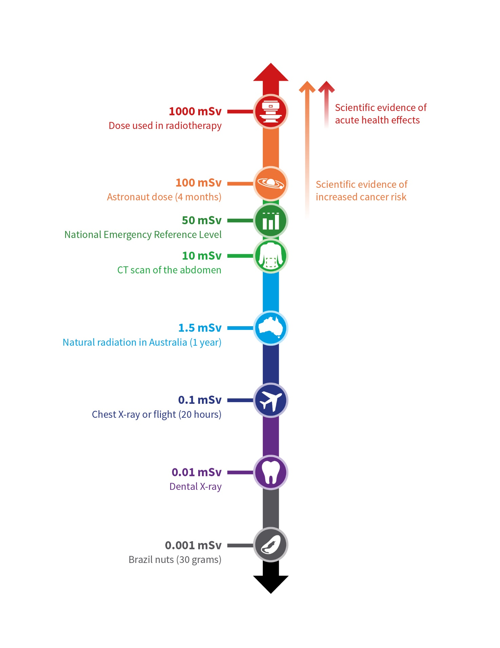

**Figure C.1**: Radiation health effects at different exposure levels.

# Glossary

Authorisation

The granting by a relevant regulatory authority of written permission for a responsible person to conduct specified activities.

Control

The function or power or (usually as controls) means of directing, regulating or restraining.

*Regulatory control*: Any form of control or regulation applied to facilities and activities by a regulatory body for reasons relating to nuclear safety and radiation protection or to nuclear security.

*Emergency Management Incident Control:* In Australia, the overall direction of response activities in an emergency, operating horizontally across agencies. Authority for control is established in legislation or in an emergency response plan, and carries with it the responsibility for tasking other agencies in accordance with the needs of the situation.

Deterministic effect

See ‘tissue reactions’.

Early protective actions

See ‘protective actions’.

Emergency

A non-routine situation (incident or accident) or event that necessitates prompt action, primarily to mitigate a hazard or adverse consequences for human health and safety, quality of life, property and the environment.

Emergency action level (EAL)

A specific, predetermined criterion for observable conditions used to detect, recognise and determine the emergency class.

Emergency arrangements

The integrated set of infrastructural elements, put in place at the preparedness stage, that are necessary to provide the capability for performing a specified function or task required in response to a nuclear or radiological emergency.

Emergency classification

The process whereby an authorised official classifies an emergency in order to declare the applicable emergency class.

Emergency exposure situation

A situation of exposure that arises as a result of an accident, a malicious act, or other unexpected event, and requires prompt action in order to avoid or to reduce adverse consequences.

Emergency plan

A description of the objectives, policy and concept of operations for the response to an emergency and of the structure, authorities and responsibilities for a systematic, coordinated and effective response. The emergency plan serves as the basis for the development of other plans, procedures and checklists.

Emergency planning distance

The extended planning distance (EPD) and the ingestion and commodities planning distance (ICPD).

Emergency planning zone

The precautionary action zone (PAZ) and the urgent protective action planning zone (UPZ).

Emergency preparedness

The capability to take actions that will effectively mitigate the consequences of an emergency for human health and safety, quality of life, property and the environment.

Emergency procedures

A set of instructions describing in detail the actions to be taken by emergency workers in an emergency.

Emergency response

The performance of actions to mitigate the consequences of an emergency for human health and safety, quality of life, property and the environment.

Emergency response action

An action to be taken in response to a nuclear or radiological emergency to mitigate the consequences of an emergency for human health and safety, quality of life, property and the environment.

Emergency response facility or location

A facility or location necessary for supporting an emergency response, for which specific functions are to be assigned at the preparedness stage, and which need to be usable under emergency conditions.

Emergency services

The local off-site response organisations that are generally available and that perform emergency response functions. These may include police, firefighters and rescue brigades, ambulance services and control teams for hazardous materials.

Emergency worker

A person having specified duties as a worker in response to an emergency.

Emergency workers may include workers employed, both directly and indirectly, by registrants and licensees, as well as personnel of response organisations, such as police officers, firefighters, medical personnel, and drivers and crews of vehicles used for evacuation.

Emergency workers may or may not be designated as such in advance to an emergency. Emergency workers not designated as such in advance of an emergency are not necessarily workers prior to the emergency.

Existing exposure situation

A situation of exposure that already exists when a decision on the need for control needs to be taken. Existing exposure situations include exposure to natural background radiation that is amenable to control; exposure due to residual radioactive material that derives from past practices that were never subject to regulatory control; and exposure due to residual radioactive material deriving from a nuclear or radiological emergency after an emergency has been declared to be ended.

Extended planning distance (EPD)

Area around a facility for which emergency arrangements are made to conduct monitoring following the declaration of a general emergency and to identify areas warranting emergency response actions to be taken off-site jurisdictions within a period following a significant radioactive release that would allow the risk of stochastic effects among members of the public to be effectively reduced.

Facilities and activities

A general term encompassing nuclear facilities, uses of all sources of ionising radiation, all radioactive waste management activities, transport of radioactive material and any other practice or circumstances in which people may be subject to exposure to radiation from naturally occurring or artificial sources.

First responders

The first members of an emergency service to respond at the site of an emergency.

Generic criteria

Levels for the projected dose, or the dose that has been received, at which protective actions and other response actions are to be taken.

Graded approach

An application of safety requirements that is commensurate with the characteristics of the facilities and activities or the source and with the magnitude and likelihood of the exposures.

Hazard assessment

Assessment of hazards associated with facilities, activities or sources within or beyond the borders of a State in order to identify:

1. those events and the associated areas for which protective actions and other response actions may be required within the state
2. actions that would be effective in mitigating the consequences of such events.

Helper in an emergency

Member of the public who willingly and voluntarily helps in the response to a nuclear or radiological emergency. Helpers in an emergency are to be made aware that they could be exposed to radiation while helping in response to a nuclear or radiological emergency.

Ingestion and commodities planning distance (ICPD)

Area around a facility for which emergency arrangements are made to take effective emergency response actions following the declaration of a general emergency in order to reduce the risk of stochastic effects among members of the public and to mitigate non radiological consequences as a result of the distribution, sale and consumption of food, milk and drinking water and the use of commodities other than food that may have contamination from a significant radioactive release.

Inner cordoned off area

An area established by first responders in an emergency around a potential radiation hazard, within which protective actions and other emergency response actions are taken to protect first responders and members of the public from possible exposure and contamination.

Justification

The process of determining for an emergency exposure situation or an existing exposure situation whether a proposed protective action or remedial action is likely, overall, to be beneficial; i.e. whether the expected benefits to individuals and to society (including the reduction in radiation detriment) from introducing or continuing the protective action or remedial action outweigh the cost of such action and any harm or damage caused by the action.

Management system

A set of interrelated or interacting elements (system) for establishing policies and objectives and enabling the objectives to be achieved in an efficient and effective manner.

Non-radiological consequences

Adverse psychological, societal or economic consequences of a nuclear or radiological emergency or of an emergency response affecting human health and safety, quality of life, property and the environment.

Notification

1. A report submitted promptly to a national or international authority providing details of an emergency or a possible emergency; for example, as required by the Convention on Early Notification of a Nuclear Accident.
2. A set of actions taken upon detection of emergency conditions with the purpose of alerting all organisations with responsibility for emergency response in the event of such conditions.

Notification point

A designated organisation with which arrangements have been made to receive notification (meaning (2)) and to initiate promptly the predetermined actions to activate a part of the emergency response.

Notifying state

The country that is responsible for notifying (see notification meaning (1)) potentially affected countries and the IAEA of an event of actual, potential or perceived radiological significance for other states. This includes:

1. The country that has jurisdiction or control over the facility or activity (including space objects) in accordance with Article 1 of the Convention on Early Notification of a Nuclear Accident

2. The country that initially detects or discovers evidence of a transnational emergency, for example by: detecting significant increases in atmospheric radiation levels of unknown origin; detecting contamination in transboundary shipments; discovering a dangerous source that may have originated in another country; or diagnosing clinical symptoms that may have resulted from exposure outside the country.

Nuclear or radiological emergency

An emergency in which there is, or is perceived to be, a hazard due to:

1. the energy resulting from a nuclear chain reaction or from the decay of the products of a chain reaction
2. radiation exposure.

Nuclear material

Includes plutonium (except that with isotopic concentration exceeding 80% in plutonium-238); uranium-233; uranium enriched in the isotope 235 or 233; uranium containing the mixture of isotopes as occurring in nature other than in the form of ore or ore residue; depleted uranium; thorium; any material containing one or more of the foregoing. For the purposes of IAEA safeguards agreements, see the Commonwealth Nuclear Non-Proliferation (Safeguards) Act 1987.

Nuclear security

The prevention and detection of, and response to, criminal or intentional unauthorised acts involving nuclear material, other radioactive material, associated facilities or associated activities.

Nuclear security event

An event that has potential or actual implications for nuclear security that must be addressed.4

Off-site jurisdiction

Any entity that has a defined emergency management role or responsibility beyond the site boundary or cordon of an emergency.

Off-site (area)

See ‘site (area)’.

On-site (area)

See ‘site (area)’.

Operating personnel

Individual workers engaged in the operation of an authorised facility or the conduct of an authorised activity.

Operating organisation

Any organisation or person applying for authorisation or authorised to operate an authorised facility or to conduct an authorised activity and responsible for its safety.

Operational criteria

Values of measurable quantities or observable conditions (i.e. observables) to be used in the response to a nuclear or radiological emergency in order to determine the need for appropriate protective actions and other response actions.

Operational intervention level (OIL)

A set level of a measurable quantity that corresponds to a generic criterion.

Optimisation (of protection and safety)

The process of determining what level of protection and safety would result in the magnitude of individual doses, the number of individuals (workers and members of the public) subject to exposure and the likelihood of exposure being ‘as low as reasonably achievable, economic and social factors being taken into account’ (ALARA).

Planned exposure situation

The situation of exposure that arises from the planned operation of a source or from a planned activity that results in an exposure due to a source. Since provision for protection and safety can be made before embarking on the activity concerned, associated exposures and their probabilities of occurrence can be restricted from the outset. The primary means of controlling exposure in planned exposure situations is by good design of installations, equipment and operating procedures. In planned exposure situations, a certain level of exposure is expected to occur.

Precautionary action zone (PAZ)

An area around a facility for which emergency arrangements have been made to take urgent protective actions in the event of a nuclear or radiological emergency to avoid or to minimise severe tissue reactions off-site jurisdictions. Protective actions within this area are to be taken before or shortly after a release of radioactive material or an exposure, on the basis of prevailing conditions at the facility.

Preparedness stage

The stage or phase at which arrangements for an effective emergency response are established prior to a nuclear or radiological emergency.

Projected dose

The dose that would be expected to be received if planned protective actions were not taken.

Protective action

An action for the purposes of avoiding or reducing doses that might otherwise be received in an emergency exposure situation or an existing exposure situation.

*Early protective action:* A protective action in the event of a nuclear or radiological emergency that can be implemented within days to weeks and still be effective.

*Mitigatory action:* Immediate action by the operator or other party:

1. to reduce the potential for conditions to develop that would result in exposure or a release of radioactive material requiring emergency response actions on-site or off-site  
   or
2. to mitigate source conditions that may result in exposure or a release of radioactive material requiring emergency response actions on-site or off-site.

*Urgent protective action:* A protective action in the event of a nuclear or radiological emergency which must be taken promptly (usually within hours to a day) in order to be effective, and the effectiveness of which will be markedly reduced if it is delayed.

Urgent protective actions include iodine thyroid blocking, evacuation, short term sheltering, actions to reduce inadvertent ingestion, decontamination of individuals and prevention of ingestion of food, milk or drinking water possibly with contamination.

*Precautionary urgent protective action:* Is an urgent protective action taken before or shortly after a release of radioactive material, or an exposure, on the basis of the prevailing conditions to avoid or to minimise severe tissue reactions.

Reference level

For an emergency exposure situation or an existing exposure situation, the level of dose, risk or activity concentration above which it is not appropriate to plan to allow exposures to occur and below which optimisation of protection and safety would continue to be implemented.

Regulatory body

The radiation protection authority or authorities designated, or otherwise recognised, for regulatory purposes in connection with protection and safety relating to applications of ionising radiation. A list of relevant regulatory authorities in Australia can be found on ARPANSA’s website at [www.arpansa.gov.au/Regulation/Regulators](http://www.arpansa.gov.au/Regulation/Regulators).

Residual dose

The dose expected to be incurred after protective actions have been terminated (or after a decision has been taken not to take protective actions). Residual dose applies for an existing exposure situation or an emergency exposure situation.

Response organisation

An organisation designated or recognised by a State as being responsible for managing or implementing any aspect of an emergency response. This also includes those organisations or services necessary to support the management and/or conduct of an emergency response, such as meteorological services.

Response time objectives

A set of pre-determined actions to be performed within set time-frames in order to achieve the goals of emergency response. RTOs should be incorporated during field exercises in order to validate the performance of preparedness arrangements.

Site area

A geographical area that contains an authorised facility, authorised activity or source, and within which the management of the authorised facility or authorised activity or first responders may directly initiate emergency response actions.

This is typically the area within the security perimeter fence or other designated property marker. It may also be the controlled area around a radiography source or an inner cordoned off area established by first responders around a suspected hazard.

*On-site (area):* (Area) within the site area.

*Off-site (area):* (Area) outside the site area.

Source

1. Anything that may cause radiation exposure — such as by emitting ionising radiation or by releasing radioactive substances or radioactive material — and can be treated as a single entity for purposes of protection and safety.

2. Radioactive material used as a source of radiation.

*Dangerous source:* A source that could, if not under control, give rise to exposure sufficient to cause severe tissue reactions. This categorisation is used for determining the need for emergency arrangements and is not to be confused with categorisations of sources for other purposes.

*Radioactive source:* A source containing radioactive material that is used as a source of radiation.

Special facility

A facility for which predetermined facility specific actions need to be taken if urgent protective actions are ordered in its locality in the event of a nuclear or radiological emergency.

Special population group

Members of the public for whom special arrangements are necessary in order for effective protective actions to be taken in the event of a nuclear or radiological emergency. Examples include persons with disabilities, hospital patients and prisoners.

Stochastic effect

A radiation induced health effect, the probability of occurrence of which is greater for a higher radiation dose and the severity of which (if it occurs) is independent of dose. Stochastic effects may be somatic effects or hereditary effects, and generally occur without a threshold level of dose. Examples include solid cancers and leukaemia.

Tissue reaction

Harmful reaction to radiation in a population of cells (tissue) where a threshold dose has to be exceeded for it to be expressed in a clinically relevant form, and where the severity of harm increases with the dose. Often used as synonymous to ‘deterministic effects’. Tissue reactions is the preferred term as the effect is susceptible to a range of modifiers, i.e. is not strictly predetermined.

Transient population group

Those members of the public who are residing for a short period of time (days to weeks) in a location (such as a camping ground) that can be identified in advance. This does not include members of the public who may be travelling through an area.

Transnational emergency

A nuclear or radiological emergency of actual, potential or perceived radiological significance for more than one country.

This may include:

1. a significant transboundary release of radioactive material (however, a transnational emergency does not necessarily imply a significant transboundary release of radioactive material)

2. a general emergency at a facility or other event that could result in a significant transboundary release (atmospheric or aquatic) of radioactive material

3. discovery of the loss or illicit removal of a dangerous source that has been transported across, or is suspected of having been transported across, a national border

4. an emergency resulting in significant disruption to international trade or travel

5. an emergency warranting the taking of protective actions for foreign nationals or embassies in the State in which it occurs

6. an emergency resulting in or potentially resulting in severe tissue reactions and involving a fault and/or problem (such as in equipment or software) that could have serious implications for safety internationally

7. an emergency resulting in or potentially resulting in great concern among the population of more than one Country owing to the actual or perceived radiological hazard

8. space-debris re-entry events are usually considered as transnational emergencies due to the significant speed of re-entry vehicles, the potential for release of radioactivity across vast distances into the atmosphere, and their unpredictable terminal landing sites.

*Significant transboundary release:* A release of radioactive material to the environment that may result in doses or levels of contamination beyond national borders from the release which exceed generic criteria for protective actions and other response actions, including food restrictions and restrictions on trade.

Urgent protective action

See ‘protective action’.

Urgent protective action planning zone (UPZ)

An area around a facility for which arrangements have been made to take urgent protective actions in the event of a nuclear or radiological emergency to avert doses off-site in accordance with international safety standards. Protective actions within this area are to be taken on the basis of environmental monitoring or, as appropriate, prevailing conditions at the facility.

Warning point

A designated organisation to act as a point of contact that is staffed or able to be alerted at all times for promptly responding to, or initiating a response to, an incoming notification, warning message, request for assistance or request for verification of a message, as appropriate, from the IAEA.

Worker

Any person who works, whether full time, part time or temporarily, for an employer and who has recognised rights and duties in relation to occupational radiation protection.

# References

ANSI 2012. American National Standards Institute 2012. *Nuclear Criticality Accident Emergency Planning and Response*. ANSI/ANS-8.23-2007 R2012. [https://webstore.ansi.org/standards/ansi/ansians232007r2012]

ARPANSA 2001. Australian Radiation Protection and Nuclear Safety Agency 2001. *Regulatory Guide: Regulatory assessment principles for controlled facilities*.  
[<https://www.arpansa.gov.au/sites/default/files/legacy/pubs/regulatory/applications/rb-std-42-00-rev1.pdf>]

ARPANSA 2014. Australian Radiation Protection and Nuclear Safety Agency 2014. *Fundamentals for Protection Against Ionising Radiation*. Radiation Protection Series F-1.  
[<https://www.arpansa.gov.au/regulation-and-licensing/regulatory-publications/radiation-protection-series/fundamentals/rpsf-1>]

ARPANSA 2015. Australia Radiation Protection and Nuclear Safety Agency 2015. *Guide for Radiation Protection of the Environment.* Radiation Protection Series G-1.

[<https://www.arpansa.gov.au/regulation-and-licensing/regulatory-publications/radiation-protection-series/guides-and-recommendations/rpsg-1>]

ARPANSA 2016. Australian Radiation Protection and Nuclear Safety Agency 2016. *Radiation Protection in Planned Exposure Situations*. Radiation Protection Series C-1. [<https://www.arpansa.gov.au/regulation-and-licensing/regulatory-publications/radiation-protection-series/codes-and-standards/rpsc-1>]

ARPANSA 2017. Australian Radiation Protection and Nuclear Safety Agency 2017. *Radiation Protection in Existing Exposure Situations*. Radiation Protection Series G-2. [<https://www.arpansa.gov.au/sites/g/files/net3086/f/rpsg-2-existing-exposure.pdf>]

ARPANSA 2019. Australian Radiation Protection and Nuclear Safety Agency 2019. *Guide for Radiation Protection in Emergency Exposure Situations - The Framework*. Radiation Protection Series G-3 Part 1.

COAG 2011. Council of Australian Governments 2011. *National Strategy for Disaster Resilience*. [<https://www.ag.gov.au/EmergencyManagement/Documents/NationalStrategyforDisasterResilience.PDF>]

DoH 2012. Department of Health 2012. *Australian Clinical Guidelines for Radiological Emergencies*. Commonwealth of Australia.  
[<http://www.health.gov.au/internet/publications/publishing.nsf/Content/ohp-radiological-toc>]

DoHS 2003. Department of Homeland Security 2003. *Radiological Emergency Preparedness: Planning and Preparing for a Fast Event*, US Federal Register 68 160 (2003) 49783–49784.   
[<https://www.gpo.gov/fdsys/pkg/FR-2003-08-19/pdf/03-21200.pdf>]

enHealth (2012). *Environmental Health Risk Assessment — Guidelines for assessing human health risks from environmental hazards*, Commonwealth of Australia.   
[<http://www.eh.org.au/resources/knowledge-centre/enhealth-national-documents>]

IAEA 2005. International Atomic Energy Agency 2005. *Generic Procedures for Medical Response During a Nuclear or Radiological Emergency*.   
[<https://www-pub.iaea.org/MTCD/Publications/PDF/EPR-MEDICAL-2005_web.pdf>]

IAEA 2006. International Atomic Energy Agency 2006. *Manual for First Responders to a Radiological Emergency.* EPR-First-Responders-2006.   
[<http://www-pub.iaea.org/MTCD/publications/PDF/EPR_FirstResponder_web.pdf>]

IAEA 2007. International Atomic Energy Agency 2007. *Arrangements for Preparedness for a Nuclear or Radiological Emergency*. Safety Guide Number GS-G-2.1.   
[<http://www-pub.iaea.org/MTCD/publications/PDF/Pub1265web.pdf>]

IAEA 2011. International Atomic Energy Agency 2011. *Criteria for Use in Preparedness and Response for a Nuclear or Radiological Emergency*. General Safety Guide Number GSG-2.   
[<https://www-pub.iaea.org/MTCD/Publications/PDF/Pub1467_web.pdf>]

IAEA 2013a. International Atomic Energy Agency 2013. *Actions to Protect the Public in an Emergency due to Severe Conditions at a Light Water Reactor*. IAEA EPR-NPP Public Protective Actions 2013.   
[<https://www-pub.iaea.org/MTCD/Publications/PDF/EPR-NPP_PPA_web.pdf>]

IAEA 2013b. International Atomic Energy Agency 2013. *IAEA Response Assistance Network* *for Use in Preparedness and Response for a Nuclear or Radiological Emergency*. EPR-RANET 2013.   
[<https://www-pub.iaea.org/MTCD/publications/PDF/EPR-RANET_2013_web.pdf>]

IAEA 2014. International Atomic Energy Agency 2014. *Radiation Protection and Safety of Radiation Sources: International Basic Safety Standards*. General Safety Requirements Part 3, Number GSR Part 3.  
[<http://www-pub.iaea.org/MTCD/publications/PDF/Pub1578_web-57265295.pdf>]

IAEA 2015a. International Atomic Energy Agency 2015. *Preparedness and Response for a Nuclear or Radiological Emergency.* General Safety Requirements, Number GSR Part 7.   
[<http://www-pub.iaea.org/MTCD/Publications/PDF/P_1708_web.pdf>]

IAEA 2015b. International Atomic Energy Agency 2015. *Risk informed approach for nuclear security measures for nuclear and other radioactive material out of regulatory control.* IAEA Nuclear Security Series Number 24-G. IAEA NSS 24-G.   
[<https://www-pub.iaea.org/MTCD/Publications/PDF/Pub1678_web.pdf>]

IAEA 2015c. International Atomic Energy Agency 2015. *Management of the interface between nuclear safety and security for research reactors.* IAEA-TECHDOC-1801.   
[<https://www-pub.iaea.org/MTCD/Publications/PDF/TE1801web.pdf>]

IAEA 2017. International Atomic Energy Agency 2017. *Guidelines on the Harmonization of Response and Assistance Capabilities for a Nuclear or Radiological Emergency.* Emergency Preparedness and Response, EPR-Harmonized Assistance Capabilities.   
[<https://www-pub.iaea.org/MTCD/Publications/PDF/EPR_HarmonizedAssis_2017_web.pdf>]

IAEA 2018. International Atomic Energy Agency 2018. *Arrangements for the Termination of a Nuclear or Radiological Emergency*. IAEA General Safety Guide Number GSG-11.   
[<https://www-pub.iaea.org/MTCD/Publications/PDF/PUB1796_web.pdf>]

ICRP 2007. International Commission on Radiological Protection 2007. *The 2007 Recommendations of the International Commission on Radiological Protection*. ICRP Publication 103.   
[<http://www.icrp.org/publication.asp?id=ICRP%20Publication%20103>]

ISO 2015. International Organization for Standardization 2015. *Quality management systems - requirements.* ISO 9001:2015.   
[<https://www.standards.org.au/>]

SA 2018. Standards Australia 2018. *General requirements for the competence of testing and calibration laboratories*. AS ISO/IEC 17025:2018.   
[<https://www.standards.org.au/>]

USEPA 2006. United States Environmental Protection Agency 2006. *Guidance on Systematic Planning Using the Data Quality Objectives Process*. EPA QA/G-4.  
[<https://www.epa.gov/sites/production/files/documents/guidance_systematic_planning_dqo_process.pdf>]

# Contributors to drafting and review

**Dr Fiona Charalambous** ARPANSA Radiation Health Services Branch

**Dr Rick Tinker** ARPANSA Radiation Health Services Branch

**Dr Marcus Grzechnik** ARPANSA Radiation Health Services Branch

**Dr Carl-Magnus Larsson** ARPANSA CEO

**Dr Stephen Solomon** ARPANSA Radiation Health Services Branch

**Mr Scott Muston** ARPANSA Radiation Health Services Branch

**Mr Stephen Marks** ARPANSA Radiation Health Services Branch

**Mr Blake Orr** ARPANSA Radiation Health Services Branch

**Mr Loch Castle** ARPANSA Regulatory Services Branch

**Mr Brendan Tate** ARPANSA Radiation Health Services Branch

**Mr David Urban** ARPANSA Radiation Health Services Branch

**Mr Thomas Sammut** Office of the CEO

1. Health is defined by the World Health Organization as a state of complete physical, mental and social well-being and not merely the absence of disease or infirmity.
2. Including nuclear security events.
3. A PAZ only applies to emergency preparedness category I for facilities (i.e. facilities with >100 MWth power generation).
4. Considering the scope of operation of the Australian facilities involving fissile material no facilities require criticality detection and alarm systems.
5. An all-hazard framework is the inclusion of all possible threat types in a threat or risk assessment. A threat or risk assessment may focus on specific types of threats, such as criminal activities, natural disasters or work safety. An assessment follows the all-hazards framework if it aims to include all types of threat, irrespective of its origination, and generate a balanced overview.
6. Observable indicators are noticeable or perceived changes of conditions of a facility, activity or on the scene, which should be used in decision making process during a nuclear or radiological emergency.
7. This should be accomplished as soon as possible. Over the past 30 years, the USA has demonstrated that this goal can be achieved within 15 minutes of detection of the event. This goal has been further formalised as part of the US emergency preparedness requirements in *Radiological Emergency Preparedness: Planning and Preparing for a Fast Event* (DoHS 2003).
8. For example, the urgent response phase may last just hours in the case of small-scale emergencies such as a radiological emergency during transport or radiological emergencies involving sealed dangerous sources.
9. For example, the early response phase may last hours to a day in the case of small scale emergencies such as a radiological emergency during transport or radiological emergencies involving sealed dangerous sources.
10. Indicated by a loss of critical safety functions needed to protect the core or large amounts of recently discharged fuel.
11. Involving release barriers, critical safety systems, instrumentation, staff, natural occurrences, fires, terrorist or criminal acts.