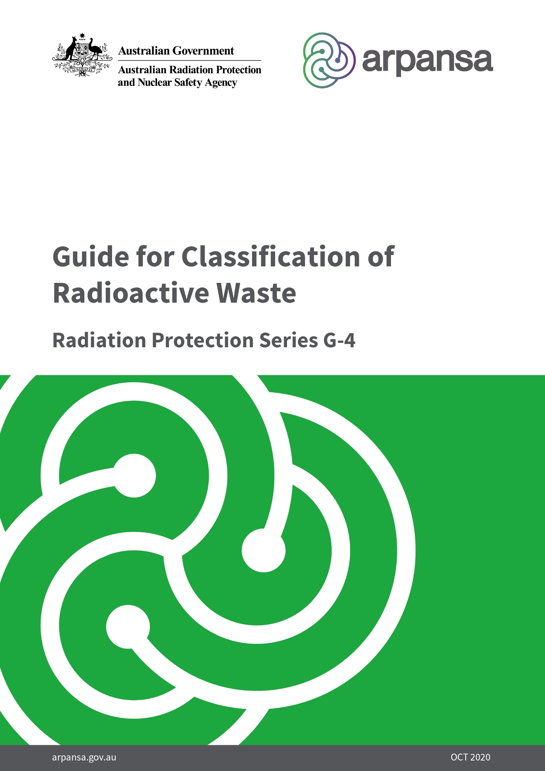

­

**Radiation Protection Series**

The Australian Radiation Protection and Nuclear Safety Agency (ARPANSA) publishes Fundamentals, Standards, Codes and Guides in the Radiation Protection Series (RPS), to promote national policies and practices that protect human health and the environment from the harmful effects of radiation. ARPANSA develops these publications jointly with state and territory regulators and other members of the Radiation Health Committee (RHC), which oversees the preparation of draft policies and standards with the view of their uniform implementation in all Australian jurisdictions. The Radiation Health and Safety Advisory Council advises the CEO of ARPANSA on adoption and publication of RPS documents on ARPANSA’s website.

When relevant for Australian circumstances, the RPS publications give effect in Australia to international standards and guidance. The sources of such standards and guidance are varied and include the International Commission on Radiological Protection (ICRP), the International Commission on Non-Ionizing Radiation Protection (ICNIRP), the International Atomic Energy Agency (IAEA), and the World Health Organization (WHO).

***Fundamentals*** set the fundamental principles for radiation protection and describe the fundamental radiation protection, safety and security objectives. They are written in an explanatory and non-regulatory style and describe the basic concepts and objectives of international best practice.

***Codes*** are regulatory in style and may be referenced by regulations or conditions of licence. They contain either general safety or security requirements which may be applicable for all dealings with radiation, or practice-specific requirements. They provide overarching requirements and are expressed as ‘must’ statements which are to be satisfied to ensure an acceptable level of safety and/or security.

***Standards*** provide a national reference point for radiation protection and safety. They mainly provide quantitative requirements, such as exposure limits and key procedural guidance regarded as essential for best practice in radiation protection. They may be referenced by regulators, authorities, industry and other stakeholders in State, Territory or Commonwealth jurisdictions.

***Guides*** provide recommendations and guidance on how to comply with the Codes and Standards or apply the principles of the Fundamentals. They are written in an explanatory and non-regulatory style and indicate the measures recommended to provide good practice. They are generally expressed as ‘should’ statements.

These four categories of publications are informed by public comment during drafting and are subject to a process of assessment of regulatory impact.

All RPS publications are available in electronic format, and can be downloaded free of charge from ARPANSA’s website at [www.arpansa.gov.au/regulation-and-licensing/regulatory-publications/radiation-protection-series](http://www.arpansa.gov.au/regulation-and-licensing/regulatory-publications/radiation-protection-series).

Further information can be obtained by telephoning ARPANSA on 1800 022 333 (free call within Australia) or +61 (03) 9433 2211, by visiting ARPANSA’s website [www.arpansa.gov.au](http://www.arpansa.gov.au) or by emailing ARPANSA at [info@arpansa.gov.au](mailto:info@arpansa.gov.au).

Contact details for state and territory regulators are available from ARPANSA’s website at <https://www.arpansa.gov.au/regulation-and-licensing/regulation/state-territory-regulators>

**Guide for Classification of Radioactive Waste**

***Radiation Protection Series G-4***

**October 2020**

**This publication was prepared jointly with the Radiation Health Committee. The Radiation Health and Safety Advisory Council advised the CEO to adopt the Guide.**

© Commonwealth of Australia 2020

This publication is protected by copyright. Copyright (and any other intellectual property rights, if any) in this publication is owned by the Commonwealth of Australia as represented by the Australian Radiation Protection and Nuclear Safety Agency (ARPANSA).



**Creative Commons**

With the exception of the Commonwealth Coat of Arms, any ARPANSA logos and any content that is marked as being third party material, this publication, *Guide for Classification of Radioactive Waste (2020)*, by the Australian Radiation Protection and Nuclear Safety Agency is licensed under a Creative Commons Attribution 3.0 Australia licence (to view a copy of the licence, visit [*http://creativecommons.org/licenses/by/3.0/au*](http://creativecommons.org/licenses/by/3.0/au)). It is a further condition of the licence that any numerical data referred to in this publication may not be changed. To the extent that copyright subsists in a third party, permission will be required from the third party to reuse the material.

In essence, you are free to copy, communicate and adapt the material as long as you attribute the work to ARPANSA and abide by the other licence terms. The works are to be attributed to the Commonwealth as follows:-

“© Commonwealth of Australia 2020, as represented by the Australian Radiation Protection and Nuclear Safety Agency (ARPANSA)”

The publication should be attributed as: Guide for Classification of Radioactive Waste (2020).

**Use of the Coat of Arms**

The terms under which the Coat of Arms can be used are detailed on the Department of the Prime Minister and Cabinet website ([www.dpmc.gov.au/government/commonwealth-coat-arms](http://www.dpmc.gov.au/government/commonwealth-coat-arms)).

Enquiries regarding the licence and any use of this report are welcome.

ARPANSA  
 619 Lower Plenty Road  
 YALLAMBIE VIC 3085

Tel: 1800 022 333 (Freecall) or +61 3 9433 2211  
  
 Email: [info@arpansa.gov.au](mailto:info@arpansa.gov.au)  
 Website: [www.arpansa.gov.au](http://www.arpansa.gov.au)

Acknowledgement of Country

ARPANSA respectfully acknowledges Australia's Aboriginal and Torres Strait Islander communities and their rich culture and pays respect to their Elders past and present. We acknowledge Aboriginal and Torres Strait Islander peoples as Australia’s first peoples and as the Traditional Owners and custodians of the land and water on which we rely.

We recognise and value the ongoing contribution of Aboriginal and Torres Strait Islander peoples and communities to Australian life and how this enriches us. We embrace the spirit of reconciliation, working towards the equality of outcomes and ensuring an equal voice.

# Foreword

The management of risks from ionising radiation requires actions that are based on fundamental principles of radiation protection, safety and security. The *Fundamentals for Protection Against Ionising Radiation,* RPS F-1 (ARPANSA 2014) provides an understanding of the effects of ionising radiation and associated risks for the health of people and of the environment, and outlines the principles that should be applied in the management of radiation risks. RPS F-1 is the top tier document in the Australian national framework for management of risks from ionising radiation and describes how radiation protection, safety and security can work individually and collectively to achieve the desired outcome in terms of protection of health and safety of people, and protection of the environment, from the harmful effects of ionising radiation.

One area that requires management of radiation risks is the generation, management and ultimate disposal of radioactive waste arising in industry, medicine and research. Some of this waste has such low activity content, sometimes after a period of decay storage, that it falls below regulatory concern and can be disposed of in conventional landfill facilities or discharged to the atmosphere or sewer. At the other end of the spectrum is radioactive waste that, because of its higher activity content, requires disposal in facilities that have been specifically designed with the radioactive properties of the waste in mind.

Various methods have evolved for classifying radioactive waste according to its physical, chemical and radiological properties. In 2010, ARPANSA published the *Safety Guide for Classification of Radioactive Waste*, RPS 20, taking into account the General Safety Guide No. GSG-1 *Classification of Radioactive Waste*, published by the International Atomic Energy Agency (IAEA) in 2009.

This Guide, *Classification of Radioactive Waste*, RPS G-4, updates and supersedes RPS 20. The text has been revised to improve clarity, and to reflect current concepts and the Australian context. The Guide sets out non-prescriptive, best-practice guidance for classifying radioactive waste, with primary focus on long term safety after disposal. The classification scheme supports implementation of the safety requirements outlined in the *Code for Disposal Facilities for Solid Radioactive Waste*, RPS C-3 (ARPANSA 2018).

ARPANSA, jointly with state and territory regulators and other members of the Radiation Health Committee (RHC), and with the contributors to drafting and review, developed this Guide, which was approved by the RHC in March 2020. A further edited version of the Guide was endorsed by the RHC for publication as RPS G-4 in October 2020.

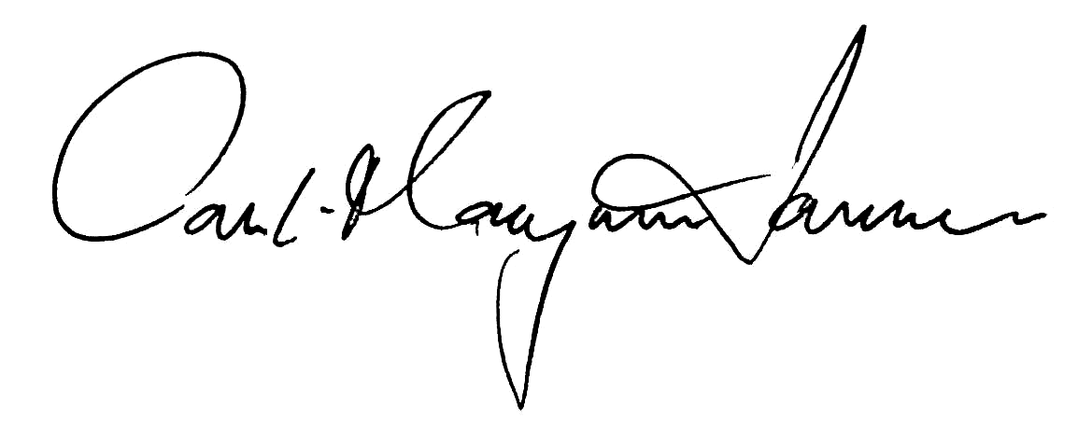

Carl-Magnus Larsson  
CEO of ARPANSA

22 October 2020

# Contents

**Foreword i**

**Contents ii**

**1. Introduction 1**

1.1 Citation 1

1.2 Background 1

1.3 Purpose 2

1.4 Scope 2

1.5 Interpretation 3

1.6 Structure 3

**2. Classification of radioactive waste: objectives and approach 4**

**3. The radioactive waste classification scheme 5**

3.1 Overview 5

3.2 Factors determining and defining classes of radioactive waste 7

**Annex 1 13**

Origin and types of radioactive waste 13

**References 18**

**Glossary 19**

**Contributors to drafting and review 23**

# Introduction

## Citation

This publication may be cited as the *Guide for Classification of Radioactive Waste (2020)*.

## Background

Radioactive waste is material for which no further use is foreseen, *and* which is not exemptorcleared[1] and thus requires specific management considerations based on its radioactive properties.

Radioactive waste is generated in numerous processes and activities, and arises in a variety of physical and chemical forms. It may contain, or be contaminated with, a wide range of radionuclidesin different amounts and concentrations.Different radioactive waste management solutions may need to be considered, depending on the properties of the waste. The recognised end state for the safe management of radioactive waste is disposal.

There are a number of conceptual and design alternatives for the safe disposal of radioactive waste, ranging from disposal in facilities on or near the surface to disposal in facilities located in stable geological formations at depths of several hundred metres. Safety requirements for disposal facilities for radioactive waste have been published in the *Code for Disposal Facilities for Solid Radioactive Waste*, RPS C-3[2] (ARPANSA 2018). When properly considered and implemented, these requirements provide assurance that the protection, safety and security objectives outlined in the *Fundamentals for Protection Against Ionising Radiation*, RPS F-1 (ARPANSA 2014) have been met. The understanding of the safety performance of the facility is supported by the safety assessment, which – together with other safety-relevant information – underpins the safety case for the facility.

An appropriate classification of the radioactive waste with regard to its properties and feasible disposal options, informs both the safety assessment and the safety case.

## Purpose

The purpose of this Guide is to set out a scheme for classifying radioactive waste that is based primarily on considerations of long term safety and disposal of the waste, and in that regard supports the practical implementation of the requirements of the *Disposal Facilities Code (2018)*.

The Guide provides guidance on the definition of different classes of waste and identifies the conceptual boundaries between the different classes. It is intended to assist the development and implementation of appropriate waste management strategies and to facilitate communication and information exchange within and among jurisdictions, as well as internationally.

This Guide supersedes the *Guide for Classification of Radioactive Waste*, RPS 20 (ARPANSA 2010).

## Scope

This Guide describes the classification of radioactive waste in Australia.

The classification scheme described in this Guide is focused on solid radioactive waste, however the fundamental approach is applicable to the management of liquid and gaseous waste. For liquid and gaseous waste, appropriate consideration should be given to treatment and conditioning of such waste to produce a solid waste form that is suitable for disposal, however this is outside the scope of this Guide.

This Guide applies to classification of solid (including solidified) radioactive waste arising in planned exposure situations. Planned exposure situations are covered in the *Code for Radiation Protection in Planned Exposure Situations* (ARPANSA 2020). This Guide also applies to waste resulting from incidents and accidents, waste from activities that were previously unregulated or not regulated to current standards, and waste left at abandoned sites (existing exposure situations).

Disposal at conventional landfill sites, discharges of liquid waste to the sewer or water bodies, and discharges of gaseous waste to the atmosphere, for which authorisations may not be required, are not covered in detail in this Guide. The *Code for Disposal of Radioactive Waste by the User*, RPS C-6[3] (ARPANSA 2018) sets out the requirements in Australia for disposal and discharges of radioactive material to landfill, sewer and the atmosphere for which no authorisation is required.

This Guide does not specifically deal with conditioning and storage of radioactive waste. Guidance can be found in the *Safety Guide for the Predisposal Management of Radioactive Waste*, RPS 16 (ARPANSA 2008).

## Interpretation

This publication provides guidance and not mandatory requirements. This guide is explanatory in nature and provides guidance on the classification of radioactive waste, based on international best practice that should be implemented by relevant parties where appropriate and/or practicable.

In applying this Guide, a regulatory body may determine that all or parts of the classification scheme do not apply to radioactive waste arising from mining and mineral processing within their jurisdiction.

## Structure

This document consists of three sections and one annex:

* Section 1 outlines the background, purpose and scope of this Guide.
* Section 2 outlines the objectives and approach.
* Section 3 outlines the scheme for classification of radioactive waste.
* Annex 1 describes origin of various types of radioactive waste with special reference to the Australian context.

A Glossary provides explanations of terms and concepts used in this Guide.

# Classification of radioactive waste: objectives and approach

A meaningful scheme for classification of radioactive waste should:

* cover the full range of radioactive waste types
* be of use at all stages of radioactive waste management and be able to address the interdependencies between them
* relate radioactive waste classes to the associated potential hazards for both present and future generations
* be flexible to serve specific needs
* be easy to understand
* be accepted as a common basis for characterising waste by regulators, operators, and other interested parties including the public.

While a classification scheme should aspire to achieve these objectives, it is not feasible to develop a unique scheme that, in every circumstance, fully satisfies all objectives. The boundaries between the classes should be viewed as transition zones whose precise determination will depend on the particular situation. Judgement needs to be applied to ensure rigour as well as simplicity, flexibility and broad applicability of the scheme, recognising that primary consideration should be given to long term safety. The waste should be classified according to the degree of containment and isolation required, with consideration given to the hazard of different types of waste, and to the magnitude and likelihood of exposures of people and the environment to radiation.

The radiation characteristics used in the classification scheme include the activity content of the waste (which can be expressed in terms of total activity or activity concentration), the half-lives of the radionuclides contained in the waste, and the hazards posed by different radionuclides including the types of radiation emitted. The implementation of the classification scheme should address these characteristics in a considered manner; for example, criteria specified in terms of total activity or activity concentration that would be suitable for bulk amounts of waste will generally not be applicable to disused sealed radioactive sources. Similarly, criteria used for waste containing naturally occurring radioactive material (NORM) may be different from those used for waste arising from medical, industrial and scientific applications.

While this guide and classification scheme apply to radiation characteristics and hazards, the waste holder also needs to consider the chemical and biological hazards posed by the waste, which can be more limiting than the radiation hazards.

Section 3 outlines how the properties of the waste as well as the disposal options, particularly with regard to containment and isolation of the waste from the biosphere over the time that the waste poses a hazard, inform the waste classification scheme.

# The radioactive waste classification scheme

## Overview

Six classes of radioactive waste have been identified. These classes take into consideration how different disposal solutions offer a level of isolation and containment that can achieve the protection, safety and security objectives for waste with different activity content and half-lives. Figure 1 provides a summary of the classification scheme. It should be noted that the delineations are not strict and can vary depending on factors that are further discussed in section 3.2.

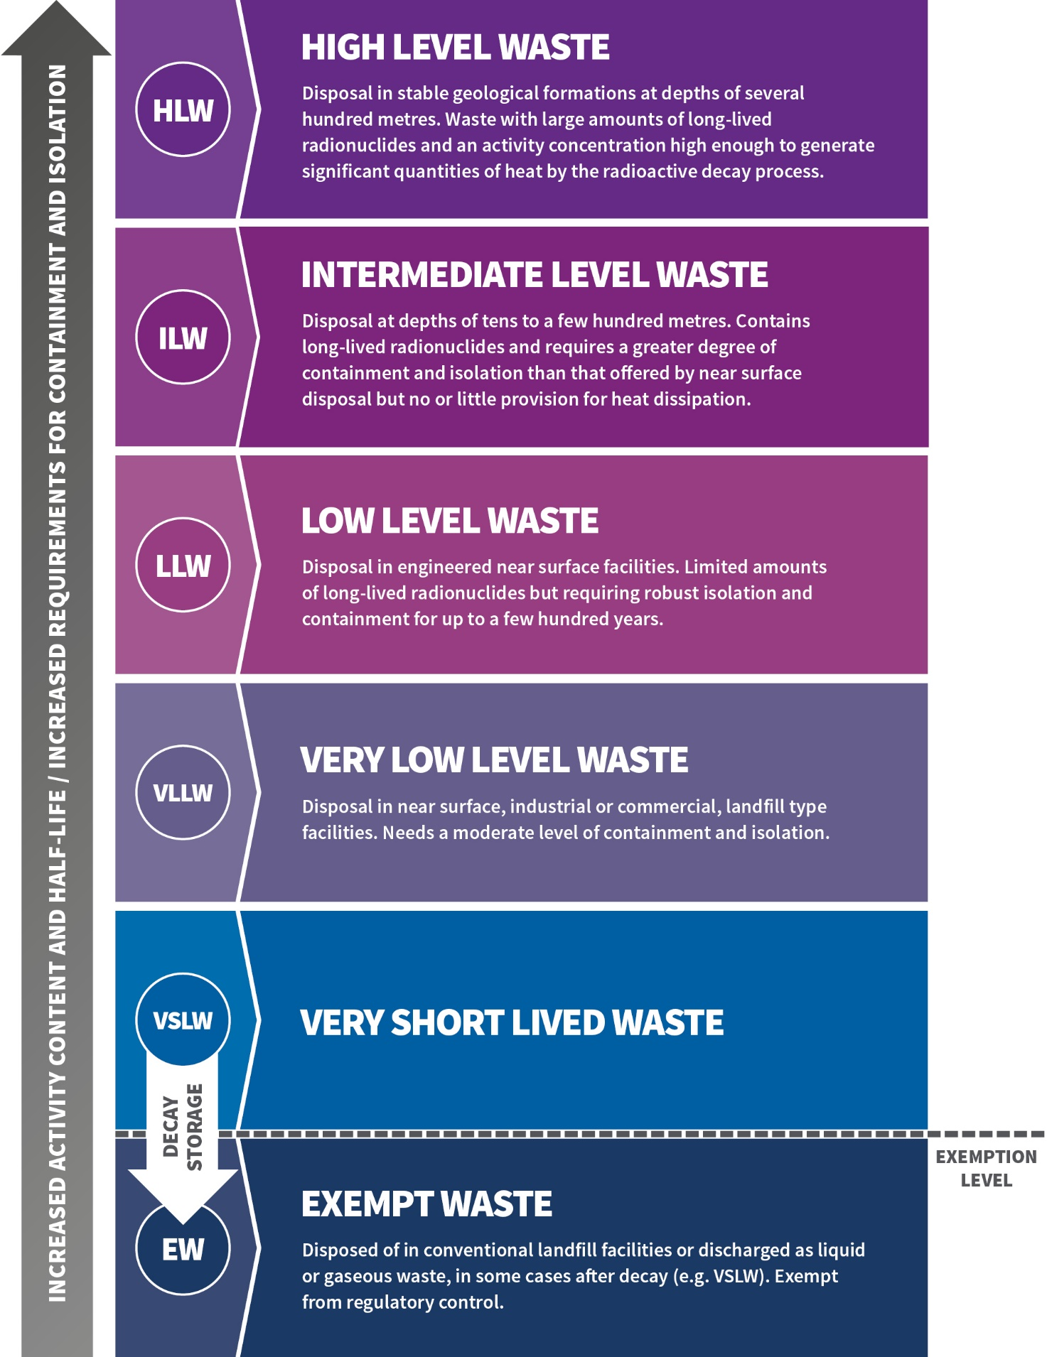

**Figure 1**: The six classes of radioactive waste. The figure illustrates in a generalised manner the relationship between classification, activity content, half-life, and disposal options. Regarding exemption (and clearance) levels, see   
section 3.2.1.

The activity content of radioactive waste can range from negligible to very high. The higher the activity content, the greater the need for containment and isolation. Below exemption levels, the management of the waste can be carried out without consideration of its radiological properties. Likewise, the half-lives of radionuclides contained in the waste can range widely, from short (seconds) to very long (millions of years). A conceptual illustration of the waste classification scheme that takes into account activity content (vertical axis) and half-life (horizontal axis) is presented in Figure 2.

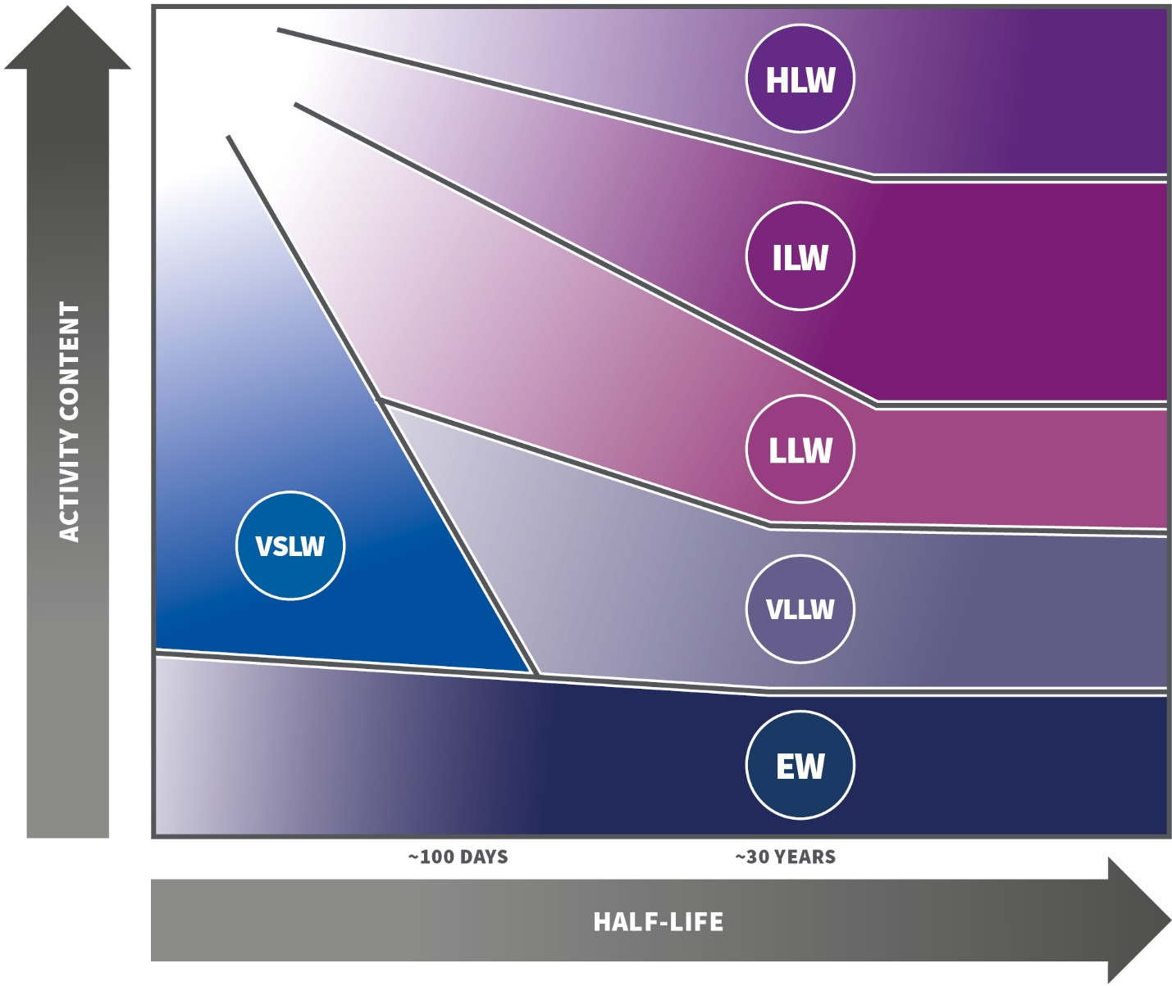

**Figure 2**: Conceptual illustration of the waste classification scheme, adapted from IAEA (2009). Note that the *activity content* can be expressed in terms of total activity or activity concentration.

## Factors determining and defining classes of radioactive waste

The level of isolation and containment required for disposal of radioactive waste in a given disposal facility will depend on the radiological, chemical and physical properties of the waste, as well as on the characteristics of the site. These matters are considered in detail in the safety assessment and safety case for the facility. It can be useful to make a distinction between waste containing radionuclides with half-lives of less than about 30 years, and waste with longer half-lives. The radiation from radionuclides with less than 30 years half-life is significantly reduced over a period of a few hundred years by radioactive decay (for example, after 300 years the activity would be 1/1000 or less of the original activity). There can be a certain degree of confidence that institutional control can be maintained and contribute to safety over such time frames, which makes it feasible to dispose the waste near or on the surface, whereas longer-lived waste would require disposal at greater depths.

A more detailed discussion of each waste class is provided below, outlining general boundary conditions. These may vary between different disposal facilities in accordance with the site-specific safety assessment and the safety case for the facility.

### Exempt waste (EW)

*Exempt waste (EW)* *meets the criteria for exemption from regulatory control for radiation protection purposes.*

Exempt waste contains low concentrations of radionuclides and does not require provisions for radiation protection, irrespective of whether the waste is disposed of in conventional landfills or recycled. Some material in this class may have been used or generated in activities and facilities that have been under regulatory control, and where the material has subsequently been cleared from regulatory control (see the Glossary for full definitions of the concepts of exemption and clearance). Material that is exempt (or cleared) does not require any further consideration from a regulatory control perspective, although special conditions may apply.

Generic criteria for exemption (and clearance) are available in Schedule I of the General Safety Requirements No. GSR Part 3 *Radiation Protection and Safety of Radiation Sources: International Basic Safety Standards*[4], published by the IAEA (2014).

Liquid or gaseous discharges to the environment at levels below those that require regulatory authorisation are analogous to disposal of exempt waste at landfill sites, in the sense that the discharged material require no further consideration from the perspective of radiation protection. The *User Disposal Code (2018)* provides information relevant to the disposal and discharge of radioactive material to landfill, sewer and the atmosphere for which no authorisation is required from the regulatory body.

### Very short lived waste (VSLW)

*Very short lived waste (VSLW)* *can be stored for decay over a period of up to a few years and subsequently be exempted from regulatory control for disposal, use or discharge. This class includes waste containing primarily radionuclides with very short half-lives, often used for industrial, medical and research purposes.*

This class contains radionuclides of very short half-life with activity concentrations above the exemption levels. Such waste can be stored until the activity has fallen beneath the levels for exemption, allowing for the waste to be managed as conventional waste. Retention before release is frequently used in the management of liquid and gaseous waste containing short-lived radionuclides, to allow decay before the waste is discharged.

The main criteria for classification as very short lived waste are the half-lives of the predominant radionuclides, and acceptability of the content of radionuclides with longer half-lives in the waste. Since the intent of storage for decay is to eventually exempt the material, possibly with conditions, acceptable concentration levels of longer half-life radionuclides are set by the exemption levels. Management of very short lived waste thus requires attention to the efficacy of the segregation processes by which the levels of such radionuclides are managed.

The boundary for the half-life of predominant radionuclides cannot be precisely specified because it depends on the planned duration of the storage and the initial activity concentration, as well as on other characteristics of the waste. In general, storage for decay is applied for waste containing radionuclides with half-lives of the order of 100 days or less.

### Very low level waste (VLLW)

*Very low level waste (VLLW)* *does not meet the criteria of exempt waste, and needs a moderate level of containment and isolation. Such waste is suitable for disposal in near surface, industrial or commercial, landfill type facilities with limited regulatory control. These facilities may also contain other hazardous waste. Typical waste in this class includes soil and rubble with low activity concentration levels. Concentrations of longer-lived radionuclides in this waste class are generally very low.*

Substantial amounts of very low level radioactive waste arise from medical, industrial and research practices, with activity concentrations in the waste at about or slightly above the exemption levels. Other such waste, for example NORM waste, may originate from the mining or processing of ores and minerals. Although the hazard posed by the radioactive properties is limited, the management of such waste requires considerations of radiation protection and safety.

An adequate level of safety for very low level waste may be achieved by its disposal in engineered surface landfill type facilities. The designs of such disposal facilities range from simple covers to more complex designs. Institutional control may be required for periods that are sufficiently long to provide confidence in compliance with the safety criteria governing the disposal of the waste.

Acceptance criteria for engineered surface landfill type facilities should be derived in order to determine their suitability for receiving very low level waste, either by using generic scenarios similar to those applied in the derivation of exemption levels or by undertaking a safety assessment in a manner approved by the regulatory body. The derived criteria will depend on the actual site conditions and the design of the engineered structures; or in the case of the use of generic scenarios, on the assumptions made to take account of these factors. For this reason, generally applicable criteria cannot be defined. Nevertheless, it is expected that with a level of engineering and controls consistent with industrial waste disposal, a landfill facility can safely accommodate waste containing short lived, artificial radionuclides with activity concentrations of one or two orders of magnitude above the levels for exempt waste and with limited total activity; and certain long lived radionuclides (such as NORM waste) where the total activity and the acceptable activity concentrations will be expected to be more limiting.

Depending on site factors and the design of the facility, it may be possible to demonstrate the safety of disposal of waste with higher activity concentrations. Factors to consider include the nature and thickness of the cover, configuration including restricting radioactive waste disposal to a portion of the landfill volume, leachate control, expected radiation exposures of the public, and the ability to cater for non-radiological hazards associated with the radioactive waste.

Incineration, dispersion in the atmosphere or disposal to sewer may also be options for some of the waste in this class, depending on the radiological properties and the physical, chemical and biological form of the waste. Another management option for some waste falling within this class, such as waste rock from mining operations, may be the authorised use of the material (e.g. for road construction). Clearance values for such waste treatment options can be derived from the *Basic Safety Standards (2014).*

### Low level waste (LLW)

*Low level waste (LLW) constitutes waste**that is above exemption levels, but with limited amounts of long lived radionuclides. Such waste requires robust isolation and containment for periods of up to a few hundred years and is suitable for disposal in engineered near surface facilities. This class covers a very broad range of waste. Low level waste may include short lived radionuclides at higher activity concentrations and long lived radionuclides, but only in relatively low activity concentrations.*

Low level waste contains such an amount of radioactive material that robust containment and isolation are required. Low level waste ranges from radioactive waste with an activity content just above the level for very low level waste, i.e. not requiring shielding or particularly robust containment and isolation, to radioactive waste with an activity concentration such that shielding and more robust containment and isolation are necessary for periods up to a few hundred years. This can be provided in engineered near surface disposal facilities.

Because low level waste may have a wide range of activity concentrations and may contain a wide range of radionuclides, there are various design options for near surface disposal facilities. These design options range from simple to more complex engineered facilities and could include shallow boreholes, and may involve disposal at varying depths, typically from the surface down to 30 metres. The waste acceptance criteria can vary between sites and will for a particular facility depend on the actual design of and planning for the facility (for example engineered barriers, duration of institutional control and site specific factors). The activity concentrations of long-lived radionuclides in individual waste packages may be restricted, and complemented by restrictions on average activity concentration and by placing more qualified waste at selected locations within the disposal facility. The design options will depend on the site characteristics and the safety assessments, all of which are captured in the safety case.

Although the waste may contain high concentrations of short-lived radionuclides, significant radioactive decay of these will occur during the period of reliable containment and isolation provided by the site, the engineered barriers and institutional controls. However, because low concentrations of long-lived radionuclides may be present, classification of waste as low level waste should relate to *all* radionuclides in the waste. Account should be taken of exposures resulting from long term migration of radionuclides from the disposal facility to the biosphere in the post-closure phase, and from human intrusion into the waste.

Contact radiation dose rate, while not necessarily a determining factor for the long-term safety of a disposal facility for low level waste, is an issue that has to be considered in handling and transporting the waste, and for operational radiation protection purposes at waste management and disposal facilities.

### Intermediate level waste (ILW)

*Intermediate level waste (ILW)**is waste**that, because of its activity content - particularly with regard to long lived radionuclides - requires a greater degree of containment and isolation than that provided by near surface disposal. Intermediate level waste needs little or no provision for heat dissipation during its storage and disposal. It may contain alpha emitting radionuclides that will not decay to an activity concentration acceptable for near surface disposal during the time for which institutional control can be relied upon. Therefore, waste in this class requires disposal at greater depths, in the order of tens of metres to a few hundred metres.*

Intermediate level waste is defined as waste that contains long lived radionuclides in quantities that need a greater degree of containment and isolation from the biosphere than provided by near surface disposal. Disposal at a depth of between a few tens and a few hundreds of metres would be required to provide the necessary level of containment and isolation.

Disposal at such depths has the potential to provide a long period of isolation from the accessible environment, provided the natural barriers and the engineered barriers of a disposal system are selected and designed properly, and the waste is conditioned to produce a long term stabilised waste form within suitable packaging. There is generally no detrimental effect of erosion on safety of the facility at such depths in the short to medium term and the likelihood of inadvertent human intrusion is greatly reduced. Consequently, long term safety will not depend on the presence of institutional controls.

The boundary between the low level waste and intermediate level waste classes cannot be precisely specified in terms of activity concentration levels, because allowable levels will depend on the actual waste disposal concept and design, including the safety case and supporting safety assessment. Pending waste facility specific information, generic safety cases may be used to determine whether certain waste constitutes low level waste or intermediate level waste.

### High level waste (HLW)

*High level waste (HLW) exhibits**activity concentration levels high enough to generate significant quantities of heat by the radioactive decay process or large amounts of long lived radionuclides that need to be considered in the design of a disposal facility for such waste. Disposal in deep, stable geological formations, usually several hundred metres below the surface, is the generally recognised option for disposal of high level waste.*

High level waste is defined as waste that contains such large concentrations of both short and long lived radionuclides that, compared to intermediate level waste, a greater degree of containment and isolation from the biosphere is needed to ensure long term safety. High level waste generates significant quantities of heat from radioactive decay, and normally continues to generate heat for several centuries.

High level waste typically has levels of activity concentration of in the range of 104 - 106 terabecquerel/m3 (e.g. for fresh spent fuel from power reactors)[5]. High level waste includes conditioned waste arising from the reprocessing of spent fuel together with any other waste requiring a comparable degree of containment and isolation. At the time of disposal, following a few decades of cooling time, waste containing such mixed fission products typically has activity concentration levels of around 104 TBq/m3. For the purposes of communication, national authorities may determine that certain waste constitutes intermediate level waste or high level waste on the basis of the properties of the waste and generic safety cases.

Annex 1 provides information regarding the management of spent fuel and reprocessing waste, including its classification, in Australia.

# Annex 1

## Origin and types of radioactive waste

Most practices involving the use of radioactive material result in the generation of radioactive waste. The waste is as varied in form, activity content, half-lives and contamination levels; as it is in type of generating activities. It may be solid, liquid or gaseous. Practices and sources of radioactive waste include:

* medical, industrial or research use of radioisotopes and sealed radioactive sources
* operation of reactors
* mining and processing (mostly large scale) of mineral ores or other materials containing naturally occurring radioactive material (NORM), which in some cases should be managed as radioactive waste
* remediation after accidents or past practices
* disused sealed radioactive sources, including orphan sources.

This Annex briefly describes the major waste-generating practices and types of radioactive waste generated, with reference to the Australian context as relevant.

**Waste from mining and minerals processing containing elevated levels of naturally occurring radionuclides**

*Mining and processing of uranium*. The initial step in the nuclear fuel cycle is the mining of uranium ores that are then used to produce nuclear fuel. The ores from which uranium is to be separated are sent to mills for processing, usually consisting of crushing and chemical processing. After removal of the uranium, the residues (tailings) contain little of the parent nuclide of the decay chain of the mined element, but they still contain most of its decay products. Some of the decay products may be more susceptible to leaching and emanation from the tailings than from the original ore. Additionally, tailings from processing can contain significant amounts of hazardous chemicals, including heavy metals such as copper, arsenic, molybdenum and vanadium; these need to be considered in assessing the safety of planned management options.

The mined materials not subjected to further processing are generally accumulated as waste rock piles, usually in close proximity to the mines. The waste rock, or mullock, resulting from the mining of uranium and thorium ores generally contain elevated levels of NORM and need to be managed as radioactive waste for radiation protection and safety reasons.

*Extraction and processing of other NORM-containing materials*. These materials include phosphate minerals, mineral sands, some gold-bearing rocks, coal, and oil and gas. The concentration of the radionuclides in these waste streams may exceed the levels for exempt waste. Of particular relevance are the often large volumes of material and the long half-lives of the radionuclides present in the waste. Some scales arising in the oil and gas industry may have high activity concentration levels that necessitate management as low level waste, or - in some cases - as intermediate level waste.

While the classification scheme described in Section 3 covers waste from extraction and processing of materials containing NORM, there is increased awareness that specific regulatory considerations and control may be necessary to ensure safety. Further guidance can be found in the *Code of Practice and Safety Guide for Radiation Protection and Radioactive Waste Management in Mining and Mineral Processing*, RPS 9 (ARPANSA 2005); and in the *Safety Guide for the Management of Naturally Occurring Radioactive Material (NORM)*, RPS 15 (ARPANSA 2008).

**Waste from institutional practices**

Institutional uses of radioactive materials include practices in the fields of research, industry and medicine. These practices, particularly in the field of research, are very varied and result in the generation of waste of different classes. Institutional waste can be generated in gaseous, liquid or solid form.

*Spent fuel from research reactors.* The Australian Nuclear Science and Technology Organisation (ANSTO) possesses the only facilities in Australia for managing nuclear fuel, including the spent fuel (sometimes referred to as used fuel or irradiated fuel) from the research reactors once operated, or currently operated, at ANSTO’s Lucas Heights Facilities.

No spent fuel is designated for direct disposal in Australia. The spent fuel contains uranium-235 and plutonium-239 that can be recovered by reprocessing the spent fuel, for reuse in the fabrication of new nuclear fuel, and is therefore not classified as radioactive waste while stored in Australia or in transit from Australia. Arrangements are in place for reprocessing of the spent fuel generated at ANSTO’s research reactors in overseas facilities, and for return of the reprocessing waste (minus the fissile material retained by the operator of the reprocessing facility) to Australia.

Heat generation is a characteristic of spent fuel and high level waste; other waste may also generate heat, albeit at lower levels. The amount of heat generated is dependent upon the types and amounts of radionuclides in the waste (half-life, decay energy, activity concentration, total activity, etc.). Consideration of factors governing heat removal (thermal conductivity, storage geometry, ventilation, etc.) is important to manage the risk of impact of heat build-up on engineered barriers. The significance of heat generation on the barriers cannot be defined by means of a single parameter value and can vary by several orders of magnitude depending on the influencing parameters and the methods in place for heat removal. Management of decay heat should be considered if the thermal power of waste packages reaches several W/m3. More restrictive values may apply, particularly in the case of waste containing long-lived radionuclides.

At the time of publication of RPS G-4 (October 2020), vitrified waste from reprocessing of research reactor fuel is stored in a single dual-purpose transport and storage cask, together with less qualified ‘technological waste’ stored in containers, at the Interim Waste Store operated by ANSTO at its Lucas Heights site, NSW. The properties of the vitrified waste, including activity concentration and thermal emission, are such that the waste is classified as intermediate level waste, at the higher end of the intermediate level waste range. Further shipments of reprocessing waste are planned to take place over a period of several decades; consideration will be given to the classification of that waste as plans for its return mature.

*Other waste from research reactors*. The waste generated by the operation of ANSTO’s OPAL reactor comprises predominantly low level solid wastes and a smaller volume of intermediate level waste. The low level waste consists of materials used in routine, day-to-day operation of the reactor facility, such as used personal protective equipment (overshoes, coats, etc.), contaminated processing items (vials, pipettes, plastic tubing), papers, towels and tissue paper, and spent ion exchange resins.

Other items, which constitute only a small volume, generated by OPAL and that may be classified as intermediate level waste include activated stainless steel components (including irradiation rigs), used thermocouples, used control rods, and spent ion exchange resins.

*Waste from the production and use of radioisotopes****.*** The type and volume of waste generated depends on the radioisotope and its production method. The volume of radioactive waste generated from the reactor production process is significantly greater than the waste generated from the accelerator production process. The reactor irradiation of uranium targets to produce molybdenum-99 by nuclear fission and the subsequent separation of molybdenum-99 from the targets results in low and intermediate level solid and liquid wastes. The waste generated from the accelerator production process principally contains short-lived radionuclides.

The use of radioisotopes may generate small volumes of waste. The type and volume of waste generated will depend on the application.

*Waste from decommissioning of nuclear installations (research reactors).* At the end of the useful life of a nuclear installation, administrative and technical actions are taken to allow the removal of some or all of the regulatory requirements from the facility. The decontamination and dismantling of a nuclear facility and the clean-up of the site will lead to the generation of radioactive waste that may be activated or contaminated and may vary greatly in type, activity concentration, size and volume. It may consist of solid materials such as process equipment, construction materials, tools and soils.

The largest volumes of waste from the dismantling of nuclear installations will mainly be very low level waste and low level waste. To reduce the amount of radioactive waste, decontamination of materials is widely applied. Liquid and gaseous waste streams may also originate from decontamination processes.

*Waste from decommissioning of radionuclide laboratories and other facilities.* Other facilities where unsealed radioactive materials are used, handled or stored such as radionuclide laboratories in hospitals, universities, and research institutes will also require decommissioning. The waste generated may be similar to that arising from the decommissioning of research reactors; however, the volumes of waste generated will be substantially smaller.

*Waste from university and medical radionuclide laboratories.* Typical wastes from medical and research laboratory use are very diverse but are generally either of short half-life (e.g. technetium-99m, the decay product of molybdenum-99, used in nuclear medicine) or of low activity or activity concentration (e.g. radium check sources, radio-immunoassay kits, carbon-14 tracers, tritium (hydrogen-3) in blood samples). Volumes of such waste tend to be small from a single laboratory). Some waste may be sent for chemical processing e.g. for reclamation of scintillant.

Some of the uses involve exempt quantities of radioactive materials. Some of the applications result in waste that can be stored until it decays to below the exemption levels. Others result in waste that can be disposed of as per the *User Disposal Code* (ARPANSA, 2018), utilising all options of disposal to landfill, venting to atmosphere, incineration or disposal to sewer. A few applications, involving higher activities of long lived isotopes, may result in waste that requires disposal in a near surface facility. Generally, therefore, this type of waste is either exempt, very short lived waste or very low level waste, with only a small percentage being low level waste.

**Radioactive material in the environment**

Radioactive residues have been deposited on the earth’s surface as a result of a variety of practices including residues from nuclear weapon testing and past practices, such as uranium mining, which were subject to less stringent regulatory control than that required by present day safety standards. The waste arising from remediation operations will have to be managed as radioactive waste and either stabilised in-situ or disposed of in an appropriate disposal facility. These circumstances are treated as existing exposure situations; guidance is provided in *Guide for Radiation Protection in Existing Exposure Situations*, RPS G-2 (ARPANSA 2017).

**Disused sealed radioactive sources.**

Sealed radioactive sources are characterised by the concentrated nature of their radioactive contents and are widely used in medical and industrial applications. They may still be hazardous at the end of their useful lives and will require appropriate management, as they can contain large and highly concentrated amounts of a single radionuclide. They may not meet the waste acceptance criteria for near surface disposal facilities, even when the radionuclide is not particularly long lived, and may thus require disposal at greater depths.

Sources may be described according to the activity and half-life of the radionuclides they contain. Sources containing radionuclides with half-lives of less than 100 days are considered very short lived waste and may be stored for decay and eventually disposed of as exempt waste. Other sources have longer half-lives and other management options will be required. Examples of sealed sources are provided in Table 1.

**Table 1** - Examples of disused sealed radioactive sources

| **No.** | **Half-life** | **Activity** | **Volume** | **Example** |
| --- | --- | --- | --- | --- |
| i | <100 d | 100 MBq | Small | Y-90, Au-198 (brachytherapy) |
| ii | 5 TBq | Small | Ir-192 (brachytherapy) |
| iii | <30 y | <10 MBq | Small | Co-60, H-3 (tritium targets), Kr-85 |
| iv | <100 TBq | Small | Co-60 (irradiators) |
| v | 30 y | <1 MBq | Small | CS-137 (brachytherapy, moisture density detectors) |
| vi | $<$ 1 PBq | Small | Cs-137 (irradiators), Sr-90 (thickness gauges, radioisotope thermoelectric generators (RTGs)) |
| vii | >30 y | <40 MBq | Small, but may be large numbers of sources | Pu-238, Am-241, Ra-226 (static eliminators) |
| viii | <10 GBq | Am-241, Ra-226 (gauges) |

Figure 3 illustrates how the sealed sources summarised in Table 1 fit within the conceptual relationship between activity content, half-life and waste class; outlined in Figure 2 of this publication.

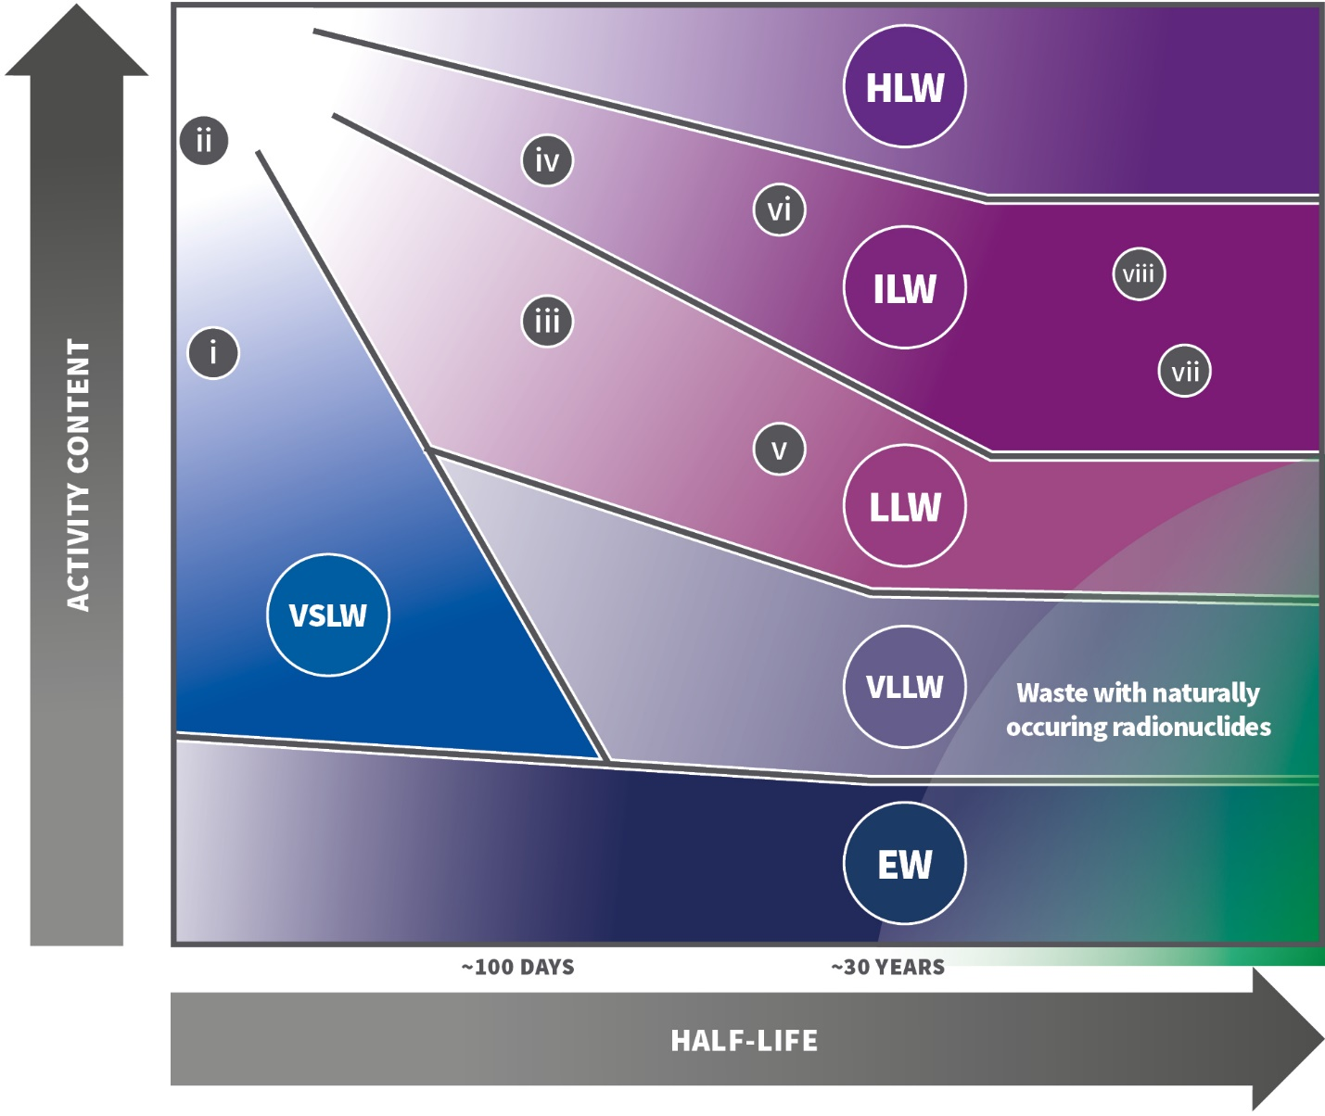

**Figure 3.** Application of the waste classification scheme (see Figure 2) to the sources listed in Table 1.

# References

Australian Radiation Protection and Nuclear Safety Agency (ARPANSA) 2005. [Code of Practice and Safety Guide for Radiation Protection and radioactive Waste Management in Mining and Milling Processing. Radiation Protection Series No. 9.](https://www.arpansa.gov.au/regulation-and-licensing/regulatory-publications/radiation-protection-series/codes-and-standards/rps9)

Australian Radiation Protection and Nuclear Safety Agency (ARPANSA) 2008. [Safety Guide for the Management of Naturally Occurring Radioactive Material (NORM), Radiation Protection Series No. 15.](https://www.arpansa.gov.au/regulation-and-licensing/regulatory-publications/radiation-protection-series/guides-and-recommendations/rps15)

Australian Radiation Protection and Nuclear Safety Agency (ARPANSA) 2008. [Safety Guide for the Predisposal Management of Radioactive Waste, Radiation Protection Series No. 16.](https://www.arpansa.gov.au/regulation-and-licensing/regulatory-publications/radiation-protection-series/guides-and-recommendations/rps16)

Australian Radiation Protection and Nuclear Safety Agency (ARPANSA) 2010. [Safety Guide for Classification of Radioactive Waste, Radiation Protection Series No. 20.](https://www.arpansa.gov.au/regulation-and-licensing/regulatory-publications/radiation-protection-series/guides-and-recommendations/rps20)

Australian Radiation Protection and Nuclear Safety Agency (ARPANSA) 2014. [Fundamentals for Protection Against Ionising Radiation, Radiation Protection Series F-1.](https://www.arpansa.gov.au/regulation-and-licensing/regulatory-publications/radiation-protection-series/fundamentals/rpsf-1)

Australian Radiation Protection and Nuclear Safety Agency (ARPANSA) 2017. [Guide for Radiation Protection in Existing Exposure Situations, Radiation Protection Series G-2.](https://www.arpansa.gov.au/regulation-and-licensing/regulatory-publications/radiation-protection-series/guides-and-recommendations/rpsg-2)

Australian Radiation Protection and Nuclear Safety Agency (ARPANSA) 2018. [Code for Disposal Facilities for Solid Radioactive Waste, Radiation Protection Series C-3](https://www.arpansa.gov.au/regulation-and-licensing/regulatory-publications/radiation-protection-series/codes-and-standards/rpsc3).

Australian Radiation Protection and Nuclear Safety Agency (ARPANSA) 2018. [Code for the Disposal of Radioactive Waste by the User, Radiation Protection Series C-6](https://www.arpansa.gov.au/regulation-and-licensing/regulatory-publications/radiation-protection-series/codes-and-standards/rpsc-6).

Australian Radiation Protection and Nuclear Safety Agency (ARPANSA) 2020. [Code for Radiation Protection in Planned Exposure Situations, Radiation Protection Series C-1 (Rev. 1).](https://www.arpansa.gov.au/regulation-and-licensing/regulatory-publications/radiation-protection-series/codes-and-standards/rpsc-1)

International Atomic Energy Agency (IAEA) 2009. [Classification of Radioactive Waste, IAEA Safety Standards Series No. GSG-1.](https://www.iaea.org/publications/8154/classification-of-radioactive-waste)

**International Atomic Energy Agency (IAEA) 2014**. [Radiation Protection and Safety of Radiation Sources: International Basic Safety Standards. General Safety Requirements No. GSR Part 3](https://www.iaea.org/publications/8930/radiation-protection-and-safety-of-radiation-sources-international-basic-safety-standards)**.**

# Glossary

**Activity**

The quantity of a radionuclide in a given energy state at a given time, defined as the number of spontaneous nuclear transformations from the given energy state per second. The SI unit for activity is reciprocal second (s–1), termed the *becquerel* *(Bq)*.

**Activity content**

The amount of activity (becquerel) in the material in question; in this publication also used as a collective term that includes *total activity* (the activity contained in the entire mass of radioactive material) and the *activity* concentration (the activity per unit mass of the radioactive material).

**becquerel (Bq)**

The SI unit of activity, equal to one (transformation) per second.

**Biosphere**

The regions of the surface (land, sea) and atmosphere of the earth occupied by living organisms.

**Clearance**

See exemption and clearance.

**Conditioning**

Those operations that produce a waste package suitable for handling, transport, storage and/or disposal. Conditioning may include the conversion of the waste to a solid waste form, enclosure of the waste in containers and, if necessary, provision of an overpack.

**Containment**

Methods or physical structures designed to prevent or control the release and the dispersion of radioactive substances.

**Decay chain**

A series of radionuclides, each of which (except for the first, or parent) is formed as a result of the radioactive decay of the previous member of the chain.

**Disposal**

Emplacement of waste in a purpose-built facility, which will eventually be closed, without any intention of retrieval of waste packages or recovery of the radioactive material in it for any purpose.

**Exemption and clearance**

*Exemption*: the determination by the regulatory body that a source or practice need not be subject to some or all aspects of regulatory control on the basis that the exposure and the potential exposure due to the source or practice are too small to warrant the application of those aspects or that this is the optimum option for protection irrespective of the actual level of the doses or risks.

*Clearance*: the removal of radioactive material or radioactive objects within authorised practices from any further regulatory control by the regulatory body.

*Clearance level*: a value, established by the regulatory body and expressed in terms of activity concentration and/or total activity, at or below which regulatory control may be removed from a source of radiation within a notified or authorised practice.

For the purpose of this guide, *exemption* is used as a generic term (e.g. ‘exempt waste’), unless the context requires specification.

Detailed and generic advice on *exemption* and *clearance* are provided in the *International Basic Safety Standards (2014)*.

**Existing exposure situation**

A situation of exposure that already exists when a decision on the need for control needs to be taken, including prolonged exposure situations after emergencies.

Existing exposure situations include exposures to natural background radiation that is amenable to control; exposure due to residual radioactive material that derives from past practices that were never subject to regulatory control; and exposure due to residual radioactive material deriving from a nuclear or radiological emergency after an emergency has been declared to be ended.

**Hazard**

The potential for harm or other detriment; a factor or condition that might operate against safety.

**Institutional control**

Control of a radioactive waste site by an authority or institution designated under the laws of a jurisdiction. Control may be active (monitoring, surveillance, remedial work) or passive (land use control) and may be a determining factor in the design of a facility (e.g. a near surface disposal facility).

**Interdependencies**

In radioactive waste generation and management systems, where two or more actions or options at different steps of the process have a dependency (impact) on each other, requiring consideration of protection, safety and security implications of different actions or options in a holistic manner.

**Isolation**

The physical separation and retention of radioactive waste away from people and from the environment.

**Naturally occurring radioactive material (NORM)**

Radioactive material containing no significant amounts of radionuclides other than naturally occurring radionuclides.

**Optimisation (of protection and safety)**

The process of determining what level of protection and safety would result in the magnitude of individual doses, the number of individuals (workers and members of the public) subject to exposure and the likelihood of exposure being ‘as low as reasonably achievable, economic and societal factors being taken into account’ (ALARA).

**Orphan source**

A radioactive source which is not under regulatory control, either because it has never been under regulatory control or because it has been abandoned, lost, misplaced, stolen or otherwise transferred without proper authorisation.

**Planned exposure situation**

A situation involving the deliberate introduction and operation of sources. Planned exposure situations may give rise both to exposures that are anticipated to occur (normal exposures) and to exposures that are not anticipated to occur (potential exposures).

**Radioactive waste**

Radioactive waste is defined for regulatory purposes as material for which no further use is foreseen that contains, or is contaminated with, radionuclides at concentrations or activities greater than clearance levels as established by the regulatory body. Radioactive waste comprises radioactive material in solid, liquid or gaseous form.

**Radionuclide**

A radionuclide (radioactive nuclide, radioisotope or radioactive isotope) is an atom that has excess nuclear energy, making it unstable. Thus radionuclides undergo radioactive ‘decay’, emitting ionising radiation in the process.

**Reprocessing**

A process or operation, the purpose of which is to extract radioactive isotopes from spent fuel for further use.

**Safety assessment**

A systematic assessment of radiation hazards that forms the main component of a safety case. It involves the quantification of radiation dose and radiation risks that may arise from the disposal facility for comparison with dose and risk criteria, and provides an understanding of the behaviour of the disposal facility under normal conditions and disturbing events over the periods for which the radioactive waste remains hazardous. The safety assessment has to include a safety analysis, which consists of a set of different quantitative analyses for evaluating and assessing challenges to safety in various operational states, anticipated operational occurrences and accident conditions, by means of deterministic and probabilistic methods.

**Safety case**

A collection of arguments and evidence in support of the safety of a facility and/or activity. This will normally include the findings of a safety assessment and a statement of confidence in these findings together with any safety analysis report that is a regulatory requirement. For a disposal facility, the safety case may relate to a given stage of development. In such cases, the safety case should acknowledge the existence of any unresolved issues and should provide guidance for work to resolve these issues in future development stages.

**Scale**

Solid deposits that grow over time, blocking and hindering fluid flow through pipelines, valves, pumps etc. used in the oil and gas industry, with significant reduction in production rates and equipment damage. The deposits may contain significant amounts of naturally occurring radioactive material.

**Sealed radioactive source**

A radioactive source in which the radioactive material is:

* + - 1. permanently sealed in a capsule  
         or
      2. closely bonded and in a solid form.

**Segregation**

An action where types of waste or material (radioactive or exempt) are separated or are kept separate on the basis of radiological, chemical and/or physical properties, to facilitate waste handling and/or processing.

**Spent fuel**

Nuclear fuel that has been irradiated in and permanently removed from a reactor core and that is no longer usable in its present form.

**Storage**

The holding of radioactive sources, radioactive material, spent fuel or radioactive waste in a facility that provides for their/its containment, with the intention of retrieval.

**Waste acceptance criteria (WAC)**

Quantitative or qualitative criteria specified by the regulatory body, or specified by an operator and approved by the regulatory body, for the waste form and waste package to be accepted by the operator of a waste management facility.

**Waste package**

The product of conditioning that includes the waste form and any container(s) and internal barriers (e.g. absorbing materials and liner), as prepared in accordance with requirements for handling, transport, storage and/or disposal.

# Contributors to drafting and review

Dr Samir Sarkar ARPANSA (Commonwealth)

Mr John Templeton ARPANSA (Commonwealth)

Ms Julia Carpenter ARPANSA (Commonwealth)

Dr Carl-Magnus Larsson ARPANSA (Commonwealth)

Mr Simon Critchley Department of Health (Queensland)

Dr Brad Cassels Department of Health and Human Services (Victoria)

Ms Amanda Fortanier Environment Protection Authority (South Australia)

1. The concepts of *exemption* and *clearance* are fully explained in the Glossary. Briefly, they relate to material not requiring regulatory control (*exemption*) or released from regulatory control (*clearance*). For the purpose of this guide, *exemption* is used generically for material that can be disposed of without authorisation that specifically considers the radioactive properties of the material; *clearance* is specifically mentioned when the context so requires.
2. In this publication referred to as the *Disposal Facilities Code (2018)*.
3. In this publication referred to as the *User Disposal Code (2018)*
4. In this document referred to as the *Basic Safety Standards (2014)*
5. 1 terabecquerel (TBq) equals 1012 Bq or a thousand billion Bq.