Safety Culture Assessment Report  
*of the ARPANSA Regulatory Services Branch*

May 2019

Traci Carse (SafetyWorks), John Ward and Chris Nickel (ARPANSA)

### Acknowledgement of Country

ARPANSA respectfully acknowledges Australia's Aboriginal and Torres Strait Islander communities and their rich culture and pays respect to their Elders past and present. We acknowledge Aboriginal and Torres Strait Islander peoples as Australia’s first peoples and as the Traditional Owners and custodians of the land and water on which we rely.

We recognise and value the ongoing contribution of Aboriginal and Torres Strait Islander peoples and communities to Australian life and how this enriches us. We embrace the spirit of reconciliation, working towards the equality of outcomes and ensuring an equal voice.

**Contents**

Executive Summary 1

Introduction 3

Purpose 3

Context 3

Methodology 5

Safety culture model 5

Data collection methods 6

Results 9

Element 1 – Leadership for safety 11

Element 2 – Individual responsibility & accountability 13

Element 3 - Safety oversight and systemic approach 16

Element 4 - Collaboration & open communication 19

Element 5 - Continuous improvement and self-assessment 21

Additional observations 23

Next steps 23

Table of findings 24

Bibliography 25

# Executive summary

### Introduction

The ARPANSA safety culture assessment project team developed a custom-built safety culture maturity model and piloted its application in a safety culture maturity assessment process within the Regulatory Services Branch (RSB) during February to March 2019.

The model ranks performance in five elements each with four sub-elements. Maturity is ranked on a five‑point scale from ‘pathological’ to ‘holistic’.

This model is based on the safety culture report of the OECD Nuclear Energy Agency (NEA), and on the assessment model developed by Bel V, a subsidiary of the Belgian Federal Agency for Nuclear Control (FANC) with responsibilities for assessment and inspection of nuclear installations.

### Safety culture maturity rating for the Regulatory Services Branch

Survey results for the five elements show an overall positive safety culture, ranging in maturity from ‘Individual’ to ‘Cooperative’ levels. The more detailed sub-elements spanned a broader range of responses and highlight successful attributes of RSB’s safety culture maturity, as well as areas which deserve attention. These results are summarised below.

### Summary of findings

This study led to two recommendations, four areas for improvement and one good practice, including:

* RSB should explore how to foster a positive culture where all employees are encouraged and provided opportunities for influence in decision-making and feel included at work
* strategies for enhancing individual responsibility and accountability should be investigated in relation to procedural adherence and the management system. The core objective in this activity would be to examine such things as the interface between employees and the management system that impacts on efficiency and effectiveness in meeting key outcomes
* communication and the relationship with licensees were found to be a good practice. RSB employees clearly recognise the value of cultivating and maintaining high quality interactions with licence holders in order to promote their safety performance.

The complete list of recommendations, areas for improvement and good practice can be found in the Table of findings at the end of this report.

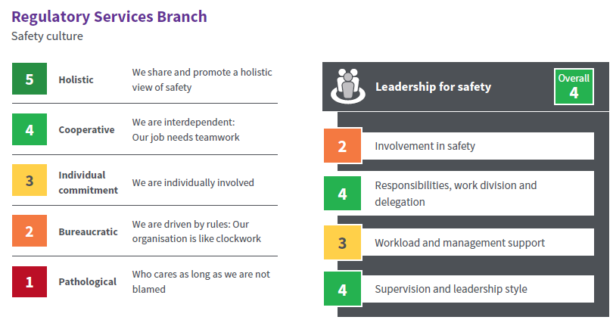

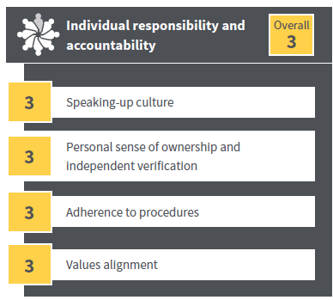 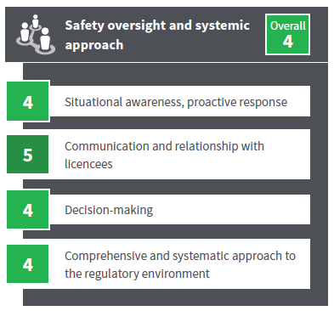

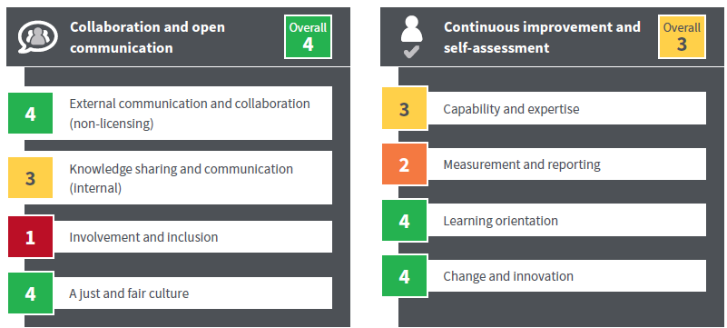

# Introduction

The Australian Radiation Protection and Nuclear Safety Agency (ARPANSA) is the Australian Government's primary authority on radiation protection and nuclear safety. ARPANSA through its Regulatory Services Branch (RSB) regulates Commonwealth entities using radiation with the objective of protecting people and the environment from the harmful effect of radiation. ARPANSA undertakes research, provides services, and promotes national uniformity and the implementation of international best practice across all jurisdictions.

ARPANSA has decided to undertake a safety culture self-assessment in the spirit of best practice. This is ARPANSA’s first formal assessment of its safety culture and it is focused on RSB. While some expertise in this area existed internally, these assessments are generally complex in nature and susceptible to unintentional bias, and benefit from oversight from external parties. ARPANSA therefore sought a partnership with a subject matter expert consultancy group to support the development of a custom-made safety culture assessment model. It was decided to pilot the developed model by assessing the leadership and safety culture of ARPANSA’s regulatory function, as a first step The intention is that following evaluation, this assessment process will be applied across all ARPANSA’s organisational units.

This assessment is also consistent with the requirements under the International Atomic Energy Agency (IAEA) General Safety Requirements Part 2: Leadership and Management for Safety (GSR Part 2). Requirement 14 of GSR Part 2 states ‘Senior management shall regularly commission assessments of leadership for safety and of safety culture in its own organisation’.

## Purpose

The safety culture assessment project was designed with the following objectives:

* to provide ARPANSA with an appreciation of how the safety culture of RSB currently looks
* to help develop a vision of where the organisation wants to be in the future
* to assist in identification of practical steps to maintain and improve the safety and security performance
* to build internal capability to undertake similar assessments in the future.

The assessment in terms of defining the maturity level, was designed to obtain an overall picture of the safety culture at ARPANSA’s RSB and identify drivers for cultural change.

Specifically, the project involved the development of a custom-made safety culture assessment model and maturity rating, undertaking an assessment within ARPANSA’s RSB, and the drafting of this report, which includes the assessment findings and the recommendations for future improvement.

## Context

ARPANSA is the Australian Government’s primary authority on radiation protection and nuclear safety. ARPANSA protects the Australian people and the environment from the harmful effects of radiation through understanding risks, best practice regulation, research, policy, services, partnership and engaging with the community.

The RSB activities include licensing, compliance monitoring, inspection and enforcement. The integrity and efficiency of the regulatory activities is supported by concentrating them into one organisational unit (RSB). However, RSB is not an independent entity. The scope and direction of agency’s regulatory activities and the collective responsibility to carry out these activities, are outlined in the [policy for ARPANSA’s regulatory activities](https://www.arpansa.gov.au/regulation-and-licensing/regulation/regulatory-integrity/policy-arpansas-regulatory-activities). The CEO is ultimately responsible for the regulatory function as well as for ARPANSA’s other functions. RSB is covered by ARPANSA’s corporate policies and systems (e.g. finance, work health and safety, people and culture, legal advice) and RSB occasionally seeks support from ARPANSA’s ‘scientific’ branches when carrying out its regulatory activities. Hence, a rollout of the safety culture assessment across all ARPANSA’s organisational units is desirable to gauge and understand the culture of the whole agency, which will also benefit the understanding of RSB-specific safety culture traits.

The consultancy secured for this project was SafetyWorks Group, who have been in existence for 20 years and have extensive experience in the development and implementation of safety culture assessments across a range of industries and work settings. This experience enables a comprehensive understanding of the variables involved in assessments and supports the co-design and implementation of this safety culture assessment to meet ARPANSA’s specific needs. The SafetyWorks consultant in this project was Traci Carse, organisational psychologist.

A joint project team was established to undertake the project, comprising Traci Carse and two ARPANSA (RSB) employees; John Ward, Director, Safety Systems Section, and Christopher Nickel, Senior regulatory officer, Safety Systems Section.

# Methodology

The safety culture assessment project team developed a custom-built safety culture maturity model and piloted its application in a safety culture maturity assessment process within the RSB during February to March 2019.

## Safety culture model

The safety culture model was developed to cover a large set of relevant safety and security culture attributes and capture cultural issues. This model draws on international safety culture models and allows ARPANSA to gauge the current safety culture as well as to help identify areas where work should be carried out to maintain and improve the organisation’s culture in the future.

The model was based on the OECD Nuclear Energy Agency (NEA) publication ‘Safety Culture of an Effective Nuclear Regulatory Body’. The model was adapted from the ‘Safety Culture Maturity Matrix’ and framework developed by Bel V (2018). Bel V is a subsidiary of the Belgian Federal Agency for Nuclear Control (FANC), which acts as an expert for the safety assessments of nuclear projects and carries out inspections of nuclear installations in Belgium. Bel V reviewed and commented on the ARPANSA model.

Improving safety culture – increasingly proactive

The model is also generally consistent with the guidance for safety culture assessment of the International Atomic Energy Agency (IAEA) Safety Standard GS-G-3.5 ‘The Management System for Nuclear Installations’. However, it has been modified to be more targeted at the role of the regulator rather than the operator.

### Maturity rating

The maturity model was anchored to five maturity levels as described below:

As a regulatory body, we share and promote a holistic view of safety

We are interdependent: Our job needs teamwork

We are individually involved

We are driven by rules: Our organisation is like clockwork

Who cares as long as we aren’t blamed

**Pathological**

**Bureaucratic**

**Holistic**

**Cooperative**

**Individual Commitment**

While the rating levels are in order of maturity, with the more desirable states being to the right, the model is not linear in that each state represents a discrete cultural aspect. As such variance in the response should not be seen as half-way between states, but rather that some aspects/individuals may be in one state of safety culture maturity while others are in a different state.

### Elements

The level of maturity was assessed through the following five safety culture elements:

* leadership for safety
* individual responsibility and accountability
* safety oversight and systematic approach
* collaboration and open communication
* continuous improvement and self-assessment.

In turn, these five elements were further broken down into sub-elements. Each element has four sub‑elements.

## Data collection methods

The key source of data was from an online survey distributed to all employees within the RSB. In addition, a ‘triangulation’ data collection process was used which involved the gathering of data using four collection methods in total. This combination of methods ensured that available data was sourced from a variety of perspectives and places. Collation of these perspectives enabled comparison, verification and sense-making of the data.

The four data collection methods are as follows:

### Survey

Safety culture surveys are designed to provide information about people’s perception of culture related factors such as leadership, risk, rule following, speaking up, team and divisional dynamics.

This survey was designed in alignment with the safety culture maturity model elements and sub-elements. Respondents were asked to select a ‘statement’ that corresponded to a maturity level that, in their opinion, best represented how they see the safety culture within RSB for each of the sub-elements.

The most commonly selected response determines the culture score, both for the elements and sub-elements. This method was preferred over averages to more accurately highlight the discreet nature of maturity. For example, if 4 responses were at bureaucratic (2) and 10 at holistic (5) maturity level, the average would yield cooperative (4.1) despite that none of the respondents selected the statement for cooperative. Instead the mode is used for the ranking, and variation is captured by including the 30th and 70th percentile scores which show the average response range.

In this way, maturity ratings were produced for each of the five elements and twenty sub-elements based on responses provided.

**Privacy considerations**

The Project Team took several steps to ensure the privacy and confidentiality of survey respondents. The survey was conducted as a voluntary and anonymous online survey and employees were not tracked in the process. Identifying information was not collected. The Survey Monkey platform was used to host the survey with only the Project Team members having access to the survey data. The SafetyWorks consultant involved is bound by the code of conduct and ethical guidelines of the Australian Psychological Society and the Psychology Board of Australia.

At the completion of the survey, the Project Team provided ARPANSA with de-identified data in the form of this report.

### Document review

This involved collecting documentation/data, including systems documents (People and Culture; Work Health and Safety), strategy documents, values documents, policies and procedures, previous reviews and assessments, and communications that contained relevant information to the maturity profiling process. The document review was completed by SafetyWorks consultant.

In reviewing documents, consideration was given to the degree to which:

* they align with the elements and sub-elements
* they provide insights into the organisation’s maturity e.g. inclusiveness, holistic approach
* documentation is consistent
* documentation is available.

It should be noted that the documentation review was not intended to be a comprehensive assessment of all documentation, but rather provide insights and areas for discussion, comparison and consideration alongside the other data collection methods.

### Interviews and focus groups

This involved facilitated interviews and focus groups with a sample population of people from the business and relevant stakeholders. These were facilitated by the SafetyWorks consultant.

**a) Interviews**

Duration: 30 minutes

Two interviews were conducted for this assessment:

1. Chief Executive Officer of ARPANSA
2. A member of the Nuclear Safety Committee (external stakeholder).

The purpose was to gather data to endorse, challenge or extend existing data.

**b) Focus Groups**

Duration: 45 minutes – 1 hour

Four focus groups were held with allmembers of RSB who were able to attend on the scheduled day. Employees were grouped according to functional work teams and position type - i.e. the sections without the managers present: (Facility Safety Section, Source Safety and Security Section, Safety Systems Section and National Codes and Standards Section) and managers.

The purpose was to gather data to endorse, challenge or extend existing data. It also allowed the observation of actions, language and perceptions of participants.

Standardised questions for all focus groups and interviews were generated by the Project Team using the safety assessment model elements and the survey responses as points of reference. Open ended questions were used, including about what’s working well, not so well, and opportunities for improvement.

### Workplace behavioural interaction observation

This typically involves targeted observations of interaction forums (e.g. meetings, start-up talks) that allow the profiling team to observe people at work. This helps to tell a story about the maturity profile. When measures are used, they can include any of the following categories; percentage measures, ratings, ratios or general counts.

In this assessment, the following interactive forum was selected for observation: Branch Executive Meeting (7 March 2019). Observation was conducted by the SafetyWorks consultant.

The behaviour observation methods selected for use included: The percentage (%) of time meeting participants spent correcting v inquiring in their communications, number of times participants stay on topic compared to the number of times they do not stay on topic and number of times ‘safety significance’, ‘risk’ or ‘safety outcomes’ is mentioned.

Results

The results below are generated from the survey responses. The survey response rate was 91% (21 employees completed the survey out of a possible 23), showing a high degree of engagement in the safety culture assessment process by staff at RSB. In the narrative provided, additional findings from the other three data collection methods are integrated throughout the commentary as relevant.

The overall result for the five elements, and each sub-element, is taken as the most common survey response (mode). This is represented by the solid rectangle in the graphs below. The range of responses is indicated by the line, representing the 30th and 70th percentile - that is the central 40% of responses.

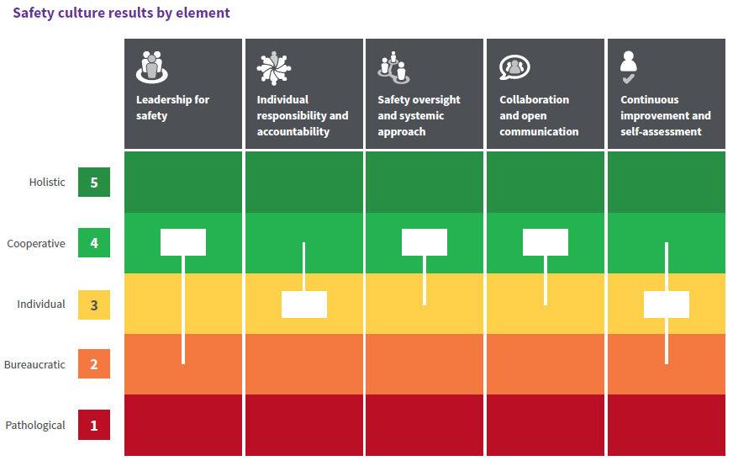

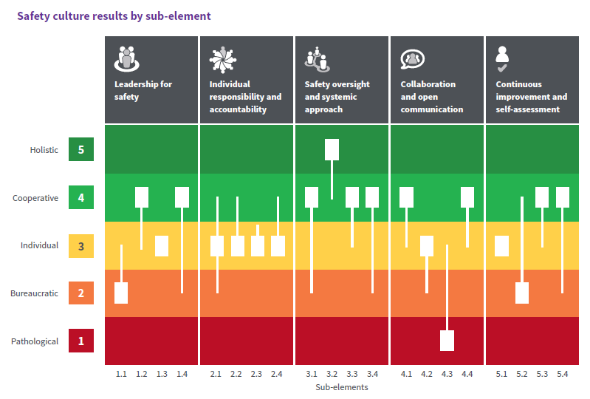

Each sub-element is based on the 21 responses for the sub-element, while the element’s overall results is based on all 84 sub-element responses. As anticipated the smaller number of data points in the sub‑elements results in a greater spread of responses within the sub-elements. However, in some instances there is significant variations in responses, which is highlighted in the element analysis. For example the analysis highlights the sub-elements where greater than 20% of responses were in the pathological scale, that is 4.3, 5.4, 3.1, 2.1.

The full percentage responses on each sub-element response is located at Appendix 5 (published separate to report).

## Element 1 – Leadership for safety

This element describes leadership behaviours that have an impact on regulatory performance, safety and security outcomes. Leadership functions, whilst focused on senior management levels, also reflect work performed at any level when staff undertake tasks and lead initiatives.

### Summary of element results

|  |  |
| --- | --- |
| **Overall rating:** | **Cooperative,** We are interdependent: Our job needs teamwork |

Evidence indicates that the safety culture in the RSB regarding leadership for safety is felt by employees to be fairly mature. However, there was some variation across the sub-elements and significant variation within some of the sub-elements.

The focus groups and interviews revealed a strong consensus that leaders in RSB would not compromise safety for popularity in their decision-making, either internally, or externally e.g. with licence holders. This is a noteworthy finding given the importance of prioritising safety above all else in a regulatory context, and the harmful consequences if this is not demonstrated.

Area for improvement

It appears that, in the main, leaders are seen to operate just to the level of compliance regarding involvement in safety. Additional (visible leadership) behaviours that would demonstrate a higher level of maturity include - proactively seeking out potential issues, identifying risks and monitoring controls, consulting on issues and strategic decisions, and adopting a strategic, structured and outcomes-focused approach.

| Sub element | Rating | Question | Most common response |
| --- | --- | --- | --- |
| 1.1  Involvement in safety | Bureaucratic | How do leaders ensure that safety issues are properly considered? | Leaders address safety issues as required by legislation and procedures. |
| 1.2 Responsibilities, work division and delegation | Cooperative | How do leaders structure work processes & define responsibilities? | Whether I’m working in teams or individually my work affects others. Leaders set teams and ensure that we each know what we are responsible for. We ensure the work is delivered at a high standard and that ARPANSA’s goals are met. |
| 1.3 Workload management & support | Individual | How do leaders ensure that resources are adequately allocated for performing RSB activities? | Individual staff have flexibility in optimising their tasks. Tasks identified as safety significant are given priority. If needed, other staff can provide support, with the approval of their manager. |
| 1.4  Supervision & leadership style | Cooperative | How do leaders supervise and engage with staff? | Leaders are frequently in the workplace and understand how work is actually performed. Supervision is typically hands-off and concentrates on support when it is needed. |

### Sub-element 1.1 - Involvement in safety:

At the bureaucratic level, organisations are characterised by focussing on compliance, relying on processes and procedures to reach their goals. Leader attributes typical of a higher maturity culture include positive leader behaviours such as actively identifying and effectively communicating/consulting, and which are conducive to a healthy safety culture. While some respondents indicated that leaders identified risks and monitored controls, in the main, respondents did not perceive that leaders in RSB adopt a structured approach by which safety issues are identified, managed and communicated.

### Sub-element 1.2 - Responsibilities, work division and delegation

RSB employees in the main, recognise that work performed by individuals is interdependent with others’ work. Responses indicate that high standards of work are performed, and that leaders are instrumental in the achievement of this. However, there was limited agreement that managers ‘empower staff to lead their work’.

### Sub-element 1.3 - Workload management & support

Respondents believe that some degree of resource allocation exists to enable employees to successfully perform their work tasks. What was not seen as present was active, dynamic planning in relation to workload, to enable agility in resource deployment. This limitation has additional implications in terms of the level of support employees experience as being provided by their team and leaders.

### Sub-element 1.4 - Supervision & leadership style

That the most frequent response points to a safety culture with a cooperative climate in relation to the style of leadership displayed, is a positive finding. However, there was significant variation in the range of responses for this sub-element with almost a third of respondents selecting the bureaucratic maturity level statement*: ‘We all have work to do and targets to meet. Reporting procedures are in place and periodic performance appraisals are carried out. Leaders focus on technical aspects.’*

This shows that many respondents see management as active and supportive, with a hands-off approach. However it also indicates that for at least some respondents, the supervision and leadership style displayed by leaders appear to follow a traditional top-down approach, which can be experienced as micro‑management and result in diminished employee motivation and engagement.

## Element 2 – Individual responsibility & accountability

This element describes individual commitment and ownership around their role and the standards they meet to support safety and regulatory outcomes.

### Summary of element results

|  |  |
| --- | --- |
| **Overall rating:** | **Individual commitment -** We are individually involved |

The overall safety culture maturity result for this element was at an Individual level. Personal accountability and commitment to a high standard for behaviours exhibited and performance is important in a healthy safety culture. Support and reinforcement of this responsibility and accountability should come from leaders, and the management systems in place. Findings indicate that there is some room for improvement in building a shared view of collective responsibility, and in how the organisation supports speaking-up behaviour.

Area for improvement

At present the Branch does not appear to hold a clear and shared perception that each person is ‘individually **and collectively** responsible for ARPANSA’s regulatory outcomes’.

This presents an opportunity for employees to adopt a more strategic and visionary view of their contribution to the organisation. Individual work should be anchored on the strategic values of ARPANSA. This would likely improve collaboration and coordination of activities across the organisation and diminish potential siloing of information.

Area for improvement

Consider implementing a values alignment initiative. Seek to determine how the organisational values could be ‘brought to life’ such that they drive employee day to day behaviours and collective goals and facilitate a common purpose and achievement of ARPANSA’s core mission.

**Recommendation**

Strategies for enhancing ‘Individual responsibility and accountability’ rating should be investigated in relation to these areas should be investigated in relation to Procedural adherence and the management system. For instance, it is suggested that feedback is sought from employees about their views and responsibilities in relation to the demands of the management system. The core objective in such an activity would be to examine the interface between employees and the management system that impacts on efficiency and effectiveness in meeting key outcomes.

| Sub element | Rating | Question | Most common response |
| --- | --- | --- | --- |
| 2.1  Speaking-up culture | Individual | How comfortable are staff to speak-up and is this behaviour supported by the organisation? | I am comfortable to speak up in meetings and talk with my supervisor about any issues. My concerns and suggestions are usually taken seriously. |
| 2.2 Personal sense of ownership and independent verification | Individual | How is personal responsibility and ownership enacted e.g. verifying information when called for? | I take pride in my work and strive to meet high standards. I take opportunities to learn and improve my own performance and also identify better ways of working. I seek further information if I am unsure about something. |
| 2.3 Values alignment | Individual | How aligned are the values employees live by, to ARPANSA's published values? | Our values and behaviours are important. I am familiar with the values, they reflect who we are, and I strive to meet them at all times. |
| 2.4 Adherence to procedures | Individual | How closely do employees adhere to procedures? | Our procedures and instructions are needed to drive high standards and consistency of our regulatory service. Where processes need to change and evolve I identify these and raise them with my supervisor. |

### Sub-element 2.1 - Speaking-up culture

Survey respondents provided a wide range of responses for this sub-element (i.e. spanning 24% for Pathological maturity rating, 14% Bureaucratic, 29% individual, through to 10% selecting Holistic).

To further explore this variation, focus group and interview participants were asked why ‘*some people might not feel comfortable to speak-up at RSB?’*

Whilst some individuals suggested this could be due to a reaction (i.e. some staff deciding to not speak-up) based on a ‘historical issue’, a consistent theme emerged in the focus groups in relation to the perception that at the timepoint when consultation is sought, decisions have already been made. Employees reported that feedback provided does not result in shaping the issue being consulted on. The ‘consultation’ is in effect, a ‘briefing’ about an issue. Because of this belief, employees choose not to speak-up because they feel they have not been listened to before, and what they do say will not impact on actions taken.

There was also some suggestion that providing a differing view may have negative impacts on the standing of the individual. Individuals expressed the view that they may be seen as opposing the individual, or against change generally, rather than the specific idea.

Note – see also sub-element 4.3

### Sub-element 2.2 - Personal sense of ownership and independent verification

Most respondents saw RSB’s safety culture as being at the Individual maturity level (see ‘most common response’ in table above) or Cooperative (collaborating as part of a team, and independently verifying information). This highlights a missing essential component of a more mature (Holistic) safety culture where employees not only take pride in their work but understand that they are ‘individually and collectively responsible for ARPANSA’s regulatory outcomes’ I.e. delivering the business of ARPANSA rather than doing work for one’s own purposes.

Additionally, it appears that people are considering their work according to function (e.g. work area) rather than process. An example of this way of thinking might be - ‘our section did our work, but it was not completed on time because of <another section/applicant didn’t supply something/waited for approval>.’ This suggests that the output by the agency is not considered the end goal but rather how the job was done by the individual.

### Sub-element 2.3 - Values alignment

Whilst respondents were consistent in their view in relation to their individual commitment to ARPANSA’s values, there is opportunity to further improve the alignment of ARPANSA’s values with those of the employees throughout the Branch to engender a greater sense of identification with the organisation and engagement.

### Sub element 2.4 - Adherence to procedures

The variation in responses (across all levels of culture maturity) indicates that there is no consistent work practice or culture across the organisation for procedural adherence.

Approximately twenty percent of respondents indicated that they don’t use procedures and instructions because they ‘know what they are doing’. It was not clear from the survey if these employees mean that they don’t (need to) refer to procedures because they feel they are familiar with the content, or that they choose not to adhere to them. However, both behaviours warrant further investigation. There could be several reasons for this behaviour e.g. poor ease of use, lack of currency, procedural drift, and/or complacency.

## Element 3 - Safety oversight and systemic approach

This Element describes how comprehensive, resilient and systematic the organisation’s approach to the regulatory environment is.

### Summary of element results

|  |  |
| --- | --- |
| **Overall rating:** | **Cooperative,** We are interdependent: Our job needs teamwork |

Survey findings reveal that, in the main, employees hold a shared perception and confidence that ARPANSA’s approach to the regulatory environment is of a high level of safety culture maturity. It is noted that the strength in this area appears to relate to external facing work (e.g. relationship with licencees), with the weaker aspect as reported by some employees relating to internal processes (e.g. the non‑technical skill of situation awareness).

Evidence from other data sources validates the employee consensus that the promotion of learning across RSB’s stakeholders and the relationship with licence holders is positive and purposeful. For example, in the post-inspection survey the average licence holder ‘overall satisfaction’ score ranged from 79% to 98% over the quarters of the 2017–18 financial year; the overall satisfaction value for the entire year was 87%. Moreover, a report reviewed within this assessment noted that ‘Licence holders reported high satisfaction levels for the inspection processes and appreciated the written guidance and information available to them.’

Good practice

Communication and relationship with licensees - RSB employees clearly recognise the value of cultivating and maintaining high quality interactions with licence holders in order to promote their safety performance.

| Sub element | Rating | Question | Most common response |
| --- | --- | --- | --- |
| 3.1  Situational awareness, proactive response | Cooperative | How effective is RSB's situational awareness and proactive response capacity? | As a team my colleagues and I often meet to share information, plan work, anticipate issues and decide how to respond to regulatory issues. |
| 3.2 Communication & relationship with licencees | Holistic | How constructive and effective is RSB's communication and relationship with licencees? | We have systems in place for reporting to meet our legislative requirements. |
| 3.3 Decision-making | Cooperative | How good is ARPANSA at regulatory decision-making and taking enforcement actions? | ARPANSA strives to improve the safety performance of licence holders rather than simply assure compliance. |
| 3.4 Comprehensive and systematic approach to the regulatory environment | Cooperative | How well does ARPANSA collect and use information to inform our decisions and interventions? | Information is widely sought to inform outcomes and conduct reviews. A wide range of information is maintained to gain an understanding of the regulatory environment. Tools help us to collect, analyse, and trend information which we then share. |

### Sub-element 3.1 - Situational awareness, proactive response

Most respondents believe the safety culture maturity to be at the higher levels including 24% at a Cooperative level for this area. However, another 24% see things differently, agreeing with the following more cynical (pathological) statement ‘*When something goes wrong we generally try to fix it, especially if it’s a risk to our reputation’.*

An essential element of a healthy safety culture is a commitment to, and ability to provide an effective proactive response. Due to the importance of this safety related factor and the substantial variation in survey responses, employees were asked in focus groups and interviews about the reasons behind the times ‘*...when we don’t respond in the best possible way to a situation’.*

Answers provided included reference to time and workload pressure, and communication related issues. These can include not having the right information available at the time of making a decision due to information being sought from the wrong sources or people, and not maintaining awareness of changing situations.

It is suggested that employee feedback provided within this assessment is documented for further examination within a post-incident (lessons-learned) group reflection forum where employees at all position levels discuss how situation awareness can be impaired. Encourage individual employees to share their opinions in a collaborative environment of continuous improvement and learning. Seek to identify processes and / or communication practices that could be improved when proactively responding to incidents.

**Note**: See also sub-element 4.2 ‘knowledge sharing and communication’, which reveals a limitation in the free-flow of communication across the organisation.

### Sub-element 3.2 - Communication & relationship with licencees

A very consistent response identifying a mature (Holistic) approach to interactions in relation to licence holders. Staff showed a clear focus on enhancing the performance of licence holders.

### Sub-element 3.3 - Decision-making

Decisions required by a regulatory body typically include assessment decisions, compliance/enforcement decisions, and responses to situations (e.g. incidents) as they arise. These decisions require an understanding of the risks, and their inherent uncertainty, to demonstrate a graded approach to compliance and enforcement. Whilst most survey responses indicated a high level of maturity (cooperative or holistic) in terms of decision-making, there was significant variation, with 19% of respondents reporting that *‘We make knee-jerk reactions and often get it wrong. There is limited long term planning or consistency of decisions’.*

### Sub-element 3.4 - Comprehensive and systematic approach to the regulatory environment

This sub-element relates to both the behaviours, and the systems and processes that promote the collection and application of knowledge in decision making. Whilst knowledge management, transfer and dissemination are important to encourage at a behavioural level, a comprehensive system would ideally go beyond reliance on human factors and include system configuration to enable and support these activities. Respondents did not, in the main, report that this is the current status within RSB.

## Element 4 - Collaboration & open communication

This Element describes the degree of cooperation and transparency in communications internally and externally, and how ‘just and fair’ the work environment is.

### Summary of element results

|  |  |
| --- | --- |
| **Overall rating:** | **Cooperative,** We are interdependent: Our job needs teamwork |

Findings for the sub-element content areas are mixed. The external facing work (e.g. external collaboration) is a strength, and reveals that information provided is used to inform decision-making, which is then fed back as appropriate. However, in other areas such as involvement and inclusion particularly around consultation and decision making were rated low.

A positive result was found in relation to a ‘just and fair’ culture. The internal work environment presents as one in which employees are treated fairly, rather than being a culture of blame when things go wrong. This is essential in relation to safety and reliability where non-emotional and non-biased decision making is key to the problem-solving process in effectively understanding root cause.

Recommendation

A positive and mature culture is one where all employees are encouraged and provided opportunities for influence in decision-making and feel included at work. Given the particularly low finding in the involvement and inclusion sub-element this is viewed as an area for improvement for the RSB and should be further explored with staff. It is noted that this activity is related to existing strategic planning e.g. ARPANSA WorkForce Plan 2017–2021. Reviewing action plan progression and tracking the deliverables/outcomes for RSB employees considering these safety culture assessment results may be useful.

| Sub element | Rating | Question | Most common response |
| --- | --- | --- | --- |
| 4.1  External communication and collaboration (Non-Licensing) | Cooperative | How well do we communicate and collaborate with external stakeholders? (e.g. Public, professional bodies, partner institutions, international bodies) | We seek advice and change policy decisions based on feedback as appropriate. We publish guidance and significant decisions including the basis of decisions. |
| 4.2 Knowledge sharing and communication | Individual | How well do we share knowledge and communicate within ARPANSA? | I think it's essential to share knowledge to improve the performance of the organisation. Team members share resources and knowledge with each other. |
| 4.3 Involvement and Inclusion | Pathological | How well does the organisation involve and include all employees? | I am not involved in decisions and people don't look to include me in anything beyond my core work. I just work here. |
| 4.4  A just and fair culture | Cooperative | How well does ARPANSA understand and foster a 'just and fair' culture? | There is a collective expectation amongst employees that people will be treated fairly and with respect. |

### Sub-element 4.1 - External communication and collaboration (Non-licensing)

Employees’ responded with general agreement that they are collaborative, consultative and use feedback provided to inform decision-making. There is an opportunity to further build on this strength and seek feedback from staff about what a unified approach to stakeholder cooperation and communication (holistic level) would look like and how this could be developed.

### Sub-element 4.2 - Knowledge sharing and communication (Internal)

Employees state that sharing knowledge and information is imperative but do not appear to agree that there is a purposeful and strategic approach to communication. The ARPANSA Communication Strategy and Communication Plan FY 2014–2017 was reviewed in light of this survey finding. The document comprised clear articulation of objectives, goals, outcomes, success measures and office responsible. Additional communication related documentation reviewed evidenced organisational efforts to support the sharing and exchange of information in alignment with strategic planning.

Considering the related employee feedback highlighting a perceived limitation in the flow of information, it is apparent that the issue may lie in behavioural norms and employee perceptions about limited internal collaboration and transparency rather than at a strategic-level.

### Sub-element 4.3 - Involvement & inclusion

Whilst this sub-element generated a range of responses, findings show a distinct skew towards lower maturity levels of safety culture.

‘Involvement’ and ‘inclusion’ are somewhat imprecise terms. However, there is general agreement that safety is fostered and supported by creating an environment where inclusion is actively promoted, and all employees feel, and are involved. The Project Team asked focus group and interview participants how we ‘could involve and include our people better’. Amongst the ideas offered, there were practical suggestions in relation to opportunities for increasing bi-directional communications and/or information sharing. For example, seeking staff views before meetings and discussing the results of meetings, rather than simply posting them.

It is noted that during the behavioural observation of an ‘Executive Branch Meeting’, there were seven (7) counts of when Leaders’ direct reports (employees at EL1 or lower) were mentioned, with only one (1) of these in relation to the views of staff. The other instances shared information about employee whereabouts and work tasks.

### Sub-element 4.4 - A just & fair culture

A strong and positive result for this sub-element. A just and fair culture is conducive to maintaining an atmosphere of trust within which people are treated fairly when things go wrong.

## Element 5 - Continuous improvement and self-assessment

This element describes the organisational commitment to continuous improvement and learning.

### Summary of element results

|  |  |
| --- | --- |
| **Overall rating:** | **Individual commitment -** We are individually involved |

Overall ARPANSA performed well against this element showing individual commitment to improvement and self-assessment. ARPANSA undertakes a significant number of assessments including this safety culture assessment, a recent International Regulatory Review Service (IRRS) mission, annual Regulatory Performance Framework (RPF) assessments, and routine internal reporting. Most improvement opportunities identified in this assessment centred on active communication and learning.

Area for improvement

Given the variance in responses in relation to the ‘measurement and reporting’ sub-element within RSB, it is suggested that this area is further explored. For instance, how effective are the current indicators selected for measurement, in providing data to drive strategic and operational planning and improve performance? How well is reporting integrated in to work items and operational activities? How well are the reporting outcomes communicated?

|  |  |  |  |
| --- | --- | --- | --- |
| Sub element | Rating | Question | Most common response |
| 5.1  Capability and expertise | Individual | How does ARPANSA ensure appropriate capability and expertise? | Individual employees consider and improve their own capability and expertise and are expected to generate personal development and training goals (responsibility lies with the individual). |
| 5.2 Measurement & reporting | Bureaucratic | How is measurement and reporting managed? | We have systems in place for reporting to meet our legislative requirements. |
| 5.3 Learning orientation | Cooperative | How well does RSB improve its activities and learn from experience? | We regularly reflect on our work and try to identify improvements. We learn from non-conformances, operating experience (including Licence holder experience), and reviews of regulatory actions, to learn and improve practice. |
| 5.4  Change and innovation | Cooperative | How do we value change and innovation at ARPANSA? | We collaborate to identify best practice and new ways of working. We promote change internally, locally, and internationally. We are open to exploring new and innovative ways to do our work. |

### Sub-element 5.1 - Capability and expertise

Survey responses indicate that employees are motivated for their own training and development. Higher responses would require integration into agency training initiatives. Focus Group discussions identified that there are limited opportunities for formal technical development, and as such a significant portion of learning is ‘on-the-job'. This is comparable to other small technical/regulatory agencies.

### Sub-element 5.2 - Measurement & reporting

While the most common response (43%) was for a bureaucratic rating, almost thirty percent of staff reported that measurement and reporting is at a cooperative level. This may indicate that some areas of the organisation use data and reporting more effectively than others, or that some staff do not see the results of their reporting. Responses did not identify that RSB has achieved a state where measurement and reporting are diagnostic tools used in a systematic and purposeful way to effectively understand the organisation and drive safety and security performance.

### Sub-element 5.3 - Learning orientation

This result indicates that ARPANSA has solid improvement programs and that improvements are driven by operational experience and reviews. The highest level of response, which was not observed in this assessment, additionally calls for proactively seeking out learnings and shaping international best practice.

### Sub-element 5.4 - Change and innovation

The most common response (33%) indicates that RSB is open to change regarding factors impacting safety culture. However, 29% of people selected a descriptor at the pathological level: ‘*People are happy with the status quo, so don't rock the boat. Change is slow in coming and, when we do change, it is typically poorly conceived or communicated and is forced on employees.’*

This view was expanded upon in the focus groups. Participants expressed that consultation about proposed change occurred ‘too late’ and that people did not always feel included in change and felt that it was ‘forced on them’.

# Additional observations

The external consultant on the Project Team notes that the level of positive engagement and willingness to contribute displayed by all parties who were invited to participate in this assessment was universally high. Furthermore, informal interactions observed between various employees, and from employees towards external stakeholders such as the reviewer, were respectful, warm, professional and inclusive. For example, in the meeting observed as part of the assessment, there were several instances of validating and positive responses (verbal and non-verbal) to participants’ ideas put forward, a use of light-hearted banter and humour, and an unsolicited apology when one participant self-reflected that they had talked over a colleague.

According to the employee and external stakeholders who participated in this assessment, contributing factors in relation to the safety culture at RSB have ‘improved in recent years’ and are ‘continuing to improve’. Moreover, this present culture assessment was cited as a demonstration of organisational transparency and safety culture maturity.

Other comments provided speak to the sense of pride employees feel in relation to the specific work RSB does, including that RSB is maturing well as a regulator, and that licence holders find value in RSB’s regulatory response.

# Next steps

The following actions are proposed to be undertaken following this assessment:

1. The Project Team will present, to RSB, the findings and **collectively discuss the recommendations**.
2. The **report** will be formally **distributed** to the workforce, including comments and any commitments by management in relation to the report’s recommendations. This will facilitate staff discussion and feedback on the summary and proposed commitments.
3. Using the findings, recommendations and any further exploration, as appropriate, RSB will **develop an action plan.** This plan will align improvement activities and interventions with existing work undertaken and will be aligned or integrated into the strategic business plans, as applicable.

Additionally an assessments of the whole agency is planned to be undertaken which will draw on the experience of conducting this assessment.

# Table of findings

| # | Type of finding | Related element | Finding |
| --- | --- | --- | --- |
| 1 | Area for improvement | 1 | It appears that, in the main, leaders are seen to operate just to the level of compliance regarding involvement in safety. Additional (visible leadership) behaviours that would demonstrate a higher level of maturity include - proactively seeking out potential issues, identifying risks and monitoring controls, consulting on issues and strategic decisions, and adopting a strategic, structured and outcomes-focused approach. |
| 2 | Area for improvement | 2 | At present RSB does not appear to hold a clear and shared perception that each person is ‘individually and collectively responsible for ARPANSA’s regulatory outcomes’.  This presents an opportunity for employees to adopt a more strategic and visionary view of their contribution to the organisation. Individual work should be anchored on the strategic values of ARPANSA. This would likely improve collaboration and coordination of activities across the organisation and diminish potential siloing of information. |
| 3 | Area for improvement | 2 | Consider implementing a values alignment initiative. Seek to determine how the organisational values could be ‘brought to life’ such that they drive employee day to day behaviours and collective goals and facilitate a common purpose and achievement of ARPANSA’s core mission. |
| 4 | Recommendation | 2 | Strategies for enhancing ‘Individual Responsibility & Accountability’ rating should be investigated in relation to these areas should be investigated in relation to Procedural adherence and the management system. For instance, it is suggested that feedback is sought from employees about their views and responsibilities in relation to the demands of the management system. The core objective in such an activity would be to examine the interface between employees and the management system that impacts on efficiency and effectiveness in meeting key outcomes. |
| 5 | Good practice | 3 | Communication and relationship with licensees - RSB employees clearly recognise the value of cultivating and maintaining high quality interactions with licence holders in order to promote their safety performance. |
| 6 | Recommendation | 4 | A positive and mature culture is one where all employees are encouraged and provided opportunities for influence in decision-making and feel included at work. Given the particularly low finding in the involvement and inclusion sub-element this is viewed as an area for improvement for the Regulatory Services Branch and should be further explored with staff. It is noted that this activity is related to existing strategic planning e.g. ARPANSA WorkForce Plan 2017-2021. Reviewing action plan progression and tracking the deliverables/outcomes for RSB employees considering these safety culture assessment results may be useful. |
| 7 | Area for improvement | 5 | Given the variance in responses in relation to the ‘measurement and reporting’ sub-element within RSB, it is suggested that this area is further explored. For instance, how effective are the current indicators selected for measurement, in providing data to drive strategic and operational planning and improve performance? How well is reporting integrated in to work items and operational activities? How well are the reporting outcomes communicated? |

Bibliography

OECD, 2016. *The Safety Culture of an Effective Nuclear Regulatory Body,* NEA No. 7247

Bernard B., 2018. *A Safety Culture Maturity Matrix for Nuclear Regulatory Bodies*, Safety 4, 1-9*.*

International Atomic Energy Agency, 2009. T*he management system for nuclear installations, IAEA* Safety Standards Series No. GS-G-3.5