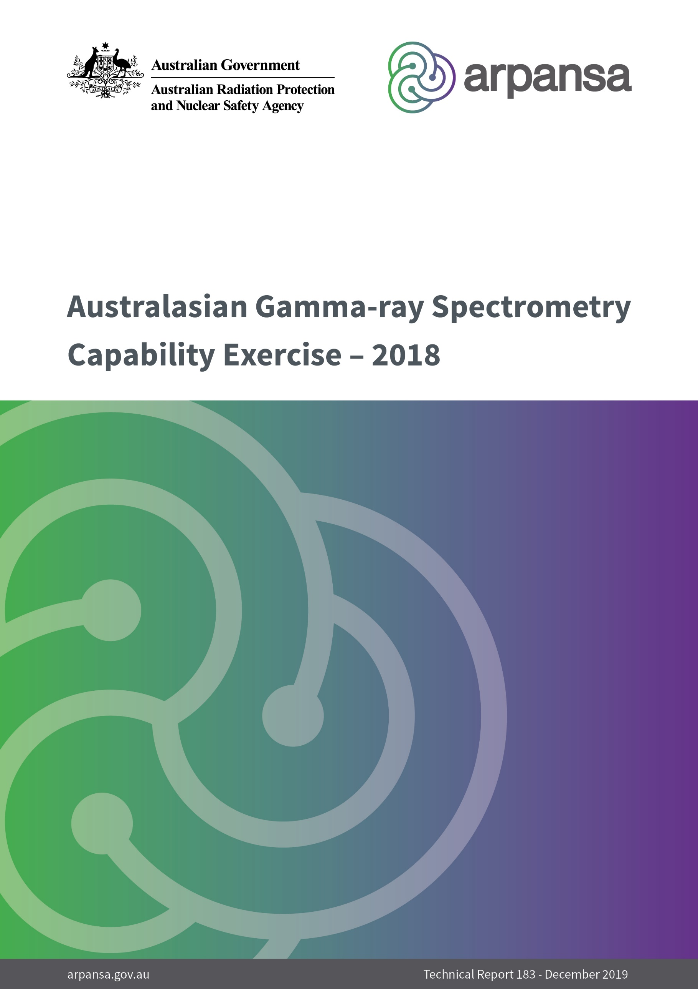

Australasian Gamma-ray Spectrometry  
Capability Exercise – 2018

Technical Report 183

December 2019

S. Marks and S. Long

|  |
| --- |
| © Commonwealth of Australia 2019  This publication is protected by copyright. Copyright (and any other intellectual property rights, if any) in this publication is owned by the Commonwealth of Australia as represented by the Australian Radiation Protection and Nuclear Safety Agency (ARPANSA).    **Creative Commons**  With the exception of the Commonwealth Coat of Arms, any ARPANSA logos and any content that is marked as being third party material, this publication, *Australasian Gamma-ray Spectrometry Capability Exercise – 2018*, by the Australian Radiation Protection and Nuclear Safety Agency is licensed under a Creative Commons Attribution 3.0 Australia licence (to view a copy of the licence, visit [*http://creativecommons.org/licenses/by/3.0/au*](http://creativecommons.org/licenses/by/3.0/au)). It is a further condition of the licence that any numerical data referred to in this publication may not be changed. To the extent that copyright subsists in a third party, permission will be required from the third party to reuse the material.  In essence, you are free to copy, communicate and adapt the material as long as you attribute the work to ARPANSA and abide by the other licence terms. The works are to be attributed to the Commonwealth as follows:-  ‘© Commonwealth of Australia 2019, as represented by the Australian Radiation Protection and Nuclear Safety Agency (ARPANSA)’  The publication should be attributed as: *Australasian Gamma-ray Spectrometry Capability Exercise – 2018*.  **Use of the Coat of Arms**  The terms under which the Coat of Arms can be used are detailed on the Department of the Prime Minister and Cabinet website ([www.dpmc.gov.au/government/commonwealth-coat-arms](http://www.dpmc.gov.au/government/commonwealth-coat-arms)).  Enquiries regarding the licence and any use of this report are welcome.  ARPANSA  619 Lower Plenty Road  YALLAMBIE VIC 3085  Tel: 1800 022 333 (Freecall) or +61 3 9433 2211   Email: [info@arpansa.gov.au](mailto:info@arpansa.gov.au)  Website: [www.arpansa.gov.au](http://www.arpansa.gov.au) |

**Acknowledgement of Country**

ARPANSA respectfully acknowledges Australia’s Aboriginal and Torres Strait Islander communities and their rich culture and pays respect to their Elders past and present. We acknowledge Aboriginal and Torres Strait Islander peoples as Australia’s first peoples and as the Traditional Owners and custodians of the land and water on which we rely.

We recognise and value the ongoing contribution of Aboriginal and Torres Strait Islander peoples and communities to Australian life and how this enriches us. We embrace the spirit of reconciliation, working towards the equality of outcomes and ensuring an equal voice.

Contents

Contents ii

Acknowledgements iii

Executive summary 1

1. Introduction 2

2. Methods 3

2.1 Analysis of results 3

3. Results and discussion 4

3.1 Performance relative to acceptance limits 4

3.2 Performance relative to the certified activity 4

3.3 Zinc-65 5

3.4 Caesium-134 6

4. Conclusion 8

5. References 9

Acknowledgements

The author wishes to thank all of the laboratories that participated in the exercise.

Executive summary

International experience with significant radiological incidents has shown that extensive measurement of environmental samples is required (Japanese Ministry of Health, Labour and Welfare, 2015) (IAEA, 1988). Many of these samples would require analysis by gamma-spectrometry. ARPANSA’s capacity to analyse samples could be overwhelmed by the response required by a significant radiological incident. Therefore, assistance from other laboratories might be required to respond to a significant radiological incident.

This exercise was conducted to ascertain the capability of participating laboratories with respect to the measurement of radionuclides in water by gamma-ray spectrometry. This exercise focussed on testing and finalising laboratory procedures using the standard geometry for gamma spectrometry measurements.

Nine radioanalytical laboratories identified as having gamma-spectrometry capabilities, participated in this exercise, these laboratories form the Australasian Radionuclide Laboratory Network (ARLN). Participants were asked to analyse 450ml of water, containing known amounts of certain radionuclides, obtained from an accredited supplier of Certified Reference Materials and Proficiency Testing products. The sample contained Am‑241, Cs-134, Cs-137, Co-60, K-40 and Zn-65.

There was a marked improvement in the Zn-65 results, which the authors attribute to the improved calibration methods implemented by the laboratories after the 2013 exercise. All laboratories now have Zn-65 in there calibration sources, which has improved the results at higher energy.

After the 2013 exercise, all laboratories now recognise the complexities of measuring Cs-134. During this year’s exercise some laboratories tested new methods to correct for true coincidence summing, with mixed results.

In almost all cases, the participants reported results that would be considered acceptable by the supplier of the samples. That is, 34 of the 35 reported results that were within the Performance Acceptance Limits defined by the supplier. This shows that when compared on other comparable laboratories from around the world the Australasian radionuclide laboratory network can be regarded as highly capable.

# Introduction

ARPANSA maintains a radioanalytical laboratory, in part, to respond to radiological incidents. Theoretically, this laboratory has the capacity to measure about 100 samples per day by gamma-spectrometry. However, even this capacity could be overwhelmed by the response required by a significant radiological incident. Therefore, assistance from other laboratories might be required to respond to such an incident.

ARPANSA has identified nine radioanalytical laboratories in Australia and New Zealand. This list includes three laboratories run by the Australian Nuclear Science and Technology Organisation (ANSTO), ARPANSA’s own laboratory, two university laboratories as well as three other state or national laboratories. However, there is considerable specialisation in the radionuclides analysed by these laboratories. This is because many of these laboratories exist to fulfil specific needs and are not funded or specifically tasked with providing analyses in the event of general radiological incident. Therefore, some laboratories may not be able to provide assistance for some radiological incidents, particularly those involving the dispersion of radioactive material created in a nuclear reactor.

This exercise was conducted to ascertain the capability of participating laboratories with respect to the measurement of radionuclides in water by gamma-ray spectrometry and was a follow-on from similar exercises conducted in 2013 (Long, 2014) and 2015 (Long, 2016).

This year’s exercise focused on testing and finalising laboratory procedures using the standard geometry for gamma spectrometry measurements. The standard geometry was agreed to after the 2013 exercise.

It should be noted that this was not a Proficiency Test Exercise because participants were not judged as to the acceptability of their procedures. The procedures used by each laboratory are appropriate to their particular objectives. Rather, the purpose of the exercise was simply to determine whether the methods currently used by each participating laboratory produced acceptable results when used for another purpose.

# **Methods**

All nine of the known Australasian radioanalytical laboratories (including ARPANSA) agreed to participate in the exercise.

Before the exercise started, a standard 450 ml in 500 ml marinelli calibration source, purchased by ANSTO, was made available to all laboratories. This ensured that all laboratory had an opportunity to participate in the exercise and measure a standard geometry that is typical of an emergency response type sample.

ARPANSA purchased nine vials of a certified reference material from an accredited supplier of such products. The water was prepared, by the supplier, by adding known amounts of Am‑241, Cs‑134, Cs-137, Co-60 and Zn-65 making a standard concentrate. This concentrate was preserved with Nitric acid to pH < 2.

The supplier also provided a certificate of analysis stating the certified values of the activity concentration of each radionuclide in the vials. The certificate of analysis also included Performance Acceptance Limits (PALs) approximating 95% confidence intervals of the performance that an experienced laboratory should achieve.

The sample concentrate was diluted by each laboratory by diluting 5 ml of the concentrate to final volume of 1L with 0.1M nitric acid using class A volumetric glassware.

## Analysis of results

For each radionuclide, ARPANSA calculated the Relative Bias (*R*) of the measured activity concentration (*M*), relative to the certified activity concentration supplied by the manufacturer (*C*):

Equation :

Due to the uncertainties in both the certified value (*uc*) and the measured value (*um*), the Relative Bias for an individual radionuclide may not be statistically significant. Therefore, ARPANSA also calculated the U-test value (*U*):

Equation :

The Relative Bias for an individual radionuclide is statistically significant if U > 2.58 and may be statistically significant if U > 1.64.

If a participant under- or over-estimated the uncertainty associated with a measurement, the U-test value will over- or underestimate the statistical significance of the Relative Bias. Therefore, ARPANSA also compared the measured value to the PALs provided by the supplier of the sample.

Each participant was provided with an individual report detailing the Relative Bias, U-test value and comparison with the PALs for each radionuclide. This report also indicated if there appeared to be systematic errors in the laboratory’s measured values and indicated the potential sources of these errors, based on the results and responses from the report form.

The laboratories were randomly designated a number to be used throughout this report.

# Results and discussion

## Performance relative to acceptance limits

As noted in section 2, the certificate of analysis for each sample also included PALs approximating 95% confidence intervals of the performance that an experienced laboratory should achieve. The reported activity concentration for each radionuclide, for each laboratory, was compared to these acceptance limits. Table 1 details the number of laboratories reporting results within these limits. This table also details the fraction of laboratories reporting acceptable results in the 2013 and 2015 exercises.

Table : Laboratories reporting acceptable results

|  |  |  |  |  |  |  |
| --- | --- | --- | --- | --- | --- | --- |
|  | 2018 Exercise (water) | | 2015 Exercise (vegetation) | | 2013 Exercise (water) | |
| Radionuclide | Number | Fraction | Number | Fraction | Number | Fraction |
| Am-241 | 9 | 100% | 8 | 89% | 5 | 83% |
| Co-60 | 9 | 100% | 9 | 100% | 6 | 100% |
| Cs-134 | 8 | 89% | 8 | 89% | 6 | 100% |
| Cs-137 | 9 | 100% | 8 | 89% | 6 | 100% |
| Zn-65 | 9 | 100% | 3 | 33% | 5 | 83% |

As was the case in the 2013 and 2015 exercises, most laboratories reported acceptable results for most radionuclides. This indicates that the methods currently used by each participating laboratory produced acceptable results when used for another purpose.

Please note that the Zn-65 measurement in 2015 was particularly difficult due to the low activity in that sample. So the comparison between exercises may not be a fair for this radionuclide.

## Performance relative to the certified activity

The comparison with manufacturer-defined acceptance limits indicates that the procedures used by each laboratory are equivalent to those used by their peers world-wide. However, these acceptance limits accommodate common analysis errors, such as the failure to correct for True Coincidence Summing (TCS).

Highly capable laboratories should produce a result that is commensurate with the certified value. The usual method to test whether a reported result is not significantly different to a certified value is the U-test (see equation 2). This test compares the measured result with the certified result in a way that accounts for the uncertainty in both values.

The U-test values for each radionuclide and each laboratory are shown in Figure 2. In the figure, the purple line indicates a U‑test value of 1.64. Results with a U‑test value below 1.64 are not statistically different from the certified value and are, therefore, consistent. The green line in the figure indicates a U‑test value of 2.58. Results with a U‑test value greater than 2.58 are statistically different from the certified value. That is, those results with a U‑test value greater than 2.58 are discrepant and indicate a significant error in the analysis.

Figure : U-test values for each radionuclide and each laboratory.

Figure 1 indicates that laboratories 3–7 provided excellent results because all of their reported values were consistent with the reference value.

Figure 1 also shows that laboratories 2 and 9 each produced results with U‑test values greater than 2.58 for Cs-134. This indicates that significant errors were made by each of these laboratories when analysing the sample for this radionuclide.

Laboratory 1 and 8 provided one result with a U‑test value greater than 1.64: that for Cs-137 and Am-241 respectively. While this indicates that an error in the analysis might have been made, this value could also be due to simple statistical variation.

## Zinc-65

Figure 2 shows that when compared to the previous exercise using a water matrix (2013) the results have improved significantly. This improvement can be attributed to the enhanced calibration procedures implemented by the laboratories after the 2013 exercise. In 2013, only three laboratories had Zn-65 in their calibration source or corrected the calibration curve for TCS.

In this year’s exercise, three of the laboratories corrected for TCS and the remainder had Zn-65 in there calibration curve. Having Zn-65 in the calibration curve improves the results for the higher energy radionuclides but doesn’t solve it completely as the Y-88 and Co-60 calibration lines still dominate the high energies. This can be seen in Figure 2 by the clear positive bias of results amongst laboratories when compared to the reference value. The provider’s acceptance criteria for Zn-65 also has a positive bias to account for this common calibration error, so, all laboratories passed this test. If we were to ignore this positive bias, one of laboratories would have failed. Given that this is a known error is highly recommended that all laboratories investigate methods for correcting for TCS to remove any bias from future results.

Figure : Zn-65 relative activity concentration

## Caesium-134

If we strictly compare the results with the 2013 we observe a slightly decline in the accepted values but this can once again be attributed TCS effects and the way the material provider sets its acceptance criteria. Cs-134 has large TCS effects, which contributes to a reduction of approximately 15% in the net peak area of the nuclides’ lines for a typical geometry and detector. In 2013, the three of the laboratories corrected for this and the other three did not. The performance acceptance limits however allows a negative bias to take this into account errors due to TCS, which allowed them to pass in 2013.

In 2018 the three laboratories that hadn’t make any correction in 2013 attempted to rectify this problem by using a separate calibration, using an uncertified Cs-134 source. This procedure produced mixed results Figure 3. The result from Laboratory 7 was outside the performance acceptance limits because they over-corrected for TCS. Generally, calibrating using a separate source for a specific radionuclide would be an accepted method for the calibration of the activity but the error occurred due to the use of an uncertified source that is not traceable to a known radiological standard. Once again, it is highly recommended that all laboratories investigate methods for correcting for TCS as a more robust method for accounting for TCS corrections in the reference material and the calibration sources.

Figure : Cs-134 relative activity concentration

# Conclusion

This exercise was conducted to ascertain the capability of participating laboratories with respect to the measurement of radionuclides in water by gamma-ray spectrometry. It should be noted the purpose of the exercise was simply to determine whether the methods currently used by each participating laboratory produced acceptable results when applied to a sample containing radionuclides created in a nuclear reactor.

Nine of radioanalytical laboratories in the Australasian radionuclide laboratory network participated in this exercise. There was a marked improvement in the Zn-65 results which the author put down to the improved calibration methods implemented by the laboratories after the 2013 exercise. All laboratories now have Zn-65 in there calibration sources, which has improved the results at higher energy. These results could be improved further if all laboratories applied corrections for the effects true coincidence summing of Co-60 and Y-88, which dominate the high energy of the calibration sources. Nonetheless, the improvement over time in the results reported the laboratories shows the importance and worth these exercises.

After the 2013 exercise, all laboratories now recognise the complexities of measuring Cs-134. During this year’s exercise some laboratories tested new methods for accounting of true coincidence summing, with mixed results. Six laboratories passes all tests for Cs-134, but there is still more work to be done for the other three laboratories.

In almost all cases, the participants reported results that would be considered acceptable by the supplier of the samples. That is, 34 of the 35 reported results that were within the Performance Acceptance Limits (PALs) defined by the supplier. This shows that when compared to other laboratories from around the world, the Australasian radionuclide laboratory network can be regarded as highly capable.

However, the PALs tolerate common errors made by laboratories, such as the failure to correct for TCS effects. Therefore, the reported results were also compared with the reference value given by the supplier. This analysis showed that only five of the nine laboratories were able to provide results that were consistent with the reference value, for all radionuclides.

# References

**IAEA** The Radiological Incident in Goiania [Report]. - Vienna : International Atomic Energy Agency, 1988.

**Japanese Ministry of Health, Labour and Welfare** Levels of Radioactive Contaminants in Foods Tested in Respective Prefectures [Online]. - 2015. - 14 August 2015. - http://www.mhlw.go.jp/english/topics/2011eq/index_food_radioactive.html.

**Long S.** Australasian Gamma-ray spectrometry Capability Exercise - 2013 [Report]. - Melbourne : ARPANSA, 2014.

**Long S.** Australasian Gamma-ray Spectrometry Capability Exercise - 2015 [Report]. - Melbourne : ARPANSA, 2016.