|  |
| --- |
| © Commonwealth of Australia 2021  This publication is protected by copyright. Copyright (and any other intellectual property rights, if any) in this publication is owned by the Commonwealth of Australia as represented by the Australian Radiation Protection and Nuclear Safety Agency (ARPANSA).    **Creative Commons**  With the exception of the Commonwealth Coat of Arms, any ARPANSA logos and any content that is marked as being third party material, this publication, *CRL Cosmic Veto System Implementation and Assessment Report*, by the Australian Radiation Protection and Nuclear Safety Agency is licensed under a Creative Commons Attribution 3.0 Australia licence (to view a copy of the licence, visit [*http://creativecommons.org/licenses/by/3.0/au*](http://creativecommons.org/licenses/by/3.0/au)). It is a further condition of the licence that any numerical data referred to in this publication may not be changed. To the extent that copyright subsists in a third party, permission will be required from the third party to reuse the material.  In essence, you are free to copy, communicate and adapt the material as long as you attribute the work to ARPANSA and abide by the other licence terms. The works are to be attributed to the Commonwealth as follows:-  ‘© Commonwealth of Australia 2021, as represented by the Australian Radiation Protection and Nuclear Safety Agency (ARPANSA)’  The publication should be attributed as: *CRL Cosmic Veto System Implementation and Assessment Report*.  **Use of the Coat of Arms**  The terms under which the Coat of Arms can be used are detailed on the Department of the Prime Minister and Cabinet website ([www.dpmc.gov.au/government/commonwealth-coat-arms](http://www.dpmc.gov.au/government/commonwealth-coat-arms)).  Enquiries regarding the licence and any use of this report are welcome.  ARPANSA  619 Lower Plenty Road  YALLAMBIE VIC 3085  Tel: 1800 022 333 (Freecall) or +61 3 9433 2211   Email: [info@arpansa.gov.au](mailto:info@arpansa.gov.au)  Website: [www.arpansa.gov.au](http://www.arpansa.gov.au) |

Acknowledgement of Country

ARPANSA respectfully acknowledges Australia’s Aboriginal and Torres Strait Islander communities and their rich culture and pays respect to their Elders past and present. We acknowledge Aboriginal and Torres Strait Islander peoples as Australia’s first peoples and as the Traditional Owners and custodians of the land and water on which we rely.

We recognise and value the ongoing contribution of Aboriginal and Torres Strait Islander peoples and communities to Australian life and how this enriches us. We embrace the spirit of reconciliation, working towards the equality of outcomes and ensuring an equal voice.

**Contents**

Acknowledgement of Country ii

Executive summary iv

1. Introduction 1

2. Spectroscopy system hardware and software 2

2.1 Existing Antler spectrometry system 2

2.2 Cosmic veto system 2

3. CosmicGuard configuration and installation 3

3.1 CosmicGuard network configuration 3

3.2 CosmicGuard initial hardware test 3

3.3 CosmicGuard installation and integration 3

3.4 CosmicGuard MCA configuration 4

4. Initial anti-coincidence timing settings and evaluation 7

4.1 Determination of initial gate timing settings 7

4.2 Method for assessment of veto system performance 7

4.3 Assessment of veto system performance, initial gate timing settings 9

4.4 Confidence in initial gate timing settings 10

5. Optimisation of anti-coincidence timing settings 11

5.1 Gate width variation 11

5.2 Gate delay variation 12

5.3 Assessment of veto system performance, optimised gate timing settings 13

5.4 Expected MDA improvement for CRL detector systems 15

6. Assessment of sample emission coincidence 16

6.1 Method for assessment of sample emission coincidence 16

6.2 Assessment of Sample Emission Coincidence 17

7. Conclusion and recommendation 19

7.1 Conclusion 19

7.2 Recommendations 19

Appendix 1: CRL ‘Antler’ and CosmicGuard technical details 20

Appendix 2: CosmicGuard configuration process 21

References 22

Executive summary

The ARPANSA CRL radionuclide laboratory operates two sensitive gamma detection systems for the measurement of CTBTO station particulate samples. The detector systems are required to comply with minimum detectable activity (MDA) specifications defined by the CTBTO. The systems operate close to the limit of the MDA specification, and can benefit greatly from a reduction in background radiation above that provided by passive lead shielding.

This report details the integration of the first of two *CosmicGuard* veto systems into the CRL radionuclide laboratory Antler detection system. The purpose of the cosmic radiation veto system is to reduce the spectral contribution of background radiation from extra-terrestrial sources, and thus improve the measurement sensitivity of the detection system.

This report covers the initial installation and testing of the CosmicGuard, further optimisation of signal processing settings, and assessment of potential negative impacts resulting from the implementation.

Testing of the CRL Antler system including veto hardware with optimised coincidence settings indicates that MDA improves approximately 18%, from 22 mBq/m3 (no veto) to ~18 mBq/m3 (veto). This MDA improvement is significant given the maximum detector MDA specified by the CTBTO is 24 mBq/m3, and the possibility of detector MDA degradation that may result from various influences.

Testing of the modified CRL Antler system also indicated negligible impact of coincidence effects that may manifest at higher count rates. The positive results suggest that both CRL detection systems will benefit substantially from the integration and optimisation of the CosmicGuard veto system.

The following actions are recommended and based on detection system performance testing:

* Implement the CosmicGuard veto system as a standard component of the Antler CRL detection system, with Gate Delay, Gate Width and SCA LLD values applied as concluded (Section 7.1)
* Integrate the second available CosmicGuard system into the Buffalo CRL detection system with SCA window fully open (LLD=0), and test to determine optimised Gate Delay and Gate Width values
* Update the calibration, background and blank acquisitions, including re-issuance of a Detector Information Form (CTBTO, 2019, Appendix VII) with veto system details before commencing operations with a veto-enabled CRL detection system
* Always save both gated and ungated spectra acquired with veto-enabled CRL detection systems, and regularly compare analyses of these spectra as a means to assess veto system performance.

# Introduction

The Comprehensive Nuclear-Test-Ban Treaty Organisation (CTBTO) is an international body that will be tasked to verify a ban on nuclear weapon testing upon entry into force of the corresponding treaty (CTBT). As part of planning for verification of treaty compliance, the Preparatory Commission for the CTBTO is implementing and operating the International Monitoring System (IMS). The IMS is based on various technologies including particulate and gaseous radionuclide sampling and detection systems. When completed, the IMS include 80 radionuclide particulate monitoring stations and 16 radionuclide laboratories for analysis of samples from those stations.

ARPANSA is the designated responsible organisation for carrying out Australia's radionuclide monitoring and laboratory obligations to the treaty. The radionuclide laboratory (CRL) at ARPANSA is certified by the CTBTO to undertake station sample analysis within specified parameters, including a requirement for minimum detectable activity (MDA) of the detection system for the radionuclide Ba-140 of ≤ 24 mBq/m3 (CTBTO, 2019).

In order to achieve the required measurement sensitivity, the CRL operates a detection technology standard for the CTBTO station and supporting laboratory network: single high-purity germanium (HPGe) detectors, each encased in a passive lead shield to reduce terrestrial background contributions. The CTBTO specifies and certifies numerous technical requirements for system performance, and supporting infrastructure and processes. Importantly, expectations of detector performance require the use of commercial HPGe systems operating at their technical limits, and with high reliability, representing challenges for laboratory operations.

Whilst the CRL detector system is certified as satisfying CTBTO requirements, several factors may significantly degrade detector sensitivity. Manageable influences on MDA values include: external radiation levels, environmental conditions, and inherent (sometimes varying) characteristics of the spectroscopy system leading to electronic noise. As is typical for ground-level spectroscopy installations, a significant spectral background contribution originates from cosmic radiation that results in muons (with predominantly vertical flux) and gamma radiation. Commercial systems to mitigate (‘veto’) this cosmic background contribution were not available during formulation of requirements for CTBTO detector systems. Cosmic veto systems are now commercially available, and represent a means to significantly improve HPGe system MDA to ensure ongoing CRL compliance.

A commercially available cosmic veto system, *CosmicGuard*, was purchased for implementation in each of the two CRL HPGe detector systems (*Buffalo* and *Antler*). This document reports on the installation and optimisation of the first of two veto systems on the Antler system, assesses the achieved detection system sensitivity improvements, and makes recommendations where possible for operational configuration of this and further cosmic veto systems in the CRL.

# Spectroscopy system hardware and software

Cosmic veto systems have existed for decades. Recent improvements in integrated electronics, detection materials and associated software have seen the production of commercial veto systems available for implementation without the previously significant burden of extensive implementation and optimisation tasks. One such off-the-shelf system, Canberra/Mirion *CosmicGuard* is produced by the same manufacturer as the CRL *Antler* HPGe spectrometry system. Antler was thus chosen for implementation of the first of two purchased CosmicGuard veto systems, with expectations of straightforward integration.

## Existing Antler spectrometry system

The CRL Antler detector system consists of the following hardware and software:

* Canberra BEGE detector, with ultra-low background cryostat and liquid nitrogen cooling
* Canberra 747 shield (10 cm lead, plus additional inner lining)
* Canberra Lynx digital multichannel analyser (MCA), including user manual (Canberra Industries, 2014)
* Canberra Genie 2000 acquisition and analysis software, including user manual (Canberra Industries, 2013).

The current measured minimum detectable activities (MDA) of the two CRL detection systems according to the CTBTO specifications are:

* Antler - 22.0 mBq/m3
* Buffalo - 23.5 mBq/m3
* CTBTO requirement - ≤ 24.0 mBq/m3

The Lynx MCA may be accessed via IP connection to an inbuilt web server, which includes a digital oscilloscope for visualisation of signal processing, and interface for inspection of spectra and settings.

Hardware details and basic settings of the existing Antler spectrometry system are provided in Appendix 1.

## Cosmic veto system

The newly installed CRL Antler cosmic veto system consists of the following hardware and software:

* Canberra CosmicGuard cosmic veto system, with plastic scintillator detector, photomultiplier tube, and Osprey Digital MCA Tube Base, including user manual (Mirion Technologies, 2017a)
* Canberra CosmicGuard Control Panel (CGCP) for configuration settings.

The Osprey MCA may be accessed via IP connection to an inbuilt web server, which includes an interface for inspection of spectra and settings.

Hardware details and basic settings of the CosmicGuard system are provided in Appendix 1.

# CosmicGuard configuration and installation

## CosmicGuard network configuration

Prior to installation, the CosmicGuard veto system and computer network software were configured to allow network connection and subsequent operational set-up.

The CosmicGuard software (CGCP) and drivers were installed on a Windows computer, and the computer connected to a network hub with a provided RJ45 CAT5 network crossover cable. The CosmicGuard was connected to the network hub via an identical cable, which provides the necessary power to the veto system via power-over-ethernet (PoE).

The CosmicGuard was also initially connected directly to the computer with a provided USB cable. The CosmicGuard maintains an unalterable IP address via this USB connection method to ensure a network connection can always be established. The computer IP4 network address and subnet mask were then configured to include the fixed USB connection IP address in the local network. After launching Internet Explorer and entering the fixed USB IP address in the browser URL field, the veto system MCA (Osprey) web server user interface was displayed.

The veto system RJ45 IP network address was configured via the Osprey MCA web server to be compatible with a simple local area network including the default IP address of a Lynx MCA. The USB connection to the veto system was then removed, and the computer IP address reconfigured to provide communication with the Osprey via the RJ45 connection. The Lynx MCA was connected to the network hub, and network connection to both MCA web servers was verified.

Note that the default Osprey MCA RJ45 IP4 network address provided in the user manual (Mirion Technologies, 2017a), was in this case incorrect. Initial connection to the CosmicGuard via USB would not be necessary if the configurable IP address (via RJ45 cable) of the Osprey is known.

## CosmicGuard initial hardware test

Following configuration of the CosmicGuard (Osprey MCA) network address and connection to a network hub, the veto system was tested for basic functionality before installation.

CGCP was initiated and the Osprey network address field configured to reflect the local network RJ45 IP address discussed above. Once connected, the veto system was enabled and acquisition initiated to verify that spectral data was displayed. High voltage was applied to the veto system according to the recommended value, and the spectral display examined to verify reduction of spectral noise. Finally, the Osprey gain and single-channel analyser were adjusted to verify functionality of those settings.

A suggested step-by-step summary of the CosmicGuard testing and configuration process is provided in Appendix 2.

## CosmicGuard installation and integration

The existing CRL spectrometry system chosen for the addition of cosmic veto hardware includes a lead shield with single-piece swinging top cover. The CosmicGuard veto hardware required the fitting of four supplied brackets in suitable locations to fit the spectrometry system lead shield. These brackets allow the CosmicGuard to be simply placed on the top of the shield top cover, and swing with the lid upon shield opening (Mirion Technologies, 2017b). More complex hardware is required to fit the CosmicGuard to a split-shield configuration.

Following installation of the brackets and placement of the veto system on the lead shield, the CosmicGuard, Lynx MCA, network hub and computer were connected via RJ45 cables and tested as detailed above (Section 3.1). Two signal connections required between the spectrometry MCA (Lynx) and the veto hardware were installed via provided RG59 50 ohm BNC cables as follows:

* CosmicGuard output: GATE > Lynx input: GATE
* CosmicGuard output: START/STOP > Lynx input: PHA ACQ SS

The Antler HPGe detector was connected to the Lynx MCA, and the Lynx configured to standard settings previously established for operational CRL spectrometry, including: high voltage, gain, rise-time, flat-top, pole zero, LLD/ULD etc. Basic settings of the Antler spectrometry system are provided in Appendix 1.

Further configuration of the Lynx MCA was performed to implement anti-coincidence counting using signals from the CosmicGuard. Coincidence settings may be enabled via Genie 2000 (menu MCA > Acquire Setup) or the Lynx MCA web server (menu Acquisition > Coincidence). In both cases, the following settings should be configured:

* Acquisition Mode: PHA
* Input Size: 16384 / 32768 (total number of spectrum channels; see comment below)
* Gate Mode: Combined Advanced Anti-Coincidence
* Gate Polarity: Positive
* Gate Delay (µs): 0 (delay to the Lynx Store pulse)
* Input Gate Delay (µs): *TO BE OPTIMISED* (delay applied to the external anti-coincidence pulse)
* Input Pulse Width (µs): *TO BE OPTIMISED* (width of the gate pulse initiated by the external pulse).

The number of channels (Input Size) required for a spectrum should account for one further configuration of the Lynx. In order to store both the gated and ungated spectrum, the Lynx may be configured to use two memory groups. To achieve this feature, the Lynx will split the number of available channels between both spectra. As such, Input Size was set to 32768 to provide 16384 channels for each spectrum.

To configure the Lynx to use two memory groups requires the Lynx configuration file (detector definition) to be modified via the Genie 2000 MID Setup Wizard. Specifically, the Memory Group check-box in the Input Settings menu should be enabled. This change in detector definition was performed to enable evaluation of the CosmicGuard system, and is recommended for all CRL spectra acquisitions. Further, the ‘Input Size’ was set to 16384 channels in the Genie 2000 Acquire Setup panel.

This Lynx configuration using two memory groups allows Genie 2000 to display both the gated and ungated spectra via the menu item: Datasource > Datagroup.

## CosmicGuard MCA configuration

Basic configuration of the CosmicGuard settings is required to ensure the veto system output is broadly suitable for gating the detector signal. The following values for the veto system Osprey MCA were configured using the CGCP software:

* CosmicGuard Output: Enabled
* High Voltage Set Value (V): 691 (as per system label)
* High Voltage Status: ON
* Coarse Gain: 1 (default)
* Fine Gain: 2 (default; see comment below)
* SCA Window Lower Limit (Ch): 0 (see comment below)
* SCA Window Upper Limit (Ch): 2048
* Acquisition: Start.

The CosmicGuard spectrum should include signals from incident muons, which have a typical full energy of approximately 10 MeV. The gain of the veto system should be set to produce that 10 MeV peak at the half-way point of the CosmicGuard spectrum in order to also capture muon coincidence (~ 20 MeV).

A spectrum was acquired from the veto system for approximately one hour. The broad peak centred at approximately channel 1000 was observed and attributed to full energy muons. As such, the default Osprey MCA gain settings were judged appropriate and were retained for further use of the system.

The veto system user manual recommends the SCA Window Lower Limit be set at the left-hand side edge of the muon peak; at approximately channel 700. Some reports on implementation of the CosmicGuard system in similar detection systems indicate acceptable veto system performance at low sample count rates with the SCA Window completely open (Lower Limit at channel 0). The Lower Limit (or Lower Level Discriminator, LLD) was initially set to zero for testing purposes, with the value of this setting to be assessed during the testing and optimisation of the system.

Figure : Image of CosmicGuard veto system installed on CRL Antler detector system

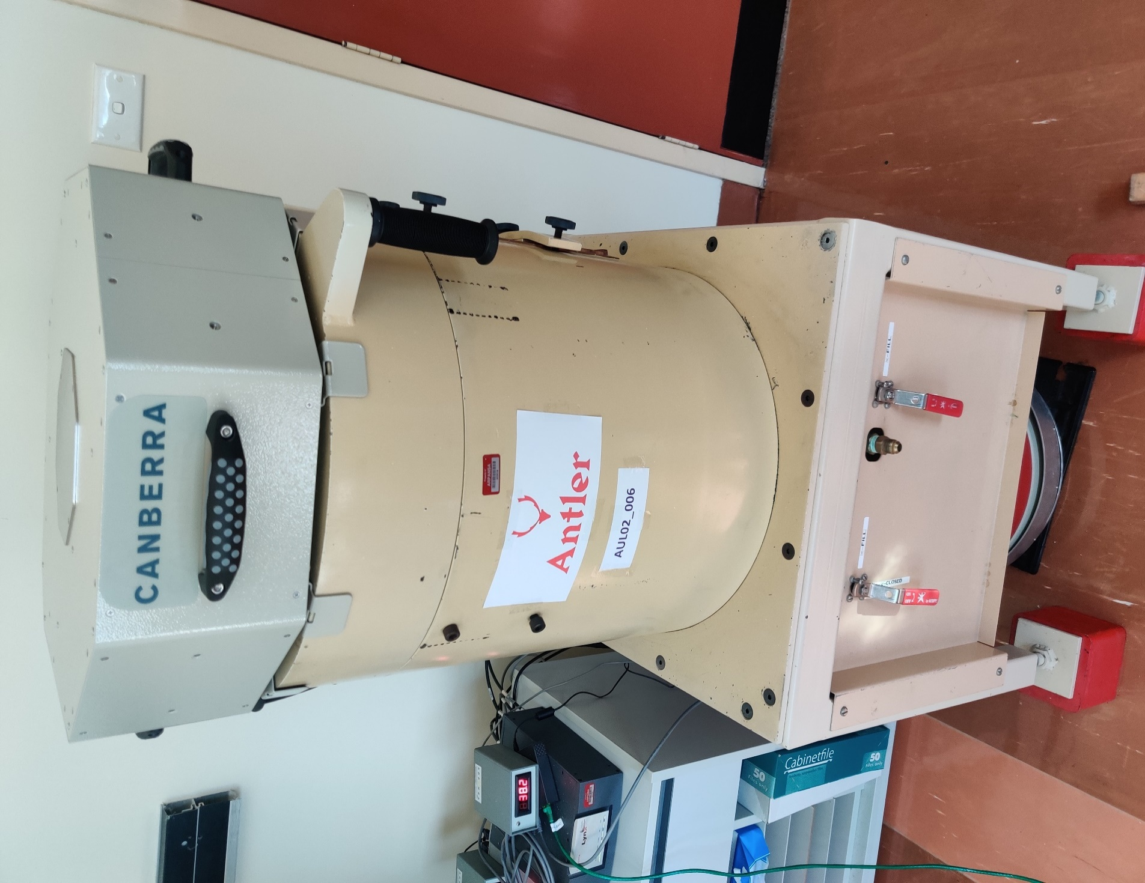

# Initial anti-coincidence timing settings and evaluation

Implementation of the veto system requires timing adjustment of anti-coincidence signals sent from the CosmicGuard Osprey MCA to the spectrometry system Lynx MCA. An *Input Gate Delay* is introduced to allow HPGe detector charge collection and Lynx digital processing before arrival of the gate signal from the Osprey MCA. The detector rise-time setting may be used as a starting point for setting the gate delay.

The *Input Pulse Width* is the duration of the gate signal that will be used by the Lynx to correlate coincident events to be ‘gated’ (excluded) from the spectrum. The CosmicGuard manual (Mirion Technologies, 2017a) suggests an initial width setting of 1 µs.

## Determination of initial gate timing settings

A digital oscilloscope application available via the Lynx MCA server was used to determine the Input Gate Delay setting. Use of the oscilloscope to identify and/or align the following digital processing signals is described in the veto system user manual (Mirion Technologies, 2017a):

* **Peak Detect** - This signal displays the status of the spectroscopy filter peak detector. The signal goes high when the system has detected the peak amplitude
* **Store** - This signal goes high when an event is detected by the MCA processor. The event will be stored in the spectrum if all storage requirements are met (LLD, ULD, coincidence gating, etc.). In this case the scope displays the width of this Store signal as ~ 0.2 µs
* **External Gate In** – This signal goes high to indicate an anticoincidence gate. The veto system initiates the generation of this signal, the delay and duration of which are set via the Input Gate Delay and Input Pulse Width settings in the Genie 2000 Acquire Setup panel.

The oscilloscope application was used to visualise the alignment of the Store and External Gate In signals. When seen in coincidence with the veto gate signal, a majority of the Store signals appeared to be generated at ~ 9 µs after the gate signal. The Genie 2000 Input Gate Delay value was varied to align the centre of the gate signal with the predominating Store signals. The following gate timing values were determined as appropriate for an initial assessment of the CosmicGuard veto system performance:

* Input Gate Delay: 9 µs
* Input Pulse Width: 1 µs, as recommended (Mirion Technologies, 2017a).

## Method for assessment of veto system performance

In order to assess the impact of the CosmicGuard on the detection system MDA, the reduction in count rates at specific spectral background peaks and representative continua were assessed. Regions of interest (ROI) were established for spectral regions as detailed in Table 1, including:

* ROI #17 at the peak for Ba140 at 537 keV. This ROI represents the energy window width (1.25*FWHM) over which the detector MDA is assessed according to CTBTO requirements
* 4 background spectrum peaks, using broader ROI’s (3*FWHM) centred at energies (keV):

73 (shield Pb X-rays), 140 (Ge activation), 511 (annihilation), 1764 (Bi-214, U-238 decay series)

* Five representative background continua across the energy spectrum. These ROIs have been chosen as suitable for assessment purposes, centred at energies (keV): 53, 170, 555, 1050, 1900.

Spectral counts in the background continua ROIs were evaluated using the integral counts of ROIs defined via Left and Right channel markers in the spectrum display of Genie 2000. Background peak MDA improvements were evaluated using a Genie 2000 peak analysis to determine both the net peak counts, and underlying continuum. The ratio (veto ‘gated’ versus non-veto ‘ungated’) of both the net peak and continuum counts was calculated, and the latter used to calculate a relative MDA improvement value. The method for calculating the two performance values follows:

* Ratio of gated to ungated ROI counts (a value <1 indicates a reduction of background counts)

RATIO = ROI[GATED] / ROI[UNGATED]

* MDA expected improvement, which varies as the square root of the count-rate ratio

MDA RELATIVE IMPROVEMENT = SQRT(1/RATIO) -1

Table : Regions of interest (ROI) for assessment of veto system performance

|  |  |  |  |  |
| --- | --- | --- | --- | --- |
| **ROI #** | **ROI Type** | **ROI Left (keV)** | **ROI Right (keV)** | **ROI Centre (keV)** |
| 1 | BG Continuum | 25.0 | 49.9 | 37.5 |
| 2 | BG Continuum (representative) | 49.9 | 55.0 | 52.5 |
| 3 | BG Continuum | 49.9 | 100.0 | 75.0 |
| 4 | BG Peak [Pb x-ray K-alpha 1&2] | 70.5 | 77.1 | 73.8 |
| 5 | BG Continuum | 100.0 | 150.0 | 125.0 |
| 6 | BG Peak [Ge(n,gamma) (3*FWHM)] | 136.9 | 142.2 | 139.6 |
| 7 | BG Continuum (representative) | 144.9 | 195.0 | 170.0 |
| 8 | BG Continuum | 205.0 | 250.0 | 227.5 |
| 9 | BG Continuum | 250.0 | 300.0 | 275.0 |
| 10 | BG Continuum | 300.0 | 349.9 | 325.0 |
| 11 | BG Continuum | 349.9 | 400.0 | 375.0 |
| 12 | BG Continuum | 400.0 | 450.0 | 425.0 |
| 13 | BG Continuum | 450.0 | 499.9 | 475.0 |
| 14 | BG Continuum | 499.9 | 550.0 | 525.0 |
| 15 | BG Peak [511 keV annihilation] | 506.7 | 514.9 | 510.8 |
| 16 | BG Continuum (representative) | 520.0 | 589.9 | 555.0 |
| 17 | BG Peak [Ba140, 537.3 keV (1.25*FWHM)] | 535.2 | 538.5 | 536.9 |
| 18 | BG Continuum | 550.0 | 600.0 | 575.0 |
| 19 | BG Continuum | 600.0 | 700.0 | 650.0 |
| 20 | BG Continuum | 700.0 | 799.9 | 750.0 |
| 21 | BG Continuum | 799.9 | 900.0 | 850.0 |
| 22 | BG Continuum | 900.0 | 1000.0 | 950.0 |
| 23 | BG Continuum (representative) | 1000.0 | 1099.9 | 1050.0 |
| 24 | BG Continuum | 1099.9 | 1200.0 | 1150.0 |
| 25 | BG Continuum | 1200.0 | 1299.9 | 1250.0 |
| 26 | BG Continuum | 1299.9 | 1400.0 | 1350.0 |
| 27 | BG Continuum | 1500.0 | 1700.0 | 1600.0 |
| 28 | BG Peak [Bi214, 1764.5 keV (3*FWHM)] | 1760.1 | 1768.7 | 1764.4 |
| 29 | BG Continuum (representative) | 1800.0 | 2000.0 | 1900.0 |
| 30 | BG Continuum | 2000.0 | 2199.9 | 2100.0 |
| 31 | BG Continuum | 2199.9 | 2400.0 | 2300.0 |
| 32 | BG Continuum | 2400.0 | 2699.9 | 2550.0 |

## Assessment of veto system performance, initial gate timing settings

A gated and ungated background spectra was acquired with the veto gate timing set to initial values based on oscilloscope visualisation (delay = 9 µs, width = 1 µs). Acquisition duration was approximately 3-days, with a dead-time of 0.03%. A chart of the gated to ungated ROI count rate ratio is presented in Figure 2. The chart displays background continua count rate ratios, net peak area ratio for the 511 keV (triangle), and continuum ratio for the 537 keV peak ROI.

A nominal minimum ROI of 500 counts was set as a lower limit for meaningful calculation of ROI ratios. In all cases except the 511 keV annihilation peak, insignificant background peak count rates and narrow ROI resulted in unacceptably high uncertainties for net peak area and subsequent ratio evaluation. In these cases, a simple ratio of gross ROI counts was used as an indicative comparison metric, as per the evaluation method for background continua. These gross peak ROI ratios remain subject to higher uncertainty due to relatively low count rates, especially at lower detector efficiencies (higher energies), including the 537 keV peak.

Figure : Chart of ROI ratios using initial gate timing settings.

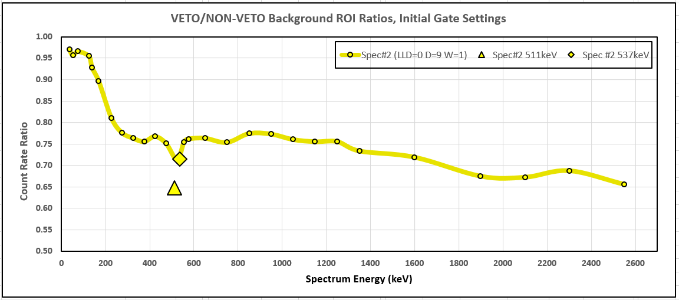

The assessment indicates a variation in background reduction across the spectrum energy. MDA improvement values range from less than 3% at the lowest assessment energy ROIs, to greater than 20% at the highest energy ROI. This energy dependence of the veto system performance may result from several influences, such as excitation-emission delays and detector charge collection time. Irrespective of the reason for this energy dependence, the results indicate that the anti-coincidence timing of the veto system implementation requires further investigation and optimisation.

Table 2 presents results for (i) ROI ratios and (ii) Relative MDA Improvement, representing key performance indicators for the veto system, configured with initial gate delay and width values.

The assessment also indicates that the net area of the 511 keV annihilation peak is reduced by a factor significantly greater than the reduction in adjacent continua ROI. This result is expected and is due to cosmic radiation being the predominant source of the spectral annihilation peak.

Table : Veto system performance assessment, initial gate settings.

|  |  |  |  |
| --- | --- | --- | --- |
| **Initial Gate Settings: Delay = 9.0 µs, Width = 1.0 µs.** | | | |
| **ROI Type** | **ROI Centre (keV)** | **ROI Ratio (Veto/Non-veto)** | **Relative MDA Improvement (%)** |
| **BG Continuum** | 52 | 0.957 | 2.2 |
| **BG Peak [Pb x-ray K-alpha 1&2]** | 74 | 0.959 | 2.1 |
| **BG Peak [Ge(n,gamma) (3*FWHM)]** | 140 | 0.928 | 3.8 |
| **BG Continuum** | 170 | 0.896 | 5.6 |
| **BG Peak [annih. (3*FWHM), net peak]** | 511 | 0.648 | - |
| **BG Peak [annih. (3*FWHM), continuum]** | 511 | 0.713 | 18.4 |
| **BG Peak [Ba140, (1.25*FWHM)]** | 537 | 0.714 | 18.3 |
| **BG Continuum** | 555 | 0.754 | 15.2 |
| **BG Continuum** | 1050 | 0.761 | 14.7 |
| **BG Peak [(Bi214, (3*FWHM)]** | 1764 | *[high unc.]* | *[high unc.]* |
| **BG Continuum** | 1900 | 0.675 | 21.7 |

## Confidence in initial gate timing settings

The above method for setting the anti-coincidence gate width is prone to uncertainty resulting from:

* a relatively low count-rate of coincident events with which to visualise gate timing
* minimal provided information regards optimisation of the gate signal delay and width settings.

This uncertainty, coupled with the observation of energy dependence in the MDA improvement values, indicates that further investigation of anti-coincidence timing of the veto system is warranted. As such, a process to compare and optimise gate timing values was undertaken.

# Optimisation of anti-coincidence timing settings

In order to optimise the timing of anti-coincidence signals from the CosmicGuard veto system, a method was developed to assess the impact of variation in gate delay and gate width values. Based on the assessment, gate timing values may be assigned to more effectively to capture coincident signals, whilst limiting random coincidences in the two detectors to acceptable levels.

## Gate width variation

Commencing with the initial gate timing values based on oscilloscope visualisation (delay = 9 µs, width = 1 µs), the gate width was widened to determine the range of delay values across which the veto system produces significant reduction in background count rates. Multi-day background spectra were acquired with the anti-coincidence gate width set to 3 µs and 5 µs (delay unchanged), and the ROI ratios evaluated.

Figure 3 shows a chart of ROI ratios for the initial gate timing values, and subsequent acquisitions where gate width was increased. The results and corresponding chart clearly indicate that a gate width of 3 µs produces a ‘flatter’ improvement in background counts across the spectrum compared to initial gate timing settings. Widening of the gate to 5 µs produces results that indicate further but less significant improvements in background and annihilation peak count rates may be achievable. These results suggest that a majority of the coincident events occur within 2.5 µs either side of the 9 µs gate delay. This range of gate width values provides suitable starting point from which to ‘scan’ across a range of gate delay values, and better determine the timing range of coincident events.

Figure : Chart of ROI ratios using various gate width settings.

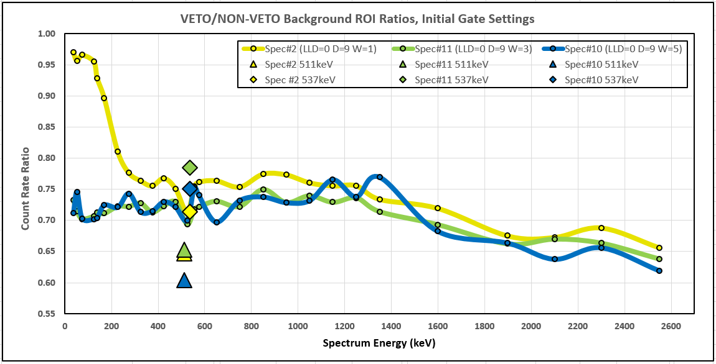

## Gate delay variation

As detailed above (Section 5.1) results of anti-coincidence gate width variation suggest that a majority of coincident events occur within 2.5 µs either side of the 9 µs gate delay. In order to more precisely determine gate delay and width settings, multi-day background spectra were acquired with a width setting of 1 µs, and delay setting between 7 µs and 12 µs at increments of 1 µs. Continua and peak ROIs were evaluated as described above (Section 4.2). ROI ratios are presented in Figure 4.

Figure : Chart of ROI ratios using various gate delay settings.

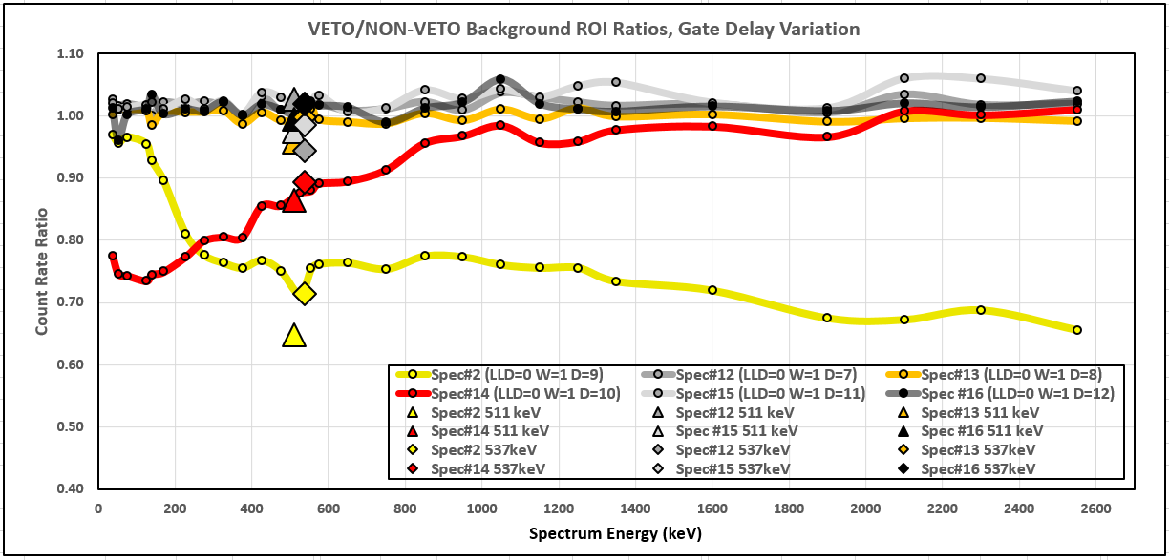

ROI ratio results indicate that two of the spectral acquisitions in total contained a significant majority of the gated coincident events:

* Delay = 9 µs (from 8.5 µs to 9.5 µs). This is the same spectrum as that acquired for testing of initial gate settings. As noted earlier, background reduction shows an energy dependence, where the proportion of gated events decreases below ~ 250 keV
* Delay = 10 µs (from 9.5 µs to 10.5 µs). These results also show an energy dependence for background reduction, but with the proportion of gated events increasing below ~ 1000 keV. Above this energy, background reduction appears minimal.

The remainder of spectra (gate delay = 7, 8, 11 and 12 µs) appear to reflect insignificant improvement in background and peak ROI, except for annihilation peak reduction of ~ 4% for a gate delay of 8 µs. To more concisely illustrate veto system performance for the incremental gate delay settings, the mean ROI ratio was calculated for three energy ranges: < 250 keV, 250 to 1000 keV, and > 1000 keV, as presented in Table 3. The table also includes ratios for the 511 keV net peak, and the 537 keV gross ROI at 1.25*FWHM, the latter subject to high uncertainty due to low count rates and narrow ROI.

Table : Mean veto system performance, incremental gate delay settings.

|  |  |  |  |  |  |  |
| --- | --- | --- | --- | --- | --- | --- |
|  | **Gate Delay** | | | | | |
| **ROI Ratio** | **7 µs** | **8 µs** | **9 µs** | **10 µs** | **11 µs** | **12 µs** |
| **Mean (< 250 keV)** | 1.017 | 1.004 | 0.930 | 0.758 | 1.030 | 1.020 |
| **Mean (250 to 1000 keV)** | 1.011 | 0.999 | 0.751 | 0.878 | 1.018 | 1.010 |
| **Mean (> 1000 keV)** | 1.023 | 0.999 | 0.713 | 0.983 | 1.041 | 1.020 |
| **BG Peak (511 keV, net)** | 1.027 | 0.957 | 0.648 | 0.864 | 0.974 | 0.994 |
| **BG Peak (537 keV, gross)** | 0.944 | 0.998 | 0.714 | 0.894 | 0.986 | 1.019 |

Determination of appropriate veto system gate width and delay settings must strike a balance between registering all cosmic coincident events and minimising exclusion of counts due to random coincidence. The results of gate delay variation suggest that a significant majority of coincident HPGe detector events occur within a 2 µs width window between 8.5 µs and 10.5 µs after the veto system event. Whilst further iterations of the above optimisation process may be performed to refine the coincidence gate width and delay settings, the benefits of such time-consuming efforts will be minimal for low count rate circumstances. As a first iteration of coincidence gate timing optimisation, the following settings suggested by the above data are considered reasonable balance for implementation of the CosmicGuard veto system:

* Input Gate Delay: 9.5 µs
* Input Pulse Width: 2 µs.

## Assessment of veto system performance, optimised gate timing settings

The Antler detector system was configured with the optimised coincidence gate width and delay settings determined above (LLD= 0, delay = 9.5 µs, width = 2 µs), and a background spectrum acquired for approximately 3 days. The acquired spectrum was analysed for ROI ratios via the previously established method.

A further spectrum was acquired with the veto system SCA LLD =600. This setting places the lower energy of the veto discriminator window more tightly around the full energy muon peak. The effect of this configuration is to exclude less energetic and higher count-rate external background radiation that may originate from other sources. Doing so may lower the probability of signals from the veto system randomly coinciding with sample emissions. Thus an increase in veto system SCA LLD will reduce loss of detector efficiency, but at the expense of increased MDA

Results of the analysis of two background spectra acquired with either LLD setting (0 and 600) and optimised gate settings are plotted in Figure 5, along with results for the initial gate configuration (delay = 9 µs, width = 1 µs). Key ROI ratio indicators are provided in Table 4.

Results of optimised gate settings with LLD=0 shows the better MDA improvement, with variation in ROI ratios relatively flat up to ~ 1300 keV, between 0.70 and 0.75. The equivalent MDA improvements range from 17.1% to 20.0%. Slightly greater MDA improvements are evident at higher spectrum energies. The mean of key indicator MDA improvement values for optimised gate settings and LLD=0 is 18.6%.

Results of optimised gate settings with LLD=600 also show MDA improvement, although less than that achieved for LLD=0. Variation in ROI ratios is again relatively flat up to ~ 1300 keV, between 0.75 and 0.80. The equivalent MDA improvements range from 12.6% to 15.6%. Again, slightly greater MDA improvements are evident at higher spectrum energies. The mean of key indicator MDA improvement values for LLD=600 is 14.2%.

Results of optimised gate settings with LLD=0 shows the better MDA improvement, with variation in ROI ratios relatively flat up to ~ 1300 keV, between 0.70 and 0.75. The equivalent MDA improvements range from 17.1% to 20.0%. Slightly greater MDA improvements are evident at higher spectrum energies. The mean of key indicator MDA improvement values for optimised gate settings and LLD=0 is 18.6%.

Results of optimised gate settings with LLD=600 also show MDA improvement, although less than that achieved for LLD=0. Variation in ROI ratios is again relatively flat up to ~ 1300 keV, between 0.75 and 0.80. The equivalent MDA improvements range from 12.6% to 15.6%. Again, slightly greater MDA improvements are evident at higher spectrum energies. The mean of key indicator MDA improvement values for LLD=600 is 14.2%.

Figure : Chart of ROI ratios using optimised gate settings.

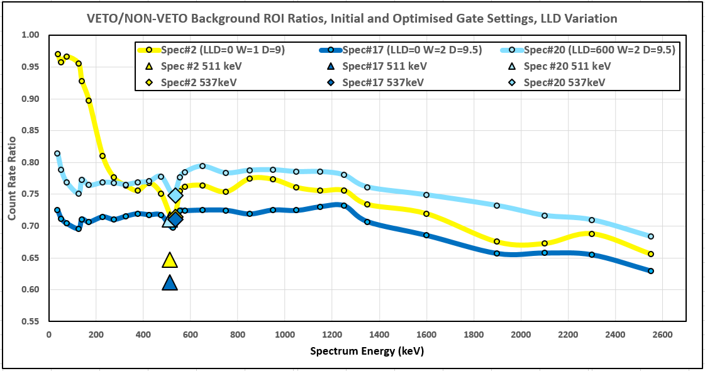

Table : ROI ratios and MDA Improvement (%) using optimised gate settings.

|  |  |  |  |  |  |
| --- | --- | --- | --- | --- | --- |
| **ROI Type** | **ROI Centre (keV)** | **LLD=0** | | **LLD=600** | |
| **ROI Ratio** | **(%) MDA Improv.** | **ROI Ratio** | **(%) MDA Improv.** |
| **BG Continuum** | 52 | 0.712 | 18.5 | 0.788 | 12.6 |
| **BG Continuum [Pb K-alpha 1&2]** | 74 | 0.695 | 20.0 | 0.777 | 13.5 |
| **BG Peak [Ge(n,gamma) (3*FWHM)]** | 140 | 0.711 | 18.6 | 0.773 | 13.7 |
| **BG Continuum** | 170 | 0.707 | 19.0 | 0.764 | 14.4 |
| **BG Peak [annih. (3*FWHM), net peak]** | 511 | 0.612 | - | 0.710 | - |
| **BG Peak [annih. (3*FWHM), contin.]** | 511 | 0.750 | 15.5 | 0.753 | 15.2 |
| **BG Peak [Ba140, (1.25*FWHM)]** | 537 | 0.710 | 18.6 | 0.748 | 15.6 |
| **BG Continuum** | 555 | 0.724 | 17.5 | 0.777 | 13.5 |
| **BG Continuum** | 1050 | 0.724 | 17.5 | 0.786 | 12.8 |
| **BG Peak [(Bi214, (3*FWHM)]** | 1764 | *[high unc.]* | *[high unc.]* | *[high unc.]* | *[high unc.]* |
| **BG Continuum** | 1900 | 0.657 | 23.4 | 0.732 | 16.9 |
|  |  |  |  |  |  |
|  | **Simple Mean** | 0.711 | 18.6 | 0.767 | 14.2 |
|  | **STD** | 0.024 | 2.1 | 0.018 | 1.4 |
|  | *(Excludes annihilation net peak)* | | | | |

## Expected MDA improvement for CRL detector systems

The CTBTO defines MDA requirements for detector systems via the Ba-140 537 keV line with a ROI based on 1.25 times the FWHM of that peak. As noted earlier, the MDA’s of the two CRL detection systems according to CTBTO specifications are:

* Antler 22.0 mBq/m3
* Buffalo 23.5 mBq/m3
* CTBTO requirement ≤ 24.0 mBq/m3.

The expected CTBTO improved MDA has been calculated for both CRL detector systems, accounting for both LLD setting, and assuming an identical benefit for both systems:

* LLD=0 (CosmicGuard SCA fully open) -  
  CTBTO MDA improvement: 18.6%.  
  Expected improved CRL system MDA’s:
  + Antler: 17.9 mBq/m3
  + Buffalo: 19.1 mBq/m3
* LLD=600 (CosmicGuard SCA set to the muon peak)-  
  CTBTO MDA improvement: 15.6%.  
  Expected improved MDA’s:
  + Antler: 18.6 mBq/m3
  + Buffalo: 19.8 mBq/m3

In both LLD cases the MDA improvement is in line with expectations for the CosmicGuard system provided by the manufacturer. The magnitude of the MDA improvement is significant given the degree of improvements achievable via alternative background reduction methods, and the potential for MDA degradation that may result from various influences.

# Assessment of sample emission coincidence

Whilst testing of the implementation of the CosmicGuard veto system indicates satisfactory MDA improvements, the detection system behaviour may have been negatively impacted as measured by other spectrometry metrics. Of particular concern is the detection efficiency of sample radionuclides that produce coincident high-energy photons. In this case, the spectrometry system may exclude sample emission events that are coincident in both the primary and veto system detectors. This unwanted exclusion is more probable at higher gamma-ray energies given the lead shielding between the two detectors. An assessment of this possible ‘side-effect’ of veto system implementation was undertaken.

## Method for assessment of sample emission coincidence

Assessment of the impact of the veto system on the detection of coincident sample emissions may be evaluated by measuring the relative change in detector efficiency for such emissions. The CRL use multi-nuclide sources in a standard filter geometry to calibrate the detection system and regularly acquire quality check spectra. The CRL quality control (QC) source contains Am-241, Eu-152 and Co-60, the last nuclide being most appropriate for a sample emission coincidence assessment due to its coincident generation of high-energy photons (1173 and 1332 keV). Comparison of gated to ungated spectra for these emission lines provides a measure of the impact of integrating the cosmic veto system.

The CRL QC source contains a total activity of ~ 5 kBq, producing a significantly higher count rate (2.9% dead time) than the typical CRL background or CTBTO air sample. The QC source activity and presence of Co-60 provides a means for assessing an upper limit for the potential impact of exclusion of coincident sample emissions.

Spectra were acquired of the CRL QC source using standard sample geometry, ensuring the 1332 keV net peak area exceeds 10,000 counts. Net peak areas were determined via a standard Genie analysis routine. The ratio of net QC peak areas of the gated and ungated spectra were then calculated, which reflects the change in QC source efficiency due to implementation of the cosmic veto system. Further, a statistical test was applied to determine whether the difference between the gated and ungated peak areas is significant.

Details of the QC spectra ROIs are provided in Table 5. The method for calculating the two performance values follows:

* Ratio of gated to ungated ROI counts (a value <1 indicates a reduction of peak counts)

RATIO = ROI[GATED] / ROI[UNGATED]

* Statistical ‘Z-test’ (possible significance: Z >1.64; definite significance: Z >2.78)

Z = (ROI[GATED] - ROI[UNGATED]) / SQRT(ROI[GATED] + ROI[UNGATED])

Table : Regions of interest for assessment of sample emission coincidence.

|  |  |  |  |  |
| --- | --- | --- | --- | --- |
| **ROI #** | **ROI Type** | **ROI Left (keV)** | **ROI Right (keV)** | **ROI Centre (keV)** |
| 1 | QC Peak [Am241, 59.5 keV] | 58.1 | 61.1 | 59.6 |
| 2 | QC Peak [Eu152, 121.8 keV] | 120.1 | 123.4 | 121.8 |
| 3 | QC Peak [Eu152, 244.7 keV] | 242.4 | 246.7 | 244.6 |
| 4 | QC Peak [Eu152, 344.3 keV] | 341.8 | 346.5 | 344.2 |
| 5 | QC Peak [Cs137, 661.6 keV] | 658.7 | 664.6 | 661.7 |
| 6 | QC Peak [Eu152, 778.9 keV] | 775.7 | 782.0 | 778.9 |
| 7 | QC Peak [Eu152, 964.0 keV] | 960.5 | 967.4 | 964.0 |
| 8 | QC Peak [Co60, 1173 keV] | 1169.5 | 1176.8 | 1173.2 |
| 9 | QC Peak [Co60, 1332 keV] | 1328.4 | 1336.3 | 1332.4 |
| 10 | QC Peak [Eu152, 1408.0 keV] | 1403.7 | 1411.7 | 1407.7 |
| 11 | QC Peak [Co60 sum peak] | 2500.3 | 2510.5 | 2505.4 |

## Assessment of Sample Emission Coincidence

Two QC source spectra were acquired with optimised gate settings, with veto system SCA set to LLD=0 and LLD=600. Ratios of gated to ungated peak areas is presented in Figure 6 and Table 6 for both LLD settings.

Figure : Chart of QC ROI ratios using optimised gate settings with LLD variation.

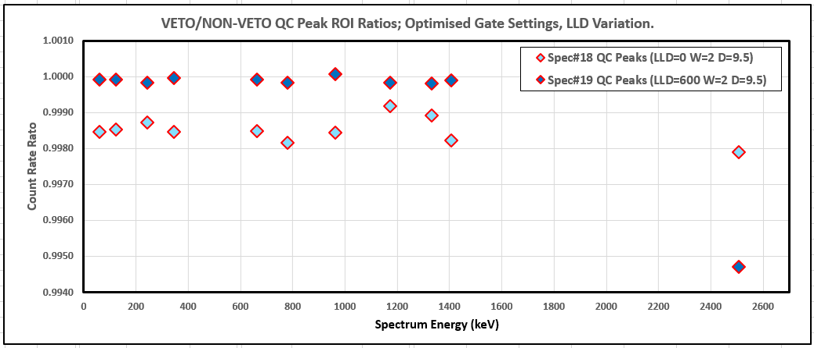

Table : QC ROI ratios using optimised gate settings with LLD variation.

|  |  |  |  |  |  |  |
| --- | --- | --- | --- | --- | --- | --- |
| **ROI Type** | **LLD = 0** | | | **LLD = 600** | | |
| **ROI Ratio** | **Z Score** | **Comment** | **ROI Ratio** | **Z Score** | **Comment** |
| **QC Peak [Am241, 59.5 keV]** | 0.9985 | 0.51 | Not Sig. | 0.9999 | 0.02 | Not Sig. |
| **QC Peak [Eu152, 121.8 keV]** | 0.9985 | 0.66 | Not Sig. | 0.9999 | 0.03 | Not Sig. |
| **QC Peak [Eu152, 244.7 keV]** | 0.9987 | 0.21 | Not Sig. | 0.9998 | 0.02 | Not Sig. |
| **QC Peak [Eu152, 344.3 keV]** | 0.9985 | 0.51 | Not Sig. | 1.0000 | 0.01 | Not Sig. |
| **QC Peak [Cs137, 661.6 keV]** | 0.9985 | 0.40 | Not Sig. | 0.9999 | 0.02 | Not Sig. |
| **QC Peak [Eu152, 778.9 keV]** | 0.9982 | 0.28 | Not Sig. | 0.9998 | 0.02 | Not Sig. |
| **QC Peak [Eu152, 964.0 keV]** | 0.9984 | 0.20 | Not Sig. | 1.0001 | 0.01 | Not Sig. |
| **QC Peak [Co60, 1173 keV]** | 0.9992 | 0.07 | Not Sig. | 0.9998 | 0.01 | Not Sig. |
| **QC Peak [Co60, 1332 keV]** | 0.9989 | 0.09 | Not Sig. | 0.9998 | 0.01 | Not Sig. |
| **QC Peak [Eu152, 1408 keV]** | 0.9982 | 0.24 | Not Sig. | 0.9999 | 0.01 | Not Sig. |
| **QC Peak [Co60 sum peak]** | 0.9979 | 0.03 | Not Sig. | 0.9947 | 0.07 | Not Sig. |

Results indicate a possible decrease of detection efficiency when fully opening the veto system SCA window (LLD=0). In deriving some representative trends for this data, the Co-60 sum peak has been excluded due to poor counting statistics.

For LLD=0, the proportion of decrease of QC peak counts is seen to be consistent across the spectral energy range 60 keV to 1400 keV. The average QC peaks ROI ratio = 0.9986 (Std Dev = 0.0003). Genie reports an uncertainty for these peak areas that ranges from ~0.2% at lower energies, to ~1.0% at mid-spectrum (e.g. Co-60). This variation in uncertainty is simply due to decreasing detector efficiency at higher energies resulting in poorer counting statistics. The consistency of the average ROI ratio across the energy range suggests that the detector system may be impacted by a systematic factor, such as count rejection due to random coincidence. The statistical test for equality of the gated and ungated spectrum peak areas suggests that, in all cases, gated and ungated QC peak areas are not significantly different.

For LLD=600, again the proportion of QC peak count decrease is consistent up to 1400 keV, with an average ROI ratio of 0.9999 (Std Dev = 0.0001). Uncertainties associated with counting statistics (0.2% to 1.0%) appear to outweigh the possible impact of the veto system rejecting a QC peak photon due random coincidence. The statistical test of the results indicates no significant difference between the gated and ungated QC peak areas.

For both LLD settings, there does not appear to be a significantly different ROI ratio for either of the Co-60 coincident high energy peaks compared to ROI ratios of (essentially) single-energy nuclides such as Am-241 and Cs-137. This result suggests that loss of Co-60 peak counts resulting from true coincidence in both detectors is not significant. The extent (efficiency variation) of this potential impact will be nuclide (energy) and geometry dependant, however this result in general indicates a negligible potential for unwanted gating of truly coincident emissions from any CTBTO sample radionuclide.

# Conclusion and recommendation

## Conclusion

Assessment results for integration of the CosmicGuard veto system into the CRL Antler detection system indicate that significant MDA improvements may be achieved with a manageable optimisation process.

A CTBTO-specified MDA improvement was measured to be between ~15.6% and ~18.6%, depending on the veto system SCA window setting. MDA improvement appears to be relatively flat across the required spectral energy range.

Quality check source acquisitions demonstrate the insignificant impact of random and (unwanted) true coincidence on detection system performance even at high count rates (dead time ~2%). Given the comparatively low activity of CTBTO air samples (and intercomparison sources), it is reasonable to configure the veto system SCA window to be fully open.

Based on the above conclusions, it is appropriate that the CosmicGuard veto system be permanently implemented with critical system parameters configured as follows:

* Input Gate Delay: 9.5 µs
* Input Pulse Width: 2 µs
* SCA LLD: 0

Based on testing of the veto-enabled Antler detection system, the suggested gate and LLD settings are expected to result in:

* A relative improvement according to CTBTO MDA specifications of: 18.6 %
* The measured MDA of the Antler system approximating: 17.9 mBq/m3

The improved MDA value represents 75% of the CTBTO detector MDA requirement of ≤ 24 mBq/m3, and provides substantially more tolerance for variation of the detector system MDA that might otherwise threaten compliance with that requirement.

## Recommendations

The following actions are recommended and based on conclusions reached above:

* Implement the CosmicGuard veto system as a standard component of the Antler CRL detection system, with Gate Delay, Gate Width and SCA LLD values applied as concluded (Section 7.1)
* Integrate the second available CosmicGuard system into the Buffalo CRL detection system with SCA window fully open (LLD=0), and test to determine optimised Gate Delay and Gate Width values
* Update the calibration, background and blank acquisitions, including re-issuance of a Detector Information Form (CTBTO, 2019, Appendix VII) with veto system details before commencing operations with a veto-enabled CRL detection system
* Always save both gated and ungated spectra acquired with veto-enabled CRL detection systems, and regularly compare analyses of these spectra as a means to assess veto system performance.

#### CRL ‘Antler’ and CosmicGuard technical details

Note that Canberra Industries was acquired by Mirion Technologies in mid-2016. The hardware details and basic settings of the existing spectrometry system (retained for veto system implementation) are as follows:

**DETECTOR and SHIELD**

Detector manufacturer / model: Canberra Industries BE5030 (‘BEGE’ model)

Serial number: 13087

Rated resolution: ≤ 2.0 keV FWHM at 1332 keV

Measured resolution: 1.6 keV FWHM at 1332 keV

Recommended high voltage: +3500 V

Cryostat model: 7500SL-RDC-4-ULB (slimline, 4” remote detector chamber, ultra-low background)

Preamplifier model: 2002CSL-10

Cooling: Liquid nitrogen

Shield manufacturer / model: 747 (4”/100 mm thick low background lead, lever activated single-piece lid)

**MCA**

Manufacturer / model: Canberra Industries Lynx

Serial number: 13007296

Recommended and applied high voltage: +3500 V

Course / Fine gain: 4.76 / 1.105

LLD / ULD: 0.1% / 100%

Rise time: 10.8 µsec

Flat top: 1.2 µsec

BLR mode: Auto

Preamp type: RC

Pole zero: 2447

The Lynx MCA may be accessed via IP connection to an inbuilt web server, and includes a digital oscilloscope for visualisation of signal processing and coincidence configuration settings.

**COSMIC VETO SYSTEM**

Manufacturer and model: Mirion Technologies CosmicGuard

Integrated MCA: Canberra Industries Osprey

Serial Number: 13000023

Recommended and applied high voltage: 691 V

The cosmic veto system is provided with Canberra CosmicGuard software for configuration and operation of the integrated Osprey MCA including network address, high voltage and single channel analyser (SCA) settings. The Osprey MCA may also be accessed via IP connection to an inbuilt web server that provides limited functionality.

#### CosmicGuard configuration process

The following process was employed when testing and configuring the CosmicGuard system via the CosmicGuard Configuration Utility (CGCP):

* Connect to the veto system:
  + Initiate the CGCP application from the networked computer
  + Enter the Osprey MCA IP4 network address in the CGCP ‘Connection’ field
  + Select the ‘Connect’ button, an ensure the ‘Disconnect’ button becomes active.
* Enable the veto system:
  + Select the CGCP button ‘Enable’
  + Ensure the indicator bar at the top of the CGCP (adjacent to the label ‘CosmicGuard Output:’) changes from red (‘Disabled’) to green (‘Enabled’).
* Test the veto system acquisition:
  + Enter ‘0’ (zero) in the ‘Lower Limit (Ch):’ entry box and ‘2048’ in the ‘Upper Limit (Ch):’ entry box in the ’SCA Window’ field, and select the ‘Set’ button
  + Select ‘1’ in the ‘Coarse:’ dropdown box and enter ‘2’ in the ‘Fine Value:’ entry box in the ‘Gain’ field
  + Select the ‘Start’ button in the CGCP ‘Acquisition’ field
  + Ensure counts are observed in the CGCP spectrum display, and ‘Status: Acquiring’ is displayed in the ‘Connection’ field
  + Repeatedly select the ‘Stop’, ‘Clear’ and ‘Start’ buttons in the CGCP ‘Acquisition’ field, ensuring the spectrum display and status message behave as expected.
* Apply voltage to the veto detector:
  + Determine the recommended operating high voltage value from the label on the rear side face of the veto hardware
  + Enter the operating high voltage value in the ‘Set Value (V):’ entry box in the CGCP ‘High Voltage’ field
  + Select the ‘Set’ button and then the ‘Enable’ button in the ‘High Voltage’ field
  + Observe the ramp-up of applied high voltage via the ‘Current Value:’ display, and ensure the achieved final value approximates the set value.
* Test the veto system gain:
  + Select the ‘Start’ button in the CGCP ‘Acquisition’ field and allow the veto spectrum to acquire for at least 15 minutes
  + Examine the resulting spectrum. A broad peak or ‘hump’ should be observed at approximately the half-way point (channel ~ 1000) of the spectrum full energy. This hump represents full energy absorption of typical muons (~ 10 MeV)
  + If necessary, adjust the system Gain to ensure the fully-energy muon peak is observed at spectrum channel ~ 1000.

References

Canberra Industries (2013) *Genie 2000 Spectroscopy Software Operations Manual v3.4*.

Canberra Industries (2014) *Lynx Digital Signal Analyzer User's Manual*.

Comprehensive Test Ban Treaty Organization (2019) *CTBT/PTS/INF.96/Rev10, Certification and surveillance assessment of radionuclide laboratories for particulate and noble gas sample analysis*.

Mirion Technologies (2017a) *CosmicGuard Cosmic Veto Background Reduction System User's Manual*.

Mirion Technologies (2017b) *CV System CosmicGuard Lid Mount Installation Manual (747 and 777 Shields)*.