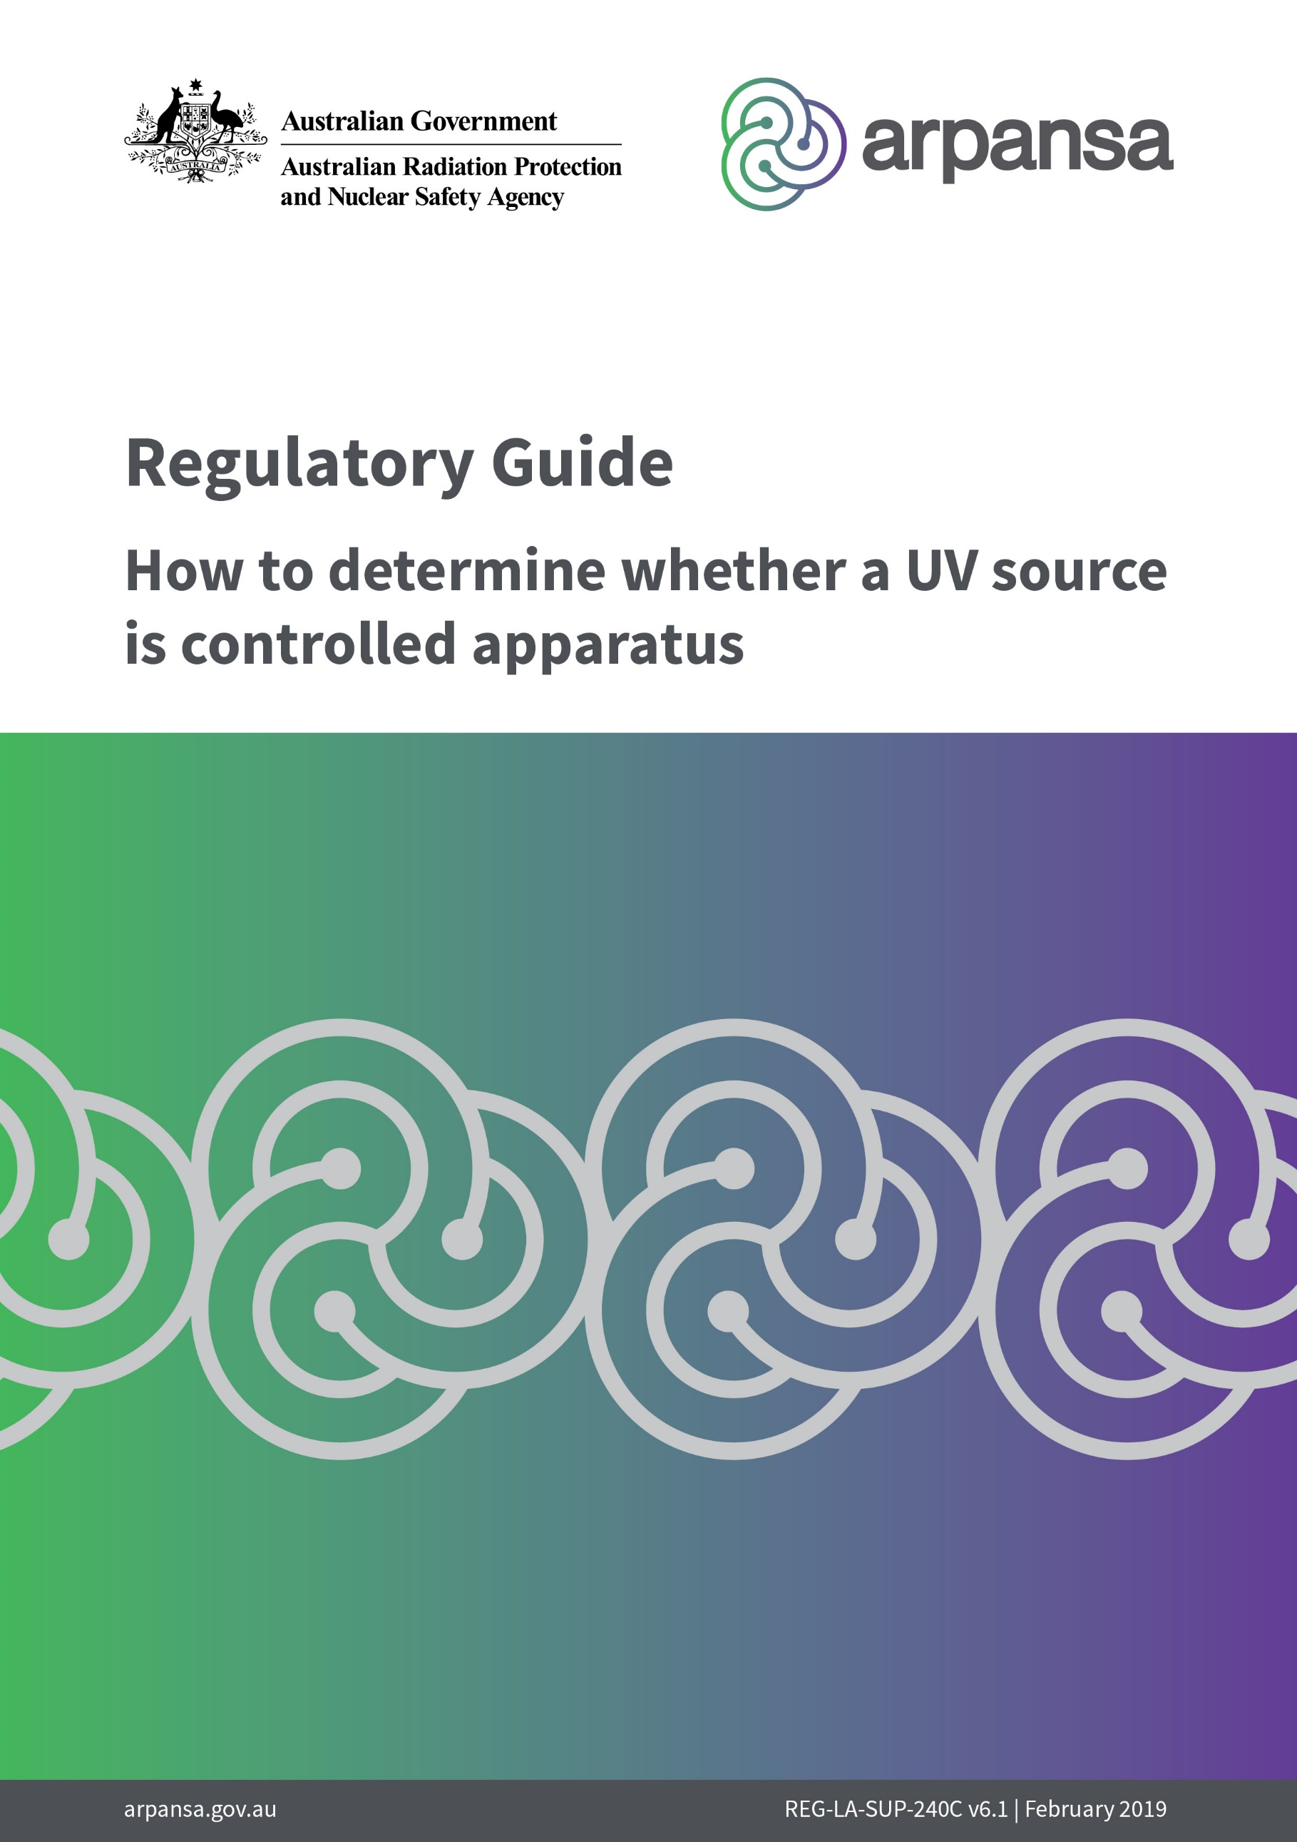

**Regulatory Guide**

How to determine whether a UV source is controlled apparatus

REGULATORY SERVICES

REG-LA-SUP-240C v6.1

February 2019

# Introduction

This document is provided to assist controlled persons to determine whether an ultraviolet (UV) source is classed as *controlled apparatus* under the [*Australian Radiation Protection and Nuclear Safety Act 1998*](http://www.comlaw.gov.au/ComLaw/Legislation/ActCompilation1.nsf/0/D971F2791F4BEDEFCA2570DF00178BA6/$file/AustRadProtNucSafety98WD02.pdf). In particular, it clarifies the conditions specified in section 9 of the [Australian Radiation Protection and Nuclear Safety Regulations](https://www.legislation.gov.au/Details/F2018L01694) 2018. A number of case studies where typical UV emitting apparatus have been assessed in accordance with this guide have been published in the document [*Regulatory Guide:*](https://www.arpansa.gov.au/sites/default/files/reg-la-sup-240t.pdf)[*UV emitting apparatus case studies*](https://www.arpansa.gov.au/sites/default/files/reg-la-sup-240t.pdf).

This document is valid for both pulsed and continuous sources of UV radiation where the exposure duration is not less than 0.1 μs. It does not apply to UV lasers.

## Reference document

[*Radiation Protection Standard for Occupational Exposure to Ultraviolet Radiation (2006)*, ARPANSA Radiation Protection Series No. 12.](https://www.arpansa.gov.au/regulation-and-licensing/regulatory-publications/radiation-protection-series/codes-and-standards)

Extracts from this document can be found in Appendix 1.

# Definitions

*Exposure limit:* the exposure which it is believed that nearly all workers can be repeatedly exposed to without adverse effect (exposure limits for UV are given in Schedule 1 of RPS 12).

Note: The exposure limits apply to artificial sources of UVR. Due to highly variable ambient solar UVR levels the application of exposure limits is not practical and limiting solar UVR exposure to as low as possible is the most effective approach.

*Permissible exposure time, tPET*: the time it takes to reach the exposure limit (calculated according to Schedule 1 of RPS12).

# Procedure

This procedure (as show by the flow chart on page 4) will assist you to determine whether your apparatus is controlled or not.

1. If the apparatus is a transilluminator or germicidal lamp where the emission is accessible, it is classed as controlled apparatus.
2. If the apparatus is a fluorescence microscope, a spectrophotometer or a high-performance liquid chromatography (HPLC) where the light source is completely enclosed, it is not controlled apparatus.
3. If there is a reasonably foreseeable abnormal event involving the apparatus that would lead to a person being exposed to levels above the exposure limits, the apparatus is classed as controlled apparatus. Examples of this are: forgetting or using the wrong PPE, possible exposure during normal maintenance, not using prescribed shielding to cover a sample, easy overriding of an interlock etc.
4. If there is a reasonably foreseeable single element failure of the apparatus that would lead to a person being exposed to levels above the exposure limits, the apparatus is classed as controlled apparatus. An example of this is a malfunctioning interlock. A *failsafe* interlock would not lead to a person being exposed as no UV is emitted if the interlock fails.
5. If a person can receive excess levels of radiation when removing protective barriers or access panels that do not require the use of tools or other specialized equipment, then the apparatus is classed as controlled apparatus.
6. Determine if the source emits UV radiation that could lead to a person being exposed to radiation levels in excess of the exposure limits in the course of intended operations or procedures. Calculate the **permissible exposure time**, *tPET*, according to the method described in Schedule 1 of RPS 12.

## Notes:

The distance to the source when the unit is in operation should be taken into account. Using the inverse square law the radiation level is calculated at the position where the closest person is situated. If the unit is handheld and no distances are specified: assume that the skin and eyes are 20 cm and 50 cm, respectively, from the source.

Embedded devices can be designed in such a way that it can be considered safe for their intended use and during normal operation as the emission hazard only becomes accessible during service or maintenance. i.e. protective housing, interlocks and other organisational safety measures. The servicing of embedded UV sources can increase the risk of injury as the servicing may include various adjustments. To carry out servicing in a safe manner it may be necessary to implement temporary procedures and safeguards appropriate to the increased level of risk. Manufacturers may provide advice on safe procedures during servicing and maintenance.

Compare with the **maximum exposure duration**, *texp*.

If $t_{exp}>t_{PET}$ the apparatus is classed as controlled apparatus.

If $t_{exp}<t_{PET}$ the apparatus is not classed as controlled apparatus.

NO

YES

YES

NO

NO

YES

NO

YES

YES

NO

NO

NO

YES

**Not controlled apparatus**

**Controlled apparatus**

Is there a reasonably foreseeable single element failure of the apparatus that would expose a person to levels above the exposure limits?

Is there a reasonably foreseeable abnormal event that would expose a person to levels above the exposure limits?

Compare with the maximum exposure duration, texp.

Is $t_{exp}>t_{PET}$ ?

Taking into account the intended operations and procedures calculate the permissible exposure time, tPET .

Is unit a spectrophotometer, fluorescence microscope or HPLC where the light source is completely enclosed?

Can a person receive excess levels of radiation when removing protective barriers or access panels without the use of tools or specialised equipment?

Is UV source a transilluminator or a germicidal lamp where the emission is accessible?

NO

NO

NO

NO

NO

NO

# Appendix 1

## Extracts from Schedule 1 Radiation Protection Standard for Occupational Exposure to Ultraviolet Radiation (2006)

### Radiation Protection Series No. 12

#### Exposure limits (EL) for UVR from artificial sources[1]

S1.1 The EL for occupational exposure to UVR incident upon the skin or eye where irradiance values are known and the exposure duration is controlled are as below. Note that S1.2 and S1.3 must both be satisfied independently.

S1.2 For the UV-A spectral region 315 to 400 nm, the total radiant exposure on the unprotected eye must not exceed 10 kJ.m–2 within an 8 hour period and the total 8 hour radiant exposure incident on the unprotected skin must not exceed the values given in Table 1. Values for the relative spectral effectiveness are given up to 400 nm to expand the action spectrum into the UV-A for determining the EL for skin exposure.

S1.3 In addition, the ultraviolet radiant exposure in the actinic UV spectral region (UV-B and UV-C from 180 to 315 nm) incident upon the unprotected skin and unprotected eye(s) within an 8 hour period must not exceed the values given in Table 1.

S1.4 For broadband sources emitting a range of wavelengths in the ultraviolet region (ie most UVR sources), determination of the effective irradiance of such a broadband source is done by weighting all wavelengths present in the emission with their corresponding spectral effectiveness by using the following weighting formula:

Eeff = ∑Eλ. Sλ. ∆λ

where

Eeff  = Effective irradiance in W.m–2 (J.s–1.m–2) normalised to a monochromatic source at 270 nm

Eλ = Spectral irradiance in W.m–2.nm

Sλ =Relative spectral effectiveness (unitless)

∆λ = Bandwidth in nanometres of the calculated or measurement intervals

S1.5 Permissible exposure time in seconds for exposure to actinic UVR incident upon the unprotected skin or eye may be computed by dividing 30 J.m–2 by Eeff in W.m–2. The maximum exposure duration may also be determined using Table 2 of this Schedule which provides representative exposure durations corresponding to effective irradiances in W.m–2 (and μW.cm-2).

**Table 1: Ultraviolet radiation exposure limits and relative spectral effectiveness**

|  |  |  |  |
| --- | --- | --- | --- |
| Wavelength (nm)a | Exposure limit (J.m-2) | Exposure limit (mJ.cm-2) | Relative spectral Effectiveness (Sλ) |
| 180 | 2 500 | 250 | 0.012 |
| 190 | 1 600 | 160 | 0.019 |
| 200 | 1 000 | 100 | 0.030 |
| 205 | 590 | 59 | 0.051 |
| 210 | 400 | 40 | 0.075 |
| 215 | 320 | 32 | 0.095 |
| 220 | 250 | 25 | 0.120 |
| 225 | 200 | 20 | 0.150 |
| 230 | 160 | 16 | 0.190 |
| 235 | 130 | 13 | 0.240 |
| 240 | 100 | 10 | 0.300 |
| 245 | 83 | 8.3 | 0.360 |
| 250 | 70 | 7.0 | 0.430 |
| 254b | 60 | 6.0 | 0.500 |
| 255 | 58 | 5.8 | 0.520 |
| 260 | 46 | 4.6 | 0.650 |
| 265 | 37 | 3.7 | 0.810 |
| 270 | 30 | 3.0 | 1.000 |
| 275 | 31 | 3.1 | 0.960 |
| 280b | 34 | 3.4 | 0.880 |
| 285 | 39 | 3.9 | 0.770 |
| 290 | 47 | 4.7 | 0.640 |
| 295 | 56 | 5.6 | 0.540 |
| 297b | 65 | 6.5 | 0.460 |
| 300 | 100 | 10 | 0.300 |
| 303b | 250 | 25 | 0.120 |
| 305 | 500 | 50 | 0.060 |
| 308 | 1 200 | 120 | 0.026 |
| 310 | 2 000 | 200 | 0.015 |
| 313b | 5 000 | 500 | 0.006 |

**Table 1: (continued) Ultraviolet radiation exposure limits and relative spectral effectiveness**

|  |  |  |  |
| --- | --- | --- | --- |
| Wavelength (nm)a | Exposure limit (J.m-2) | Exposure limit (mJ.cm-2) | Relative spectral effectiveness (Sλ) |
| 315 | 1.0 × 104 | 1.0 × 103 | 0.003 |
| 316 | 1.3 × 104 | 1.3 × 103 | 0.0024 |
| 317 | 1.5 × 104 | 1.5 × 103 | 0.0020 |
| 318 | 1.9 × 104 | 1.9 × 103 | 0.0016 |
| 319 | 2.5 × 104 | 2.5 × 103 | 0.0012 |
| 320 | 2.9 × 104 | 2.9 × 103 | 0.0010 |
| 322 | 4.5 × 104 | 4.5 × 103 | 0.00067 |
| 323 | 5.6 × 104 | 5.6 × 103 | 0.00054 |
| 325 | 6.0 × 104 | 6.0 × 103 | 0.00050 |
| 328 | 6.8 × 104 | 6.8 × 103 | 0.00044 |
| 330 | 7.3 × 104 | 7.3 × 103 | 0.00041 |
| 333 | 8.1 × 104 | 8.1 × 103 | 0.00037 |
| 335 | 8.8 × 104 | 8.8 × 103 | 0.00034 |
| 340 | 1.1 × 105 | 1.1 × 104 | 0.00028 |
| 345 | 1.3 × 105 | 1.3 × 104 | 0.00024 |
| 350 | 1.5 × 105 | 1.5 × 104 | 0.00020 |
| 355 | 1.9 × 105 | 1.9 × 104 | 0.00016 |
| 360 | 2.3 × 105 | 2.3 × 104 | 0.00013 |
| 365b | 2.7 × 105 | 2.7 × 104 | 0.00011 |
| 370 | 3.2 × 105 | 3.2 × 104 | 0.000093 |
| 375 | 3.9 × 105 | 3.9 × 104 | 0.000077 |
| 380 | 4.7 × 105 | 4.7 × 104 | 0.000064 |
| 385 | 5.7 × 105 | 5.7 × 104 | 0.000053 |
| 390 | 6.8 × 105 | 6.8 × 104 | 0.000044 |
| 395 | 8.3 × 105 | 8.3 × 104 | 0.000036 |
| 400 | 1.0 × 106 | 1.0 × 105 | 0.000030 |

a Wavelengths chosen are representative; other values should be interpolated at intermediate wavelengths

b Emission lines of a mercury discharge spectrum

**Table 2: Limiting ultraviolet exposure durations based on exposure limit**

|  |  |  |  |  |
| --- | --- | --- | --- | --- |
| Duration of exposure per day | | | Effective irradiance | |
| **Eeff (W.m–2)** | **Eeff (µW.cm–2)** |
| 8 | | Hr | 0.001 | 0.1 |
| 4 | | Hr | 0.002 | 0.2 |
| 2 | | Hr | 0.004 | 0.4 |
| 1 | | Hr | 0.008 | 0.8 |
| 30 | | Min | 0.017 | 1.7 |
| 15 | | Min | 0.033 | 3.3 |
| 10 | | Min | 0.05 | 5 |
| 5 | | Min | 0.1 | 10 |
| 1 | | Min | 0.5 | 50 |
| 30 | | Sec | 1.0 | 100 |
| 10 | | Sec | 3.0 | 300 |
| 1 | | Sec | 30 | 3 000 |
| 0.5 | Sec | | 60 | 6 000 |
| 0.1 | Sec | | 300 | 30 000 |

1. These exposure limits are intended to be used as guidelines only for solar UVR exposure